Biogas Production, Upgrading, and Utilization:
A Comprehensive Review
Ahmed Olanrewaju Ijaola ^{1,2}, Damilola Akamo ³, Emmanuel Anuoluwa Bamidele ⁴, Lateef Akorede Jolaoso ⁵, Eylem Asmatulu ¹, Peter Kayode Farayibi ⁶, Oluwatobi Gbenga Adelakun ⁶, and Vasilije Manovic* ²
- Department of Mechanical Engineering, Wichita State University, 1845 Fairmount St., Wichita, KS 67270, USA
- Centre for Climate and Environmental Protection, Cranfield University, Bedford, Bedfordshire MK43 0AL, United Kingdom
- Bredesen Center for Interdisciplinary Research and Graduate Education, University of Tennessee, Knoxville, TN 37996, USA.
- Material Science and Engineering Program, University of Colorado, Boulder, USA.
- Mewbourne School of Petroleum and Geological Engineering, University of Oklahoma, Norman, OK, USA.
- Department of Industrial and Production Engineering, Federal University of Technology Akure, Nigeria.
Abstract
In recent years, researchers have focused on developing alternative fuels derived from bioresources. The aim of these efforts is to reduce greenhouse gas emissions and carbon footprint. Biogas is a renewable, environmentally friendly, and inexpensive energy source that has the potential to help achieve this goal. Anaerobic digestion (AD) is a significant method for creating biogas in the absence of oxygen. It involves the activities of bacterial consortiums. However, increasing the quality of biogas is essential to meet the requirements of potential consumption regions. The efficiency of upgrading technologies is evaluated based on several criteria, such as operation and maintenance expenses, investment cost, methane recovery, and methane loss. Although membrane technology has lower operating and maintenance expenses compared to chemical absorption technology, it requires significant investment costs. This study aims to comprehensively assess the various technologies available for the production, upgrading, and usage of biogas. It also offers a framework that matches the required quality of biogas for every potential usage region to the necessary upgrading technologies. Additionally, it investigates future work related to the production, upgrading, and consumption of biogas, as well as government regulations that may facilitate the implementation of this work.
Keywords:
biogas; renewable energy; alternative fuels; anaerobic digestion; carbon footprint.

Submitted:
19-JAN-24

Accepted:
21-MAR-24

Published:

DOI:

Distributed under
Creative Commons CC-BY 4.0

OPEN ACCESS

*Corresponding author: v.manovic@cranfield.ac.uk

Introduction
The global threat posed by climate change has necessitated the utilization of alternative renewable energy sources with low to zero greenhouse gas emissions. The decomposition of organic waste without air generates gaseous fuel called biogas [1], deemed renewable and sustainable [2]. Biogas production necessitates an environment devoid of oxygen, along with the presence of anaerobic microorganisms. Recently, biogas has gained prominent attention due to its potential as a solution to the global climatic challenge and its ability to protect the environment and preserve natural resources [3]. Its main constituent is methane (CH4) (50—75%) and carbon (IV) oxide (25—50%), which makes it a promising substitute for fossil fuel [4], a significant source of greenhouse gases. Researchers have worked extensively on producing biofuels such as ethanol, dimethyl ether, methanol, and hydrogen; however, simplicity in biogas production has given it an edge over other solutions. Furthermore, governmental entities have established policies, conducted studies, and implemented programs aimed at further advancing the utilization of biofuels. For instance, the European Union has set 10% of its energy in the transport sector to be from biofuels in 2020, and the United States has placed its annual production of biofuels to be 36 billion gallons by 2022 [5].
Among all the bioenergy production forms, anaerobic digestion (AD), a form of organic matter decomposition widely used in biogas production because of its notable advantages over others, is classified among the most environmentally beneficial and energy-efficient technologies [8]. It is also applied in the processing of agricultural feedstocks. AD is the biological decomposition of organic matter, such as agricultural waste, kitchen waste, and sewage sludge, among others, without oxygen. This technique consists of four processes for the complete decomposition of feedstocks: hydrolysis, acidogenesis, acetogenesis, and methanogenesis [6]. This process involves four stages to fully break down feedstocks: hydrolysis, acidogenesis, acetogenesis, and methanogenesis. During hydrolysis, complex molecules are broken down into simpler compounds. Acidogenesis converts these compounds into organic acids. Acetogenesis transforms the organic acids into acetic acid, hydrogen, and carbon dioxide. Finally, methanogenesis produces methane gas from acetic acid, hydrogen, and carbon dioxide, completing the decomposition process. In principle, AD occurs in the temperature range of 0oC to 60oC [4]. This temperature span can be classified into psychrophilic, mesophilic, and thermophilic [7]. Although the exact global biogas production is unknown, several biogas production plants have been reported to operate around the globe. In 2007, Germany worked with more than 3,700 agricultural biogas plants [3][8], and biogas is produced in many Asian countries for home utilities using small-scale digesters [3]. For instance, the annual production of biogas in the 26.5 million plants in China increased from 10.5 billion m3 in 2007 to 248 billion m3 in 2010 [9]. In 2011, the electricity produced from biogas in Italy was 3405 GWh, and due to the cheap feedstock, biogas from AD is becoming a thriving source of sustainable power generation [10]. In 2007, the European Union estimated biogas production to be around 69 TWh [11]. A recent study on biogas potential for improved sustainability in Guangzhou, China, reported that an estimated 15,000 tons of food waste could provide 0.3 million Nm3 of biomethane, 18 tons of nitrogen fertilizer, and 6 tons of phosphorous fertilizer annually, consequently setting the annual reduction in greenhouse gas emission at 1,780 tons of CO2-eq. per year [12]. This clearly shows the potential of biogas production from sustainable, readily available feedstock sources such as food waste using various technologies, including AD.
However, biogas produced through AD and other production methods contains various impurities, including hydrogen sulfide (H2S), carbon monoxide (CO), halogenated compounds, nitrogen gas (N2), and organic silicon (Si) compounds. The amount of impurities in the biogas depends on its source, process condition, and digestion time [13]. In biogas systems, these impurities have significant adverse effects, including corrosion, fouling, increased emissions, and hazards to human health [14]. In order to increase the heating value of the biogas, these impurities must be eliminated through a process called biogas cleaning. The two primary steps in biogas purification are cleaning and methane enrichment. Enrichment or upgrading includes separating carbon (IV) oxide from biogas, whereas cleaning involves removing pollutants and acidic gases [11]. Conventional upgrading technologies include water scrubbing, organic physical scrubbing, chemical scrubbing, and pressure swing adsorption. Also, new technologies such as cryogenic upgrading, in situ methane enrichment, and ecological lung have been developed to make this process even more effective and efficient [11]. The intended purpose and national policy determine the quality of the enhanced biogas, which has several potential uses ranging from residential consumption to power generation [4].
Herein, an overview of biogas production, upgrading, and different routes available for its utilization is reported. More specifically, this paper provides a comprehensive review of the various feedstocks used for biogas production, the factors affecting anaerobic digestion, and the recent trends in biogas production. In addition, different biogas upgrading technologies, both traditional and newly developed, are extensively reviewed. Several areas of biogas utilization are explored, and these utilization routes are matched with the appropriate biogas upgrading technologies.

Biogas production

2.1 Feedstocks and their classifications
Biogas may be made from a wide variety of organic materials, such as trees, plants, and animal waste (manure), as well as solid waste (MSW, sewage, and other municipal biosolids) [15]. Biomass is an alternative to fossil fuels, the sun being the second-oldest energy source after the sun. It is also the only naturally occurring resource that contains energy and carbon [15]. Since people started using fire to cook and heat their houses thousands of years ago, biomass has played an essential role in human energy generation [16]. Lignocellulosic biomass, energy crops, sewage sludge, landfill gas, animal manure/slurry, and municipal solid waste are the significant feedstocks used in biogas plants.
Biogas production often makes use of landfills as a feedstock. Methane comprises around 40-60% of landfill gas, with carbon dioxide and volatile organic substances comprising the rest. This complex gas combination is created when microbes in a landfill break down organic matter [17]. Decomposition occurs because these microbes feed on dead plants and animals that end up in landfills. Decomposition happens slower at a landfill, releasing methane gas [16]. Engine generators may be made from landfill gas after treatment to remove water and hydrogen sulfide [18]. Because of new rules to regulate the use of landfill methane gas for safety and environmental concerns, generating electricity from landfills also decreases emissions of greenhouse gases [19]. Advancements in biogas production, particularly using landfill gas, contribute to sustainability by reducing greenhouse gas emissions, generating renewable energy, diverting waste, recovering resources, creating economic opportunities, and providing community and environmental benefits. These advancements address waste management challenges, combat climate change, and support the transition to a circular economy model.
An additional form of feedstock is sewage sludge, which consists of semi-solid materials that are not utilized and are a result of wastewater treatment processes (both industrial and municipal). Several factories use sewage sludge for wastewater treatment and act as a feedstock for biogas generation. Therefore, sewage sludge digestion residue can be used as a soil conditioner [20]. [21]. Agriculture plants cultivated for use as feedstock in biogas plants are known as energy crops; they also include sewage sludge. In the Western Hemisphere, sugar beets, sweet sorghum, and maize are the most widely grown energy crops. One common feedstock for biogas plants in Europe is a mixture of manure and maize [22]. Wheat, sugarcane, switchgrass, rice, and other energy crops are available. To be classified as an energy crop, a crop needs to meet two criteria: first, it needs a high biomass yield per hectare, which means less land needs to be used for cultivation. Second, its chemical and physical properties must be suitable for converting it into biogas or biofuel [23]. Biogas production from sewage sludge and energy crops can have positive environmental and economic impacts, but their contribution depends on various factors. It can help reduce greenhouse gas emissions, conserve resources, recycle nutrients, and promote a circular economy. However, it can also have implications on land use and feedstock acquisition costs. Revenue from biogas sales and government incentives can enhance economic viability. Sustainable feedstock sourcing, efficient digestion processes, and favorable policies can make biogas production more sustainable over time [22].
A significant portion of the biogas produced comes from animal dung or slurry and waste from industries and households [24]. Plant fertilizers are often made from manure collected from cattle and kept for several months on most farms. In particular, the lower layers of manure decompose while it is in storage. The energy-rich methane gas is a byproduct of this breakdown process. Combining manure with energy crops or other waste products during anaerobic digestion can enhance biogas generation. In several impoverished nations, manure is digested in small-scale home digesters, and the resulting gas is used for cooking and lighting [25]. Another established biogas feedstock is municipal solid waste, organic garbage collected from homes and local governments [26] [27]. Garbage, trash, food scraps, refuse, glass, and plastic are all part of this waste category; however, the organic portion of fraction of municipal solid waste (FMSW) is often the only one utilized as a feedstock for AD. Biogas production can be made more efficient and sustainable by integrating diverse waste streams, leading to optimized biogas yield, waste reduction, and improved digestion performance. Biogas technology can also have significant socioeconomic impacts in impoverished regions, including improved access to clean energy, health benefits, income generation, employment opportunities, and environmental conservation.
Microalgae is another feedstock used to produce biogas through anaerobic digestion and has gained much attention in recent years. They offer several advantages such as fast growth rate, absorption of atmospheric CO2, the possibility of cultivation in non-arable lands employing wastewaters, raceway ponds, photobioreactors, and seawater as growth media, reduced sludge production, minimum operational costs, lesser energy usage, and feasibility to recycle nutrients [28][29]. Despite these benefits, there exist some techno-economic hurdles yet to be overcome; these include the buildup of volatile fatty acids (VFAs) in the reactor, low biogas yield, low carbon-nitrogen (C:N) ratio, reusability of digestate as a soil conditioner, and difficulty in degrading raw microalgal feedstock [30][31]. Additionally, the methane generation ability of microalgae depends on the algal species used as feedstock [29]. The selection of the best species for a sustainable bioprocess still poses a major challenge due to the wide variation in the biogas yield among the species/strain [31][32]. Numerous studies have reported that the methane yield from anaerobic digestion of microalgae falls between 0.1- 0.39 L CH4/g VS [33], which is low for large-scale industrial applications. Hence, pretreatment and co-digestion of other substrates are adopted to increase the biomethane yield through synergistic effects.[33][34] Examples of microalgae species used for AD include Chlamydomonas reinhardtii, Chlorella vulgaris, Dunaliella sp., Scenedesmus obliquus, Spirulina sp., and Spirulina maxima [36]. Microalgae have high growth rates and can be grown in various environments. They can be used for biogas production, but there are challenges. They have a high lipid content, but also contain complex carbohydrates and proteins, making them less digestible. VFAs buildup during anaerobic digestion can inhibit methane production. Harvesting and dewatering techniques are energy-intensive and costly. Selecting microalgae species with high lipid content and low protein content can help. Co-digestion with other organic wastes and process optimization can also improve biogas production efficiency. Table 1 shows the composition and operational parameters of the relevant agricultural feedstocks for anaerobic digestion.

2.2 Composition of biogas
A plant's biogas composition is mainly dictated by the feedstock type and the operating conditions of its anaerobic digestion [4]. In general, methane gas makes about 50–75 percent of biogas, with carbon (IV) oxide accounting for 25–50 percent. Trace amounts of hydrogen sulfide, ammonia (NH3), water vapor (H2O), saturated hydrocarbons, and siloxanes round out the composition [4]. You may see the standard components and their properties of raw biogas in Table 2.
Methane is the sole component of biogas that increases its heating value; all other components negatively affect it. For example, the heating value of pure CH4 is 35.8 MJ/m3 at standard pressure and temperature, but raw biogas, which contains 60 percent CH4, has a value of 21.5 MJ/m3 under these same conditions [4]. To avoid unwanted consequences, it is necessary to eliminate the hydrogen sulfide and water [37]. Furthermore, despite their smaller volume fraction compared to methane, trace components have detrimental effects on the ecosystem, such as ozone layer degradation and lower local air quality [39]. While using some trace chemicals as an energy source, engines might malfunction or knock. Landfill gas is a significant source of several volatile organic compounds (VOCs), including aromatics, terpenes, hydrogenated aliphatics, ketones, and more. Organic silicon compounds, siloxanes, sulfur compounds, and halogenated compounds are the trace components of biogas. One of the most common sulfur compounds in biogas is hydrogen sulfide. As for the other sulfur compounds found in biogas, such as thiols (like methanethiol), sulfides, and disulfides (like dimethyl sulfide), their percentages are relatively modest [40]. Biogas must be treated before use to remove sulfur compounds, which can cause corrosion in gas storage tanks, compressors, and engines when exposed to water [41]. Biogas composition, particularly trace components like hydrogen sulfide (H2S) and VOCs, can cause corrosion, affect engine performance, lead to odor and environmental pollution. Techniques like desulfurization, VOC removal, gas treatment systems, biogas upgrading, and regular monitoring can help remove or mitigate these components and optimize biogas heating value.
These chemicals induce corrosion in the vehicle engine or combustion when biogas is utilized for energy generation; nevertheless, under specific combustion circumstances, furans and dioxins can be formed [41]. In industry, foaming agents, solvents, refrigeration aggregates, and fuels are some of the many uses for fluorinated compounds, whereas chlorinated and aromatic compounds are mainly employed as solvents [42].
The presence of fluorinated, chlorinated, aromatic, and organic silicon compounds in biogas can contribute to engine corrosion and combustion issues through various mechanisms:
1. Corrosion: Fluorinated and chlorinated compounds can lead to corrosion of engine components due to their corrosive nature. These compounds can react with metal surfaces, leading to degradation and weakening of engine parts.
2. Fouling: Aromatic compounds, such as benzene and toluene, and organic silicon compounds can deposit on engine surfaces, leading to fouling. This buildup can interfere with engine operation, reduce efficiency, and increase maintenance requirements.
3. Combustion Issues: Fluorinated, chlorinated, and aromatic compounds can also affect combustion efficiency by altering the combustion kinetics and producing undesirable by-products. This can lead to incomplete combustion, increased emissions, and reduced engine performance.
Furans and dioxins formed during combustion can have severe environmental and operational implications. They are persistent organic pollutants that can contribute to air pollution, pose health risks, and accumulate in the food chain. Furthermore, they can cause equipment fouling and corrosion, non-compliance with environmental regulations, reduce efficiency, and decrease productivity. Effective emission control measures, regulatory compliance, and operational best practices are necessary to mitigate these challenges.
Biogas also contains tiny amounts of organic silicon compounds, which, when burned, undergo oxidation to form silicon dioxide, which has a microcrystalline structure and looks like glass. As a result, when these compounds are heavily accumulated, they clog and wear down the valves, pistons, and cylinder heads [40]. In biogas, siloxane is the silicon component that is most often discovered. Organic radicals bonded to silicon form Si-O bonds in siloxanes, a class of silicone compounds. Functional groups such as methyl and ethyl are examples of organic radicals [43]. The poor solubility and high vapor pressure of siloxanes in water allow them to migrate from water to air readily. In wastewater digesters and landfills, they are converted into biogas by volatilization.

2.3. Anaerobic digestion
The production of biogas and treatment of waste is mainly accomplished by anaerobic digestion [44]. Microbes break down organic materials without oxygen to create carbon dioxide, methane, and other trace chemicals [45][46]. Digesters are sealed containers that conduct biochemical breakdowns, allowing microorganisms to convert organic waste into biogas [47]. The degradation of organic materials in AD is a multi-step process that calls for the cooperation of several bacteria, each of which plays a unique function [46].
However, the type of digester utilized in the degradation process can be classified using several parameters, including:
- Feed mode (continuous or batch systems): Continuous feed systems ensure a consistent supply of organic material, promoting stable microbial activity and biogas production. Batch feed systems may experience fluctuations in feedstock availability, potentially leading to inefficient digestion and lower biogas yields.
- Presence of moisture in the substrate (dry or wet digestion): Adequate moisture is crucial for microbial activity and nutrient availability in anaerobic digestion. Low moisture content can impede microbial growth and digestion rates, reducing biogas production. Excess moisture may lead to poor mixing and substrate channelling, lowering efficiency.
- Operating temperature of the system (thermophilic or mesophilic): Thermophilic (50-60°C) temperatures enhance digestion rates and
Feedstock | Constituents and processing condition |  |  |  | Product |  | Unwanted substances | Inhibitors | Frequent challenges
Feedstock | Total solids  TS (%) | Volatile solids  (% of TS) | C: N  ratio | Retention time (days) | Biogas yield  (m³ kg⁻¹VS) ^{c} | CH₄  Content (%) | Unwanted substances | Inhibitors | Frequent challenges
Cow slurry | 5–12^{d} | 75–85 | 6–20ª | 20–30 | 0.20–0.30 | 55–75 | Bristles, soil, H₂O, NH₄⁺, straw, wood | Antibiotics | Scum layers, poor biogas yield
Pig slurry | 3–8^{d} | 70–80 | 3–10 | 20-40 | 0.25–0.50 | 70–80 | Wood shavings, bristles, H₂O, sand, cords, straw | Antibiotics, disinfectants | Scum layers, sediments
Chicken slurry | 10–30 ^{d} | 70–80 | 3–10 | 430 | 0.35–0.60 | 60–80 | NH₄⁺ grit, sand, feathers | disinfectants  Antibiotics, disinfectants | NH₄⁺ -inhibition, scum layers
Fruit wastes | 15–20 | 75 | 35 | 8–20 | 0.25–0.50 | n.a. | Undegradable fruit remains, | grit Pesticides | pH-reduction
Food remains | 10 | 80 | n.a. | 10–20 | 0.50–0.60 | 70–80 | Bones, plastic material | Disinfectants | Sediments, mechanical problems
Whey | 1–5 | n.a. | 80–95 | 3–10 | 0.80–0.95 | 60–80 | Transportation impurities |  | pH-reduction
Grass | 20–25 | 90 | 12–25 | 10 | 0.55 | n.a. | Grit | Pesticides | pH-reduction
Grass silage | 15–25 | 90 | 10–25 | 10 | 0.56 | n.a. | Grit |  | pH-reduction
Garden wastes | 60–70 | 90 | 100-150 | 8–30 | 0.20–0.50 | n.a. | Soil, cellulosic component | Pesticides | Poor degradation of cellulosic components
Leaves | 80 | 90 | 30–80 | 8–20 | 0.10–0.30^{b} | n.a. | Soil | Pesticides
Straw | 70 | 90 | 90 | 10–50e | 0.35–0.45e | n.a. | Sand, grit |  | Scum layers, poor digestion
Wood  wastes | 60–70 | 99.6 | 723 | 1 | n. a | n. a | Unwanted material |  | Poor anaerobic biodegradation
Wood shavings | 80 | 95 | 511 | n.a. | n.a. | n.a. | Unwanted material |  | Mechanical problems
Ferment slops | 1–5 | 80–95 | 4–10 | 3–10 | 0.35–0.55 | 55–75 | Undegradable fruit remains |  | High acid conc., VFA-inhibition
Microalgae | 10-18 | 70-90 | 4-20 | 20-50 | 0.25 – 0.59 | 55-70 | NH₄⁺ |  | NH₄⁺ inhibition, VFA accumulation
Table 1: Comparison between composition and operational parameters of different feedstocks for biogas production. [31][38]
n.a. – unavailable; a - Depending on straw addition; b - Depending on dry ingrate; c - Depending on retention time; e - Depending on particle size; d - Depending on dilution.
Table 2: Biogas Constituents and Their Properties [4][11]
Component | Concentration | Properties
Methane (CH₄) | 50–75 vol% | Energy carrier
Carbon dioxide (CO₂) | 25–50 vol% | It lowers the heating value, causes corrosion, and creates a moist environment.
Hydrogen sulfide (H₂S) | 0–4,000 ppm | Corrosive SO₂ release during combustion
Ammonia (NH₃) | ~ 100 ppm | Emission of NO_{x} gases during combustion
Nitrogen gas (N₂) | ~ 0.2 vol% | Lowers heating value
Water vapor (H₂O) | 1–5 vol% | Enhances corrosion in the presence of CO₂ and SO₂
Hydrogen | 10-60 ppm | –
Oxygen | 0 | –
Other hydrocarbons | ~0 | –

pathogen destruction but require more energy for heating. Mesophilic (35-40°C) temperatures are suitable for diverse microbial populations and efficient biogas production from various organic materials. Suboptimal temperatures can slow microbial activity and decrease biogas yields. [48].
Optimizing feed mode, maintaining appropriate moisture content, and controlling operating temperature within the mesophilic or thermophilic range are essential for maximizing the efficiency and effectiveness of anaerobic digestion systems for biogas production.
Digester systems can also be grouped based on their scale; for instance, households utilize small-scale digesters for biogas production, while industries and communities use large-scale digesters. Another type of digester is the multiple bio-digester system, which includes cheap polyvinyl chloride (PVC) tubular digesters, fixed domes, floating drums, and plug flow types [48].
Anaerobic digestion typically entails four primary biological and chemical processes. Anaerobic digestion is a complex biochemical process involving a series of biological and chemical reactions. The key stages include hydrolysis, acidogenesis, acetogenesis, and methanogenesis. At the outset of AD is hydrolysis. Extracellular enzymes (such as amylase, protease, cellulase, and lipase) break down or depolymerize complex organic molecules like proteins, lipids, starches, cellulose, and carbohydrates into simpler molecules like amino acids, sugars, long-chain fatty acids, and glycerol during hydrolysis [49][50]. Depolymerization improves the substrate surface area that hydrolytic enzymes operate with, increasing the feedstock's solubility as hydrolysis processes occur in the aqueous phase. The sluggish hydrolysis process might positively or adversely affect the pace of anaerobic digestion [51]. For example, if the substrate contains solid trash, the AD rate can be regulated [50][52]. You may describe the hydrolysis process using the general equation:
Biomass (complex organic molecules) + Water$→$Monomers + Hydrogen Gas (H₂)
Acidogenesis, the process of acid formation, starts after hydrolysis is finished. A combination of hydrogen, carbon (IV) oxide, VFAs, including butyric and propionic acids, and alcohol are produced when acidogenic bacteria ferment the simple soluble chemicals that have been generated [4][50]. Acidogenesis is similar to the soured milk process. After acidogenesis, the next step is acetogenesis. At this stage, acetogenic bacteria oxidize the alcohols and VFAs that are byproducts of acidogenesis into carbon dioxide, acetate, and hydrogen gas [4][44]. A mechanism known as homoacetogenesis allows hydrogen-oxidizing acetogenic bacteria, or homoacetogens, to further act upon CO₂ and H₂ to produce acetate. Anaerobes can be voluntary or mandatory for acidogenic and acetogenic bacteria [50].
When methanogens, or bacteria that produce methane, are present, the last stage in producing methane through anaerobic digestion is known as methanogenesis [53]. Regarding speed, this AD procedure is dead last [50]. Methanogenesis is the process by which bacteria that feed on hydrogen, carbon dioxide, and acetate produce a gaseous mixture of carbon dioxide and methane. Acetotrophic methanogenesis includes using acetate as a substrate by acetotrophic methanogens, whereas hydrogenotrophic methanogens reduce CO2 by utilizing H2 as an electron donor in hydrogenotrophic methanogenesis [4]. Figure 1 shows the steps of the Alzheimer's disease process.

2.4. Factors affecting anaerobic digestion (AD)
The following factors impact the anaerobic digestion of organic materials for biogas generation:
Anaerobic digestion is significantly affected by the operating temperature of the anaerobic digester. This is because temperature is a crucial element that affects the physicochemical characteristics of the substrates used in the digesting process. It also influences the survival and association of the micro-organisms essential for digestion [55][56]. Generally, a temperature increase increases the biogas production rate but reduces the percentage of methane. This is because higher temperature reduces the retention time by expediting the decomposition of organic materials [57]. Hence, temperature is a crucial parameter that must be optimized for a stable and more efficient AD process.
Anaerobic bacteria operate at three optimum temperature ranges: psychrophilic, mesophilic, and thermophilic [56][58][59]. Psychrophilic digestion occurs below 20oC, mesophilic digestion occurs effectively within a temperature range of 25—40oC, while thermophilic digestion occurs within a temperature range of 50—65oC. Among them, mesophilic and thermophilic conditions are the standard modes of AD [56][60]. It has been reported that thermophilic anaerobic digestion has several advantages over mesophilic digestion, which include the following: speedy rate of reaction, high load-bearing ability, pathogen destruction, and increased productivity [56]. However, biogas production may be inhibited during thermophilic digestion due to free ammonia in the system, which causes reduced stability and formation of relatively high concentrations of volatile fatty acids, ultimately limiting the gas yield.[61] Other disadvantages of thermophilic digestion include elevated toxicity, low-quality effluent, higher investments, high sensitivity to environmental changes, and increased energy input [10][56].
On the other hand, mesophilic anaerobic digestive systems have better process stability, powerful bacteria consortia, easy maintenance, and low sensitivity to environmental changes [10][56]. Despite the merits above, mesophilic AD systems have the following drawbacks: low methane yield, poor anaerobic decomposition, imbalance of nutrients, and a more extended retention period [10]. Mesophilic AD systems are more suitable for commercial scale due to easy maintenance and reduced cost of investment [56]. Efforts have been focused on ensuring an optimal operating condition between the mesophilic and thermophilic systems. For example, Cavinato et al. (2013) demonstrated that by changing the reactor temperature from the mesophilic (37°C) to the thermophilic (55°C) range during anaerobic co-digestion of waste-activated sludge and biowaste, the specific biogas yield can be increased by 44% and the gas production rate by 47% with high-quality effluents[62]. In another study, Parawira et al. [63] compared two-stage anaerobic digesters of mesophilic–mesophilic, mesophilic–thermophilic, and thermophilic–thermophilic configurations with solid potato waste substrate. The findings showed that the methane yield was higher in the mesophilic second stage than the thermophilic second stage, but the thermophilic second-stage reactors produced a shorter retention time. Thus, for optimal operating conditions, anaerobic digestion must occur under thermophilic hydrolysis/acidogenesis and mesophilic methanogenesis, which is familiar with the two-stage AD process [10][46]. Fig. 2 presents the effect of operating temperature on biogas yield, pH value, sodium hydroxide (NaOH) consumption, and VFA content. Fig. 2a shows NaOH consumption and pH value as a function of temperature. Alkali consumption is reduced with increasing temperature, while the pH value becomes stable around 7.0. The production of biogas, methane, and VFA concentration is presented in Fig. 2b. With increasing temperature, methane and biogas production increases.

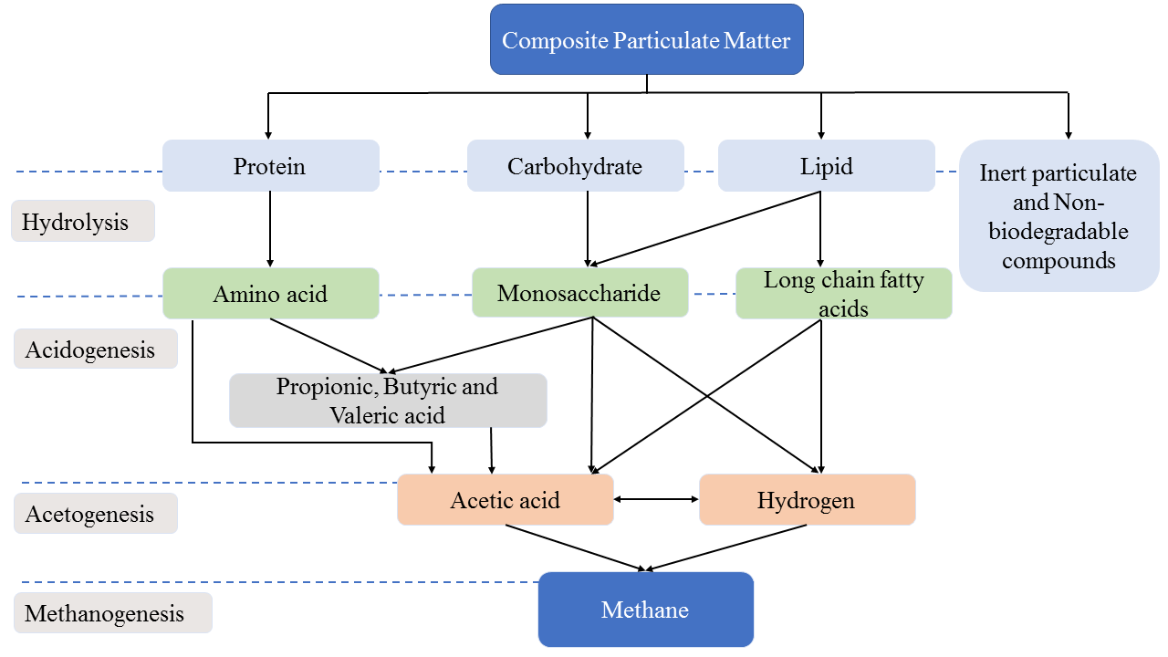
Fig. 1. Anaerobic Digestive Process Steps [54]

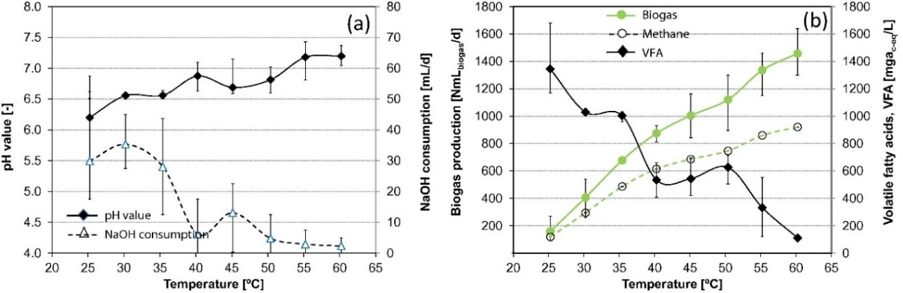
Fig. 2. Effect of Operating Temperature on (A) Ph Value and Naoh Consumption and (B) Biogas Production and Volatile Fatty Acids Concentration. As The Temperature Increases from The Mesophilic to The Thermophilic Regime, The Ph Value Becomes Stable Around 7.0. Also, The Biogas and Methane Yield Increased with a Corresponding Decrease in The Vfa Accumulation in The System [55].

Temperature ranges in psychrophilic, mesophilic, and thermophilic anaerobic digestion systems significantly influence microbial activity, biogas production rates, and process stability. Mesophilic conditions offer a balance between efficiency and stability, while thermophilic conditions can enhance biogas production rates but require careful control to maintain stability. Psychrophilic systems operate at lower rates and are suitable for specific applications in colder environments.
The pH range: regulating the pH is crucial for anaerobic digestion to be effective and efficient. The pH concentration affects the solubility threshold of organic substances in a substrate. As a bonus, it may indicate the conditions necessary for enzymatic activities and microbial survival that are essential for Alzheimer's disease [64][60][61]. Most research suggests that an AD process typically operates best within a pH range of 6.5 to 7.6 for maximum biogas and methane output [58]. The experiment results show that substrates with an optimal pH range of 7 have better degradation efficiency and biogas production yield than those with other pH values [56][67]. This is supported by Figure 3, which shows that the substrate with the highest biogas production has a pH of 7 [68]. On the other hand, methanogens may multiply quickly at pH values over 7.5 and approaching 8, which impedes acetogenesis [57].
Through careful regulation of the anaerobic fermentation process, Chen et al. [69] revealed a novel way to enhance the yields of hydrogen and methane produced from municipal organic waste (MOW). It was discovered that the yields of hydrogen and methane were considerably improved at pH 8 and pH 7, respectively, after anaerobic treatment of the fermentation liquid at a neutral pH value. This was followed by anaerobic fermentation of the MOW under alkaline conditions to produce hydrogen and a volatile fatty acid (VFA)-enriched fermentation liquid (stage I). The effect of pH modification on biogas production from food wastes during AD was examined in separate research by Yang et al. [70]. According to the findings, the pH 8 group achieved maximum values for cumulative biogas generation (1.49 times higher), cumulative methane yield (7.57 times higher), and methane content (5.06 times higher) compared to the pH unregulated group. Anaerobic hydrolysis and acidogenesis of paniculate organic materials at mesophilic and thermophilic temperatures were also studied by Kim et al. [71] about pH. The pH sensitivity of particulate organic materials was higher under thermophilic fermentation conditions than mesophilic ones.
The major pH-related challenge facing the stable production of biogas through AD is the acidification of the system, which is caused by the presence and accumulation of VFAs (acetic, propionic, and butyric acids, mainly) at early phases of digestion, which include hydrolysis and acidogenesis. Because acidity harms methane formers, keeping the pH below 6.5 is necessary at this stage [51]. Methane synthesis requires a pH greater than 7. The solution to this problem is to fix the pH and make the biodigester system more buffering by adding alkali chemicals like NaOH and CaCO3 [51][72]. Adding NaOH as a buffer to the system should be cautiously approached, as it inhibits anaerobic digestion by releasing Na+ ions in the medium [65]. When sugar beet by-products and pig dung were digested together, Aboudi et al. [73] tracked the changes in pH. Figure 4 shows the pH profile and trends of total vegetable fatty acid (TVFA) — the weighted sum of all VFAs — at the beginning of digestion. Hydrolysis and acidification activities kept the pH below 7 during the start-up phase, which resulted in higher TVFA readings. The pH was adjusted by adding 8M NaOH to the mixture. As a result, VFA buildup was reduced, and the pH rose steadily from 6.7 (on day 6) to 7.4–7.8 (beginning on day 16) and beyond.
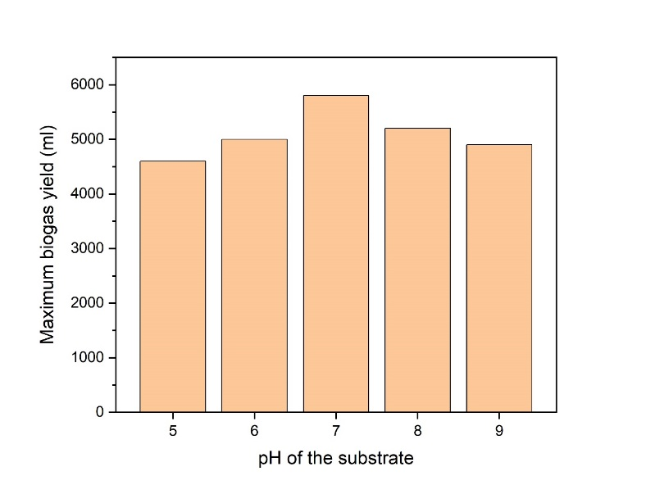
Fig. 3. Effect of substrate pH on biogas yield. The maximum biodegradation efficiency and biogas production are observed at a pH of 7 compared to other pH values [68].

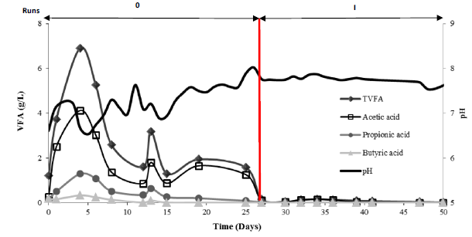
Fig. 4. Detailed evolution of pH, TVFA, and individual VFAs during the early phase of anaerobic digestion. Initially, a higher concentration of VFAs was observed, but the introduction of NaOH helped to reduce the acid accumulation and ultimately keep the pH within the 7.4-7.8 range for optimum methane production [73]

pH levels greatly impact the efficiency of anaerobic digestion processes. Maintaining a pH range of 6.5 to 8.0 is optimal for most digesters. Low pH inhibits hydrolysis and acidogenesis, while high pH inhibits methanogenesis. To regulate pH, enhance buffering capacity, choose feedstocks with balanced pH levels, monitor and control pH levels, introduce microbial inoculants, implement recirculation systems, and optimize operational parameters.
The organic loading rate is the rate at which organic materials are loaded into a digester when feeding is continuous [10]. Biogas output heavily depends on the loading rate, which influences microbial activity. The ideal organic loading rate (OLR) changes as different organic materials are added to the digester. The generation of biogas can be affected by either an excess of organic matter (high OLR) or a deficiency of it (low OLR) [55]. Inefficient AD systems and technologies may result from low OLR, whereas increased OLR improves microbial species, decreases heating energy needs, and decreases digester size and cost [64][74].
The optimal OLR is crucial for stable and efficient biogas generation in anaerobic digestion systems. Higher OLRs can increase microbial activity and biogas production, but excessively high OLRs can overwhelm microbial populations, leading to incomplete digestion and reduced biogas yields. Optimal OLR ranges depend on the composition and characteristics of the organic material being digested, and operators should monitor and adjust OLRs based on process performance and feedback from monitoring systems to mitigate risks such as acidification and system damage.
If the OLR is too high, the pump that circulates the fluid throughout the system might be damaged [75]. A drop in pH and the subsequent elimination of methanogenic bacteria is another consequence of this increase in acidogenic bacteria [56]. Figures 5(a) and (b) illustrate the results of a 1:1 co-digest of rice straw and cow dung, showing the specific biogas production (SBP) and volumetric gas production rate (VBPR) values at different OLRs [76]. Stable biogas production was achieved with an SBP of 350-500 L/kg VS when the OLR was 3-6 kg VS/(m3.d). An average VBPR of 2.3 m3/(m3.d) was achieved at an OLR of 6 kg VS/, which grew as the OLR did (m3.d). A reduction in SBP and VBPR was noted, along with considerable foaming when the OLR reached 8 kg VS/ (m3.d). As the OLR was raised to 12 kg VS/ (m3.d), the SBP and VBPR values dropped significantly, indicating a buildup of VFAs that impeded biogas generation. Additionally, Nagao et al. [64] used AD on food waste. They successfully reached a stable operating level at an OLR of 9.2 kg-VS m−3 day−1, resulting in a high VS reduction of 91.8% and a high methane output (455 mL g-VS-1).

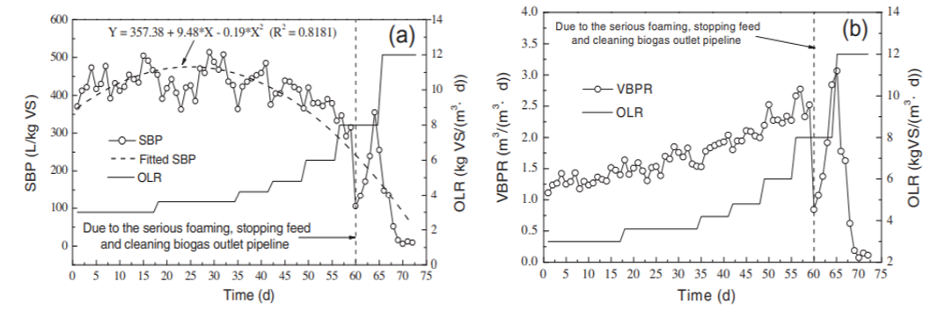
Fig. 5. Effect of OLR on (a) Specific biogas production, (b) volumetric biogas production rate during anaerobic continuous stable co-digestion of rice straw and cow manure. Maximum SBP and VBPR are observed at OLR range between 3-6 kg VS/ (m³.d). There was a reduction in SBP and VBPR due to the foaming in the system before a dramatic drop in SBP and VBPR at 12 kg VS/ (m³.d) due to excessive acid accumulation [76].

At a loading rate of 30.0 g VS/L under mesophilic (37°C) conditions, the highest biogas output is 93.6 mL/g VS added, according to Bah et al. [77], who used a 3:1 ratio of palm-pressed fiber (PPF) and cow dung (CM) for anaerobic co-digestion. Anaerobic co-digestion (co-AD) of maize stover (CS) and chicken manure (CM) utilizing a continuous stirred tank reactor was examined in a recent work by Yu et al. [78]. Under medium and high OLR conditions, the results demonstrated the highest methane output. At an OLR of 6.2 g VS/L/d, the system ran well, producing 2.160 L/L/d of volumetric methane—32.8 percent to 89.6 percent more significant than other reactors—and 1.616 L/L/d of volumetric methane—27.8 percent to 96.4 percent higher.
Degradation of organic materials takes a certain amount of time, called the retention time [10]. The organic loading rate, operating temperature, and substrate composition all have a role in retention time, which in turn is related to the development and metabolism of bacteria [10][56]. One kind of retention time is the solids retention time (SRT), which is the typical amount of time solids remain in a digester. As a key operational parameter in AD, SRT monitors the level of LCFA buildup, which in turn aids in extending lipid conversion and impacts methanogenic activity. Lipids produce more methane than proteins or carbs, making them an ideal substrate for AD [79]. Consequently, to maximize biogas output, it is critical to guarantee a high SRT of feedstock since this promotes the metabolism of slow-growing microbes that aid in the breakdown of LCFAs. In addition, by making microbes more adaptable to inhibitory conductions, high SRT protects the reactor against shock loadings [80]. Hydraulic retention time (HRT), which is defined as [10]:

Finding the best HRT for anaerobic digestion and biogas generation is paramount. The investment cost rises due to increasing the digester volume for long HRTs [76]. The microbes might perish because essential digestion and methane generation nutrients are either unavailable or insufficient [65]. Short HRTs that fall short of the ideal value cause volatile fatty acid buildup, which in turn causes digester clogging and reduced biogas output [10]. [55]. It is crucial to consider both microbial populations when choosing the retention duration for a digester [56]. Acidogenic agents prefer a short retention time, whereas methanogens prefer a long one and work at distinct rates.
Nweke et al. [81] processed industrial effluent from soft drink production using anaerobic digestion. Figure 6 shows the results of their investigation into the impact of retention time on digestion-related biogas output. The biogas output peaked at 25 milliliters on the tenth or eleventh day. Shi et al. [82] looked at how HRT affected the anaerobic digestion of wheat straw in another study. This study utilized three continuous stirred-tank reactors (CSTRs,) or semicontinuous continuous stirred-tank reactors, that operated at 35°C in mesophilic conditions. Total solid biogas output averaged 46.8, 79.9, and 89.1 mL/g after 20, 40, and 60 days of HRT, whereas volatile solid biogas production was 55, 9, 4, and 105.2 mL/g. The methane level was the lowest among the three reactors, with a 20-day HRT ranging from 14.2% to 28.5%. A decrease in methane concentration in biogas is caused by the buildup of propionate in the reactor, which inhibits the activities of methanogens. Additionally, the use of a fluidized bed digester for the anaerobic digestion of wastewater from breweries was shown by Okonkwo et al. [79]. Figure 7 shows the impact of heat radiation therapy on the concentration of microbes in the reactor. It demonstrates that microbial concentration rises with an increasing hydraulic retention period and falls soon after 10 hours. This could be because the restriction of microbial development significantly impacts methane generation.
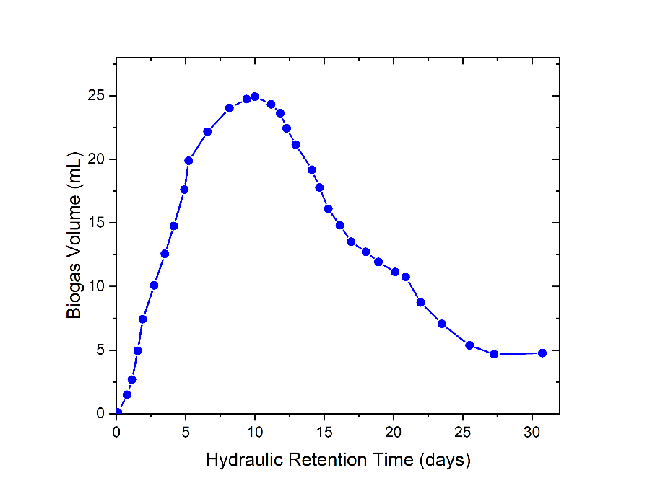
Fig. 6. Effect of Retention Period on Biogas Production. The peak period of biogas production is between 10 and 15 days [81].

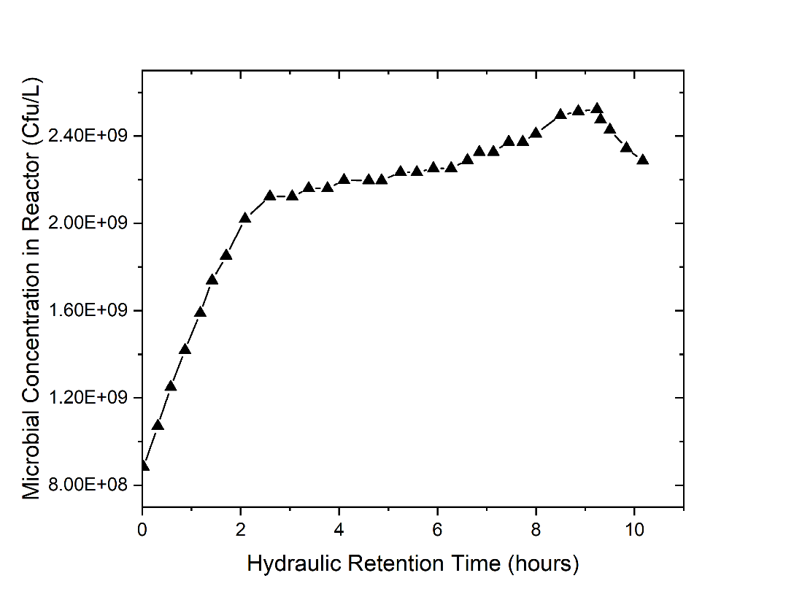
Fig. 7. Effect of hydraulic retention time on microbial concentration. The microbial concentration increased until close to 10 days before decline [83].
The HRT in anaerobic digestion systems directly impacts biogas production and microbial activity:
  - Effect on Biogas Production: Longer HRT allows for extended contact time between microorganisms and organic matter, facilitating more complete digestion and higher biogas yields. Shorter HRT may limit the efficiency of digestion, resulting in lower biogas production rates.
  - Influence on Microbial Activity: Longer HRTs provide microorganisms with more time to degrade complex organic compounds into simpler substrates, enhancing microbial activity and promoting the growth of methanogens. Shorter HRTs may lead to suboptimal conditions for microbial growth and metabolism, potentially inhibiting methane production and causing accumulation of intermediate products like VFAs.
The optimal HRT varies depending on factors such as the type of feedstock, reactor design, and operational parameters. Generally, HRTs for anaerobic digestion systems range from several days to several weeks. To maximize biogas yield while minimizing the buildup of inhibitory substances like propionate, optimal HRT conditions typically fall within the range of 20 to 30 days for mesophilic digestion and 10 to 15 days for thermophilic digestion. These ranges allow sufficient time for microbial activity to proceed efficiently without causing excessive accumulation of VFAs or inhibitory compounds.
The ratio of carbon to nitrogen (C/N): Because it shows the nutritional content of the digestion substrate, the C/N ratio is an essential component of anaerobic digestion. Substrates with an ideal C/N ratio must supply enough nutrients for microbial metabolism to optimize biogas generation. Substrates obtained by distinct AD methods will likely have varied excellent C/N ratios. Not only does the substrate type affect the C/N ratio, but biodegradability and trace element concentrations also play a role [49]. According to the research, a C/N ratio of 20–30 makes the AD process more stable [64]. Figure 8 shows that between 20 and 30 degrees Celsius, Biga's output is at its highest [10]. When the carbon-to-nitrogen ratio is low, more ammonia is produced, which raises the pH and makes microbe development more difficult [84]. Extra VFAs build up when the C/N ratio is higher than ideal. As a result, the AD process for biogas production relies on keeping the C/N ratio optimal.
Strategies to Optimize C/N Ratios: a) Co-digestion of different waste streams with complementary C/N ratios can help achieve optimal ratios in the substrate, b) Mixing carbon-rich and nitrogen-rich feedstocks, such as food waste and animal manure, can balance the C/N ratio and improve biogas production efficiency, c) Adjusting the blending ratio of feedstocks based on their C/N content can help maintain nutritional balance and process stability, d) Supplementing nitrogen-rich substrates with carbon sources or vice versa can optimize C/N ratios and promote microbial activity without compromising nutrient availability.
Table 3 shows that most substrates do not have C/N ratios within the optimal range, indicating that substrates with the ideal C/N ratio are rare. A plant-based substrate is unsuitable for AD due to its high carbon-to-nitrogen ratio and complicated lignocellulosic structure. The inefficient use of animal-based manure for AD is hindered by its low C/N ratio and carbon deficit. One possible way to control the carbon-to-nitrogen ratio of each substrate and maintain a healthy nutritional balance is to digest them together [64][65].
According to Wang et al. [85], the co-digestion of multi-component substrates with a C/N ratio of 27.2:1 was the most effective when employing a combination of wheat straw, dairy manure, and chicken manure. Also, Li et al. [86] compared the efficiency of single digestion with either kitchen trash or cow waste to that of co-digesting the two types of waste. According to their findings, the methane output was 44% higher when kitchen trash and cattle dung were digested together rather than separately. They ascribed this rise to the synergistic impact and optimal C/N ratio during co-digestion. Researchers Zhang et al. [87] looked at two processes: anaerobic digestion of sorghum stem with urea to change its C/N ratio and sorghum stem and cow dung co-digestion. Compared to raw sorghum stem without C/N modulation, the biogas output was 413 mL/g VS when the C/N ratio was modified to 25 using urea, a 26% increase. The biogas output was 478 mL/g VS, the highest, when sorghum stem and cow dung were co-digested with a C/N ratio 25. In their study, Cheng and Zhong [88] combined the digestion of cotton stalk and swine manure in a 50:50 ratio to produce biogas. They discovered that a C/N ratio of 25 produced the best results, with a biogas production rate of 0.65 L/(L·day) and a yield of 449 mL/(g of VS added)) that were up to 1.8- and 1.9-fold, respectively, compared to when they digested just cotton stalk.
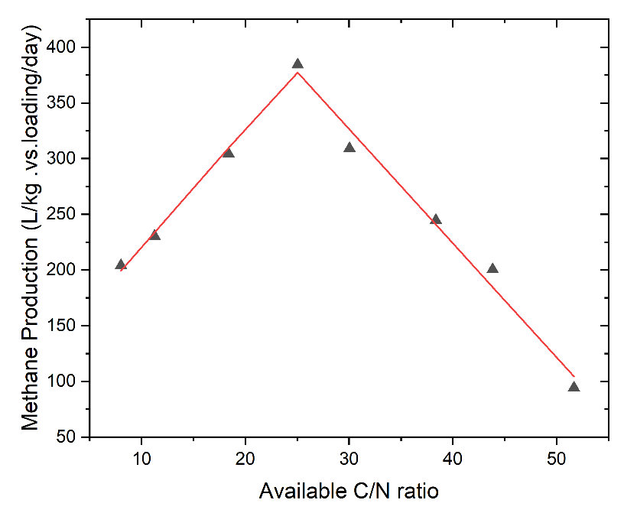
Fig. 8. Effect of Carbon-To-Nitrogen Ratio on Methane Production. The Optimum C/N Ratio is Between 20 And 30, and Biogas Production is at Its Maximum in This Range [55].

Table 3. C/N Ratios for Different Types of Substrates[55][80][89].
Substrate | C/N Ratio
Cow Dung | 16-25
Poultry Manure | 5-15
Goat Manure | 10-17
Horse Manure | 20-25
Kitchen Waste | 6-14
Vegetable and Fruits Waste | 7-35
Food Waste | 3-17
Mixed Food Waste | 15-32
Peanut Waste | 19-32
Sheep Manure | 20-34
Slaughterhouse Waste | 21-36
Fallen Leaves | 50-63
Potatoes | 35-60
Oat Straw | 48-50
Corn Straw | 50-56
Rice Straw | 51-67
Seaweed | 70-79
Wheat Straw | 50-150
Algae | 79-101
Sugarcane Straw | 140-150

Accelerating the substrate's breakdown rate, mixing/agitation helps to homogenize the substrate and increases bacterial interaction with the substrate. Another benefit of mixing is that it helps distribute heat evenly, which keeps particles suspended, and speeds up the transmission of biogas bubbles in the digester [90][91]. Proper agitation enhances substrate breakdown, increases biogas production rates, and improves overall digestion efficiency [55]. Excessive agitation can lead to energy wastage, shear stress on microorganisms, and potential disruption of microbial communities, compromising system stability.
Imagine for a second that the substrate mixture is stirring unevenly. During extended retention time, biogas generation might be hindered if lightweight materials, like bedding or animal hair, float on top of the mixture as hard scum. Manual mixing, mechanical mixing, recirculating the digester contents, or pumping the created biogas back into the system are some common ways mixing is carried out [92].
Mechanical stirring with slow-moving paddles is commonly used in large-scale digesters. Gas recirculation involves injecting gases to promote mixing, while hydraulic mixing uses incoming feedstock or digestate flow. Continuous or intermittent mixing at a tailored frequency is often sufficient to maintain homogeneity and ensure effective substrate breakdown.
Because optimal biogas generation relies on slow-growing microbes, it is crucial to be careful with the amount of mixing during AD. Adjusting the digester's ideal conditions temperature, pH, retention time, etc. might affect its stability. Hajj et al. [91] studied the impact of changing the agitation mode on biogas generation. In Fig. 9, the impact of the agitation becomes apparent during the methanogenesis phase after the sixth day. It was discovered that digestion with continuous agitation significantly and consistently increased biogas production, reaching around 0.6m3/j on the thirteenth day. In contrast, digestion without agitation exhibited a progressive decline in biogas production after the sixth day, corresponding values around 0.14m3/j. The first reason is that the substrate isn't being fully biassed because the bacteria aren't coming into touch with it.
The second reason is that a crust has formed on the digester's surface, which prevents the substrate from being fully degasified [91]. Additionally, Sunny et al. [55] found that biogas output improved by around 62% when agitation was used instead of when it was not.
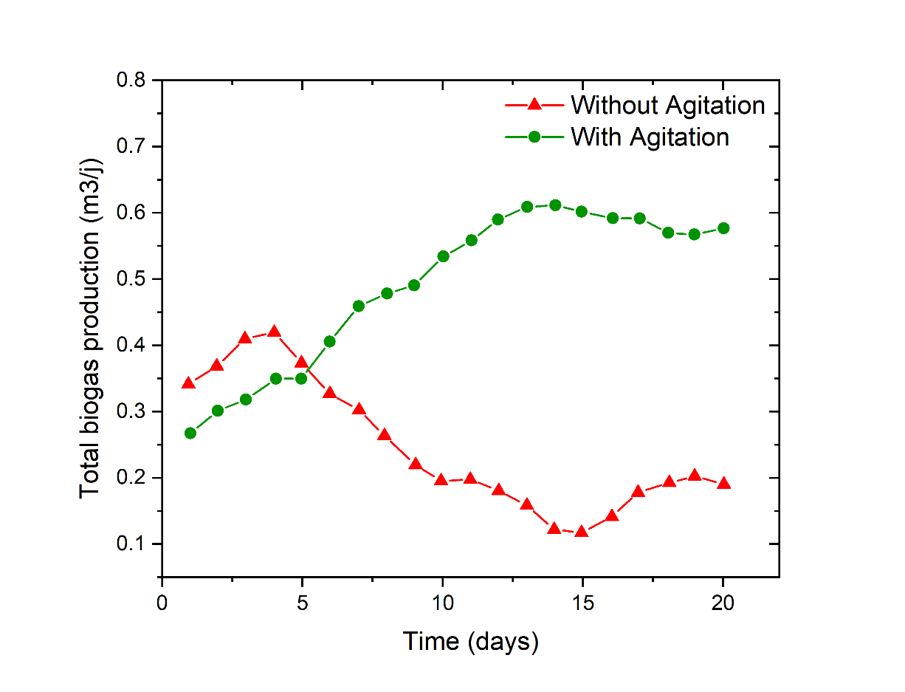
Fig. 9. Effect of agitation/stirring on total biogas production. After 6 days, the substrate with agitation showed increased biogas production, peaking at 0.6. Meanwhile, the substrate without agitation showed a decrease in biogas production over a long retention time [91].

2.5. Anaerobic reactors
Digestive systems revolve around anaerobic reactors, which are the parts responsible for breaking down organic materials. Separate types of reactors include batch, single-stage, multi-stage, and continuous-process models. High biogas production, short hydraulic retention time, and a continual high organic load rate are the three most important characteristics of an optimal anaerobic reactor [46]. One reactor in a single-stage reactor can undergo both acidogenic and methanogenic reactions. Some subcategories are SSHSRs, or single-stage high solids reactors, and SSLSRs, or single-stage low solids reactors [38]. However, in multi-stage reactors, each stage of anaerobic digestion is carried out in its reactor.
Batch Reactors: Operate in discontinuous mode, with periodic loading and unloading of feedstock. Simple design, low capital costs, and flexibility in handling various feedstocks. Suitable for small-scale applications and research purposes, but biogas production may be intermittent and less efficient compared to continuous systems.
Single-Stage Continuous Reactors: Continuous flow of feedstock through a single reactor chamber. Stable operation, consistent biogas production, and relatively simple design. Offers steady biogas yields, suitable for medium to large-scale applications, and easy to operate and maintain.
Multi-Stage Continuous Reactors: Consist of multiple reactor chambers with distinct microbial environments. Allows for specialized microbial communities and optimized process conditions for different stages of anaerobic digestion. Provides enhanced degradation of complex substrates, higher biogas yields, and improved removal of inhibitory compounds, suitable for treating diverse feedstocks and achieving high levels of process stability.
Fluidized Bed Reactors: Utilize upward flow of fluid to suspend and mix the solid biomass particles. Enhanced mass transfer and substrate mixing, leading to higher biogas production rates and better process efficiency. Enables effective digestion of particulate substrates and better control of microbial activity, suitable for treating wastewater sludge and high-solid content feedstocks.
Fixed Bed Reactors: Employ stationary support media, such as rocks or plastic materials, to provide surface area for microbial attachment. Provides stable microbial environments, enhanced retention of biomass, and improved resistance to shock loads. Offers efficient digestion of high-strength wastewaters and organic residues, with potential for higher biogas yields and better process stability compared to suspended growth systems.
The goal of designing reactors with several stages is to maximize the rate of anaerobic digestion and net energy generation by optimizing the conditions in each step. Each reactor's organic input rate, oxygen availability, intermediate treatment, and general architecture might vary throughout operation [93][94].
Li et al. [95] conducted a two-stage anaerobic digestion process for food and horticulture waste in a high-solid system in a recent study. The first stage involved high-solid co-digestion of chicken slurry and food waste. The second stage involved moving and co-digesting grass. The efficiency of removing volatile solids from wastewater was 57.30% with two-stage co-digestion and 83.25% with one-stage co-digestion, according to the research. The work might benefit from a more in-depth examination of how microbial activities improve the performance of the two-phase AD process. The AD performance and bacterial consortia structure of maize stover in three-stage continuously stirred tank reactors were the subject of additional research by Liu et al. [93]. (CSTR). At an organic loading rate of 1.8 g TSL-1d-1 and a hydraulic retention duration of 50 d, respectively, the methane production for a three-stage AD process is 33.2% to 50.5% more than that of a one-stage AD process. This study's findings corroborate Li et al. [95], who found that multistage AD processes frequently provide better buffering abilities and system stability.
Fluidized bed reactors, up-flow anaerobic sludge blankets, plug flow reactors, continuous stirred tank reactors, and fixed bed reactors are the major types of reactors utilized for biogas generation by anaerobic digestion. The biomass culture attaches biofilms containing various packing materials (inert or biodegradable) to the base of fixed bed reactors (Fig. 10 (a)). Some examples of such packing materials are activated carbon, ceramics, beads, and zeolite [96][97]. Because the liquid part of the biomass culture flows via the porous area between the packings, the porosity of the materials utilized for biomass immobilization often determines the fluid dynamics in the FBR. FBRs' low hydraulic turbulence hinders immobile cell mass transfer, leading to limited substrate conversion and low hydrogen generation [38]. This problem was thought to be caused by low turbulence, which makes it impossible to maintain a uniform pH in the reactor and leads to a uniform distribution of microbial activity [98].
Arimi et al. [96] proposed recirculating flow as a solution in discussing mass transfer resistance and pH heterogeneity. Recirculating the digestates in both reactors, recent research by Chiumenti et al. [99] evaluated the anaerobic digestion of slurry utilizing two hybrid fixed-bed anaerobic reactors, D1 and D2. D1 had a hydraulic retention time ranging from 18.3 to 9.3 days while D2 had a period ranging from 28.9 to 20.3 days. Research shows that the best methane output (486.7 NL CH4/kg VS) was achieved by a hybrid digester running with the shortest process time (approximately 9.3 days). Optimal decomposition of ammonia-rich feedstocks has been performed recently using intermittent illumination and the bio-zeolite fixed-bed method.
Intermittent illumination and bio-zeolite fixed-bed methods offer innovative strategies to address challenges associated with ammonia inhibition in anaerobic digestion processes. These techniques promote nitrogen removal, enhance digestion performance, and contribute to increased biogas yields, ultimately advancing the efficiency and sustainability of anaerobic digestion technologies.
In a bio-zeolite fixed-bed bioreactor, Zhang et al. [97] conducted semi-continuous anaerobic digestion of ammonium-ich sewage sludge with a concentration of 3000 mg/L under intermittent illumination conditions. According to the paper, a fixed-bed bioreactor with illumination produced the maximum methane output (283 mL/g-DOC), concentration (70 percent), and number of methanogens compared to a no-bed bioreactor in dark experimental circumstances. They improved the efficiency and stability of the ammonium-rich AD process by combining a bio-zeolite fixed bed method with intermittent lighting.
Figure 10 shows that enhanced ammonia absorption, a high quantity of immobilized microbes, increased methane concentration, and shortened start-up period were the results of the intermittent illumination technique, which may have improved the anaerobes' tolerance level and activity to the high ammonium concentration in the Fig 10 (b).
CSTRs are commonly used in anaerobic digestion processes due to their uniform mixing, continuous operation, simple design, and flexibility. However, they also have certain disadvantages such as low solid retention time, sensitivity to process conditions, and vulnerability to inhibition. To address these issues, innovative approaches like multistage CSTRs, combination with aerobic digesters, advanced monitoring and control systems, and pre-treatment of feedstock can be implemented. These approaches can effectively improve process efficiency, stability, and biogas production.
Fig. 11 (a) and (b) indicate that CSTRs are structurally comparable to pond-type AD reactors and have a straightforward design (b). An agitator mixes the anaerobes and effluent thoroughly in CSTRs, preventing particles from sinking to the bottom of the reactor and facilitating the effective release of trapped gas bubbles in the medium by lowering the barrier to mass transfer [101][100]. The intervals between mixing steps determine whether the procedure is continuous or intermittent. In anaerobic digestion, CSTRs reliably handle feedstocks with large amounts of suspended solids, including wastewater, organic industrial wastes, and liquid animal manure [46]. Traditional CSTR's low solid retention time, biomass washout, sensitivity to AD conditions (pH, HRT, and temperature), energy consumption for maintaining agitation, large VFA production, and limited stirring speed for bio-hydrogen production are some of its downsides, despite the simplicity of its operation [96][101][102][103]. Some of these problems with CSTRs have recently been the focus of much research.
As an example, Mohite and Salimath [104] used a CSTR to conduct anaerobic digestion of distillery waste wash, which had a very high chemical oxygen demand (COD) of 110,000–140,000 mg/L and a biochemical oxygen demand (BOD) of 55,000–65,000 mg/L. The author tried to stabilize the digester's pH by recirculating neutral overflow water into the raw wasted wash. However, the strategy was ineffective since organic loading led to increased VFA generation and a subsequent decrease in alkalinity. Recent research by Pashaki et al. [105] examined the effect of anaerobic-aerobic digestion under mesophilic (2-stage CSTRs) and ambient/aerobic conditions on the decomposition of leachate from municipal solid waste (MSW) landfills, which had a total biochemical oxygen demand (BOD) ranging from 53,110 to 6,2120 mg/L. The optimal organic load removal rate (OLR) was found to be 2.05 kg COD/m3/day when the COD removal efficiencies in the 2-stage anaerobic phase were 93%, the ambient phase at 37.1%, and the treatment system overall at 95.6%. Nevertheless, during the 2-phase anaerobic stage, alkalinity, turbidity, and ammonia nitrogen levels rose by 15.18%, 18.7%, and 31.28%, respectively. In contrast, these parameters decreased by 57.23%, 72.18%, and 50.30% during the aerobic stage. One possible solution to the issues with single-stage CSTRs is to use multistage CSTRs in conjunction with aerobic digesters and treatment systems.

One standard method for anaerobic digestion of wastewater, particularly wastewater containing many carbohydrates, is using up-flow anaerobic sludge blanket (UASB) reactors [106]. In addition to retaining a large amount of biomass and keeping the biomass-to-substrate ratio constant, they are simple, compact, and cost-effective [107]. Their layout calls for a thick sludge bed at the base to mix biomass with wastewater efficiently.
Therefore, UASBs eliminate the requirement for effluent recycling compared to other reactor types. This is because the biomass and sewage will come into contact even with a modest organic loading rate. Reduced digester volume and space requirements, increased flow velocity, increased biogas production, and reduced susceptibility to increased organic load rates are some of the benefits of UASBs over flocculent sludge bed reactors [101].

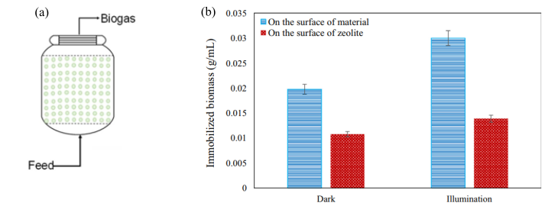
Fig. 10. (a) schematic of a typical fixed bed reactor for anaerobic digestion [100]. (b) effect of intermittent illumination strategy on the quantity of immobilized biomass in a bio-zeolite fixed bed reactor [97].

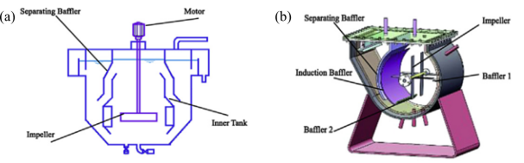
Fig. 11. Schematic of (a) vertical CSTR and (b) horizontal CSTR [102].

The use of UASBs for anaerobic digestion of organic wastes is not without its difficulties, however, including a lengthy beginning period, a high microbial concentration in the sludge, a substantial wash-out of wastewater during the early stage of AD, and a lack of technical competence [101][108]. To combat these shortcomings, UASB setups have recently undergone several changes. To recycle the effluents from the anaerobic digestion of cassava wastewater at a mesophilic temperature (37 C), Jiraprasertwong et al. [109] created a three-stage UASB. By reusing the effluent, we kept the pH levels of the first and second digesters in a good range, which reduced the amount of sodium hydroxide needed to regulate the pH in the first digester. Reportedly, compared to single- and two-stage UASB reactors, three-stage digesters offer superior overall energy production and an optimal COD loading rate of fifteen kilograms per cubic meter per day. On the other hand, micronutrients added to the reactor, and co-digestion might boost the performance of UASB digesters. A recent study by Vassallo et al. [110] used a UASB reactor that allowed the recycling of effluents to co-digest microalgae and raw sewage. The authors found that 61% of N-NH4 and 65% of COD were removed from the system. On top of that, co-digestdifferent researche output by 25%, from 156 to 211 NL CH4 kg-1 VS. Adding conductive carbon materials—graphite, biochar, and carbon cloth—to USB reactors improved syntrophic metabolism, according to different research by Zhao et al. [111]. According to this study, carbon compounds improved AD process efficiency and reduced hydraulic retention time.
Plug flow reactors (PFR) are conventional and commonly used digesters like CSTRs. They consist of a long, linear trough above ground [101]. In PFRs, the acidogenic and methanogenic stages are separated along the digester's flow path, contributing to the reactor's treatment efficiency and stability [112]. PFRs are reported to be highly suitable for dry anaerobic digestion processes, and they are considered to be relatively inexpensive to install compared to CSTRs [38][113][114][115]. Other merits of using PBRs to decompose organic matter include—a high level of sludge retention, low concentration of VFA in the effluent, absence of short-circuiting, and lower operational energy demands compared to CSTRs [116][117]. Due to these advantages, PFRs are gaining prominence around the globe for the digestion of high-solid manures, especially in North America [118][119]. Nonetheless, there are still some limitations associated with the use of PFRs: lower mass transfer since agitation is absent, high settling of solids, thermal stratification, formation of scum, and low efficiency when used for substrates with low total solid content [114][120][121].
Over the past few years, several techniques, such as pretreatment, impellers, and multistage digestion systems, have been reported to address these challenges. In 2020, Dong et al. [122] reported an increase in the yield of biogas when cornstalk was pretreated with biogas slurry in a PFR; the pretreatment process was said to increase lignin content of the cornstalk by 24.96%, while hemicellulose and cellulose were decreased by 19.44%.
The specific methane and biogas yields were about 0.21 m3/kg VS and 0.36 m3/kg VS, respectively. In a different study, Veluchamy et al. [123] optimized the biogas yield and process performance of the anaerobic digestion of corn silage, done under mesophilic conditions using a semi-continuous plug flow reactor equipped with an impeller for axial agitation of the substrate, as shown in Fig. 12. It was found that maximum biogas production was achieved when the PFR was fed with corn silage and digestate at a critical OLR of 6.5 kg-3d-1 with an HRT of 17 days. Improved biogas yield was also achieved using a PBR coupled with an internal mixer in a study by Gomez et al. [118].
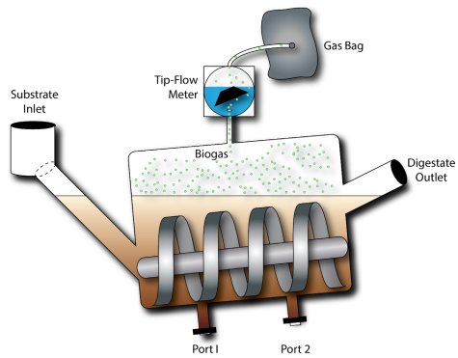
Fig. 12. Schematic of an anaerobic plug flow reactor equipped with an impeller for axial agitation of corn silage substrate [123].
Two common anaerobic digestion reactor types are UASB reactors and PFRs. UASB reactors have advantages such as high organic loading rates, minimal energy requirements, and biogas production. However, they also have challenges, including sensitivity to hydraulic and organic shock loads, poor solids retention, and limited application to low-strength wastewaters. Innovative approaches to address these challenges and enhance biogas production and process efficiency include effluent recycling, co-digestion, and pretreatment techniques like thermal hydrolysis or acidification. PFRs offer better solids retention than UASB reactors, leading to higher treatment efficiencies and biogas production rates. PFRs can effectively treat low-strength wastewaters with lower organic loading rates, making them versatile for various types of feedstocks. However, PFRs have limited mixing and typically require energy-intensive mixing systems to maintain optimal flow conditions, increasing operational costs. Innovative approaches such as optimized impeller design, pretreatment techniques, and effluent recycling can address these challenges, leading to enhanced biogas production and process efficiency.

2.6. Current trends in biogas production
Improvements in AD performance through the use of novel processes (additives, mixing methods, etc.), co-digestion of substrates with low digestibility, and the development of new, cheaper, and upgraded reactor designs are all part of the current trends in worldwide biogas production [125].

2.6.1 Pre-treatment
When two or more substrates are combined for co-digestion, such as with lignocellulose waste, pre-treatment of the substrates becomes an integral part of biogas generation [125]. Anaerobic digestion may be accomplished with readily available and affordable lignocellulosic materials, which include cellulose, hemicellulose, and lignin. However, they are not as well suited for traditional AD procedures because of their resistant nature and complicated polymerized structure. Because lignocellulosic biomass makes up the bulk of AD feedstocks, it is strongly recommended that these feedstocks be pre-treated to maximize biogas output [125]. So, improving the substrates' digestibility and increasing biogas output are both helped by pre-treatment. Methane generation in an AD process is impacted by pre-treatment, as seen in Fig. 13.
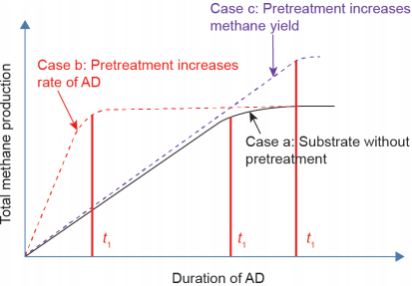
Fig. 13. Effect of Pre-Treatment on Methane Production [126].

On the other hand, specific substrates utilized in biogas generation are affected by pre-treatment in the following ways:
- The biodegradability is improved.
- Decreases substrate particle sizes.
- The formation of refractory chemicals is triggered.
- Makes substrates more soluble and more accessible to hydrolyze.
- Results in the decomposition of some chemical compounds [127].

Depending on their underlying concepts, anaerobic digestion pre-treatment techniques can be classified as physical, biological, chemical, or a mix [127].

2.6.1.1 Physical pre-treatment methods
These techniques make use of mechanical and thermal energy disturbance [128]. The mechanical processes that fall under this category include irradiation, mesh grating/sandpapering, ball-milling grinding, ultrasonic pre-treatment, microwave treatment, and high-shear mixing [129][128]. Physical pre-treatment is expensive to produce because of the large amount of energy required, but it is easy to implement and does not harm the environment [130]. The necessary features of efficient physical pre-treatment procedures are displayed in Table 4.
There are a few main types of physical pre-treatment methods:
Mechanical pre-treatment: This method is used to disintegrate solid particles of the feedstocks to reduce their particle sizes and thereby increase the surface area of the substrates [131]. Subsequently, better contact exists between the bacteria and the substrate, enhancing the anaerobic digestion [131]. Generally speaking, mechanical pre-treatment enhances the distribution of particles, accessibility of enzymes, flow, porosity, and bulk density of substrates [129].
In addition, mechanical pre-treatment is often used in preparation for other methods to make the following method more effective and accessible [130]. Mechanical pre-treatment methods include wet crushing, sonication, maceration, dry crushing, extruding, liquid shearing, high-pressure homogenization, compression, milling (e.g., vibratory mills, ball mills, hammer mills, knife mills, etc.), and lysis-centrifuging [131][129][130].
Ultrasonic pre-treatment: The mechanoacoustic effect is used to decrease the size of the substrate particles using sound waves with low frequencies (20-40 kHz) [129][131]. However, in contrast, the sonochemical action is responsible for producing radicals such as OH- and H+ [129][131]. Using ultrasonic sound with an energy intensity ranging from 31 to 93 Wh/L, experiments have demonstrated a 71% increase in biogas production [125].

Table 4. Characteristics of Effective Physical Pre-Treatment Methods [129].

Attribute | Remarks
Cost | Low operational and capital costs are attributes of an effective physical pre-treatment process. Costly materials such as catalysts, solvents, and reagents should not be used during biological pre-treatment, and subsequent neutralization should be avoided.
Energy Performance | Low-energy demand is an attribute of an effective physical pre-treatment process. Physical pre-treatment technologies can ensure better energy performance and overall process efficiency, with process feedstock having a large dimension.
Operating Environment | The use of highly corrosive chemicals should be avoided in physical pre-treatment technologies. Also, operations carried out at high pressure should be avoided.
Presence of Inhibitors | An effective physical pre-treatment process should have limited or no use of chemicals as they inhibit hydrolysis and fermentation.
Cost Effectiveness | An effective physical pre-treatment process should bring about maximum recovery of the lignocellulosic material in a usable form in distinct fractions. A cost-effective physical pre-treatment method must improve the formation of sugars in the subsequent phase of enzymatic hydrolysis, reducing the degradation of carbohydrates and forming inhibitors for hydrolysis and fermentation.
Process Integration and Intensification | An effective physical pre-treatment process should withstand a wide range of loading of lignocellulosic material. Conditioning should be eliminated to reduce yield losses and costs. To ensure that ethanol concentrations are adequate to keep recovery and other downstream costs manageable, the concentration of sugars from the combined operations of physical pre-treatment and enzymatic hydrolysis should be above 10%.

In addition, during the pre-treatment process, cavitation effects are induced by ultrasonic acoustic waves using ultrasonic energy [129]. Severe cavitation damages the crystalline structure of solid substrate materials, causing them to fuse or melt during collisions [129]. This damage results from the formation of localized hot spots (temperature of 5,000oC, pressure of 500 atm) on the solid materials due to a large quantity of energy released during cavitation collapse [129]. Also, combining ultrasound and alkali pre-treatment can destroy hydrogen bonds that bind lignocellulosic molecules and lower crystallinity, thus improving lignin degradation and the enzymatic saccharification rate [130].
As a first step in the treatment process, irradiation is vital for degrading, grafting, and crosslinking polymeric materials, among other ways to alter their intricate structure [129]. Conventional irradiation pre-treatment techniques for substrates include electron beams, gamma rays, and microwaves [129].
In electron beam pre-treatment, ionizing radiation creates long-lived radicals by targeting specific molecules in cellulose materials, which are otherwise complicated [129]. Subsequently, the radicals induce substrate materials' degradation via chemical reactions like cross-linking and chain cutting [129]. Microwave radiation generates heat and multiple collisions due to the vibration and movement of polar molecules and ions [129]. Dielectric properties of the lignocellulosic material dictate the performance of microwave radiation [130].
Lignocellulosic materials undergo heating as a preliminary step in the processing [132]. The solubilization of hemicelluloses and lignin co-occurs at temperatures greater than 150–180 degrees Celsius [132]. Various phenolic and heterocyclic chemicals, including furfural, 5-hydroxymethylfurfural, vanillin, and vanillin alcohol, can be formed from soluble lignin and hemicellulose molecules when they are heated [132]. Because these phenolic chemicals are toxic to methanogens, yeast, and bacteria, anaerobic digestion is slowed [132].
Thermal pre-treatment also uses steam injection or steam explosion to heat the material [127]. Compared to other pre-treatment procedures, thermal pre-treatment reduces digestate viscosity, improves dewatering efficiency, eliminates pathogens, and makes digestate handling easier [131]. However, when applied to easily biodegradable substrates, heat pre-treatment can reduce biomethane production levels and lead to the loss of volatile organic molecules [131]. Thermal pre-treatment effects depend on the substrate type and operational temperature range [131].
Pre-treatment methods like ultrasonic, irradiation, and thermal pre-treatment can improve anaerobic digestion efficiency by making feedstocks more accessible to microbial degradation. Ultrasonic pre-treatment generates high temperatures and pressures that break down organic compounds, while irradiation breaks chemical bonds and induces structural changes in organic molecules. Thermal pre-treatment involves heating the feedstock to moderate to high temperatures, causing physical and chemical changes. Optimal conditions for each method include selecting appropriate parameters such as frequency, intensity, dosage, temperature, and duration. These pre-treatment methods can enhance biogas production while minimizing potential inhibitory effects on microbial activity.

2.6.1.2 Biological pre-treatment methods
To break down lignocellulosic materials' hemicelluloses and lignin, biological pre-treatment techniques use microbes like bacteria and fungus, specifically white, brown, or soft rot fungi [129][130]. The brown-rot fungus feeds on cellulose, but the white-rot fungus breaks down lignin very well. To degrade lignin in an anaerobic environment, fungi employ extracellular enzymes called lignases. Biological pre-treatment efficiency is process-dependent and influenced by biomass type and composition, pH, moisture level, incubation temperature and duration, aeration rate, inoculum concentration, and microbe species [129].
Also, biological pre-treatment technologies have many benefits, such as gentler conditions, less pollution, and low energy consumption [130]. Because they require a long incubation period to degrade enough lignin, they are difficult to obtain for large-scale industrial applications. Large amounts of room are thus necessary [129][130]. Compared to other pre-treatment procedures, biological pre-treatment has a poor rate of hydrolysis due to the high degradation requirement caused by the small number of microbe species responsible for lignin degradation [129][130].

2.6.1.3 Chemical pre-treatment methods
To prepare a substrate chemically, acids, alkalis, or oxidants dissolve organic compounds [127][131]. Because anaerobic digestion typically requires pH adjustment, which is accomplished by increasing alkalinity, the most used chemical technique is the alkali pre-treatment method [131]. Another way to do chemical pre-treatment is via the thermo-chemical process, which involves increasing the temperature.
The substrate swells and becomes more accessible to anaerobic microorganisms due to the early processes that occur with alkali pre-treatment technology, which includes saponification and solvation [132][131]. However, lignin is redistributed and condenses after alkali pre-treatment, which also causes solubilization and changes the crystalline form of cellulose [132]. An effective alkali for alkali pre-treatment is calcium hydroxide (Ca(OH)2), potassium hydroxide (KOH), or sodium hydroxide (NaOH) [130]. Research has shown that compared to untreated wheat straw, wheat straw treated chemically with NaOH produces 87.5% more biogas [125].
The bacteria responsible for hydrolysis can swiftly adapt to acidic conditions and acid pre-treatment efficiently destroys lignin, making it a more efficient process for lignocellulosic materials [131]. The acid pre-treatment of feedstock can be carried out using either concentrated or dilute acids, such as hydrochloric, nitric, sulfuric, etc. [130]. To make the hemicellulose more accessible, acid pre-treatment of lignocellulosic biomass primarily aims to dissolve it [132]. Acid pre-treatment of lignocellulosic biomass mainly involves hydrolysis of hemicellulose into various monosaccharides, with secondary reactions including condensation and lignin precipitation [131]. [130].
As a summary, chemical pre-treatment methods like alkali and acid pre-treatment are widely used to prepare lignocellulosic substrates for anaerobic digestion. It has several advantages such as delignification, enhanced enzymatic hydrolysis, reduced inhibition, and increased methane content. However, its disadvantages include being energy and cost-intensive, the formation of inhibitors, and environmental impact. The effectiveness of the pre-treatment process depends on the type of chemical used, its concentration, and the duration of treatment. Optimizing these factors is essential for maximizing its effectiveness.

2.6.1.4 Combined pre-treatment
Enzymatic hydrolysis is greatly enhanced by pre-treatment procedures, which combine the strengths of several pre-treatment technologies for different lignocelluloses [130]. The reason is that several technologies are required to mitigate the drawbacks and hazards associated with a single pre-treatment technique, such as increased energy consumption, longer reaction times, and environmental contamination. Therefore, mechanical crushing-chemical processing, mechanical crushing-microwave-chemical processing, mechanical crushing-electronic radiation-alkali treatment, and many other combinations of pre-treatment methods are possible [130]. Table 5 shows the advantages and disadvantages of different pre-treatment tactics, and Table 6 shows the correct pre-treatment procedures for other feedstocks.

2.6.2 Anaerobic co-digestion
Anaerobic digestion is utilizing several new processes, including pre-treatment technologies and co-digestion. Co-digestion is treating several substrates at once by combining their complementary properties [133][53]. The combined substrates provide a favorable synergy due to the balanced supply of nutrients and the increased moisture content during co-digestion, increasing the AD process's efficiency [134][135]. The terms co-fermentation and co-digestion are interchangeable [53].

Table 5. Evaluation of Various Lignocellulose Pre-Treatment Technologies: Pros and Cons [130].

Pre-Treatment |  | Pros | Cons
Physical | Mechanical splintered | Reduced cellulose crystallinity and particle size | High energy, inability to remove hemicellulose and lignin
Physical | Microwave | Energy-efficient, easy to operate, short treatment time | Costly
Physical | Ultrasonic | Improved reactivity and accessibility of cellulose | Negatively affects enzymatic hydrolysis
Physical | Electron beam | Reduced degree of cellulose polymerization | Costly
Physical | High-temperature pyrolysis | Rapid cellulose decomposition | Low productivity, high energy usage
Chemical | Concentrated acid | High sugar conversion | High toxicity, equipment prone to corrosion
Chemical | Dilute acid | Quick process and elimination of acid recycling | High pressure and temperature, formation of inhibitors
Chemical | Alkali | Takes place at room temperature, possible destruction of lignin | Less-degraded sugar
Chemical | Oxidation | Eco-friendly, effective removal of lignin | Expensive
Chemical | Organosolv | Yields pure lignin, hemicelluloses, and cellulose | Costly, specific impacts on fermentation and the environment
Chemical | Ionic liquid | Eco-friendly, operates on a wide range of temperatures | Expensive
Biological | - | Degradation of hemicellulose and lignin | Low rate of hydrolysis
Biological | - | Low energy usage | Low rate of hydrolysis

Table 6. Pre-Treatment Methods and Findings from Previous Research [131].

Substrate | Pre-Treatment Methods | Important Findings
Organic fraction of municipal solid waste (OFMSW) | All pre-treatment methods | - Physical pre-treatment is a prominent method for OFMSW, while other methods are not employed at the industrial level.  - Future research on pre-treatment should be done by modeling the pre-treatment and overall AD processes.
All organic substrates | All pre-treatment methods | - The most suitable pre-treatment methods are ultrasonic and thermal for wastewater treatment plant (WWTP) sludge, mechanical for OFMSW, and chemical for lignocellulosic substrates.  - Systematic studies on economic feasibility and energy balance are needed.  - Predictive and descriptive variables should be further developed.
Lignocellulosic substrates | Thermal, thermo-chemical, and chemical | - The digestibility of lignocellulosic substrates could be improved via pre-treatment.  - An efficient process could be obtained via pre-treatment compared to the conventional process.
Lignocellulosic substrates | Thermal, thermo-chemical, and chemical | - The digestibility of lignocellulosic substrates could be improved effectively through thermal pre-treatment and ammonia and lime chemical methods.
Pulp and paper sludge | Thermal, thermo-chemical, and chemical | - Pre-treatment could enhance methane production, lower hydraulic retention time, and decrease sludge size.
Wastewater treatment plant (WWTP) sludge | Chemical, ultrasound, thermal, and microwave | - Biogas production is improved by 30-50% via pre-treatment.  A comprehensive model for evaluating the economic feasibility was developed.
Wastewater treatment plant (WWTP) sludge | Chemical, thermal, and thermo-chemical | - The intensity of the method and characteristics of the sludge determine the impact of pre-treatment methods.  - Better digestion with highly recoverable nutrients could be obtained through pre-treatment.
Wastewater treatment plant (WWTP) sludge | Thermal and thermo-chemical | - Sludge dewaterability could be effectively improved through thermal pre-treatment at elevated temperatures (>175⁰C) and thermochemical methods.

Compared to digesting a single waste product, co-digestion of substrates has several advantages:
- Enhances the pH, carbon-to-nitrogen ratio, and moisture content.

- A boost to the buffer capacity and biodegradable feedstock concentration is achieved.

- Waters down potentially harmful chemicals that could block AD.

- Raises the bacterial pool accessible to the AD process [136].

However, anaerobic co-digestion has several significant drawbacks, such as the high expenses of collecting, transporting, and pre-treating these substrates and the increased likelihood of pump and pipe clogging and crust development in the digestion tank [136]. Table 7 displays a selection of published research on co-digestion.

Table 7. Previous Research on Co-Digestion in Published Works.

Substrate | Co-substrate | Biogas Production Rate (l/d) | Methane Yield (l/kgVS) | Comments | Reference
Cattle excreta | Olive mill waste | 1.10 | 179 | Biogas production increased by 33.7%. | [137]
Cattle manure | Agricultural waste and energy crops | 2.70 | 620 | A noticeable rise in biogas production. | [138]
Fruit and vegetable waste | Abattoir wastewater | 2.53 | 611 | Rise in biogas production by 51.5% with the addition of abattoir wastewater. | [139]
Municipal solid waste | Fly ash | 6.50 | 222 | Improved rate of biogas production from municipal solid waste by adding fly ash. | [140]
Sewage sludge | Municipal solid waste | 3.00 | 532 | We varied the linear biogas production rate by adding municipal solid waste. | [141]

2.6.3 Two-stage anaerobic digestion
The two-stage anaerobic digestion process has recently become a viable option for recycling organic waste into biohydrogen and biomethane [142][143]. The two-stage AD system has been employed to make up for the single-stage AD system's poor cost-effectiveness and biomass conversion efficiency [125]. Nevertheless, the following are the four steps involved in a two-stage AD system:
- The first stage involves hydrolysis and acidogenesis, breaking organic waste into liquid-phase organic acids and other intermediates [125].
- The second stage is the Methanogenesis and Acetogenesis Processes, which Convert Liquid Phase Intermediates into Methane Gas [125].
Superior stability and pH control, faster organic loading, lower volatile solids, more pathogen removal propensity, and more excellent methanogen activity are benefits of a two-stage AD system compared to a one-stage AD system [143][131]. Possible loss of nutrients required for methane-forming bacteria, a high degree of technological complexity, an increase in the investment cost, and the generation of hydrogen that might impede acid-forming bacteria are all drawbacks of the two-stage AD system [131]. Figure 10 depicts a curbed variant of a two-stage AD system.
As a result, a two-stage anaerobic digestion system has advantages like enhanced biohydrogen and biomethane production, improved process stability, and reduced reactor volume. However, it also has challenges such as increased complexity, higher operational costs, potential for process imbalance, and longer start-up time. The feasibility and effectiveness depend on factors such as the facility's goals, organic waste feedstock, and available resources for process management and control.

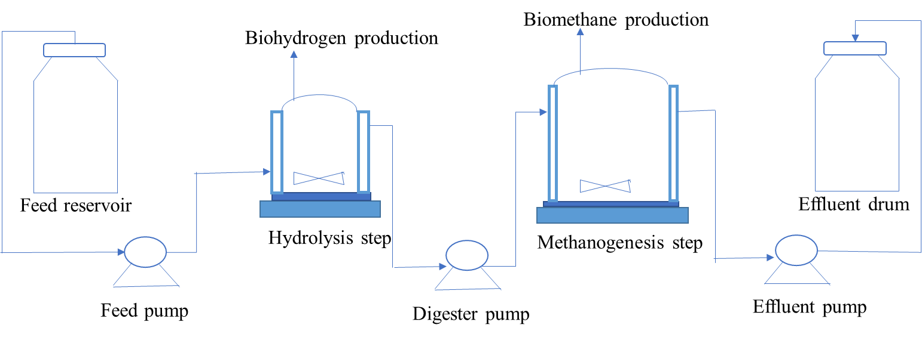
Fig. 14. Simplified Schematic Diagram of Two-Stage Ad System [131].

2.6.4 Solid-state anaerobic digestion
It's no surprise that solid-state anaerobic digestion (SS-AD) is so widely used; over 60% of European anaerobic digesters use it [144]. The solid concentration for SS-AD ranges from 15 to 40 wt percent, which differs from the range of 0.5 to 15 wt percent for conventional AD [125]. The organic portion of MSW is best digested using SS-AD, whereas sewage sludge, animal manure, and food scraps are often decomposed using liquid AD [125]. By and large, the digestate from SS-AD has a low moisture content, making it more manageable than the liquid anaerobic digestion effluent and more suited for use in land and transportation applications [144][145].
When compared to the liquid AD system, SS-AD offers several benefits, such as increased volumetric biogas productivity, decreased heating energy requirements, less scum/foam formation, low-moisture digestate, less material handling, less wastewater generation, and less overall parasitic energy loss [144][145]. These benefits aren't without SS-drawbacks, AD though a prolonged retention period, a delayed mass transfer between the inoculum and feedstock, a high probability of inhibitor buildup, process instability, and a comparatively poor methane output [125][144][145].
As a summary, SS-AD and AD offer distinct advantages and disadvantages for organic waste treatment. SS-AD excels with high solids content, lower water usage, and reduced energy requirements but may face limitations with certain feedstocks and slower biogas production. Liquid AD, on the other hand, is more suitable for high-moisture waste streams but requires more water and energy. The choice of method depends on the characteristics of the waste stream. Strategies to enhance SS-AD include substrate pre-treatment, process optimization, co-digestion, improved mixing, reactor design, and microbial inoculation. These measures can improve efficiency and effectiveness in biogas production.

Biogas upgrading
Separating gases, eliminating CO2 as a bulk component, drying the gas, removing minor components, and compressing the gas are all steps in the biogas upgrading process [146]. The biogas upgrading process produces biomethane, which has a methane level of more than 95% (v/v) and a low composition of pollutants, which makes it challenging to use efficiently [146]. Nevertheless, the bioenergy sector in Europe is keenly interested in improving biogas into biomethane. For example, between 2001 and 2011, the total installed capacity of facilities used to upgrade biogas increased from less than 10,900 m3/h for raw gas to more than 175,000 m3/h for natural gas [147][148]. Figure 15 illustrates the locations and capacities of biogas upgrading facilities across Europe, while Table 8 gives the overall capacity of these plants in a few chosen European nations in 2016.

Table 8. Locations and Capacities of Biogas Upgrading Plants Across Europe [149].

Country | Biogas Plants | Biogas Upgrading Plants | Upgrading Capacity (Nm³/h)
Germany | 94 | 120 | 204,082
Austria | 9,066 | 10 | 5,160
Sweden | 187 | 53 | 38,858
Italy | 1,264 | 1 | 540
UK | - | - | 18,957
Netherlands | 211 | 16 | 16,720
Switzerland | - | - | 6,310

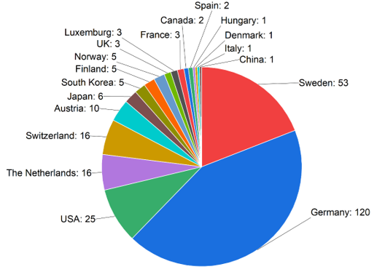
Fig. 15. Biogas Upgrading Plant Locations in the World [150].

The goals of biogas upgrading include increasing the gas's heating value, standardizing it, and meeting the needs of its area of use (gas engines, automobiles, boilers, fuel cells, etc.) [151]. To help you choose the right technology to fulfill your biomethane quality and other needs in specific places, this section compares and contrasts different biogas upgrading methods using several criteria and gives you some pointers on what to look for in a promising technology. We will also look at essential energy efficiency and cost analyses of the various biogas technologies and methane loss related to their use in upgrading biogas.

3.1 Upgrading Technologies
Biogas may be upgraded using methods that remove carbon (IV) oxide (CO₂) and lower the concentration of pollutants such as siloxanes, water, and hydrogen sulfide during the pre-upgrade stage [149]. Many aspects should be considered when choosing an upgrading technology, such as the biogas consumption regions in question, the cost of operation and maintenance (O&M), the capital expenditure (CAPEX), availability, etc. [148]. There are two broad categories into which these technologies fall: long-standing methods and cutting-edge innovations. Figure 16 displays several technologies for improving biogas:
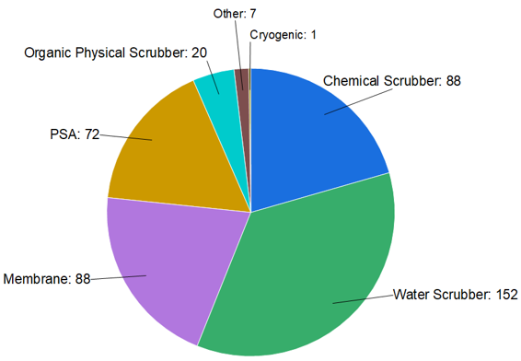
Fig. 16. Biogas Upgrading Technologies Based on Commercial Readiness Level [152].

3.1.1 Traditional Upgrading Technologies
Conventional methods of technology enhancement are those that have reached their full potential. Among these methods are membrane separation technology, chemical absorption (amine scrubbing), organic physical scrubbing, pressure swing adsorption (PSA), and pressure water scrubbing (gas permeation).

3.1.1.1 Pressure Swing Adsorption
Gas molecules are selectively adsorbed by a solid surface (the adsorbent) in pressure swing adsorption (PSA) [147][152], with the rate of absorption depending on the molecule size and the affinity of the solid medium. Activated carbon, silica gels, carbon molecular sieves, zeolites (e.g., clinoptilolite), and trioxosilicates are among the most popular absorbent materials [146][152].
Clinoptilolite, a natural zeolite, is a critical adsorbent material used in the PSA process. It has a high surface area, pore structure, and selective adsorption properties. It has a high affinity for CO2, H2S, and water vapor, allowing for the preferential adsorption of impurities, leaving methane relatively untouched.
The regenerable, stable, and inexpensive clinoptilolite is the ideal adsorbent material for biogas upgrading and purification [153]. Clinoptilolite has a high adsorption capacity of 173.9 mg CO2/g, which allows it to modify the biogas's methane-to-carbon dioxide ratio. The method separates CH4 from N2, CO2, and O2 gas because methane molecules are significantly larger than those of the gases above [148]. Since the adsorbent medium absorbs H2S permanently, H2S hinders the upgrading process and must be eliminated before this upgrading method is applied [148].
There are four steps to the PSA column cycle: pressurization, feed, blowdown, and purge [154]. During the feed phase of the pressure swing adoption cycle, raw biogas compressed to a pressure of 4-10 bar is introduced into the column [154]. The adsorbent passes the biogas's methane through the column unretained, while the column bed traps the carbon dioxide [152]. The blowdown phase begins when the intake is sealed, and the column bed contains more CO₂ than it can absorb [155]. After removing the carbon (IV) oxide from the adsorbent, the blowdown phase involves reducing the pressure in the column to ambient or lower pressure. The desorbed CO2 and off-gas are then evacuated from the column [155]. The purge phase begins when the pressure in the column drops to its lowest point. So, the CO2 is removed from the column bed, and the upgraded gas is blasted through the column to liberate it. For regeneration and depressurization, the column can be supplied with either the improved gas or raw biogas [152]. The usual flow diagram of a PSA unit is shown in Figure 17.
But after upgrading, the methane content is between 96% and 98%, and the usual loss is between 2% and 4% [155]. One way to improve landfill gas is by using PSA, which has the following essential characteristics: cycle duration, adsorbent, feeding pressure, purging pressure, and column interconnectivity [156]. Among the several upgrading methods, PSA ranks second in popularity [156].

3.1.1.2 Pressurized water scrubbing
In the past, the most well-known way of upgrading was pressurized water washing. This method is based on the fact that carbon dioxide and hydrogen sulfide are very soluble in water, particularly at lower temperatures and higher pressures (around 5 to 10 bar) [148][154]. To be sure, Henry's law—which states that the amount of dissolved gas is precisely proportional to the partial pressure in the gas stream [149][155]—forms the basis of this method's operation. Since carbon (IV) oxide and hydrogen sulfide are more soluble in water than methane, this technique extracts them from raw biogas [149]. The water scrubbing unit was constructed to improve the rate of CO₂ removal, decrease energy consumption, and enable counter-current movement of gas and liquid [154]. A typical water scrubbing unit's process flow is shown in Fig. 18.
The pressured water scrubbing process begins with the introduction of pressurized biogas, often packed in a random pattern to enhance gas-liquid interaction, into the base of the absorption column, which is heated to around 40°C. The next step is to pump water from the column's top [152]. Due to their different partial pressures and solubilities, carbon (IV) oxide and a small amount of methane dissolve in water when biogas flows countercurrently against it [157]. Consequently, when the gas (biomethane) rises to the top of the column, its methane concentration increases. Simultaneously, the hydrosulfide and carbon (IV) oxide that have been absorbed are directed out of the column via its base and desorbed in a flash tank or stripper at pressures ranging from 2 to 4 bars [158]. After being dried and compressed to around 200 bar, the improved biogas is extracted from the column top and prepared for transit or storage [157].

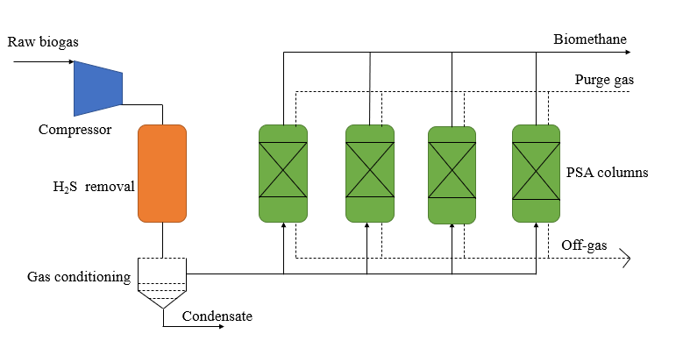
Fig. 17. Schematic Diagram for Pressure Swing Adsorption (Psa) Unit [154].

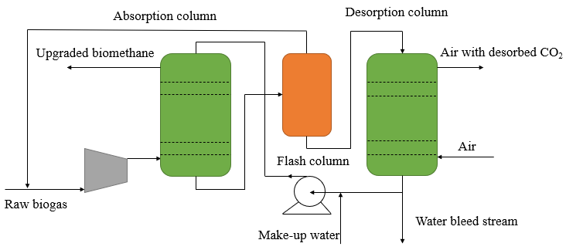
Fig. 18. Process Flow for High-Pressure Water Scrubbing Unit [155].

Another option is to recycle the water after scrubbing to remove any remaining dissolved gasses; this can be done in a single-pass system or by recirculating it for the next upgrade step [152][157]. Methane loss typically ranges from 3% to 5%, whereas the gas generated by water scrubbing has a concentration of more than 97% [148][149]. Environmental friendliness and high methane recovery are two advantages of the water-scrubbing process [149]. The technique has several drawbacks, such as high energy consumption, increased water demand (even with regeneration), column clogging from organic growth, and expensive operating and investment expenses. [151][149].
In summary, water scrubbing is highly efficient, cost-effective, and versatile, but it requires a significant amount of water, energy, and proper waste disposal measures.

3.1.1.3 Organic physical scrubbing
The idea behind organic physical scrubbing is the same as that of water scrubbing, except that instead of water, certain organic solvents are used to collect carbon dioxide and hydrogen sulfide [152]. Organic scrubbing often makes use of methanol, N-methyl-pyrrolidone (NMP), or dimethyl ethers of polyethylene glycol (DMPEG) as solvents [157]. The GenosorbTM process is most often used to upgrade biogas. This procedure uses a solvent combination of dimethyl ethers and polyethylene glycol [154]. Since CO2 is five times more soluble in an organic solvent
than water, an organic scrubber significantly reduces the amount of solvent that needs to be recirculated compared to a water scrubber [154].
Because H2S regeneration from the solvent is complicated and might reduce the solvent's CO₂ absorption capability, removing it from the raw biogas is necessary before absorption [148]. There is a significant energy difference between organic and water scrubbers regarding solvent regeneration, although organic scrubbers are more efficient overall [149]. On top of that, water is less costly than organic solvents. A typical organic cleaning unit is schematically shown in Fig. 19.

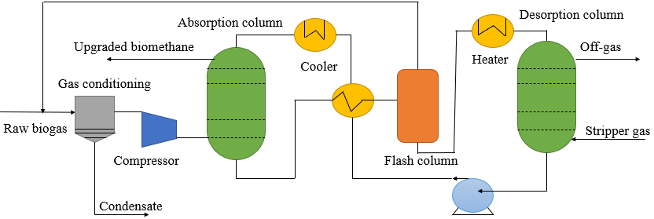
Fig. 19. Schematic Diagram of Organic Physical Scrubbing Unit [155].

3.1.1.4 Chemical absorption (amine scrubbing)
The solvent and absorbed material undergo a reversible reaction in chemical absorption technology. This approach removes it from the raw biogas using a reagent that forms a chemical link with the carbon (IV) oxide molecule [154]. The most popular amines for removing carbon (IV) oxide and hydrogen sulfide are methyl diethanolamine (MDEA), monoethanolamine (MEA), and diethanolamine (DEA) [149]. This is usually accomplished by employing a water solution of amines. One amine cleaning agent recently gaining popularity is activated MDEA (aMDEA), a combination of MDEA and piperazine (PZ). Because activated MDEA includes tertiary amine, which causes a high rate of CO2 absorption, while PZ contains primary and secondary amines, started MDEA has a more robust absorption capacity than conventional MDEA [157].
Furthermore, the absorber is positioned at the top of the column, and raw biogas is added to the bottom, where it comes into contact with the amine solution. By reacting with amine, the CO2 in the raw biogas undergoes an exothermic reaction, allowing the liquid phase to absorb the CO2 [154]. Therefore, the absorber operates at a 1-2 bar pressure, and the product gas exits the column through its top [152]. After passing through the heat exchanger, the liquid at the absorber's base is pushed to the stripper column's top. It is combined with steam to produce carbon (IV) oxide [149]. At 120-150oC, the amine is heated in a reboiler located at the foot of the stripper column. Before the amine scrubbing can take place, hydrogen sulfide must be eliminated [159]. A typical amine scrubbing unit's process flow is shown in Fig. 20.
Among the benefits of amine scrubbing technology are its ability to produce gas with a high concentration of methane (up to 99 percent), minimal or no loss of methane (<0.1 percent), elimination of hydrogen sulfide (H₂S), the ability to operate at low pressure, and greater efficiency compared to water scrubbing [153][152]. However, the inconvenient and costly nature of the solvents is a drawback of this upgrading approach. Evaporation and the significant energy consumption of chemical regeneration are the leading causes of amine loss [152].

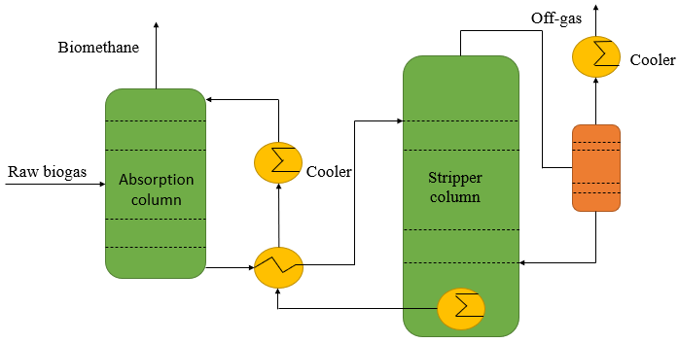
Fig. 20. Process Flow for Typical Amine Scrubbing Unit [154].

3.1.1.5 Membrane separation technology (gas permeation)
The use of membrane separation technologies to improve biogas has been more popular in the past several years [160]. The permeation process depends on the concentration gradient of the permeate, and this technology functions on the concept of selective permeation [157][153]. Gases containing carbon (IV) oxide can flow through the membrane, while gases containing methane are kept in it when raw biogas is pumped into it under pressure (between 5 and 20 bar) [154]. The process yields very pure biomethane, but it loses a lot of methane because methane molecules can escape through the membrane [148].
Three distinct biogas purification membranes exist: inorganic, polymeric, and mixed matrix (MMMs). Membranes based on polyimide, polysulfone, or cellulose acetate are the most used commercially [148][149]. The key drawbacks of this method are its fragility and price [152], and the result of this upgrading procedure contains 95-98 percent methane, with some methane loss due to permeation. Modern membrane systems minimize methane loss and maximize separation efficiency.
The operation of membrane separation technology is shown in Fig. 21.
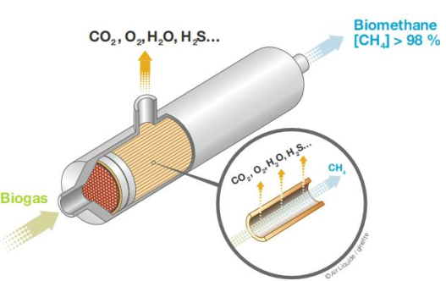
Fig. 21. Illustration of How Membrane Separation Technology Works [161].

3.1.2 Newly developed upgrading technologies
Upgrading technologies that are brand new have just been released and are still in the works. This category includes biological and hydrate separation methods, cryogenic technologies, and in-situ methane enrichment.

3.1.2.1 Cryogenic separation technology
Cryogenic separation uses distillation and condensation to separate methane and carbon dioxide, two gases with differing condensing temperatures and pressures [148]. This separation process involves cooling raw biogas to -70oC using a heat exchanger [153]. Following this, the biogas is cooled further by
passing it through a series of heat exchangers and compressors operating at a pressure of 40 bars [153]. After that, the gas goes into the distillation column, separating it from other impurities such as hydrogen sulfide and carbon (IV) oxide [149]. There is minimal methane loss (<1 percent) and a high methane concentration (over 99 percent) in the biomethane, which is the result of this separation procedure. To keep the equipment in the cryogenic separation unit from being clogged, it is necessary to remove hydrogen sulfide from the raw biogas beforehand [149].
Benefits of this process include a high methane concentration, a low methane loss rate, scalability, the absence of contaminants, and the emission of pure carbon dioxide [147]. Consequences of this technology include a high energy demand, the potential for operators to encounter technical difficulties, and an increased investment and maintenance cost due to the process's reliance on several heat exchangers and compressors [147][149][153][162]. The cryogenic separation technology process flow is illustrated in Fig. 22.

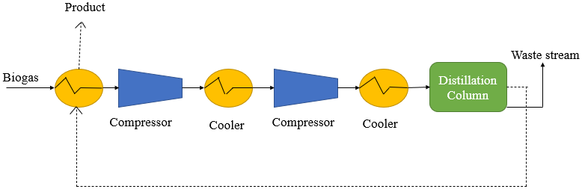
Fig. 22. Schematic Diagram of Cryogenic Separation Technology [149].

3.1.2.2 In situ methane enrichment
This improvement method involves returning the digesting chamber's liquid sludge to the desorption unit for reuse [153]. Carbon dioxide is desorbed when the sludge contacts nitrogen gas or air running counter-flowing in the desorption column [148]. To increase the sludge's CO2 absorption, it is sent back to the digestion chamber [147]. This technique can produce biogas with a methane concentration of 95% while reducing methane loss to less than 2% [153]. Smaller facilities that do not require methane purity levels exceeding 95 percent can employ this cost-effective technology [157]. In situ methane enrichment technology has several benefits, including being easy to operate, having the potential to capture carbon, being environmentally friendly, and providing a stable supply of sustainable power [163]. A typical in situ methane enrichment plant is seen in Fig. 23, which is a flow diagram.

3.1.2.3 Hydrate separation
There has been a lot of recent focus on hydrate formation to remove carbon dioxide from raw biogas streams [164]. This separation method is based on the fact that different species produce hydrates in different ways [148]. The hexahydrate separation method mainly works by selectively dividing the required component into the gaseous and hydrate phases [148]. The technology's drawbacks include the significant energy consumption caused by the formation of the hydrate and the removal of a massive volume of methane with carbon dioxide. The amount of methane lost and the quality of the resultant biogas is unknown because the technology is currently under development [148].

3.1.2.4 Biological technologies
Biological technologies convert carbon dioxide into energy-containing goods with high value-added properties. Photosynthetic and chemoautotrophic technologies are two broad categories that include this approach [152]. The process of chemoautotrophic methanogens converting carbon dioxide gas to methane gas involves the usage of hydrogen gas [148]. Using autotrophic and chemoautotrophic methods, H2S can be removed with a 97% methane recovery rate. Biological methods are simple, reliable, and do not require chemicals [165].

3.2 Separation of other trace components
Hydrogen sulfide, siloxanes, ammonia, water, and a few volatile organic compounds are trace amounts in biogas, while carbon (IV) oxide and methane make up the bulk of the mixture [149]. Among contaminants, H2S and H2O provide the most significant threat [148]. Because of their negative impact on the utilization area, these contaminants must be eliminated before they can be used, either through upgrading or pretreatment procedures. Absorption on activated charcoal is the standard method for removing siloxanes. Table 9 displays several techniques for extracting water and hydrogen sulfide.

3.3 Using biogas in a way that is compatible with the necessary quality and suitable upgrading technologies
Any application of biogas must meet specific standards. The pollutants that need to be cleaned up depend on where they will be used. Table 10 displays the biogas quality requirements for different applications.

Table 9. Strategies for the Pre- and Post-Removal of Hydrogen Gas and Water [149].

Pre-Treatment Methods for H₂S | Removal Methods for H₂O
Membranes | Demister
Air stripping and recovery | Moisture trap
Iron oxide | Cyclone
Biological removal on a filter bed | Adsorption layer
Zinc oxide sorbents | Aluminum
Air/O₂ dosing to biogas reactor. | Silica
Chemical and physical absorption | Condensation
Iron sponge | Physical absorption with glycol
Absorption on activated charcoal | Absorption with hygroscopic salts

Table 10. Aligning Gas Quality Standards with Areas of Use and Enhancement of Technology [148][149].

Utilization Area | H₂S | CO₂  (% vol.) | H₂O  (% vol.) | Suitable Upgrading Technologies
Gas Heating (boiler) | <250 ppm | No removal required (25-30) | No removal (6) | CO₂: no need  H₂S: biological desulfurization
Kitchen Stove | <10 ppm | No removal required (25-30) | No removal (6) | H₂S: iron hydroxide or oxide  CO₂: chemical absorption
Stationary Engine (Combined Heat and Power Systems) | <1000 ppm | No removal required (25-30) | Avoid condensation (<3) | CO₂: no need  H₂S: biological desulfurization
Vehicle Fuel | Removal required (5 mg/m³) | Recommended (<4) | Removal required (<3) | CO₂: cryogenic separation or chemical absorption  H₂S: iron oxide/hydroxide and impregnated activated carbon
Natural Gas Grid | Removal required (2-15 mg/m³) | Removal required (≤3) | Removal required (1-8) | CO₂: pressure swing adsorption (PSA) and membrane if the removal of O₂ and N₂ is required; PSA and chemical absorption if high CH₄ purity is needed  H₂S: impregnated iron hydroxide/oxide and activated carbon
Fuel Cell | Molten-carbonate fuel cell (MCFC): 1-5 ppm.  Solid oxide fuel cell (SOFC): 1 ppm | MCFC: <35  SOFC: as little as possible | – | H₂S: impregnated iron hydroxide/oxide and activated carbon

3.4 Comparative analysis of biogas upgrading technologies
Additional metrics for comparing biogas upgrading technology include operating pressure, pre-purification, energy consumption, cost economics, methane losses, and methane purity [156]. There is no ideal upgrade technology as none satisfies all specified requirements [157]. Operators of the plants must thus prioritize the characteristics and criteria that will lead to the desired gas quality. Water scrubbing uses incredibly little energy compared to chemical scrubbing and physical absorption, which are the two procedures that demand the most incredible energy [156]. A comparison of several biogas upgrading systems is presented in Table 11.

Table 11. Evaluation of Alternative Upgrade Methods [157][149].

 | Cryogenic | PSA | Water Scrubbing | Physical Scrubbing | Chemical Absorption | Membrane Separation
Consumption of raw biogas (kWh/Nm³) | 0.76 | 0.23-0.30 | 0.25-0.3 | 0.2-0.3 | 0.05-0.15 | 0.18-0.20
Consumption of clean biogas (kWh/Nm³) | not found | 0.29-1.00 | 0.3-0.9 | 0.4 | 0.05-0.25 | 0.14-0.26
Heat consumption (kWh/Nm³) | not found | None | None | <0.2 | 0.5-0.75 | None
Heat demand (ºC) | -196 |  |  | 55-80 | 100-180
Cost | High | Medium | Medium | Medium | High | High
CH₄ losses (%) | 2 | <4 | <2 | 2-4 | <0.1 | <0.6
CH₄ recovery (%) | 97-98 | 96-98 | 96-98 | 96-98 | 96-99 | 96-98
Pre-purification | Yes | Yes | Recommended | Recommended | Yes | Recommended
H₂S  co-removal | Yes | Possible | Yes | Possible | Contaminant | Possible
N₂ and O₂  co-removal | Yes | Possible | No | No | No | Partial
Operation pressure (bar) | 80 | 3-10 | 4-10 | 4-8 | Atmospheric | 5-8
Pressure at the outlet (bar) | 8-10 | 4-5 | 7-10 | 1.3-7.5 | 4-5 | 4-6

3.5 Cost of biogas upgrading technologies
Numerous factors affect the efficiency of biogas upgrading technologies in terms of cost: the capacity of the upgrading plant, the technology of the upgrading plant, the location of the upgrading plant, and the necessary biogas quality [166]. The investment/capital expenditure (CAPEX) and operating and maintenance (O&M) expenses may also be used to calculate the costs of upgrading biogas. Investment costs rise with decreasing plant size and fall with increasing plant size, indicating an inverse connection between plant size and particular CAPEX [148][149]. The results in Table 12 and Figure 24 clearly show this.
Power, water or chemicals, and personnel consumption are significant operational and maintenance expenses for an upgrading facility [148]. Improving technology and maintenance procedures can increase operating and maintenance fees, increasing capital/investment costs [149]. When it comes to big facilities, cryogenic technology is more cost-effective for maintenance than membrane separation technology, which requires a high initial investment but offers low ongoing expenses [168]. Because of increasing solvent consumption owing to solvent loss and oxidation-induced degradation, chemical absorption technology has significant operating and maintenance costs in extensive upgrading facilities [148]. The cost of maintenance for an upgrading facility is displayed in Table 13.

Table 12. Capital Costs of Different Upgrading Technologies [149][14][167].

Upgrading Technology | Capital Cost
Pressure swing adsorption | 0.40€/Nm³ of biogas  Capital costs for 1,000, 600, 500, and 250 m³/h are 2.2, 2.4, 3.2, and 5.5 kUSD/(m³/h), respectively.
High-pressure water scrubbing | 0.13€/Nm³ of biogas  Capital costs for 1,000, 660, 500, and 250 m³/h are 2, 2.78, 2.7, and 1.22 kUSD/(m³/h), respectively.
Organic physical scrubbing | Capital costs for 1,000, 500, and 250 m³/h are 2.4, 3.8, and 4.8 kUSD/(m³/h), respectively.
Chemical Scrubbing process | 0.17€/Nm³ of biogas  Capital costs for 1,000, 500, 250, and 100 m³/h are 2.6, 3.6, 5.5, and 10.5 kUSD/(m³/h), respectively.
Membrane separation | 0.12€/Nm³ of biogas  Capital costs for 700-1400, 600, and 100 m³/h are 2.2, 2.5, and 6.6 kUSD/(m³/h), respectively.

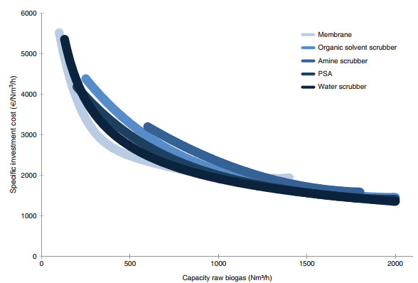
Fig. 24. Comparison of Different Upgrading Technologies Based on Investment Cost and Raw Biogas Capacity [166].
Table 13. The Expenses of Upgrading Technologies and Their Maintenance [157][156].

 | Water Scrubbing | Physical Absorption | Chemical Absorption |  | Pressure Swing Absorption | Membrane Technology
Maintenance cost (€/year) for 1,000 m³ | 15,000 | 39,000 | 59,000 |  | 56,000 | 25,000

3.6 Efficiency of biogas upgrading technologies
The total energy efficiency of biogas upgrading methods is affected by key characteristics such as methane loss and energy consumption [169]. The total efficiency of any technique used to improve biogas is provided as:

Table 14 shows the energy efficiency of different biogas upgrading technologies.

Efficiency of biogas upgrading technologies
Raw or refined biogas has several potential uses, including in places traditionally utilized for natural gas [149]. What pollutants need to be eliminated depends on the specific needs of each application area. The primary use of biogas is regulated by national frameworks including tax systems, subsidies, and the presence of gas and heat networks [151]. Fig. 25 displays the possible applications of biogas at various upgrading levels.

4.1 Fuels for Gas Burners and Boilers
It is possible to substitute biogas for the natural gas used in household stoves. However, this may only be done per preexisting regulations based on sensible and secure usage, such as the Swedish regulation for burning gas (SS-EN 30-2-1/A2:2005) [148]. At the 20-bar gauge pressure often used for home stoves, natural gas outperforms biogas in terms of heating value [153]. Thus, increasing the methane content of biogas to around 100% is necessary for it to substitute natural gas in home stoves [148]. But even at higher pressures, biomethane with a lower proportion of methane may be burned in home stoves. With a supply pressure of 100 mbar (gauge), biogas with a 93% methane content, for example, may be utilized as stove fuel [148]. The toxic and corrosive properties of hydrogen sulfide necessitate keeping it below 10 parts per million.
Furthermore, boilers can function with lower-quality biogas since the combustion process in boilers is less influenced by biogas impurities. As a result, biogas may be directly used in combustion boilers without any prior upgrading [170]. Boilers that run on biogas typically have their gauge pressure adjusted at 8–25 bar [151]. The dew point must be kept at roughly 150oC for biogas in combustion boilers with a concentration of less than 1,000 ppm of hydrogen sulfide [170].

Table 14. Efficient Energy Use by Various Biogas Upgrading Methods [148][8].

Upgrading Technologies | Efficiency (%) | Range of Efficiency (%)
Water Scrubbing | 88.9-92.8 | 88.9-92.8
Water Scrubbing + Regeneration | 92.8 | 92.7-96.0
Cryogenic Separation | 93.1 | 84.9-96.7
Physical Absorption | 91.0 | 90.0-95.5
Chemical Absorption | 88.5 | 88.5-97.7
Pressure Swing Absorption | 92.1 | 84.8-93.6
Membrane Technology | 82.4 | 82.4-98.0
Insitu Upgrading | N/A | N/A
N/A-Not Available
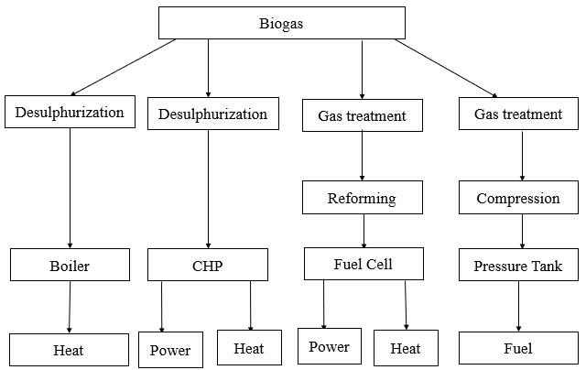
Fig. 25. Potential Utilization of Biogas [149].

4.2 The use of biogas in power production and CHP
Shortly, biogas can potentially become the world's principal power source [171]. The combustion of biogas has allowed for its conversion to mechanical and electrical energy in numerous industrialized nations in recent years. This conversion has occurred through internal combustion engines (both compression and spark ignition), Stirling engines, gas turbines, and micro-turbines [156]. Hydrogen sulfide (H2S) levels below 250 ppm are maintained in combined heat and power (CHP) facilities using biogas. This helps to prevent expensive lubricating oil degradation and excessive corrosion [8]. Although CHP engines do not necessitate specially treated gas, upgrading is essential to avoid condensation water and maintain control over H2S levels [170].
One of the most prevalent ways to convert biogas into electricity is using internal combustion engines. The ideal concentration of methane for combustion to occur is around 21% (mol) [148], and they often contain a combination of carbon (IV) oxide and methane. Biogas has a poor calorific value, so it can't be used to generate CHP [149]. Two gas engine types are utilized for combined heat and power (CHP) generation: spark ignition and dual-fuel engines [151]. Although they produce more pollution, dual-fuel engines are electrically efficient at 43% [8]. Another way to categorize spark ignition engines is stoichiometric or lean-burn; the former is more efficient [151].

4.3 Biogas injection into the natural gas grid
Since natural gas reserves have steadily declined in quality and quantity, biogas has become a viable substitute [149]. An upgrading procedure is necessary for biogas to be considered natural gas quality [148]. Some nations have established regulations for injecting biogas into the natural gas infrastructure to avoid equipment corrosion; they include Germany, Sweden, France, and Switzerland [149]. Table 15 displays these criteria.
Further, there are several benefits to injecting biogas into the existing natural gas infrastructure. One advantage of grid-connected biogas production sites is the significant potential for increased output at outlying places, even when these facilities are already linked to more densely populated areas. Also, all of the gas is used simultaneously [151]. Since most nations use more gas than they generate, injecting biogas into the natural gas system also improves the local supply security [151].

Table 15. Criteria for injecting Biogas into Natural Gas Distribution Systems [149].

Component | Sweden | France | Switzerland | Germany
CH₄ (%vol) | $toto≥$97 | $≥$86 | $≥$96 | $≥$96
CO₂ (%vol) | $$≤3$$ | $to ≤$2.5 | $≤$6 | $≤$6
H₂ (%vol) | $≤$0.5 | $≤$6 | $≤$4 | $≤$5
O₂ (%vol) | $≤$1 | $≤$0.01 | $≤$0.5 | $≤$0.5
H₂S (mg/Nm³) | $≤$1$0$ | $≤$5 | $≤$5 | $≤$5
CO (%vol) | - | $≤$2 |  | -
Total sulfur (mg/Nm³) | $≤$23 | $≤$30 | $≤$30 | $≤$30
NH₃ (mg/Nm³) | $≤$20 | $≤$3 | $≤$20 | -
H₂O (mg/Nm³) | $≤$3 | - | - | -
Heavy metals (mg/Nm³) | - | $≤$1 | $≤$5 | $≤$5
Water dew point (ºC) | $≤$-5 | $≤$-5, Pmax | - | Soil temperature
Halogens (mg/Nm³) | - | $≤$1(Cl) $≤$10(F) | $$≤1$$ | 0
Siloxanes (mg/ Nm³) | - | - | - | -
Mercaptans (mg/Nm³) | - | $$≤6$$ | $$≤5$$ | $≤$15

4.4 Fuels for vehicles
The fuel for automobiles that normally run on natural gas can be replaced with biogas. When converted into a vehicle fuel, biogas follows the same protocol as natural gas regarding the vehicle and engine setup [170]. Using biogas as a fuel is not limited by vehicle configuration, as demonstrated by the approximately 10,000 automobiles and buses that use it and the three million vehicles that use natural gas [172]. Despite its excellent quality, biogas must be processed before it can be used as a vehicle fuel. Fuel for vehicles can have a higher concentration of hydrogen gas than what is allowed in the natural gas system, and biogas used for fuel must have a higher proportion of methane [148].
Biogas upgrading for usage as motor fuel requires extremely pure methane, which can only be achieved by cryogenic and chemical absorption processes. Activated carbon treated with iron hydroxide or oxide and used for this purpose removes hydrogen sulfide [148]. Bio-compressed natural gas, or Bio-CNG, has the makings of a future fuel that is sustainable, environmentally benign, and cost-effective. Reduced emissions of greenhouse gases and other harmful substances like sulfur, lead, and heavy hydrocarbons are among the many benefits of bio-CNG as a vehicle fuel, in addition to its low density, excellent thermal efficiency, and calorific value [149]. Among European nations, bio-CNG is a popular choice for vehicle fuel, particularly in the UK, France, Italy, Germany, the Netherlands, and Switzerland [149].

4.5 Hydrogen gas from biogas/fuel cell application
Some fuel cells use methane as fuel, while others turn the chemical energy of a fuel/oxidizer combination into electricity. Two examples of these are molten carbonate fuel cells (MCFCs) and solid oxide fuel cells (SOFCs), which function between 600 and 700 degrees Celsius and 800-1000 degrees Celsius, respectively [148]. Another major obstacle to the widespread use of environmentally friendly and technologically advanced systems, such as fuels, is the manufacturing and storage of hydrogen [173]. Fuel cells that rely on hydrogen can be powered by hydrogen instead of methane, which can be created by reforming biogas (on a supported catalyst) [149]. Reduced emissions of the greenhouse gas carbon dioxide are a result of this. Because hydrogen sulfide is toxic to the nickel catalyst, it must be eliminated before reforming. Hydrogen from biogas is now the fuel for commercial-scale fuel cells that generate energy [149].

5. Future work and perspectives
The decomposition of organic matter via anaerobic digestion has been proven to be an efficient method for biogas production, but it still has some challenges that must be solved. First, the presence of unwanted materials such as glass and plastics in feedstocks (particularly municipal solid wastes) impacts its efficient breakdown. Operation of the anaerobic digester could be negatively affected due to these undesired materials, eventually resulting in prolonged shutdown of digester units. Feedstock separation and the central separation of undesired materials are promising solutions to this problem. Although South Korea, the United Kingdom, and Sweden practice feedstock separation, several countries have yet to instigate an appropriate feedstock separation program [174]. Therefore, in the upcoming years, most countries should fund the separation of municipal solid wastes, either through central or source separation. Another main challenge is the stability of the anaerobic digestion process, although co-digestion has shown to be a viable approach to tackle this. Optimization and improvement studies should be carried out on the co-digestion of different wastes in the future. In addition, microbial activities during AD can be improved through the introduction of micronutrients in the form of nanoparticles [175] [176][177][178]. However, there are only a few studies on the specific impacts of these micronutrients on the AD of different feedstocks, and the minimization of risks associated with these micronutrients has yet to be explored.
In recent years, hybrid biogas upgrading technologies have proven promising approaches to optimizing the upgrading process because they lead to high sulfur and carbon (IV) oxide capture, low operating costs, and less energy usage [157]. In the future, more research needs to be done on hybrid upgrading technologies to exploit the merits of combined technologies and how to optimize the techno-economic aspect of the upgrading process. In addition, methane is lost in most biogas upgrading plants in the form of off-gas, which is released into the atmosphere. Since methane is a greenhouse gas contributing to global warming, there is an urgent need to treat the off-gas leaving the plant. In the future, capturing methane in off-gas should be considered while designing biogas upgrading plants and its utilization in a combined heat and power gas engine. In general, the size of any upgrading plant determines the cost of upgrading biogas, as the cost associated with biogas upgrading is reduced with the increase in plant capacity, as shown previously in Figure 20 [146].Thus, low-capacity plants (< 200 Nm3/h) are too expensive because of the high cost of upgrading equipment, such as valves, sensors, analysis equipment, and control systems. Low-capacity plants need almost the same amount of this equipment as large-capacity plants. To reduce the cost of upgrading biogas, it is recommended that the design of the control system installed in the plant should be simple, and the methane content in the upgraded biogas should be less than 95% [179].
In the future, more research should focus on realistic ways of lowering the cost of small-capacity upgrading plants in rural regions. Also, more research is required to close the knowledge gap between pilot-scale and commercial-scale operations of biogas upgrading plants.
Finally, government policies are needed to support biogas production and utilization in areas such as household combustion, vehicular fuel, and the natural gas grid. Biogas production is increasing tremendously in countries with consistent and coherent government support policies. Other ways in which the government could support biogas production and utilization are the following: a subsidy provision for automobile manufacturers in developing countries, introducing engines that run on biogas in the market, provision of a profitable feed-in-tariff to firms generating their electricity with biogas technologies, creation of a seed capital scheme for start-ups working on biogas- to-bioenergy technologies, separation and conveyance of crop residues or bio-waste-to-biogas plants, and creation of skill acquisition centers to train future workforce for electricity generation from biogas, among others [180][181][182][183][184].

6. Conclusion
Anaerobic digestion is a process that produces biogas. However, before the biogas can be used, it needs to be treated and improved. This is known as upgrading the biogas. Upgrading removes impurities like hydrogen sulfide and carbon dioxide. There are various technologies available for upgrading biogas including pressure swing adsorption, water scrubbing, and amine scrubbing. Emerging technologies include cryogenic technology and membrane separation. Cryogenic technology is the most effective upgrading technology. When choosing an upgrade technology, three main factors should be considered: the possible utilization area, the upgrading process cost, and the boosting technology efficiency.
The efficiency of the upgrading technologies is evaluated based on the following criteria: operation and maintenance expenses, investment cost, methane recovery, and methane loss. Membrane technology has comparatively low operating and maintenance expenses compared to chemical absorption technology but requires the most significant investment cost. Different biogas applications have different requirements. For stove applications, chemical absorption is the most appropriate upgrading technology. For vehicle applications, cryogenic separation/chemical absorption is the best. For the natural gas grid, PSA/membrane separation is ideal. If the requirement is to remove O2 and N2 or to produce high CH4 purity, then PSA/chemical absorption is the appropriate upgrade technology.
There are numerous uses for biogas, including fuel cells, combined heat and power generation, vehicles, stoves, boilers, and injection into the natural gas system. Cars have the highest biogas quality requirements of all the possible biogas application sectors. The national framework that regulates biogas use includes subsidies, taxes, and the accessibility of gas and heat networks. Hybrid upgrading technologies require further investigation to maximize the techno-economic benefits of combining technology. Further investigation into practical approaches to reducing the price of small-capacity upgrading plants for usage in rural areas is required. To bridge the gap between what is known about biogas upgrading facilities operating on a pilot size and what is known about commercial-scale operations, further study is necessary.

Acknowledgment
The authors thank Munonyedi Egbo for his help and suggestions during the writing process.

Declaration of Competing Interest
The authors declare that they have no known competing financial interests or relationships that could have appeared to influence the work reported in this paper.

Data Availability
All data underlying the results are available in the article, and no additional source data is required.

References
[1] N.P. Adhikari, and R.C. Adhikari, "Analysis of biogas production potential based on livestock dung availability: A case of household biogas plants in Nepal," Biofuels, 13(6), pp.735-743, 2022.
[2] X. Zhao, B. Joseph, J. Kuhn, and S. Ozcan, “Biogas reforming to syngas: a review,” iScience, vol. 23, no. 5, p. 101082, 2020.
[3] A. Arshid, and Z. A. Kazmi "Three-dimensional Interaction of Granular Media Simulated by Discrete Element Method," JEAS, 2017; 4(1), pp. 19-25
[4] K. C. Surendra, D. Takara, A. G. Hashimoto, and S. K. Khanal, “Biogas as a sustainable energy source for developing countries: opportunities and challenges,” Renew. Sustain. Energy Rev., vol. 31, pp. 846–859, 2014.
[5] A. Molino, V. Larocca, S. Chianese, and D. Musmarra, “Biofuels production by biomass gasification: A review,” Energies, vol. 11, no. 4, pp. 1–31, 2018.
[6] Y. Chen, J. J. Cheng, and K. S. Creamer, “Inhibition of anaerobic digestion process: a review,” Bioresour. Technol., vol. 99, no. 10, pp. 4044–4064, 2008.
[7] J. B. Holm-Nielsen, T. Al Seadi, and P. Oleskowicz-Popiel, “The future of anaerobic digestion and biogas utilization,” Bioresour. Technol., vol. 100, no. 22, pp. 5478–5484, 2009.
[8] P. Weiland, “Biogas production: current state and perspectives,” Appl. Microbiol. Biotechnol., vol. 85, no. 4, pp. 849–860, 2010.
[9] Y. Deng, J. Xu, Y. Liu, and K. Mancl, “Biogas as a sustainable energy source in China: regional development strategy application and decision making,” Renew. Sustain. Energy Rev., vol. 35, pp. 294–303, 2014.
[10] C. Mao, Y. Feng, X. Wang, and G. Ren, “Review on research achievements of biogas from anaerobic digestion,” Renew. Sustain. Energy Rev., vol. 45, pp. 540–555, 2015.
[11] A. Petersson and A. Wellinger, “Biogas upgrading technologies-developments and innovations .,” IEA bioenergy, vol. 20, pp. 1–19, 2009.
[12] R. Feiz et al., “Biogas potential for improved sustainability in Guangzhou, China-a study focusing on food waste on Xiaoguwei Island,” Sustainability, vol. 11, no. 6, p. 1556, 2019.
[13] I. S. Horváth, M. Tabatabaei, K. Karimi, and R. Kumar, “Recent updates on biogas production -a review,” Biofuel Res. J., vol. 10, pp. 394–402, 2016.
[14] L. Yang, X. Ge, C. Wan, F. Yu, and Y. Li, “Progress and perspectives in converting biogas to transportation fuels,” Renew. Sustain. Energy Rev., vol. 40, pp. 1133–1152, 2014.
[15] S. Ahmad, V.V. Pathak, R. Kothari, and R.P. Singh, "Prospects for pretreatment methods of lignocellulosic waste biomass for biogas enhancement: opportunities and challenges," Biofuels, 9(5), pp.575-594, 2018.
[16] N. J. Themelis and P. A. Ulloa, “Methane generation in landfills,” Renew. Energy, vol. 32, no. 7, pp. 1243–1257, 2007.
[17] S. Rasi, A. Veijanen, and J. Rintala, “Trace compounds of biogas from different biogas production plants,” Energy, vol. 32, no. 8, pp. 1375–1380, 2007.
[18] B. Purmessur and D. Surroop, “Power generation using landfill gas generated from new cell at the existing landfill site,” J. Environ. Chem. Eng., vol. 7, no. 3, p. 103060, 2019.
[19] C. H. Benson, M. A. Barlaz, D. T. Lane, and J. M. Rawe, “Practice review of five bioreactor/recirculation landfills,” Waste Manag., vol. 27, no. 1, pp. 13–29, 2007.
[20] L. Mu, L. Zhang, K. Zhu, J. Ma, M. Ifran, and A. Li, “Anaerobic co-digestion of sewage sludge, food waste and yard waste: Synergistic enhancement on process stability and biogas production,” Sci. Total Environ., vol. 704, p. 135429, 2020.
[21] N. Bachmann, “Sustainable biogas production in municipal wastewater treatment plants,” 2015.
[22] B. Stürmer, “Feedstock change at biogas plants – Impact on production costs,” Biomass and Bioenergy, vol. 98, pp. 228–235, 2017.
[23] S. C. Davis, W. Hay, and J. Pierce, Biomass in the energy industry : an introduction. 2014.
[24] I. S. Horváth, M. Tabatabaei, K. Karimi, and R. Kumar, “Recent updates on biogas production - a review Recent updates on biogas production - a review,” Biofuel Res. J., vol. 10, pp. 394–402, 2016.
[25] S. Alexander, P. Harris, and B. K. McCabe, “Biogas in the suburbs: An untapped source of clean energy?,” J. Clean. Prod., vol. 215, pp. 1025–1035, 2019.
[26] B. K. McCabe and T. Schmidt, Integrated biogas systems: local applications of anaerobic digestion towards integrated sustainable solutions, vol. 5. 2018.
[27] Department for Environment Food & Rural Affairs, “Advanced biological treatment of municipal solid waste,” 2013.
[28] H. M. Zabed et al., “Recent advances in biological pretreatment of microalgae and lignocellulosic biomass for biofuel production,” Renew. Sustain. Energy Rev., vol. 105, pp. 105–128, 2019.
[29] R. Ganesh Saratale, G. Kumar, R. Banu, A. Xia, S. Periyasamy, and G. Dattatraya Saratale, “A critical review on anaerobic digestion of microalgae and macroalgae and co-digestion of biomass for enhanced methane generation,” Bioresour. Technol., vol. 262, pp. 319–332, 2018.
[30] P. Bohutskyi, M. J. Betenbaugh, and E. J. Bouwer, “The effects of alternative pretreatment strategies on anaerobic digestion and methane production from different algal strains,” Bioresour. Technol., vol. 155, pp. 366–372, 2014.
[31] H. M. Zabed, S. Akter, J. Yun, G. Zhang, Y. Zhang, and X. Qi, “Biogas from microalgae: Technologies, challenges and opportunities,” Renew. Sustain. Energy Rev., vol. 117, no. July 2018, p. 109503, 2020.
[32] J. C. Frigon, F. Matteau-Lebrun, R. Hamani Abdou, P. J. McGinn, S. J. B. O’Leary, and S. R. Guiot, “Screening microalgae strains for their productivity in methane following anaerobic digestion,” Appl. Energy, vol. 108, pp. 100–107, Aug. 2013.
[33] Y. Chisti, "Fuels from microalgae," Biofuels, 1(2), pp.233-235, 2010.
[34] C. Herrmann, N. Kalita, D. Wall, A. Xia, and J. D. Murphy, “Optimised biogas production from microalgae through co-digestion with carbon-rich co-substrates,” Bioresour. Technol., vol. 214, pp. 328–337, 2016.
[35] E. Thorin, J. Olsson, S. Schwede, and E. Nehrenheim, “Co-digestion of sewage sludge and microalgae – Biogas production investigations,” Appl. Energy, vol. 227, no. January, pp. 64–72, 2018.
[36] C. González-Fernández, B. Sialve, N. Bernet, and J. P. Steyer, “Impact of microalgae characteristics on their conversion to biofuel. Part II: Focus on biomethane production,” Biofuels, Bioproducts and Biorefining, vol. 6, no. 2. pp. 205–218, Mar-2012.
[37] B. Bharathiraja, T. Sudharsana, J. Jayamuthunagai, R. Praveenkumar, S. Chozhavendhan, and J. Iyyappan, “Biogas production – a review on composition, fuel properties, feed stock and principles of anaerobic digestion,” Renew. Sustain. Energy Rev., vol. 90, no. c, pp. 570–582, 2018.
[38] R. Kothari, A. K. Pandey, S. Kumar, V. V. Tyagi, and S. K. Tyagi, “Different aspects of dry anaerobic digestion for bio-energy: an overview,” Renew. Sustain. Energy Rev., vol. 39, pp. 174–195, 2014.
[39] O. Hijazi et al., “Life cycle assessment of the use of nanomaterials in biogas production from anaerobic digestion of manure,” Renew. Energy, vol. 148, pp. 417–424, 2020.
[40] S. Rasi, Biogas composition and upgrading to biomethane. 2009.
[41] M. Persson, O. Jönsson, and A. Wellinger, “Biogas upgrading to vehicle fuel standards and grid,” IEA Bioenergy, vol. 37, pp. 1–19, 2006.
[42] C. Scheutz, H. Mosbaek, and P. Kjeldsen, “Attenuation of methane and volatile organic compounds in landfill soil covers.,” J. Environ. Qual., vol. 33, no. 1, pp. 61–71, 2004.
[43] Scottish Environmental Protection Agency, “Guidance on gas treatment technologies for landfill gas engines,” 2004.
[44] C. Baskar, S. Baskar, and R. S. Dhillon, Biomass conversion: the interface of biotechnology, chemistry and materials science, 1st ed. 2012.

[45] M. Tilahun, O. Sahu, M. Kotha, and H. Sahu, “Cogeneration of renewable energy from biomass (utilization of municipal solid waste as electricity production: gasification method),” Mater. Renew. Sustain. Energy, vol. 4, no. 1, p. 4, 2015.
[46] A. J. Ward, P. J. Hobbs, P. J. Holliman, and D. L. Jones, “Optimisation of the anaerobic digestion of agricultural resources,” Bioresour. Technol., vol. 99, no. 17, pp. 7928–7940, 2008.
[47] A. Hilkiah Igoni, M. J. Ayotamuno, C. L. Eze, S. O. T. Ogaji, and S. D. Probert, “Designs of anaerobic digesters for producing biogas from municipal solid-waste,” Appl. Energy, vol. 85, no. 6, pp. 430–438, 2008.
[48] A. Roopnarain and R. Adeleke, “Current status, hurdles and future prospects of biogas digestion technology in Africa,” Renew. Sustain. Energy Rev., vol. 67, pp. 1162–1179, 2017.
[49] S. Pugesgaard, J. E. Olesen, U. Jorgensen, and T. Dalgaard, “Biogas in organic agriculture - effects on productivity, energy self-sufficiency and greenhouse gas emissions,” Renew. Agric. Food Syst., vol. 29, no. 1, pp. 28–41, 2014.
[50] P. Bajpai, “Basics of anaerobic digestion process,” in Anaerobic technology in pulp and paper industry, 2017, pp. 7–13.
[51] L. Appels, J. Baeyens, J. Degrève, and R. Dewil, “Principles and potential of the anaerobic digestion of waste-activated sludge,” Prog. Energy Combust. Sci., vol. 34, no. 6, pp. 755–781, 2008.
[52] L. De Baere, “Anaerobic digestion of solid waste: state-of-the-art,” Water Sci. Technol., vol. 41, no. 3, pp. 283–290, 2000.
[53] A. Khalid, M. Arshad, M. Anjum, T. Mahmood, and L. Dawson, “The anaerobic digestion of solid organic waste,” Waste Manag., vol. 31, no. 8, pp. 1737–1744, 2011.
[54] C. Zhang, H. Su, J. Baeyens, and T. Tan, “Reviewing the anaerobic digestion of food waste for biogas production,” Renew. Sustain. Energy Rev., vol. 38, pp. 383–392, 2014.
[55] S. M. Sunny and K. Joseph, “Review on factors affecting biogas production,” Int. J. Technol. Res. Eng., vol. 5, no. 9, pp. 3693–3697, 2018.
[56] S. Singh, K. S. Kaushik, B. Prashanth, and S. K. Nayak, “Factors affecting anaerobic digestion of organic waste,” Int. J. Eng. Res. Mech. Civ. Eng., vol. 3, no. 2, pp. 99–108, 2018.
[57] H. S. Sorathia, P. P. Rathod, and A. S. Sorathiya, “Biogas generation and factors affecting the biogas generation – a review study,” Int. J. Adv. Eng. Technol. E, vol. 3, no. 3, pp. 72–78, 2012.
[58] V. Moset, M. Poulsen, R. Wahid, O. Højberg, and H. B. Møller, “Mesophilic versus thermophilic anaerobic digestion of cattle manure: methane productivity and microbial ecology,” Microb. Biotechnol., vol. 8, no. 5, pp. 787–800, 2015.
[59] J. Kainthola, A. S. Kalamdhad, and V. V. Goud, “A review on enhanced biogas production from anaerobic digestion of lignocellulosic biomass by different enhancement techniques,” Process Biochem., vol. 84, no. January, pp. 81–90, 2019.
[60] L. Zhang, K. C. Loh, and J. Zhang, “Enhanced biogas production from anaerobic digestion of solid organic wastes: Current status and prospects,” Bioresour. Technol. Reports, vol. 5, no. July 2018, pp. 280–296, 2019.
[61] G. D. Gebreeyessus and P. Jenicek, “Thermophilic versus mesophilic anaerobic digestion of sewage sludge: A comparative review,” Bioengineering, vol. 3, no. 2. MDPI AG, Jun-2016.
[62] C. Cavinato, D. Bolzonella, P. Pavan, F. Fatone, and F. Cecchi, “Mesophilic and thermophilic anaerobic co-digestion of waste activated sludge and source sorted biowaste in pilot- and full-scale reactors,” Renew. Energy, vol. 55, pp. 260–265, Jul. 2013.
[63] W. Parawira, M. Murto, J. S. Read, and B. Mattiasson, “A Study of Two-Stage Anaerobic Digestion of Solid Potato Waste using Reactors under Mesophilic and Thermophilic Conditions,” Environ. Technol., vol. 28, no. 11, pp. 1205–1216, 2007.
[64] M. N. I. Siddique and Z. A. Wahid, “Achievements and perspectives of anaerobic co-digestion: A review,” Journal of Cleaner Production, vol. 194. Elsevier Ltd, pp. 359–371, Sep-2018.
[65] S. A. Neshat, M. Mohammadi, G. D. Najafpour, and P. Lahijani, “Anaerobic co-digestion of animal manures and lignocellulosic residues as a potent approach for sustainable biogas production,” Renewable and Sustainable Energy Reviews, vol. 79. Elsevier Ltd, pp. 308–322, Nov-2017.
[66] B. Dai et al., “Acid inhibition during anaerobic digestion of biodegradable kitchen waste,” J. Renew. Sustain. Energy, vol. 7, no. 2, p. 023118, Mar. 2015.
[67] S. Kusch, B. Schumacher, H. Oechsner, and W. Schäfer, “Methane yield of oat husks,” Biomass and Bioenergy, vol. 35, no. 7, pp. 2627–2633, Jul. 2011.
[68] S. Jayaraj, B. Deepanraj, and V. Sivasubramanian, “Study on the effect of pH on biogas production from food waste by anaerobic digestion,” in 9th Annual Green Energy Conference in Tianjin China (IGEC-IX), 2014, pp. 25–28.
[69] Y. Chen, H. Liu, X. Zheng, X. Wang, and J. Wu, “New method for enhancement of bioenergy production from municipal organic wastes via regulation of anaerobic fermentation process,” Appl. Energy, vol. 196, pp. 190–198, 2017.
[70] L. Yang et al., “Enhancing biogas generation performance from food wastes by high-solids thermophilic anaerobic digestion: Effect of pH adjustment,” Int. Biodeterior. Biodegrad., vol. 105, pp. 153–159, 2015.
[71] M. Kim, C. Y. Gomec, Y. Ahn, and R. E. Speece, “Hydrolysis and acidogenesis of particulate organic material in mesophilic and thermophilic anaerobic digestion,” Environ. Technol. (United Kingdom), vol. 24, no. 9, pp. 1183–1190, Sep. 2003.
[72] M. N. I. Siddique, M. S. A. Munaim, and Z. B. A. Wahid, “The combined effect of ultrasonic and microwave pre-treatment on bio-methane generation from co-digestion of petrochemical wastewater,” J. Clean. Prod., vol. 145, pp. 303–309, Mar. 2017.
[73] K. Aboudi, C. J. Álvarez-Gallego, and L. I. Romero-García, “Semi-continuous anaerobic co-digestion of sugar beet byproduct and pig manure: Effect of the organic loading rate (OLR) on process performance,” Bioresour. Technol., vol. 194, pp. 283–290, Oct. 2015.
[74] R. Chandra, H. Takeuchi, and T. Hasegawa, “Methane production from lignocellulosic agricultural crop wastes: A review in context to second generation of biofuel production,” Renewable and Sustainable Energy Reviews, vol. 16, no. 3. Pergamon, pp. 1462–1476, Apr-2012.
[75] C. Rico, N. Muñoz, J. Fernández, and J. L. Rico, “High-load anaerobic co-digestion of cheese whey and liquid fraction of dairy manure in a one-stage UASB process: Limits in co-substrates ratio and organic loading rate,” Chem. Eng. J., vol. 262, pp. 794–802, Feb. 2015.
[76] D. Li et al., “Effects of feedstock ratio and organic loading rate on the anaerobic mesophilic co-digestion of rice straw and cow manure,” Bioresour. Technol., vol. 189, pp. 319–326, 2015.
[77] H. Bah, W. Zhang, S. Wu, D. Qi, S. Kizito, and R. Dong, “Evaluation of batch anaerobic co-digestion of palm pressed fiber and cattle manure under mesophilic conditions,” Waste Manag., vol. 34, no. 11, pp. 1984–1991, 2014.
[78] Q. Yu et al., “Anaerobic co-digestion of corn stover and chicken manure using continuous stirred tank reactor: The effect of biochar addition and urea pretreatment,” Bioresour. Technol., vol. 319, p. 124197, Jan. 2021.
[79] M. M. Alves et al., “Waste lipids to energy: How to optimize methane production from long-chain fatty acids (LCFA),” Microbial Biotechnology, vol. 2, no. 5. pp. 538–550, Sep-2009.
[80] K. Bella and P. V. Rao, “Anaerobic digestion of dairy wastewater: effect of different parameters and co-digestion options—a review,” Biomass Conversion and Biorefinery. Springer Science and Business Media Deutschland GmbH, pp. 1–26, Jan-2021.
[81] C. Nweke, J. Nwabanne, and P. Igbokwe, “Anaerobic Digestion Treatment of Soft Drink Wastewater,” J. Environ. Hum., vol. 2, no. 1, pp. 25–35, 2015.
[82] X. S. Shi et al., “Effect of Hydraulic Retention Time on Anaerobic Digestion of Wheat Straw in the Semicontinuous Continuous Stirred-Tank Reactors,” Biomed Res. Int., vol. 2017, 2017.
[83] Okonkwo P.C, B. . Aderemi, and Okoli C.S, “Factors affecting biogas production during anaerobic decomposition of brewery effluent-wastewater in a fluidized bed digester,” J. Environ. Earth Sci., vol. 3, no. 8, pp. 32–41, 2013.
[84] M. Kayhanian, “Ammonia inhibition in high-solids biogasification: An overview and practical solutions,” Environ. Technol. (United Kingdom), vol. 20, no. 4, pp. 355–365, Apr. 1999.
[85] X. Wang, G. Yang, Y. Feng, G. Ren, and X. Han, “Optimizing feeding composition and carbon-nitrogen ratios for improved methane yield during anaerobic co-digestion of dairy, chicken manure and wheat straw,” Bioresour. Technol., vol. 120, pp. 78–83, Sep. 2012.
[86] R. Li, S. Chen, X. Li, J. S. Lar, Y. He, and B. Zhu, “Anaerobic codigestion of Kitchen waste with cattle manure for biogas production,” Energy and Fuels, vol. 23, no. 4, pp. 2225–2228, Apr. 2009.
[87] Z. Zhang, G. Zhang, W. Li, C. Li, and G. Xu, “Enhanced biogas production from sorghum stem by co-digestion with cow manure,” Int. J. Hydrogen Energy, vol. 41, no. 21, pp. 9153–9158, Jun. 2016.
[88] X. Y. Cheng and C. Zhong, “Effects of feed to inoculum ratio, co-digestion, and pretreatment on biogas production from anaerobic digestion of cotton stalk,” Energy and Fuels, vol. 28, no. 5, pp. 3157–3166, May 2014.
[89] S. Guillaume and T. Lendormi, “Anaerobic co-digestion of dairy cattle slurry and agro-industrial fats: Effect of fat ratio on the digester efficiency,” Can. J. Chem. Eng., vol. 93, no. 2, pp. 304–308, Feb. 2015.
[90] K. M. Kangle, S. V Kore, V. S. Kore, and G. S. Kulkarni, “Recent trends in anaerobic codigestion: a review.,” Univers. J. Environ. Res. Technol., vol. 2, no. 4, pp. 210–219, 2012.
[91] A. Hajji, M. Rhachi, M. Garoum, and N. Laaroussi, “The effects of pH, temperature and agitation on biogas production under mesophilic regime,” in 2016 3rd International Conference on Renewable Energies for Developing Countries, REDEC, 2016, pp. 1–4.
[92] K. Karim, R. Hoffmann, K. T. Klasson, and M. H. Al-Dahhan, “Anaerobic digestion of animal waste: Effect of mode of mixing,” Water Res., vol. 39, no. 15, pp. 3597–3606, Sep. 2005.
[93] Y. Liu, A. C. Wachemo, H. R. Yuan, and X. J. Li, “Anaerobic digestion performance and microbial community structure of corn stover in three-stage continuously stirred tank reactors,” Bioresour. Technol., vol. 287, p. 121339, 2019.
[94] B. Chatterjee and D. Mazumder, “Role of stage-separation in the ubiquitous development of anaerobic digestion of organic fraction of municipal solid waste: a critical review,” Renew. Sustain. Energy Rev., vol. 104, pp. 439–469, 2019.
[95] W. Li, K. C. Loh, J. Zhang, Y. W. Tong, and Y. Dai, “Two-stage anaerobic digestion of food waste and horticultural waste in high-solid system,” Appl. Energy, vol. 209, pp. 400–408, 2018.
[96] M. M. Arimi, J. Knodel, A. Kiprop, S. S. Namango, Y. Zhang, and S. U. Geißen, “Strategies for improvement of biohydrogen production from organic-rich wastewater: A review,” Biomass and Bioenergy, vol. 75, pp. 101–118, 2015.
[97] N. Zhang et al., “Strategy of mitigating ammonium-rich waste inhibition on anaerobic digestion by using illuminated bio-zeolite fixed-bed process,” Bioresour. Technol., vol. 222, pp. 59–65, 2016.
[98] K. Y. Show, D. J. Lee, and J. S. Chang, “Bioreactor and process design for biohydrogen production,” Bioresour. Technol., vol. 102, no. 18, pp. 8524–8533, 2011.
[99] A. Chiumenti, G. Fait, S. Limina, and F. da Borso, “Performances of conventional and hybrid fixed bed anaerobic reactors for the treatment of aquaculture sludge,” Bioengineering, vol. 7, no. 3, p. 63, 2020.
[100] G. Náthia-Neves, M. Berni, G. Dragone, S. I. Mussatto, and T. Forster-Carneiro, “Anaerobic digestion process: technological aspects and recent developments,” Int. J. Environ. Sci. Technol., vol. 15, no. 9, pp. 2033–2046, 2018.
[101] C. Mao, Y. Feng, X. Wang, and G. Ren, “Review on research achievements of biogas from anaerobic digestion,” Renew. Sustain. Energy Rev., vol. 45, pp. 540–555, 2015.
[102] P. C. Ri, N. Q. Ren, J. Ding, J. S. Kim, and W. Q. Guo, “CFD optimization of horizontal continuous stirred-tank (HCSTR) reactor for bio-hydrogen production,” Int. J. Hydrogen Energy, vol. 42, no. 15, pp. 9630–9640, 2017.
[103] J. Ding, X. Wang, X. F. Zhou, N. Q. Ren, and W. Q. Guo, “CFD optimization of continuous stirred-tank (CSTR) reactor for biohydrogen production,” Bioresour. Technol., vol. 101, no. 18, pp. 7005–7013, 2010.
[104] D. D. Mohite and S. S. Salimath, “Performance optimization of anaerobic continuous stirred-tank reactor operating on distillery spent wash,” J. Environ. Eng., vol. 145, no. 9, p. 04019054, 2019.
[105] S. G. Azad Pashaki, M. Khojastehpour, M. Ebrahimi-Nik, and A. Rohani, “Treatment of municipal landfill leachate: optimization of organic loading rate in a two-stage CSTR followed by aerobic degradation,” Renew. Energy, vol. 163, pp. 1210–1221, 2021.
[106] M. K. Daud et al., “Review of upflow anaerobic sludge blanket reactor technology: effect of different parameters and developments for domestic wastewater treatment,” J. Chem., vol. 2018, 2018.
[107] M. M. Arimi, J. Knodel, A. Kiprop, S. S. Namango, Y. Zhang, and S. U. Geißen, “Strategies for improvement of biohydrogen production from organic-rich wastewater: a review,” Biomass and Bioenergy, vol. 75, pp. 101–118, 2015.
[108] M. Mainardis, M. Buttazzoni, and D. Goi, “Up-flow anaerobic sludge blanket (UASB) technology for energy recovery: a review on state-of-the-art and recent technological advances,” Bioengineering, vol. 7, no. 2, p. 43, 2020.
[109] A. Jiraprasertwong, K. Maitriwong, and S. Chavadej, “Production of biogas from cassava wastewater using a three-stage upflow anaerobic sludge blanket (UASB) reactor,” Renew. Energy, vol. 130, pp. 191–205, 2019.
[110] L. Vassalle et al., “Upflow anaerobic sludge blanket in microalgae-based sewage treatment: co-digestion for improving biogas production,” Bioresour. Technol., vol. 300, p. 122677, 2020.
[111] Z. Zhao, Y. Zhang, T. L. Woodard, K. P. Nevin, and D. R. Lovley, “Enhancing syntrophic metabolism in up-flow anaerobic sludge blanket reactors with conductive carbon materials,” Bioresour. Technol., vol. 191, pp. 140–145, 2015.
[112] P. Namsree, W. Suvajittanont, C. Puttanlek, D. Uttapap, and V. Rungsardthong, “Anaerobic digestion of pineapple pulp and peel in a plug-flow reactor,” J. Environ. Manage., vol. 110, pp. 40–47, 2012.
[113] L. Dong, G. Cao, J. Wu, S. Yang, and N. Ren, “Reflux of acidizing fluid for enhancing biomethane production from cattle manure in plug flow reactor,” Bioresour. Technol., vol. 284, pp. 248–255, 2019.
[114] S. Lansing, J. F. Martin, R. B. Botero, T. N. da Silva, and E. D. da Silva, “Methane production in low-cost, unheated, plug-flow digesters treating swine manure and used cooking grease,” Bioresour. Technol., vol. 101, no. 12, pp. 4362–4370, 2010.
[115] L. E. Rowse, “Design of Small Scale Anaerobic Digesters for Application in Rural Developing Countries,” 2011.
[116] S. Brito-Espino, A. Ramos-Martín, S. O. Pérez-Báez, and C. Mendieta-Pino, “Application of a mathematical model to predict simultaneous reactions in anaerobic plug-flow reactors as a primary treatment for constructed wetlands,” Sci. Total Environ., vol. 713, p. 136244, 2020.
[117] R. J. Patinvoh, A. Kalantar Mehrjerdi, I. Sárvári Horváth, and M. J. Taherzadeh, “Dry fermentation of manure with straw in continuous plug flow reactor: Reactor development and process stability at different loading rates,” Bioresour. Technol., vol. 224, pp. 197–205, 2017.
[118] D. Gómez et al., “Development of a modified plug-flow anaerobic digester for biogas production from animal manures,” Energies, vol. 12, no. 13, pp. 1–17, 2019.
[119] United States Environmental Protection Agency, “Anaerobic digester facts and trends,” AgSTAR data and trends, 2020. [Online]. Available: https://www.epa.gov/agstar/agstar-data-and-trends#adfacts.
[120] K. B. Cantrell, T. Ducey, K. S. Ro, and P. G. Hunt, “Livestock waste-to-bioenergy generation opportunities,” Bioresour. Technol., vol. 99, no. 17, pp. 7941–7953, 2008.
[121] A. Donoso-Bravo, C. Sadino-Riquelme, D. Gómez, C. Segura, E. Valdebenito, and F. Hansen, “Modelling of an anaerobic plug-flow reactor. Process analysis and evaluation approaches with non-ideal mixing considerations,” Bioresour. Technol., vol. 260, pp. 95–104, 2018.
[122] L. Dong et al., “Improvement of biogas production in plug flow reactor using biogas slurry pretreated cornstalk,” Bioresour. Technol. Reports, vol. 9, p. 100378, 2020.
[123] C. Veluchamy, B. H. Gilroyed, and A. S. Kalamdhad, “Process performance and biogas production optimizing of mesophilic plug flow anaerobic digestion of corn silage,” Fuel, vol. 253, pp. 1097–1103, 2019.
[124] L. Dong, G. Cao, X. Guo, T. Liu, J. Wu, and N. Ren, “Efficient biogas production from cattle manure in a plug flow reactor: a large scale long term study,” Bioresour. Technol., vol. 278, pp. 450–455, 2019.
[125] W. M. Budzianowski, “A review of potential innovations for production, conditioning and utilization of biogas with multiple-criteria assessment,” Renew. Sustain. Energy Rev., vol. 54, pp. 1148–1171, 2016.
[126] S. Achinas, V. Achinas, and G. J. W. Euverink, “A technological overview of biogas production from biowaste,” Engineering, vol. 3, no. 3, pp. 299–307, 2017.
[127] M. Carlsson, A. Lagerkvist, and F. Morgan-Sagastume, “The effects of substrate pre-treatment on anaerobic digestion systems: A review,” Waste Manag., vol. 32, no. 9, pp. 1634–1650, 2012.
[128] Q. Zhang, J. Hu, and D. J. Lee, “Biogas from anaerobic digestion processes: Research updates,” Renew. Energy, vol. 98, pp. 108–119, 2016.
[129] A. W. Bhutto et al., “Insight into progress in pre-treatment of lignocellulosic biomass,” Energy, vol. 122, pp. 724–745, 2017.
[130] H. Chen et al., “A review on the pretreatment of lignocellulose for high-value chemicals,” Fuel Process. Technol., vol. 160, pp. 196–206, 2017.
[131] J. Ariunbaatar, A. Panico, G. Esposito, F. Pirozzi, and P. N. L. Lens, “Pretreatment methods to enhance anaerobic digestion of organic solid waste,” Appl. Energy, vol. 123, pp. 143–156, 2014.
[132] A. T. W. M. Hendriks and G. Zeeman, “Pretreatments to enhance the digestibility of lignocellulosic biomass,” Bioresour. Technol., vol. 100, no. 1, pp. 10–18, 2009.
[133] M. S. Prabhu and S. Mutnuri, “Anaerobic co-digestion of sewage sludge and food waste,” Waste Manag. Res., vol. 34, no. 4, pp. 307–315, 2016.
[134] I. Sárvári Horváth, M. Tabatabaei, K. Karimi, and R. Kumar, “Recent updates on biogas production - a review,” Biofuel Res. J., vol. 10, pp. 394–402, 2016.
[135] H. M. El-Mashad and R. Zhang, “Biogas production from co-digestion of dairy manure and food waste,” Bioresour. Technol., vol. 101, no. 11, pp. 4021–4028, 2010.
[136] M. M. Søndergaard, I. A. Fotidis, A. Kovalovszki, and I. Angelidaki, “Anaerobic co-digestion of agricultural byproducts with manure for enhanced biogas production,” Energy and Fuels, vol. 29, no. 12, pp. 8088–8094, 2015.
[137] M. Goberna, M. A. Schoen, D. Sperl, B. Wett, and H. Insam, “Mesophilic and thermophilic co-fermentation of cattle excreta and olive mill wastes in pilot anaerobic digesters,” Biomass and Bioenergy, vol. 34, no. 3, pp. 340–346, 2010.
[138] C. Cavinato, F. Fatone, D. Bolzonella, and P. Pavan, “Thermophilic anaerobic co-digestion of cattle manure with agro-wastes and energy crops: comparison of pilot and full scale experiences,” Bioresour. Technol., vol. 101, no. 2, pp. 545–550, 2010.
[139] H. Bouallagui, H. Lahdheb, E. Ben Romdan, B. Rachdi, and M. Hamdi, “Improvement of fruit and vegetable waste anaerobic digestion performance and stability with co-substrates addition,” J. Environ. Manage., vol. 90, no. 5, pp. 1844–1849, 2009.
[140] H. M. Lo et al., “Modeling biogas production from organic fraction of MSW co-digested with MSWI ashes in anaerobic bioreactors,” Bioresour. Technol., vol. 101, no. 16, pp. 6329–6335, 2010.
[141] P. Sosnowski, A. Wieczorek, and S. Ledakowicz, “Anaerobic co-digestion of sewage sludge and organic fraction of municipal solid wastes,” Adv. Environ. Res., vol. 7, no. 3, pp. 609–616, 2003.
[142] M. J. Park, J. H. Jo, D. Park, D. S. Lee, and J. M. Park, “Comprehensive study on a two-stage anaerobic digestion process for the sequential production of hydrogen and methane from cost-effective molasses,” Renew. Energy, vol. 35, no. 12, pp. 6194–6202, 2010.
[143] A. Schievano et al., “Two-stage vs single-stage thermophilic anaerobic digestion: comparison of energy production and biodegradation efficiencies,” Environ. Sci. Technol., vol. 46, no. 15, pp. 8502–8510, 2012.
[144] L. Yang, F. Xu, X. Ge, and Y. Li, “Challenges and strategies for solid-state anaerobic digestion of lignocellulosic biomass,” Renew. Sustain. Energy Rev., vol. 44, pp. 824–834, 2015.
[145] Y. Li, S. Y. Park, and J. Zhu, “Solid-state anaerobic digestion for methane production from organic waste,” Renew. Sustain. Energy Rev., vol. 15, no. 1, pp. 821–826, 2011.
[146] M. Miltner, A. Makaruk, and M. Harasek, “Review on available biogas upgrading technologies and innovations towards advanced solutions,” J. Clean. Prod., vol. 161, pp. 1329–1337, 2017.
[147] G. Leonzio, “Upgrading of biogas to bio-methane with chemical absorption process: Simulation and environmental impact,” J. Clean. Prod., vol. 131, pp. 364–375, 2016.
[148] Q. Sun, H. Li, J. Yan, L. Liu, Z. Yu, and X. Yu, “Selection of appropriate biogas upgrading technology-a review of biogas cleaning, upgrading and utilisation,” Renew. Sustain. Energy Rev., vol. 51, pp. 521–532, 2015.
[149] I. Ullah Khan et al., “Biogas as a renewable energy fuel – a review of biogas upgrading, utilisation and storage,” Energy Convers. Manag., vol. 150, pp. 277–294, 2017.
[150] D. Thrän et al., “Biomethane: status and factors affecting market development and trade,” 2014.
[151] M. Persson, O. Jonsson, and A. Wellinger, “Persson, M., Jonsson, O., & Wellinger, A. (2007). Biogas upgrading to vehicle fuel standards and grid. IEA Bioenergy, 1–32.Biogas upgrading to vehicle fuel standards and grid,” IEA Bioenergy, pp. 1–32, 2007.
[152] I. Angelidaki et al., “Biogas upgrading and utilization: current status and perspectives,” Biotechnol. Adv., vol. 36, no. 2, pp. 452–466, 2018.
[153] R. Kadam and N. L. Panwar, “Recent advancement in biogas enrichment and its applications,” Renew. Sustain. Energy Rev., vol. 73, no. September 2016, pp. 892–903, 2017.
[154] B. Fedric, P. Tobias, H. Christian, and T. Daniel, “Biogas upgrading-technology overview, comparison and perspectives for the future,” Biofuels, Bioprod. Biorefining, no. 7, pp. 499–511, 2013.
[155] F. Bauer, C. Hulteberg, T. Persson, and D. Tamm, “Biogas upgrading – review of commercial technologies,” Swedish Gas Technol. Centre, SGC, p. 82, 2013.
[156] R. Kadam and N. L. Panwar, “Recent advancement in biogas enrichment and its applications,” Renew. Sustain. Energy Rev., vol. 73, no. January, pp. 892–903, 2017.
[157] S. Sahota et al., “Review of trends in biogas upgradation technologies and future perspectives,” Bioresour. Technol. Reports, vol. 1, pp. 79–88, 2018.
[158] R. Kapoor et al., “Factors affecting methane loss from a water scrubbing based biogas upgrading system,” Appl. Energy, vol. 208, pp. 1379–1388, 2017.
[159] F. R. H. Abdeen, M. Mel, M. S. Jami, S. I. Ihsan, and A. F. Ismail, “A review of chemical absorption of carbon dioxide for biogas upgrading,” Chinese J. Chem. Eng., vol. 24, no. 6, pp. 693–702, 2016.
[160] M. Scholz, T. Melin, and M. Wessling, “Transforming biogas into biomethane using membrane technology,” Renew. Sustain. Energy Rev., vol. 17, pp. 199–212, 2013.
[161] F. Bauer, C. Hulteberg, T. Persson, and D. Tamm, “Biogas upgrading-review of commercial technologies,” SGC Rapp., p. 83, 2013.
[162] M. Goswami et al., “Comparison of water nanodroplet properties on different graphite-based substrates,” AIP Adv., vol. 11, no. 3, p. 035009, 2021.
[163] S. Fu, I. Angelidaki, and Y. Zhang, “In situ Biogas Upgrading by CO2-to-CH4 Bioconversion,” Trends Biotechnol., pp. 1–12, 2020.
[164] M. van Denderen, E. Ineke, and M. Golombok, “CO2 removal from contaminated natural gas mixtures by hydrate formation,” Ind. Eng. Chem. Res., vol. 48, no. 12, pp. 5802–5807, 2009.
[165] TU Wien, “Biogas To Biomethane Technology Review,” Vienna Univ. Technol., no. May, pp. 1–15, 2012.
[166] A. Salihu and Z. Alam, “Upgrading strategies for effective utilization of biogas,” Environ. Prog. Sustain. Energy, vol. 34, no. 5, 2015.
[167] X. Y. Chen, H. Vinh-Thang, A. A. Ramirez, D. Rodrigue, and S. Kaliaguine, “Membrane gas separation technologies for biogas upgrading,” RSC Adv., vol. 5, no. 31, pp. 24399–24448, 2015.
[168] V. Vrbová and K. Ciahotný, “Upgrading biogas to biomethane using membrane separation,” Energy and Fuels, vol. 31, no. 9, pp. 9393–9401, 2017.
[169] A. M. I. Yousef, Y. A. Eldrainy, W. M. El-Maghlany, and A. Attia, “Upgrading biogas by a low-temperature CO2 removal technique,” Alexandria Eng. J., vol. 55, no. 2, pp. 1143–1150, 2016.
[170] P. Wheeler, J. B. Holm-Nielsen, T. Jaatinen, A. Wellinger, A. Lindberg, and A. Pettigrew, “Biogas upgrading and utilisation,” 1999.
[171] D. O. Akinyele and R. K. Rayudu, “Review of energy storage technologies for sustainable power networks,” Sustain. Energy Technol. Assessments, vol. 8, pp. 74–91, 2014.
[172] A. Wellinger, “Biogas production and utilisation,” 2005.
[173] A. Galvagno, V. Chiodo, F. Urbani, and F. Freni, “Biogas as hydrogen source for fuel cell applications,” Int. J. Hydrogen Energy, vol. 38, no. 10, pp. 3913–3920, 2013.
[174] S. Mirmohamadsadeghi, K. Karimi, M. Tabatabaei, and M. Aghbashlo, “Biogas production from food wastes: a review on recent developments and future perspectives,” Bioresour. Technol. Reports, vol. 7, p. 100202, 2019.
[175] A. Menon, J.-Y. Wang, and A. Giannis, “Optimization of micronutrient supplement for enhancing biogas production from food waste in two-phase thermophilic anaerobic digestion,” Waste Manag., vol. 59, pp. 465–475, 2017.
[176] Y. Gu, X. Chen, Z. Liu, X. Zhou, and Y. Zhang, “Effect of inoculum sources on the anaerobic digestion of rice straw,” Bioresour. Technol., vol. 158, pp. 149–155, 2014.
[177] I. A. Nges and L. Björnsson, “High methane yields and stable operation during anaerobic digestion of nutrient-supplemented energy crop mixtures,” Biomass and Bioenergy, vol. 47, pp. 62–70, 2012.
[178] A. Noyola and A. Tinajero, “Effect of biological additives and micronutrients on the anaerobic digestion of physicochemical sludge,” Water Sci. Technol., vol. 52, no. 1–2, pp. 275–281, 2005.
[179] S. Sahota et al., “Review of trends in biogas upgradation technologies and future perspectives,” Bioresour. Technol. Reports, vol. 1, pp. 79–88, 2018.
[180] G. Muhammad, A.D.P. Ngatcha, Y. Lv, W. Xiong, Y.A. El-Badry, E. Asmatulu, J. Xu, and M.A. Alam "Enhanced biodiesel production from wet microalgae biomass optimized via response surface methodology and artificial neural network" Renewable Energy, 184, pp.753-764, 2022.
[181] A.M. Hasan, M.A. Kabir, M.T. Hoq, M.T. Johansson, and P. Thollander, "Drivers and barriers to the implementation of biogas technologies in Bangladesh," Biofuels, 13(5), pp.643-655, 2022.
[182] I. Alsaduni, "Numerical Approach for Energy Analysis of GT Power Plant," JEAS, vol.10, pp. 13-29, 2023.
[183] M. A. El-Hakiem, and A.A. Ansari, "Effect of Radiation and Double Dispersion on Mixed Convection Heat and Mass Transfer in Non-Darcy Porous Medium,"JEAS. 2016; 3(1), pp. 1-16
[184] V. Ali, and Z. Rehman, "Space Air- Conditioning by Aqua Ammonia Absorption System using Exhaust Waste Heat of Diesel Generator Set," JEAS. 2016; 3(2), pp.1-7

