Performance Analysis and Optimization of Cognitive Radio Networks with Zero Trust Access Model (ZTAM)
Using Red Deer Algorithm
Ahmad Raza Khan¹
¹ Department of Information Technology, Computer Sciences and Information Technology College, Majmaah University, Al-Majmaah, Riyadh, 11952, Saudi Arabia
Abstract
As communication systems demands increase day in and out so does its complexity to manage and handle large integrated devices that are required to communicate with each other. As communication systems are complex systems their security needs more attention and should be strong. Due to the growing need in the market for communication system there is a pressure to improve and enhance the security of the current models being used in communication technology systems. the available cognitive radio networks are under high risk. after going through all different network transactions, the zero-trust access model (ZTAM) is the model which offers better security for communication systems. In this research the ZTAM is used to improve the security and enhance the CRN's. As many algorithms can be used to achieve this goal the red deer algorithm is the most relevant with optimized parameters that can enhance the security and improve the performance. Cognitive radio networks (CRN's) that utilizes the red deer algorithm and the ZTAM are the focus of the research implementation and optimization measures. as the study focuses on enhancing the networks efficiency the ZTAM provides high level of security. This research work uses red deer algorithm to enhance and improve the CRN functionality that is in the ZTAM framework by configuring the systems settings. The throughput and energy efficiency are the metrics used to check the systems efficiency and performance in this research. This research aims to provide high level of optimization and energy efficiency at the same time. Number of parameters are adjusted to do so using the red deer algorithm (RDA). To get deep understanding of the work and how the system will function. The research provides a silumated result that are obtained using the ZTAM-RDA system configuration.
Keywords:
Performance Analysis; Zero Trust Access Model (ZTAM) Optimization; Cognitive Radio Networks; Security Enrichment; Red Deer Algorithm.

Submitted:
31-JAN-24

Accepted:
15-MAR-24

Published:

DOI:

Distributed under
Creative Commons CC-BY 4.0

OPEN ACCESS

Introduction
Through the process of distributing wireless communication to unlicensed users on the fly, Cognitive Radio Networks (CRNs) [1] completely revolutionize wireless communication. This action aims to address the inadequacies caused by a lack of available spectrum to improve the condition. The underutilization of wireless spectrum can be attributed to four primary factors: static allocation, restricted access for secondary users, and limited access for primary users. Clever and adaptable algorithms utilized by CRNs enable the efficient use of surplus spectrum while keeping licensed users as far away as practically possible. With decision-making algorithms, spectrum sensing, and spectrum management [2], CRNs can opportunistically access idle bands and achieve the highest possible level of spectral efficiency. Their advanced real-time band switching capabilities, ambient sensing skills, and frequency identification capabilities make CRNs a source of magic. This dynamic spectrum access paradigm supports more effective use of the spectrum resource, which is increasingly crucial as the demand for wireless communication systems continues to expand for various reasons.
The usage of the spectrum that is accessible is maximized by the employment of intelligent algorithms for dynamic spectrum resource management, which are utilized by CRNs. When the spectrum is not being utilized, they are able to recognize when it is not being used and then offer unlicensed users with access to those frequencies, if they do not interfere with the principal users. Their versatile design makes it possible for them to do this (licensed users). The security architecture that is often referred to as the Zero Trust Architecture Model (ZTAM) [3] is founded on the philosophy of "never trust, always verify." Because it does not have the ability to validate and authorize, it treats every person, device, and system as if they are not trustworthy. When it comes to users who are situated inside the network perimeter, ZTAM lays a significant focus on continuous monitoring and stringent access restrictions. The purpose of this action is to avoid adjacent movement and moderate potential harm rising from security breaches. The Red Deer Algorithm is a flexible optimization strategy that draws encouragement from the performance of red deer, from which it likely instigated. This practice can be applied across a wide range of contexts by exhibiting the behavior of red deer in their natural habitat and exhibiting it to improve and find solutions in complex locations. Integrating these modules can enhance the functioning of the CRN and establish a ZTAM [4] to ensure secure access to network resources.
Through the utilization of the Red Deer Algorithm in various ways. For instance, applying it to CRNs can enhance spectrum distribution and access, resulting in more efficient use of existing frequencies and reduced interference. Additionally, the Red Deer Algorithm may offer support in configuring ZTAM and making real-time adjustments to its settings. Furthermore, the optimization of CRN [5] capabilities may prove beneficial in access control rules, authentication methods, and privilege management. Overall, utilizing the Red Deer Algorithm can help achieve these goals.
It is possible that this technique could prove useful for dynamically adjusting CRN settings in response to changes in network circumstances or security issues, if it can effectively identify these changes. The Red Deer Algorithm may have the potential to optimize resource allocation in CRNs while also considering the limitations of ZTAM's security measures, resulting in a secure and efficient network operation. However, it is crucial to ensure that the optimization process does not compromise ZTAM's strict security restrictions. Balancing these constraints requires a complex undertaking, as both CRNs and ZTAM are constantly evolving and adapting to new vulnerabilities and surroundings. By integrating the adaptability of CRNs, the strict security controls of ZTAM, and the optimization capabilities of the Red Deer Algorithm, a secure and efficient CRN environment can be achieved [6]. This integration will leverage the advantages of each feature to deliver optimal results.
As an additional point of interest, the research strives to improve the efficiency and flexibility of CRNs inside a ZTAM environment by using the Red Deer Algorithm, which is an approach for optimization that takes its inspiration from the natural world. In addition to complying with severe security laws, this algorithmic solution provides a unique way to dynamically adjust network settings. This is accomplished while adhering to compliance standards. All of this is done with the intention of enhancing performance.
It is possible that the research will result in the development of wireless communication systems that are not only flexible and secure, but also high performing for a wide variety of applications. This could be accomplished through the implementation of an integrated framework that strikes a balance between the competing requirements of network efficiency and stringent security [8].
Following is a trajectory that will be outlined in the subsequent portions of the paper: Within the second section, a summary of the relevant literature is presented. In Section III, the technique that is being presented is outlined. In the fourth section, the outcomes of the simulation are analyzed. Lastly, the findings and conclusions of the investigation are summarized in Section V.

Related Work
At this very moment, wireless communication networks are going through a major technological transformation that is being seen all over the globe. Internet of Things, most often referred to as IoT, is the formidable strategy that will undoubtedly be required of the fifth generation [9]. There is a possibility that consumers may face interference with other devices because of the Internet of Things' vast machine connection and direct interaction between gadgets. It is essential to make use of a suitable SS method to successfully detect the primary user (PU) signal. The usage of cognitive radio (CR) that monitors the spectrum that is not being utilized at a certain time, place, and geographical location is known to as SS. This monitoring is done to improve efficiency.
Because of this, CR has seemed to be an efficient solution to the issue of the insufficiency band on account of its effectiveness. These spectral bands are fixed in nature, which is the reason behind this. There are several methods that have been used in the research that has been published to quantify SS. Some of these methods include the eigenvalue, the covariance matrix, the matching filter, energy detection, the cyclisation feature, and the wavelet transform. Considering the findings of the study that has been carried out, it is possible to assume that the energy detection (ED) approach is the one that is the most well-liked and uncomplicated among various spectrum sensing (SS) strategies [10]. Shadowing and multipath fading are two phenomena that often occur simultaneously in real-world environments. This is not an unusual occurrence. This is also the case for the great majority of systems that have wireless communication capabilities (WCS). An example of a composite fading effect is a combination of the two fading effects that were explained earlier [11].
The many defenses against the Spectrum Sensing Data Falsification Attack are explained in Table 1, along with the detection technologies that are used by each of these defenses. The table also includes an explanation of the pros and drawbacks of each of these defenses. It was suggested in [12] that a system that is based on reputation may be used for the purpose of spectrum sensing collaboration. It was suggested that the outputs that were meant to be generated by the secondary user be updated by using a multiplicative weight update function, and the results shown that this approach was more effective than the alternative possibilities. As the solution to counteract Spectrum Sensing Data Falsification (SSDF) outbreaks is to employ Honest Secondary Users, according to [13]. This method is one of the possible solutions, with each consistent secondary user (SU) responsible for determining the ZTAM outcomes. To compare the ZTAM results with the sensing outputs of each individual unit, specific criteria are used. [14] the focus is to help utilization of the SSDF concepts based on linear weight combinations, which has the prospective to help soften the impression of attacks.
More often, an adaptive repute system capable of differentiating between multiple users (MU) and SUs is provided. Before the completion of the study, [15] utilized XOR distance analysis to disconnect the impact of SSDF on CRN. A strategy that combines XOR distance with assumption detection has been used to identify whether the two super-users were analogous. The XOR distance is employed to differentiate between MUs and SUs, as opposed to the SU distance. To combating SSDF, [16] devised an approach that is based on making judgments that are not very firm. 24 In the course of their study, [17] suggested a strategy that makes use of Bayesian methodologies to reduce the impact that MUs have on CRNs. This was done to lessen the effect that MUs have. To determine whether PU was present, the authors took use of statistical characteristics of the samples that they collected before making their determination. [18] carried out research to ascertain whether it would be feasible to use the Fuzzy C-Means algorithm for the purpose of spectrum sensing. A significant contribution to the enhancement of the detection performance is made by the capacity of the technique that has been offered to differentiate between PU signals in an effective way. To provide a robust solution for the protection of SSDF, [19] developed a method in which sensing nodes are given unique weights. It was the writers that came up with this method. The method was shown to be capable of recognizing MUs, as was demonstrated. It is important to consider both the mean and the standard deviation of the samples that were made available to us.
The data shown in [20] suggests that there is a technique that may be used to reduce the impact of SSDF in CRN. The data indicates that the technique that was described can minimize the number of false alarms that are generated. According to [21], they came up with a plan to protect themselves against attacks from SSDF because they wanted to protect themselves. To determine the average value of the samples that we have gathered, we calculate the average value. As a means of enhancing the detection performance, the Likelihood Ratio Test (LRT) technique utilizes two parameters, namely α and β, which contribute to the enhancement of the identification process.

Table 1: Comparison of Existing work
Name of the  Authors | Technique used | Advantages | Disadvantages
He, Y., Yu, F. R., Wei, Z., & Leung, V | They proposed a  reputation-based  mechanism for  co-operative  spectrum  sensing. | - Some of the secondary users  are made as distributed.  fusion center to get the best.  result  - They have proposed a  multiplicative weight update  function for reputed outputs  of secondary user which  showed a better performance  - They proved that DFC based  system provides better  output compared to  conventional system. | - Distributing few secondary  Users as fusion center was.  a tough task.  - Marking few secondary  users as reputed cannot be  done initially based on  past values only we can  mark it as reputed.  - Assumed Malicious users  are minority and honest  users are majority.
Li, S., Iqbal, M., & Saxena, N | They proposed a  novel algorithm  to prevent SSDF  using Honest  Secondary Users | Experimental outcomes are  given to prove the  effectiveness of the proposed  scheme  - They applied reliability  value to dynamically select  sensing strategy. | - They assumed all the SUs  are honest.  - Independent spectrum  sensing result gives best  result compared to treating all the secondary users as honest.
Tangsen, H., Li, X., & Ying, X | linear weights +  Adaptive  reputation  method | Analysis the effect of attack,  Individually and  cooperatively | - FC randomly chooses an honest node.  - Both the Fp and Pm  considered as 50%.
Khan, A. | XDA+XOR  distance analysis | - Accurate based on the trust value | The proposed method can prevent SSDF to some extent.

In order to assist the separation between real SUs and MUs, [26] used an unsupervised machine learning technique. This was done in order to simplify the process. In order to accomplish the task of user categorization, the model that has been suggested makes use of feature vectors that have been created from previous sensing reports. It has been suggested that a defensive approach that is based on the Bayesian learning model [27] be implemented. The significance of a user's viewpoint is directly proportional to the degree to which they can be trusted that they are. It was with the purpose of recognizing PU activity in particular that a method known as Support Vector Data Description (SVDD) was first developed [28]. MUs and honest SUs may be distinguished from one another with the use of the energy statistic signal, which is utilized in the technique that has been described. On the other hand, this method did not seem to be effective in reducing the likelihood of false alarms happening. Through the use of Self-Organizing Maps (SOM), which was established by [29], nodes have the capability of being categorized as either trustworthy or malevolent.
Through the use of Anomaly Score Distribution (ASD), the method that has been outlined has the power to identify between MUs and authorized users. It is important to note that this model takes into consideration a wide range of tangible implementation concerns. Among these factors are the uncertainties associated with sensing, the differences between user attributes, the insufficiency of the reporting route, and the inference mistakes that are formed from the results of transmission.
CRNs, ZTAM, and optimization techniques have each been explored independently; nevertheless, there is a dearth of thorough research that closely links these three fields of study. This is despite the fact that each study has been conducted independently. In the present corpus of research, which mainly focuses on either the security concepts of ZTAM or the optimization of CRNs separately, there is a paucity of holistic integration solutions that integrate optimum spectrum utilization coupled with strict security measures [30].
Even though optimization algorithms that are based on natural phenomena, such as the Red Deer Algorithm, have been shown to be effective in other domains, there has been a remarkably limited amount of research carried out on the potential applications of these algorithms in the context of CRNs and ZTAM integration [31].
When ZTAM's zero-trust security architecture is combined with CRNs, which, due to their more dynamic nature, are required to make regular adjustments to changing environmental conditions, there is the potential for conflicts to occur. This is because CRNs are required to make adjustments to their environment whenever it changes. The process of determining how to strike the optimal balance between dynamic adaptation in CRNs and the maintenance of the stringent access controls and continual verification that are required by ZTAM is an area in which research is lacking. This is known as the process of determining how to strike the optimal balance.
There are occasions when the research that is currently available does not have sufficient data to conduct a comprehensive study of connected systems. Within the integrated CRN-ZTAM architecture, the corpus of research that is now accessible does not include any significant assessments that measure spectrum efficiency, security robustness, and system flexibility. They are all lacking. Alternatively, individual components might be examined using simulations or experiments. Both of these methods are available.
There is a lack of comprehension among certain individuals about the difficulties that are associated with putting a fully integrated CRN-ZTAM system into action in scenarios that are based on the real world. Because the bulk of research is focused on theoretical frameworks, concerns about scalability, interoperability, and practical applicability in a range of operational contexts are not addressed. This is because the majority of research is focused on theoretical frameworks.
The provision of a standard architecture that is able to accommodate both the adaptive spectrum consumption of CRNs and the stringent access constraints imposed by ZTAM is the fundamental purpose of the research that is being conducted. Bringing about this result will be achieved by addressing the deficiencies in the existing integration solutions. The purpose of this study is to provide insight on the function that the Red Deer Algorithm plays in dynamically optimizing spectrum allocation and strengthening security measures. This will be accomplished via the examination of its application within this integration. Providing novel approaches to making real-time modifications to spectrum consumption without sacrificing strong security procedures is the goal of the research. This will be accomplished by striking a balance between the dynamic adaptation requirements of CRNs and the continuous verification principles of ZTAM. This is done in order to give unique techniques to make alterations to the utilization of spectrum. In order to fill a gap that has been identified in the existing empirical literature, the purpose of this research is to examine the spectrum efficiency, security robustness, and system flexibility of the integrated CRN-ZTAM architecture all at the same time. This will be accomplished through the utilization of an all-encompassing assessment technique. For the purpose of enhancing the understanding of wireless communication networks that are safe, adaptable, and efficient, insights into actual implementation difficulties and solutions aim to give helpful perspectives from the real world. This is done with the intention of enhancing the potential implementation of such networks.

Proposed Zero Trust Access Model (ZTAM) Using the Red Deer Algorithm

3.1 System Model
As an example of a CRN, take into consideration the core network that is shown in Figure 1. The existence of a number of major components and features that have an effect on the dynamics of communication is one of the defining characteristics of a system model in which main and secondary users share the spectrum. The key components that are used by the user on a regular basis are the transmitter and receiver, in addition to accompanying channel power metrics such as transmission levels and channel gain. While the secondary user (SU) is involved in the process of calculating the channel power characteristics, the transmitter and receiver are also involved in the process. When it comes to channel power characteristics, transmission power and channel gain are two examples of related features. A variety of factors have the potential to influence the effectiveness and efficiency of communication between PU and SU. These factors include a number of different variables. This category encompasses factors such as channel noise, capacity, and interference levels. To achieve the goals of improving service quality, optimizing transmission powers, and reducing interference, it is essential to have adaptive modulation systems, efficient power management algorithms, and spectrum allocation rules in place. In shared spectrum scenarios, employing dynamic changes, channel estimate algorithms, and quality measures is crucial to enable dependable communication while minimizing interference between primary and secondary users.
$P_{\text{detect }}=1-e^{-\frac{P_{d}}{α}}$ (1)
A measure denoting the likelihood of detecting cognitive radio network spectrum sensing is P-detect in equation 1 As in the figure given below. The received power level, which shows the existence of principal user signals, is denoted by the symbol 𝑃-d, while the threshold value is represented by the symbol 𝛼. Both symbols are used to distinguish between the two. There is a relationship between it and the exponential distribution that may be considered. Utilizing the spectrum data, the equation produces a forecast on the likelihood of effectively identifying the major user activity. This prediction is based on the equation. When it comes to secondary user access in a ZTAM system, a higher value of the G-detect parameter suggests a more accurate identification of the signals originating from the main user during spectrum sensing. This is because the G-detect parameter is used to determine the frequency of the signals. The choices about access for secondary users are guided by this equation, which not only helps in assessing the dependability of spectrum detecting devices but also ensures that there is little interference with transmissions coming from prime user.
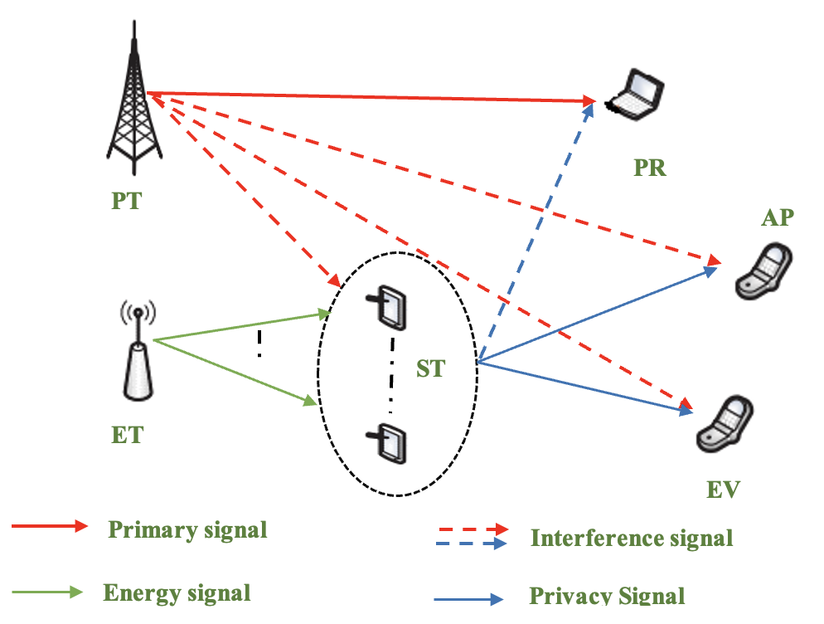
Fig. 1. ZTAM relied cognitive radio network.

Within the network that is being suggested, there is a Primary User (PU) channel as well as a large number of Secondary Users (SUs) with the IDs N = {1, 2,..., N}. The time intervals shown in Figure 1 are those which are responsible for controlling the operation of the system. The steps of sensing, cooperation, and transmission are included in these time periods. The illustration in Figure 1 demonstrates that Secondary Users (SUs) technique throughout the period of time that has been set aside for them to carry out sensing. In the next step, they present their results to a Fusion Center (FC) in accordance with the criteria that have been established beforehand. As shown in Equation 2, the ED method is able to determine whether or not the channel has a PU signal by using two binary hypotheses, which are denoted by the letters H0 and H1:
$Y(t)=\left\{\begin{matrix}W(t), & H_{0} \\ h(t)X(t)+W(t), & H_{1}\end{matrix}\right.$ (2)
In the Community Radio Network which is a localized broadcasting network system that is owned and operated by the community members that servers the interest and needs of a specific area, the probability of detection, which is sometimes referred to as P-di, is used to determine the degree of sensitivity with which PU signals are identified in real-time (CRN). In contrast, the symbol P-f represents the chance of incorrectly detecting a PU signal over a channel when there was really none present. This is a signal that was not actually there. One is able to ascertain the value of P-fit and P-d,i for any SU that is exposed to circularly symmetric complex Gaussian (CSCG) noise by using the formulae that are shown below.
$P_{f,i}=Q\left(\left(\frac{λ_{s}}{σ_{n}^{2}}-1\right)\sqrt{t_{s}f_{s}}\right)$ (3)
$\begin{matrix} \\ { P}_{d,i}=Q\left(\left(\frac{λ_{s}}{σ_{n}^{2}}-γ_{i}-1\right)\sqrt{\frac{t_{s}f_{s}}{2γ_{i}+1}}\right)\end{matrix}$ (4)
This is the case regardless of the subject matter. In order for the SUs to send their individual sensing judgments to the fusion center, they make use of a technology known as time division multiple access (TDMA) (FC). Because it is easy to implement and has a lower degree of processing complexity, the hard fusion rule is used in order to make decision fusion more accessible.
The ZTAM system that we have developed is intended to maximize three crucial aspects by increasing throughput by using the capability of the licensed band. Consider the chosen cooperative SUs in the scheme to be denoted by the symbol 𝔾. Through the utilization of the OR fusion rule, Equations 5 and 6 are utilized to ascertain the cooperative probability of detection, denoted as ℚ−𝑑,𝐺, and the cooperative probability of false alarm, denoted as ℚ−𝑓,𝐺, specific to group 𝐰.
$Q_{d,G}=1-\prod_{i∈G}{ } \left(1-P_{d,i}\right)$ (5)
$\begin{matrix} & \\ & Q_{f,G}=1-\prod_{i∈G}{ } \left(1-P_{f,i}\right)\end{matrix}$ (6)
Here, $P_{H}0$ and $P_{H}1$ represent the probabilities of the $PU$ being absent and present on a given channel, respectively, where $P_{H}0+P_{H}1=1$. The probabilities of PU absence when actually absent $\left(P_{0∣0}\right)$ and when present $\left(P_{0∣1}\right)$ are computed using Eqs. 7 and 8.
$P_{0∣0}=P_{H0}\left(1-Q_{f,G}\right)$ (7)
$\begin{matrix} & \\ & P_{0∣1}=P_{H1}\left(1-Q_{d,G}\right)\end{matrix}$ (8)
$C=P_{0∣0}t_{t}\left(\sum_{j=1}^{G∣}{ } r_{j}\right)/(|G|),j∈G$ (9)
$L$, the average penalty imposed on $SUs$ due to $PU$ communication interruption, is calculated using Eq. 10.
$L=P_{0∣1}t_{t}\left(\sum_{j=1}^{|G|}{ } r_{j}\right)/(|G|),j∈G$ (10)
Energy consumption during ZTAM, which is represented by the symbol 𝐸, is mostly caused by operations involving sensing and coordination.(Eq. 11).
$E=\sum_{i=1}^{|G|}{ }\left(E_{s,i}+E_{c,i}\right),i∈G$ (11)
In order to have an effective ZTAM system, it is essential to optimise the average throughput, the penalty that is imposed, and the energy overhead. Therefore, we define this as a problem that requires optimization of many objectives by using the weighted global criteria technique (WGCM). The importance of striking a balance between these goals cannot be overstated. Throughput should be seen as a cooperative benefit, while penalty fee and energy overhead should be regarded as cooperative expenses from the United States perspective.
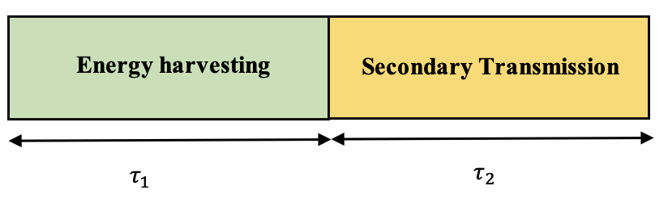
Fig. 2. The policy for distributing time slot.

When it comes to ZTAM, the precise goals that have an impact on the overall objective function are contingent upon the specific criteria that are imposed by the network or application. In order to determine the relevance of each component of the global goal function in relation to the overall aim, we dole out weights to each of the components. A larger weight may be ascribed to penalty charges, for example, if SUs tries to access the PU band when it is serving time-critical applications. This might result in a higher penalty fee. Because of this, the PU is protected against the possibility of suffering enormous losses as a result of even minor interruptions in its connectivity. On the other hand, when SUs is involved in applications that need a significant amount of bandwidth, the throughput component of the function might be given a substantial amount of weight. In environments that are cognizant of energy use, such as cognitive radio sensor networks, where the primary source of power for SUs is batteries, it is necessary to have a considerable weight in order to optimize energy overhead. Therefore, in order to achieve a state of equilibrium between these primary goals, the weighting variables are integrated into the weighted global criteria function, as shown in Equation 12..
$U=w_{c}⋅C-w_{l}⋅L-w_{e}⋅E$ (12)
This is done in order to account for the possibility that these objectives may possess different units of representation. Equation 13 is the representation of the function after these normalized components have been included.
$U=αw_{c}⋅C-βw_{l}⋅L-δw_{e}⋅E$ (13)
This is done in order to account for the possibility that these objectives may possess different units of representation. Equation 14 is the representation of the function after these normalized components have been included.
$U=αw_{c}⋅C-βw_{l}⋅L-δw_{e}⋅E$ (14)
As a consequence of this, the optimization issue for ZTAM is phrased as follows:
$\max_{G} U(G)=αw_{c}⋅C-βw_{l}⋅L-δw_{c}⋅E$ (15)
The criteria for the likelihood of detection and the probability of false alarm should be specified, according to the restrictions that are indicated in Equation 15.

3.2 For ZTAM Relied CRN with for Secure Transmission
The Zero Trust Access Model (ZTAM) implemented within a Cognitive Radio Network (CRN) sets stringent security standards for data transmission. To ensure secure communication, several key equations are fundamental:
Secrecy Rate Calculation:
In a ZTAM-based CRN, the secrecy rate represents the secure communication capacity between nodes. It can be calculated using equations 16 like:
R_"sec " =max(0,R_"trans " -R_"eve " ) (16)
where:
R_"sec " is the secrecy rate, R_"trans " is the transmission rate, R_"eve " is the eavesdropper's received rate absence and existence of PU signal in. a channel, respectively as shown in Figure 2.
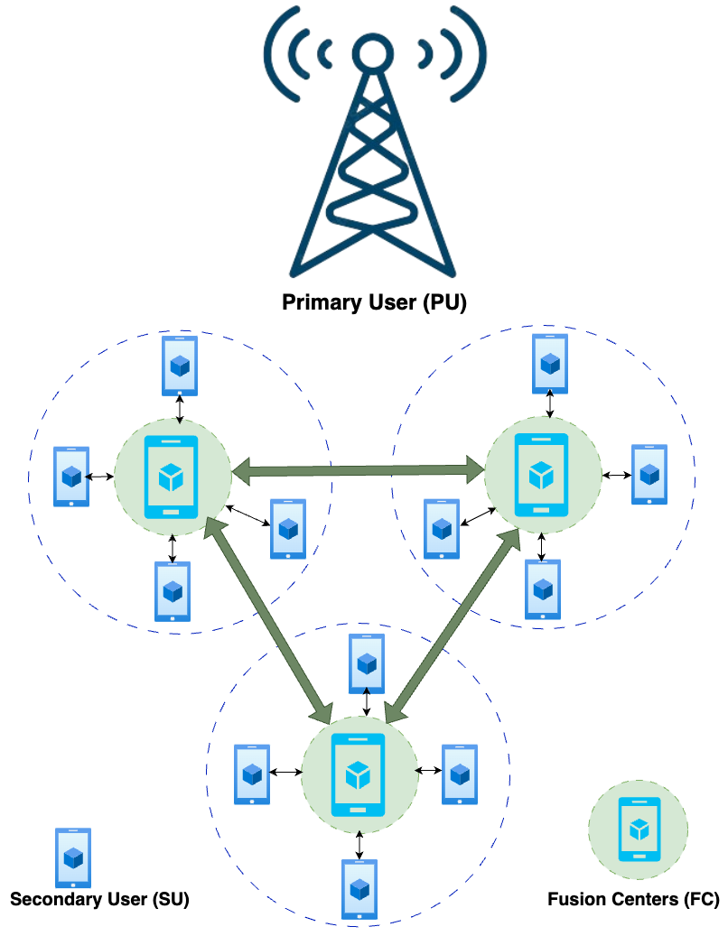
Fig. 3. Network Structure.
Probability of Secrecy Outage: Assessing the probability of secrecy outage involves evaluating the likelihood that an eavesdropper successfully intercepts communication. The equation 17 could be:
Figure 3 illustrate the Zero Trust Access Model (ZTAM) relied cognitive radio network within the network architecture. The figure depicts a Primary User (PU) channel alongside numerous Secondary Users (SUs) identified by IDs N = {1, 2,..., N}. It showcases the time intervals governing the system's operation, including sensing, cooperation, and transmission phases. Secondary Users (SUs) are shown engaging in sensing activities during their designated time slots and subsequently sharing their findings with a Fusion Center (FC) based on predefined criteria. Equation 2 is referenced in the figure to explain how the Energy Detection (ED) method determines the presence of a PU signal using binary hypotheses H0 and H1. This visualization aids in understanding the operational flow and interactions within the cognitive radio network under the ZTAM framework, highlighting key components and processes involved in secure and efficient wireless communication networks.
$P_{\text{outage }}=P\left(R_{\text{eve }}≥R_{\text{trans }}-Δ\right)$ (17)

where: $P_{\text{outage }}$ is the probability of secrecy outage, $Δ$ represents the security margin. Signal-to-Noise Ratio (SNR) for Secure Communication:SNR plays a crucial role in determining the quality of secure communication. The SNR equation could be:
${SNR}_{\text{sec }}=\frac{P_{\text{signal }}}{P_{\text{noise }}}$ (18)

where:
${SNR}_{sec}$ is the representation of Signal-to-Noise Ratio that is needed in the secure communication, $P_{\text{signal }}$ illustrates the signal power, $P_{\text{noise }}$ describes the noise power.
Secrecy Capacity:
The term 'secrecy capacity' refers to the highest possible rate of secure data transmission that can be achieved with reliability. The equation might be:
$C_{\text{sec }}=max\left(0,C_{\text{trans }}-C_{\text{eve }}\right)$ (19)

where:
$C_{sec}$ is us for the description of secrecy capacity, $C_{\text{trans }}$ is used for the transmission capacity, $C_{\text{eve }}$ is used for the eavesdropper's capacity. These mathematical formulas help in assessing protection in a type of wireless network called ZTAM-based CRN. They help us and provide us a solution of how well information is being scattered securely and where there might be problems. With help of these equations, we can adjust settings and improve methods, we can make the network more robust.

3.3 Zero Trust Access Model (ZTAM) using the Red Deer Algorithm
To tackle optimization issues, the Red Deer Algorithm (RDA) is a metaheuristic technique that replicates the behaviours of red deer during their mating season. This allows the algorithm to find optimal solutions. Listed below is a synopsis of its most important actions and behaviours:
The starting point for the method is a population of random solutions that are referred to as Red Deer (RD). The male RDs, which are the finest solutions, and the hinds make up these RDs (other solutions). The male RDs make a roaring sound to demonstrate their might and to attract hinds. Fitness is a primary factor in the selection of successful individuals for the position of commander (solution quality).
There is a competition between commanders and other men, known as stags, and the victor’s become commanders who build harems (groups of hinds). Some commanders who are more physically fit are able to get more hinds to join their harems. For the purpose of expanding their domain, commander mate with hinds from their own harems as well as hinds from other harems.
In spite of the presence of harems, stags are permitted to mate with the hinds who are closest to them. The outcomes of the mating phase are evaluated, and the best solutions are selected for the subsequent generation. There are several selection methods that are used, such as the roulette wheel or tournament selection. The algorithm will continue this procedure until a certain termination condition is satisfied or until a limit number of iterations have been completed.
To avoid reaching a state of local optimality, the RDA strives to strike a balance between exploitation (such as roaring, fighting, and mating) and exploration (such as the establishment of harems). The stages of roaring, fighting, and mating all contribute to the extraction of resources, while the building of harems and mating with random hinds contribute to the exploration of the environment.
Pseudo code of Zero Trust Access Model (ZTAM) using the Red Deer Algorithm
function initialize Population():
// Generate initial population of Red Deer’s
(male RDs and hinds)
// Initialize their characteristics and solutions

function roaringAndSelection():
// Male RDs roar to attract hinds
// Select commanders based on fitness/power of
solutions

function fightingAndHaremFormation():
// Commanders compete with other males (stags)
// Winners become commanders forming harems
// Commanders mate with hinds to extend
territory

function matingPhase():
// Commanders mate with hinds in their harems
and some from other harems
// Stags mate with nearest hinds, regardless of
harems

function evolutionarySelection():
// Select better solutions resulting from the
mating phase
// Use roulette wheel or tournament selection
mechanisms

function mainRDA():
initializePopulation()
while not terminationCondition:
roaringAndSelection()
fightingAndHaremFormation()
matingPhase()
evolutionarySelection()
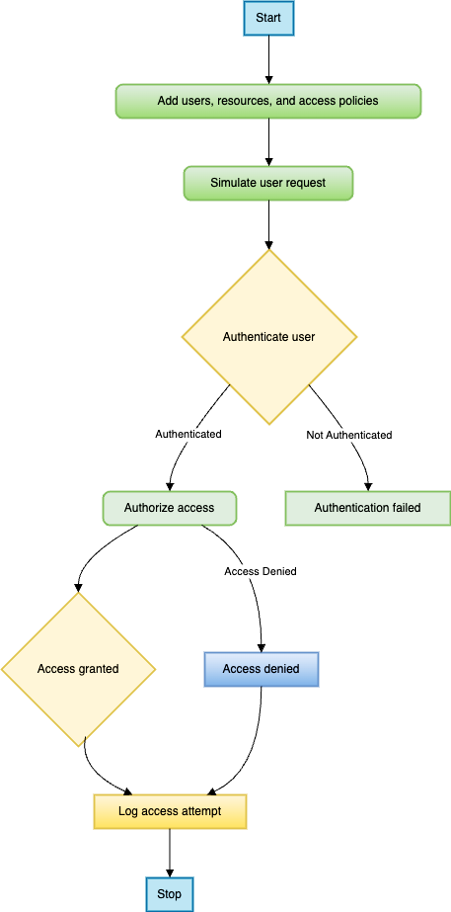
Fig. 4. Flow Chart for Zero Trust Access Model (ZTAM) using the Red Deer Algorithm.
The Zero Trust Access Model (ZTAM) coupled with the Red Deer Algorithm offers an innovative approach to network security and access control as shown in above figure 4.
Trust Score Computation:
The trust score can be computed as a weighted sum of various parameters representing the entity's behavior, such as:
Trust_Score $=w_{1}⋅$ Parameter $_{1}+w_{2}⋅$ Parameter $_{2}+…+w_{n}⋅$ Parameter n (20)
Here, Trust_Score represents the overall trust score, Parameter $_{i}$ signifies specific behavioral parameters, and $w_{i}$ denotes the corresponding weights assigned to these parameters.
Developing a pseudocode for integrating the Zero Trust Access Model (ZTAM) with Cognitive Radio Networks requires a conceptual understanding of both ZTAM principles and the workings of cognitive radio networks. Here's a basic representation of how you might approach the integration conceptually.
Pseudo code of Zero Trust Access Model (ZTAM) using the Red Deer Algorithm in Cognitive Radio Networks
function authenticate User(username, password):
if validate Credentials(username, password) and
checkMFA(username):
return true
else:
return false

function validateCredentials(username, password):
// Check if username and password match stored
credentials
// Replace this with actual authentication logic
(e.g., database lookup)

if storedUsername == username and
storedPassword == hash(password):
return true
else:
return false

function checkMFA(username):
// Check if multi-factor authentication is
successful for the user
// Replace this with MFA verification logic (e.g.,
token validation)

if MFA.verifyToken(username):
return true
else:
return false

function enforceAccessPolicy(username, resource):
if validateUser(username):
if isAuthorized(username, resource):
return "Access Granted: Accessing " + resource
else:
return "Access Denied: Unauthorized for this
resource"
else:
return "Access Denied: Invalid credentials"

function validateUser(username):
// Additional checks for user validity (e.g.,
account status)
// Replace this with user validation logic as per
ZTSM requirements

if userExists(username) and accountActive(username):
return true
else:
return false

function isAuthorized(username, resource):
// Check if the user is authorized to access the
resource
// Replace this with access control logic based on
least privilege

if userHasAccess(username, resource):
return true
else:
return false

// Main function for simulating access attempt

function main():
user = "username"
pass = "password"
requestedResource = "sensitiveData"
result = enforceAccessPolicy(user,requestedResource)
print(result)

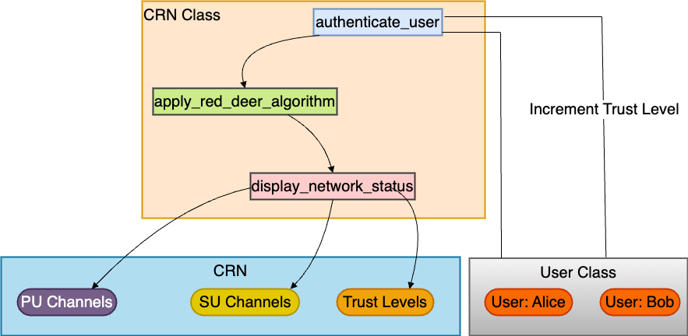
Fig. 5. Flow Chart for Zero Trust Access Model (ZTAM) using the Red Deer Algorithm in Cognitive Radio Networks.
This pseudocode demonstrates basic functions and logic for implementing parts of a Zero Trust Security Model algorithm: Figure 5 above shows the flow chart of the pseudocode.
authenticate User: Validates user credentials and checks multi-factor authentication (MFA).
enforceAccessPolicy: Enforces access policies based on user validation and resource authorization.
validateUser and isAuthorized: Check user validity and authorization for accessing a specific resource.
main: Simulates an access attempt by a user to a requested resource.
This is a very high-level representation, and the actual implementation would involve detailed considerations of ZTAM's security principles, cognitive radio network functionalities, and the integration points between these systems.

Red Deer Algorithm:
The algorithm known as Red Deer works by updating trust scores iteratively, taking into consideration historical behavior and interactions in the network. The trust score at each iteration is updated using a function that incorporates both the trust score at the previous iteration and new observations.

${\text{ Trust_Score }}_{t+1}=f\text{ (Trust_Score }x_{t},\text{ New_Observations)}$ (21)
Here, Trust_Score $_{t+1}$ Updated trust score is used to compute trust based on latest information.

Threshold for Access:
ZTAM usually establishes a limit for trust scores, which determines whether access should be granted or denied based on these limits. This type of decision-making, which relies on thresholds, can be described as threshold based.
$\text{Access Decision }=\left\{\begin{matrix}\text{ Allow } & \text{ if Trust_Score }≥\text{ Threshold } \\ \text{ Deny } & \text{ if Trust_Score }<\text{ Threshold }\end{matrix}\right.$ (22)
In “Access Decision" refers to the determination of whether or not access is permitted, given that the calculated trust score is compared to the threshold that has been established beforehand.
Considering that the Red Deer Algorithm is iterative in nature, it is possible to make dynamic adjustments to trust ratings. ZTAM is able to continually reevaluate and fine-tune access credentials since the algorithm adjusts trust levels in accordance with the changing behaviors.

Result and Discussion
In order to investigate and assess the efficacy of the suggested distributed cooperative spectrum sensing strategy that is founded on greedy coalitional games, we conduct an experiment that is based on MATLAB. This serves the purpose of studying and evaluating the effectiveness of the approach. Comparative analysis is performed between the outcomes of the simulation and those of the standard non-cooperative sensing approach as well as the exhaustive search method that serves as a benchmark. The reason for this is because there is no solution that currently exists that takes into consideration the trade-off between all three components of collaborating sensing, which are throughput benefit, penalty incurred, and energy overhead. Every single SU is accountable for its own sensing within the scope of the standard non-cooperative (NC) sensing approach. This means that no other SUs is involved in the coordination process. Equation 4.15 a gives a description of the goal function, and the exhaustive search (ES) approach is used to discover which subset of SUs is the most appropriate for cooperation. This is accomplished by exhaustively listing all of the available subsets. The results of the simulation are shown in Table 2, which includes the values of the various parameters that were used throughout the whole procedure.

Table 2: Simulation Parameters and Their Values
Parameters | Values
T | 100 s
t_{s} | 2 s
t_{c} | 0.1 s
Qd | 0.8
Qf | 0.3
dˆ | 500 meters
γ | ranges in -18dB to -25dB with a variance of 0.5
PH,0 | 0.5
es | 500 nJ
ec | 10 nJ

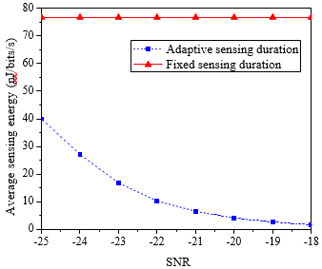
Fig. 6. In comparison to the signal-to-noise ratio, the average sensing energy overhead rate.
Figure 6 indicates that the adaptive sensing duration-based sensing technique. When the signal-to-noise ratio (SNR) of SUs is high, it is possible that a fixed sensing duration scheme will result in the loss of both energy and time. More specifically, it demonstrates that the sensing energy overhead decreases by as much as 24 times when the signal-to-noise ratio (SNR) is at a level of -18 dB as opposed to a level of -25 db.
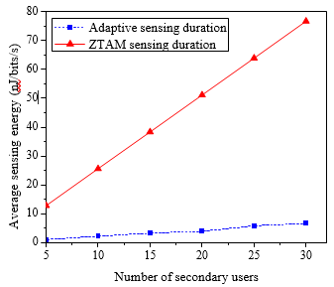
Fig. 7. When compared to the total number of secondary users, the average sensing energy overhead.
As shown in Figure 7, the average sensing energy overhead increases as the number of SUs increases. This is true for both the fixed sensing time scheme and the adaptive sensing time scheme. When opposed to a fixed sensing duration-based scheme, which displays linear growth, an adaptive sensing duration-based system has a growth rate that is much slower. One explanation for this is because, given a certain sensing period, the cumulative sensing time may be calculated simply adding the sensing times in a linear way. This is the reason why this is the case. Adaptive sensing duration, on the other hand, is contingent upon the SUs as well as the levels of received SNR in relation to the overall amount of time spent collecting data.
Consequently, when a cooperative user count of thirty is taken into consideration, the energy consumption of the technique based on fixed duration is about eleven times greater than that of the approach based on adaptive sensing.

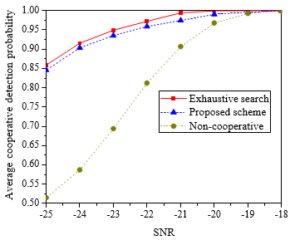
Fig. 8. Calculating the average cooperative detection probability in relation to the signal-to-noise ratio.

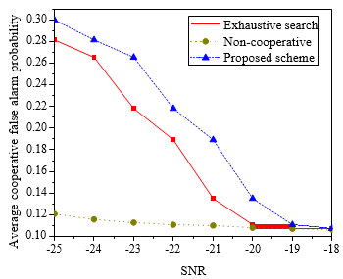
Fig. 9. A comparison of the average false alarm probability for cooperative alarms and the signal-to-noise ratio.
Based on the data shown in Figure 8, it can be seen that the proposed and exhaustive search (ES) systems have a higher average cooperative false alarm probability when compared to the non-cooperative (NC) system. This is due to the fact that the cooperative false alarm probability may be enhanced when many SUs work together. This, in turn, increases the potential that certain SUs would incorrectly detect the existence of PU in the licensed channel when, in reality, PU is not there. The lack of communication inside the NC system ensures that the average chance of false alarms remains consistently low. Increasing the signal-to-noise ratio (SNR) level results in a drop in the average false alarm likelihood for all systems. Increasing the signal-to-noise ratio (SNR) results in an increase in the strength of the PU signal, which in turn reduces the risk of an inaccurate detection being made (assuming the sensing threshold stays constant) as shown in figure 9.
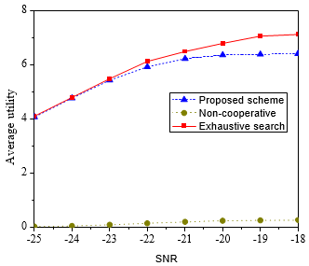
Fig. 10. When compared to the signal-to-noise ratio, the average utility.
The results shown in Figure 10 demonstrate that the proposed system obtains an average utility that is about 39 times higher than that of the NC scheme. A comparison of the proposed system to the NC scheme reveals that the combined efforts of SUs are responsible for the enhanced average utility of the proposed system. This new technique achieves 96 percent of the average utility, which is a significant improvement above the ES scheme's performance. This occurs due to the fact that the ES scheme selects SUs for group formation in the most optimal manner feasible in order to obtain the highest potential level of utility. Alternatively, the approach that has been proposed makes use of a coalition game that is founded on greed in order to build groups, which results in utility that is less than optimal.
It is clear from looking at Figure 11, which depicts the relationship between execution time and the number of SUs, that the amount of time required to carry out the proposed scheme and the ES scheme rises as the number of SUs increases. However, the ES technique exceeds the indicated approach in terms of growth rate, with an exponential increase from 10 to 40 SUs. This strategy is superior to the suggested approach. Because the ES technique computes all possible subsets of SUs, it is able to find the ideal coalition structure during an exhaustive search. This is the reason why this occurred.
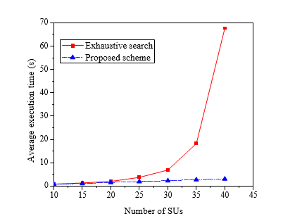
Fig. 11. Typical execution time in comparison to the total number of secondary users

Conclusion
To sum up, the incorporation of the Zero Trust Access Model (ZTAM) into Cognitive Radio Networks (CRNs) is a promising avenue to strengthen security measures. This study's evaluation and refinement of ZTAM within CRNs, utilizing the Red Deer Algorithm (RDA), highlights the possibility of improving both security and network performance. Through analysis, this research has confirmed the success of ZTAM in reinforcing CRN security by sensibly examining network transactions. The use of the Red Deer Algorithm to refine the ZTAM framework has demonstrated the potential for improving CRN functionality, stressing increased efficiency and flexibility against security vulnerabilities.
This research examines into the development of Cognitive Radio Networks (CRNs) applying the Zero Trust Access Model (ZTAM) and the Red Deer Algorithm. The main focus of this implementation is to enrich CRN implementation by measuring and improving the impression of ZTAM, with an importance on network efficiency and security. The Red Deer Algorithm is deployed within the ZTAM framework to improve CRN functionality by fine-tuning system parameters. Throughput and energy efficiency functions are evaluated to improve both parallel, with the goal of creating a protected and operational CRN environment. By combining the Red Deer Algorithm with ZTAM, the research intentions to achieve a balance between network efficiency and robust security measures. It highlights the necessity of adapting CRNs and ZTAM to changing acquaintances and environments to ensure a secure and functional network. This article points to integrate latest technology with fundamental security principles to advance wireless communication networks robustly.
In future this research can show how ZTAM can enlarge within more complex and wide CRN systems. By evaluating its efficiency and robustnuss in vast networks that encompass a variety of communication scenarios, we can gain a deeper understanding of its enlargement and implementation. Overall, upcoming efforts should focus on enhancing ZTAM's integration within CRNs, enhancing the Red Deer Algorithm's proficiencies for CRN-specific parameters, and investigating the model's adaptableness and scalability in diverse network settings. This research path on CRNs, ensuring their resilience to evolving security threats and heightened network performance.

References
- A. M. Wyglinski, M. Nekovee, and Y. T. Hou, "Cognitive Radio Communications and Networks: Principles and Practice," Academic Press, 2009. [ISBN: 9780123747150]
- T. Yucek and H. Arslan, "A Survey of Spectrum Sensing Algorithms for Cognitive Radio Applications," IEEE Communications Surveys & Tutorials, vol. 11, no. 1, pp. 116-130, 2009. [DOI: 10.1109/SURV.2009.090109]
- S. Haykin, "Cognitive Radio: Brain-Empowered Wireless Communications," IEEE Journal on Selected Areas in Communications, vol. 23, no. 2, pp. 201-220, 2005. [DOI: 10.1109/JSAC.2004.839380]
- I. F. Akyildiz, W.-Y. Lee, M. C. Vuran, and S. Mohanty, "NeXt Generation/Dynamic Spectrum Access/Cognitive Radio Wireless Networks: A Survey," Computer Networks, vol. 50, no. 13, pp. 2127-2159, 2006. [DOI: 10.1016/j.comnet.2006.05.001]
- R. Zhang and Y.-C. Liang, "Exploiting Multi-User Diversity for Opportunistic Spectrum Access," IEEE Transactions on Wireless Communications, vol. 6, no. 12, pp. 4504-4513, 2007. [DOI: 10.1109/TWC.2007.05917]
- Y.-C. Liang, Y. Zeng, E. C. Y. Peh, and A. T. Hoang, "Sensing-Throughput Tradeoff for Cognitive Radio Networks," IEEE Transactions on Wireless Communications, vol. 7, no. 4, pp. 1326-1337, 2008. [DOI: 10.1109/TWC.2008.060869]
- Q. Zhao and B. M. Sadler, "A Survey of Dynamic Spectrum Access," IEEE Signal Processing Magazine, vol. 24, no. 3, pp. 79-89, 2007. [DOI: 10.1109/MSP.2007.360113]
- H. Kim, B. Krishnamachari, and V. V. Veeravalli, "A Low-Complexity Distributed Method for Spectrum Sensing in Cognitive Radios," IEEE Transactions on Signal Processing, vol. 56, no. 8, pp. 3439-3452, 2008.
[DOI: 10.1109/TSP.2008.920237]
- J. Mitola III, "Cognitive Radio Architecture Evolution," IEEE Personal Communications, vol. 6, no. 4, pp. 13-26, 1999. [DOI: 10.1109/98.788210]
- K. Challapali, S. Mangold, and S. Shankar, "Spectrum Sensing for Cognitive Radio," IEEE Communications Magazine, vol. 46, no. 4, pp. 32-39, 2008.
[DOI: 10.1109/MCOM.2008.4481337]
- Cambou, B., Philabaum, C., Hoffstein, J., & Herlihy, M. (2023). Methods to Encrypt and Authenticate Digital Files in Distributed Networks and Zero-Trust Environments. Axioms, 12(6), 531.
- Feng, Y., Zhong, Z., Sun, X., Wang, L., Lu, Y., & Zhu, Y. (2023). Blockchain enabled zero trust based authentication scheme for railway communication networks. Journal of Cloud Computing, 12(1), 1-21.
- Wang, F., Li, G., Wang, Y., Rafique, W., Khosravi, M. R., Liu, G., ... & Qi, L. (2023). Privacy-aware traffic flow prediction based on multi-party sensor data with zero trust in smart city. ACM Transactions on Internet Technology, 23(3), 1-19.
- Federici, F., Martintoni, D., & Senni, V. (2023). A Zero-Trust Architecture for Remote Access in Industrial IoT Infrastructures. Electronics, 12(3), 566.
- Ahmed, A., Shoufan, A., & Belwafi, K. (2023). Formal Verification of Light-Weight Security Protocol and Data Model for Chip-to-Chip Zero Trust. IEEE Access.
- Jain, A., Gupta, N., & Sreenu, M. (2023). Blockchain based smart contract for cooperative spectrum sensing in cognitive radio networks for sustainable beyond 5G wireless communication. Green Technologies and Sustainability, 1(2), 100019.
- Gayathri, N., Anandakumar, H., Gowri, S., Keerthika, J., & Nithyapriya, S. (2023, March). An analysis of Network Security Attacks and their mitigation for Cognitive Radio Communication. In 2023 9th International Conference on Advanced Computing and Communication Systems (ICACCS) (Vol. 1, pp. 2413-2417). IEEE.
- Luo, S., Lai, Y., & Liu, J. (2023). Selective forwarding attack detection and network recovery mechanism based on cloud-edge cooperation in software-defined wireless sensor network. Computers & Security, 126, 103083.
- Zhang, T. (2023). Collaborative Cognitive Wireless Network Optimization Model and Network Parameter Optimization Algorithm. Journal of Electrical and Computer Engineering, 2023.
- Jabeen, T., Jabeen, I., Ashraf, H., Ullah, A., Jhanjhi, N. Z., Ghoniem, R. M., & Ray, S. K. (2023). “Smart Wireless Sensor Technology for Healthcare Monitoring System using Cognitive Radio Networks,” Sensors 23, no. 13: 6104. https://doi.org/10.3390/s23136104.
- Ramezanpour, K., & Jagannath, J. (2022). Intelligent zero trust architecture for 5G/6G networks: Principles, challenges, and the role of machine learning in the context of O-RAN. Computer Networks, 217, 109358.
- He, Y., Yu, F. R., Wei, Z., & Leung, V. (2019). Trust management for secure cognitive radio vehicular ad hoc networks. Ad Hoc Networks, 86, 154-165.
- Li, S., Iqbal, M., & Saxena, N. (2022). Future industry internet of things with zero-trust security. Information Systems Frontiers, 1-14.
- Tangsen, H., Li, X., & Ying, X. (2020). A blockchain-based node selection algorithm in cognitive wireless networks. IEEE Access, 8, 207156-207166.
- Khan, A. (2022). Using virtualized multimedia tools for video conferencing solution integrated in teaching and learning environment. Journal of Discrete Mathematical Sciences and Cryptography, 25(3), 801–815.
https://doi.org/10.1080/09720529.2021.2014137.
- Alagappan, A., Venkatachary, S. K., & Andrews, L. J. B. (2022). Augmenting Zero Trust Network Architecture to enhance security in virtual power plants. Energy Reports, 8, 1309-1320.
- Dhar, S., & Bose, I. (2021). Securing IoT devices using zero trust and blockchain. Journal of Organizational Computing and Electronic Commerce, 31(1), 18-34.
- Saleem, M. A., Zhou, S., Sharif, A., Saba, T., Zia, M. A., Javed, A., ... & Mittal, M. (2019). Expansion of cluster head stability using fuzzy in cognitive radio CR-VANET. IEEE Access, 7, 173185-173195.
- Khan, A. R., & Author_Id, N. (2022). Secure PAAS environment over hybrid cloud using load-balanced Docker containers. International Journal of Advanced and Applied Sciences, 9(3), 133–141.
https://doi.org/10.21833/ijaas.2022.03.015.
- Yadav, K., Roy, S. D., & Kundu, S. (2020). Defense against spectrum sensing data falsification attacker in cognitive radio networks. Wireless Personal Communications, 112, 849-862.
- Salahdine, F., & Kaabouch, N. (2020). Security threats, detection, and countermeasures for physical layer in cognitive radio networks: A survey. Physical Communication, 39, 101001

