Numerical way out through finite volume method for Navier-Stokes type blood flow inside stenosed curved arteries
Shahah Almutairi ¹
¹ Department of Mathematics, College of Sciences, Northern Border University, Arar, Saudi Arabia
Abstract
This article explores the intricate fluid dynamics within stenosed curved arteries, focusing on Newtonian or viscous fluids' incompressible, two-dimensional, and time-independent flow. The modeled Navier-Stokes equations in curvilinear coordinates are solved numerically through the finite volume method by using open foam, and exact solutions are also computed after using the assumptions of mild stenosis. The flow inside a stenosed curved artery having computational results through FVM is the main achievement of the present work. We have included 2D and 3D graphics depicting pressure gradient, velocity distribution, and shear stress for physical visualization. This helps provide a clear understanding of the physical circumstances exhibited in the analysis. This work contributes significantly to biomechanics by unraveling the intricacies of fluid flow in stenosed curved arteries. The combination of numerical simulations, exact solutions, and visual representations enhances our understanding of the underlying physical phenomena, paving the way for further advancements in cardiovascular research and clinical applications. These visual representations serve as crucial tools for physical visualization, enhancing the interpretability of the complex flow patterns observed in the analysis.
Keywords:
Curved artery, symmetric stenosis, Blood flow phenomenon, non-symmetric stenosis.

Submitted:
5-MAR-24

Accepted:
31-MAR-24

Published:

DOI:

Distributed under
Creative Commons CC-BY 4.0

OPEN ACCESS

Introduction
Many scholars in the recent past have extensively investigated the blood flow mechanism inside small-scale stenosed arteries. When a thin layer of lipids (wax, fats, and oils) builds up inside an artery, it causes stenosis. As a result, the sick artery's hemodynamic activity becomes aberrant, the channel narrows and restricts flow, or, worst case, a stenosis completely blocks an artery. Typically, the flow in an artery of this type ceases to be laminar and exhibits both turbulent and unsteady flow characteristics. Quantification and stenosis detection are prerequisites for surgical operation [1]. A comparison of Newtonian and non-Newtonian blood models was presented by Pontrelli [2].
A numerical study is always the way to go when dealing with blood flow problems where stenosed walls complicate the geometric model and turbulent and erratic flow are anticipated. Mandal [3] has quantitatively studied the erratic blood flow within a stenosed artery. Our study of such blood flow issues is constrained to a steady and laminar flow approach if we adopt an exact or perturbation solution technique. A few studies that explain the consistent and laminar blood flow within an ill artery are [4-6]. Among the fascinating blood flow mechanisms found inside numerous stenosed arteries is one of the current studies.
A numerical investigation into the hemodynamic mechanism of several stenosed arteries was conducted by Varshney et al. [7]. A generalized mathematical model explaining the multiple stenosis in a cylindrical tube was presented by Changdar et al. [8]. Furthermore, the notion of multiple stenosis and other recent developments in arterial blood flow issues are given [9–11]. This analysis is not restricted to straight channel flow issues; blood flow inside curved, stenosed arteries must also be interpreted due to the artery's curvature. However, there aren't many studies available in this area [12–14].
The body of research that is now available indicates that no single study research describes the hemodynamic process of a curved artery with numerous stenosis. Here, we describe a mathematical analysis that interprets the blood flow within a curved artery with numerous stenosis. For such arterial blood flow problems, a comparison between the precise and numerical solutions approaches is also given. The blood flow issue of curved arteries with numerous stenosis was first addressed using the exact solution strategy. Next, a numerical solution approach is also considered to determine the benefits of a numerical approach for such intricate geometrical structures. With such arterial flow problems, the numerical solution method turns out to be a more beneficial approach. Using a numerical method instead of an exact solution approach makes choosing the ideal stenosis locations easier. In this curved artery with numerous stenosis, the numerical technique provides the 2D slice view of flow, 3D flow profile, and pressure distribution at different times.
The exact solution section contains the velocity, pressure gradient, and wall shear stress results. Using the open-source OPENFOAM program, the numerical results are assessed using the finite volume method; moreover, by considering two different kinds of stenosis shapes—symmetric and non-symmetric shapes—the current study is made more engaging for the readers. Some useful studies in these directions are presented in the Refs. [15-19]
In the studies mentioned above, the usual or straightforward geometries are considered; however, in certain situations, the geometries are very complex, and the solutions for those complex geometries are not very straightforward [20-26]. Some of the more recent studies on numerical solutions are highlighted in these references [27-29]. Other related studies are reported in [30-48]. The novel intention of this investigation is to scrutinize the blood flow patterns inside a curved, complicated, stenosed artery. We have computed both exact and Numerical solutions.
The main theme of the present work is to highlight the curved stenosed artery and its computational solutions, which are not available in literature according to the author's knowledge. The numerical solutions are computed with the help of the finite volume method through Open Foam software. The solutions are convergent and impressive. Cardiovascular diseases remain a significant global health concern, with arterial stenosis being a common precursor to various complications. Understanding the hemodynamic intricacies of blood flow within stenosed curved arteries is paramount for advancing theoretical knowledge and clinical applications.
This study focuses on providing a numerical solution using the finite volume method (FVM) for simulating the Navier-Stokes type blood flow inside these complex arterial geometries. By delving into the numerical intricacies of this physiological phenomenon, we aim to unravel insights that contribute to the comprehension of arterial health and disease progression. The novelty of this research lies in the meticulous application of the finite volume method to model the Navier-Stokes equations governing blood flow within stenosed curved arteries. While numerical simulations have become integral in cardiovascular research, the specific focus on curved arteries with stenosis adds a distinctive dimension to the study. The curvature of arteries, combined with the presence of stenosis, introduces unique fluid dynamics that necessitate specialized numerical approaches.

Mathematical Formulation
The flow diagram for the proposed curved stenosed artery is sketched below. This variable or parameter is represented by the tilde symbol (~) above the letter "K." Tilde notation is often used to denote dimensionless quantities or normalized variables. This is another variable, possibly related to length or a characteristic dimension. The subscript "l" might suggest a length scale. Like K, this is likely a dimensionless variable or parameter denoted by the tilde symbol (~) above the letter "N." This represents another variable or function denoted by the tilde symbol (~) above the letter "Ʀ." It might depend on N based on its expression's presence of (−1+N).
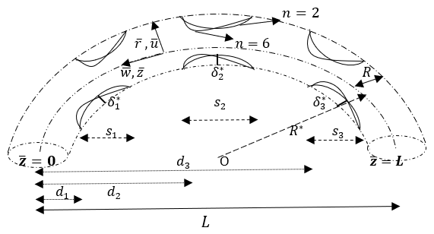
Fig. (1) Flow diagram
The equation represents a mathematical relationship involving dimensionless parameters (K and N), a length scale (Sl), and a function or variable Ʀ~. The specific meaning and interpretation of the equation would depend on the context of the problem or field in which it is applied. Let us consider a curved artery having radius r and is along the z-axis, and L exhibits the length of the curved artery. The artery has stenosed at various lengths on both the upper and lower walls of the artery. We have also sketched the mesh diagrams for the artery, as shown in Figs 2a and 2b, through open foam.
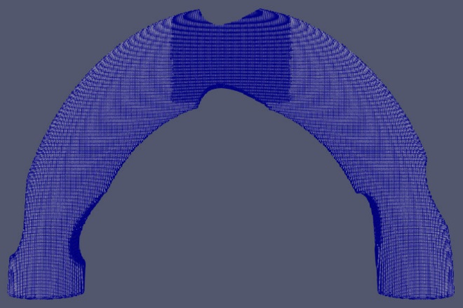

Fig. 2a: Mesh in the case of non-symmetric stenosis

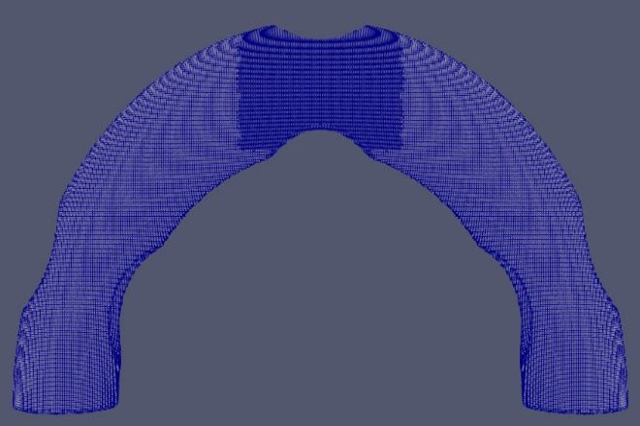

Fig. 2b: Mesh in the case of symmetric stenosis.
Mathematically, the dimensionless form of multifarious stenosis is illustrated by considering the curved artery. [10-11]
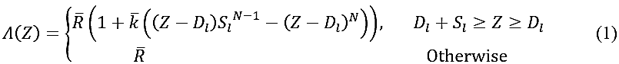
In Eq. (1), R ̅ represents the non-stenotic radius, stenosis length is described by S_l, N is the multiple stenosis shape parameter, and D_l exhibits the stenosis location.
In Eq. (1), the expressions of k ̅ are depicted in the following manner.
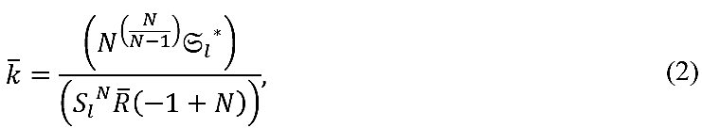
In Eq. (2), ${S_{l}}^{*}$is the maximum height of stenosis.
Following are the appropriate equations that govern the ongoing problem [10-11]
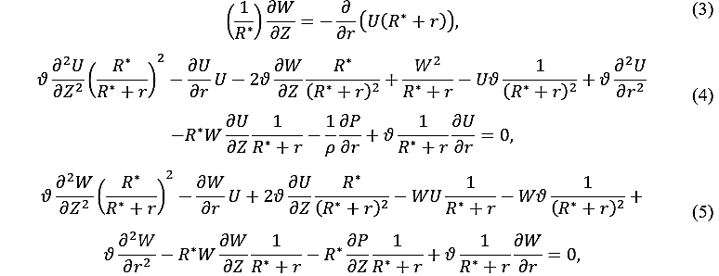

In above equations, W and U are the axial and radial components of the velocity in the cylindrical coordinates (r,Z), ϑ is the kinematic viscosity, pressure is P, and density is represented by ρ.

Now, define the following set of relevant dimensionless ansatz
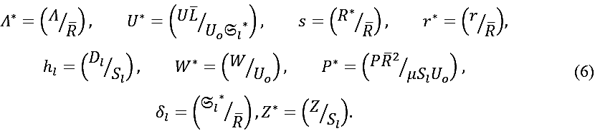

In above equations, we take the following suppositions by considering the situation of mild stenosis [4-6]
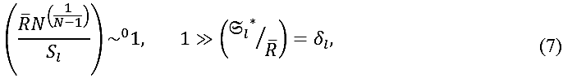

We acquire the following equations in dimensionless pattern after the accomplishment of Eqs. (6-7) into Eqs. (3-5).
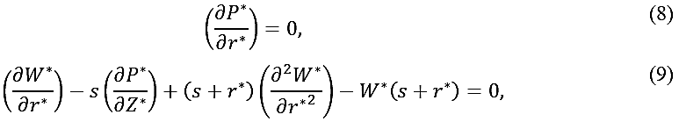

The conditions at the boundary in their dimensionless structure have the following expressions:
Eq. (1) can be written in the following dimensionless pattern:

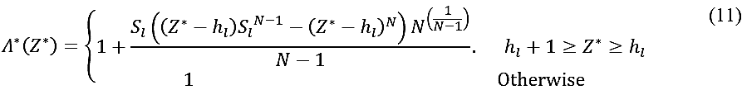

Main Results
The outcomes of Eq. (9) in context to Eq. (10) is manifested in the following Eq. (12) which displays the result of the velocity field. Efficient software Mathematica is employed to acquire the desirable results. The velocity field is described by the following precise result:
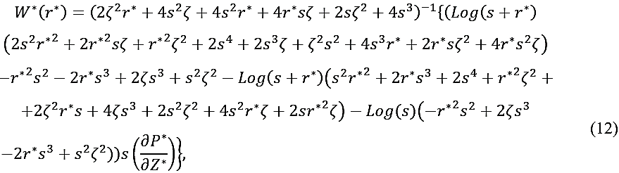

The considered artery, which experiences multivariate stenosis has the following rate of the flow,

By choosing $Ω=\left(1/{{\left(2+F\right)}^{-1}}\right)$ in above equation, we acquire the pressure gradient outcomes which can be define in the following way:
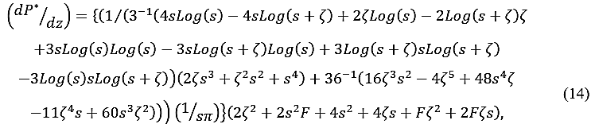

The following expressions indicates the wall shear stress as follows:
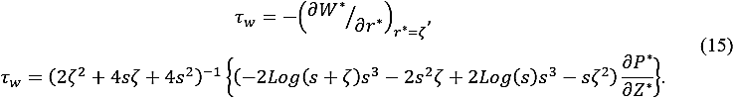

Numerical outcomes with finite volume technique
The ongoing flow problem is numerically tackled through the application of Open-FOAM, a toolbox commonly employed in computational fluid dynamics (CFD). The mechanism behind Open-FOAM is reliant on finite-volume methodology. In this approach, the discrete control volumes are produced with the help of complete domain. After that, on these control volumes with little sizes, the numerical calculations of differential equations are conducted. We have utilized the Open-Foam software to explore the turbulent mechanism in a well-known blood flow. To scrutinize the turbulent flow with incompressibility condition for the current analysis, the Open FOAM with its SIMPLE version is operated.

Results and discussion
The numerical and precise findings of the ongoing analysis through graphics are manifested in this section. In graphical illustrations, the selection of N ̃=6 is taken to indicate the stenosis non-symmetric form, while N ̃=2 is utilized to point out the stenosis symmetric pattern. Through the applications of OPENFOAM and Mathematica, exact and numerical outcomes in context to wall sear stress, velocity, and pressure gradient are conducted. Therefore, the outcomes of the flow phenomenon are related to numerical simulations and line graphs. The outcomes of the pressure division featuring non-symmetric formation of stenosis are indicated in Figs. 3(a-d). Figs. 3(b-d) demonstrate that in relation to higher time intervals, the pressure starts to share out throughout the configuration while at the earliest stage of time in Fig. 3a, the circulation of pressure is observed in the neighborhood of the inlet. By employing various time periods and in context of symmetric stenosis form, the distribution of pressure in the considered geometry is disclosed in Figs. 4(a-d). The results of these graphics are same as in the case of non-symmetric stenosis. By considering distinct periods of time t=1, t=2, t=3, and t=4, the 2D velocity field in context of symmetric form of stenosis is depicted in Figs. 5(a-d) respectively.
The flow phenomenon demonstrated by these graphics depicts the turbulent mechanism with the existence of stenosis inside the considered configuration. The phenomenon in Fig. 5a shows that the outlet that is positioned artery’s left side exhibits the lower mechanism of flow. On the other hand, the flow phenomenon is exceeded towards the inlet that is situated artery’s right side. Now, in context of stenosis non-symmetric framework, the turbulent flow field in 2D in correspondence of various time intervals is divulged in Figs. 6(a-d). Likewise, pressure division, at higher rate of time, the flow field with its greater amplitude completely spread inside the medium.
On the other hand, near the inlet, the flow distribution with lower time period leads to an accelerating phenomenon. The flow profile with its 3D simulation in relation to non-symmetric case is revealed in Figs. 7(a-d). At different time intervals, the purpose of structuring Figs. 8(a-d) is to scrutinize the 3D visualization of the flow mechanism. These graphics indicate the phenomenon that with the passage of time, the flow is circulating through the configuration.
Moreover, at the inlet surface, the movement of flow is incredibly high. A deteriorating mechanism in the wall shear stress is identified relative to amplification of s, as disclosed in Fig. 9a. The nature of wall shear stress in context to F parameter and corresponding to both concerned cases is manifested in Fig. 9b. This graphic portrays the augmenting nature of flow field. With the consideration of both desirable pattern of stenosis, the curve of wall shear stress influenced by parameter δ_l is discussed in Fig. 9c.
The acceleration of δ_l parameter leads to an exaggeration in the wall shear stress by taking both stenosis cases. In accordance with both considered stenosis patterns, Fig. 10a elucidates the consequence of escalating δ_l parameter on the curve of velocity. An inclination in the velocity distribution is indicated. The reason behind this occurrence of phenomenon is that the artery becomes slenderer due to the heighted stenosis, as the stenosis height is characterized by δ_l. Consequently, an intensification is identified in the flow field. The intension behind presenting Fig. 10b is to scrutinize the velocity field characteristics in context of non-symmetric case and symmetric case corresponding to the greater magnitude of F parameter. In relation to both cases, there exists an augmentation in the velocity curve.

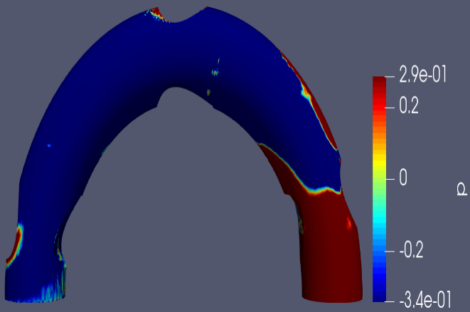  Fig. 3a: At $t=1,$ pressure distribution in context of non-symmetric form. | 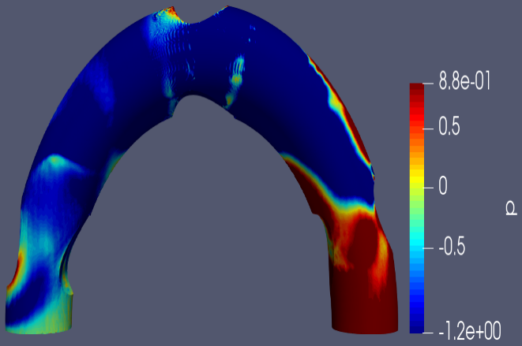  Fig. 3b: At $t=2,$ pressure distribution in context of non-symmetric form.
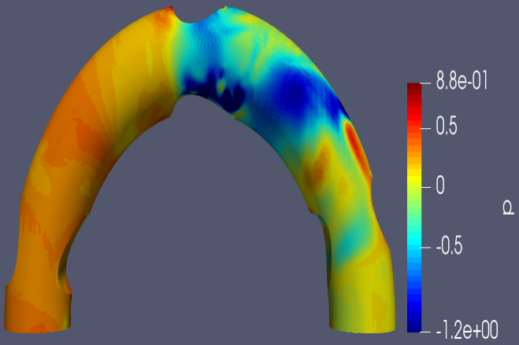  Fig. 3c: At $t=3,$ pressure distribution in context of non-symmetric form. | 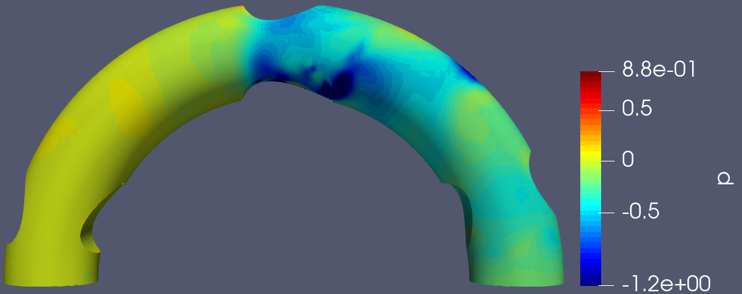  Fig. 3d: At $t=4,$ pressure distribution in context of non-symmetric form.
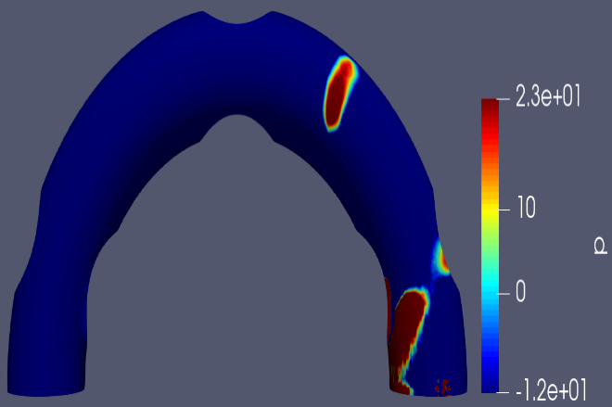  Fig. 4a: At $t=1,$ pressure distribution in context of symmetric form. | 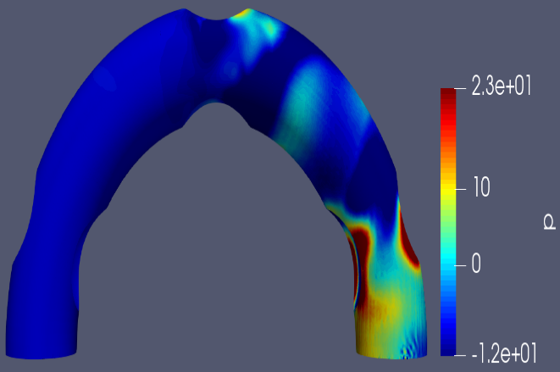  Fig. 4b: At $t=2,$ pressure distribution in context of symmetric form.
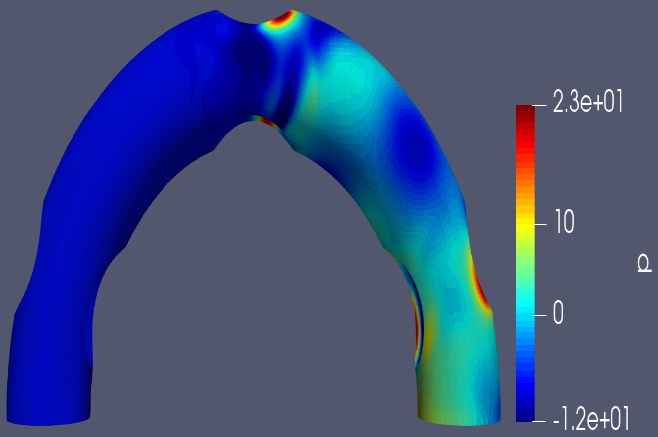  Fig. 4c: At $t=3,$ pressure distribution in context of symmetric form. | 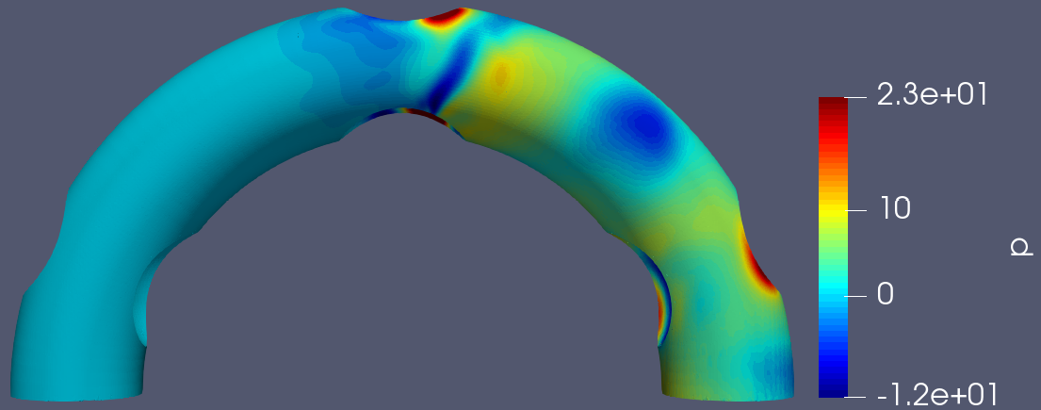  Fig. 4d: At $t=4,$ pressure distribution in context of symmetric form.
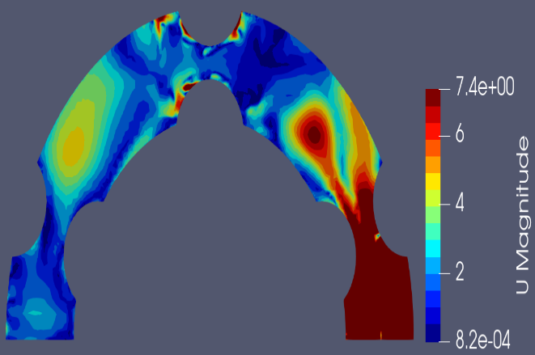  Fig. 5a: At $t=1,$ 2D velocity curve in context of symmetric form. | 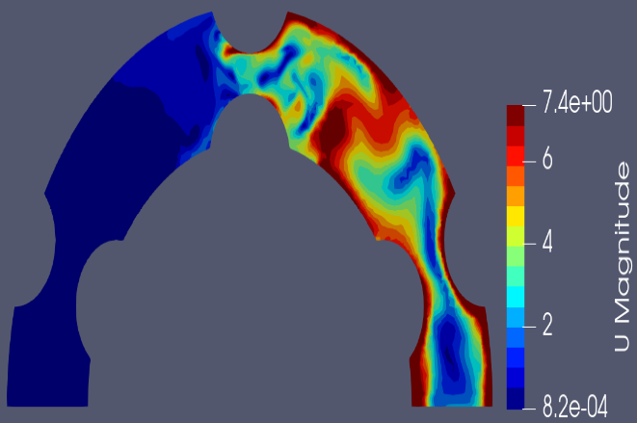  Fig. 5b: At $t=2,$ 2D velocity curve in context of symmetric form.
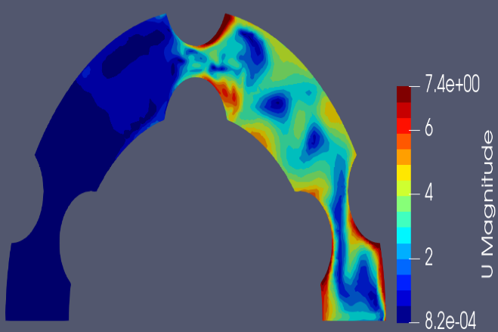  Fig. 5c: At $t=3,$ 2D velocity curve in context of symmetric form. | 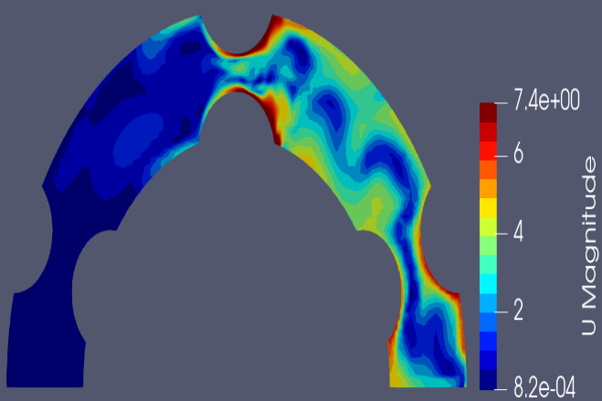  Fig. 5d: At $t=4,$ 2D velocity curve in context of symmetric form.
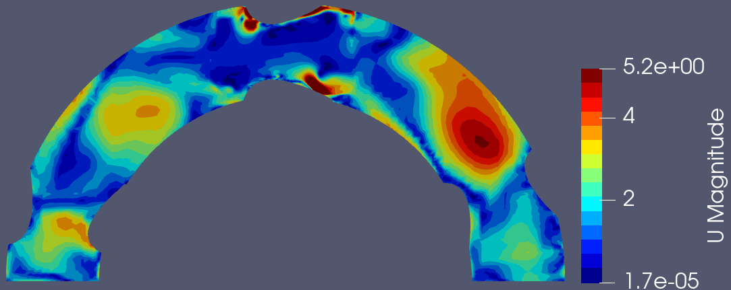  Fig. 6a: At $t=1,$ 2D velocity curve in context of non-symmetric form. | 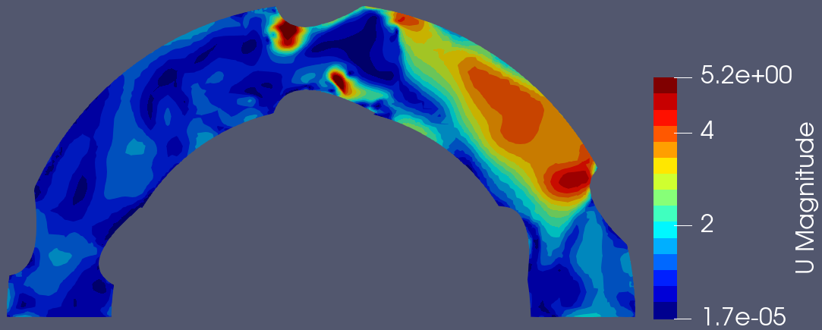  Fig. 6b: At $t=2,$ 2D velocity curve in the context of the non-symmetric form.
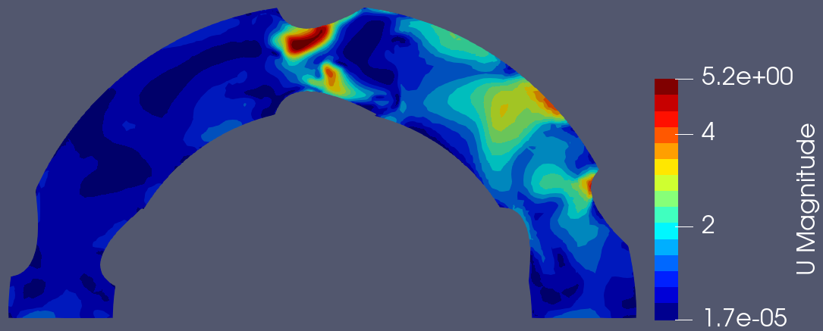  Fig. 6c: At $t=3,$ 2D velocity curve in the context of the non-symmetric form. | 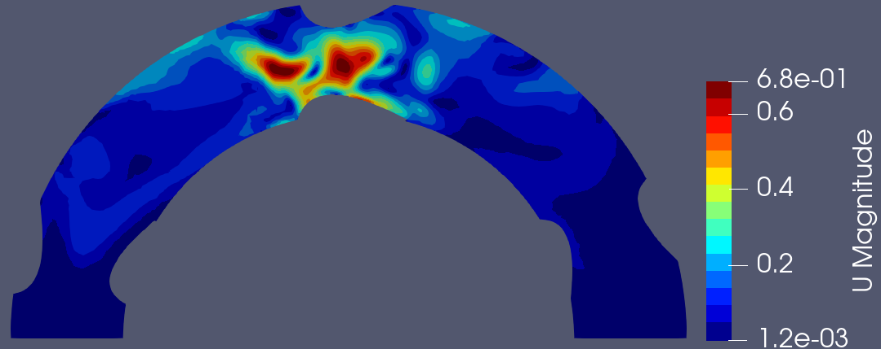  Fig. 6d: At $t=4,$ 2D velocity curve in the context of the non-symmetric form.
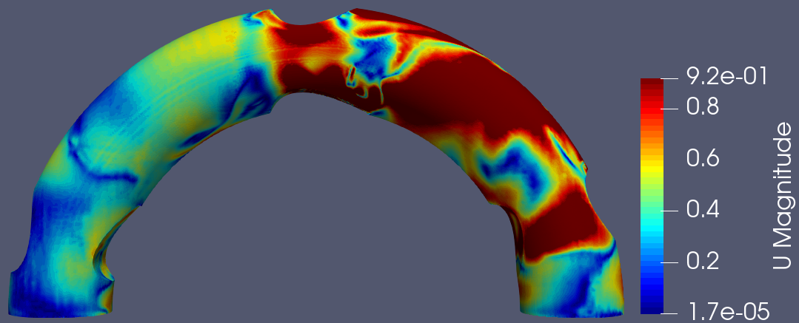  Fig. 7a: At $t=1$, 3D velocity curve in the context of the non-symmetric form. | 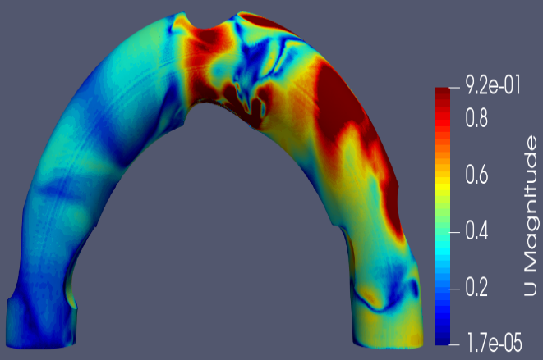  Fig. 7b: At $t=2,$ 3D velocity curve in context of non-symmetric form.
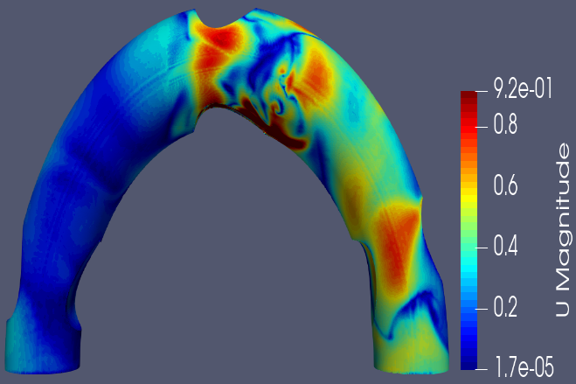  Fig. 7c: At $t=3,$ 3D velocity curve in context of non-symmetric form. | 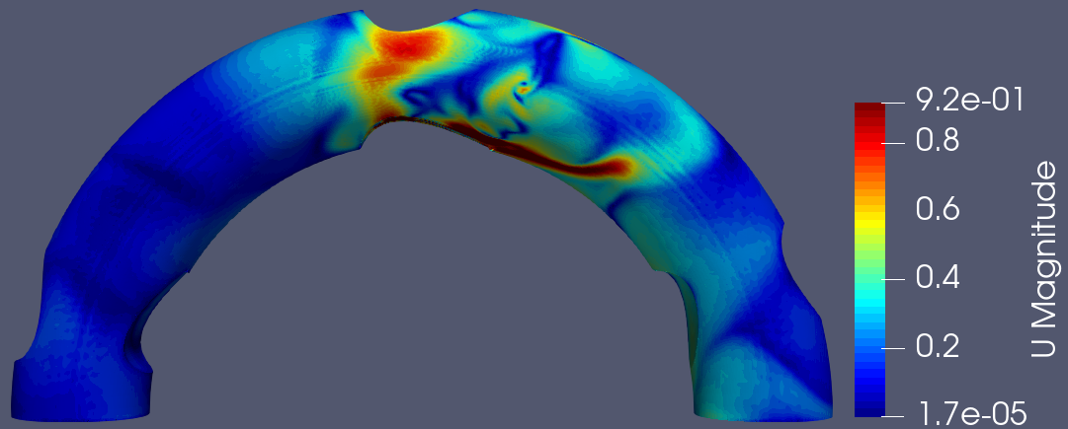  Fig. 7d: At $t=4,$ 3D velocity curve in context of non-symmetric form.
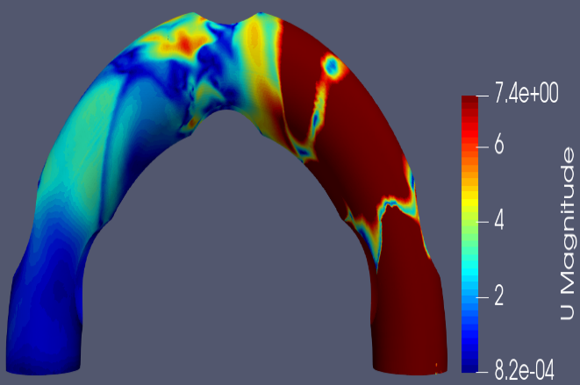  Fig. 8a: At $t=1,$ 3D velocity curve in context of symmetric form. | 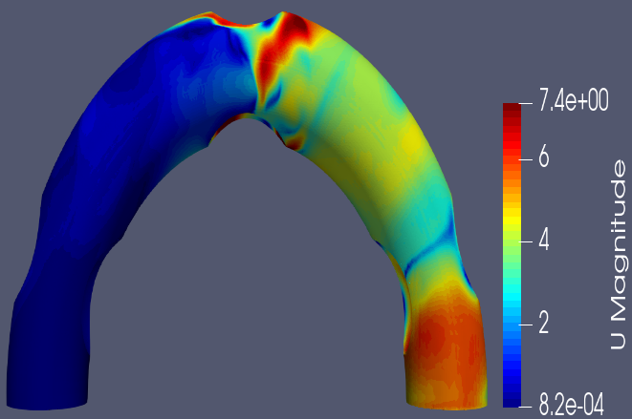  Fig. 8b: At $t=2,$ 3D velocity curve in context of symmetric form.
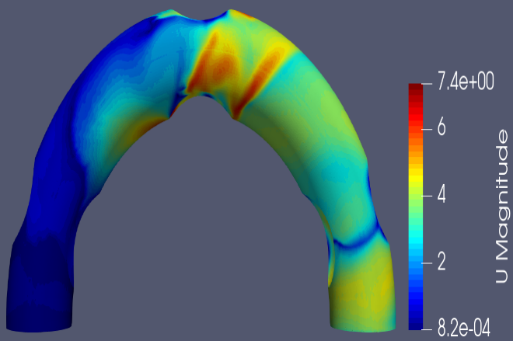  Fig. 8c: At $t=3,$ 3D velocity curve in context of symmetric form. | 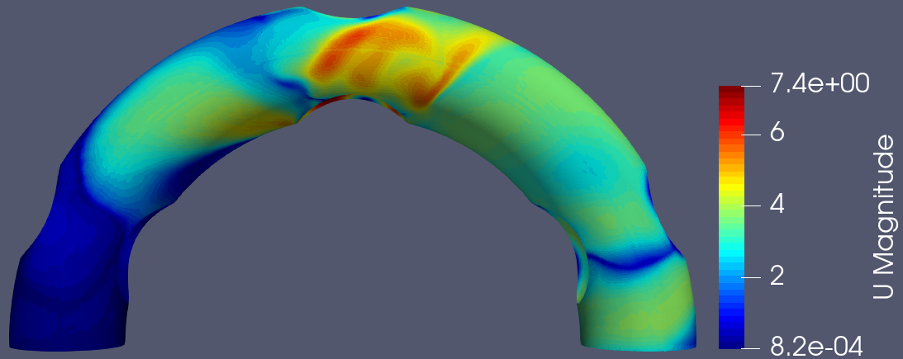  Fig. 8d: At $t=4,$ 3D velocity curve in the context of the symmetric form.
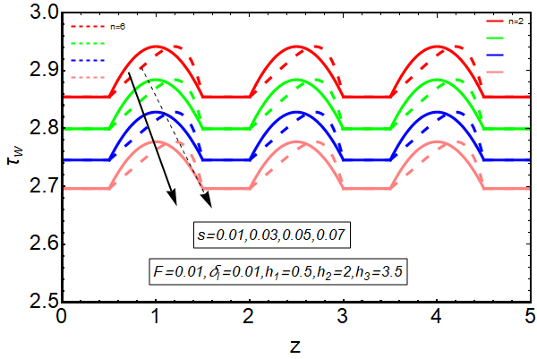  Fig. 9a: Increment of $s$ on wall shear stress. | 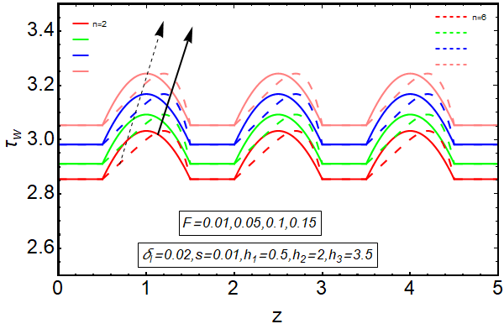  Fig. 9b: Increment of $F$ on wall shear stress.
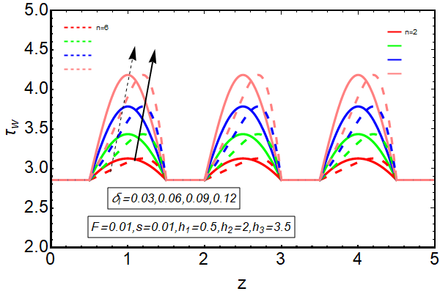
Fig. 9c: Increment of $δ_{l}$ on wall shear stress.
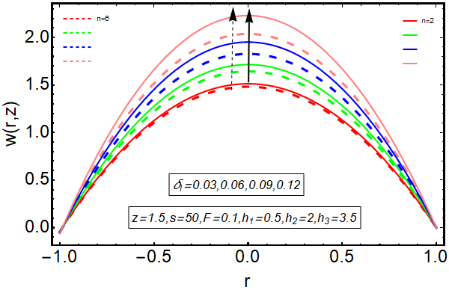  Fig. 10a: Increment of $δ_{l}$ on velocity curve. | 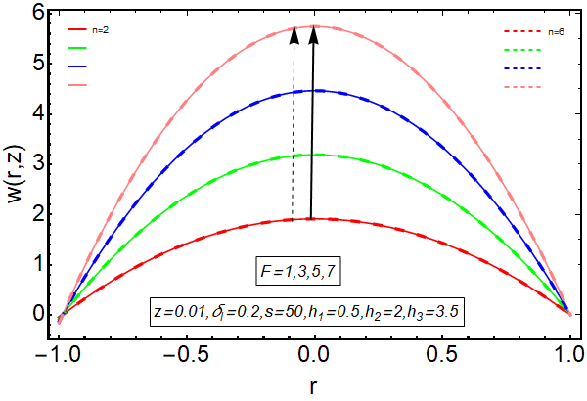  Fig. 10b: Increment of $F$ on velocity curve.

Future Works
Future research could explore the study of blood flow with the Casson model more deeply, particularly in arteries featuring multiple stenosis. This extended investigation would provide a more comprehensive understanding of the complex interplay between stenotic formations and blood flow dynamics. Further analysis incorporating the heat transfer mechanism could also enhance our comprehension of the physiological implications and thermal aspects associated with stenosis in arterial blood flow.

Conclusions
An investigation is conducted on the blood flow mechanism by taking a curved artery exhibiting non-symmetric and symmetric stenotic formations. A comparative study is elucidated in relation to both non-symmetric and symmetric stenosis. Due to the involvement of several stenosis positions in the blood flow phenomenon developed by a complicated configuration, the exact findings were challenging in the past. In order to acquire the suitable positions of stenosis in the flow phenomenon, it is beneficial to implement the numerical approach. Through the execution of numerical techniques, the blood flow dynamics generated within intricate configurations featuring distinct stenosis patterns can be effectively addressed. By employing numerical methodology, it is possible to scrutinize the characteristics of the turbulent flow mechanisms.
Following the implementation of the numerical technique, it is deduced that the increment of parameters delta sub l and cap Leads to an improvement in the velocity profile. In proximity to the position of stenosis, a flow phenomenon of greater magnitude is observed for both types of stenosis.
Furthermore, a flow mechanism with a disrupted pattern is detected in conjunction with the presence of stenosis. The employment of a numerical approach proves to be instrumental in identifying optimal stenosis positions within the intricate flow phenomenon. Numerical techniques effectively address the complexities of distinct stenosis patterns, allowing for a comprehensive understanding of blood flow dynamics. The turbulent flow mechanisms within these intricate configurations are scrutinized through numerical methodology, revealing valuable insights. Overall, using numerical techniques not only facilitates a detailed examination of turbulent flow characteristics but also enhances our understanding of the intricate dynamics associated with stenosed curved arteries. The current problem can be further study for blood flow with Casson model corresponding to an artery having multiple stenosis. Moreover, the current study can be analyzed with the heat transfer mechanism.

Ethical Approval
This is not a human or animal study, so ethical approval is not required as it is theoretical work.

Availability of supporting data
The required work is the author's own work, so no permission is required from anyone.

Competing interests
Author declares that she does not has any competing address with anyone.

Funding
Not Applicable

References
- Ku, D. N. (1997). Blood flow in arteries. Annual review of fluid mechanics, 29(1), 399-434.
- Pontrelli, G. (2001). Blood flow through an axisymmetric stenosis. Proceedings of the Institution of Mechanical Engineers, Part H: Journal of Engineering in Medicine, 215(1), 1-10.
- Mandal, P. K. (2005). An unsteady analysis of non-Newtonian blood flow through tapered arteries with a stenosis. International journal of non-linear mechanics, 40(1), 151-164.
- Akbar, N. S., Nadeem, S., & Ali, M. (2011). Jeffrey fluid model for blood flow through a tapered artery with a stenosis. Journal of Mechanics in Medicine and Biology, 11(03), 529-545.
- Akbar, N. S., & Nadeem, S. (2014). Carreau fluid model for blood flow through a tapered artery with a stenosis. Ain Shams Engineering Journal, 5(4), 1307-1316.
- Akbar, N. S. (2016). Non-Newtonian model study for blood flow through a tapered artery with a stenosis. Alexandria Engineering Journal, 55(1), 321-329.
- Varshney, G., Katiyar, V., & Kumar, S. (2010). Effect of magnetic field on the blood flow in artery having multiple stenosis: a numerical study. International Journal of Engineering, Science and Technology, 2(2), 967-82.
- Changdar, S., & De, S. (2016). Analysis of non-linear pulsatile blood flow in artery through a generalized multiple stenosis. Arabian Journal of Mathematics, 5(1), 51-61.
- Alsemiry, R. D., Mandal, P. K., Sayed, H. M., & Amin, N. (2020). Numerical solution of blood flow and mass transport in an elastic tube with multiple stenoses. BioMed research international, 2020.
- Zidan, A. M., McCash, L. B., Akhtar, S., Saleem, A., Issakhov, A., & Nadeem, S. (2021). Entropy generation for the blood flow in an artery with multiple stenosis having a catheter. Alexandria Engineering Journal, 60(6), 5741-5748.
- Akhtar, S., McCash, L. B., Nadeem, S., Saleem, S., & Issakhov, A. (2021). Mechanics of non-Newtonian blood flow in an artery having multiple stenosis and electroosmotic effects. Science Progress, 104(3), 00368504211031693.
- Nadeem, S., & Ijaz, S. (2015). Theoretical analysis of metallic nanoparticles on blood flow through stenosed artery with permeable walls. Physics Letters A, 379(6), 542-554.
- Nadeem, S., & Ijaz, S. (2016). Mechanics of biological blood flow analysis through curved artery with stenosis. Journal of Mechanics in Medicine and Biology, 16(03), 1650024.
- Zaman, A., Mabood, F., Khan, A. A., Abbasi, A., Nadeem, M. F., & Badruddin, I. A. (2021). Simulations of unsteady blood flow through curved stenosed channel with effects of entropy generations and magneto-hydrodynamics. International Communications in Heat and Mass Transfer, 127, 105569.
- Sakthivel, M., & Anupindi, K. (2021). An off-lattice Boltzmann method for blood flow simulation through a model irregular arterial stenosis: The effects of amplitude and frequency of the irregularity. Physics of Fluids, 33(3), 031912.
- Das, S., Pal, T. K., Jana, R. N., & Giri, B. (2021). Significance of Hall currents on hybrid nano-blood flow through an inclined artery having mild stenosis: Homotopy perturbation approach. Microvascular Research, 137, 104192.
- Kadhim, S. K., Al-Azawy, M. G., Ali, S. A. G., & Kadhim, M. Q. (2021). The influence of non-Newtonian model on properties of blood flow through a left coronary artery with presence of different double stenosis. International Journal of Heat and Technology, 39(3), 895-905.
- Liu, X., Chen, X., Zhang, Y., Xie, J., Jia, X., Deng, T., ... & Majid, Z. (2022). The thermal behavior of blood flow in the arteries with various radii and various stenosis angles using non-Newtonian Sisko model. Alexandria Engineering Journal.
- Zhou, W., Sun, Y. P., Divakaran, S., Bajaj, N. S., Gupta, A., Chandra, A., ... & Di Carli, M. F. (2022). Association of myocardial blood flow reserve with adverse left ventricular remodeling in patients with aortic stenosis: the microvascular disease in aortic stenosis (MIDAS) Study. JAMA cardiology, 7(1), 93-99.
- Ganesh, N. V., Al-Mdallal, Q. M., & Kameswaran, P. K. (2019). Numerical study of MHD effective Prandtl number boundary layer flow of γ Al2O3 nanofluids past a melting surface. Case Studies in Thermal Engineering, 13, 100413.
- Saleem, S., Animasaun, I. L., Yook, S. J., Al-Mdallal, Q. M., Shah, N. A., & Faisal, M. (2022). Insight into the motion of water conveying three kinds of nanoparticles shapes on a horizontal surface: Significance of thermo-migration and Brownian motion. Surfaces and Interfaces, 30, 101854.
- Koriko, O. K., Animasaun, I. L., Mahanthesh, B., Saleem, S., Sarojamma, G., & Sivaraj, R. (2018). Heat transfer in the flow of blood‐gold Carreau nanofluid induced by partial slip and buoyancy. Heat Transfer—Asian Research, 47(6), 806-823.
- Kumawat, C., Sharma, B. K., Al-Mdallal, Q. M., & Rahimi-Gorji, M. (2022). Entropy generation for MHD two phase blood flow through a curved permeable artery having variable viscosity with heat and mass transfer. International Communications in Heat and Mass Transfer, 133, 105954.
- Misra, J. C., Shit, G. C., Chandra, S., & Kundu, P. K. (2011). Hydromagnetic flow and heat transfer of a second-grade viscoelastic fluid in a channel with oscillatory stretching walls: application to the dynamics of blood flow. Journal of Engineering Mathematics, 69(1), 91-100.
- Ganesh, N. V., Javed, S., Al-Mdallal, Q. M., Kalaivanan, R., & Chamkha, A. J. (2020). Numerical study of heat generating γ Al2O3–H2O nanofluid inside a square cavity with multiple obstacles of different shapes. Heliyon, 6(12), e05752.
- Ganesh, N. V., Al-Mdallal, Q. M., Hirankumar, G., Kalaivanan, R., & Chamkha, A. J. (2022). Buoyancy-driven convection of MWCNT–Casson nanofluid in a wavy enclosure with a circular barrier and parallel hot/cold fins. Alexandria Engineering Journal, 61(4), 3249-3264.
- Ibrahim Alsaduni (2023) Numerical Approach for Energy Analysis of Gt Power Plant. Journal of Engineering and Applied Sciences, 10 (2), 13-29. doi:10.5455/jeas.2023110102.
- Jayadev Gyani (2021) Predicting Academic Performance of Students from Formative Assessment Methods using Machine Learning Algorithms. Journal of Engineering and Applied Sciences, 8 (2), 54-60. doi:10.5455/jeas.2021110106.
- Abdulmajeed Almaneea (2018) Numerical Investigation of 6 Chips Mounted on a Vertical Substrate in an Enclosure. Journal of Engineering and Applied Sciences, 5 (2), 14-24. doi:10.5455/jeas.2018110102.
- M. Subhani, N. Ullah, S. Nadeem, A. Aziz, and H. Sardar, "Modeling and numerical analysis of micropolar hybrid-nanofluid flow subject to entropy generation," International Journal of Modern Physics B, p. 2450285, 2023.
- M. H. Shahzad, S. Nadeem, A. U. Awan, S. A. Allahyani, N. A. Ahammad, and S. M. Eldin, "On the steady flow of non-newtonian fluid through multi-stenosed elliptical artery: A theoretical model," Ain Shams Engineering Journal, p. 102262, 2023.
- S. Nadeem, M. Rashid, and A. El-Shafay, "Electromagnetohydrodynamic flow of Casson nanofluid inside a vertical conduit with curved corrugated wavy walls," Waves in Random and Complex Media, pp. 1-22, 2023.
- S. Nadeem, A. Mushtaq, J. Alzabut, H. A. Ghazwani, and S. M. Eldin, "The flow of an Eyring Powell Nanofluid in a porous peristaltic channel through a porous medium," Scientific Reports, vol. 13, no. 1, pp. 1-16, 2023.
- S. Nadeem, B. Ishtiaq, M. B. Ben Hamida, S. Almutairi, H. A. Ghazwani, S. M. Eldin, and A. Al-Shafay, "Reynolds nano fluid model for Casson fluid flow conveying exponential nanoparticles through a slandering sheet," Scientific Reports, vol. 13, no. 1, p. 1953, 2023.
- S. Nadeem, B. Ishtiaq, J. Alzabut, and A. M. Hassan, "Fractional Nadeem trigonometric non-Newtonian (NTNN) fluid model based on Caputo-Fabrizio fractional derivative with heated boundaries," 2023.
- S. Nadeem, B. Ishtiaq, J. Alzabut, and S. M. Eldin, "Implementation of differential transform method on the squeezing flow of trigonometric non-Newtonian fluid between two heated plates," International Journal of Modern Physics B, p. 2450326, 2023.
- S. Nadeem, B. Ishtiaq, J. Alzabut, and S. M. Eldin, "Three parametric Prabhakar fractional derivative-based thermal analysis of Brinkman hybrid nanofluid flow over exponentially heated plate," Case Studies in Thermal Engineering, p. 103077, 2023.
- S. Nadeem, B. Ishtiaq, N. Akkurt, and H. A. Ghazwani, "Entropy optimized flow of hybrid nanofluid with partial slip boundary effects and induced magnetic field," International Journal of Modern Physics B, p. 2350252, 2023.
- S. Nadeem, B. Ishtiaq, N. Akkurt, and S. M. Eldin, "Swirling flow analysis of Eyring-Powell fluid between coaxial disks with variable property," Journal of Computational Design and Engineering, p. qwad015, 2023.
- S. Nadeem, S. Almutairi, and S. Akhtar, "A significant wave form analysis on the peristaltic flow in a duct with convection and diffusion effects," Waves in Random and Complex Media, pp. 1-20, 2023.
- S. Nadeem, S. Ali, J. Alzabut, M. B. B. Hamida, and S. M. Eldin, "Numerical investigation of the influence of hybrid nano-fluid on heat transfer in semi-annular channel," Case Studies in Thermal Engineering, p. 102855, 2023.
- S. Nadeem et al., "Corrigendum to “Modeling and numerical simulation of non-Newtonian arterial blood flow for mild to severe stenosis”[Alex. Eng. J. 72 (2023) 195–211]," Alexandria Engineering Journal, vol. 78, p. 306, 2023.
- S. Nadeem et al., "Modeling and numerical simulation of non-Newtonian arterial blood flow for mild to severe stenosis," Alexandria Engineering Journal, vol. 72, pp. 195-211, 2023.
- S. Nadeem, S. Akhtar, A. Saleem, N. Akkurt, H. A. Ghazwani, and S. M. Eldin, "Numerical computations of blood flow through stenosed arteries via CFD tool OpenFOAM," Alexandria Engineering Journal, vol. 69, pp. 613-637, 2023.
- S. Nadeem, S. Akhtar, A. Saleem, N. Akkurt, S. Almutairi, H. A. Ghazwani, and S. M. Eldin, "Entropy analysis for a novel peristaltic flow in a curved heated endoscope: an application of applied sciences," Scientific Reports, vol. 13, no. 1, p. 1504, 2023.
- S. Nadeem, J. Abbas Haider, and S. Akhtar, "Mathematical modeling of Williamson's model for blood flow inside permeable multiple stenosed arteries with electro-osmosis," Scientia Iranica, 2023.
- B. Ishtiaq, S. Nadeem, and J. Alzabut, "Effects of variable magnetic field and partial slips on the dynamics of Sutterby nanofluid due to biaxially exponential and nonlinear stretchable sheets," Heliyon, 2023.
- B. Ishtiaq and S. Nadeem, "Contraction/dilation flow analysis of non-Newtonian fluid in a deformable channel with exponential permeable walls," Chinese Journal of Physics, 2023.

