Novel 3D Printing Designs of Drywall Anchor

Ahmad Abdulaziz Alshiha ^{1,*}, Riyadh Abdullah Alotaibi ¹, Abdullah Abdulmohsen Alrawsaa ¹, Badr dhawi Almutairi ¹, Abdullah Ahmad Alfuraih ¹, Abdullah Sami Alobaid ¹
¹ Department of Mechanical and Industrial Engineering, College of Engineering, Majmaah University, Al-Majmaah, Riyadh, 11952, Saudi Arabia
Abstract
In this research project, the unique designs for 3D printed drywall anchors in this study were inspired by the skin of animals seen in nature, including reptiles, fish, and butterflies. The tough skin of these animals inspired our drywall anchor design. Engineered nylon produces drywall Anchors, one-piece, self-drilling drywall, and hollow cavity anchors. It may be installed in walls as thin as 12mm and optimized for drywall usage. You can screw with the nylon piece. A drywall sleeve anchor is an insert or sleeve made of plastic inserted into a tiny pilot hole. The research uses PLA, TPU, ABS, and Nylon engineering, a strong, flexible material that resists corrosion and wear. The one-piece, self-drilling anchor design eliminates the need for pre-drilled holes, reducing the risk of wall weakening and maintaining anchor strength. By incorporating biomimicry principles, the project explores the potential of nature-inspired engineering solutions to improve sustainability and efficiency in the construction industry. The sleeve enlarges as the drywall metal screw provided is threaded into it. This increases the shear strength, which helps the metal screw remain in the wall. Drywall sleeve anchors are often the sort of drywall anchor that has the lowest price point. The study's scope encompasses design optimization, performance testing, environmental impact assessment, and exploring nature-inspired engineering solutions. Ultimately, this research project strives to enhance construction practices and promote sustainability in the industry. They work well for lightweight products. The purpose of a drywall anchor is to firmly mount framed artwork, mirrors, clocks, and shelving to walls.
Keywords:
Drywall, Shear testing; Tensile testing; lightweight; Carbon fibers.

Submitted:
5-APR-24

Accepted:
23-MAY-24

Published:

DOI:

Distributed under
Creative Commons CC-BY 4.0

OPEN ACCESS

Introduction
3D printing technology has transformed how we manufacture products, enabling us to create custom designs and prototypes quickly and efficiently. Technology has applications in various fields, including healthcare, automotive, aerospace, and construction. In the construction industry, 3D printing has created innovative designs for building materials, such as concrete, steel, and plastics. In this research project, we aim to leverage the benefits of 3D printing technology to create a new drywall anchor optimized for use with drywalls of varying thicknesses. Our approach is inspired by biomimicry, which involves using natural designs and processes as a source of inspiration for engineering solutions. Specifically, we look to the skin of animals seen in nature, such as reptiles and fish, which have evolved to have tough and durable skin that provides protection and support, as shown in Fig. 1.
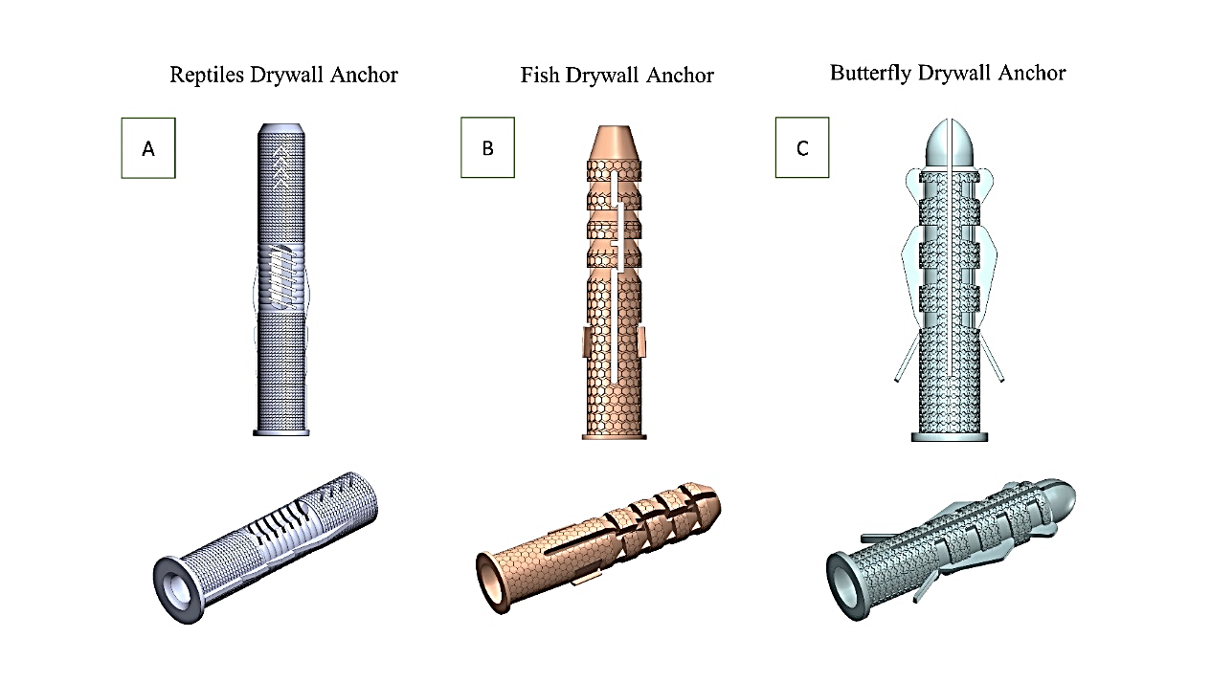

Fig. 1. Our 3D-printed drywall anchor design,
a) Reptiles drywall, b) Fish drywall, c) Butterfly drywall.
It seeks to mimic the characteristics of animal skin by incorporating unique textures, shapes, and materials that can enhance its strength and durability. By creating a stronger and more durable drywall anchor, we aim to reduce the risk of damage to walls and objects and provide a more efficient solution for hanging objects on walls. This research project aims to revolutionize the construction industry by developing a bio-inspired 3D-printed drywall anchor design. Inspired by animal skin textures, this innovative anchor offers increased durability, efficiency, and load-bearing capability compared to traditional anchors. The anchor simplifies installation by utilizing TPU engineering and a self-drilling one-piece design while providing long-lasting support for heavy objects. Furthermore, the project explores the potential of biomimicry in construction, paving the way for sustainable and efficient building practices. With a focus on environmental impact assessment and materials exploration, this research project aims to contribute to a more sustainable and efficient construction industry.

Introduction of Drywall Designs
Drywall anchors are essential construction components, supporting objects hung on walls. Traditional drywall anchors are made of plastic or metal and can be challenging to install, especially in thicker drywall. These anchors often require pre-drilled holes, which can weaken the wall and reduce the anchor's strength. Traditional drywall anchors can also fail under heavy loads, damaging walls and objects. In recent years, 3D printing technology has enabled the development of more advanced and efficient drywall anchors with unique and innovative designs. This makes it an ideal material for creating drywall anchors that can provide long-lasting support for heavy objects.
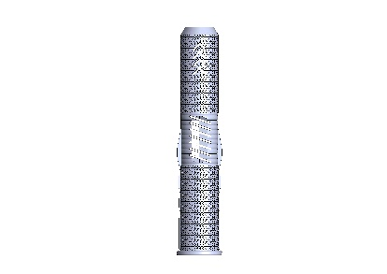 | 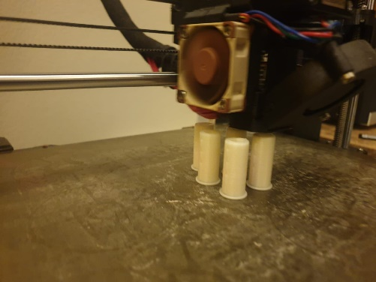
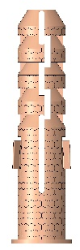 | 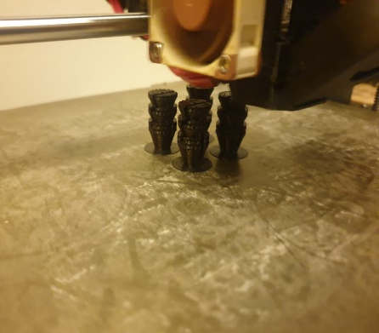
Fig. 2. 3D printing process of anchor design drywall.
Our 3D-printed drywall anchor design is a one-piece, self-drilling anchor that can be installed on walls as thin as 12mm, as shown in Fig. 2. The anchor is optimized for usage with drywall and can be screwed directly into the nylon piece. The unique design of the anchor provides a stronger grip on the drywall, reducing the risk of damage to walls and objects. Additionally, the design of the anchor allows for easier installation, reducing the time and effort required to hang objects on walls.

Problem Statement
The traditional drywall anchors on the market have limitations in terms of their durability and efficiency. They can be challenging to install, especially in thicker drywall, and can fail under heavy loads. This can lead to damage to walls and objects and the need for costly repairs. This research project aims to address these limitations by developing a new 3D-printed drywall anchor design inspired by the skin of animals seen in nature. The hope is that this new design will provide a more durable and efficient alternative to traditional drywall anchors. By leveraging the advantages of 3D printing technology and nylon engineering, we aim to create a drywall anchor that can withstand heavy loads and provide long-lasting support for objects. Additionally, the design of the anchor will make it easier and faster to install, reducing the time and effort required for hanging objects on walls.
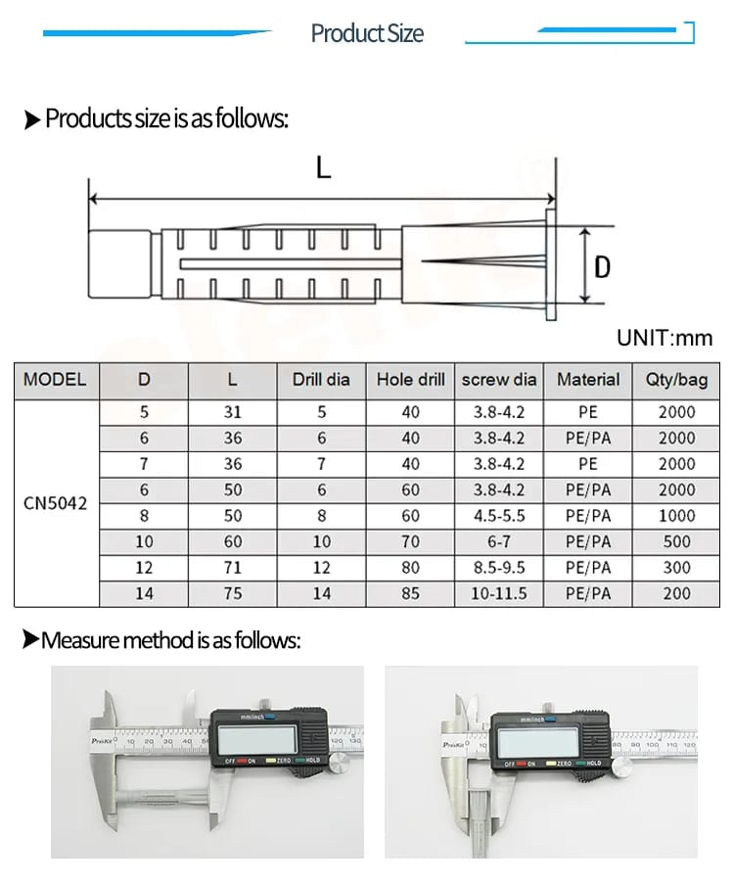

Fig. 3. Product size of 3 models of Anchor drywall.
Moreover, using biomimicry in designing our 3D-printed drywall anchor presents a unique opportunity to explore the potential of nature-inspired engineering solutions in the construction industry, as shown in Fig. 3. By learning from nature, we can create more sustainable and efficient solutions that can help reduce the environmental impact of construction activities. Additionally, using 3D printing technology can enable us to create custom designs that can meet the specific needs of different construction projects, further improving their efficiency and sustainability. In summary, this research project aims to contribute to developing more efficient and sustainable construction practices by providing a new and innovative solution to a common problem in the industry. By combining the benefits of 3D printing technology, nylon engineering, and biomimicry, we want to create a drywall anchor that can provide long-lasting support for heavy objects, reduce damage to walls and objects, and help reduce the environmental impact of construction activities.

Scope of work
- Existing drywall anchors and their limitations were reviewed, as well as the use of 3D printing and biomimetic technology in building materials. The review should examine the different materials used in producing drywall fasteners and the various techniques and processes involved in 3D printing on the environmental impact of manufacturing and the use of materials in construction.
- Identify suitable materials and 3D printing techniques to produce the drywall anchor, considering strength, flexibility, and cost factors. The research should evaluate different materials, such as nylon, PLA (polylactic acid), and ABS (acrylonitrile butadiene styrene), and other 3D printing techniques, such as FDM (fused deposition modeling) and SLS (selective laser sintering). The study should also consider the potential for using recycled or biodegradable materials.
- Design and model the drywall anchor using Auto CAD software, incorporating the desired textures, shapes, and materials inspired by animal and fish skin. The design should be optimized for drywall of varying thicknesses and should be a one-piece, self-drilling anchor that can be installed without requiring pre-drilled holes. The model should be tested using simulation software to evaluate its strength and durability.
- Print and test the prototype of the drywall anchor, assessing its performance under different loads and conditions and comparing it to traditional drywall anchors. To evaluate the anchor's strength and durability, the testing should be conducted in a laboratory setting, using different types of drywall and other loads and vibrations. The design should also be tested for its ease of installation and removal.
- Evaluate the environmental impact of the 3D printing process and nylon engineering used in producing the drywall anchor and compare it to traditional manufacturing methods. The evaluation should consider energy consumption, waste generation, carbon emissions, and material recycling and reuse. The study should also consider the potential for using alternative, biodegradable, or compostable materials.

Literature Review
The introduction section of the literature review should provide a comprehensive background for the research study about drywall fasteners, highlighting the limitations and drawbacks of current designs. The section should also explain the potential benefits of 3D printing and biomimetic technology in producing building materials, including drywall fasteners.

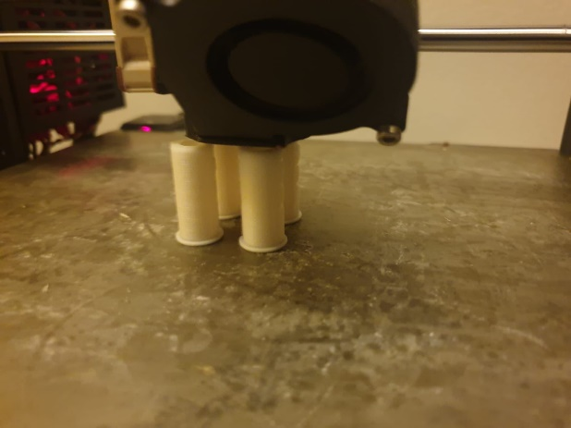

Fig. 4. The 3D printing method of 3 models of Anchor drywall.
The introduction should also clearly state the research questions the study aims to answer. This will help guide the subsequent sections of the literature review and ensure that the analysis and evaluation of the literature are directly relevant to the research study, as shown in Fig. 4. The introduction should also provide a brief overview of the structure of the literature review and the topics to be covered in subsequent sections. This will help ensure that the literature review is well-organized and easy for the reader to follow. In subsequent sections of the literature review, it is essential to critically analyze and evaluate the existing literature on the research topic. This involves synthesizing and summarizing the essential findings and insights from relevant studies, identifying gaps and limitations in the existing research, and providing recommendations for future research.
It is also essential to use various sources when conducting a literature review, including academic journal articles, books, reports, and other relevant publications. This will help ensure that the literature review is comprehensive and reflects current knowledge on the research topic. The section must be close by highlighting the research questions the study aims to answer. In addition, it should provide a brief overview of the literature review structure and the topics to be covered in subsequent sections. When writing the introduction section of a literature review, it is essential to provide a comprehensive background on the research topic. This includes highlighting the limitations and drawbacks of current designs and the potential benefits of using innovative technologies such as 3D printing and biomimetic technology.

Testing Methods
Testing is a crucial aspect of designing and evaluating the performance of drywall anchors. This section of the literature review should provide a comprehensive overview of the different testing methods used to assess the strength and durability of drywall anchors. It should discuss the various types of loads that can be applied to the anchor, such as tensile, shear, and bending loads, and the different types of drywalls that can be used for testing. The section should also discuss the importance of testing under various environmental conditions, such as temperature, humidity, and vibration, and how these factors can affect the anchor's performance. Fig. 5 provides information on the industry and academia's different testing standards and protocols.
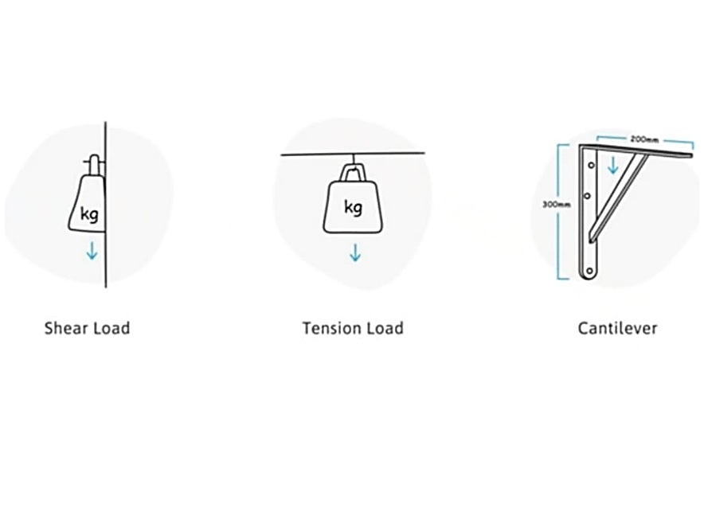
Fig. 5. Testing methods of 3 models of Anchor drywall

The literature review should discuss the advantages and disadvantages of each testing method, highlighting the strengths and limitations of the current study's testing approach and how it differs from existing methods. Furthermore, it should describe the specific testing procedures used in the current research, including the instrumentation and data collection methods. Additionally, the section may discuss the use of computational modeling and simulation to predict the performance of the drywall anchor under different loading conditions.

3D Printing Industries
This section of the literature review will provide a comprehensive overview of the use of 3D printing technology in manufacturing building materials, including drywall fasteners, as shown in Figure 6. It discusses the different types of 3D printing technologies, such as FDM, SLS, and SLA, and how they can produce complex shapes and structures. This section will let you know the different materials available for 3D printing, such as nylon, PLA, and ABS, and how they can be improved for strength, durability, and other properties. Furthermore, challenges associated with 3D printing should be discussed, such as the need for post-print processing and the limited size of the print.
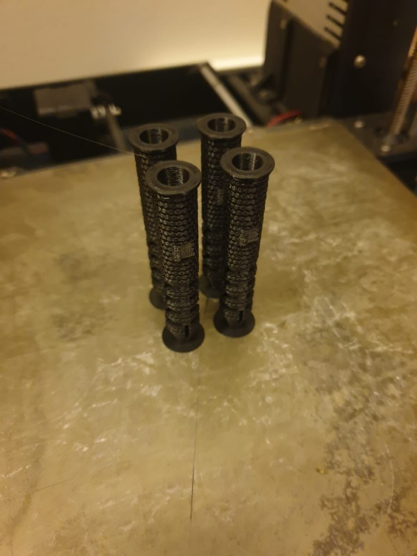 | 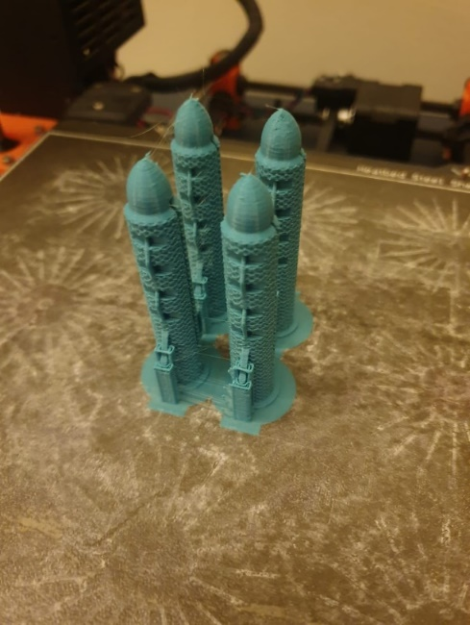
Fig. 6. Final products of 3 models of Anchor drywall.
The literature review also discusses the potential benefits of using 3D printing technology in construction, such as reduced waste, increased customization, and improved sustainability. Also, the section may discuss using additive manufacturing technologies other than 3D printing, such as robotic fabrication and bio-printing, to create building materials with new properties. Finally, the literature review should provide a detailed analysis of the current state-of-the-art 3D printing technology, including materials, hardware, and software advancements. It should also discuss the potential for future development in the construction industry and how 3D printing technology can be leveraged to create innovative and sustainable solutions. Additionally, the section should discuss the specific 3D printing technologies and materials used in the current study, along with the design and fabrication process. The section may also discuss the post-processing techniques that will be used to improve the mechanical and physical properties of the 3D-printed drywall anchor.

Experimental Detail
The overall objective of the work was to systematically investigate the process parameters that may be adjusted during production to control the wall thickness distribution of parts manufactured by plug‐assisted thermoforming. The parameters studied were plug temperature, speed, displacement, shape, and air pressure. As well as quantifying the effects of each parameter on the wall thickness distribution, a further aim of the work was to improve the understanding of the physical mechanisms during the different stages of the process. The process parameters shown to have the most significant effect on experimentally determined wall thickness distribution were the plug displacement, temperature, and shape. It is proposed that during the plug‐assisted thermoforming of polystyrene, the temperature-dependent friction between the plug and surface was the most critical factor in determining product wall thickness distribution. In contrast, heat transfer was shown to play a less crucial role.

Materials
The investigated PLA and TPU material in the present study was used practically on any desktop 3D Printer and manufactured based on the ASTM D638-10 standard [15]. The main features of PLA filament are high modulus, excellent surface quality, dimensional stability, lightweight, and ease of printing. On the other hand, the chemical specifications include the following items:
- Less strong than ABS.
- Amorphous: Low and near isotropic shrinkage
- Very low emission during printing.
- Wide processing range: 185 - 240°C
The print conditions of PLA filament have the following items:
- Extruder: Ideally 185 to235°C
- Platform Temp: 50 to 60°C
- Platform Prep: Adhesive tape, Kapton tape, hot glass, vinyl

TPU (Thermoplastic Polyurethane) with the given characteristics to the previous comparison with PLA, we can identify additional differences:
- Strength: TPU is generally less strong than ABS (Acrylonitrile Butadiene Styrene) but offers greater flexibility and elongation at break. TPU is known for its excellent tensile strength and tear resistance, making it suitable for highly flexible and durable applications.
- Shrinkage: TPU, like PLA, has low and near isotropic shrinkage, meaning it experiences minimal dimensional changes during the cooling process after printing. This characteristic helps in achieving more accurate prints.
- Emissions: Similar to PLA, TPU exhibits very low emission levels during printing. This makes it safer and more environmentally friendly than materials with higher emissions.
- Wide Processing Range: TPU, like PLA, has a wide processing temperature range. It can typically be printed between 185 and 240°C. This flexibility in processing temperatures allows for versatility in printing various TPU-based objects.
Overall, TPU showcases unique properties such as excellent flexibility, elongation at break, low shrinkage, low emissions, and a wide processing range. These characteristics make TPU well-suited for applications that require flexibility, durability, and good dimensional stability, such as flexible parts, seals, gaskets, and wearable devices.

3D Printing Designs
3D printing design involves using a 3D printer to create a three-dimensional object from a digital file. The design of the object is made using CAD software, which enables designers to construct intricate shapes and structures that are impossible to produce through conventional manufacturing methods. The 3D-printed drywall anchor design outlined in the prompt strives to integrate distinct textures, forms, and materials to enhance its robustness and endurance. By imitating animal skin characteristics, this innovative design approach takes inspiration from the idea that animal skin has evolved to withstand diverse external pressures and environmental conditions.

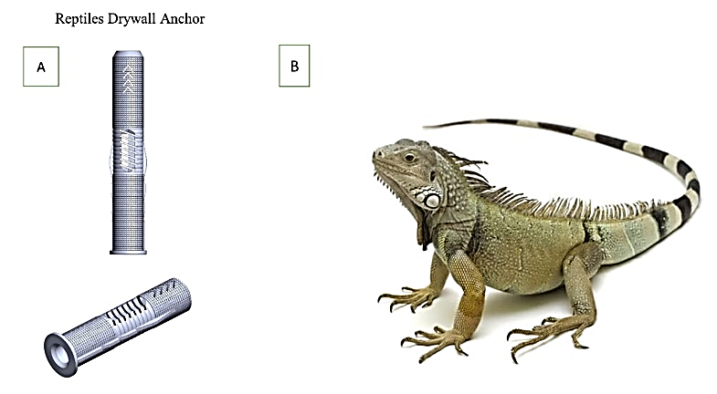

Fig. 7. Illustration of a) Reptiles drywall anchor, b) Reptiles actual image.
The accompanying (Fig. 7) illustrates three distinct 2D drywall anchor designs influenced by various animals, including a reptile, fish, and butterfly drywall anchor. Each design features unique textures and shapes to improve its strength and durability. When embedded in drywall, the reptile drywall anchor has a textured surface with scales and ridges that offer improved grip and stability. The fish drywall anchor has a sleek shape and fins that decrease resistance and facilitate easier insertion into drywall. The butterfly drywall anchor design features wings that provide extra support and stability when hanging objects on walls.
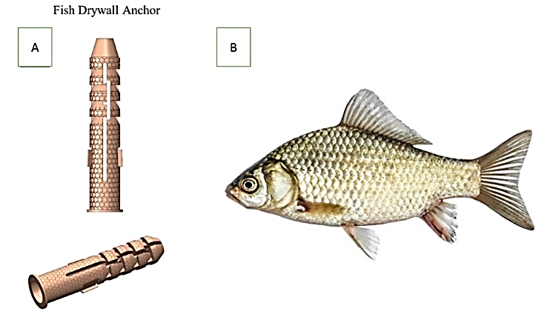

Fig. 8. Illustration of a) Fish drywall anchor,
b) Fish actual image.
The 3D-printed drywall anchor design has the potential to revolutionize how we hang objects on walls by providing a sturdier and more durable solution, as shown in Fig 8. Fig 9 shows that this design approach could extend to other industries and products, such as aerospace, construction, and automotive, to create more robust and long-lasting goods.
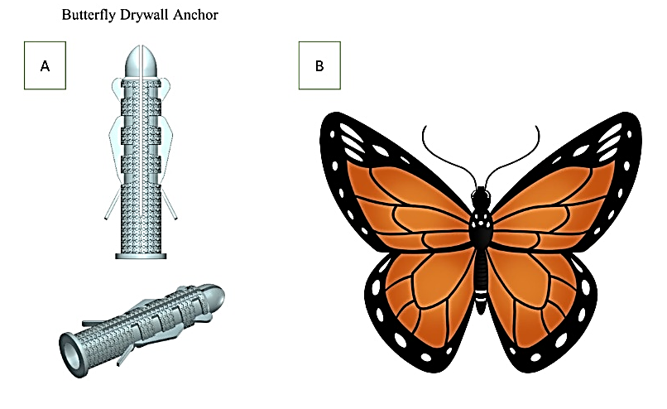

Fig. 9. Illustration of a) Butterfly drywall anchor,
b) Butterfly actual image.

Reptile drywall anchor design
The Reptiles drywall anchor design is a novel approach to enhancing the strength and durability of drywall anchors. This design takes inspiration from reptile skin, which has evolved to withstand external pressures and environmental conditions. By mimicking the unique textures and shapes of reptile skin, this design seeks to create a drywall anchor that can withstand the stress of hanging heavy objects on walls. The textured surface of the Reptiles drywall anchor, with its ridges and scales, offers improved grip and stability when inserted into drywall. This texture also distributes the load evenly, reducing the risk of damage to both walls and the objects being hung. The anchor's conical shape allows easy insertion into the drywall, while the wider base offers excellent stability and support for the hanging object. The dimensions in Fig. 10 are crucial for accurately producing the Reptiles drywall anchor using a 3D printer. Ensuring that the anchor is made to the exact specifications can provide the intended level of strength and durability.
The Reptiles drywall anchor design is an exciting innovation in the field of drywall anchors. Its incorporation of unique textures and shapes inspired by reptile skin offers a stronger and more durable solution for hanging objects on walls. This design approach can be extended to other industries and products, such as construction, automotive, and aerospace, to create stronger, more durable goods. 3D printing technology enables the production of intricate designs, making it an ideal tool for realizing the full potential of this innovative approach.

Fig. 10. All dimensions of Reptiles drywall anchor in (mm).
Table 1 provides the dimensions and specifications for different models of the Reptiles drywall anchor. The table lists the dimensions for the length (L), diameter (D), drill diameter, hole drill, and screw diameter, as well as the recommended materials for manufacturing. The dimensions of the Reptiles drywall anchor vary depending on the model. The length of the anchor ranges from 5mm to 71mm, while the diameter ranges from 6mm to 12mm. The drill diameter and hole drill are also different for each model, ranging from 5mm to 12mm and 40mm to 80mm, respectively. The screw diameter ranges from 3.8mm to 9.5mm, depending on the model.
The recommended material for manufacturing all Reptiles drywall anchor models is PLA, a biodegradable and eco-friendly thermoplastic material commonly used in 3D printing. The information in Table 1 is essential for accurately producing the Reptiles drywall anchor using a 3D printer. The dimensions provided help ensure that the anchor is the correct size and shape for the intended use and that it will fit securely into the drywall without causing damage.
Table 1 provides valuable information for anyone interested in using or manufacturing the Reptiles drywall anchor, making it an essential reference for those working in 3D printing and product design.

Table 1. The dimensions of the Reptiles drywall anchor (mm)
Models | D | L | Drill diameter | Hole drill | Screw diameter | Materials
Reptiles’ drywall anchor | 5 | 31 | 5 | 40 | 3.8-4.2 | PLA and PTU
Reptiles’ drywall anchor | 6 | 36 | 6 | 40 | 3.8-4.2 | PLA and PTU
Reptiles’ drywall anchor | 7 | 36 | 7 | 40 | 3.8-4.2 | PLA and PTU
Reptiles’ drywall anchor | 6 | 50 | 6 | 60 | 3.8-4.2 | PLA and PTU
Reptiles’ drywall anchor | 8 | 50 | 8 | 60 | 4.5-5.5 | PLA and PTU
Reptiles’ drywall anchor | 10 | 60 | 10 | 70 | 6-7 | PLA and PTU
Reptiles’ drywall anchor | 12 | 71 | 12 | 80 | 8.5-9.5 | PLA and PTU
Reptiles’ drywall anchor | 14 | 75 | 14 | 85 | 10-11.5 | PLA and PTU

Fish Drywall Anchor Design
The Fish drywall anchor design is another innovative 3D-printed drywall anchor that incorporates unique textures and shapes inspired by fish to enhance its strength and durability. Fish skin has evolved to reduce drag and resist external forces, making it an ideal source of inspiration for this type of design. The Fish drywall anchor design has a streamlined shape with fins that reduce drag and make it easier to insert into drywall. The fins also provide better grip and stability when the anchor is inserted, reducing the risk of damage to walls and objects. The anchor is designed with a conical shape that allows for easy insertion into the drywall, and the base of the anchor is wider than the tip to provide excellent stability and support for hanging objects.
Fig 11 provides all the dimensions of the Fish drywall anchor in mm, including the length, width, and height of the anchor, as well as the size of the fins. This information is crucial for accurately producing the anchor using a 3D printer. The Fish drywall anchor design comes in various sizes, with different dimensions for the length, drill diameter, hole drill, and screw diameter. The material used for this design is PLA, a biodegradable thermoplastic material that is easy to print and environmentally friendly.
The Fish drywall anchor design is an innovative and promising solution for hanging objects on walls. By incorporating unique textures and shapes inspired by fish, this design offers a stronger and more durable solution for hanging objects on walls. With the help of 3D printing technology, this design approach can be extended to other products and industries to create stronger and more durable goods.

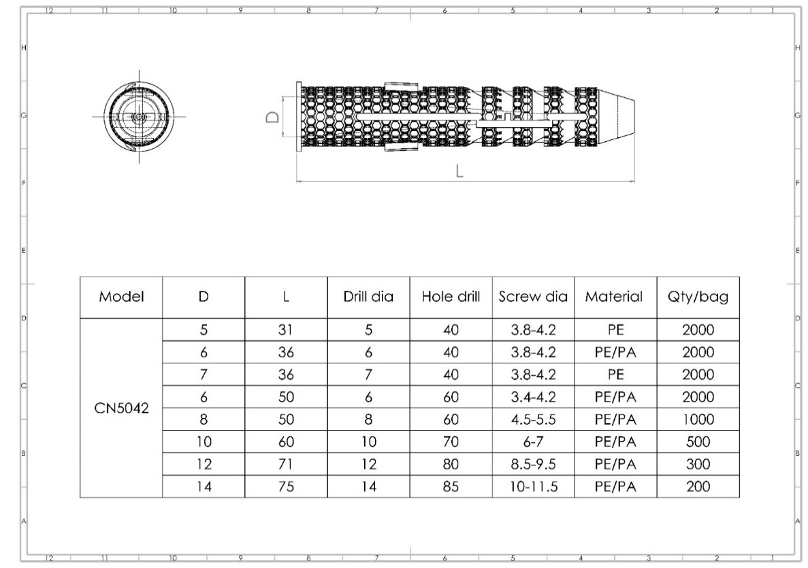

Fig. 11. All dimensions of the fish drywall anchor are in (mm).
Table 2 provides the dimensions of the Fish drywall anchor in mm. This 3D-printed drywall anchor is designed with unique textures and shapes inspired by fish, intended to enhance its strength and durability. The anchor has a streamlined shape and fins that reduce drag and make it easier to insert into drywall. Like the Reptile drywall anchor, the Fish drywall anchor also has a conical shape that allows easy insertion into the drywall. The table includes the various models of the Fish drywall anchor, each with different dimensions. The D column refers to the diameter of the anchor, while the L column indicates the length. The drill diameter column suggests the diameter of the drill bit required to create the hole for the anchor, while the hole drill column provides the recommended depth of the hole.
The screw diameter column lists the recommended screw diameter for each anchor model. Finally, the Materials column lists the recommended material for printing each anchor model: PLA. The dimensions in Table 2 are essential for accurately producing the Fish drywall anchor using a 3D printer. This information enables designers and manufacturers to select the appropriate model and size for their needs, ensuring that the anchor is strong, durable, and able to support the weight of objects hung on walls.
Table 2. The dimensions of the Fish drywall anchor (mm)
Models | D | L | Drill diameter | Hole drill | Screw diameter | Materials
Fish drywall anchor | 5 | 31 | 5 | 40 | 3.8-4.2 | PLA and PTU
Fish drywall anchor | 6 | 36 | 6 | 40 | 3.8-4.2 | PLA and PTU
Fish drywall anchor | 7 | 36 | 7 | 40 | 3.8-4.2 | PLA and PTU
Fish drywall anchor | 6 | 50 | 6 | 60 | 3.8-4.2 | PLA and PTU
Fish drywall anchor | 8 | 50 | 8 | 60 | 4.5-5.5 | PLA and PTU
Fish drywall anchor | 10 | 60 | 10 | 70 | 6-7 | PLA and PTU
Fish drywall anchor | 12 | 71 | 12 | 80 | 8.5-9.5 | PLA and PTU
Fish drywall anchor | 14 | 75 | 14 | 85 | 10-11.5 | PLA and PTU

Butterfly Drywall Anchor Design
The Butterfly drywall anchor design is another innovative design in the field of drywall anchors. This anchor is inspired by butterfly wings' delicate yet strong structure and is designed to provide a strong and secure hold for hanging objects on drywall. The Butterfly drywall anchor features two wings designed to expand behind the drywall, providing a wider surface area for more significant support and stability. The wings have a textured surface that enhances grip and prevents the anchor from rotating inside the wall. The anchor also has a conical shape that allows for easy insertion into the drywall and a tapered tip that facilitates screwing in the anchor.
The dimensions of the butterfly drywall anchor in mm in Fig. 12. The anchor comes in various sizes, ranging from 6mm to 16mm in diameter, and can accommodate screws of different sizes. The table also provides the recommended drill diameter and hole depth for each anchor size. The Butterfly drywall anchor design is a unique and promising solution for hanging objects on drywall. Its innovative design provides a stronger and more secure hold, reducing the risk of damage to walls and objects. With the help of 3D printing technology, this design can be easily replicated and produced in various sizes to meet different needs.
Fig. 12 also provides all the necessary dimensions for accurately producing the Butterfly drywall anchor using a 3D printer. This information is crucial for ensuring the anchor's optimal performance and durability.

Fig. 12. All dimensions of the Butterfly drywall anchor in (mm).
Table 3 shows the dimensions of the Butterfly drywall anchor in mm. The Butterfly drywall anchor design incorporates the shape and structure of butterfly wings to enhance its strength and durability. The anchor has a unique shape with wings designed to distribute the load evenly, reducing the risk of damage to walls and objects.
The table lists seven different models of the Butterfly drywall anchor, with varying dimensions and drill diameters. The length (L) of the anchors ranges from 31 mm to 75 mm, while the drill diameter ranges from 5 mm to 14 mm. The hole drill size is 40 mm for all models, and the screw diameter ranges from 3.8-4.2 mm to 10-11.5 mm, depending on the model. All the Butterfly drywall anchor models are made from PLA material, a biodegradable thermoplastic derived from renewable resources. PLA is a popular choice for 3D printing because it is easy to print and has good mechanical properties.
The Butterfly drywall anchor design offers a unique and innovative solution for hanging objects on drywall. By incorporating the structure of butterfly wings, this design provides a more robust and durable alternative to traditional drywall anchors. The dimensions listed in the table are essential for accurately producing the anchor using a 3D printer.
Table 3. The dimensions of the Butterfly drywall anchor (mm)
Models | D | L | Drill diameter | Hole drill | Screw diameter | Materials
Butterfly drywall anchor | 5 | 31 | 5 | 40 | 3.8-4.2 | PLA and PTU
Butterfly drywall anchor | 6 | 36 | 6 | 40 | 3.8-4.2 | PLA and PTU
Butterfly drywall anchor | 7 | 36 | 7 | 40 | 3.8-4.2 | PLA and PTU
Butterfly drywall anchor | 6 | 50 | 6 | 60 | 3.8-4.2 | PLA and PTU
Butterfly drywall anchor | 8 | 50 | 8 | 60 | 4.5-5.5 | PLA and PTU
Butterfly drywall anchor | 10 | 60 | 10 | 70 | 6-7 | PLA and PTU
Butterfly drywall anchor | 12 | 71 | 12 | 80 | 8.5-9.5 | PLA and PTU
Butterfly drywall anchor | 14 | 75 | 14 | 85 | 10-11.5 | PLA and PTU

Results and Discussion
At first, we chose nylon because it has a high tensile strength and is very durable. Also, nylon is a Resilient material, as it may have thin fibers, but it is strong and can withstand years of wear. However, nylon couldn’t achieve a good surface finish because it can be sticky when moving between the shells in the drywall. In fast and small moves, it can pull some of the material from the past shell, resulting in a bad finish.

Fig. 13. Nylon concept failure
We chose another material: ABS and PLA. PLA has excellent features. It is the most accessible material to print and can produce a high-quality print. Also, it is a strong material, less strong than ABS. However, the two materials have something in common: Fig. 13 is considered hard materials, and PLA is relatively cheaper. We did our testing and got a perfect surface finish, though the drywall was brittle and easy to break.
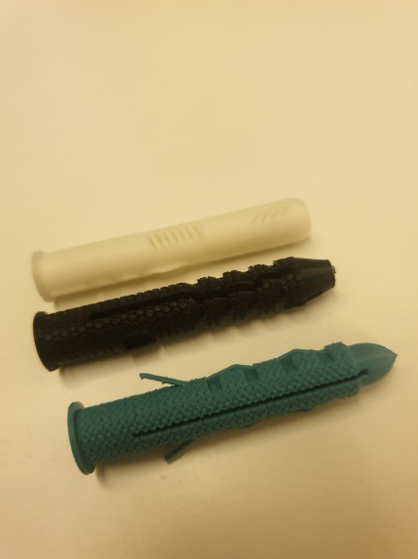 | 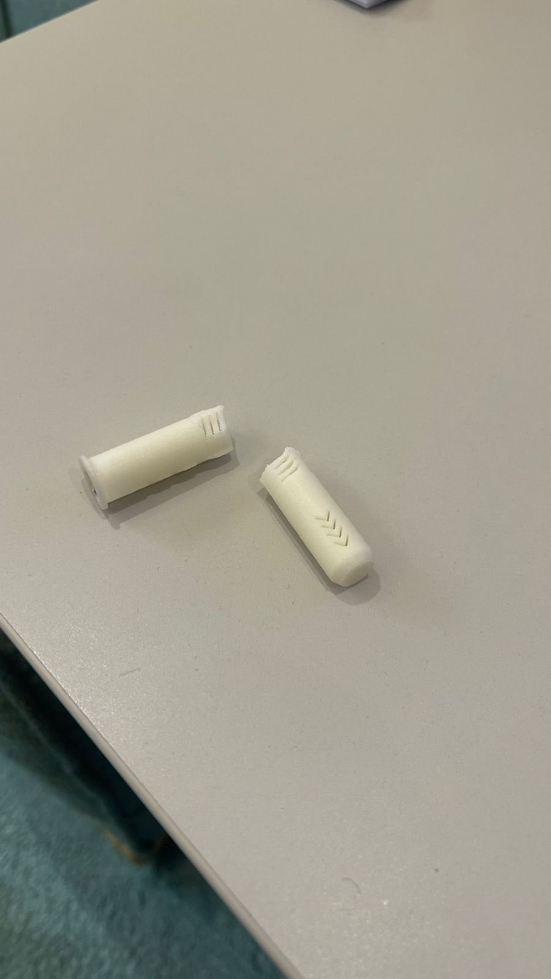

Fig. 14. PLA concept and PLA concept of brittle failure
Finally, we chose TPU and have not seen its results. However, TPU is known for its high abrasion and scratch resistance, guaranteed durability, and aesthetic value. Fig. 14 shows high elasticity across the entire hardness range and good flexibility, which we aim for.

Shear Analysis
Shear testing assesses a material's response to forces applied parallel to its surface, measuring its shear strength and deformation characteristics. For TPU (Thermoplastic Polyurethane), a shear test helps evaluate how the material resists forces that act parallel to its plane.

Sample Preparation: A specific sample geometry is often rectangular. The sample is then placed in a testing apparatus.

Application of Force: A force is applied parallel to the material's surface, inducing shear stress. The machine records the force applied and the resulting deformation.

Shear Strength: The material can withstand maximum shear stress before yielding or breaking. It provides insights into how well the material can resist forces applied parallel to its surface.

Shear Strain: This measures the deformation resulting from the applied shear stress. It's a key parameter for understanding the material's response to shear forces.
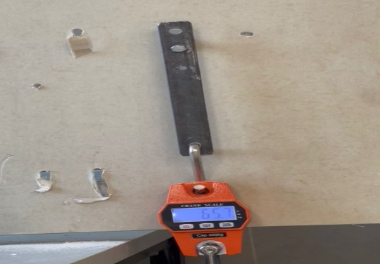

Fig. 15. Shear Testing
Fig. 15 shows that shear testing is valuable for industries where materials experience forces acting parallel to their surfaces, such as adhesive bonding, joints, or layered structures. The data obtained from shear tests helps engineers and material scientists design and select materials for applications where shear strength is critical. We experimented using a drill, and after experimenting with the three samples, we found that Reptiles drywall had the highest results among the other samples. Table 4 shows that our product is better than the market product we tested, possibly due to our product's material and the printing method.
Table 4. Shear testing results.
No. | Product from market  (kg) | Reptiles’  product  (kg) | Butterfly product (kg) | Fish product (kg)
1 | 49.3 | 65.7 | 54.3 | 56.7
2 | 52.2 | 60.2 | 52.4 | 58.3
3 | 50 | 63.7 | 52.9 | 55.1
4 | 54.6 | 58.6 | 55.2 | 55.7
5 | 49.7 | 60.5 | 51.6 | 54.8
Avg | 51.2 | 61.7 | 53.3 | 56.1

Tensile Analysis
Tensile testing is a mechanical test used to determine the behavior of materials under tension. It involves pulling a material sample until it breaks while measuring the applied force and the resulting elongation or deformation. The test helps understand the material's strength, elasticity, ductility, and mechanical properties. The process typically involves clamping a sample between two grips and gradually applying force until the material fails, providing valuable data for engineering and material science purposes.
 | 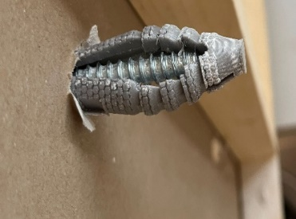
a) Reptiles drywall | b) Fish drywall
c) Butterfly drywall

Fig. 16. Shows the real images of tensile failure.

In this test, we noticed how the anchor works after the nail is inserted into it, as the reptile product differs from the butterfly and fish in terms of the product's shape behind the drywall, as shown in Fig. 16. Table 5 noticed in the following pictures that the reptile's anchor does not open but instead rotates around itself, unlike the butterfly's and fish's anchor, which is why the reptile's anchor is the weakest in this test, unlike the other tests.

Table 5. Tensile testing results.
No. | Product from market  (kg) | Reptiles’  product  (kg) | Butterfly product (kg) | Fish product (kg)
1 | 30.9 | 19.3 | 25.7 | 28.5
2 | 31.2 | 20.1 | 26.1 | 29.7
3 | 31.8 | 21.2 | 25.9 | 28.8
4 | 31.5 | 21.9 | 26.6 | 29.3
5 | 32.4 | 22.5 | 26.9 | 30.1
Avg | 31.56 | 21 | 26.24 | 29.28

Cantilever Analysis
The cantilever method involves subjecting the drywall anchor to a load by fixing one end securely to a vertical surface, simulating the conditions it would experience in a real-world application. Fig. 17 shows that the cantilever test is considered one of the most weight-bearing tests.
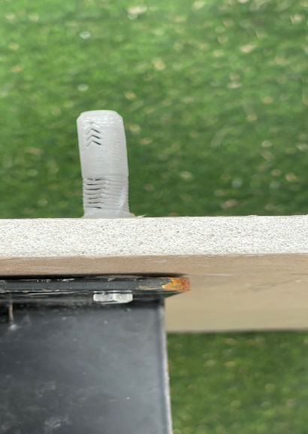

Fig. 17. shows the weight-bearing tests.
Our cantilever is based on 2 brackets, each 20cm. The result was similar to the shear test, in which the reptiles could hold higher than the other products, as shown in Table 6.
Table 6. Cantilever testing results.
No. | Product from market  (kg) | Reptiles’  product  (kg) | Butterfly product (kg) | Fish product (kg)
1 | 55.8 | 68.9 | 61.8 | 61.7
2 | 57.2 | 65.9 | 57.5 | 64.5
3 | 56.5 | 69.1 | 60.4 | 59.7
4 | 60.1 | 62.5 | 59.9 | 59.1
5 | 53.9 | 65.2 | 62.3 | 60.3
Avg | 56.7 | 66.3 | 60.4 | 61.0

Conclusions
In recent years, 3D printing has revolutionized manufacturing, including the construction industry. Traditional drywall anchors have limitations in terms of durability and installation. This research project aims to develop a new 3D-printed drywall anchor design inspired by animal skin textures. Incorporating these aspects into the design would create a more durable and efficient solution that can withstand heavy loads and reduce damage. The design focuses on using PLA engineering, which provides a strong material. The anchor is self-drilling and can be installed without pre-drilled holes. Biomimicry presents an opportunity to explore nature-inspired engineering solutions. The project's objectives include developing and optimizing the design, testing its performance, and evaluating installation and removal. This approach could be extended beyond skin textures to other animal-inspired designs, such as the structure of bones or spider webs. Using biomimicry in the design of the drywall anchor also presents an opportunity to explore the potential of nature-inspired engineering solutions in the construction industry, leading to more sustainable and efficient building practices. The research project's objectives include developing and optimizing the drywall anchor design, testing its performance under different loads and conditions, and evaluating its ease of installation and removal. An environmental impact assessment of 3D printing and PLA engineering will be conducted. This research project aims to develop a sustainable and efficient construction industry by creating an innovative drywall anchor design through 3D printing and biomimicry.

Data Availability
The data used to support the findings of this study are included in the article. Further data or information is available from the corresponding author upon request.

Declaration of Conflict Interest
The authors state that they have no recognized competing financial interests or personal relationships that could appear to have influenced the work described in this paper.

References
- Kapsali, V., 2016. Biomimetics for designers. Thames & Hudson.
- Albalawi, H.I., Khan, Z.N., Valle-Pérez, A.U., Kahin, K.M., Hountondji, M., Alwazani, H., Schmidt-Roach, S., Bilalis, P., Aranda, M., Duarte, C.M. and Hauser, C.A., 2021. Sustainable and eco-friendly coral restoration through 3D printing and fabrication. ACS Sustainable Chemistry & Engineering, 9(37), pp.12634-12645.
- Verbrugghe, N., Rubinacci, E. and Khan, A.Z., 2023. Biomimicry in Architecture: A Review of Definitions, Case Studies, and Design Methods. Biomimetics, 8(1), p.107.
- Tay, Y.W.D., Panda, B., Paul, S.C., Noor Mohamed, N.A., Tan, M.J. and Leong, K.F., 2017. 3D printing trends in building and construction industry: a review. Virtual and Physical Prototyping, 12(3), pp.261-276.
- Antonini, E., Boeri, A. and Giglio, F., 2022. Classification criteria and markers for biomimetic building envelope within circular economy principles: a critical review. Architectural Engineering and Design Management, 18(4), pp.387-409.
- du Plessis, A., Babafemi, A.J., Paul, S.C., Panda, B., Tran, J.P. and Broeckhoven, C., 2021. Biomimicry for 3D concrete printing: A review and perspective. Additive Manufacturing, 38, p.101823.
- Nadagouda, M.N., Ginn, M. and Rastogi, V., 2020. A review of 3D printing techniques for environmental applications. Current opinion in chemical engineering, 28, pp.173-178.
- Fratzl, P., 2007. Biomimetic materials research: what can we learn from nature's structural materials?. Journal of the Royal Society Interface, 4(15), pp.637-642.
- Yi, L., Glatt, M., Sridhar, P., de Payrebrune, K., Linke, B.S., Ravani, B. and Aurich, J.C., 2020. An eco-design for additive manufacturing framework based on energy performance assessment. Additive Manufacturing, 33, p.101120.
- Uchiyama, Y., Blanco, E. and Kohsaka, R., 2020. Application of biomimetics to architectural and urban design: A review across scales. Sustainability, 12(23), p.9813.
- Liu, Z., Jiang, Q., Zhang, Y., Li, T. and Zhang, H.C., 2016, June. Sustainability of 3D printing: A critical review and recommendations. In International Manufacturing Science and Engineering Conference (Vol. 49903, p. V002T05A004). American Society of Mechanical Engineers.
- Lenau, T.A., 2009. Biomimetics as a design methodology-possibilities and challenges. In DS 58-5: Proceedings of ICED 09, the 17th International Conference on Engineering Design, Vol. 5, Design Methods and Tools (pt. 1), Palo Alto, CA, USA, 24.-27.08. 2009 (pp. 121-132).
- Chadha, U., Abrol, A., Vora, N.P., Tiwari, A., Shanker, S.K. and Selvaraj, S.K., 2022. Performance evaluation of 3D printing technologies: a review, recent advances, current challenges, and future directions. Progress in Additive Manufacturing, 7(5), pp.853-886.
- Dommati, H., Ray, S.S., Wang, J.C. and Chen, S.S., 2019. A comprehensive review of recent developments in 3D printing technique for ceramic membrane fabrication for water purification. RSC advances, 9(29), pp.16869-16883.
- ASTM D638 - 10, Standard Test Method for Tensile Properties of Plastics, D20.10, Ed. West Conshohocken, PA: ASTM International, 2011. [Online]. Available: www.astm.org
- Comprehensive Guide on Thermoplastic Polyurethanes (TPU).” Thermoplastic Polyurethane (TPU) Material: Properties & Applications, omnexus.specialchem.com/
selection-guide/thermoplastic-polyurethanes-tpu. Accessed 29 May 2023.
- 3D Printing Materials Simply Explained.” All3DP, 25 Apr. 2022, all3dp.com/2/what-is-pla-3d-printing-materials-simply-explained/. “ Properties of Nylon.” Xometrys RSS, 4 Aug. 2022

