Mechanical Behavioral of Orthopedic Footbed Vertical Curlicue Auxetic Structure

Salem Awadh Alsurur¹
¹ Department of Medical Equipment Technology, College of Applied Medical Science, Majmaah University, Al-Majmaah, Riyadh, 11952, Saudi Arabia

Abstract
Diabetic foot ulcer is a common worldwide disease resulting in major or minor amputations. Different researchers have suggested that foot ulcers are curable if treated properly. Offloading the ulcer area is the first step in healing foot ulcers. Advanced orthopedic footwear is required to effectively distribute plantar pressure without stressing the ulcer. Based on the literature survey, auxetic structure can be the potential design variable for orthopedic footwear. The maximum compressive strength of specimen 1 is about 0.5 MPa. In this project, two material specimens with auxetic structures are tested. Tensile, compressive, and 3P bending tests are carried out. A comparison is made between materials by plotting stress-strain curves. Specimen 1 performed well under testing conditions and is better for auxetic structure footwear. FEA analysis is carried out to verify the result. The maximum compressive strength of specimen 2 is around 0.1 MPa. The average tensile strength of both specimens is approximately 3.135 MPA. Overall, the results of this study highlight the potential of auxetic structures in orthopedic footwear for diabetic foot ulcer treatment. Specimen 1, with its superior performance in the tests conducted, shows promise for further development and implementation in this field.
Keywords:
Diabetic foot ulcer; Orthopedic footwear; Auxetic structure; Compressive strength; Tensile strength.

Submitted:
6-APR-24

Accepted:
7-MAY-24

Published:

DOI:

Distributed under
Creative Commons CC-BY 4.0

OPEN ACCESS

Introduction
The wounds associated with the foot require significant attention in the medical field because they are a substantial part of the human body. The damage might be due to fatal accidents, cuts, or general conditions. Medically, injuries are typically divided into two categories: acute wounds and chronic wounds. Acute wounds are formed due to sudden injury [1-18].
If a patient is healthy and has no records of chronic diseases, these wounds heal within a few weeks. On the other hand, regular damage results from an old disease [2]. This project is typically based on addressing chronic wounds of the foot. A foot ulcer is a particular case of a chronic injury caused by diabetes [4]. Diabetes is a medical condition in which a patient's pancreas loses its ability to form insulin [5].
In the human body, an issue is a chemical formed that helps absorb glucose formed by the breakdown of food. Due to dysfunction of the pancreas, the blood sugar level rises. There is no way to cure diabetes; however, it can be controlled to prevent other complications. The statistics of some countries with increasing diabetes are shown in Figure 1 [19].
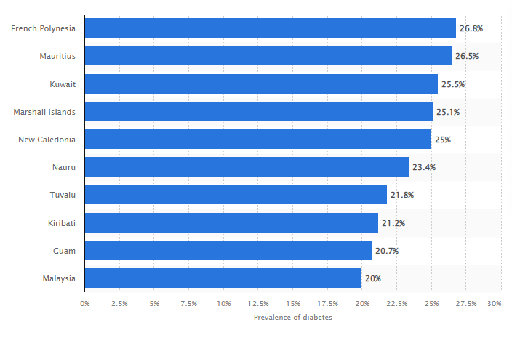
Figure 1. The statistics of some countries with increasing rates of diabetes [19].

One of the complicated stages of diabetes is the damage to neurons. In these conditions, a patient loses the sense of pain, and it is typically started from the foot. There is a blockage of blood vessels from leg to toe in some cases. This phenomenon cuts the blood supply of the toe. The complications in neuropathy and blood vessels result in diabetic foot ulcers. It is a condition in which the toe tissue starts to die. If this condition remains untreated, it softens the muscles and bones. In medical terms, this condition is called Charcot's foot [20]. The other name of 3D printing is additive manufacturing, which initially came in the 1980s and has made more and more progress. 3D printing has evolved to cover various distinct technologies as it originated as a tool for fast prototyping.
Charcot's foot is a medical condition caused by the complications of diabetes. This is due to peripheral neuropathy, in which the neurons of the lower foot get damaged and disconnected from the body [21]. The sensation of pain is lost due to the damage of neurons. The joints, muscles, tissues, tendons, and joints get effective due to the condition of the Charcot's foot. Bones lose strength and can easily break if excessive pressure is applied [14]. It explores the advantages of 3D printing, including its design adaptability and swift prototyping capabilities. Furthermore, it delves into the difficulties of integrating reinforcement materials into the polymer matrix used in this process [23]. This research investigates the impact of infill configuration and density on the crashworthiness and crash performance of 3D-printed structures subjected to quasi-static axial loading [24]. This study aims to analyze the influence of infill pattern structure on the crashworthiness and deformation characteristics of 3D-printed tubes when subjected to quasi-static axial compression loads [25].
This study aims to offer a novel design approach for orthotic insoles that divides the insole into two sections to decrease plantar pressure. Industries or companies need help determining innovative methods to develop innovative business models or opportunities linked with the technology as the potential uses for 3D printing enhancement. Auxetic structures, also known as negative Poisson's ratio structures, are a fascinating area of research and development in materials science and engineering. Unlike conventional materials that expand in one direction and contract in the perpendicular direction when stretched, auxetic structures exhibit a unique growth property when subjected to an applied force. This complication worsens when there is an open wound on the foot, which causes foot deformation. There is a high probability of injection in the injury, which may result in the amputation of the lower limb. Various causes are registered daily in medical energies, and imputations are carried out due to diabetic complications. Utilizing 3D printing technology to produce insoles presents an opportunity to efficiently manufacture personalized insoles with fast turnaround times and cost-effectiveness [26]. The utilization of 3D-printed insoles is gaining traction in foot pathology management. Recent literature highlights numerous experimental studies focusing on 3D-printed whole-foot orthoses or pads. These studies explore their efficacy and potential benefits in addressing various foot-related conditions [28]. The advent of 3D printing positions it as a promising technology for meeting the demands of mass customization and the objectives of environmental, social, and governance (ESG) considerations during digital transformation [29].

Experimental Details

2.1 Materials
In single designs, Curlicue—re-entrant unit cells, modifications were made to the fundamental re-entrant Curlicue unit cell. Then, Flexible Polyurethane 3D-printed manufacturing material was used, as shown in Figure 2. The structure is considered (h) to be high. R is the angle, and the term of length is presented (l):

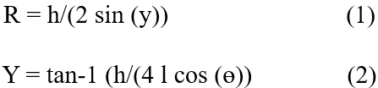

This research was carried out to examine the suitability of a thermoplastic polymer named polyurethane (TPU) compared to rigid protectors. This material is widely used in 3D printing, and this research evaluates all the associated results. Figure 2 shows the elliptical pockets used to replace the two vertical ligaments of the re-entrant unit cell in the Curlicue-entrant design, which was used in the original design.

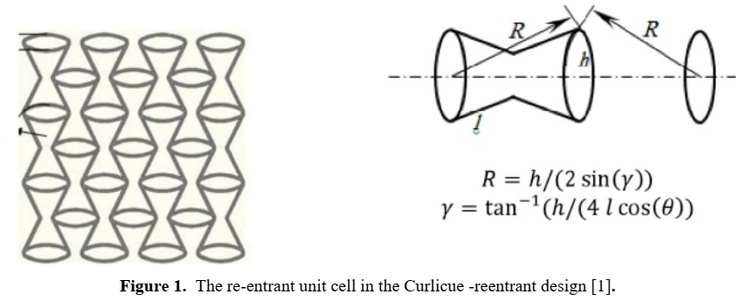

Figure 2. In the Curlicue reentrant design, elliptical pockets replace the two vertical ligaments of the re-entrant unit cell.

2.2 Methodology
The methodology is based on reducing the pressure on the foot ulcer's region by optimizing the footwear’s insole design. Selecting suitable materials is a primary requirement for designing footwear for diabetic patients. Reducing the pressure on the foot ulcer's region will eventually promote its healing. The selection of suitable footwear materials may prevent ulcers in diabetic patients. This study aims to offer a novel design approach for orthotic insoles that divides the insole into two sections to decrease plantar pressure.
Materials selection is based on research methodology. Different materials are used in 3D printing, such as PLA, ABS plastic, polycarbonate material, thermoplastic, etc. Material selection is carried out with suitable assumptions and reasons. For this project, polyurethane material is selected. The reason for choosing this material is that it has excellent mechanical properties and the potential to withstand the pressures applied by the human foot. [22]. After selecting the material, the next step in the methodology is to make a computer-aided design. This design will be tested using finite element analysis to determine its results.

2.3 CAD Design Software Used
SolidWorks is computer-aided design software that is popular in creating engineering products. The company was established in 1993 and released its first CAD software in 1995. The founder of this company is Jhon Hirsch Tick, an MIT graduate student. The main goal of this software was to provide CAD design, but it was submerged with other software to enhance its capabilities. New features like simulations, CDF analysis, photorealistic renderings, CAM, drawings, and PCB designs have been added to the latest release of SolidWorks 2020. Various additions are also introduced in every release, including weldments, SolidWorks plastics, mold creation, and surfacing. This is a powerful tool with a complete design and fabrication package. SolidWorks is based only on the Windows operating system and cannot be run on MacBook. Dassault System is also a CAD software manufacturing company. CATIA is the product of Dassault Systems, and it purchased SolidWorks in 1997. [13].

3D Printing Fabrication
The evolution of 3D printing is a rapid advancement in industries and companies that use this technology. The use cases and applications change along with companies while broadly including tooling aids, functional and visual prototypes, or end components. Industries or companies struggle to determine innovative methods to develop innovative business models or opportunities linked with the technology as the potential uses for 3D printing enhancement. The application of traditional manufacturing methods is limited mainly by the element's geometrical complexity or the production size run, and due to this, one employs the tools and processes that enhance the element's final budget being developed. The working of 3d printing is shown in Figure 3 [1].
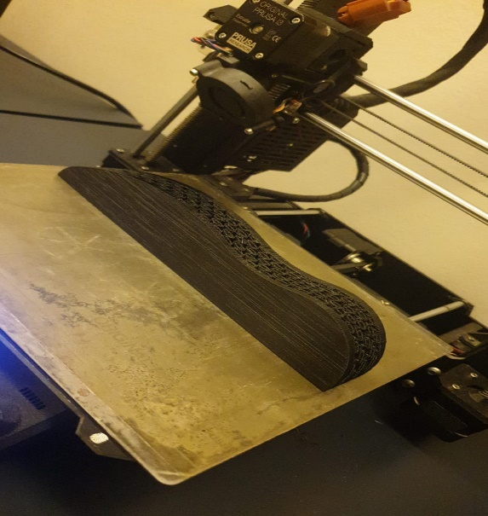

Figure 3. The work on 3d printing.
The different techniques of additive manufacturing supply mainly competitive benefits because they are adapted to the complexity of geometrical or element-customized design to be modeled. Following the application field, some of the essential things can be accomplished like products of multi-material products of ergonomic, effective little productive runs, lighter products of weight, lower linked budgets, lower investment budgets, the integration of a variety of processes of manufacturing, the optimal materials use, or the efficient method of manufacturing. AM is considered the most inflictive stage of the industry for the following few eras. AM has a few options, including ordinary RepRap machinery and complicated structures of fused metal deposition. The organization is employing additive manufacturing to replace the scale economies, which hinder the commercialization of the innovative product, with scope economies, which enable achieving goals and products cheaper and faster or launching and testing creative ideas as early as possible.
Figure 4 shows Flexible Polyurethane 3D-printed manufacturing with the diameter of the nozzle’s filament. The maximum diameter of the filament was 1.75 mm, with a tolerance of 0.05m, which is used in 3D printing.

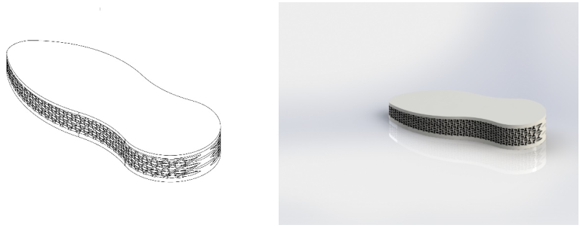
Figure 4. (a) CAD design, (b) Final rendering

Table 1. 3D Printing Main FDM printing parameters.

Extruder Temp | 250 degrees
Bed Temp | 80 degrees
Printing Speed | 45 mm/s
Extruder Multiplier | 1
Filament Diameter | 1.75
Needle outer diameter | 0.4
Needle inner diameter | 1.8
Raster width | 0.25
Layer height | 0.25
First layer height | 0.25
Fill density | 100%

An insole with a thickness of 1.75 mm was designed using CAD software (SOLIDWORKS); TPU samples were 3D printed under different conditions to form test pieces for tensile, impact, and compressibility tests based on the appropriate standards. The model sample size was selected for adult Female foot size. 36 EU, as shown in Figure 5.

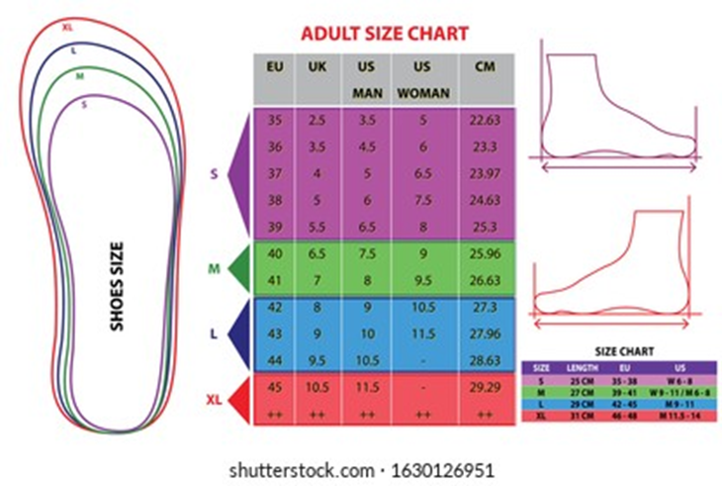
Figure 5. Adult Shoe Size Chart.

Tensile Testing
Then, physical testing will be done using the Instron 3365 dual-column Universal Testing System (UTS) to find tensile, compressing, and bending stresses. When stresses are applied parallel to the material axis, the material stretches in the direction of the applied force. This stretch is called tension. Tension is a physical property of the material that helps determine its resistance under tensile loads. The insole will be tested using tensile forces to determine the behavior of the thermo-polymer used [10].

Figure 6 shows the specimen under tensile loading. It is completely stretched under the tensile load. The image was taken during the middle of the test.

A B
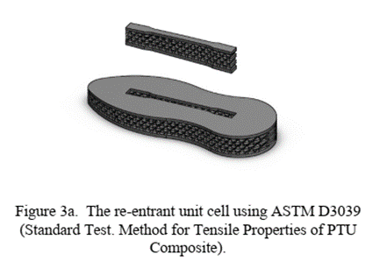 | 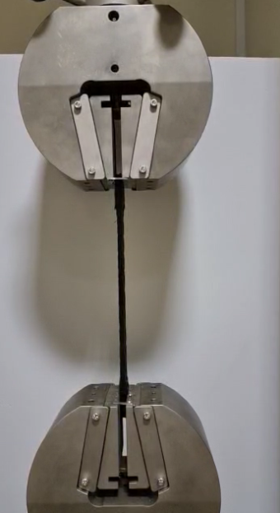
Figure 6. (A) The re-entrant unit cell using ASTM D3039 (standard testing method for Tensile properties of PTU composite, (B) The specimen under tensile loading.

Bending Testing
The bending usually occurs at the material's perpendicular axis. This project will determine the bending produced in the insole by human foot pressure. Bending testing will be done using the Instron 3365 dual-column Universal Testing System (UTS) to find bending stresses.
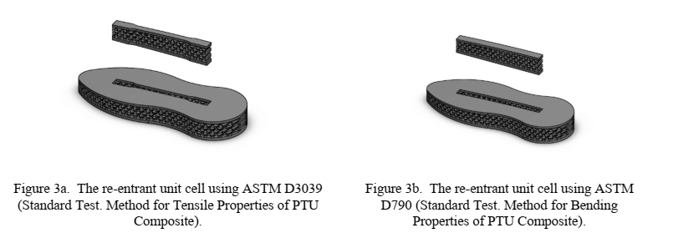
Figure 7. The re-entrant unit cell using ASTM D790 (standard testing method for Bending properties of PTU composite.
Figure 7 shows the specimen under 3-point bending loading. The specimen is completely pressed from the center under the 3P load. The image was taken during the middle of the test. Figure 8 shows the specimen before and after 3P bending loading. The bending characteristics of the specimen can be observed. The specimen was bent entirely during loading, but it did not break. This represents the effectiveness of this material.
A B
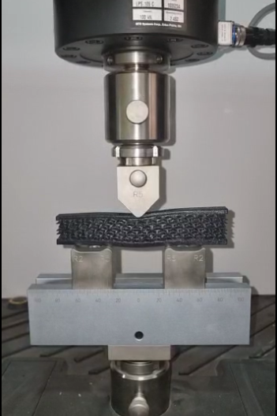 | 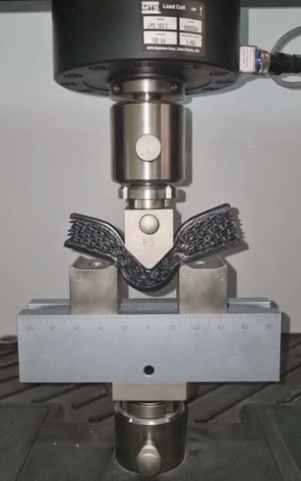
Figure 8. The specimen is shown before and after 3P bending loading.

Compressive Testing
Compressive testing is a fundamental method used in material mechanisms to find the internal resistance of a material to the applied load. It also covers the tendency of a material to resonate with its physical share when the pressure is removed. Compressive testing is only possible if the applied stress exceeds the material's elastic limit. The previous three tests were used to test the geometrical structures, models, and the specific features and uses of the auxetic polymeric materials created in this work. Compressive testing will use the Instron 3365 dual-column Universal Testing System (UTS) to find compressing stresses.
When the loading is applied, the material is stretched. If the loading is within the elastic limit, its shape is restored. If the stresses exceed the yield point, permanent deformation occurs, resulting in rupture or material failure. The arrangement of the experiment consists of a sole on which load is applied. Compared to the flat construction, the support region is located beneath the midfoot, shares a portion of the plantar pressure, and has good acceleration control characteristics, as shown in Figure 9.
Figure 9. The re-entrant unit cell using ASTM D7137 (standard).

Figure 10 shows the specimen under compressive loading. It is completely squeezed under the compressive load. The image was taken during the middle of the test.
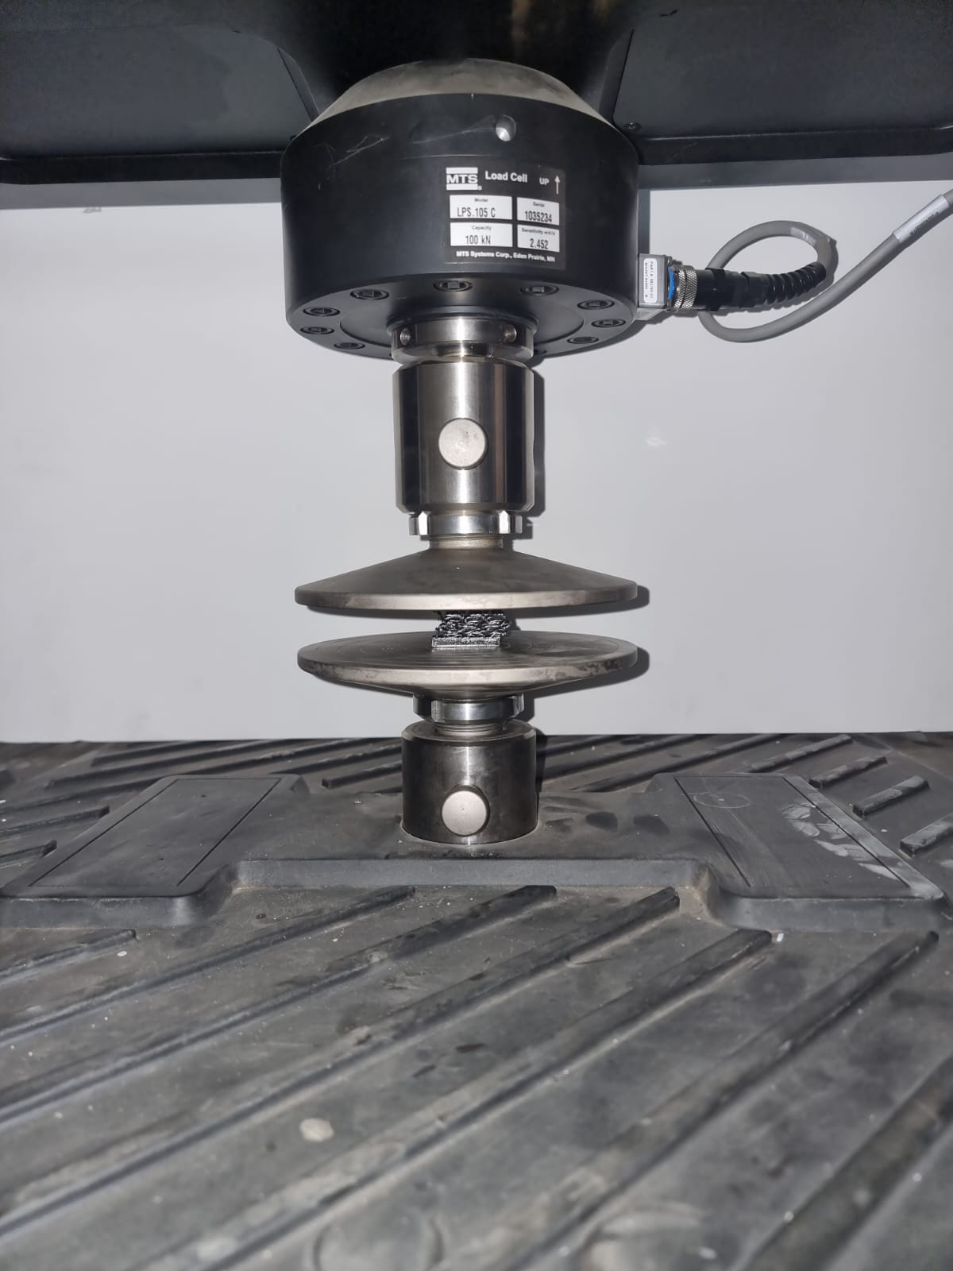
Figure 10. The specimen is under compressive loading.

Results and Discussion

4.1 Tensile Analysis
The tensile analysis provided valuable insights into the behavior of the 3D-printed structures under tensile loading conditions. The results demonstrated the strength and mechanical properties of the printed materials. During the tensile testing, the 3D-printed specimens exhibited excellent tensile strength and ductility. The materials displayed remarkable resistance to applied forces, with minimal deformation and no signs of fracture or failure. The analysis also revealed that the infill pattern structure significantly impacted the printed structures' tensile properties. Certain infill patterns enhanced tensile strength and improved load distribution across the specimens. These patterns effectively resisted the applied forces, ensuring uniform stress distribution and reducing the risk of localized failure.
Additionally, the tensile analysis provided valuable data on the printed materials' elastic and plastic deformation behavior. The stress-strain curves exhibited well-defined yield points, indicating the materials' ability to undergo plastic deformation before reaching their ultimate tensile strength.
Overall, the tensile analysis demonstrated the impressive mechanical performance and structural integrity of the 3D-printed structures. The findings emphasize the importance of selecting suitable infill patterns to optimize the tensile properties and ensure reliable performance in applications requiring high tensile strength and resistance to deformation. Further research could advance material selection, design optimization, and manufacturing techniques for 3D-printed components subjected to tensile loading.
The ASTM D638 technique for classical polymer testing was used in this experiment, which is defined in detail in the standard. Since this standard specifies the use of a form specimen and constant speed, it has been concluded that a 5mm/min specimen and a frequency of 20 Hz were selected in the data acquisition. In addition, the tensile tests were carried out on the SHIMADZU machine, which was fitted with a 5kN load cell. The tensile load P[N] and upper crossbar displacement DL were recorded and saved.
Figures 11 represent the stress-strain curves obtained from the tensile tests on the two identical test specimens; their average is calculated and indicated in the figure. The tensile test clearly shows yield strength, yield strength, yield stress, ultimate strength, strain, ultimate stress, breaking strength, and breaking strength. The test also indicates breaking strength, breaking strain, and breaking strain. The linear elastic modulus of elasticity is the proportionality coefficient between stresses and strains in the linear elastic region. The ultimate tensile strength is the maximum stress value it can tolerate before breaking on a stress-strain curve. Stress-strain curves are graphic and are characterized as having a maximum value reached by constraint at a certain point.
The preceding figure can be used to extract the tensile yield strength and tensile ultimate strength values. The tensile strength of specimen 1 is about 15 MPa, and that of specimen 2 is around 8.9 MPa. The blue line indicates the average of both results at approximately 7.1 MPA.
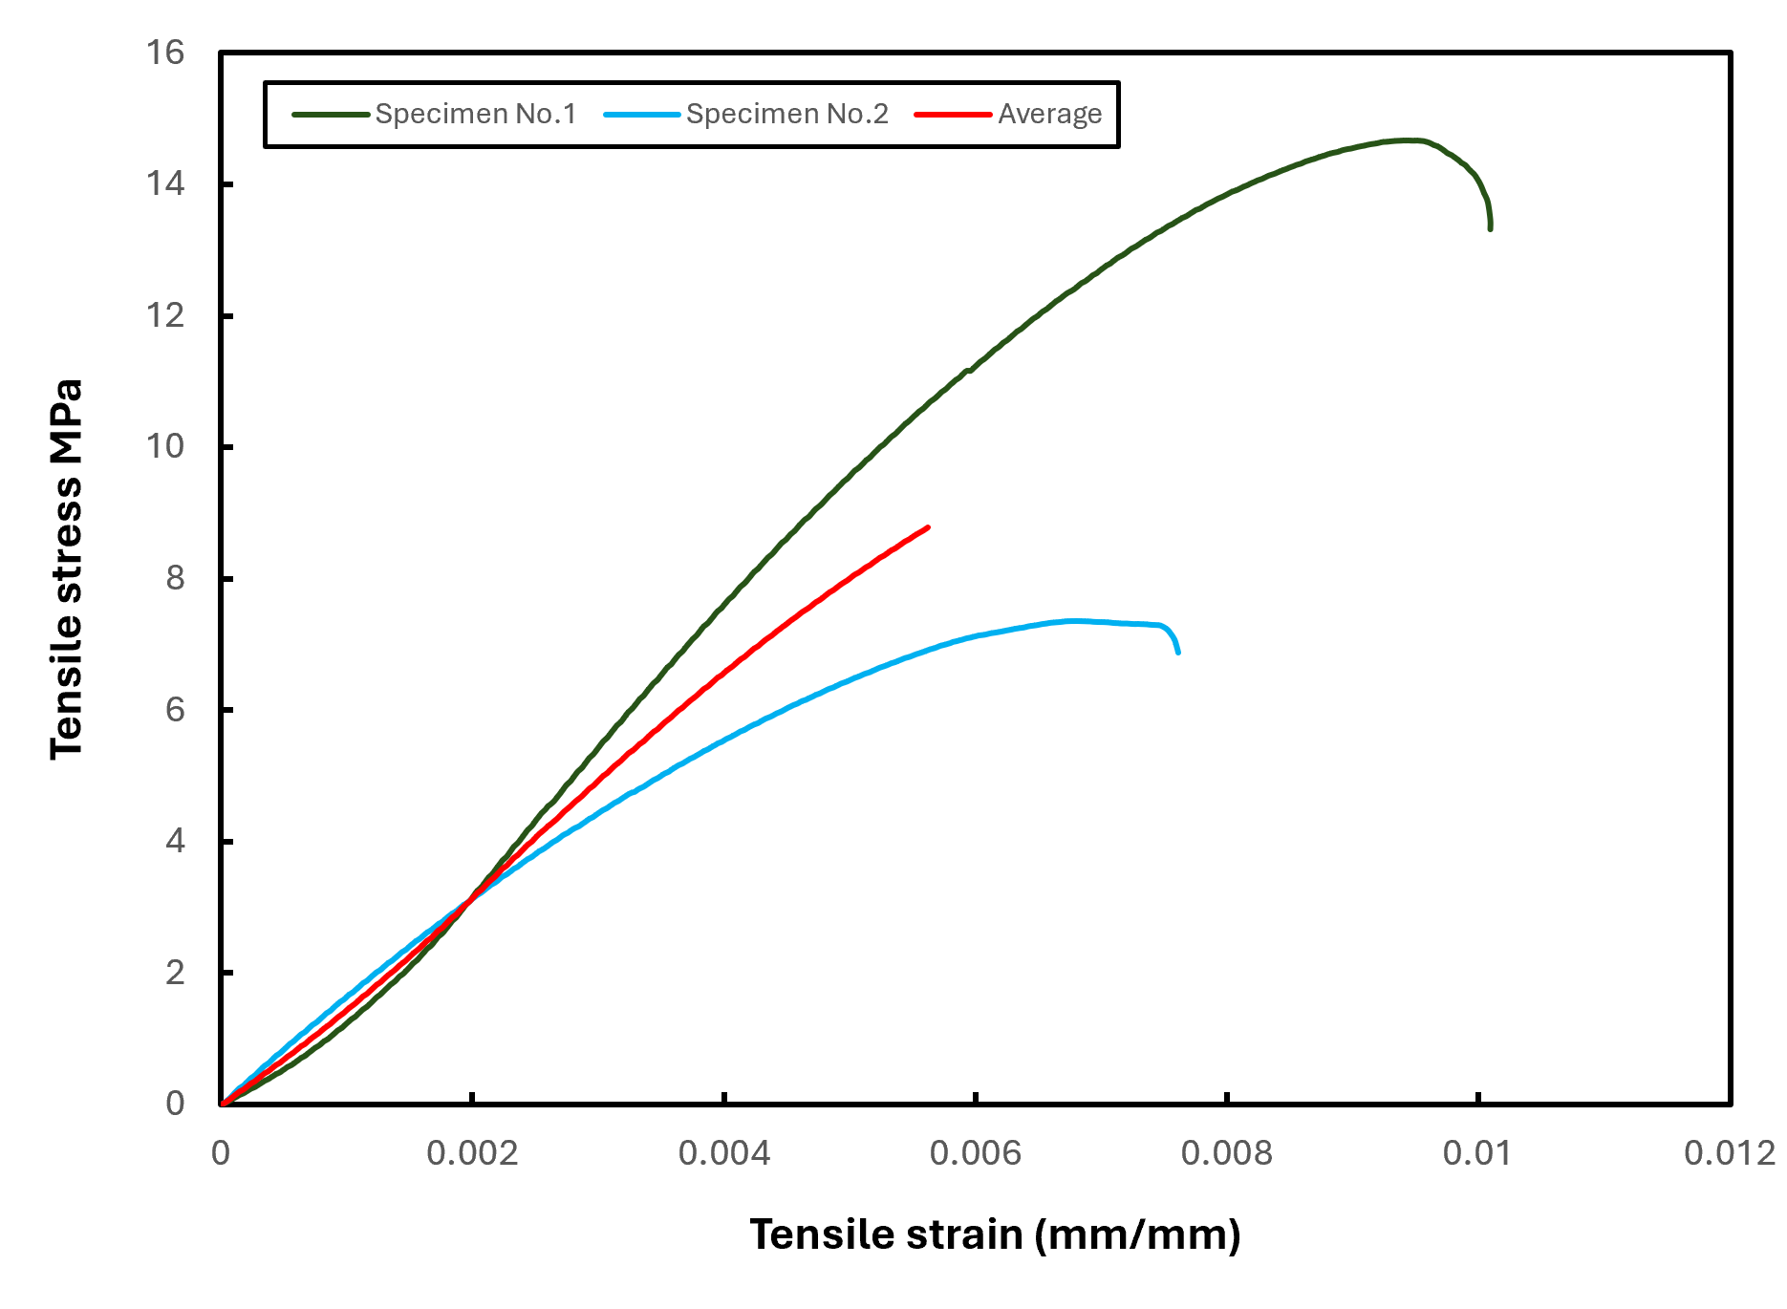
Figure 11. The stress-strain curves were obtained from the tensile tests on the two identical test specimens.

Figures 12 and 13 offer a brief overview of the proposed values, enabling researchers to discuss the results quickly. These figures help to give the values of tensile yield strength. The tensile yield strength of specimen 1 is about 3.14 MPa, and that of specimen 2 is around 3.13 MPa. The blue line indicates the average of both results at approximately 3.135 MPA.

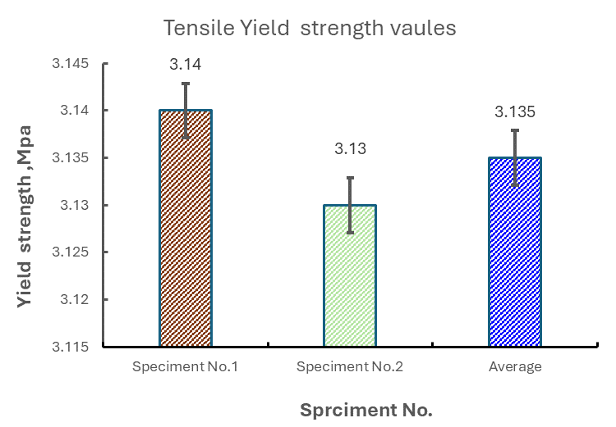

Figure 12. Tensile yield strength values.

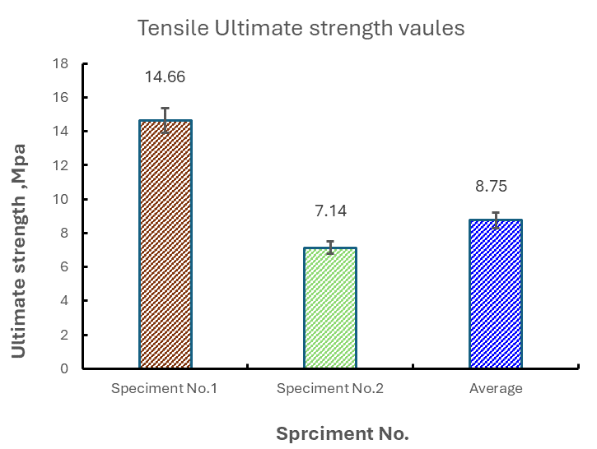
Figure 13. Ultimate tensile strength values.

4.2 Compression Analysis
The compression analysis revealed significant findings. The 3D-printed structures exhibited remarkable resistance to axial compression loads. The infill pattern structure played a crucial role in determining the crashworthiness and deformation behavior of the tubes. Specifically, certain infill pattern structures improved crashworthiness. These structures effectively distributed the applied load, enhancing energy absorption and deformation control. As a result, the 3D-printed tubes exhibited higher structural integrity and reduced risk of catastrophic failure during compression. Furthermore, the deformation history analysis indicated that the infill pattern structure influenced the post-crash behavior of the tubes. Certain patterns exhibited a more gradual and controlled deformation process, allowing for better absorption of impact energy and reducing the likelihood of sudden structural collapse. These findings highlight the importance of selecting appropriate infill pattern structures in 3D-printed designs to optimize crashworthiness and deformation characteristics. Further research and development in this area could lead to advancements in designing and manufacturing 3D-printed structures for applications requiring high-impact resistance. This compression test used the ASTM D695-15 technique for classical polymer testing, detailed in the standard. Since this standard specifies the use of a form specimen and constant speed, it has been concluded that a 5mm/min specimen and a frequency of 20 Hz were employed in the data collection.
Compression tests were also performed on the SHIMADZU machine with a 5kN load cell. During these tests, the compression load P[N] and the displacement DL (in [mm]) of the upper crossbar were recorded and saved. Two different specimens were tested to determine their reaction under compressive loading. The results obtained from the compression test are presented in graphs, as shown in Figure 14.
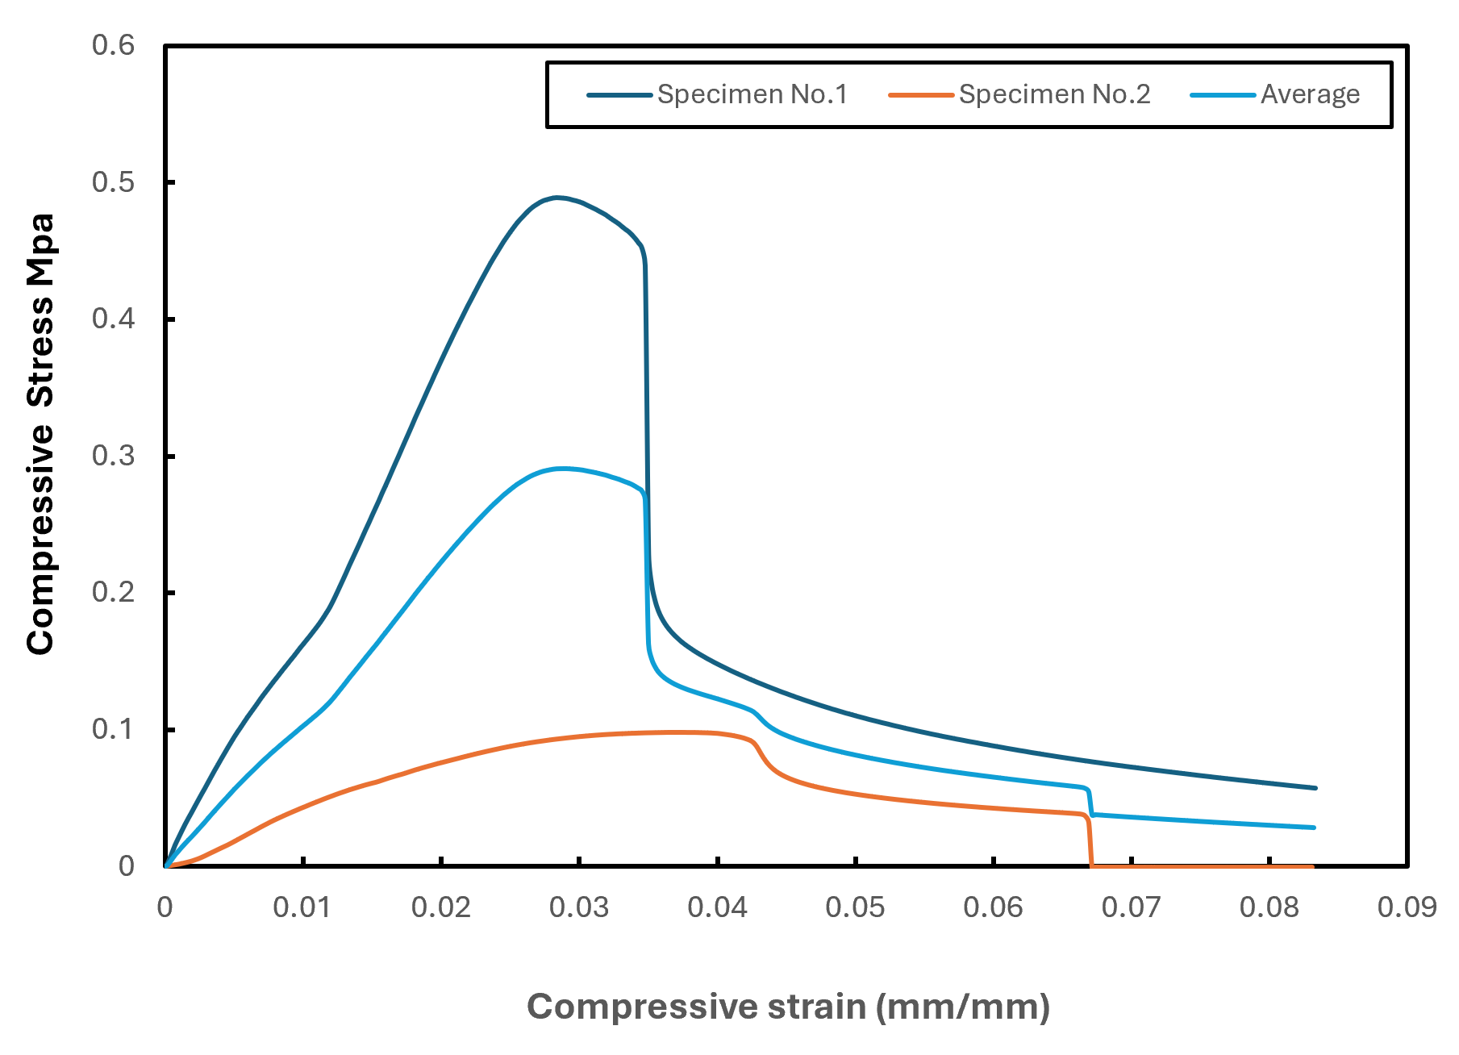

Figure 14. The results obtained from the compression test.
This figure helps to give the values of compressive strength. The maximum compressive strength of specimen 1 is about 0.5 MPa, and the maximum compressive strength of specimen 2 is around 0.1 MPa. The average of both results is indicated in the yellow line at around 0.1 MPA.
The ASTM 695 compression test provides information on the ultimate and compressive yield strength. Figures 15 & 16 provide a high-level summary of the recommended values, allowing researchers to discuss the results straightforwardly.
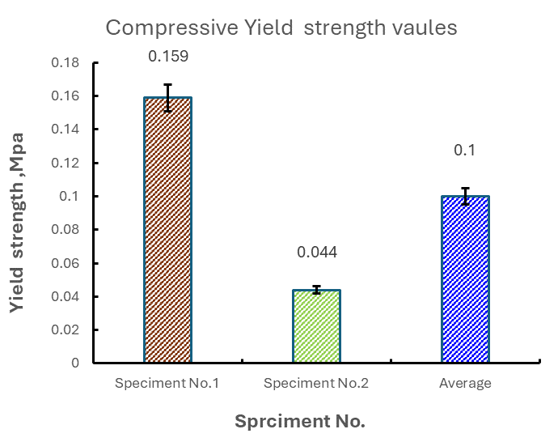

Figure 15. Compressive yield strength.
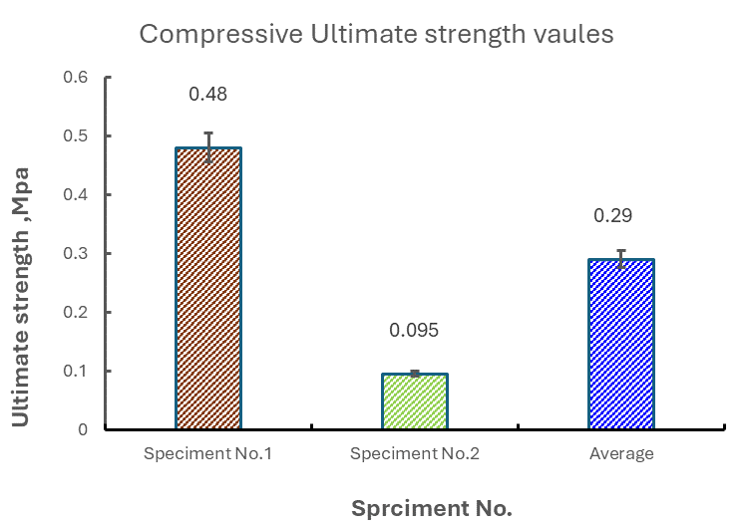

Figure 16. Compressive ultimate strength.

4.3 Three-Point Bending Analysis
The three-point bending analysis provided valuable insights into the structural behavior and strength of 3D-printed components when subjected to bending loads. The results shed light on the flexural properties and deformation characteristics of the printed structures.
During the three-point bending test, it was observed that the 3D-printed components exhibited considerable resistance to bending loads. The infill pattern structure played a crucial role in determining the flexural strength and behavior of the printed parts.
The analysis revealed that certain infill patterns improved flexural strength and stiffness. These patterns effectively distributed the applied load, reducing stress concentrations and minimizing the risk of structural failure. As a result, the 3D-printed components displayed enhanced bending resistance and maintained their structural integrity even under significant bending forces. Furthermore, the three-point bending analysis provided valuable data on the deformation behavior of the printed structures. The load-displacement curves exhibited distinct elastic and plastic regions, indicating the materials' ability to undergo reversible and irreversible deformations during bending.
The findings of the three-point bending analysis highlight the importance of selecting appropriate infill patterns to optimize the flexural properties and ensure the reliable performance of 3D-printed components in bending applications. Further research and development could advance design optimization, material selection, and manufacturing techniques for 3D-printed structures subjected to bending loads.
In this three-point bend test, fully described in the standard, the ASTM 790 procedure was used for the conventional polymer test. The machine was programmed with a crosshead movement speed (R) equal to 1.4 mm per minute. A bending test was performed in three different directions. Figures 17 represent the bending deformation results obtained by performing a bending test on two specimens.
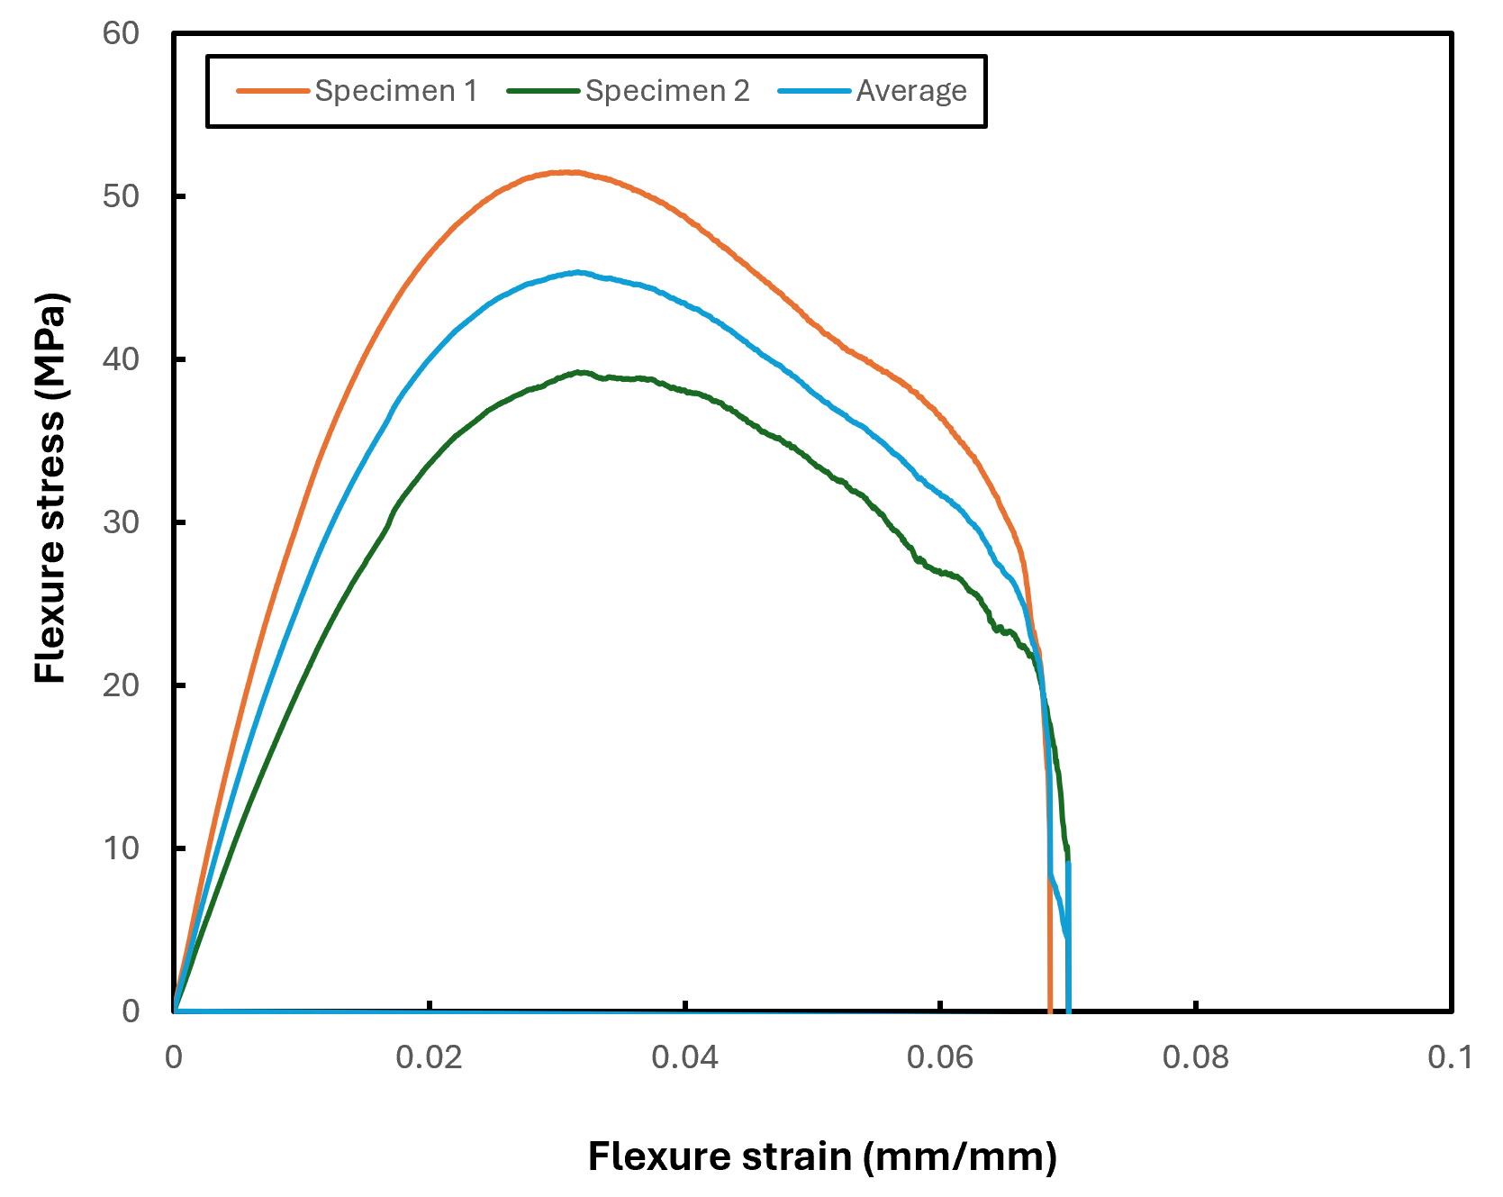
Figure 17. The graph between flexure stress and flexure strain.
The ASTM 790 three-point bending test may provide information on the Modules of Elasticity, bending yield strength, and Bending Ultimate Strength. Figures 18 and 19 provide a high-level overview of the suggested values, enabling researchers to understand them easily.
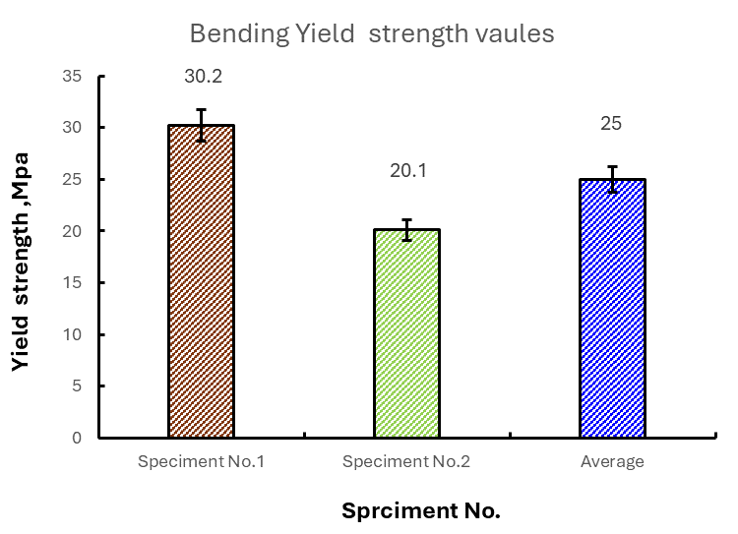

Figure 18. Bending yield strength values.
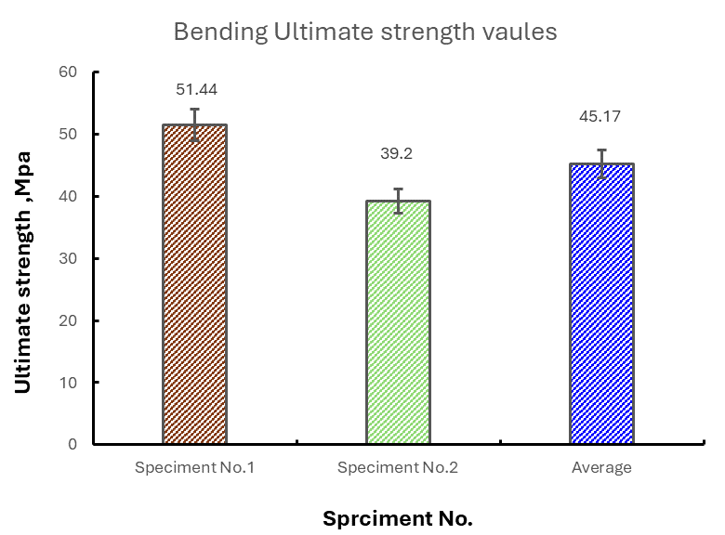

Figure 19. Bending Ultimate strength values.

Determine the ultimate strength by analyzing the stress at the point of failure or the maximum applied load before failure and dividing it by the cross-sectional area of the specimen. Consider the material properties and characteristics, such as elasticity, yield strength, and fracture behavior, as they can affect the ultimate strength values.

Data Availability
The data used to support the findings of this study are included in the article. Further data or information is available from the corresponding author upon request.

Declaration of Conflict Interest
The author states that they have no recognized competing financial interests or personal relationships that could appear to have influenced the work described in this paper.

Conclusions
The purpose of this project is to design an insole for orthopedic footwear. According to a research study, it is found that stress generally by foot can cause ulcers in diabetic patients. It is also found that this ulcer can be prevented by using suitable orthopedic footwear. Also, the existence of foot ulcer healing can be promoted using soft insole material. The material selected for this study is polyurethane, arranged in an auxetic structure. According to research, auxetic studies are very versatile and can be used as an insole of diabetic footwear because it has a negative Poisson ratio. Three different tests are performed: the 3-point bending, tensile, and compressive. In tensile testing, specimen 1 has a maximum stress of 14.6 MPa, and specimen 2 has a maximum of 7.4 MPa. The tensile and bending stresses created on the foot are absorbed and distributed equally. This helps to minimize the exercise pressure on the ulcer. The material study is carried out on the auxetic structure. Two specimens were studied under the ultimate testing machine. It is found that specimen 1 performed best in all tests, and it is suitable for manufacturing orthopedic footwear. In compressive, specimen 1 has a maximum stress of 0.15 MPa, and specimen 2 has a maximum stress of 0.04 MPa. Based on these values, specimen 1 showed maximum resistance toward applied stresses. In the bending testing, specimen 1 has a maximum stress of 51.4, and specimen 2 has a maximum of 39.4. It is concluded that specimen 1 is ideal for the Auxetic structure of orthopedic footwear.

References
- Ahangar, P., Cooke, M.E., Weber, M.H. and Rosenzweig, D.H., 2019. Current biomedical applications of 3D printing and additive manufacturing. Applied sciences, 9(8), p.1713.

- Jeffcoate, W., Lima, J. and Nobrega, L., 2000. The Charcot foot. Diabetic Medicine, 17(4), pp.253-258.

- Attaran, M., 2017. Additive manufacturing: the most promising technology to alter the supply chain and logistics. Journal of Service Science and Management, 10(03), p.189.

- Jorgetto, J.V., Gamba, M.A. and Kusahara, D.M., 2019. Evaluation of the use of therapeutic footwear in people with diabetes mellitus–a scoping review. Journal of Diabetes & Metabolic Disorders, 18(2), pp.613-624.

- Chaudhary, N. and Tyagi, N., 2018. Diabetes mellitus: An overview. International Journal of Research and Development in Pharmacy & Life Sciences, 7(4), pp.3030-3033.

- Cho, K.S. and Lee, J.H., 2021. Incidence and prevalence of pressure ulcers in hospitals: 10-year cohort study. Journal of Wound Care, 30(Sup12), pp.S38-S45.

- Diegel, O., Singamneni, S., Reay, S. and Withell, A., 2010. Tools for sustainable product design: additive manufacturing.

- Egbuna, C., Mishra, A.P. and Goyal, M.R. eds., 2020. Preparation of phytopharmaceuticals for the management of disorders: The development of nutraceuticals and traditional medicine. Academic Press.

- El-Butch, A.M., 2015. The Effect of the Geometry on The Negative Poisson’s Ratio of Re-Entrant Periodic Honeycomb Structure (Doctoral dissertation, Doctoral dissertation, Helwan University).

- Huerta, E., Corona, J.E., Oliva, A.I., Avilés, F. and González-Hernández, J., 2010. Universal testing machine for mechanical properties of thin materials. Revista mexicana de física, 56(4), pp.317-322.

- Faselis, C., Katsimardou, A., Imprialos, K., Deligkaris, P., Kallistratos, M. and Dimitriadis, K., 2020. Microvascular complications of type 2 diabetes mellitus. Current vascular pharmacology, 18(2), pp.117-124.

- Ganesan, S. and Ranganathan, R., 2018. Design and development of customised split insole using additive manufacturing technique. International Journal of Rapid Manufacturing, 7(4), pp.295-309.

- Systemes, D., 2011. Solidworks. 2019. Dessault Systemes: Vélizy-Villacoublay, France.

- Hastings, M.K., Johnson, J.E., Strube, M.J., Hildebolt, C.F., Bohnert, K.L., Prior, F.W. and Sinacore, D.R., 2013. Progression of foot deformity in Charcot neuropathic osteoarthropathy. JBJS, 95(13), pp.1206-1213.

- Hengsbach, S. and Lantada, A.D., 2014. Direct laser writing of auxetic structures: present capabilities and challenges. Smart materials and structures, 23(8), p.085033.

- Herderick, E.D., 2015. Progress in additive manufacturing. Jom, 67(3), pp.580-581.

- Hilton, J.R., Williams, D.T., Beuker, B., Miller, D.R. and Harding, K.G., 2004. Wound dressings in diabetic foot disease. Clinical Infectious Diseases, 39(Supplement_2), pp.S100-S103.

- Holman, H.R., 2020. The Relation of the Chronic Disease Epidemic to the Health Care Crisis. ACR open rheumatology, 2 (3), pp. 167-173.

- Nieto-Martinez, R., Barengo, N.C., Restrepo, M., Grinspan, A., Assefi, A. and Mechanick, J.I., 2023. Large scale application of the Finnish diabetes risk score in Latin American and Caribbean populations: a descriptive study. Frontiers in Endocrinology, 14, p.1188784.

- Paul, D.E.E.P.R.A.J. and Paul, K.A.R.T.H.I.K.A., 2012. Diabetes mellitus and its complications: A review. Int J Curr Pharm Res, 4(2), pp.12-7.

- Kucera, T., Shaikh, H.H. and Sponer, P., 2016. Charcot neuropathic arthropathy of the foot: a literature review and single-center experience. Journal of diabetes research, 2016.

- Chua, C.K. and Leong, K.F., 2014. 3D Printing and additive manufacturing: Principles and applications (with companion media pack)-of rapid prototyping. World Scientific Publishing Company.
- Abd-Elaziem, W., Khedr, M., Abd-Elaziem, A.E., Allah, M.M.A., Mousa, A.A., Yehia, H.M., Daoush, W.M. and El-Baky, M.A.A., 2023. Particle-reinforced polymer matrix composites (PMC) fabricated by 3D printing. Journal of Inorganic and Organometallic Polymers and Materials, 33(12), pp.3732-3749.

- Abd El Aal, M.I., Awd Allah, M.M., Abd Alaziz, S.A. and Abd El-baky, M.A., 2024. Biodegradable 3D printed polylactic acid structures for different engineering applications: effect of infill pattern and density. Journal of Polymer Research, 31(1), p.4.

- M. Awd Allah, M., Abdel-Aziem, W. and A. Abd El-baky, M., 2023. Collapse Behavior and Energy Absorbing Characteristics of 3D-Printed Tubes with Different Infill Pattern Structures: An Experimental Study. Fibers and Polymers, 24(7), pp.2609-2622.

- Gothard, A.T. and Anton, S.R., 2021, September. Towards Dynamic Characterization of Fully 3D Printed Capacitive Sensors for Footbed Pressure Sensing Applications. In Smart Materials, Adaptive Structures and Intelligent Systems (Vol. 85499, p. V001T03A005). American Society of Mechanical Engineers.

- Mancuso, M., Bulzomì, R., Mannisi, M., Martelli, F. and Giacomozzi, C., 2023. 3D-Printed Insoles for People with Type 2 Diabetes: An Italian, Ambulatory Case Report on the Innovative Care Model. Diabetology, 4(3), pp.339-355.

- Mancuso, M., Bulzomì, R., Mannisi, M., Martelli, F. and Giacomozzi, C., 2023. 3D-Printed Insoles for People with Type 2 Diabetes: An Italian, Ambulatory Case Report on the Innovative Care Model. Diabetology, 4(3), pp.339-355.

- Cheng, J. and Wang, J.C., 2024. Exploring the Feasibility of Advanced Manufacturing for Mass Customization of Insoles in the Context of ESG. International Journal of Precision Engineering and Manufacturing-Green Technology, pp.1-18.

