Effect of Intake Conditions and Combustion Factors on Gasoline and Diesel Engines Performance and Exhaust Emissions

Ahmed Sayed Ahmed Hassan ¹, and Ali Saeed Al-Shahrany ²
¹ Mechanical Engineering Department, Jazan University, Jazan, Kingdom of Saudi Arabia, Email: ashassan7@yahoo.com
² Mechanical Engineering Department, Jazan University, Jazan, Kingdom of Saudi Arabia, Email: aalshahrany@jazanu.edu.sa
Abstract
The effect of intake conditions from water injection, filter presence, and temperature variations on the performance of petrol and diesel engines and gas pollution rates was studied. The experiment was conducted at varying speeds and loads for single-cylinder four-stroke engines. The composition of the exhaust emissions was analyzed to determine the combustion method. According to the results, injecting a mixture of water and air into the engine inlet can reduce engine emissions by 17-33% and exhaust temperature by 13-35% for both engines. When an air filter and water injection are present, air flow restrictions in the air inlet increase, leading to better combustion and less unburned mixture due to increased air availability.
In this theoretical study, we investigated the impact of combustion parameters on heat generation and emissions inside the combustion chamber of gasoline and diesel engines. We selected the following parameters to study: intake temperature, intake pressure, equivalence ratio, compression ratio, engine speed, turbulence kinetic energy, and combustion chamber design. Gasoline engine test results showed that higher intake temperatures lead to increased heat generation, increased overall engine efficiency, and reduced CO2 and NOx emissions. Increasing the value of the parity ratio led to improved overall efficiency of the two engines.
Keywords:
Gasoline engine; Diesel engine; Four strokes; Combustion; Water injection; Emission.

Submitted:
7-MAY-24

Accepted:
12-JUNE-24

Published:

DOI:

Distributed under
Creative Commons CC-BY 4.0

OPEN ACCESS

Introduction
Nguyen and Ocktaeck [1] studied the effect of combustion period on gasoline engines performance and proved that an increase in combustion time leads to decrease in maximum combustion temperature, pressure, and increase in the trapped residual gas. To improve engine power and reduce toxic gas emissions, [2 -4] improved injection timing, fuel-air ratios, and valve overlap. Different types of alternative fuels have been studied [5-9] as an effective way to reduce the production of toxic gases and solve the fossil fuel crisis.
Abdullah et al. [10] found that increasing air pressure improves combustion, reduces unburned fuel ratios, and improves fuel and energy consumption and exhaust emissions. Controlling the temperature of petroleum gas in the range of 30-40°C [11] reduces energy loss, increases engine braking force by about 1.85%, and reduces nitrogen oxide emissions by 2%.
Truong, et al. [12], found that the percentage of carbon dioxide and hydrocarbons decreased with the rich mixture combustion and vice versa with the poor one. Gong et al. [13] noticed that the exhaust gas temperature increased as the equivalence ratio increased. On the other hand, Zhao et al. [14] discovered that the highest energy gain and efficiency were attained when a compression ratio of 10 and a coefficient of 0.9 were used. Bhasker & Porpatham [15] concluded that raising the compression ratio in an SI engine increases the engine's brake thermal efficiency.
Chen et al. [16] showed that increasing the turbulence intensity in gasoline engines increases the initial rotation ratio, flame speed, and engine performance. In their study, researchers from [17-21] discovered that the efficiency of a gasoline engine can be improved by ensuring that the combustion process takes place entirely within the combustion chamber and by controlling the air intake conditions [22-27].
However, reducing the pressure inside the combustion chamber can lead to increased fuel consumption [28-30], which ultimately decreases engine efficiency and causes an increase in NOx emission [31, 32]. The researchers also found that mathematical programs supported their findings.
According to research [32], when the temperature of the air entering the engine is increased, it impacts the timing and duration of combustion. This, in turn, increases both the volumetric and braking efficiency of the engine. Ramesh and his team [33] have further confirmed this phenomenon and found that it also helps to reduce the levels of nitrogen oxide and smoke. Several studies have been conducted to investigate the impact of various factors on fuel consumption and pollution reduction.
For instance, the effect of burning room shapes and fuel-air ratio has been examined in references [34-37]. In addition, Melih and Bilge [38] investigated the impact of different variables, such as intake temperature, on gasoline performance and emissions. Further theoretical work was conducted by [39-41] on a gasoline engine to investigate how the mixed flame reacts to changes in intake pressure, temperature, and equivalence ratio.

Experimental Setup
In figure 1, you can see a test layer that has a spark ignition engine fitted with instruments to measure braking torque and temperatures in different areas, along with a gauge to determine fuel and air consumption rate. The gasoline engine is replaced with a diesel engine in figure 2. A digital meter on the control panel displays the engine speed. The engine cooling water inlet and outlet temperatures are measured by thermocouples, while the exhaust gas temperature is measured by a thermal sensor.
The AVL Di-gas analyzer (Fig. 3) is used to measure the engine exhaust emission as CO, HC, NOx, CO2, and O2. The measured uncertainty in specific fuel consumption is ±1.5%, brake power ±0.5%, brake thermal efficiency ±1%, NO emission ±4.1%, CO emission ±1.5%. Moreover, a computer model called "PROPOERTIES", was used to estimate combustion chamber final pressures and temperatures at different initial operating conditions for gasoline engine fueled with isooctane (C8H18).
The model was also capable to predicate emissions concentrations at different conditions (NOx, CO and CO2). Figure 4 shows sample of the input data and the output calculations obtained from "Propoerties" Model that used in calculations of different parameters like combustion chamber temperature, pressure, enthalpy, and Lewis number.
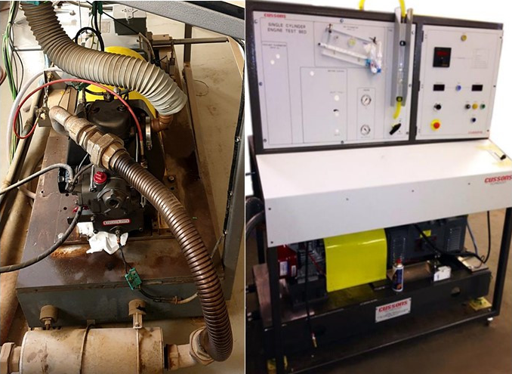

Fig. 1. Gasoline engine measuring device

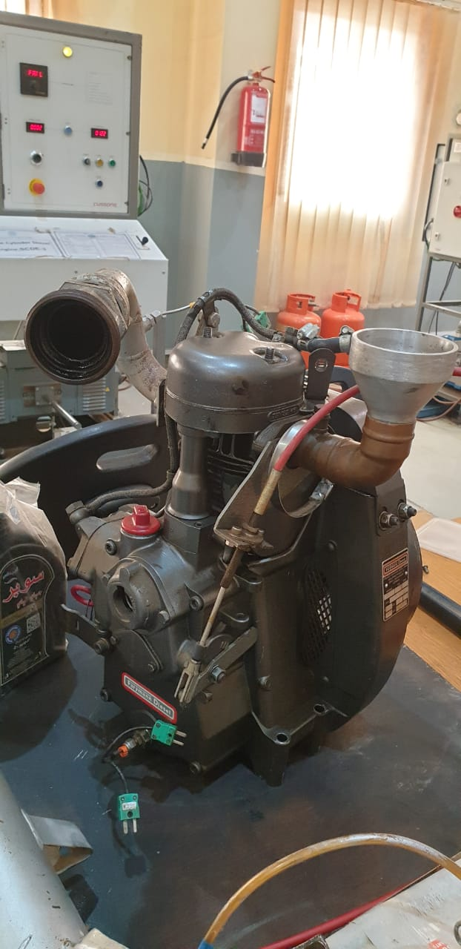

Fig. 2. Compression ignition engine



Fig. 3. Pollution measuring tool

Fig. 4 (a). Input (initial conditions)

Fig. 4 (b). Lewis No. (other properties)

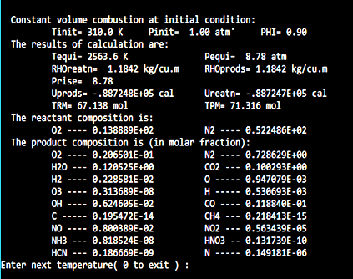

Fig. 4 (c). Emissitions

Fig. 4. Sample output calculations.

Results and Discussion
Figure 5 shows increasing engine brake thermal efficiency with increasing the pressure due to increases of heat gain inside burning area. At constant pressure, engine brake thermal efficiency increases with an increase in intake temperature. Effect of water injection with different proportions (Fig. 6) at a maximum of 1.5 on the NOx for both gasoline and diesel engines shows decreasing the NOx emission with increasing water injection into the two different machines.
The reduction in exhaust gas emissions from the gasoline engine about 59% and 50% from diesel engine at the same water spray rate 1.5 relatives to fuel consumption rate. It is evident in this figure that increased water spraying reduces levels of oxides coming out of exhaust gas. The present results emphasized that decreasing exhaust exit temperature leads to decreases in the engine's NOx.

Fig. 5. Effect of water injection on exhaust temperature.

Fig. 6. Effect of water injection on NOx (ppm by volume).
Figure 7 shows effect of air filter at engine intake for gasoline and diesel engine at different water injection. Effect of air filter is very noticeable in the figure that decrease percentage of carbon dioxide emissions, and more effects with diesel engine than gasoline. The percentage of carbon dioxide by volume is higher without air filter and lower with air filter. The enhancement in carbon dioxide emissions with diesel engine result of installing air filter is 20% while it about 11% with gasoline engine. The addition of water injection in air filters reduces carbon dioxide emissions by 10.5%.
Fig. 7. Effect of air filter on carbon dioxide, CO₂

Figure 8 shows Graph effect of air filter and water injection on the NO_{x} emissions at constant engine speed for the both diesel and gasoline engines. The most obvious difference between both variables in this NO_{x} formation was in lower values of water injection with diesel engine, where the NOx composition of the variable without an air filter was almost 23.5% more than the variable with an air filter, while it was 11.7 with the gasoline engine. Both engine variants produced similar NOx formation at high water injection, with only 5.6% additional formation for the variant with and without the filter.

Figures (9 – 11) show effects of fuel-air equivalence ratio or so called mixture strength (φ), on emissions production rates of NOx, carbon dioxide CO₂, and carbon monoxide CO, at different initial temperatures. It is quite clear that NO_{x} and CO₂ species decrease as equivalence ratio, (φ), with an exception that CO₂ at the range of (0.7 -0.9), increases then drops sharply at stoichiometry condition (φ = 1). On the hand, CO specie in figure 11, shows always continues increase as mixture strength shifts from lean to rich conditions. One possibility of this behavior is due to high concentrations of carbon atoms in the mixture. Also form the previous Graphs, temperatures changes have, nearly no effects on emissions production rates for all three species.

Fig. 8. Effect of air filter on NO_{x} emissions

Fig. 9. Effect of inlet temperature on NO_{x} emissions

Fig. 10. Effect of inlet temperature on CO₂ emissions
Fig. 11. Effect of inlet temperature on carbon monoxide, CO₂ emissions

Figures 12 and 13 show the final combustion pressures and final adiabatic temperatures inside combustion chamber. Maximum values seem to be between 1.1 and 1.2 equivalence ratios, for temperature and pressure respectively, then it tends to decrease beyond those two values. This is due to chemical reaction chains termination for oxidant and fuel.
Finally, figure 14 shows Lewis Number, (Le), variations with equivalence ratio, which is a dimensionless number, named after Warren K. Lewis (1882–1975). It is defined as the ratio of mass diffusivity to thermal diffusivity. It is used to characterize fluid flows where there is simultaneous heat and mass transfer, and also combustion stability for the mixtures.

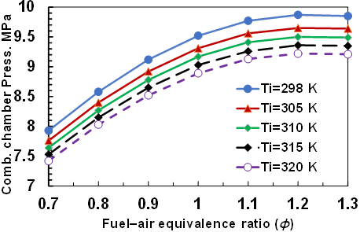
Fig. 12. Effect of inlet temperature on combustion pressure

Fig. 13. Effect of inlet temperature on combustion chamber temperature

If the Lewis number is greater than unity, flames tend to be stable. Therefore, it is a measure of the relative thermal and concentration boundary layer thicknesses [42, 43]. It can be calculated using the following equation (1):
Le = D/α (1)
Where, α: thermal diffusivity, D: mass diffusivity. Figure 14 shows gradual decrease for Lewis Number, Le, and then sharp drop in its values at equivalence ratio values (0.9 – 1.1), then tends to steady after the value combustion stability for the mixtures. If the Lewis number is greater than unity, flames tend to be stable. On the other hand, temperatures changes have no effects on values of Lewis number, as can be seen from the Graph.

Fig. 14. Outcome of inlet temperature on latest eliminating

Conclusions
In this research, the effect of inlet temperature, filter, and water injection in gasoline and diesel engines on their performance and exhaust gas emissions was studied practically and theoretically. The effect of combustion conditions on the efficiency of gasoline and diesel engines and exhaust pollution was studied using a numerical method.
The following results were reached:
- Increased cloud temperature increases heat generation, overall engine efficiency, CO2 levels, and NOx emissions.
- The strength of the mixture has a strong effect on the Lewis number at different initial temperatures.
- Injecting a mixture of water and air into the engine intake reduced engine emissions by 17-33% and exhaust temperature by 13-35% for both engines.
- The presence of an air filter and water injection into the engine inlet, leads to better combustion and a reduction in unburned mixture due to increased air availability.

Conflicts of Interest
The effects of using a filter at the engine intake, intake conditions, and water injection on gasoline and diesel engine on their performance and exhaust gas emission were investigated experimentally and theoretically. Unburned hydrocarbons, particulates, and smoke opacity were not analyzed.

References
- X. Nguyen and K. Ocktaeck, “Influence of Combustion Duration on the Performance and Emission Characteristics of a Spark-Ignition Engine Fueled with Pure Methanol and Ethanol,” Published by American Chemical Society, ACS Omega, doi: 10.1021/acsomega.1c05759, pp. 14505-14515, 2022.
- Y. Şöhret, H. Gürbüz and H. Akçay, “Energy and exergy analyses of a hydrogen fueled SI engine: Effect of ignition timing and compression ratio,” Energy, 175, 410 - 422, DOI: 10.1016/j.energy.2019.03.091, 2019.
- M. Channappagoudra, K. Ramesh and G. Manavendra, “Effect of injection timing on modified direct injection diesel engine performance operated with dairy scum biodiesel and Bio-CNG,” Renewable Energy, 147, 1019– 1032, DOI: 10.1016/j.renene.2019.09.070, 2020.
- J. Hunicz, M. Mikulski, S. Geca and A. Rybak, “An applicable approach to mitigate pressure rise rate in an HCCI engine with negative valve overlap,” Appl. Energy, 257, 114018, DOI: 10.1016/j.apenergy.2019.114018, 2020.
- R. Erdiwansyah, M. Mamat, K. Sani, A. Sudhakar, M. Kadarohman and R. Sardjono, “An overview of Higher alcohol and biodiesel as alternative fuels in engines,” Energy Rep., 5, 467– 479, DOI: 10.1016/j.egyr.2019.04.009, 2019.
- B. Waluyo, M. Setiyo and I. Wardana, “Fuel performance for stable homogeneous gasoline-methanol-ethanol blends,” Fuel, 294, 120565, DOI: 10.1016/j.fuel.120565, 2021.
- X. Zhen, X. Li, Y. Wang, D. Liu and Z. Tian, “Comparative study on combustion and emission characteristics of methanol / hydrogen, ethanol / hydrogen and methane / hydrogen blends in high compression ratio SI engine,” Fuel, 267, 117193, DOI: 10.1016/j.fuel.2020.117193, 2020.
- J. Anderson, U. Kramer and S. Mueller, T. Wallington, “Octane Numbers of Ethanol - and Methanol - Gasoline Blends Estimated from Molar Concentrations”, Energy Fuels, 6576– 6585, DOI: 10.1021/ef101125c, 2010.
- H. Young, J. Cong and N. Jung, “Effects of Ethanol–Diesel on the Combustion and Emissions from a Diesel Engine at a Low Idle Speed,” MDPI, A Appl. Sci. 2020, 10(12), 4153; https://doi.org/10.3390/app10124153, 2020.
- A. Abdullah, “Effects of Air Intake Pressure to the Fuel Economy and Exhaust Emissions on a Small SI Engine,” Procedia Engineering, 68, pp. 278-284, 2013.
- M. Ceviz, A. Kaleli and E. Güner, “Controlling LPG temperature for SI engine applications,” Applied Thermal Engineering 82, pp.298-305, 2015.
- N. Trung, H. Tien and P. Due, “The Effect of Ethanol, Butanol Addition on the Equivalence Air Fuel Ratio, Engine Performance and Pollutant Emission of an SI Engine Using Gasohol Fuels,” International Conference on System Science and Engineering (ICSSE), 44, 2017.
- C. Gong, L. Peng and F. Liu, “Modeling of the overall equivalence ratio effects on combustion process and unregulated emissions of an SIDI methanol engine,” Energy, 125, pp. 118-126, 2017.
- J. Zhao and F. Xu, “The effects of the engine design and operation parameters on the performance of an Atkinson engine considering heat-transfer, friction, combustion efficiency and variable specific-heat,” Energy Conversion and Management, 151, pp.11-22, 2017.
- J. Bhasker and E. Porpatham, “Effects of compression ratio and hydrogen addition on lean combustion characteristics and emission formation in a Compressed Natural Gas fuelled spark ignition engine,” Fuel, 208, pp., 260-270, 2017.
- E. Chen, “Numerical investigations on the effects of turbulence intensity on knocking combustion in a downsized gasoline engine,” Energy, 166, pp. 318-325, 2019.
- M. Nguyen, T. Dong, V. Pham, T. Hieu, “Wet technologies as effective primary solutions in reducing emissions for marine diesel engines,” Journal of Mechanical Engineering Research and Developments ISSN: 1024-1752 CODEN: JERDFO Vol. 44, No. 8, pp. 269-279 Published, 2021.
- I. Anufriev, “Review of water/steam addition in liquid-fuel combustion systems for NOx reduction: Waste-to-energy trends,” Renewable and Sustain Energy R, Vol. 138, 110665, Mar. 2021.
- M. Hsueh, C. Lai, M. Hsieh, S. Wang, C. Hsieh, C. Yu Pan and W. Huang, “Effect of Water Vapor Injection on the Performance and Emissions Characteristics of a Spark-Ignition Engine,” MDPI, 2021, 13(16), 9229; https://doi.org/10.3390/su13169229 Sustainability, Volume 13, Issue 16 , Aug. 2021.
- X. Sun, Z. Jia, X. Liang, G. Jing, H. Liu and G. Shen, “Investigation of water/steam direct injection on performance and emissions of two-stroke marine diesel engine”, International Journal of Green Energy, Vol.18, Issue 8, https://doi.org/10.1080/15435075.2021.1880918, 2021.
- H. Salah, L. Muthana, and R. Al-Zuhairy, “The Influence of Ambient Conditions on Compression Ignition Engine performance: (Experimental Study)”, J. of Mech. Eng. Res. and Develop. ISSN: 1024-1752 CODEN: JERDFO Vol. 43, No. 7, pp. 317-325, 2020.
- J. Huichao, Z. Run, W. Nana, L. Baoyang, R. Wenchao and L. Jinxiang, “Optimization Design of the Ignition System for Wankel Rotary Engine Considering Ignition Environment Flow and Combustion,” Applied Thermal Eng. Vol. 201, Part A, Jan. 2022.
- L. Teodosio, L. Marchitto, C. Tornatore, F. Bozza and G. Valentino, “Effect of Cylinder-by-Cylinder Variation on Performance and Gaseous Emissions of a PFI Spark Ignition Engine: Experimental and 1D Numerical Study,” MDPI, J. Applied Sciences, Vol. 11, Issue 13, Appl. Sci. 2021, 11(13), 6035; https://doi.org/10.3390/app11136035June 2021.
- A. Shuklaa, J. Vaghasiab and M. Mistry, “Effect of Laser Ignition on Combustion and Performance of Internal Combustion Engine Review,” Energy Conversion and Management, https://doi.org/10.1016/j.ecmx.2021.100166, Vol. 13, 100166, Jan. 2022.
- P. Pedro and M. Joaquín, “Impact of Exhaust Gas Recirculation on Gaseous Emissions of Turbocharged Spark-Ignition Engines,” Https://Doi.Org/10.3390/App10217634, J. Applied Sciences, Vol. 10, Issue 2021.
- J. Huichao, L. Jinxiang and W. Nana, “Combined Influence of Ignition Chamber Volume and Spark Plug Channel Diameter on the Performance of Small-Scale Natural Gas Wankel Rotary Engine,” Eng. Applications of Computational Fluid Mechanics, Vol. 15 - Issue 1, 2021.
- S. Zbigniew, “Influence of Physicochemical Properties of Gasoline on the Formation of DISI Engine Fuel Injector Deposits,” DOI: https://doi.org/10.19206/CE-133730, Combustion Engines, 16-23, Vol. 184 1, 2021.
- W. Marouf, “CFD Investigations of a Single Cylinder Spark Ignition Engine Using Digital Valve Mechanism,” J. Energy and Power, P-ISSN: 2163-159X, E-ISSN: 2163-1603, 11(1): 26-32, Jun. 2021.
- R. Indudhar, R. Banapurmath, and K. Govinda K., “Effects of Combustion Vestibule Configuration on the Competence, Emissions and Combustion attributes of Direct Injection Diesel Prime Mover Powered with Diesel and Corn Oil Methyl Ester,” Eur. J. of Sustainable Develop. Res., 3(4), ISSN: 2542-4742, 2019.
- D. Matlotse, “Vehicle Emissions and Emission Control Technologies,” University of Botswana, Mech. Eng. Dept., 2017.
- R. Ramzi R., M. Ibraheem, A. Kawa and A. Abdullah, “Effect of Ambient Air Temperature on the Performance of Petrol Engine,” Diyala Journal of Engineering Sciences, Vol. 12, No. 01, pp. 7-11, DOI: 10.26367/DJES/VOL.12/NO.1/2 eISSN 2616-6909, 2019.
- R. Maurya and A. Agarwal, “Experimental investigation on the effect of inlet air temperature and air-fuel ratio on cycle to cycle variation of HCCI combustion and performance parameter,” Appl. Energy 88, 1153-1163, 2011.
- A. Ramesh, S. Swami, and J. Mallikarjuna, “An experimental study of the biogas–diesel HCCI mode of engine operation,” Energy Conversion and Management, Vol. 51, Issue 7, July 2010, pp. 1347-1353, https://doi.org/10.1016/j.enconman.2009.09.008, 2010.
- J. Zhao, Y. Li and F. Xu, “The effects of the engine design and operation parameters on the performance of an Atkinson engine considering heat-transfer, friction, combustion efficiency and variable specific-heat,” Energy Conversion and Management, 151, 11-22, 2017.
- N. Trung N., H. Tien and P. Due, “The Effect of Ethanol, Butanol Addition on the Equivalence Air Fuel Ratio, Engine Performance and Pollutant Emission of an SI Engine Using Gasohol Fuels,” Int. Conf. on System Science and Engineering (ICSSE), 44, 2017.
- C. Gong, L. Peng and F. Liu F., “Modeling of the overall equivalence ratio effects on combustion process and unregulated emissions of an SIDI methanol engine,” Energy, 125(118-126), 2017.
- R. Nik, I. Hazimi, M. Zeno, A. Asiah, and S. Hazim, “Effects of Air Intake Temperature on the Fuel Consumption and Exhaust Emissions of Natural Aspirated Gasoline Engine,” J. of Sciences & Engineering, 76:9, 25-29, 2015.
- Y. Melih and Bilge A., “Detailed Experimental Investigation of a Spark Ignition Engine in A Wide Range of Work,” Energy, Environment and Storage, 01-01-42-49, 2021.
- H. Mitchell and R. David, “Sensitivity Analysis of Particle Formation in a Spark-Ignition Engine during Premixed Operation”, 8^{t}h U. S. National Combustion Meeting Organized by the Western States Section of the Combustion Institute and hosted by the University of Utah May 19-22, 2013.
- K. Tyagi, K. Sharma, A. Chandra, S. Maheshwari and P. Goyal, “Improved Intake Manifold Design for I.C. Engine Emission Control,” Journal of Engineering Science and Technology Vol. 10, No. 9, 1188 – 1202, 2015.
- S. Murillo, L. Mı´Guez, J. Porteiro, M. Gonza´Lez, E. Granada and C. Mora, “Pollutant Emission and Performance Enhancement for Spark-Ignition Four Strokes Outboard Engines,” Applied Thermal Engineering 25,1882–1893, 2005.
- N. Corner, “What is Lewis number – Thermal Engineering,” https://www.thermal-engineering.org/, 2019.
- E. Bastian Rapp, in Microfluidics: Modelling, Mechanics and Mathematics, 2017.
Note that: Engine specification: 4 Stroke, diesel engine, single cylinder with diameter of 87.5 mm, 110 mm stroke, swept volume 134 cc, connecting rod length 234 mm, compression ratio 16:1, rated brake power 7.2 kW, 7000 rpm. The gasoline engine has approximately the same specification.

