Effectiveness Of Calcined Clay in Saudi Arabia as Supplementary Cementitious Material

Mohammed A. Almarshoud ¹
¹ Civil and Environmental Engineering Department – College of Engineering - University of Jeddah – Jeddah – Kingdom of Saudi Arabia Email: malmarshoud@uj.edu.sa
Abstract
Portland cement concrete is the most consumed material in buildings and infrastructure. The applications of Portland cement are not limited to building constructions, Portland cement is also used as a repairing material. The production of Portland cement has noticeable economic and environmental effects. The paper addresses the economic and environmental benefits of using calcined clay as supplementary cementitious material with high partial replacement of Portland cement. The economic benefits include initial and maintenance costs, which are achieved by enhancing the concrete durability. The cost of calcined clay is strongly affected by transportation expenses and the availability of local sources. The environmental benefits include the reduction of the CO2 footprint caused by Portland cement production.
Keywords:
Portland Cement; Concrete; Building Material; Cementitious Material, Cement; Portland; Repairing Material.

Submitted:
22-MAY-24

Accepted:
17-JUNE-24

Published:

DOI:

Distributed under
Creative Commons CC-BY 4.0

OPEN ACCESS

Introduction
Portland cement production contributed producing more than 5% of the CO2 emissions to the atmosphere [1], [2], [3]. Cement production comes in second place after the power industry in CO2 emissions [4]. The main cause of the CO2 emissions in the cement industry is the reactivation of calcium carbonate to produce calcium oxide [1], [3], [5], [6].
The increasing demand for concrete is strongly noticed along with economic growth, which requires providing infrastructure, utilities, and facilities [2]. In Saudi Arabia, there are 24 fully operating Portland cement plants to accommodate the local demand for Portland cement [7].
The reduction of Portland cement can be accomplished by partially replacing the Portland cement with supplementary cementitious materials (SCM) or limestone filler (LF), the SCMs include the use of slag (SG), fly ash (FA), silica fume (SF), metakaolin (MK), natural pozzolan (NP) and calcined clay (CC), it was noticed that the use of SCM and LF improves the ultimate strength [8], [9], [10], [11], [12]. The improvement in the concrete mechanical properties varies between the SCMs due to variations in reactivity and phase formation, which could cause a reduction in early-age strength, such as in slag and fly ash [10], [11], [13]. The early age strength increases in the case of using early-age reactive SCMs due to the reactivity and the early-age phase formation, such as silica fume, metakaolin, and calcined clay [2], [10], [13]. The use of SCMs in general showed an improvement in the concrete durability properties by showing improvements in the electrical resistivity, water penetrability, and sorptivity [13], [14], [15].
Calcined clay was introduced as an SCM due to its easy accessibility on a global scale [16], [17], and to the proper chemical composition that provides a reactive aluminosilicate phase that reacts with other phases in cement hydration products to produce chemically stable materials. Calcined clay is produced by heating aluminate-silicate plates to reactivate the material as shown in Fig 1.
The economic growth in Saudi Arabia is accompanied by construction growth [18], which consumes portland cement as a construction material for buildings and infrastructures. Increasing the demand for construction materials is expected to increase the production of Portland cement, which would increase the production of carbon dioxide from cement plants.
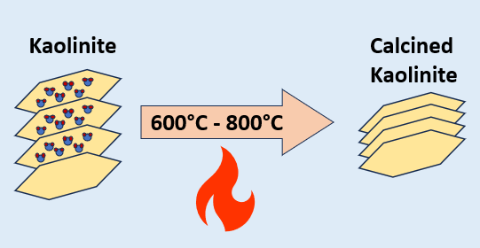

Fig. 1. the rehydration process in producing calcined clay.
Calcined clay as part of LC3 cementitious materials mixtures was studied to reach up to 50% replacement of Portland cement as shown in Table 1. However, the effectiveness of producing calcined clay is strongly dependent on the availability and chemical properties that could produce LC3 that reaches up to type I Portland cement [14]. The chemical composition of the calcined clay and the level of impurities strongly affect the dosage of Portland cement replacement, the impurities include quartz and dolomite that act as a filler to the mixture [14], [19].
Table 1: the expected dosage of cementitious materials in LC3.

Materials | Dosage (%)
Portland cement | 50
Calcined clay | 30
Limestone | 15
Gypsum | 5
Calcined clay as a supplementary cementitious material, particularly in producing LC3, hasn’t been tested sufficiently in Saudi Arabia. Even though, the raw materials are expected to be available locally and within an acceptable chemical and physical condition [20], [21].

Environmental exposure in Saudi Arabia
The Kingdom of Saudi Arabia is located in the far southwestern part of the continent of Asia. The east coastal line is around 610 kilometers long and opens toward the Arabian Gulf. The western coastal line is around 1,100 kilometers opening toward the Red Sea [22]. The topography of the Kingdom is unique due to its large area, which reaches up to 2.000.000 square kilometers. The western region lays the chain mountains of Sarawat, which reaches up to 3.000 meters and the rest of the country is mostly desert [22].

2.1 Temperature differential
The high-temperature differential is considered a significant matter affecting the concrete durability and expected service life as a result of the thermal stress generated from the partial thermal expansion of a concrete member [23]. The solar radiation in Saudi Arabia ranges between 7.0 kWh/m2 and 4.5 kWh/m2 [24], which increases the daily temperature differential causing thermal internal stresses.
The salt formation and crystallization in concrete pores are considered a major cause of concrete deterioration as a result of the internal stress caused by salt crystal formation, which strongly affected by the temperature[25], [26].

2.2 Soil composition and availability of corrosive materials
The soil composition in Saudi Arabia has a wide variety of mineralogical properties, which include Torrifluvents, Gypsiorthids, Torripsamments, Haplargids, and other types. The clay with a range of kaolinite content is dominant in the central region of the Kingdom with some fractions in the eastern and western regions[27], as illustrated in Table 2.
Table 2: showing soil composition in Saudi Arabia [27], [28]

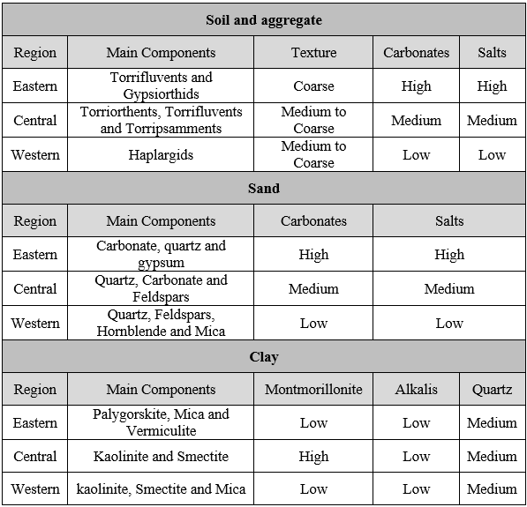
The availability of corrosive salts is dominant in the coastal areas located in the east and west parts of Saudi Arabia, which could have a significant effect on concrete durability expectation and life cycle[27], [29], [30].
Sabkha soil is a common coastal soil in the kingdom, that has a high content of corrosive and unstable salts that reacts with concrete reinforcement, hydrated and unreacted phases of cement, such as chlorine and sulfate salts[27], [29], [30], [31].

Calcined clay in Saudi Arabia
The ability to use calcined clay as an SCM depends on two main factors. The first factor is about the suitability of clay, which includes kaolinite content and availability of impurities[14], [17], [20]. The second factor is related to the cost-effectiveness of the process of producing calcined clay, which includes the bulk availability of the material and location[17].

3.1 Clay suitability
The major reactive material in calcined clay is Alumina (Al2O3), which is available in the form of kaolinite (Al2O3. 2SiO2. 2H2O)[2], [14], [17], [20]. Kaolinite has been commonly used in producing paper, ceramics, and tiles for ages, depending on the purity of the clay (90% and more) [21].
Kaolinite clay has a wide range of applications in various fields mentioned as follows:
- Ceramics: Kaolinite is a fundamental component in ceramic production. It imparts plasticity and contributes to the final properties of ceramics[32].
- Paper Industry: Kaolinite is used as a coating and filler in paper production to improve print quality, opacity, and ink receptivity[33].
- Paint Industry: In the paint industry, kaolin serves as a white pigment, providing opacity and improving paint properties[34].
- Cosmetics and pharmaceuticals: Kaolin is used in cosmetics and skin care products for its gentle exfoliating and oil-absorbing properties[35]. Correspondingly, it is used in pharmaceutical formulations as an excipient and as an adsorbent in antidiarrheal medications[36].
- Agriculture: Kaolinite-based products are used in agriculture for pest and disease control, and for improving soil properties[37].
- Rubber: Kaolin is used as a filler in plastics and rubber to improve mechanical properties[38].
- Environmental Applications: Kaolinite is used in wastewater treatment and as a component in geosynthetic liners for landfills[39], [40].
- Construction and concrete production: In the construction industry, kaolinite is considered supplementary cementitious materials that react with cement and cement and the hydration by-products to improve concrete plastic, mechanical and durability properties[2], [14], [17], [20], [41].

In the case of lower kaolinite content clay, which ranges between 40 and 60 %, it is mostly suitable as an SCM containing enough kaolinite to react with cementitious material and cement hydration products. The remaining contents of the clay, other than kaolinite, act as a filler for the cementitious mixture[14], [17], [20], [21], [42], which limits the use of calcined clay with a purity of less than 90% and more than 40% for construction and concrete production.
The most common use of calcined clay cementitious materials mixtures are produced as Limestone, Calcined Clay, Cement (LC3) [14], [17], [20], [41]. The reduction in carbon dioxide emissions is expected to reach 40% depending on many factors, which include the source of electrical energy and heat, the chemical composition of clay and cement, and the logistic emissions. Fig 2 shows the process of producing calcined clay and limestone mixtures, which is the major part of producing LC3. The ground limestone and calcined clay mixture is known as LC2.
After the completion of the LC2 production, a blend with Portland cement is made depending on the chemical composition of Portland cement and the calcined clay. This process includes adding gypsum as a source of sulfate to normalize the alumina content, which was elevated due to the high alumina content in calcined clay [14], [17]. Fig 3 simply explains the process.

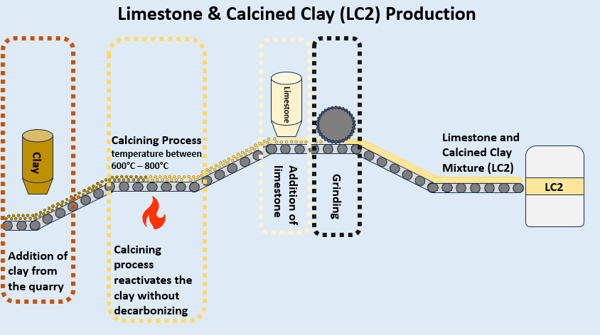

Fig. 2. The process of producing calcined clay and limestone mixture.
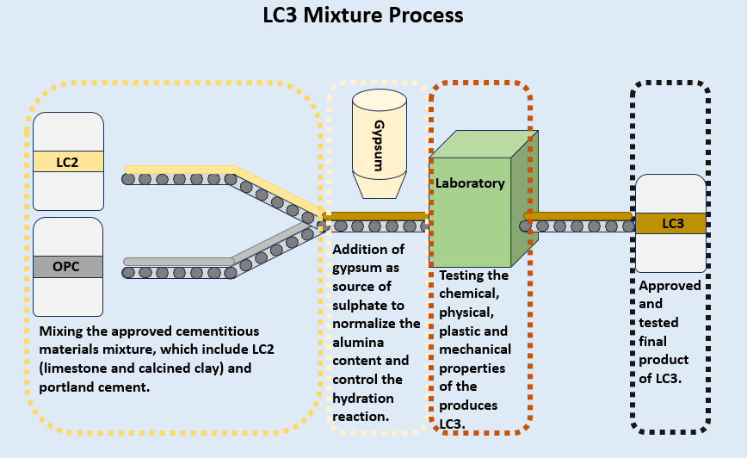

Fig. 3. The final process of producing LC3.

3.2 Cost-effectiveness of clay
The cost-effectiveness of using calcined clay as a supplementary cementitious material in concrete or producing LC3 depends on various factors, including the local availability and cost of calcined clay, performance benefits, specific project requirements, and environmental exposure. Here are some considerations:
- Raw material cost and availability: The cost of calcined clay as a raw material can vary depending on availability and logistic causes. In Saudi Arabia, the availability of suitable clay is reasonable, including an acceptable Alumina content, and is within acceptable limits of impurities which makes it suitable for concrete and construction uses[20], [28].
- Performance improvements: it was shown that using calcined clay as SCM in producing LC3 improves the plastic, mechanical, and durability properties of concrete, which leads to long-term cost savings by reducing maintenance and repair expenses[14], [17], [20].
- Logistics: The availability of calcined clay in reachable locations would reduce transportation costs, making using calcined clay more cost-effective[28].
- Substitution rate of SCM: The fraction of calcined clay used in concrete mixtures influences the total cost of producing concrete since the production of calcined clay doesn’t cost as much as Portland cement[14]. Therefore, increasing the substitution rate reduces the overall cost.
- Energy and emission savings: The partial replacement of calcined clay with portland cement in concrete mixtures has environmental benefits as a result of reducing CO2 emissions associated with portland cement production [3], as well as a reduction in the energy consumed in producing Portland cement[14], [17].

Therefore, conducting a cost-benefit analysis for each project is significant to determine the cost-effectiveness of using calcined clay as a partial replacement for Portland cement in concrete mixtures and producing LC3, since each project has a different environment, location, exposure, specifications, and logistics conditions. As shown in Table 3, the variables that could affect the cost-effectiveness of producing LC3 instead of OPC are not limited to economics, the environmental impact may overcome all other factors.
The cost-benefit analysis focuses on three major factors:
- Cost saving: as the process of producing calcined clay requires less energy compared to Portland cement.
- Infrastructure: the availability of infrastructure or the investment in processing infrastructure for clay calcination, which is profitable depending on the location and quantity of suitable clay for concrete uses.
- Incentives: as sustainability is a focal point in the Saudi Arabian Vision 2030, carbon dioxide footprint drop due to reducing portland cement content in concrete mixtures is expected to have a sustainability-added value for construction industries and products.

Table 3: Comparison between OPC and LC3.

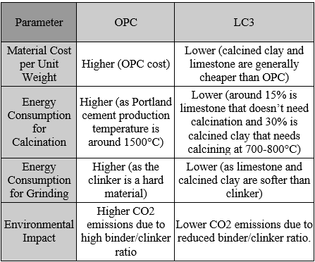

Conclusion and recommendations
In conclusion, utilizing calcined clay as a partial replacement for Portland cement has proven to be an effective and sustainable strategy in the construction industry under specific conditions. The following points were concluded:
- The practice of utilizing LC3 doesn't reduce the negative environmental impact by mitigating the carbon dioxide footprint caused by cement production emissions but also helps enhance the overall performance of concrete and durability to resist aggressive environmental exposure.
- Calcined clay offers cost benefits and conserves valuable natural resources.
- The cost-effectiveness of producing LC3 is not fully dependent on the economic aspects, the environmental impact, and the equivalent CO2 production, which includes net CO2 has an effect depending on the regulations.
- It is recommended to address the locations, quantities, and quality of clay in quarries to support researchers and investors in evaluating the cost-effectiveness of producing LC3.
- The value of produced CO2 should be included in the cost-effectiveness study.
As research and real-world applications continue to validate its efficacy, the adoption of calcined clay as a supplementary cementitious material is a promising avenue for achieving more sustainable and resilient construction practices.

References
- D. N. Huntzinger and T. D. Eatmon, ‘A life-cycle assessment of Portland cement manufacturing: comparing the traditional process with alternative technologies’, Journal of Cleaner Production, vol. 17, no. 7, pp. 668–675, May 2009, doi: 10.1016/j.jclepro.2008.04.007.
- Y. Cancio Díaz et al., ‘Limestone calcined clay cement as a low-carbon solution to meet expanding cement demand in emerging economies’, Development Engineering, vol. 2, pp. 82–91, Jan. 2017, doi: 10.1016/j.deveng.2017.06.001.
- J. Deja, A. Uliasz-Bochenczyk, and E. Mokrzycki, ‘CO2 emissions from Polish cement industry’, International Journal of Greenhouse Gas Control, vol. 4, no. 4, pp. 583–588, Jul. 2010, doi: 10.1016/j.ijggc.2010.02.002.
- ‘Carbon Dioxide Capture and Storage — IPCC’. Accessed: Jul. 27, 2020. [Online]. Available: https://www.ipcc.ch/report/carbon-dioxide-capture-and-storage/
- B. Eliasson, P. Riemer, and A. Wokaun, Greenhouse Gas Control Technologies. Elsevier, 1999.
- Inventory of U.S. Greenhouse Gas Emissions and Sinks: 1990-1997. The Agency, 1999.
- ‘Cement Plant Location Information for Saudi Arabia’, The Global Cement Report. Accessed: Oct. 21, 2020. [Online]. Available: https://www.cemnet.com/global-cement-report/country/saudi-arabia
- D. D. Higgins, ‘Increased sulfate resistance of ggbs concrete in the presence of carbonate’, Cement and Concrete Composites, vol. 25, no. 8, pp. 913–919, Dec. 2003, doi: 10.1016/S0958-9465(03)00148-3.
- M. Bouasker, P. Mounanga, P. Turcry, A. Loukili, and A. Khelidj, ‘Chemical shrinkage of cement pastes and mortars at very early age: Effect of limestone filler and granular inclusions’, Cement and Concrete Composites, vol. 30, no. 1, pp. 13–22, Jan. 2008, doi: 10.1016/j.cemconcomp.2007.06.004.
- T. K. Erdem and Ö. Kırca, ‘Use of binary and ternary blends in high strength concrete’, Construction and Building Materials, vol. 22, no. 7, pp. 1477–1483, Jul. 2008, doi: 10.1016/j.conbuildmat.2007.03.026.
- G. Menéndez, V. Bonavetti, and E. F. Irassar, ‘Strength development of ternary blended cement with limestone filler and blast-furnace slag’, Cement and Concrete Composites, vol. 25, no. 1, pp. 61–67, Jan. 2003, doi: 10.1016/S0958-9465(01)00056-7.
- B. Kanagaraj, N. Anand, R. Samuvel Raj, and E. Lubloy, ‘Techno-socio-economic aspects of Portland cement, Geopolymer, and Limestone Calcined Clay Cement (LC3) composite systems: A-State-of-Art-Review’, Construction and Building Materials, vol. 398, p. 132484, Sep. 2023, doi: 10.1016/j.conbuildmat.2023.132484.
- Kyle A. Riding, Christopher C. Ferraro, Mohammed Almarshoud, Hossein Mosavi, Raid Alrashidi, and Mohammed Hussain Alyami, ‘Durability Evaluation of Ternary Mix Designs for Extremely Aggressive Exposures’, Department of Civil and Coastal Engineering Engineering School of Sustainable Infrastructure & Environment University of Florida 365 Weil Hall – P.O. Box 116580 Gainesville, FL 32611-6580, Florida Department of Transportation 605 Suwannee Street, MS 30 Tallahassee, FL 32399, BDV31 977-65, Mar. 2018.
- K. Scrivener, F. Martirena, S. Bishnoi, and S. Maity, ‘Calcined clay limestone cements (LC3)’, Cement and Concrete Research, vol. 114, pp. 49–56, Dec. 2018, doi: 10.1016/j.cemconres.2017.08.017.
- H. Mosavi et al., ‘Use of Electrical Test Method on Determination Aging Factor of Concrete Incorporating Supplementary Cementitious Materials’, in Proceedings of the International Conference of Sustainable Production and Use of Cement and Concrete, J. F. Martirena-Hernandez, A. Alujas-Díaz, and M. Amador-Hernandez, Eds., in RILEM Bookseries. Cham: Springer International Publishing, 2020, pp. 299–306. doi: 10.1007/978-3-030-22034-1_34.
- K. L. Scrivener, V. M. John, and E. M. Gartner, ‘Eco-efficient cements: Potential economically viable solutions for a low-CO2 cement-based materials industry’, Cement and Concrete Research, vol. 114, pp. 2–26, Dec. 2018, doi: 10.1016/j.cemconres.2018.03.015.
- F. A. Zunino Sommariva, ‘Limestone calcined clay cements (LC3): raw material processing, sulfate balance and hydration kinetics’, EPFL, 2020. doi: 10.5075/epfl-thesis-8173.
- H. A. H. Esmail, ‘Economic Growth of Saudi Arabia Between Present and Future According to 2030 Vision’, ASS, vol. 14, no. 12, p. 192, Nov. 2018, doi: 10.5539/ass.v14n12p192.
- S. S. Patil, V. S. Jadhav, S. S. Nalavade, and M. M. Maske, ‘Limestone Calcined Clay Cement as A Green Construction Material’, ASEAN Journal of Science and Engineering, vol. 2, no. 2, Art. no. 2, 2022.
- M. Abdulqader et al., ‘Physicochemical properties of limestone calcined clay cement (LC3) concrete made using Saudi clays’, Journal of Materials Research and Technology, vol. 25, pp. 2769–2783, Jul. 2023, doi: 10.1016/j.jmrt.2023.06.114.
- C. Detellier, ‘Functional Kaolinite’, The Chemical Record, vol. 18, no. 7–8, pp. 868–877, 2018, doi: 10.1002/tcr.201700072.
- azalghamdi, ‘General Information about The Kingdom of Saudi Arabia’, General Authority for Statistics. Accessed: Nov. 03, 2020. [Online]. Available: https://www.stats.gov.sa/en/4025
- Kyle A. Riding, ‘Early Age Concrete Thermal Stress Measurement and Modeling’, PhD, The University of Texas, Austin TX, 2007. [Online]. Available: https://repositories.lib.utexas.edu/bitstream/handle/2152/3281/ridingd43672.pdf?sequence=2
- A. H. Almasoud and H. M. Gandayh, ‘Future of solar energy in Saudi Arabia’, Journal of King Saud University - Engineering Sciences, vol. 27, no. 2, pp. 153–157, Jul. 2015, doi: 10.1016/j.jksues.2014.03.007.
- M. H. Alyami, R. S. Alrashidi, H. Mosavi, M. A. Almarshoud, and K. A. Riding, ‘Potential accelerated test methods for physical sulfate attack on concrete’, Construction and Building Materials, vol. 229, p. 116920, Dec. 2019, doi: 10.1016/j.conbuildmat.2019.116920.
- M. H. Alyami, H. Mosavi, R. S. Alrashidi, M. A. Almarshoud, C. C. Ferraro, and K. A. Riding, ‘Lab and Field Study of Physical Sulfate Attack on Concrete Mixtures with Supplementary Cementitious Materials’, Journal of Materials in Civil Engineering, vol. 33, no. 1, p. 04020397, Jan. 2021, doi: 10.1061/(ASCE)MT.1943-5533.0003500.
- H. Shadfan, A. Mashhady, A. Eter, and A. A. Hussen, ‘Mineral Composition of Selected Soils in Saudi Arabia’, Zeitschrift für Pflanzenernährung und Bodenkunde, vol. 147, no. 6, Art. no. 6, 1984, doi: https://doi.org/10.1002/jpln.19841470603.
- Q. Mohsen and A. El-maghraby, ‘Characterization and assessment of Saudi clays raw material at different area’, Arabian Journal of Chemistry, vol. 3, no. 4, pp. 271–277, Oct. 2010, doi: 10.1016/j.arabjc.2010.06.015.
- I. S. Oweis and J. Bowman, ‘Geotechnical Considerations for Construction in Saudi Arabia’, Journal of the Geotechnical Engineering Division, vol. 107, no. 3, pp. 319–338, Mar. 1981, doi: 10.1061/AJGEB6.0001103.
- A. O. Alshenawy, W. M. Hamid, and A. M. Alnuaim, ‘A review on the characteristics of sabkha soils in the Arabian Gulf Region’, Arab J Geosci, vol. 14, no. 19, p. 2018, Sep. 2021, doi: 10.1007/s12517-021-08275-w.
- H. S. Al-Alawi, A. A. Ganiyu, and A. Badr, ‘Stabilisation of Sohar’s Sabkha soil using waste gypsum plasterboard’, IOP Conf. Ser.: Mater. Sci. Eng., vol. 849, no. 1, p. 012028, May 2020, doi: 10.1088/1757-899X/849/1/012028.
- H. H. Murray, Applied Clay Mineralogy: Occurrences, Processing and Applications of Kaolins, Bentonites, Palygorskitesepiolite, and Common Clays. Elsevier, 2006.
- Handbook of Clay Science. Newnes, 2013.
- K. A. Buyondo, H. Kasedde, and J. B. Kirabira, ‘A comprehensive review on kaolin as pigment for paint and coating: Recent trends of chemical-based paints, their environmental impacts and regulation’, Case Studies in Chemical and Environmental Engineering, vol. 6, p. 100244, Dec. 2022, doi: 10.1016/j.cscee.2022.100244.
- ‘CLAYS IN COSMETICS AND PERSONAL-CARE PRODUCTS | Clays and Clay Minerals’. Accessed: Nov. 06, 2023. [Online]. Available: https://link.springer.com/article/10.1007/s42860-021-00154-5
- M. E. Awad, A. López-Galindo, M. Setti, M. M. El-Rahmany, and C. V. Iborra, ‘Kaolinite in pharmaceutics and biomedicine’, International Journal of Pharmaceutics, vol. 533, no. 1, pp. 34–48, Nov. 2017, doi: 10.1016/j.ijpharm.2017.09.056.
- H. H. Murray, ‘Traditional and new applications for kaolin, smectite, and palygorskite: a general overview’, Applied Clay Science, vol. 17, no. 5, pp. 207–221, Nov. 2000, doi: 10.1016/S0169-1317(00)00016-8.
- W. Wu and L. Tian, ‘Formulation and morphology of kaolin-filled rubber composites’, Applied Clay Science, vol. 80–81, pp. 93–97, Aug. 2013, doi: 10.1016/j.clay.2013.06.025.
- S. A. Rasaki, Z. Bingxue, R. Guarecuco, T. Thomas, and Y. Minghui, ‘Geopolymer for use in heavy metals adsorption, and advanced oxidative processes: A critical review’, Journal of Cleaner Production, vol. 213, pp. 42–58, Mar. 2019, doi: 10.1016/j.jclepro.2018.12.145.
- X. Zhang et al., ‘Defect Engineering Modulated Iron Single Atoms with Assist of Layered Clay for Enhanced Advanced Oxidation Processes’, Small, vol. 18, no. 52, p. 2204793, 2022, doi: 10.1002/smll.202204793.
- H. Du and S. D. Pang, ‘High-performance concrete incorporating calcined kaolin clay and limestone as cement substitute’, Construction and Building Materials, vol. 264, p. 120152, Dec. 2020, doi: 10.1016/j.conbuildmat.2020.120152.
- J. C. Miranda-Trevino and C. A. Coles, ‘Kaolinite properties, structure and influence of metal retention on pH’, Applied Clay Science, vol. 23, no. 1, pp. 133–139, Aug. 2003, doi: 10.1016/S0169-1317(03)00095-4.

