Human-Digital Twins: Enabling Technologies, Applications, and in the Era of Industry 5.0
Riyaz Sheikh Abdullah ¹

¹ Department of MIS, College of Business Administration, Jazan University, Jazan, Kingdom of Saudi Arabia, Email: rasheikh@jazanu.edu.sa
Abstract
The research aims to thoroughly examine the incorporation of human-digital twins (HDT) into the industry 5.0 framework to comprehend its applications, challenges and possible advantages. This research aims to clarify the revolutionary impact of HDT in the manufacturing sector by examining representative case studies spanning various phases of product development and production. The current deficiency in research concerns the necessity for a comprehensive analysis of HDT, encompassing its organizational, technological, application, and societal dimensions, as well as its implementations in production, design, and other phases of the lifecycle.
To bridge this divide, a comprehensive literature review, analysis of representative case studies, and discussion of challenges and opportunities comprised the systematic research methodology. The results indicate that HDT substantially contributes to Industry 5.0 in user-centric design, real-time collaboration, safety improvement, and efficiency enhancement. Significantly, obstacles recognized encompass the implementation of an authentically human-centric methodology and the resolution of security concerns. The adaptability of HDT is better comprehended through a comparative analysis of case studies, and its theoretical framework, HDT = (HE, VE, and IS), is consistent with the objectives of Industry 5.0, which envision a manufacturing ecosystem that is interconnected, intelligent, and centred around human beings.
The research contributes to the field by providing industry practitioners with practical implications that inform and direct strategies for effectively implementing HDT. This study first examines how the relationship between people and digital twins is changing, including ethical issues and societal effects. The findings strengthen the ideas behind HDT and Industry 5.0. Overall, this research contributes to advancing HDT discourse by providing industry and academia with invaluable insights.
Keywords:
Human Digital Twin(HDT); Industry 5.0; smart manufacturing; human-machine collaboration.

Submitted:
22-MAY-24

Accepted:
26-MAY-24

Published:

DOI:

Distributed under
Creative Commons CC-BY 4.0

OPEN ACCESS

Introduction : Industrial Revolution 5.0 and Human Digital Twin (HDT)

1.1 Background
The industrial landscape is undergoing a significant shift towards Industry 5.0, marked by the integration of digital technology for enhanced efficiency, environmental sustainability, and overall robustness ^{1–3}. Figure 1 visually maps the progression from Industry 1.0 to Industry 5.0, with Industry 4.0 introducing improved efficiency and process automation ⁴. However, Industry 5.0 aims to address overlooked aspects like environmental and social metrics, as well as human health and safety, by emphasizing human-centricity. This approach taps into the cognitive abilities, defect tolerance, and inventiveness of individuals, fostering adaptability, resilience, and agility.

The human-centric approach becomes crucial for sustained competitiveness, prioritizing the development of labor skills and considering the mental and physical health of individuals within an industry ^{5,6}. It aligns with the broader goals of contributing enduringly to society and promoting sustainable economic development while ensuring technological advancements uphold human rights ⁷. This approach is vital for achieving societal sustainability and resilience by placing humans at the center of production processes and meeting diverse human needs ⁸.

Humans play a unique role in smart manufacturing systems, offering values such as creativity, decision-making ability, cognition, and dexterity ⁹. Collaboration between humans and machines results in higher productivity for manufacturing tasks compared to manual work or automation alone, spanning inspections, assembly, logistics, and maintenance ¹⁰.
Despite the attention Industry 5.0 has garnered, further clarification is needed for its form and implementation. The general human-centered vision necessitates closer scrutiny for practical application, urging the inclusion of specific case studies ¹¹. Collaboration improvements between humans and machines are vital, requiring novel approaches that allow seamless cooperation and eliminate the need for workers to adapt to machine requirements ¹². Extensive research is imperative, combining various enabling technologies, including human digital twin. These digital twins (DTs) are foundational for future manufacturing, virtually representing assets, products, and resources for simulating performance, predicting failures, or investigating problems within the factory^{9,10}.

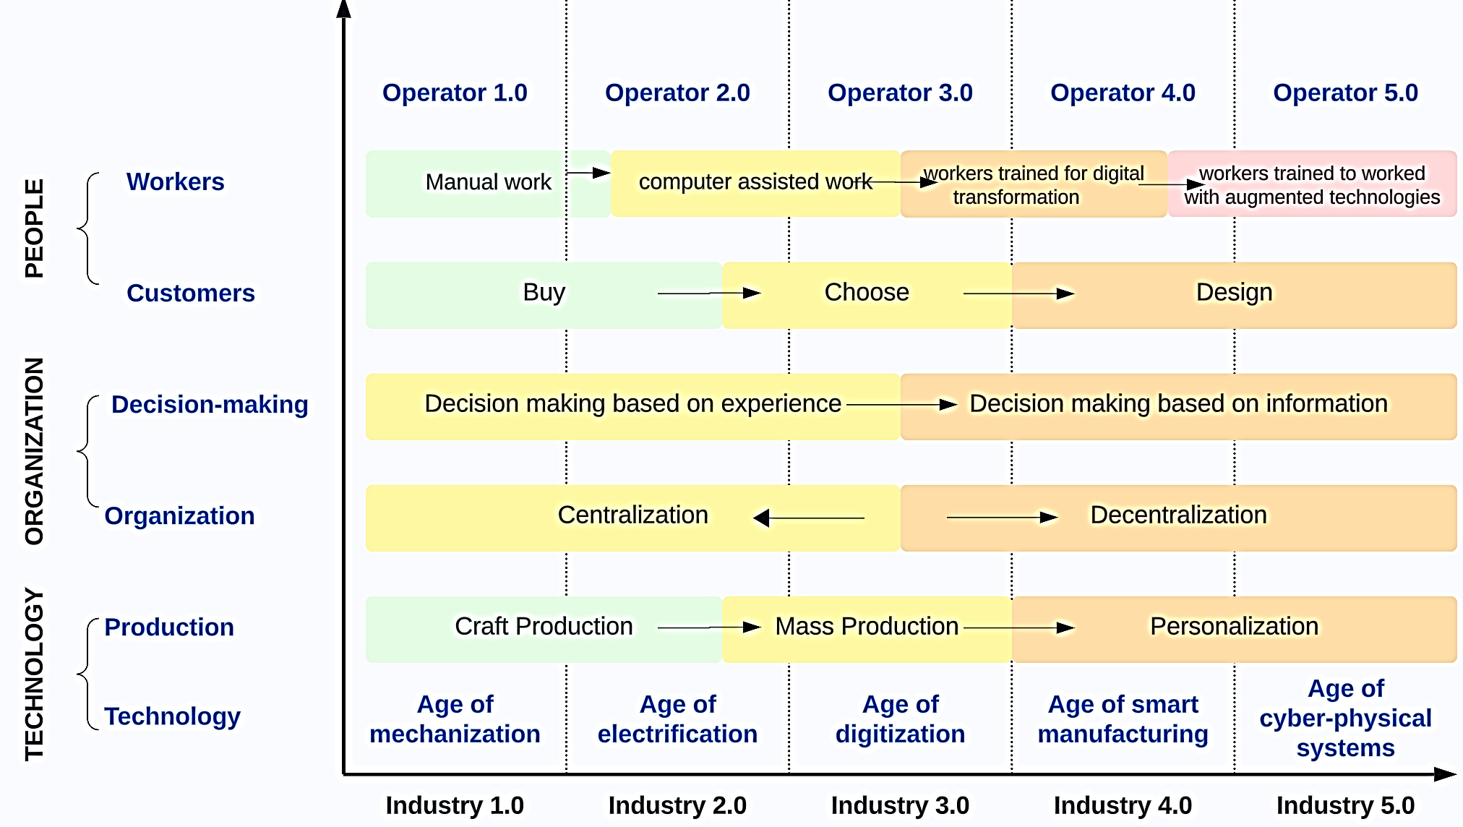

Fig. 1. Transition of industrial revolutions from 1.0 to 5.0

Human Digital Twin (HDT) technology plays a pivotal role in achieving a human-centric scenario within Industry 5.0. HDTs are digital representations of humans, complementing their strengths and prioritizing well-being in smart manufacturing systems ^{5,13,14}. Leveraging a virtual representation of physical processes and assets in real-time, organizations gain deeper insights, optimize performance, and make informed decisions ¹⁵. HDTs contribute to safer work environments by utilizing sensors and data analytics, facilitating the creation of robust contingency plans through scenario modeling and vulnerability assessments. Monitoring resource utilization and environmental impact, HDTs drive sustainability, providing a platform for predictive maintenance, risk mitigation, and adaptive strategies crucial for resilience ^{9,10}.

The potential of HDTs lies in their ability to bring humans and smart devices together in smart manufacturing systems, serving as a vital driver of prosperity for all involved human groups ¹⁶. Unlike previous industrial revolutions focused solely on cost-efficiency and profit maximization, HDT in Industry 5.0 attracts attention from various domains ^{16,17}. These technologies embody human-centricity, sustainability, and resilience principles, allowing organizations to visually represent physical processes and assets in real-time, providing deeper insights, optimizing performance, and facilitating informed decision-making ¹⁵.
Leveraging sensors and data analytics, HDTs contribute to creating safer and more ergonomic work environments. Recent research trends, as depicted in Table 1 and Figure 2, underline the growing interest and potential practical applications of Human Digital Twin technology.

Table 1. Number of Publications based on the keyword

Number of Publications (Year wise and country wise) (Source: Scopus database)
Year | Documents |  | COUNTRY/TERRITORY | Number of Documents
2010 | 12 |  | Russian Federation | 75
2011 | 13 |  | Netherlands | 77
2012 | 10 |  | Australia | 78
2013 | 10 |  | India | 116
2014 | 16 |  | France | 122
2015 | 9 |  | Italy | 191
2016 | 16 |  | United Kingdom | 219
2017 | 28 |  | Germany | 277
2018 | 51 |  | United States | 398
2019 | 145 |  | China | 409
2020 | 238
2021 | 420
2022 | 690
2023 | 815
2024 | 18
Total | 2491
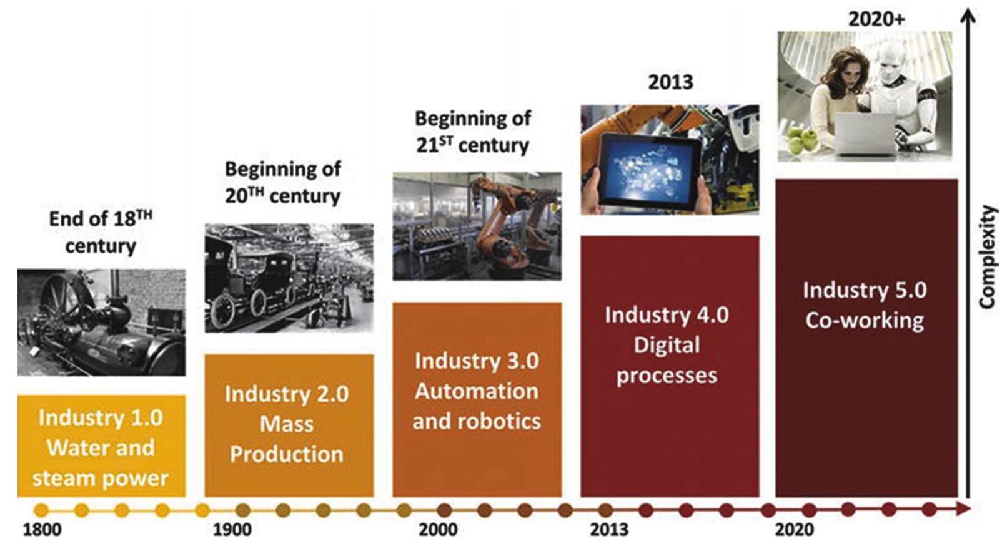

Fig. 2. Phases of the industrial revolution.²³

1.2 Problem Statement
Industry 5.0 presents a paradigm shift in manufacturing, but it introduces a new set of challenges that HDT technology aims to address. Traditional manufacturing approaches often overlooked human-centric considerations, environmental and social metrics, and the need for adaptability. Industry 5.0 prioritizes these aspects, emphasizing the integration of human workers, sustainability, and resilience. HDT plays a pivotal role in this transformation by facilitating seamless collaboration between humans and machines, prioritizing human health and safety, and contributing to environmentally sustainable practices. Additionally, HDT addresses challenges related to workforce skill development, privacy, ethical considerations, and the technical integration complexities within the industry 5.0 framework. Through its capabilities in real-time monitoring, decision support, and fostering human-machine collaboration, HDT endeavors to mitigate these challenges, paving the way for a more inclusive, adaptive, and human-centric manufacturing landscape. Based on the above problem statement, following research questions were set:

- How does HDT in Industry 5.0 prioritize human well-being and contribute to workforce adaptability and resilience?
- What are the key technologies enabling HDT, and how do they integrate to optimize performance and enhance safety in smart manufacturing?
- What challenges and opportunities arise in implementing HDT in Industry 5.0, particularly in workforce development, privacy, and sustainability, and how do they impact overall performance?

This research will be structured into distinct sections to provide a comprehensive exploration of HDT technology in the context of Industry 5.0. The initial section, "Introduction," will set the stage by introducing the background and emphasizing the significance of HDT in addressing evolving challenges within the manufacturing landscape. The second section, "Literature Review," will delve into the foundational principles of Industry 5.0, HDT, and the enabling technologies that form its backbone. Following this, the third section, "Methodology," will outline the approach taken to examine the applications and implications of HDT, emphasizing research methods and data collection techniques. The subsequent section, "Review of extracted research," will present the outcomes of the study, incorporating insights from the literature review and empirical investigations. The fifth section, "Discussion," will provide a thorough analysis of the findings, exploring their implications and potential contributions to the field. Subsequently, the sixth section, titled "Conclusion" will succinctly summarize key discoveries and their significance in the context of Industry 5.0. It will seamlessly transition to proposing potential areas for future research, ensuring a forward-looking perspective on the evolving role of HDT in smart manufacturing.

Literature Review: Theoretical Foundation of the research

2.1 Industry 5.0- principles, characteristics, and implications
The concept of Industry 5.0 represents the next evolutionary stage in industrial development, building upon previous revolutions such as Industry 1.0, 2.0, 3.0, and more recently, Industry 4.0. Industry 4.0, characterized by technologies like Big Data, the Internet of Things (IoT), 3D printing, cloud-based computing, and artificial intelligence (AI), has set the stage for Industry 5.0. The distinguishing feature of Industry 5.0 lies in its emphasis on a digitally intelligent society where real and virtual spaces seamlessly coexist, incorporating elements like robots, augmented reality, innovation ecosystems, mind-machine interfaces, and a central focus on people as the driving force of innovation² . Unlike its predecessor, Industry 5.0 enables a higher level of human-machine interaction, allowing for the customization of goods and services based on individual expression. This shift is attributed to the growing collaboration between humans and machines, fostering a customer- and human-centric approach to product development. As organizations grapple with the challenges posed by Industry 4.0, Industry 5.0 is already on the horizon, promising to eliminate barriers between the physical and virtual worlds. Despite uncertainties about its precise implementation, Industry 5.0 is envisioned as a convergence of human creativity and craftsmanship with the efficiency of robots, ultimately leading to improved human-machine interactions and a transformative revolution in industry¹⁸. The exploration of Industry 5.0 involves understanding its key principles, characteristics, and implications for the manufacturing sector and broader industries.
In the healthcare industry, I5.0's success is attributable to the following factors: educating individuals on technology usage, establishing dependable hardware and infrastructure, and delivering quick internet access ¹⁹. The establishment of advanced telemedicine services and continuous health monitoring systems requires the inclusion of these components. These enable direct digital communication between physicians and patients, irrespective of geographical location, and facilitate access to specialized healthcare, particularly in remote regions ²⁰. Radiologists can benefit from computer-assisted diagnosis (CAD) and robotic surgery when deciphering the meaning of medical images. These technologies reduce the need for interventional procedures and improve patient outcomes ²¹. Using technologies such as telemedicine, artificial intelligence, and robotic surgery, human-machine collaboration in healthcare aims to improve the efficacy and precision of treatment. This association reduces resource consumption and enhances patient outcomes through the implementation of more precise procedures. I5.0 will enable collaborative robots, or "cobots," to comprehend and collaborate effectively with humans. This collaboration will significantly improve the efficiency and utility of production processes ^{2,22}. As adopted by ²³, Figure 2 summarizes industrial revolutions and their characteristics.

2.2 Human-Digital Twin – definition, roles, and integration of human aspect
Human Digital Twin emerges as a pivotal concept in the realm of Industry 5.0, acting as a dynamic and human-centric system that facilitates bidirectional communication between the physical and electronic realms ^{24,25}. Originating from the digital twin concept, credited to Michael Grieves, HDT extends beyond the replication of physical entities by integrating intelligent interpretation, analysis, and visualization of industrial work floors ²⁶. Unlike traditional DT, which focuses on intangible physical entities, HDT center on the development of virtual human replicas encompassing intrinsic and extrinsic attributes, including personality, cognition, sensibilities, and capabilities ²⁷. The literature review underscores that HDT not only enables more profound insights into industrial processes but also fosters a sociomorphic multi-agent system, allowing seamless connections and interactions among agents for group task completion and optimization. As depicted in Figure 4, Wang et al. ²⁸ proposed a three-dimensional conceptual framework for HDT that center on the human entity (HE), the virtual entity (VE), and the interactive system (IS). The model prioritized improving human welfare, roles, requirements, capabilities, and rights, emphasizing human beings. The body of literature places significant importance on integrating human and digital twins as a fundamental principle for capitalizing on the capabilities of HDT within the context of Industry 5.0.
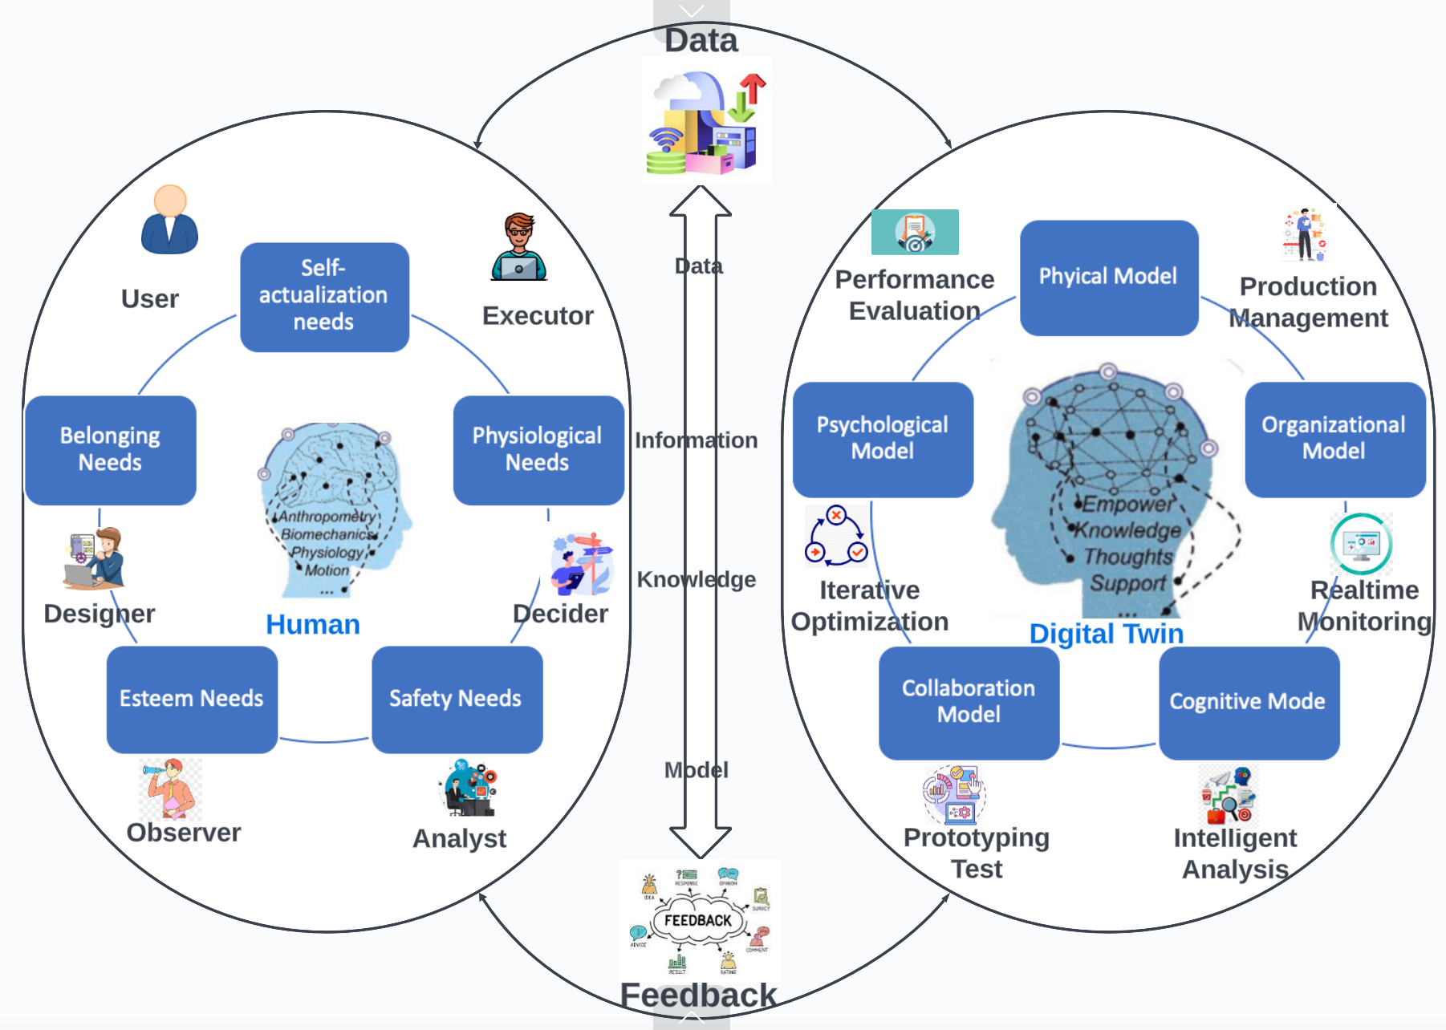
Fig. 3. Theoretical framework of HDT( source: derived from ²⁸)

Research Methodology
The study undertakes an extensive literature review, evaluating and screening pertinent research studies for relevance and duplication after exporting them into a digital library as shown in figure 4. The research articles considered for this study were exported from Scopus, Saudi Digital Library (SDL), and Google Scholar and published between 2010 and 2024. These databases were chosen because they offer the most comprehensive coverage of published research papers, the most recent full-text peer-reviewed articles, and sophisticated search capabilities.

("Human Digital Twin" OR "Digital Twin") AND ("Human-Centric" OR "Human Centred" OR "Human Robot Collaboration" OR "Human Robot Interaction" OR "Human Machine Interaction" OR "Industry 5.0" OR "Industry 4.0" ) are the keywords utilized to conduct a keywords-based search approach. The number of citations in the publications was considered while choosing the key papers, and some of the highly referenced articles in our review (Table 2) are used as seed papers. The first step of this search method involves screening by looking through the abstracts of 768 research publications. After being developed with Mendeley software and imported into the digital library, pertinent papers are further evaluated for redundancy and duplicates. We only choose studies in which the human component of DTs is a significant factor in the investigation. Lastly, this evaluation includes the last literature volume, which contains 143 recent publications from 2017 to 2024.

Fig. 4. Results of systematic review using the PRISMA flow diagram (derived from ²⁹)

Table 2: Top 10 most cited articles based on the result ( Source: Scopus database)

Sr.No. | Authors | Title | Year | Source title | Cited by
1 | Negri E.; Fumagalli L.; Macchi M. | A Review of the Roles of Digital Twin in CPS-based Production Systems | 2017 | Procedia Manufacturing | 1005
2 | Qi Q.; Tao F. | Digital Twin and Big Data Towards Smart Manufacturing and Industry 4.0: 360 Degree Comparison | 2018 | IEEE Access | 954
3 | Fuller A.; Fan Z.; Day C.; Barlow C. | Digital Twin: Enabling Technologies, Challenges and Open Research | 2020 | IEEE Access | 862
4 | Tao F.; Zhang M. | Digital Twin Shop-Floor: A New Shop-Floor Paradigm Towards Smart Manufacturing | 2017 | IEEE Access | 853
5 | Lu Y.; Liu C.; Wang K.I.-K.; Huang H.; Xu X. | Digital Twin-driven smart manufacturing: Connotation, reference model, applications and research issues | 2020 | Robotics and Computer-Integrated Manufacturing | 759
6 | Uhlemann T.H.-J.; Lehmann C.; Steinhilper R. | The Digital Twin: Realizing the Cyber-Physical Production System for Industry 4.0 | 2017 | Procedia CIRP | 699
7 | Tao F.; Qi Q.; Wang L.; Nee A.Y.C. | Digital Twins and Cyber–Physical Systems toward Smart Manufacturing and Industry 4.0: Correlation and Comparison | 2019 | Engineering | 647
8 | Maddikunta P.K.R.; Pham Q.-V.; B P.; Deepa N.; Dev K.; Gadekallu T.R.; Ruby R.; Liyanage M. | Industry 5.0: A survey on enabling technologies and potential applications | 2022 | Journal of Industrial Information Integration | 553
9 | Ivanov D.; Dolgui A. | A digital supply chain twin for managing the disruption risks and resilience in the era of Industry 4.0 | 2021 | Production Planning and Control | 498
10 | Cimino C.; Negri E.; Fumagalli L. | Review of digital twin applications in manufacturing | 2019 | Computers in Industry | 431

Review of Extracted Research

4.1 Enabling Technologies for HDT
The efficacy of HDT integration in Industry 5.0 is predominantly contingent upon the seamless and strategic deployment of many enabling technologies ¹³. Blockchain, big data, and the Internet of Things are the fundamental technologies that facilitate the transmission, processing, and accumulation of data in a streamlined manner; these technologies serve as the foundation for creating efficient HDT models³⁰. IoT enhance service efficiency and decision making through the seamless collection of data via sensors that are either embedded in instruments or worn by workers. Furthermore, the notion of the internet of all (IoA) expands this by integrating human behaviors, aspirations, and sentiments into the framework. Every individual is regarded as a node possessing the capability to actuate the system, communicate and exchange information, and access data³¹. It is shown in figure 5 below:
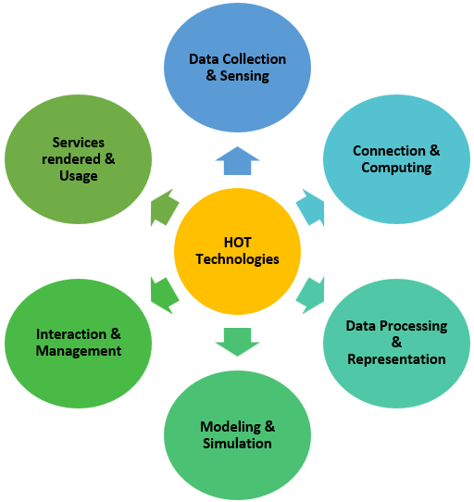

Fig. 5. Categories of HDT Enabling Technologies

Machine learning (ML) and artificial intelligence (AI) are the two primary technologies that contribute to the HDT's intelligence or smartness. For data collection and extraction of pertinent information, numerous ML models are implemented, including K-means, Decision Tree, Bayesian Network, and Support Vector Machine ^{25,32}. On the other hand, advanced models such as deep learning (DL) and artificial neural network (ANN) are designed to process substantial volumes of high-dimensional data³³. In order to accomplish smart manufacturing, reinforcement learning (RL) algorithms, including Deep Q-Network (DQN) and Deep Deterministic Policy Gradient (DDPG), are utilized to enhance human-robot collaboration within the HDT framework ^{34,35}.

Augmented Reality (AR) and Virtual Reality (VR) technologies, collectively known as Extended Reality (XR), play a pivotal role in providing immersive and interactive experiences within HDT systems. AR overlays computer-generated data onto the physical world, benefiting applications like assembly, maintenance, and product design ³⁶. VR, on the other hand, simulates physical or imaginary worlds, providing users with intuitive sensations and finding applications in vehicle health monitoring and training programs. Mixed Reality (MR) integrates digital and physical components, enabling real-time interaction between physical and digital objects, making it adaptable and widely utilized in various HDT applications.

Data Analytics, including data collection, sensing, and processing technologies, are essential components of the technological foundation supporting HDT. Physical, physiological, psychological, and cognitive data are collected through sensors and utilized to mirror human attributes, while AI-based and non-AI-based methods process this data to extract meaningful insights ³⁷. Data pre-processing technologies ensure that raw data is transformed into usable information through techniques such as filtering, segmentation, feature dimensionality reduction, and normalization. Table 3 below depicts the major technologies applied in the realization of HDT.

In conclusion, the successful development and implementation of HDT depend on the synergy of IoT, AI, ML, AR/VR, and data analytics technologies. These technological foundations collectively propel HDT within the Industry 5.0 paradigm, fostering more efficient, safer, and collaborative manufacturing processes by seamlessly integrating humans and digital systems ⁴⁹.

Table 3. Major HDT Technologies for Connection & Computing

Technology | Description | Functions | Reference
Internet of Things (IoT) | A collection of interconnected devices that include actuators, controllers, sensors, and human operators. | Efficiently accomplish comprehensive digital integration across the complete manufacturing enterprise. | ³⁰
Industrial IoT | Industrial IoT (IIoT) refers to the implementation of traditional Internet of Things (IoT) principles and technologies in the business sector. | Enhance industrial operations through real-time data, predictive maintenance, and improved efficiency via interconnected devices and systems. | ³⁰
Social IoT (SIoT) | The modeling of internet-connected devices according to the connections between humans and their daily activities is referred to as SIoT. | Enable seamless communication and collaboration between smart objects, facilitating efficient information exchange and decision-making in the Internet of Things (IoT) ecosystem. | ³⁸
Internet of Services (IoS) | Internet of Services (IoS) is a paradigm that emphasizes the dynamic and scalable composition of services over the internet to fulfill diverse user needs. | dynamically and flexibly compose and deliver digital services over the internet to meet diverse user requirements. | ³⁹
Intenet of People (IoP) | Humans are a part of the network structure and play an active role in its management services. | enable direct interactions and connections between individuals through digital platforms and devices. | ⁴⁰
Internet of All (IoA) | The statement encompasses not solely conventional IoT but also incorporates human beings as an essential constituent. | integrate and interconnect diverse entities, including devices, data, and people, fostering seamless communication and collaboration across the digital ecosystem. | ⁴¹
Internet of Everything (IoE) | By establishing connections between entities, data, processes, and humans, this technology improves the well-being and communication of numerous communities. | Enable the comprehensive connectivity and interaction of people, processes, data, and devices, creating a unified and intelligent network. | ⁴²
Edge computing | The text pertains to the computations that take place on the device's terminal and are not sent to the cloud. | process and analyze data near the source of generation, reducing latency and optimizing network bandwidth. | ⁴³
Cloud Computing | Users can access computing services and resources through the cloud. | This platform provides computing and storage resources to meet your needs. | ⁴⁴
Wireless Sensor Networks | Data is collected through the extensive use of numerous sensors. This data is then processed, analyzed, and transmitted as information. | Preserving the confidentiality of transmitted and collected data within the HDT system. | ⁴⁵
5G Technology | It is suitable for connecting many nodes in an industrial context due to its high bandwidth, speed, low latency, and reliability. | Wireless communication among HDT system modules facilitates control, real-time interaction, and high-quality simulation, among other vital capabilities. | ⁴⁶
6G Technology | This technology offers numerous advantages, such as low latency and high bandwidth for integration. Sustainability-related energy management is also a top priority. | Enable ultra-fast and reliable wireless communication, offering unprecedented data speeds, low latency, and supporting advanced technologies like holographic communication and seamless integration of physical and virtual worlds. | ¹⁹
Wifi Technology | This technology facilitates Internet access and local area networking of devices. It is a technology for wireless networking. | Facilitate wireless connectivity by employing radio waves to enable devices to establish connections with the internet and exchange information over brief distances. | ⁴⁷
Bluetooth Technology | A technology standard that enables the exchange of data between mobile and fixed devices over short distances is known as wireless technology. | Enable short-range wireless communication between devices, facilitating data transfer, audio streaming, and device connectivity. | ⁴⁸

4.2 Representative Applications of HDT in Industry 5.0

Industry 5.0, a manufacturing paradigm, aims to deliver tailored, satisfactory products while liberating humans from strenuous tasks. HDT plays a pivotal role by creating real-time versions of people, optimizing and managing services for different human roles. This section explores representative HDT applications in product design, production, optimization, and maintenance.

4.2.1 HDT in Design
Application # 1: A cloud-based additive manufacturing and design system

To tackle this concern, an innovative system utilizing cloud-based design and additive manufacturing (CDAM) has been devised to fabricate prototypes of ankle foot orthosis (AFO). The application architecture is depicted in the figure 6 below. This system is user-centric, placing an emphasis on their requirements. An optical scanning process is employed to generate a three-dimensional geometry of the user's foot and limb during their clinic visit. This data is subsequently converted into a designated file format and transmitted to the cyber design center. Clinicians then have the ability to modify the personalized point cloud data in accordance with the needs of the user by accessing it via a web portal and interface on a cloud server. By making the tool path for validating the HDT design scheme, the additive manufacturing software makes it easier for clinicians to solve difficult engineering analysis and design problems. Continuously executed outside of the clinic utilizing embedded IMU, the performance evaluation determines whether additional modifications are required. An expeditious, effortless, and precise customization has resulted from the implementation of the CDAM system, thereby enhancing the one-day visitor experience. An HDT ⁵⁰ study that demonstrated the CDAM system's viability indicates a positive outlook for the system's implementation in clinical environments.

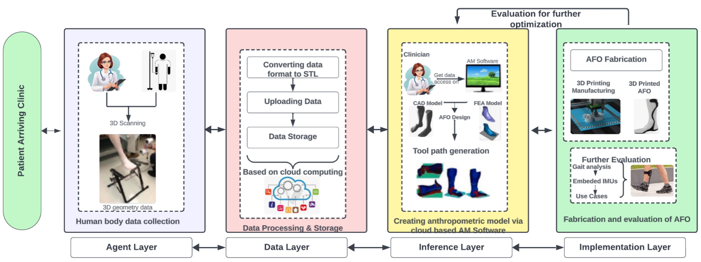

Fig. 6. A cloud-based additive manufacturing and design system for customizing orthosis prototypes

4.2.2 HDT in Production
Application # 2: Dynamic Collaboration Between Humans and Robots

In the contemporary world of mass-customized production, collaborative robotics with humans engaged in complex manufacturing tasks must be capable of adapting to their surroundings and rendering prompt decisions. A novel approach for forecasting instances in which humans and machines desire collaboration is the fusion-based spiking neural network (FSNN), a multi-channel information processing method ⁵¹. As an instance of real-time monitoring and decision-making, this FSNN-based module initiates robotic responses in response to alterations in the surrounding environment. The inference layer of the system integrates and analyses HDT data acquired via video capturing, fusion, and processing, including information on assembly part status, robot posture sequence, and human behavior. Decoded output spiking signals pass as instructions to the automaton. In contrast to alternative prediction techniques like LSTM and HMM, the proposed method has achieved an almost 30% improvement in decision accuracy. Robotic systems enhance productivity and operational efficiency by reducing human intervention and facilitating real-time adaptive robot assistance.

In conclusion, the proposed multi-channel information processing method using a fusion- based spiking neural network has the potential to revolutionize the collaborative task completion process for complex manufacturing tasks. It allows for real-time monitoring and decision-making, increasing accuracy and efficiency. The advent of Industry 5.0 has precipitated a substantial paradigm shift that prioritizes the welfare of personnel. Nevertheless, instruments capable of quantitatively assessing and analyzing a multitude of factors within the workplace continue to be necessary. As illustrated in Figure 7 ⁵², an HDT system for operator safety and labor management has been suggested as a solution to this problem. By utilizing motion capture apparatus and mobile devices, this system collects musculoskeletal data and real-time location coordinates. Following the collection of data, DHM is implemented within the virtual environment.

Additionally, the obtained data is subjected to analysis in order to assess the safety of the workers, employing rule-based reasoning to ascertain their position and location. An additional function of the skeleton data analysis is the standardization of working time and fatigue. Work performance fatigue and accident safety level are the results of this analysis, which empowers employees on the shop floor to promptly alter their posture in order to maintain a more secure working environment. Additionally, the system empowers safety administrators to oversee employees and implement preventative actions in order to avert potential incidents. In addition, process administrators have the ability to safeguard against musculoskeletal injuries and maintain productivity. In general, the suggested HDT system presents a viable resolution to the obstacles intrinsic in the industry 5.0 framework, delivering substantial enhancements in both labor force security and efficiency.

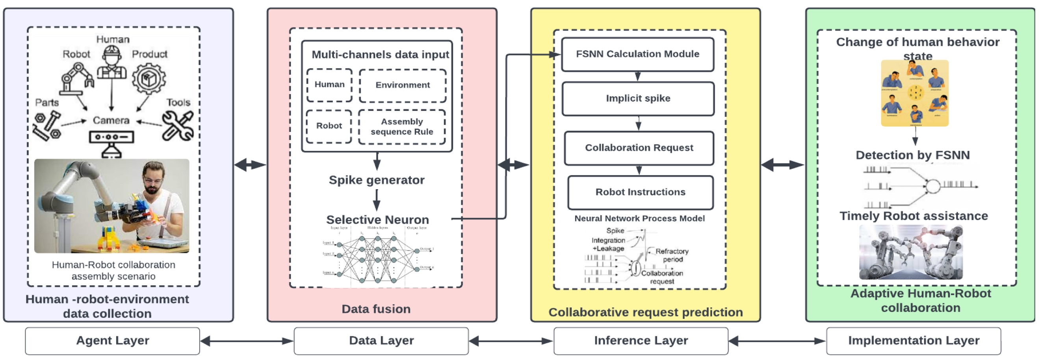

Fig. 7. An FSNN-based multichannel information processing method for forecasting collaboration requests.

4.2.3 HDT in Other Lifecycle Stages

At the present moment, there are a multitude of approaches available to evaluate the potential for biomechanical overload; however, these methods are predominantly methodical, time-intensive, and objective in nature. To improve the precision and consistency of measurements and overcome the shortcomings of these approaches, a methodological framework has been suggested and verified in an assembly scenario. As depicted in figure 8 ⁵³, this framework is intended to facilitate monitoring and decision-making regarding the ergonomic performance of manual production lines. The suggested approach entails gathering data pertaining to working postures throughout consecutive working cycles by means of a wearable inertial motion monitoring system. Following the transmission of the gathered data to commercial software, it is merged with human avatars and numerically simulated. Four risk indices—working postures, exerted forces, material manual handling, and repetitive actions—are assessed through the analysis of the numerical data. Occupational clinicians and seasoned ergonomists should deliberate on the feasibility of layout modification if the analysis reveals critical issues. Case study results demonstrating the framework's efficacy included a cycle time of four seconds and a risk index reduction of 38.5%. This methodology enables ergonomists to concentrate predominantly on problem identification and solution proposition.

In its entirety, the suggested methodology offers a holistic strategy to tackle the obstacles faced by traditional approaches in evaluating the risk of biomechanical overload. Moreover, it improves measurement precision and repeatability, as well as monitoring and decision-making pertaining to the ergonomic performance of manual production lines.

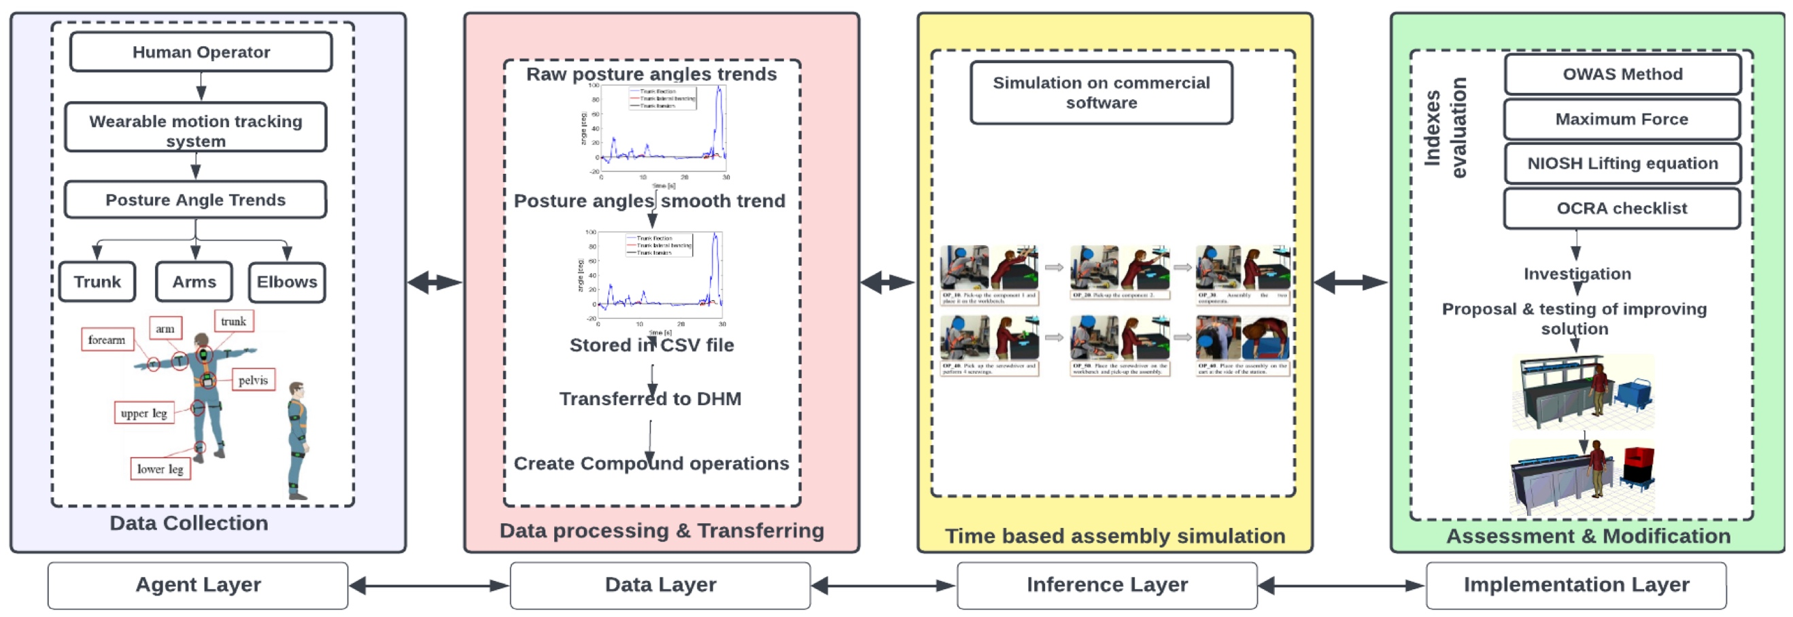

Fig. 8. A methodological HDT framework to facilitate decision-making and monitoring with respect to ergonomics performance.

4.2.4 Applications Summary

The table 3 below summarizes the key details of each case study, including the implementation, impact, and lessons learned. The Cloud-Based Design and Additive Manufacturing (CDAM) system, a standout implementation of HDT in design, revolutionizes the creation of ankle-foot orthosis prototypes. Utilizing optical scanning during clinic visits, this system generates real-time 3D foot and limb geometry, facilitating seamless modifications through a web portal. In order to optimize the overall user experience, Inertial Measurement Units (IMU) ensure timely and precise customization via ongoing assessment. Moreover, to expand the capabilities of human-centred design, the proposed system exhibits its efficacy in a clinical environment that necessitates instantaneous customization and adaptation.

HDT introduces two primary applications into the production process. Initially, the Fusion-Based Spiking Neural Network (FSNN) facilitates real-time collaboration between humans and machines by achieving 30% greater accuracy in decision-making compared to alternative approaches. This utilizes HDT to assist adaptive robots with mass-customized production while simultaneously increasing output and requiring minimal human intervention. Furthermore, HDT systems incorporate mobile devices that gather joint data and motion capture to enhance worker safety and management. The incorporation of Digital Human Modeling (DHM) enables safety managers to monitor employees, implement preventative measures, and safeguard against musculoskeletal accidents. The aforementioned applications underscore the significance of HDT in enhancing workplace health and safety, productivity, and collaboration.

HDT has numerous applications that transcend the manufacturing process and permeate various phases of a product's lifecycle, thereby resolving critical challenges. An assessment framework that integrates wearable technology and numerical simulations successfully reduces risk factors by 38.5% in the context of biomechanical excess potential. This demonstrates that HDT permits a closer examination of ergonomic risks, indicating that it is capable of substantially mitigating the dangers. The application of cloud-based algorithms, digital duplicates, and knowledge databases to human knowledge-based decision support for maintenance is the subject of extensive research. This application facilitates the decision-making process for maintenance managers with an average similarity of 87.1%, demonstrating the utility of HDT in the maintenance domain. These applications demonstrate the adaptability and utility of HDT throughout the product lifecycle. They instruct us in comprehensive methodologies, the utilization of real-time data, and the enhancement of efficiency.

Table 4. Summary of Cases based on HDT

Cases | Data Input | Computing | Modeling | Control & Optimization | Services | References
﻿Human-centric product prototype customization | ﻿3D geometry data of human body | ﻿Tailored tool paths and process parameters in additive manufacturing software. | ﻿Anthropometric model for orthosis customization | ﻿Prototype model optimization through gait analysis in the usage stage. | ﻿Accurate, easy, and quick customization for designers and a one-day visit experience for users. | ⁵⁰
Dynamic collaboration between humans and robots | Image data of environmental factors affecting human robots | Utilizing the FSNNs methodology to map data to neurons and decode the spike signal into robot instructions. | Cognitive model for predicting collaborative requests | The update of robot decisions occurs concurrently with the alteration of human behavior. | Elimination of repetitious robot monitoring and control tasks and provision of the operator with real-time adaptive robot assistance. | ⁵¹
﻿Operator safety and worker management | ﻿Real-time location coordinates and musculoskeletal data | Fatigue analysis and safety evaluation via localization and posture detection. | A physical model including position, ergonomic, and motion detection | Precautions, adjusting work posture, and ensuring productivity in accordance with anticipated outcomes. | Enabling administrators to oversee and render decisions at any moment and in any location. | ⁵²
Adaptation of the layout to ergonomics | Data on posture angles | An ergonomic evaluation using numbers for four distinct risk indices. | Physical ergonomic model and dynamic posture model | Analyzing, implementing, simulating, and assessing modification strategies for identified critical issues. | Physicians and ergonomists are then able to concentrate on problem identification and solution proposal. | ⁵³
Human knowledge-based decision support for maintenance | Textual maintenance requirements the process of calculating | Analyzing similarities between current cases and those previously recorded in the knowledge base. | A cognitive framework for making maintenance decisions based on knowledge | In order to update the knowledge base, one may implement a model-recommended strategy or generate, retain, and store a potentially viable new solution. | System value enhancement as an intangible knowledge asset and reduction of the cognitive burden associated with maintenance. | ⁵⁴

These case studies conclude by demonstrating the numerous beneficial and practical applications of Human-Digital Twins in Industry 5.0. During various phases of product lifecycle management, they prioritize safety, efficiency, customization, and collaboration. The insights acquired pertain to the importance of current information, seamless integration, and comprehensive approaches for the successful implementation of HDT.

4.3 HDT Adoption Challenges
A foundational technology that facilitates human-centricity within the industry 5.0 framework is human-digital twins. HDT emphasizes intelligentization, networking, and digitization ²⁷. In order to facilitate the optimal growth and integration of HDT, it is imperative to address philosophical, social, moral, and empirical challenges. We will discuss the difficulties associated with digitization, networking, and intelligentization in the subsequent section. There are technical, organizational, social, and practical challenges involved.

4.3.1 Making Feedback More Realistic
In HDT, digitization entails the utilization of multimodal sensory technologies to access information from various online sources. To improve the performance of HDT, it is crucial to establish more robust connections with reality in terms of feedback. XR technologies and incorporating additional data sources can bolster HDT, enabling improved decision-making and novel service delivery models.

4.3.2 Embracing Web 3.0 for Networking
HDT requires a network to administer and distribute digital resources. Implementing the user-friendly and highly decentralized Web 3.0 could be an asset to the digital twin system. The incorporation of IoT sensors and Web 3.0 could enhance HDT in a variety of sectors and domains, fostering transparency and adaptability in the setting.

4.3.3 Leveraging Generative AI for Intelligentization
By utilizing innovative AI technologies like ChatGPT, HDT may become more intelligent. Generative AI, through simulating scenarios and constructing virtual physical system models, can predict events while maintaining data on-premises, secure, and private. This technology has the potential to significantly impact the design and construction of HDT models. Developing digitization and intelligentization in HDT presents challenges, including technological, application, and organizational societal issues.

4.4 HDT Technological Challenges

4.4.1 Standardization of Technologies
Standardization is crucial for managing diverse systems efficiently. HDT, as a comprehensive development platform, faces challenges in standardizing data formats, interfaces, communication protocols, etc. The adherence of current systems to unique standards hinders effective communication, necessitating global collaborative standards to facilitate HDT integration⁵⁵.

4.4.2 Transparency and Explainability
Transparency and explainability are critical for personalized HDT, demanding algorithmic decisions to be explicit and easily understood. The current system lacks transparency, hindering the establishment of trust between individuals and the physical system. Ensuring consumers understand data origins and algorithmic ramifications is essential for credibility and comprehensibility.

4.5 HDT Application Challenges

4.5.1 Human-centric Approach
While systems claim to be human-centric, achieving genuinely human-centric methodologies in HDT remains a challenge. HDT prioritizes human rights, sustainability, and resilience, emphasizing its potential benefits for human well-being ⁵⁶. Existing systems fall short in fully incorporating human factors, necessitating a precise definition to facilitate classification and comprehension.

4.5.2 Exhaustive Modeling
Digital Human Modeling (DHM) in congruence with HDT specifications requires interactive environments supporting diverse physical characteristics and effective communication functionalities. Addressing Human-Robot Collaboration (HRC) in relation to efficiency, security, and planning sequences is essential for Industry 5.0 development ⁵⁷. Enhancing DHM research with dynamic interaction is crucial for electronic systems' development in HDT.

Challenges of Organizational and Societal Nature

4.6.1 Security and Privacy Considerations
Developing a Human-Centric Production System (HCPS) in HDT requires collaboration beyond technical aspects. Legal, political, and ethical dimensions become imperative for innovative manufacturing systems operating in diverse contexts. Protecting personal information, privacy, and security against cyber-attacks necessitates advanced technologies and novel system architecture designs.

4.6.2 Market Awareness within the Trade
Ensuring the rights of laborers and establishing them as significant contributors require integrating socio-centric and human-centric perspectives into industrial policies. Restructuring social policies, including health protection and welfare systems, is necessary for substantial collaboration between businesses and educational institutions.
HDT adoption challenges span technological, application, organizational, and societal dimensions. Standardizing technologies, ensuring transparency, and embracing a human-centric approach are vital for optimal HDT development. Overcoming challenges in networking, intelligentization, and organizational awareness is essential for HDT to continue promoting human-centricity and meet the evolving demands of the modern world in the industry 5.0 landscape.

Discussion

5.1 Integration of HDT in Industry 5.0

The integration of HDT within the Industry 5.0 paradigm is a strategic move towards a more human-centric and interconnected manufacturing landscape. HDT's role in creating real-time digital replicas of individuals aligns with the overarching goal of Industry 5.0 – the convergence of physical and digital systems. By providing a dynamic, human-centric system that enables bidirectional communication between the physical and digital realms, HDT addresses the need for personalized, efficient, and safe industrial processes. The adoption of HDT reflects a conscious effort to eliminate barriers between the actual and virtual worlds, emphasizing the centrality of human intelligence and capabilities in Industry 5.0.

HDT seamlessly fits into the broader Industry 5.0 framework by augmenting traditional Digital Twin concepts with a distinct focus on human elements. While DT emphasizes intangible physical entities, HDT extends this by integrating intelligent interpretation, analysis, and visualization of industrial work floors with a specific emphasis on virtual representations of humans. Adhering to the comprehensive approach of Industry 5.0 is consistent with the three dimensions of HDT's theoretical framework: HE, VE, and IS. A collaborative ecosystem fostering collaboration, communication, and efficiency is established through the interplay between the Interactive System (IS), the Human Entity (HE), and the Virtual Entity (VE). This is consistent with Industry 5.0's notion of human-centric intelligent manufacturing systems.

5.2 Possible benefits and connections

The potential advantages and opportunities of integrating HDT into Industry 5.0 are enormous. HDT enables real-time collaboration between humans and machines, thereby enhancing predictive analysis, decision-making, and overall operational efficiency. The multidimensional database of HDT, considering human interactions with other resources, ensures a comprehensive representation of human attributes, leading to personalized and adaptive manufacturing processes. The integration of technologies like IoT, AI, machine learning, AR/VR, and data analytics within the HDT framework enhances its capabilities, offering benefits such as improved safety, optimized production, and a user-centric approach. The elimination of barriers between physical and virtual realms fosters an environment where humans and machines coexist, collaborate, and mutually benefit, creating a symbiotic relationship within Industry 5.0.

5.3 Comparative Analysis of case studies

The case studies present a diverse range of applications showcasing the versatility of HDT in Industry 5.0. In the design domain, the CDAM system exemplifies how HDT can optimize and manage services by creating customized orthosis prototypes, highlighting the significance of real-time versions for user-centric design. In production, the FSNN-based collaboration method and the HDT system for operator safety demonstrate the potential for enhanced decision-making, efficiency, and worker well-being. The ergonomic evaluation and maintenance decision support case studies further underscore the adaptability and effectiveness of HDT in different lifecycle stages. Commonalities include the emphasis on real-time data, user-centric approaches, and safety, while differences lie in specific applications and methodologies.

5.4 Findings

The implications of the case studies are potentially applicable across various industries. In the manufacturing industry, safety, efficiency, user-centered design, and real-time collaboration are all prevalent objectives. Assuring security and privacy concerns and adopting a genuinely human-centric approach are a few of the issues that are likely to impact a wide variety of business categories. The adaptable nature of HDT enables its utility to transcend numerous contexts. Consequently, it serves as a critical underpinning for the objective of Industry 5.0, which is to enhance the efficiency, safety, and collaboration of manufacturing processes. Despite the constant evolution of technology, HDT's fundamental principles and procedures should continue to be applicable in various industrial contexts.

Conclusion
In short, the case studies and analysis show how human-digital twins can change things in the setting of Industry 5.0. Key results include how HDT can be used in many ways at different stages of product development and production, focusing on user-centered design, real-time collaboration, improving safety, and making things run more smoothly. The problems that were named, like making sure that the method is truly human-centered and taking security into account, show how challenging it is to implement HDT in industrial settings.

This study greatly improves our knowledge of HDT in Industry 5.0 by looking into all of its uses, difficulties, and how it fits into the bigger picture of manufacturing. A comparison of case studies shows similarities and variations, giving a more complete picture of HDT's flexibility. The idea behind HDT(HE, VE, and IS) is based on a theoretical framework that fits with Industry 5.0's goal of an integrated, smart, and human-centered manufacturing ecosystem.

The practical applications and effects of this study on people who work in the field are immense. The results show that HDT has the potential to help people make better decisions, improve production methods, and put people's health first. Practitioners can use what they have learned about problems, like the need for a more human-centered approach and security issues, to make their plans for implementing HDT more effectively. Real-time collaboration and safety are important in many applications. This shows that using HDT can make manufacturing more efficient, flexible, and safe.

There are a lot of interesting directions that studies in HDT and Industry 5.0 can go in the future. More research into solving the problems found, especially how to make the method truly human-centered and how to deal with security issues, will help improve HDT applications. Additional research into HDT's use in different industries and its adaptability to various production settings will make it more useful in a wider range of situations. For a complete picture, it is also important to look into the moral issues connected to implementing HDT and how it affects society. It will be important to study how the relationship between people and digital twins changes as technology keeps getting better if you want to stay ahead of the changes in Industry 5.0.

In conclusion, this study helps us learn more about HDT in Industry 5.0, which is useful for both education and business. The multifaceted contributions, real-world implications, and ideas for future study all add to the ongoing conversation about HDT's role in shaping the future of manufacturing.

References
- Cotta J, Breque M, Nul L De, Petridis A. Towards a sustainable, human- centric and resilient European industry. Luxemb Publ Off Eur Union. Published online 2021. doi:10.2777/308407

- Nahavandi S. Industry 5 . 0 — A Human-Centric Solution. Sustain. Published online 2019.

- Zizic MC, Mladineo M, Gjeldum N, Celent L. of Paradigm Shift for the People , Organization and Technology. Energies. Published online 2022.

- Alves J, Lima TM, Gaspar PD. Is Industry 5.0 a Human-Centred Approach? A Systematic Review. Processes. 2023;11(1):0-15. doi:10.3390/pr11010193

- Zhou J, Zhou Y, Wang B, Zang J. Human–Cyber–Physical Systems (HCPSs) in the Context of New-Generation Intelligent Manufacturing. Engineering. 2019;5(4). doi:10.1016/j.eng.2019.07.015
- Alam S, Bhatia S, Shuaib M, et al. An Overview of Blockchain and IoT Integration for Secure and Reliable Health Records Monitoring. Sustain. 2023;15(7). doi:10.3390/su15075660

- Huang S, Wang B, Li X, Zheng P, Mourtzis D, Wang L. Industry 5.0 and Society 5.0—Comparison, complementation and co-evolution. J Manuf Syst. 2022;64. doi:10.1016/j.jmsy.2022.07.010

- Kolade O, Owoseni A. Employment 5.0: The work of the future and the future of work. Technol Soc. 2022;71. doi:10.1016/j.techsoc.2022.102086

- Lorenzini M, Lagomarsino M, Fortini L, Gholami S, Ajoudani A. Ergonomic human-robot collaboration in industry: A review. Front Robot AI. 2023;9. doi:10.3389/frobt.2022.813907

- Li X, Koren Y, Epureanu BI. Complementary learning-team machines to enlighten and exploit human expertise. CIRP Ann. 2022;71(1). doi:10.1016/j.cirp.2022.04.019

- Leng J, Sha W, Wang B, et al. Industry 5.0: Prospect and retrospect. J Manuf Syst. 2022;65. doi:10.1016/j.jmsy.2022.09.017

- Lu Y, Zheng H, Chand S, et al. Outlook on human-centric manufacturing towards Industry 5.0. J Manuf Syst. 2022;62. doi:10.1016/j.jmsy.2022.02.001

- Wang B, Zhou H, Yang G, Li X, Yang H. Human Digital Twin (HDT) Driven Human-Cyber-Physical Systems: Key Technologies and Applications. Chinese J Mech Eng (English Ed. 2022;35(1). doi:10.1186/s10033-022-00680-w

- Wang B, Zheng P, Yin Y, Shih A, Wang L. Toward human-centric smart manufacturing: A human-cyber-physical systems (HCPS) perspective. J Manuf Syst. 2022;63. doi:10.1016/j.jmsy.2022.05.005

- Ghobakhloo M, Iranmanesh M, Mubarak MF, Mubarik M, Rejeb A, Nilashi M. Identifying industry 5.0 contributions to sustainable development: A strategy roadmap for delivering sustainability values. Sustain Prod Consum. 2022;33:716-737. doi:10.1016/j.spc.2022.08.003

- Agrawal A, Thiel R, Jain P, Singh V, Fischer M. Digital Twin: Where do humans fit in? Autom Constr. 2023;148. doi:10.1016/j.autcon.2023.104749

- Okegbile SD, Cai J, Niyato D, Yi C. Human Digital Twin for Personalized Healthcare: Vision, Architecture and Future Directions. IEEE Netw. 2023;37(2). doi:10.1109/MNET.118.2200071

- Paschek D, Mocan A, Draghici A. Industry 5 . 0 – The Expected Impact of Next Industrial Revolution. Manag Knowl Learn Int Conf. Published online 2019:125-132. http://www.toknowpress.net/ISBN/978-961-6914-25-3/papers/ML19-017.pdf

- Adel A. Future of industry 5.0 in society: human-centric solutions, challenges and prospective research areas. J Cloud Comput. 2022;11(1). doi:10.1186/s13677-022-00314-5

- Basulo-ribeiro J. The Future of Healthcare with Industry 5 . 0 : Preliminary Interview-Based Qualitative Analysis. Published online 2024.

- Kermode N. Challenges and future research. Renew Energy from Ocean. Published online 2019:425-445. doi:10.1049/pbpo129e_ch12

- Pang TY, Lee TK, Murshed M. Towards a New Paradigm for Digital Health Training and Education in Australia: Exploring the Implication of the Fifth Industrial Revolution. Appl Sci. 2023;13(11). doi:10.3390/app13116854

- Petrillo A, Felice F De, Cioffi R, Zomparelli F. Fourth Industrial Revolution: Current Practices, Challenges, and Opportunities. Digit Transform Smart Manuf. Published online 2018. doi:10.5772/intechopen.72304

- Longo F, Padovano A, Umbrello S. Value-oriented and ethical technology engineering in industry 5.0: A human-centric perspective for the design of the factory of the future. Appl Sci. 2020;10(12):1-25. doi:10.3390/APP10124182

- Sheikh R, Goje N. Role of Big Data Analytics in Business Transformation. In: Internet of Things in Business Transformation. Wiley Online Library; 2021.

- Grieves M. Digital Twin : Manufacturing Excellence through Virtual Factory Replication. White Pap. 2014;(March).

- Bomström H, Annanperä E, Kelanti M, et al. Digital Twins about Humans—Design Objectives from Three Projects. J Comput Inf Sci Eng. 2022;22(5). doi:10.1115/1.4054270

- Wang B, Zhou H, Li X, et al. Human Digital Twin in the context of Industry 5.0. Robot Comput Integr Manuf. 2024;85(April 2023):102626. doi:10.1016/j.rcim.2023.102626

- Liberati A, Altman DG, Tetzlaff J, et al. The PRISMA statement for reporting systematic reviews and meta-analyses of studies that evaluate health care interventions: Explanation and elaboration. PLoS Med. 2009;6(7). doi:10.1371/journal.pmed.1000100

- Latif S, Driss M, Boulila W, et al. Deep learning for the industrial internet of things (Iiot): A comprehensive survey of techniques, implementation frameworks, potential applications, and future directions. Sensors. 2021;21(22). doi:10.3390/s21227518

- Menolotto M, Komaris DS, Tedesco S, O’flynn B, Walsh M. Motion capture technology in industrial applications: A systematic review. Sensors (Switzerland). 2020;20(19). doi:10.3390/s20195687

- Asensio-Cubero J, Gan JQ, Palaniappan R. Extracting optimal tempo-spatial features using local discriminant bases and common spatial patterns for brain computer interfacing. Biomed Signal Process Control. 2013;8(6). doi:10.1016/j.bspc.2013.07.004

- Buerkle A, Eaton W, Lohse N, Bamber T, Ferreira P. EEG based arm movement intention recognition towards enhanced safety in symbiotic Human-Robot Collaboration. Robot Comput Integr Manuf. 2021;70. doi:10.1016/j.rcim.2021.102137

- Zhang R, Lv Q, Li J, Bao J, Liu T, Liu S. A reinforcement learning method for human-robot collaboration in assembly tasks. Robot Comput Integr Manuf. 2022;73. doi:10.1016/j.rcim.2021.102227

- Liu Z, Liu Q, Wang L, Xu W, Zhou Z. Task-level decision-making for dynamic and stochastic human-robot collaboration based on dual agents deep reinforcement learning. Int J Adv Manuf Technol. 2021;115(11-12). doi:10.1007/s00170-021-07265-2

- Mihai S, Yaqoob M, Hung D V., et al. Digital Twins: A Survey on Enabling Technologies, Challenges, Trends and Future Prospects. IEEE Commun Surv Tutorials. 2022;24(4):2255-2291. doi:10.1109/COMST.2022.3208773

- Khamaisi RK, Brunzini A, Grandi F, Peruzzini M, Pellicciari M. UX assessment strategy to identify potential stressful conditions for workers. Robot Comput Integr Manuf. 2022;78. doi:10.1016/j.rcim.2022.102403

- Atzori L, Iera A, Morabito G, Nitti M. The social internet of things (SIoT) - When social networks meet the internet of things: Concept, architecture and network characterization. Comput Networks. 2012;56(16). doi:10.1016/j.comnet.2012.07.010

- Cardoso J, Voigt K, Winkler M. Service engineering for the internet of services. Lect Notes Bus Inf Process. 2009;19. doi:10.1007/978-3-642-00670-8_2

- Younis M. Internet of everything and everybody: Architecture and service virtualization. Comput Commun. 2018;131. doi:10.1016/j.comcom.2018.07.008

- Sousa Nunes DS, Zhang P, Sa Silva J. A Survey on human-in-The-loop applications towards an internet of all. IEEE Commun Surv Tutorials. 2015;17(2). doi:10.1109/COMST.2015.2398816

- Galitsky B, Parnis A. Accessing Validity of Argumentation of Agents of the Internet of Everything. In: Artificial Intelligence for the Internet of Everything. ; 2019. doi:10.1016/B978-0-12-817636-8.00011-9

- Svorobej S, Endo PT, Bendechache M, et al. Simulating fog and edge computing scenarios: An overview and research challenges. Futur Internet. 2019;11(3). doi:10.3390/fi11030055

- Adamson G, Wang L, Holm M, Moore P. Cloud manufacturing–a critical review of recent development and future trends. Int J Comput Integr Manuf. 2017;30(4-5). doi:10.1080/0951192X.2015.1031704

- Yang J, Liu T, Liu Y, Morgan P. REVIEW OF HUMAN-MACHINE INTERACTION TOWARDS INDUSTRY 5.0: HUMAN-CENTRIC SMART MANUFACTURING. In: Proceedings of the ASME Design Engineering Technical Conference. Vol 2. ; 2022. doi:10.1115/DETC2022-89711

- Cheng J, Yang Y, Zou X, Zuo Y. 5G in manufacturing: a literature review and future research. Int J Adv Manuf Technol. Published online 2022. doi:10.1007/s00170-022-08990-y

- Henry PS, Luo H. WiFi : What ’ s Next ? IEEE Commun Mag. 2002;(December).

- McDermott-Wells P. What is Bluetooth? IEEE Potentials. 2004;23(5). doi:10.1109/MP.2005.1368913

- Bilberg A, Malik AA. Digital twin driven human–robot collaborative assembly. CIRP Ann. 2019;68(1). doi:10.1016/j.cirp.2019.04.011

- Shih A, Park DW, Yang YY, Chisena R, Wu D. Cloud-based Design and Additive Manufacturing of Custom Orthoses. In: Procedia CIRP. Vol 63. ; 2017. doi:10.1016/j.procir.2017.03.355

- Zhang R, Li J, Zheng P, Lu Y, Bao J, Sun X. A fusion-based spiking neural network approach for predicting collaboration request in human-robot collaboration. Robot Comput Integr Manuf. 2022;78. doi:10.1016/j.rcim.2022.102383

- Kim GY, Kim D, Do Noh S, et al. Human Digital Twin System for Operator Safety and Work Management. In: IFIP Advances in Information and Communication Technology. Vol 664 IFIP. ; 2022. doi:10.1007/978-3-031-16411-8_61

- Greco A, Caterino M, Fera M, Gerbino S. Digital twin for monitoring ergonomics during manufacturing production. Appl Sci. 2020;10(21). doi:10.3390/app10217758

- Naqvi SMR, Ghufran M, Meraghni S, Varnier C, Nicod JM, Zerhouni N. Human knowledge centered maintenance decision support in digital twin environment. J Manuf Syst. 2022;65. doi:10.1016/j.jmsy.2022.10.003

- Strategies I. Human-CentricDigital Twins in Industry : Published online 2023.

- Ahmed I, Medabesh AM, Mehrez KH, Shili N, Socci C, Deriu S. Socioeconomic spillovers of COVID-19: case of Saudi Arabia. Kybernetes. 2023;52(3). doi:10.1108/K-04-2021-0275

- Gualtieri L, Rauch E, Vidoni R. Emerging research fields in safety and ergonomics in industrial collaborative robotics: A systematic literature review. Robot Comput Integr Manuf. 2021;67. doi:10.1016/j.rcim.2020.101998

