Case Report

PARTIAL HYDATIDIFORM MOLE AND COEXISTENT LIVE FETUS WITH ANENCEPHALY: A CASE REPORT
Neha Anjum¹, Sowmya Uppalapati², Sriya Gudavarthi³, Anthapu Keerthi Reddy⁴, Kalla Mounica⁵
1,2,3,4,5-Post graduate students, Department of Radiology, Osmania Medical college, Koti, Hyderabad.
*Corresponding author details: Sowmya Uppalapati, Post graduate student, Department of Radiology, Osmania Medical college, Koti, Hyderabad. Email: neha.anjum775@gmail.com
Article received: 3-Jun-2023,
Accepted: 23-June 2023
Published: 11-july-2023

Abstract
Partial molar pregnancy is a rare entity in which there is usually a triploid abnormal fetus associated with a large placenta with cystic changes. The fetus is usually not compatible due to multiple abnormalities. Here we present a case of a 24-year-old pregnant woman who came for routine first trimester scan and was diagnosed with partial mole and a live fetus with anencephaly and multiple spinal anomalies.
Key Words: Partial mole, live fetus, anencephaly

INTRODUCTION
Molar pregnancy occurs due to improper fertilization. There are two types of molar pregnancies: partial mole and complete mole. Partial mole is a result of fertilization of a haploid normal oocyte with two spermatozoa simultaneously, with the formation of a zygote with a triploid set of chromosomes. Partial hydatidiform mole usually presents with a dead fetus. Hydatidiform mole with a coexistent live fetus is very rare, and complete molar pregnancy is involved in most cases. Here we present a case of a 24- year-old pregnant woman who came for routine first trimester scan and was diagnosed with partial mole and a live fetus with anencephaly and multiple spinal anomalies.
CASE REPORT
A 24-year-old pregnant woman who is G2P1L1 came for routine first trimester ultrasound scanning at 12 weeks of gestation, with no history of systemic illness, no significant family history. She had conceived spontaneously which was confirmed by UPT at home. Past history of spotting per vaginum at 11 weeks of gestation for which she received progesterone injections. On ultrasound scanning, a single live intrauterine fetus was noted with CRL measuring 3.4cm corresponding to 10 weeks with cardiac activity of 188bpm. The Fetus has an absent cranial vault - suggestive of anencephaly, with multiple spinal anomalies at thoracic and lumbar levels. There was diffusely thickened placental tissue with multiple large nonvascular echogenic areas with tiny cystic areas within, anterior to the gestational sac. On colour doppler, no significant increased vascularity was seen. The maternal serum β-hCG levels were 7230 mIU/ml. In this case the pregnancy was terminated by giving injection methotrexate on Day 0,7,14 to the patient followed by suction evacuation of the retained products of conception. The maternal serum β-hCG levels were 3345mIU/ml and 1370mIU/ml on days 7 and 14 respectively. The transabdominal ultrasonogram revealed no retained products of conception. The histopathologic findings were consistent with a partial molar pregnancy. One month following delivery, the maternal β-hCG serum titre reached undetectable levels. She was healthy and on follow-up sonography.

DISCUSSION
Gestational trophoblastic disease (GTD) comprises a group of disorders arising from the anomalous growth of trophoblastic tissue. It presents a benign clinical spectrum represented by hydatidiform mole, either partial or complete, and by gestational trophoblastic neoplasia (GTN). Incidence rates of HM show wide geographic variations, with reported estimates ranging from 1/500–1000 pregnancies in Europe and North America to 1– 12/1000 pregnancies in some areas of Asia and the Middle East. This variation has been attributed, at least in part, to racial/ethnic differences. While the incidence of molar pregnancies is decreasing, certain ethnic groups such as Hispanics, Asians, and American Indians continue to have an increased risk of developing gestational trophoblastic disease across the globe. Hydatidiform mole occurs due to errors in fertilisation. When an oocyte with no chromosome fertilises with a haploid sperm with subsequent duplication of paternal chromosomes or two spermatozoa (dispermy ) it leads to the formation of a zygote with a diploid karyotype (46, XX or 46, XY), purely of paternal origin- this leads to formation of complete mole. When an oocyte with haploid chromosomes fertilises with two sperms, it leads to the formation of a zygote with triploid diandric karyotype (47, XXX or 47, XXY) - leading to the formation of partial mole. Ultrasound is the main method for hydatidiform mole diagnosis along with maternal serum β-hCG levels. Partial hydatidiform mole usually presents as thickened placental tissue attached to the myometrium with various anechoic cystic spaces in honey-comb like pattern within, sometimes with a functional umbilical circulation. It is often accompanied by malformation of the gestational sac or of the fetus, which can have characteristics such as anencephaly, hydrocephalus, syndactyly, cleft lip, skeletal abnormalities and growth restriction. Most of the fetuses are dead due to the triploid karyotype. Hydropic degeneration of the placenta, which occurs in some cases of abortion, causes the placenta to fill with anechoic cystic lesions which represent necrosis and haemorrhage. This produces images of the placenta similar to those seen in cases of partial hydatidiform mole, thus increasing the difficulty of making the diagnosis with ultrasound. In such cases β-hCG blood levels are helpful.
Clinical examination and β-hCG determinations are the recommended initial tests for hydatidiform mole. MRI has no established role in the initial diagnosis of hydatidiform mole. Pregnancy complicated with hydatidiform mole is usually terminated immediately after diagnosis. Suction and evacuation is the preferred method of termination of pregnancy regardless of the uterine size. Hysterectomy is advisable in patients with gravida >3 and age >40 years due to increased risk of GTD. Inj. Methotrexate im. is given to patients with partial mole with a live fetus as a prophylaxis to prevent the malignant transformation of the trophoblastic tissue into choriocarcinoma. The serum β-hCG level can be a helpful marker to assess the prognosis and for follow-up. Gradual decline in the serum β-hCG levels should be observed.
CONCLUSION
In this report, we have described a rare case of partial hydatidiform molar pregnancy coexistent with a live fetus with anencephaly. Early diagnosis and management of the condition is associated with decreased risk of morbidity and mortality.

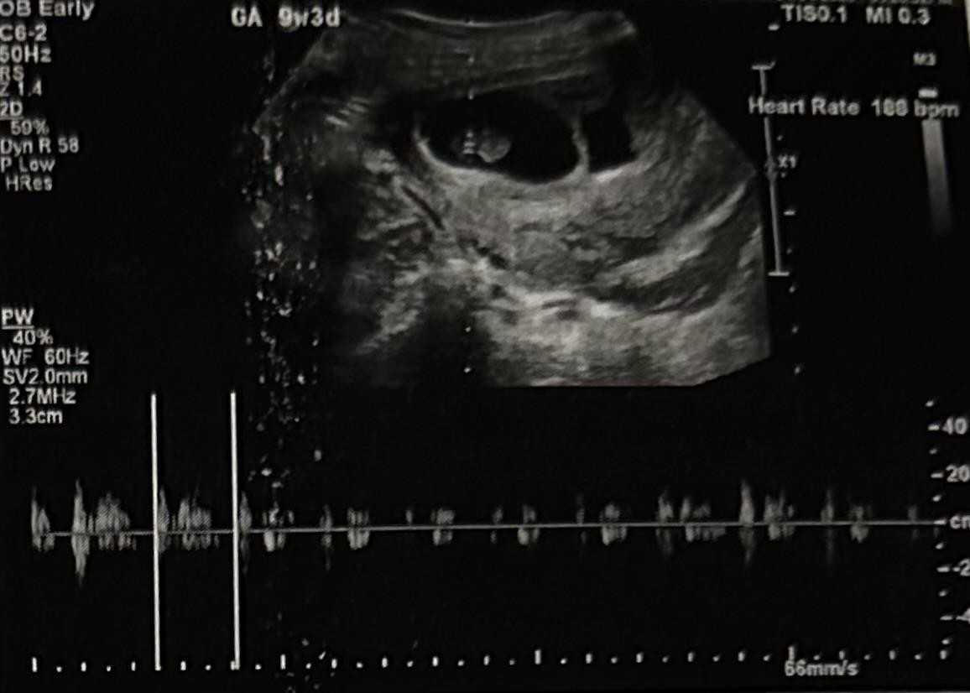
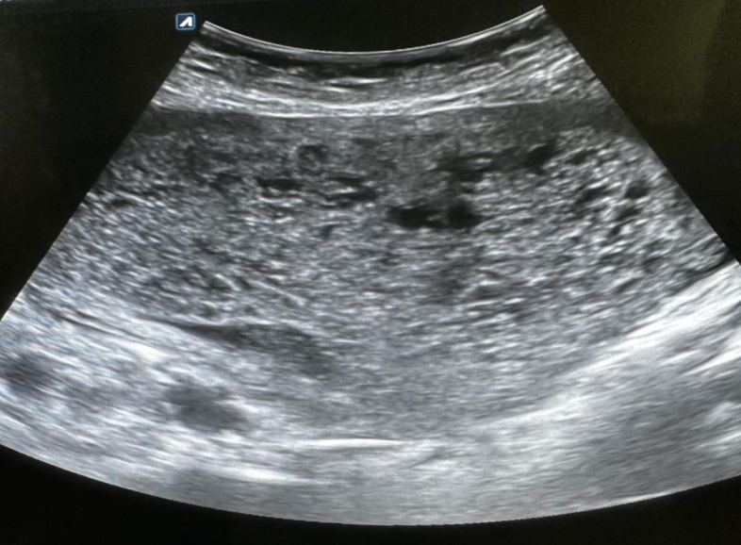
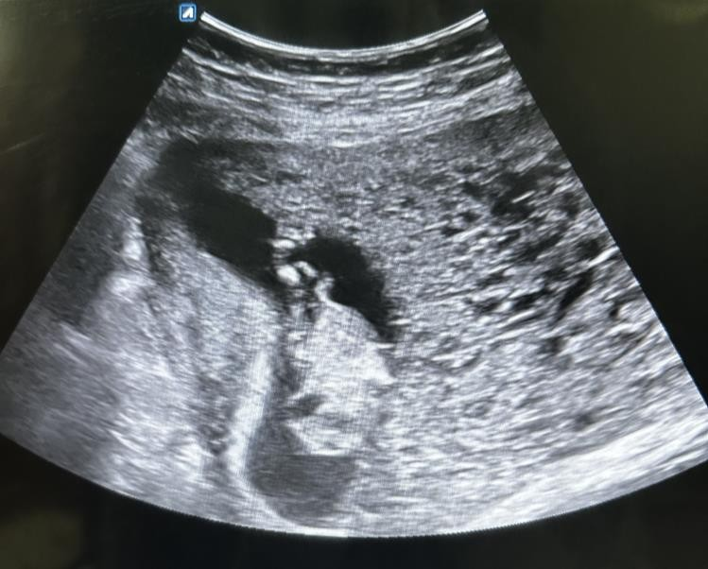
Fig 4: Products of conception post suction evacuation
Fig 3: Transabdominal Ultrasound showing Live fetus with absent skull vault - anencephaly and spinal cord anomalies at thoracic and lumbar levels. There is thickened placental tissue with multiple large nonvascular echogenic areas and anechoic cystic spaces within. Mild perisac collection is also seen.

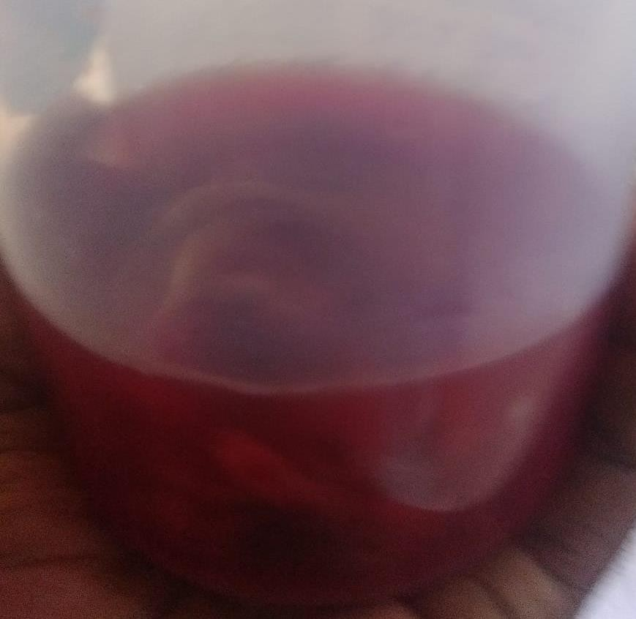
Fig 2: Transabdominal ultrasound showing entire placenta filled with cystic spaces in honeycomb pattern.

Fig 1: Transabdominal ultrasound showing
single live fetus with good cardiac activity

REFERENCES

- Kovachev E, Ingilizova G, Anzhel S, et al. Molar pregnancy – case presentation of 23-year-old pregnant women with partial molar pregnancy. MOJ Anat Physiol. 2020;7(5):150-153. DOI: 10.15406/mojap.2020.07.00306

- Lima LL, Parente RC, Maesta´ I, Amim Junior J, de Rezende Filho JF, Montenegro CA, Braga A. Clinical and radiological correlations in patients with gestational trophoblastic disease. Radiol Bras. 2016 Jul-Aug;49(4):241-250. doi: 10.1590/0100-3984.2015.0073. PMID: 27777478; PMCID: PMC5073391.
- Zeng C, Chen Y, Zhao L, Wan B. Partial Hydatidiform Mole and Coexistent Live Fetus: A Case Report and Review of the Literature. Open Med (Wars). 2019 Nov 10;14:843-846. doi: 10.1515/med-2019-0098. PMID: 31737788; PMCID:PMC6843492.
- Naumoff P, Szulman AE, Weinstein B, Mazer J, Surti U. Ultrasonography of partial hydatidiform mole. Radiology. 1981 Aug;140(2):467-70. doi: 10.1148/radiology.140.2.7255725. PMID: 7255725.
- Maryam Rahamni, Sara Parviz, A case report of partial molar pregnancy associated with a normal appearing dizygotic fetus, Asian Pacific Journal of Reproduction, Volume 5, Issue 2, 2016, Pages 171-173, ISSN 2305-0500
- P Naumoff, A E Szulman, B Weinstein, J Mazer, and U Surti Ultrasonography of partial hydatidiform mole Radiology 1981 140:2, 467-470
- De Franciscis, P., Schiattarella, A., Labriola, D. et al. A partial molar pregnancy associated with a fetus with intrauterine growth restriction delivered at 31 weeks: a case report. J Med Case Reports 13, 204 (2019).
- 1 Archana D Rathod, 2 SP Pajai, 3 A Gaddikeri Partial Mole with a Coexistent Viable Fetus—A Clinical Dilemma: A Case Report with Review of Literature. Journal of South Asian Federation of Obstetrics and Gynaecology, January-April 2014;6(1):51-55
- Thapa S, Rana R, Kumari S. An Incidental Ultrasonographic Diagnosis of Partial Hydatidiform Mole in an Old Primigravida: A Case Report. JNMA J Nepal Med Assoc. 2020 Feb;58(222):112-114. doi: 10.31729/jnma.4575. PMID: 32335624; PMCID: PMC7654454.
- Cavaliere A, Ermito S, Dinatale A, Pedata R. Management of molar pregnancy. J Prenat Med. 2009 Jan;3(1):15-7. PMID: 22439034; PMCID: PMC3279094.
- Urika Joneborg, Yasin Folkvaljon, Nikos Papadogiannakis, Mats Lambe & Lena Marions (2018) Temporal trends in incidence and outcome of hydatidiform mole: a retrospective cohort study, Acta Oncologica, 57:8, 1094-1099, DOI: 10.1080/0284186X.2018.1438653
- Gockley AA, Joseph NT, Melamed A, Sun SY, Goodwin B, Bernstein M, Goldstein DP, Berkowitz RS, Horowitz NS. Effect of race/ethnicity on clinical presentation and risk of gestational trophoblastic neoplasia in patients with complete and partial molar pregnancy at a tertiary care referral center. Am J Obstet Gynecol. 2016 Sep;215(3):334.e1-6. doi: 10.1016/j.ajog.2016.04.019. Epub 2016 Apr 26. PMID: 27130239.

