Genes of virulence of E.coli isolated from humans and broilers in the Alexandria government
Rahma M. Harraze^{1*}, Samy A. khalil¹, Yasser N. Hagag²
¹Department of Microbiology, Faculty of Veterinary Medicine, Alexandria University.
²Department of Animal Hygiene and Zoonoses, Faculty of Veterinary Medicine, Alexandria University.

ABSTRACT
Avian pathogenic Escherichia coli (APEC) and human uropathogenic Escherichia coli (UPEC) may encounter similar difficulties during the establishment of infection in extraintestinal sites. They may share similar virulence genes and the ability to cause disease. In the present study, 12 APEC isolates and 16 UPEC isolates were compared by their virulence genes content, The two groups showed a significant overlap of virulence genotypes including genes encoding adhesins (fimH, fimAvMT78, and papC), which were the most prevalent genes among both APEC and human UPEC isolates. Genes related to large transmissible R plasmid known as pTJ100 plasmid (isS, iutA, sitA, and traT) were more dominant among APEC than UPEC isolates, iron-related (feoB gene) that mediates ferric iron uptake and ompT gene which encodes outer membrane proteins and presented with high incidence in APEC isolates, while tsh gene was absent in the two groups. these results indicated that the examined virulence genes occurred among both APEC and human UPEC isolates but with differences in their prevalence, these similarities give a hypothesis that APEC probably serves as a source or as a reservoir of virulence genes for human ExPEC and may be able to cause extraintestinal disease in humans.
Keywords: E.coli, virulence genes, PCR, broilers, and humans.
Corresponding Author: rahmamahmoudfathalla@gmail.com
1. INTRODUCTION

Extraintestinal pathogenic E.coli (ExPEC) considered an existing health concern for women, newborns, elderly, and immune-compromised persons due to increased numbers of UTI, newborn meningitis, abdominal sepsis, and septicemia. E. coli considered as the primary source of UTIs, The latest studies indicated that E. coli considered as the main reason for nosocomial and neonatal sepsis infections (Mellata, 2013).
APEC cause extra-intestinal infection in different avian species through the invasion of the respiratory tract which results in characteristic signs related to colibacillosis, such as septicemia, airsacculitis, granulomas, swollen head syndrome, cellulitis, sinusitis, omphalitis, arthritis/synovitis, enteritis, peritonitis, pericarditis, and perihepatitis. Disease caused by strains of APEC causes important economic losses to the universal poultry industry (Kunert Filho et al., 2015).
ExPEC derived from Avian and human sources share common features such as virulence factors and phylogenetic groupings (A, B1, B2, and D) proposing the zoonotic probability of Extraintestinal APEC (Giufrè et al., 2012), which considered as colibacillosis main cause in birds and recognized to have similar virulence features as human ExPEC. This proposes a possible spreading way of ExPEC in the community through poultry and poultry products which act as an ExPEC potential reservoir (Bergeron et al., 2012). The gene prevalence studies recognized some similarities between APEC and UPEC isolates. The PCR results of examined virulence genes of UPEC U17 and APEC E058 revealed that they shared 20 of the 37 virulence genes studied (Zhao et al., 2009a). The common pathogenic potential of both EXPEC from human and avian gave the proposal of these EXPEC may be obtained from the same bacterial origin (Manges, 2016), and similarities between strains of EXPEC of human and avian origin propose that the avian strains potentially have zoonotic importance to human (Moulin-Schouleur et al., 2007).
In APEC Fl fimbriae are essential for initial bacterial colonization of the upper respiratory tract. The aerobactin system enhances the multiplication and persistence of the bacteria after host infection. Kl capsule and phase variation of F1 fimbriae enhance the resistance of bacteria to the non-specific immune defenses of the host. P fimbrial adhesins totally presented in internal organs. The entry of bacteria from the respiratory tract into the bloodstream seems to occur in the air-exchange areas of lungs and air sacs (Dho-moulin et al., 1999). In UPEC, type1fim and P pili enhance bacteria to bind and invade host cells and tissues within the urinary tract while iron-chelating factors (siderophores) permit UPEC to take host iron stores. Hemolysin toxin and cytotoxic necrotizing factor 1 (CNF1), enable UPEC to cause extensive tissue damage, facilitating bacterial propagation in addition to releasing host nutrients and inactivating immune effector cells. These toxins also affect inflammatory responses, host cell survival, and cytoskeletal dynamics (Wiles et al., 2008).
This study was aimed to identify the prevalence of some virulence genes in both APEC isolates and UPEC isolates and detect the similarities between them to recognize the zoonotic importance of APEC as a reservoir of virulence genes for UPEC.
2. MATERIALS AND METHODS:
2.1. Sampling:
A total of 130 samples were used in this study, including100 human urine samples were collected from patients suffering from urinary tract infections (75 from females, 25 from males) and examined bacteriologically. Other 30 samples were collected from internal organs of broiler chickens exhibited typical signs of colibacillosis (liver (7), liver capsule (9), heart blood (4), and pericardium (10) of chickens exhibiting (airsacculitis, pericarditis, peritonitis and septicemia) then immersed in nutrient or Trypticase soy broth and transferred in icebox for bacteriological examination.

2.2. Isolation and identification of bacteria from human urine samples and broiler chicken samples:
Each sample was inoculated separately into the nutrient broth and incubated at 37˚C for 18 -24hrs. Loopful from the broth of each sample was streaked onto MacConkey's agar medium according to (Quinn et al., 2011), then inoculated plates were incubated at 37°C for 24 hours. Suspected E. coli colonies were purified and kept for further identification. Gram's stain was used for morphological characterization (Cruickshank et al., 1975). Biochemical identification according to (Quinn et al., 2011), including Indole test, Methyl red test, Citrate utilization test, Catalase test.
2.3. Hemolytic activity of E .coli isolates:
APEC and UPEC isolates were assessed for hemolytic activity on blood agar plates (supplemented with 5% sheep blood) using standard methods (Carter and Cole, 1990).
2.4. Molecular identification of isolated E. coli:
a. DNA extraction:
DNA Extraction was carried out for 70 biochemically identified E. coli isolates by the boiling method (Sambrook and Russell, 2001).
b. Virulence genotyping:
UPEC and APEC isolates were investigated for 10 virulence-related genes by conventional polymerase chain reaction (PCR). Targeted genes primer sequences for the amplification procedures are given in Table (1). All primers used in the amplification of the virulence genes were obtained from Sigma Company.
c. DNA Molecular weight marker:
Six μl of the required ladder were directly loaded after mixing it gently by pipetting up and down.
d. Agarose gel electrophoresis (Sambrook and Russell, 2001):
The amplified PCR products were analyzed via 1.5% % agarose gel electrophoresis and visualized with ethidium bromide staining and UV illumination.

Table (1) primer sequences used for the amplification of different genes of the isolated E.coli.
Gene | Amplicon size (bp) | Primer sequence | Reference
PhoA | 720 | F) CGATTCTGGAAATGGCAAAAG  R) CGTGATCAGCGGTGACTATGAC | (Hu et al., 2011)
feoB | 470 | F)AAT TGG CGT GCA TGA AGA TAA CTG  R)GGCGACCTGATAGAACAATG | (Zhao et al., 2009b)
sitA | 608 | F) AGG GGG CAC AAC TGA TTC TCG  R) TAC CGG GCC GTT TTC TGT GC | (Zhao et al., 2009b)
fimAvMT78 | 266 | F) TCT GGC TGA TAC TAC ACC  R) ACT TTA GGA TGA GTA CTG | (Moulin-Schouleur et al., 2006)
fimH | 508 | F)TGCAGAACGGATAAGCCGTGG  R) GCAGTCACCTGCCCTCCGGTA | (Tiba et al., 2008)
papC | 200 | F) GTG GCA GTA TGA GTA ATG ACC GTT A  R) ATA TCC TTT CTG CAG GGA TGC AAT A | (López-Banda et al., 2014)
traT | 290 | F) GGT GTG GTG CGA TGA GCA CAG  R)CAC GGT TCA GCG ATC CCT GAG | (López-Banda et al., 2014)
ompT | 144 | F) TGC GAT CAG CTC TTT TGC TTC T  R) AGT TGA CTG ACT TTT CGG CCT C | (Abdi and Ghalehnoo, 2015)
iutA | 587 | F)ATGAGCATATCTCCGGACG  R) CAGGTCGAAGAACATCTGG | (Moulin-Schouleur et al., 2006)
isS | 266 | F)ATGTTATTTTCTGCCGCTCTG  R)CTATTGTGAGCAATATATACCC | (Tawfik, Khalil, & Torky, 2016)
tsh | 620 | F) GGTGGTGCACTGGAGTGG  R) AGTCCAGCGTGATAGTGG | (Provence and Curtiss, 1994)

Table (2) Cycling conditions of PCR used for amplification of E.coli genes:
Gene | Initial denaturation | Denaturation | Annealing | Extension | No. of cycles | Final extension
PhoA | 94˚C  5 min. | 94˚C  30 sec. | 58˚C  45 sec. | 72˚C  45 sec. | 35 | 72˚C  10 min.
TSH | 94˚C  5 min. | 94˚C  1min. | 55˚C  1min. | 72˚C  2 min. | 30 | 72˚C  10 min.
isS | 94˚C  5 min. | 94˚C  30 sec. | 54˚C  45 sec. | 72˚C  45 sec. | 35 | 72˚C  10 min.
fimH | 95˚C  2 min. | 94˚C  30 sec. | 58˚C  30 sec. | 72˚C  1min. | 33 | 72˚C  7 min.
traT | 95˚C  5 min. | 94˚C  30 sec. | 62.5˚C  30 sec | 68˚C  180 sec. | 35 | 72˚C  5 min.
papC | 95˚C  5 min. | 94˚C  30 sec. | 58.2˚C  30 sec | 72˚C  40 sec. | 40 | 72˚C  5 min.
fimAvMT78 | 94˚C  3 min. | 94˚C  1 min. | 52˚C  1 min. | 72˚C  30 sec. | 30 | 72˚C  10 min.
sitA, feoB  multiplex | 94°C  5 min | 94°C  30sec. | 59ºC  30 sec. | 72ºC  30 sec. | 30 | 72˚C  5 min.
iutA | 95°C  5 min | 94°C  30sec | 67.1°C  30sec | 68°C  160sec | 30 | 72˚C  5 min
ompT | 94°C  5 min | 94°C  60sec. | 59ºC  50 sec. | 72ºC  70 sec. | 30 | 72˚C  6 min.

3. RESULTS AND DISCUSSION:

Escherichia coli that have the ability to cause infection outside the intestine are recognized as extraintestinal pathogenic E.coli which incorporate both human UPEC and APEC. ExPEC strains share similar contents of virulence genes regardless of their origin. These similarities may permit APEC to cause infection in humans (Johnson et al., 2007). In this study, the incidence of E.coli in broiler chickens was 56.6% this result was lower than that reported by Dadheech et al. (2016), who found that all samples of poultry tissue were positive for E. coli isolates. E. coli occurred in the tissue samples with 100.0% prevalence , This variation may be attributed to using different breeds of chickens, different ages, collection of samples from different sites and at different seasons, while the incidence of E.coli in human urine samples was 61.6% which is higher than reported by Iranpour et al.(2015), who found that the prevalence of E.coli isolates was 39.33%.
Out of 17 E.coli isolated from broiler chickens,12 (70.58%) exhibited alpha hemolysis and 5(29.4%) exhibited beta hemolysis on blood agar plates, while out of 53 uropathogenic E.coli isolated from human samples, 37 (69.8%) exhibited alpha hemolysis and 16 (30.18%) exhibited beta hemolysis , Those results were in contrast with that reported by Zhao et al. (2009b), who found that 20 (10%) among 202 UPEC isolates caused clearing of blood agar around areas of bacterial growth, but none of the 100 APEC isolates haemolysed blood agar.
Results of amplification of the E. coli phoA encoding gene by using PCR which has been proven to be a marker for the detection of E. coli (Kong et al., 1999). As shown in figure (1, 2, 3, 4, 5, 6, 7, and 8) the prevalence of phoA gene among broiler chicken samples was higher than human urine samples as out of 70 tested isolates, 28(40%) isolates were positive for the phoA gene, 16 (30.18%) out of 53 isolates from human urine samples and 12 (70.58%) out of 17 isolates from broiler chicken samples. Alnahass et al. ( 2017), found that the prevalence of phoA gene among E.coli isolated from broiler chicken samples was 75%, while Tawfik et al. (2016), described that the incidence of phoA gene among E.coli isolated from broilers was (37.5%). Another study found that the phoA gene was presented among all E.coli isolated from humans suffering from diarrhea (Yu and Thong, 2009). The prevalence differences may be due to variations in collected samples and the site of collection.
Table (3) lists the differential prevalence of 10 genes between UPEC and APEC.in this study, the pTJ100-related genes which are known for their contribution to APEC virulence and have been localized to large, transmissible R plasmids (Johnson et al., 2002),include (isS, iutA, traT, and sitA) which were more prevalent among APEC isolates (66.6%, 66.6, % 91.6%, and 50% respectively) than human UPEC isolates (43.75 %, 12.5 %, 56.25%, and 12.5% respectively). Zhao et al. (2009b) recognized that all the pTJ100-related genes occurred in the majority of APEC isolates, with (isS, iutA, sitA and traT ) presented in 75% of isolates or more, while in human UPEC isolates presented in more than 50% ,while Mora et al. ( 2009) found the prevalence of (isS, iutA, and traT) was 95% in those 3 genes among APEC isolates while among UPEC isolates was (35%, 87%, and 87% respectively). Johnson et al. (2008), reported that (isS, iutA, sitA, and traT) genes prevalence among APEC was (82.7%, 80.8%, 89.6%, and 78.1% respectively), while in UPEC was (26.6 %,48.4 %,83.4 %,and 67.8% respectively).
Genes encoding adhesins (fimH, fimAvMT78, and papC) were the most prevalent genes among both APEC and human UPEC isolates , while these genes were more prevalent among APEC isolates (91.66, 83.3, and 91.6% respectively ) than those of human UPEC (68.75%, 56.25%, and 56.25% respectively). Mora et al.( 2009), recognized that fimH and papC genes occurred among APEC isolates with the highest prevalence 100.0% while fimAvMT78 occurred with a low prevalence (10%) but in case of human UPEC isolates papC was the most prevalent (91%) followed by fimH (87%) then fimAvMT78(43%). Zhao et al. (2009a), found that the fimH gene presented with high prevalence among both APEC (95%) and human UPEC (92%) isolates, while papC was less prevalent (37% and 54% respectively).
In this study, the prevalence of feoB gene which mediates ferric iron uptake among APEC isolates (66.6%) was higher than human UPEC isolates (37.5%) this result was lower than that detected by Zhao et al. (2009a), who reported that feoB presented with high prevalence among both human UPEC(95%) and APEC isolates (90%), and Rodriguez-siek et al. (2005) who recognized the high incidence of feoB gene among both APEC (99.4%) and human UPEC isolates (99%). Such differences might be due to geographical variations or differences related to the host characteristics.
The prevalence of the ompT gene that encodes outer membrane proteins among APEC isolates was 83.3% which is higher than its prevalence among human UPEC isolates 37.5%. Zhao et al. (2009a), reported that the prevalence of the ompT gene was nearly similar among both APEC (60%) and human UPEC (63%) isolates. Johnson et al. (2008) and Rodriguez-siek et al. (2005), reported nearly similar results which indicated that the prevalence of ompT was high in both APEC(70.4% and 70% respectively) and human UPEC isolates (81.5% and 83.5%, respectively).
This study showed the absence of the tsh gene among both APEC and human UPEC isolates. This result was similar to Aazam et al. (2012), who reported that there were no positive samples for the tsh virulence gene among UPEC isolates, while Mora et al. (2009) recognized the low prevalence of tsh among APEC isolates (9%).
Our results indicated that UPEC and APEC show similarities in their content of virulence genes which, in turn, suggest that APEC probably serves as a source or as a reservoir of virulence genes for human ExPEC and may be able to cause extraintestinal disease in humans. A large study using UPEC isolates from widely various regions and types of UTIs might be useful for the overall interpretation of the data. Further research will be required to determine if APEC can actually overcome the hurdles vital for transmission to humans.

Table ( 3): Prevalence % of different virulence genes in APEC and UPEC isolates.
Gene | APEC(12) | UPEC(16) | Total(28)
fimH | 91.66 | 68.75 | 78.57
isS | 66.6 | 43.75 | 53.57
papC | 91.6 | 56.25 | 71.4
traT | 91.6 | 56.25 | 71.4
fimAvMT78 | 83.3 | 56.25 | 67.85
iutA | 66.6 | 12.5 | 35.7
sitA | 50 | 12.5 | 28.57
feoB | 66.6 | 37.5 | 50
OmpT | 83.3 | 37.5 | 57.14
tsH | 0 | 0 | 0
% was calculated according to the number of isolates.

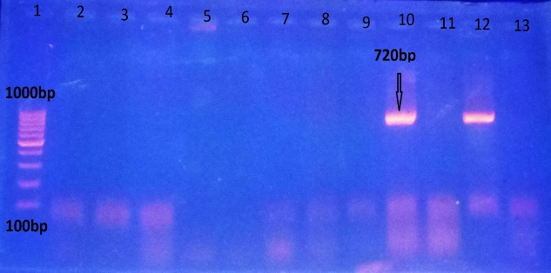
Figure (1): Agarose gel electrophoresis of the amplified phoA gene of the isolated E. coli. Lane (1): DNA molecular weight ladder (100bp ladder). Lanes 10 and 12 are Positive results for the phoA gene (specific band at 720bp). Lanes 2, 3, 4, 5, 6, 7, 8, 9, 11, and 13 are negative results for the phoA gene.
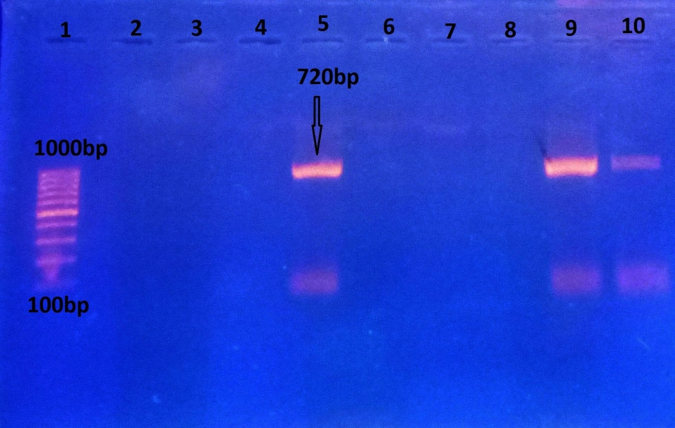
Figure (2): Agarose gel electrophoresis of the amplified phoA gene of the isolated E. coli. Lane (1): DNA molecular weight ladder (100bp ladder). Lanes 5, 9 and 10 are positive results for the phoA gene (specific band at 720bp). Lanes 2, 3, 4, 6, 7 and 8 are negative results for the phoA gene.

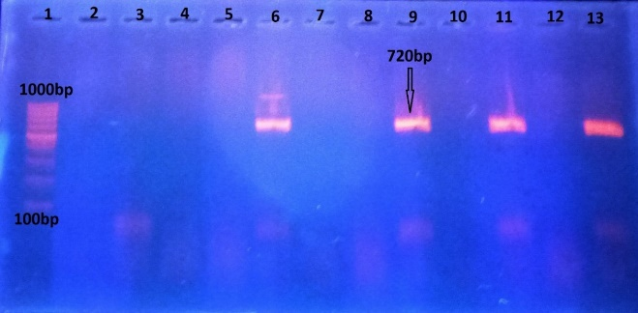
Figure (3): Agarose gel electrophoresis of the amplified phoA gene of the isolated E. coli. Lane (1): DNA molecular weight ladder (100bp ladder). Lanes 6, 9, 11 and 13 are positive results for the phoA gene (specific band at 720bp). Lanes 2, 3, 4, 5, 7, 8, 10 and 12 are negative results for the phoA gene.

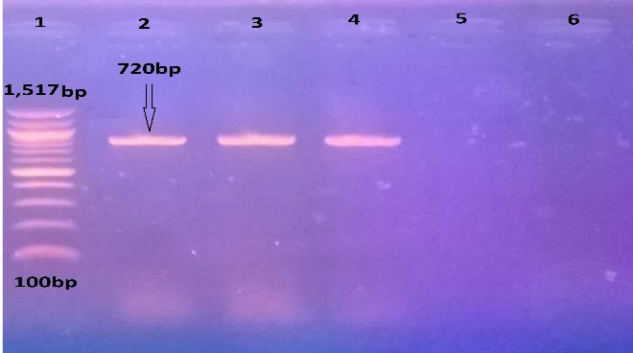
Figure (4): Agarose gel electrophoresis of the amplified phoA gene of the isolated E. coli. Lane (1): DNA molecular weight ladder (100bp ladder). Lanes 2, 3, and 4 are positive results for the phoA gene (specific band at 720bp). Lanes 5 and 6 are negative results for the phoA gene.

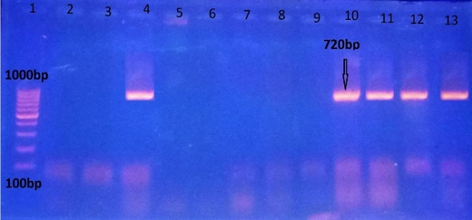
Figure (5): Agarose gel electrophoresis of the amplified phoA gene of the isolated E. coli. Lane (1): DNA molecular weight ladder (100bp ladder). Lanes 4, 10, 11, 12 and 13 are positive results for the phoA gene (specific band at 720bp). Lanes 2, 3, 5, 6, 7, 8 and 9 are negative results for the phoA gene.

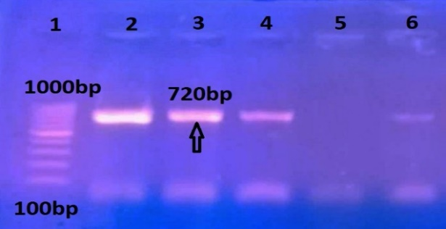
Figure (6): Agarose gel electrophoresis of the amplified phoA gene of the isolated E. coli. Lane (1): DNA molecular weight ladder (100bp ladder). Lanes 2, 3, 4 and 6 are positive results for the phoA gene (specific band at 720bp). Lane (5) is a negative result of the phoA gene.

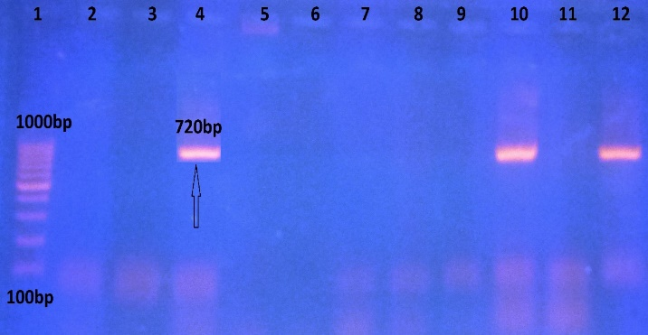
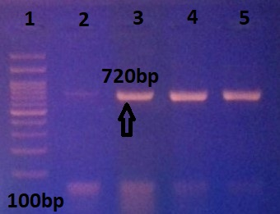

Figure (7): Agarose gel electrophoresis of the amplified phoA gene of the isolated E. coli. Lane (1): DNA molecular weight ladder (100bp ladder). Lanes 4, 10, and 12 are positive results for the phoA gene (specific band at 720bp). Lanes 2, 3, 5, 6, 7, 8, 9, and 11 are negative results for the phoA gene.
Figure (8): Agarose gel electrophoresis of the amplified phoA gene of the isolated E. coli. Lane (1): DNA molecular weight ladder (100bp ladder). Lanes 2, 3, 4 and 5 are positive results for the phoA gene (specific band at 720bp).

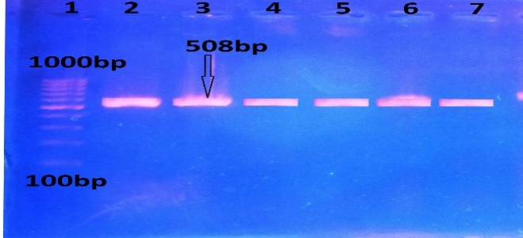
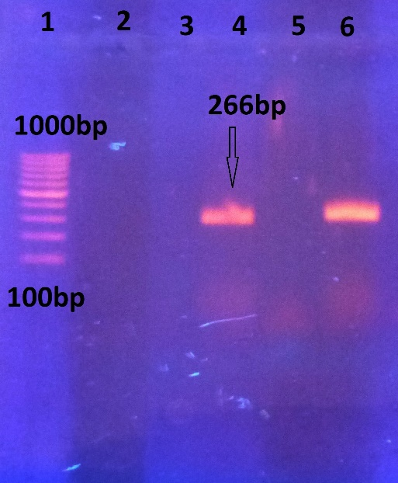
Figure (9): Agarose gel electrophoresis of the amplified fimH gene of the isolated E. coli. Lane (1): DNA molecular weight ladder (100bp ladder). Lanes 2, 3, 4, 5, 6, and 7 are positive results for the fimH gene (specific band at 508bp).

Figure (10): Agarose gel electrophoresis of the amplified isS gene of the isolated E. coli. Lane (1): DNA molecular weight ladder (100bp ladder). Lanes 4 and 6 are positive results for the isS gene (specific band at 266bp). Lanes 2, 3 and 5 are negative results for the isS gene.

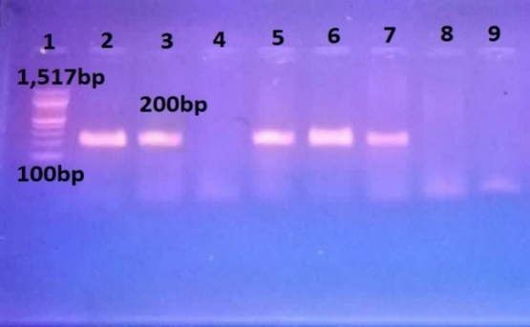

Figure (11): Agarose gel electrophoresis of the amplified papC gene of the isolated E. coli. Lane (1): DNA molecular weight ladder (100bp ladder). Lanes 2, 3, 5, 6 and 7 are positive results for the papC gene (specific band at 200bp). Lanes 4, 8 and 9 are negative results for the papC gene.

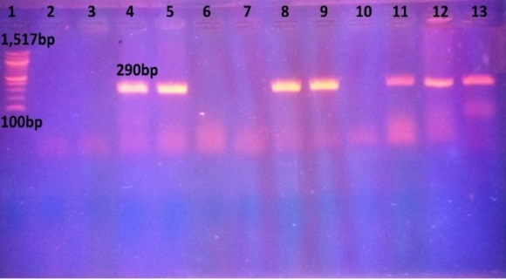

Figure (12): Agarose gel electrophoresis of the amplified traT gene of the isolated E. coli. Lane (1): DNA molecular weight ladder (100bp ladder). Lanes 4, 5, 8, 9, 11, 12 and 13 are positive results for traT gene (specific band at 290bp), lanes 2, 3, 6, 7 and 10 are negative results for the traT gene.

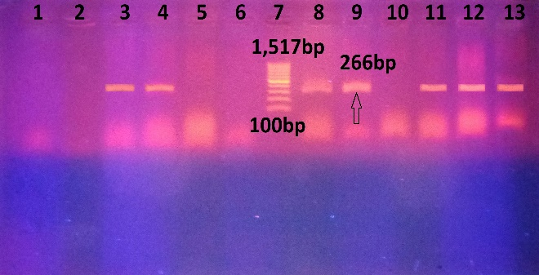
Figure (13): Agarose gel electrophoresis of the amplified fimAvMT78 gene of the isolated E.coli. Lane (7): DNA molecular weight ladder (100bp ladder). Lanes 3, 4, 8, 9, 11, 12 and 13 are positive results for the fimAvMT78 gene (specific band at 266bp), lanes 1, 2, 5, 6 and 10 are negative results for the fimAvMT78 gene.

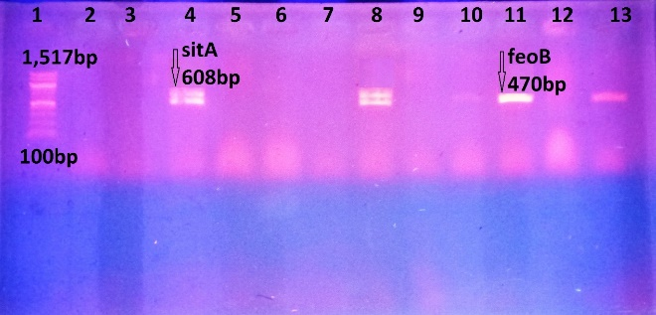
Figure (14): Agarose gel electrophoresis of the amplified sitA gene and feoB gene of the isolated E.coli in a multiplex reaction. Lane (1): DNA molecular weight ladder (100bp ladder). Lanes 4 and 8 are positive results for sitA and feoB gene (specific band at 608bp for sitA gene, 470bp for feoB gene). Lanes 10, 11, and 13 are positive results for feoB. Lanes 2, 3, 5, 6, 7, 9 and 12 are negative results for both sitA and feoB genes.

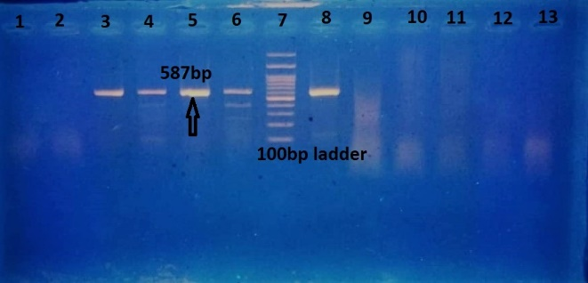
Figure (15): Agarose gel electrophoresis of the amplified iutA gene of the isolated E. coli. Lane (7): DNA molecular weight ladder (100bp ladder). Lanes 3, 4, 5, 6, and 8 are positive results for the iutA gene (specific band at 578bp). Lanes 1, 2, 9, 10, 11, 12 and 13 are negative results for the iutA gene.

Figure (16): Agarose gel electrophoresis of the amplified ompT gene of the isolated E. coli. (100bp ladder), Lane (3, 4, 7, 8, 10, 11, 16 and 17): Positive results for ompT gene (specific band at 144bp). Lanes 2, 5, 6, 9, 12, 13, 14, and 15 are negative results for the ompT gene. Lane (1): DNA molecular weight ladder.

4.REFERENCES:
Aazam, K., Hassan, M., Mahbobe, M., 2012. Detection of uropathogenic Escherichia coli virulence factors in patients with urinary tract infections in Iran. African J. Microbiol. Res. 6, 6811–6816.
Abdi, H.A., Ghalehnoo, M.R., 2015. Virulence Genes , Genetic Diversity , Antimicrobial Susceptibility and Phylogenetic Background of Escherichia coli Isolates 3.
Alnahass, R., Khaliel, S., Ellakany, H., Ibrahim, M., 2017. Comparison between Bacteriological Isolation and Molecular Detection of E. coli from Chickens Suffering from Colibacillosis and/or Diarrhea. Alexandria J. Vet. Sci. 1.
Bergeron, C.R., Prussing, C., Boerlin, P., Daignault, D., Dutil, L., Reid-Smith, R.J., Zhanel, G.G., Manges, A.R., 2012. Chicken as reservoir for extraintestinal pathogenic Escherichia coli in Humans, Canada. Emerg. Infect. Dis. 18, 415–421.
Carter, G.R., Cole, J.R., 1990. Diagnosti c Procedure s in Veterinar y Bacteriolog y an d Mycolog y.
Cruickshank, R., Duguid, J P., Marmion, B P A., Swain, R H A. 1975. Medical Microbiology, 12th ed., Edinburgh and London, vol. 2.
Dadheech, T., Vyas, R., Rastogi, V., 2016. Prevalence , Bacteriology , Pathogenesis and Isolation of E . coli in Sick Layer Chickens in Ajmer Region of Rajasthan , India 5, 129–136.
Dho-moulin, M., Fairbrother, J.M., Dho-moulin, M., Morris, J., Avian, F., Morris, J., 1999. Avian pathogenic Escherichia coli ( APEC ) To cite this version : HAL Id : hal-00902571 30, 299–316.
Giufrè, M., Graziani, C., Accogli, M., Luzzi, I., Busani, L., Cerquetti, M., 2012. Escherichia coli of human and avian origin: Detection of clonal groups associated with fluoroquinolone and multidrug resistance in Italy. J. Antimicrob. Chemother. 67, 860–867.
Hu, Q., Tu, J., Han, X., Zhu, Y., Ding, C., Yu, S., 2011. Development of multiplex PCR assay for rapid detection of Riemerella anatipestifer, Escherichia coli, and Salmonella enterica simultaneously from ducks. J. Microbiol. Methods 87, 64–69.
Iranpour, D., Hassanpour, M., Ansari, H., Tajbakhsh, S., Khamisipour, G., Najafi, A., 2015. Phylogenetic Groups of Escherichia coli Strains from Patients with Urinary Tract Infection in Iran Based on the New Clermont Phylotyping Method . Biomed Res. Int. 2015, 1–7.
Johnson, T.J., Kariyawasam, S., Wannemuehler, Y., Mangiamele, P., Johnson, S.J., Doetkott, C., Skyberg, J.A., Lynne, A.M., Johnson, J.R., Nolan, L.K., 2007. The genome sequence of avian pathogenic Escherichia coli strain O1:K1:H7 shares strong similarities with human extraintestinal pathogenic E. coli genomes. J. Bacteriol. 189, 3228–3236.
Johnson, T.J., Wannemuehler, Y., Johnson, S.J., Stell, A.L., Doetkott, C., Johnson, J.R., Kim, K.S., Spanjaard, L., Nolan, L.K., 2008. Comparison of extraintestinal pathogenic Escherichia coli strains from human and avian sources reveals a mixed subset representing potential zoonotic pathogens. Appl. Environ. Microbiol. 74, 7043–7050.
Kong, R.Y.C., So, C.L., Law, W.F., Wu, R.S.S., 1999. A sensitive and versatile multiplex PCR system for the rapid detection of enterotoxigenic (ETEC), enterohaemorrhagic (EHEC) and enteropathogenic (EPEC) strains of Escherichia coli. Mar. Pollut. Bull. 38, 1207–1215.
Kunert Filho, H.C., Carvalho, D., Grassotti, T.T., Soares, B.D., Rossato, J.M., Cunha, A.C., Brito, K.C.T., Cavalli, L.S., Brito, B.G., 2015. Avian pathogenic Escherichia coli - Methods for improved diagnosis. Worlds. Poult. Sci. J. 71, 249–258.
López-Banda, D.A., Carrillo-Casas, E.M., Leyva-Leyva, M., Orozco-Hoyuela, G., Manjarrez-Hernández, Á.H., Arroyo-Escalante, S., Moncada-Barrón, D., Villanueva-Recillas, S., Xicohtencatl-Cortes, J., Hernández-Castro, R., 2014. Identification of virulence factors genes in escherichia coli isolates from women with urinary tract infection in Mexico. Biomed Res. Int. 2014.
Manges, A.R., 2016. Escherichia coli and urinary tract infections: The role of poultry-meat. Clin. Microbiol. Infect.
Mellata, M., 2013. Human and Avian Extraintestinal Pathogenic Escherichia coli : Infections, Zoonotic Risks, and Antibiotic Resistance Trends. Foodborne Pathog. Dis. 10, 916–932.
Mora, A., López, C., Dabhi, G., Blanco, M., Blanco, J.E., Alonso, M.P., Herrera, A., Mamani, R., Bonacorsi, S., Moulin-Schouleur, M., Blanco, J., 2009. Extraintestinal pathogenic Escherichia coli O1:K1:H7/NM from human and avian origin: Detection of clonal groups B2 ST95 and D ST59 with different host distribution. BMC Microbiol. 9, 1–11.
Moulin-Schouleur, M., Répérant, M., Laurent, S., Brée, A., Mignon-Grasteau, S., Germon, P., Rasschaert, D., Schouler, C., 2007. Extraintestinal pathogenic Escherichia coli strains of avian and human origin: Link between phylogenetic relationships and common virulence patterns. J. Clin. Microbiol. 45, 3366–3376.
Moulin-Schouleur, M., Schouler, C., Tailliez, P., Kao, M.R., Brée, A., Germon, P., Oswald, E., Mainil, J., Blanco, M., Blanco, J., 2006. Common virulence factors and genetic relationships between O18:K1:H7 Escherichia coli isolates of human and avian origin. J. Clin. Microbiol. 44, 3484–3492.
Provence, D.L., Curtiss, R., 1994. Isolation and characterization of a gene involved in hemagglutination by an avian pathogenic Escherichia coli strain. Infect. Immun. 62, 1369–1380.
Quinn, P.J., Markey, B.K., Leonard, F.C., Hartigan, P., Fanning, S., FitzPatrick, E.S., 2011. Vet. Microbiol. Microbial Dis.Wiley.
Rodriguez-siek, K.E., Giddings, C.W., Doetkott, C., Johnson, T.J., Fakhr, M.K., Nolan, L.K., Nolan, L.K., 2005. Comparison of Escherichia coli isolates implicated in human urinary tract infection and avian colibacillosis 2097–2110.
Sambrook, J., Russell, D.W., 2001. Molecular Cloning: A Laboratory Manual. Cold Spring Harbor Laboratory Press.
Tawfik, R., Khalil, S., Torky, H., 2016. Mycoplasma synoviae and other associated bacteria causing arthritis in chickens. Alexandria J. Vet. Sci. 49, 1.
Tiba, M.R., Yano, T., Leite, D.D.S., 2008. Genotypic characterization of virulence factors in Escherichia coli strains from patients with cystitis. Rev. Inst. Med. Trop. Sao Paulo 50, 255–260.
Wiles, T.J., Kulesus, R.R., Mulvey, M.A., 2008. Origins and virulence mechanisms of uropathogenic Escherichia coli 85, 11–19.
Yu, K. xin, Thong, K.L., 2009. Multiplex PCR for Simultaneous Detection of Virulence Genes in Escherichia coli. Malaysian J. Sci. 28, 1–14.
Zhao, L., Gao, S., Huan, H., Xu, X., Zhu, X., Yang, W., Gao, Q., Liu, X., 2009a. Comparison of virulence factors and expression of specific genes between uropathogenic Escherichia coli and avian pathogenic E. coli in a murine urinary tract infection model and a chicken challenge model. Microbiology 155, 1634–1644.
Zhao, L., Gao, S., Huan, H., Xu, X., Zhu, X., Yang, W., Gao, Q., Liu, X., 2009b. Comparison of virulence factors and expression of specific genes between uropathogenic Escherichia coli and avian pathogenic E . coli in a murine urinary tract infection model and a chicken challenge model 1634–1644.

