Insight on Prevailing Bacterial Diseases Affecting Grass carp (Ctenopharyngodon idella) at Aswan Fish Hatchery, Egypt

Awatef H. Hamouda¹*, Eman M. Moustafa²
¹Fish Diseases Department, Faculty of Fish and Fisheries Technology, Aswan University, Aswan, Egypt.
²Department of Fish Diseases and Management, Faculty of Veterinary Medicine, Kafrelsheikh University, Kafr El-Sheikh, Egypt.
* Correspondence to: Awatef Hamed Hamouda, Fish Diseases Department, Faculty of Fish and Fisheries Technology, Aswan University, Aswan, Egypt; Email: awatefhamouda@yahoo.com; awatefhamouda@aswu.edu.eg
Telephone number: 01019599964
ABSTRACT
Bacterial fish diseases are the major serious problems in the intensive aquaculture due to naturally presence of their fish pathogens in the fish surrounding environment. An epizootic was noticed in grass carp from El-Shalal fish hatchery, Aswan Governorate, Egypt during the induced spawning season (April & May, 2018). Diseased fish showed hemorrhages all over the body, excess mucus on skin and gills and abdominal distension with congested gills. The current study aims to spot light on the most predominant bacterial infections in the current hatchery; with special focus on biochemical characterization, molecular identification; as well as, pathogenicity, antimicrobial susceptibility and histopathological changes by the most prevalent isolated microbe. Phenotypic and biochemical identification revealed prevalence of Aeromonas hydrophila (A. hydrophila), Pseudomonas fluorescens (P. fluorescens) and Enterococcus faecalis (E. faecalis) with prevalence of (26%), (35%), and (14%) respectively. P. fluorescens, the most prevalent pathogen, was molecularly identified using the 16S rRNA gene in PCR technique and its pathogenicity was confirmed by experimental infection of grass carp as well as, the histopathological examination. Antibiogramme test revealed that P. fluorescens was sensitive to Ciprofloxacin, Cephalothin, Gentamicin and Amikacin and resistant to Cloxacillin, Penicillin, Erythromycin and Ampicillin.
Keywords: Aeromonas hydrophila, Pseudomonas fluorescens, grass carp, molecular characterization, Antibiogramme, histopathological examination.
Short running title: Prevailing Bacterial Diseases Affecting Grass carp.
- INTRODUCTION
Grass carp (Ctenopharyngodon idella) is one of the most economically cultured freshwater fish species in the world (FAO, 2016, Shehata et al., 2018). It is reproductive significantly, having high growth rates, rich in nutrients and mainly native to China that was first-time introduced to Egypt in the 1980s (Essa et al., 2004, Saleh, 2007). Since being stocked for many decades in the government hatcheries; and in 2012, around 44.226 million units of grass carp fingerlings were delivered (GAFRD, 2016). The extensive number of the delivered seed was utilized by the two major national projects: the National Aquatic Weed Control Project (NAWCP) mainly for biological weed control purposes in the main irrigation canals and agriculture drainage, and fish culture in rice fields (FCRF). The rest of grass carp seed was utilized for stocking inland lakes for weed control as well as, polyculture in lakes.
Grass carp have an extraordinary capacity to process a lot of aquatic plants; releasing and reusing the nutrients held in these plants which stimulate the production of preferred plankton communities increasing the fish production and reducing the wastage of freshwater. Grass carp usually has incomplete digestion and about half of the ingested food material is excreted as feces supporting a large biomass of other fish species in the polyculture system (Jhingran and Pullin, 1985). In 2004, this species accounted for more than 23.700 tons of freshwater fish harvested from irrigation and agriculture drainage canals of River Nile, Egypt (GAFRD, 2005).
Grass carp participate with black carp to dispose snails which are the intermediate hosts for different parasitic diseases of zoonotic importance as schistosomiasis, a historically widespread parasitic disease in Egypt as well as, other serious diseases in fish. Grass carp improve the environment and the public health through removing the refuges covering the snails by trimming vegetation and thus improving their predation process by black carp.
To overcome the increasing demand for fish production, the intensive culture of many fish species is now a world strategy, resulting in increased outbreaks from bacterial, viral and/or parasitic diseases particularly when fish are reared at high densities (Woo, 2011). Recently, the quick worldwide increase in aquaculture has led to a correspondingly predictable increase especially in the severity and incidence of the long-recognized bacterial diseases which are responsible for heavy mortalities and subsequent serious economic losses in both cultured and wild fish (Noga, 2010, Roberts, 2012, El-Barbary, 2017). There are 34 different bacterial families, including approximately 125 different bacterial species have been associated with various fish diseases in the world (Öztürk and Altınok, 2014); few of them are transmissible to humans e.g., A. hydrophila can infect the skin, cause gastroenteritis or systemic infections (Lehane and Rawlin, 2000). Aeromonas, Pseudomonas and Enterococcus are from the major genera of fish pathogens causing diseases in different tropical freshwater fishes (Plumb, 1997, Roberts, 2012).
The current study was conducted to shed light on the most predominant bacterial infections in cultured grass carp in El-Shalal fish hatchery, Aswan Governorate with special focus on biochemical characterization, molecular identification; as well as, the pathogenicity, antimicrobial susceptibility and the histopathological changes induced by the most prevalent isolated microbe.

- MATERIAL AND METHODS
Study Area
This study was conducted in El-Shalal fish hatchery for grass carp, Aswan Governorate, Egypt. This hatchery was constructed in 1973 and started working in 1991 under the supervision of the Egyptian Ministry of Water Resources and Irrigation, producing 4-6 million fry annually.
Ethical Approval
All handlings of fish were directed according to the the local and national animal welfare laws, guidelines and policies for scientific purposes. The protocol was approved by Faculty of Fish and Fisheries Technology, Aswan University (approval No. 2/2018).
2.1. Fish:
A total number of 100 clinically diseased grass carp (Ctenopharyngeodon idella) were collected alive from El-Shalal fish hatchery, Aswan Governorate, Egypt in April and May 2018. The samples were collected with different body weights of (100-2500 g) and total lengths (17.5-50 cm) during an epizootic with history of septicemic clinical signs and mortality rates.
The collected fish were transferred alive to the wet lab., Fish Diseases Department, Faculty of Fish and Fisheries Technology, Aswan University, Egypt (Langdon and Jones, 2002), held in well-prepared glass aquaria supplied with sufficient amounts of dechlorinated water with continuous aeration (Innes, 1966).
2.2. Clinical examination:
The collected fish were examined clinically to detect any external changes or abnormalities; as well as postmortem examination of the fish internal organs were conducted according to the methods described by Buller (2004), Austin and Austin (2012).
2.3. Bacterial isolation:
For bacteriological examination, tissue samples were aseptically collected from skin, liver, kidneys and spleen of each examined fish. The collected samples were firstly pre-enriched on Tryptic Soy Broth (TSB, Oxoid) and incubated at 28˚C for 24 hrs. After which (pre-enrichment on TSB), they were streaked on tryptic soy agar (TSA, Oxoid) and incubated at 30˚C for 48 hrs. Well-differentiated single pure bacterial colonies were further streaked onto selective differential media for many bacterial pathogens; Rimler Shotts agar (RS), Aeromonas selective agar base with Ampicillin supplement, XLD medium, Pseudomonas-F-agar base medium and Streptococcus selective agar and incubated at 28-30 °C for 24 hrs. Culture characteristics of isolated bacteria were recorded. Moreover, tissue samples were selectively pre-enriched on Enterococcus M broth medium and incubated at 37°C for 18-24 hrs and further streaked on BBL_{TM} Enterococcosel Agar (EA) and incubated at 37°C overnight; especially for isolation of Enterococci bacteria.
  - Bacterial identification:
Phenotypic characterizations of the bacterial isolates were identified according to Bergey's (1994), Elemar et al. (1997), Madigan and Martinko (2005). For phenotypic identification, pure cultures were subjected to Gram staining and motility test, and then viewed microscopically (Cruickshank et al., 1975). Further conventional biochemical tests following the criteria proposed by Kreig and Holt (1984), MacFaddin (2000) were performed.
Molecular identification of Polymerase Chain Reaction (PCR):
The most prevalent bacterial isolate was selected and subjected to molecular identification using PCR.
Primer sequences used for PCR identification system:
The f-species specific genes for detection of P. fluorescens were applied by using the following primers (Pharmacia Biotech) in Table 1.
Table 1. The primers used for PCR identification:
Target | Primers | Oligonucleotide sequence (5′ → 3′) | Product size (bp) | References
P. fluorescens | 16SPSEfluF (F) | 5′ TGCATTCAAAACTGACTG ′3 | 850 | Scarpellini et al. (2004)
 | 16SPSER (R) | 5′ AATCACACCGTGGTAACCG ′3

DNA Extraction of P. fluorescens using QIA amp kit (Shah et al., 2009):
Accurately, template DNA was prepared by boiling 200 μL of bacterial suspension in distilled water in Eppendorf tubes for 10 min. The tubes were immediately cooled on ice and centrifuged (20000 g for 1 min) at 4°C. The supernatants were subsequently kept at -20°C.
DNA amplification reaction by using 16S rRNA for P. fluorescens (Scarpellini et al., 2004):
The PCR was performed in a volume of 50 μL containing 3 μL template DNA, 5 μL of 10 × PCR buffer, 200 μM of each dNTPs, 2 mM of MgCl2, 0.5 μM of each primer and 1.5 U of Taq Polymerase. The PCR cycling protocol was applied as following: An initial denaturation at 94°C for 2 min followed by 35 cycles consisting of denaturation at 94°C for 45 sec, annealing at 54°C for 45 sec, extension at 68°C for 2 min and final extension of 68°C for 2 min as well as, final cooling at 4°C. Finally, 7 μL of amplicon was electrophoresed in 1% agrose gel (Sigma –USA) at 100 V, stained with ethidium bromide and visualized as well as captured on UV transilluminator.
  - Experimental infection:
Total Bacterial count
The drop plate technique for estimation of P. fluorescens strain per 1 ml was utilized in demonstration of the inoculum dose for the experimental studies as indicated by Cruickshank et al. (1975).

Lethal Dose 50
A total number of 50 apparently healthy grass carp weighting (100±5 g) obtained from the hatchery and transported to Fish Diseases department at Faculty of Fish and Fisheries Technology, Aswan University. The fish were divided into 5 groups, 10 fish per each group and the fifth one was kept un-injected as a control group. All fish were kept for 15 days under observation prior to injection for acclimation and to confirm that they are free from diseases.
Colony culture of P. fluorescens strain of 24 hours on TSA was utilized; the colonies were picked up and suspended in sterile saline in a tenfold serial dilution with subsequent incubation at 28 °C for 24 hours for plate counts on TSA. Only the dilutions (10⁶–10⁸ cfu/mL) were used. The first three groups were intraperitoneally injected with 0.5 ml/fish of each bacterial dilution. The fish in the fourth group were injected with 0.5 ml PBS/fish (Phosphate Buffer Saline). The control group was kept un-injected. All fish groups were kept for one week post-inoculation for observation. Clinical signs and mortalities were recorded twice/ day according to Mastan (2013). The freshly dead fish were moved for further postmortem examination to re-isolate the causative P. fluorescens strain from the internal organs. The LD₅₀ (the dose which kill 50% of the injected fish) was calculated according to Reed and Muench (1938).
Pathogenicity test
Experimental infection was conducted to decide the pathogenicity of P. fluorescens strain utilizing intra-peritoneal route injection according to Masbouba (2004), Eissa et al. (2010). A total number of 30 apparently healthy grass carp fish weighing (100±5 g), were divided into 3 groups; 10 fish per each. Each fish in the first group was intraperitoneally injected with 0.2 ml/fish of LD₅₀ dose P. fluorescens strain which was determined previously (1 x 10⁸ cfu). Each fish in the second group (control negative group), was intraperitoneally injected with 0.2 ml/fish of PBS (Phosphate Buffer Saline). Each fish in the third group (Control positive group), was intraperitoneally injected with 0.2 ml/fish of got reference P. fluorescens strain (obtained from the food analysis center, faculty of veterinary center, Benha University, Egypt). All the injected fish were watched for a time of 21 days post-inoculation. Mortalities were recorded day by day and freshly dead fish were moved for further pm examination and histopathological studies. Toward the finish of the experiment, all remained grass carp were sacrificed and examined as described.
  - Histopathological examination:
Branchial, hepatic, Renal and splenic tissue samples of experimentally infected fish with P. fluorescens were taken. Specimens were fixed immediately in 10% neutral buffered formalin solution, dehydrated and embedded in paraffin blocks. Paraffin blocks were sectioned at 4-5 µm thickness and stained with Hematoxilin & Eosin (H&E) then examined under microscope using methods described by Bancroft and Gamble (2007).
  - Antimicrobial susceptibility assay of P. fluorescens (Antibiogramme):
Antimicrobial susceptibility for P. flurescens strain was conducted by the single diffusion method according to Kittinger et al. (2016). Sensitivity discs with variable concentrations were utilized to decide the powerlessness of the segregated bacterial strain (Oxoid Limited, Basingstoke, Hampshire, UK).
Agar plate method was applied by utilizing of nutrient agar as a substrate for development of the tried bacterium for its antibiotic sensitivity. The bacterial culture was consistently spread on the outside surface of nutrient agar. At that point, the antibiotic discs were set over the surface of inoculated plate. In addition, the plate was then incubated at reasonable temperature (25°C) for 2-7 days and checked for the development of the bacterium around the antibiotic discs. The maximal inhibition zone for the growth of microbe is said to that antibiotic had greatest impact on the microbe growth. Therefore, the antimicrobial discs and their concentrations as well as the diameters of the zones of inhibition for the tested strain was applied according to the guidelines stipulated by National Committee for Clinical Laboratory Standards "NCCLS" (2001). The tested strains were evaluated as susceptible, intermediate and resistant.
3. RESULTS AND DISCUSSION
Bacterial diseases are the major serious problems in aquaculture (Ibrahim et al., 2013). Bacterial fish pathogens are naturally present in the fish surrounding environment; nonetheless, under certain stress conditions, they may cause extreme financial misfortunes with 80% mortalities in fish farms. Pseudomonas infection has been implicated as a standout amongst the most widely recognized bacterial infection and appear to be stress related disease of freshwater fish, especially under culture conditions (Khalil et al., 2010, Omar et al., 2017).
In the current study, external examination of naturally infected grass carp revealed signs of hemorrhages all over the body especially on the operculum, pectoral, anal and caudal fins as well as, erosions of the caudal fin. Excess mucus on both skin and gills was apparent. Hyperemia of the anal opening, abdominal distension and congested gills were watched (Fig. 1). The clinical signs displayed in the current study were nearly similar to that obtained by Uzbülek and Yildiz (2002), Geng et al. (2006), Meyer et al. (2008), Zhang et al. ((2009), Shagar and El-Refaee (2012), Zheng et al. (2012), Song et al. (2014), Luo et al. (2015), Dahdouh et al. (2016) who isolated these different bacterial pathogens (A. hydrophila, P. fluoroscens and E. faecalis) from the same or other fish species with septicemic picture.
Necropsy examination showed congestion of the oral cavity (Fig. 1); congestion of the kidney, spleen, intestine with fatty liver were noticed as well as, there were hemorrhages all over the abdominal cavity (Fig. 2). The postmortem findings displayed in this study were nearly similar to those reported by Zhang et al. (2006), Zhang et al. (2009), Song et al. (2014), Li et al. (2016), Kong et al. (2017), Ren et al. (2017). These finding may be attributed to the action of extracellular products of A. hydrophila, P. fluoroscens and E. faecalis which secrete toxins such as haemolysin, aerolysin, cytotoxic toxins, S-layers and extracellular enzymes as proteases, gelatinase and aggregation substance that possess a haemolytic, cytolytic, enterotoxic characteristics playing important roles during infection activities of these pathogens (Daskalov, 2006, Zhang et al., 2009, Savaşan et al., 2016, Omar et al., 2016).
The presumptive identification of different isolated bacteria was carried out from the colony morphology over different used selective media. Colonies of Aeromonas sp. on TSA medium appeared round, creamy and shiny. However, on RS medium, appeared light yellow colonies with entire margin after 24 hrs of incubation due to maltose fermentation. On the other hand, on Aeromonas base agar medium appeared small, dark green colonies with a dark center while, on XLD medium appeared large, round yellow colonies. Gram staining for these colonies showed gram-negative cocco-bacilli to rod-shaped bacteria motile. These obtained results were similar to that recorded by Masbouba (2004), Omar et al. (2016), Matter et al. (2018).
Colonies of Pseudomonas sp. on TSA medium appeared spindle shape and after 24 hrs producing a diffusible faint yellow-green fluorescence pigments. On RS medium, it appeared greenish in color after 24 hrs of incubation. While, on Pseudomonas-F agar, it appeared as yellowish green colonies and produce fluorescence after 48 hrs of incubation. Gram staining revealed that they are Gram-negative, rod-shaped motile bacteria. These results were similar to that reported by many previous authors (Austin ad Austin, 1993, Masbouba, 2004, Darak and Barde, 2015, Omar et al., 2017, Matter et al., 2018).
Colonies of Enterococcus sp. on Streptococcus Selective agar showed dew drops like, white colonies, rounded with entire edges or creamy rounded, large colonies. These observations were in accordance with what has been reported by Khafagy et al. (2009), Arumugam et al. (2017), Rahman et al. (2017). Color change of Enterococcus M broth medium was evaluated as an indicator of enterococci growth. An enterococci on BBL_{TM} Enterococcosel Agar (EA) appeared black and dark brown colonies. With Gram's stain, E. faecalis were gram-positive arranged in pairs and sometimes short chains. This result was similar to that recorded by Savaşan et al. (2016).
Biochemical characterizations have proven to be a valuable method for typing and differentiation of bacterial fish pathogens (Darak and Barde, 2015, Lopez et al., 2012). The biochemical characteristics of these bacterial pathogens are given in Table 2. The characteristics exhibited by these bacteria coincided with those given by Mastan (2013), Parvez and Mudarris (2014), Omar et al. (2016), Arumugam et al. (2017).
The bacteriological and biochemical examinations of the diseased grass carp indicated that, mainly three pathogenic bacteria, A. hydrophila, P. fluorescens and E. faecalis have been associated with most of septicemic cases. Total prevalence of naturally infected grass carp with bacterial infections was (60%). The isolated bacteria were A. hydrophila (26%), P. fluoroscens (35%), and E. faecalis (14 %). These findings were higher or lower than that recorded by many authors and this difference may be attributed to the different fish types, the site of sample collection, the number of examined fish, the size and age of fish and/or environmental conditions (Khafagy et al., 2009, Awad, 2011, Shagar and El-Refaee, 2012 , Matter et al., 2018).
Almost all the detected bacterial pathogens were isolated from the liver, kidney, and spleen samples of grass carp. These results may be due to the fact that, these organs have a haemopiotic function so they may be highly susceptible to infections especially in septicaemic diseases (Matter et al., 2018).
Bacterial diseases in aquatic animals are multi-factorial related to the host, the environment and the pathogen which work in concert to define the nature of the infection's course (Sniesko, 1974, Thune et al., 1993). The detected septicemic disease condition due to A. hydrophila, P. fluoroscens and E. faecalis was found to be associated with the existence of stressful environmental conditions (Roberts, 2012) expressed by over wintering of the grass carp, inappropriate handling, physical injury during transportation and induced spawning in April and May, and this might be involved in triggering the disease outbreaks in these months each year, during the induced spawning period.
Molecular characterization with conventional PCR to confirm biochemically identified P. fluorescens using the specific primers revealed presence of a common band at 850bp (Fig. 3). These results agreed with that described by Scarpellini et al. (2004) who used the PCR to amplify a specific portion of the 16S gene, allowing the recognition of P. fluorescens and the target regions for PCR primers 16SPSEfluF and 16SPSER were identified a single DNA fragment of 850 bp of 16S rRNA amplified only for P. fluorescens.
Experimental infection indicated that P. fluorescens was highly pathogenic to grass carp and the cumulative mortality was 56 % in the challenged group. The fish began to die on the 2nd day post-challenge. The clinical signs observed in the experimentally infected grass carp were similar to those recorded in the natural infections (Badran, 1993, Azza et al., 2002, Omar et al., 2017). P. fluorescens was re-isolated from the experimentally infected fish. No clinical signs or mortalities were observed in the control group.
In the present study, the histopathological findings of the experimentally infected grass carp with P. fluorescens, demonstrated thickened secondary gill lamellae due to hypertrophy and hyperplasia of its epithelia, leading to fusion of secondary lamellae together with mononuclear cells infiltrations. Telangiectasia (dilatation of the tip of secondary lamellae) due to congestion of the gills blood vessels was noticed (Fig. 4). The liver showed degeneration, necrosis, vaculation of hepatocytes with pyknotic nucleus, degenerated cells as well as, loss of architecture. Dilatation and congestion of blood sinusoids were apparent. Fibrosis around blood vessels and bile ducts with fatty degeneration were recorded (Fig. 5). These results were nearly similar to that recorded by Luo et al. (2015) who noticed that many irregular vacuolations and damaged hepatocytes in the livers of experimentally infected grass carp with P. aeruginosa. The spleen showed necrosis, depletion of lymphoid cells, congestion of blood vessels and increase of melanomacrophage center cells (Fig.6). The kidney demonstrated vaculation, necrosis of the main duct of the kidney with mononuclear cells infiltrations and congestion of blood vessels. Dilated blood capillary in the glomeruli of renal corpuscle was apparent. Peritubular fibrosis with appearance of normal tubules around was noticed (Fig.7). These findings were nearly similar to those reported by Miyazaki et al. (1984). These results support the hypothesis that P. fluorescens is pathogenic to grass carp (Geng et al., 2006) and that the gills, liver, spleen and kidney were the major target organs of the pathogen in this fish. The pathogenicity of P. fluorescens for experimentally infected grass carp may be attributed to the production of extracellular enzymes and lethal toxins (Masbouba, 2004, Zhang et al., 2009, Omar et al., 2017, Matter et al., 2018).
P. fluorescens is one of the most prevalent fish bacterial pathogens in aquaculture due to its ubiquitous nature in aquatic environment (Ahne et al., 1982). The antibiotic resistance is a great concern in the management of bacterial diseases, so the selection of suitable antibiotic for its control is of prime importance at any aquaculture facility (Zaki et al., 2011).
The susceptibility of P. fluorescens to 13 antimicrobial agents was recorded (Table 3). The results indicated that P. fluorescens was sensitive to Ciprofloxacin, Cephalothin, Gentamicin, Amikacin and was moderately sensitive to Oxytetracycline, Sulphamethoxazol, Kanamycin, Nalidixic acid, Cefotaxim, however, it was resistant to Cloxacillin, Penicillin, Erythromycin and Ampicillin. These findings were nearly similar to those reported by Luo et al. (2015) who found that grass carp infected with P. aeruginosa was sensitive to Enoxacin, Ciprofloxacin and resistant to Ampicillin and Erythromycin in addition to, Shagar and El-Refaee (2012) showed that sliver carp infected with P. fluorescens was sensitive to Ciprofloxacin and Tetracycline while it was resistant to Ampicllin and Kanamycin. Foysal et al. (2011) declared that P. fluorescens was sensitive only against Streptomycin and Gentamycin. Nusbaum and Shotts (2006), Ghosh et al. (2011) mentioned that P. fluorescens was generally sensitive to Gentamycin and Tobramycin. Zaki et al. (2011) declared that Enrofloxacin has proved a superior efficacy against pseudomonas infections.
4. CONCLUSION
The current study provides a fundamental basis for demonstrating the bacterial diseases infecting grass carp in Aswan Governorate (southern Egypt); that will helpful as a starting point for bacterial diseases diagnosis, prevention and control plans in this region. A. hydrophila, P. fluorescens and E. faecalis are the most significant microbial agents affecting grass carp. Stressors play a great role in triggering the disease outbreaks. P. fluorescens were the most prevalent bacterial species, causing septicemia and mortalities that could lead to serious economic losses. P. fluorescens was sensitive to Ciprofloxacin, Cephalothin, Gentamicin and Amikacin.
Competing interests
Authors have declared that there is no competing interest
5. REFERENCES
Ahne, W., Popp, W., Haffman, R. 1982. Pseudomnas Fluorescence as a pathogen of tench (Tinca tinca). Bull Eur Assoc Fish Path. 4:56-57.
Arumugam, U., Stalin, N., Rebecca, G. 2017. Isolation, Molecular Identification and Antibiotic Resistance of Enterococcus faecalis from Diseased Tilapia. International Journal of Current Microbiology and Applied Sciences. 6(6): 136-146.
Austin, B., Austin, D.A. 1993. Bacterial Fish Pathogens. In: Disease in Farmed and wild fish. Ellis Horwood Ltd Publisher, Chichester, England: 171-187.
Austin, B., Austin, D.A. 2012. Bacterial fish pathogens, diseases of farmed and wild fish. Springer, New York, London.
Awad, S. M. 2011. Studies on prevailing bacterial diseases in carp. PhD Thesis, Fac. of Veterinary Medicine, Suez Canal University, Egypt.
Azza, M. M., El- Nobi, G. A., Moustafa, A. M. 2002. Studies on Pseudomonas Septicemia Among Tilapia Fish in Abbassa Fish Farms. Zag. Vet. J. 30 (1): 25 -31.
Badran, A. F. 1993. Studies on Pseudomonas septicemia outbreak among cultured freshwater fishes with special reference to its control. Zag. Vet. J. 21 (4):737 - 746.
Bancroft, J.D., Gamble, M. 2007. Theory and practice of histological techniques. Fifth ed. Churchill Livingstone: London: 125-138.
Bergey, D.H. 1994. Bergey's Manual of Determinative Bacteriology, ed. R. E. Buchaman & N. E. Gibbons. 9th ed. Baltimore, Williams and Wilkins.
Buller, N.B. 2014. Bacteria from Fish and Other Aquatic Animals: A Practical Identification Manual. CABI Publishing: Cambridge.
Cruickshank, R., Duguid, J.P., Marmion, B.P., Swain, R. H.1975. Medical Microbiology. The practical of Microbiology. Chucohill Livingstone. 12th ed. (11).Edinburgh, London and New York.
Dahdouh, B., Basha, O., Khalil, S., Tanekhy, M. 2016. Molecular Characterization, Antimicrobial Susceptibility and Salt Tolerance of Aeromonas hydrophila from Fresh, Brackish and Marine fishes. Alex. J. Vet. Sci. 48 (2): 46-53.
Daskalov, H. 2006. The importance of Aeromonas hydrophila in food safety. Food Control. 17: 474-483.
Darak, O., Barde, R. D. 2015. Pseudomonas fluorescens associated with Bacterial Disease in Catla catla in Marathwada Region of Maharashtra. International Journal of Advanced Biotechnology and Research (IJBR). 6(2):189-195.
Eissa, N.M.E., Abou El-Ghiet, E.N., Shaheen, A.A., Abbass, A. 2010. Characterization of Pseudomonas Species Isolated from Tilapia "Oreochromis niloticus" in Qaroun and Wadi-El-Rayan Lakes, Egypt. Global Veterinaria. 5 (2): 116-121.
El-Barbary, M. I. 2017. Serum Biochemical and Histopathological Changes Associated with Aeromonas hydrophila Isolated from Oreochromis niloticus and Sparus aurata with Multiple Antibiotic Resistance Index. Journal of Biological Sciences. 17: 222-234.
Elemar, W. K., Stephen, D. A., William, M. J., Paul, C. S., Washington, Cw. Jr. 1997. Color Atlas and Textbook of Diagnostic Microbiology. 5th Ed. Lippincott, Philadelphia, New York.
Essa, A. M., Mabrouk, H.A., Zaki, M. A. 2004. Growth performance of grass carp, Ctenopharyngodon idella, and hybrid grass carp fingerlings fed on different types of aquatic plants and artificial diet in concrete basins. Egyptian journal of aquatic research. 30(B):341-348.
FAO 2016. FAO-Yearbook of Fishery Statistics: Aquaculture Production. Food and Agriculture Organization of the United Nations, Rome: 30.
Foysal, M.J., Rahman, M. M., Alam, M. 2011. Antibiotic sensitivity and in vitro antimicrobial activity of plant extracts to pseudomonas fluorescens isolates collected from diseased fish. International Journal of Natural Sciences. 1(4):82-88.
GAFRD 2005. The 2004 Statistics Yearbook. General Authority for Fish Resources Development. Ministry of Agriculture Publications.
GAFRD 2016. Fish Statistics Yearbook, 26th edition. General Authority for Fish Resources Development. Ministry of Agriculture Publications.
Geng, X. X., Ding, S. H., Sun, H. C., Xie, J. G. 2006. Immunogenicity and protective effects of Pseudomonas fluorescens vaccines on grass carp. Xi Nan Nong Ye Da Xue Xue Bao (Natural Science). 28: 120-123.
Ghosh, A., Das, B. K., Roy, A., Chandra, G. 2011. Antibiotic resistance and herbal treatment of bacterial fish pathogens causing Epizootic Ulcerative Syndrome. J. Herbs spic. Med. Plants. 17 (1): 47-51.
Ibrahim, M. D., Shahed, I. B., Abo El-Yazeed, H., Korani, H. 2011. Assessment of the susceptibility of polyculture reared African catfish and Nile tilapia to Edwardsiella tarda. Journal of American Sciences. 7(3):779-786.
Innes, W. T. 1966. Exotic Aquarium Fishes. 19th ed. Aquarium Incorporated, New Jersey, 1(12):24-25, 29-30 and530-533.
Jhingran, V.G., Pullin, R. S. V. 1985. A Hatchery Manual for the Common, Chinese and Indian Major Carps. The Asian Development Bank, Manila, Philippines and the International Center for Living Aquatic Resources Management, MCC, Philippine.
Khafagy, A., Eid, H., Abou El-Atta, M., Abd El-Fattah, L. 2009. Isolation of Enterococcus faecalis from tilapia in Lake Temsah in Ismailia governorate. SCVMJ, IVX. (2):45-54.
Khalil, S.A., Khalil, R.H., Saad, T.T., Safaa, M.H. 2010. Studies on Pseudomonas Septicemia among Cultured Oreochromus niloticus. J. of the Arabian Aquaculture Society. 5 (1): 55-64.
Kittinger, C., Michaela, Lipp, M., Baumert, R., Folli, B., Koraimann, G., Toplitsch, D., Liebmann, A., Grisold, A., Farnleitner, A., Kirschner, A., Zarfel, A. 2016. Antibiotic Resistance Patterns of Pseudomonas spp. Isolated from the River Danube. Front Microbiol. 7: 586.
Kong, W., Huang, C., Tang, Y., Zhang, D., Wu, Z., Chen, X. 2017. Effect of Bacillus subtilis on Aeromonas hydrophila-induced intestinal mucosal barrier function damage and inflammation in grass carp (Ctenopharyngodon idella). Sci Rep.7:1588.
Kreig, N., Holt, J. 1984. Bergey's Manual of systemic bacteriology Vol.1.William and Wilkins, Baltimore, M.D.21202, USA.
Langdon, J., Jones, B. 2002. Design and implementation of health testing protocols for fish with special reference to sample size, test sensitivity and specifity, predictive value and risk, Australian Standard Diagnostic Techniques for Fish Diseases.
Lehane, L., Rawlin, G. 2000. Topically acquired bacterial zoonoses from fish: A review. Medical Journal of Australia. 173: 256 – 259.
Li, L., Dang, Y., Shen, Y., Xu, X., Huang, W., Li, J. 2016. Hematological and Immunological plasma assays for grass carp (Ctenopharyngodon idella) infected with Aeromonas hydrophila as an immune model in carp aquaculture. Fish & Shellfish Immunology. 55: 647:653.
Lopez, J.R., Dieguez, A.L., Doce, A., De la Roca, E., De la Herran, R., Navas, J. I, Toranzo, A. E., Romalde, J.L. 2012. Pseudomonas baeticasp. nov., a fish pathogen isolated from wedge sole, Dicologlossa cuneate (Moreau). International Journal of Systematic and Evolutionary Microbiology.62: 874–882.
Luo, Z., Bai, X., XU, Y., Zhang, Z., Hao, Sh., Li, N., Feng, Sh. 2015. Recovery of Pseudomonas aeruginosa from Diseased Grass Carp (Ctenopharyngodon idella) in China. The Israeli Journal of Aquaculture – Bamidgeh. IJA_67.2015.1206, 7 pages.
MacFaddin, J. F.2000. Biochemical tests for identification medical bacteria. Warery Press Inc, Baltimore, Md. 21202 USA.
Madigan, M., Martinko J. 2005. Brock Biology of Microorganisms, 11th ed. Prentice Hall.
Masbouba, I. M. M. 2004. Studies on Pseudomonas infection in fish in Kafr El-Sheikh Province. MSc Thesis, Fac. Vet. Med., Tanta University, Kafr El-Sheikh branch, Egypt.
Mastan, S.A. 2013. Pseudomonas septicemia in Labeo rohita (HAM) and Cyprinus carpio (LINN) in andhra pradesh-natural occurance and artificial challenge. International Journal of Pharmacy and Pharmaceutical Sciences. 5(2): 564-568.
Matter, A., El Asely, A., Shaheen, A., Abd El-Gawad, E., El-Abd, H., Abbass, A. 2018. Phenotypic and molecular characterization of bacterial pathogens isolated from diseased freshwater fishes. International Journal of Fisheries and Aquatic Studies. 6(2): 34-41.
Meyer, T., Burton, T., Bentz, C., Starkey, N. 2008. Common diseases of wild and cultured fishes in Alaska. Alaska Department of Fish and Game, second printing. 333 raspberry Road, Anchorage, Alaska 99918.
Miyazaki, T., Kubotas, S., Miyashita, T. 1984. A histopathological study of Pseudomonas fluorescens infectionin tilapia. Fish Pathol. 19 (3): 161-166.
National Committee for Clinical Laboratory Standards "NCCLS" 2001. Performance standards for antimicrobial susceptibility testing. Supplement M100-S11. Villanova, PA, USA.
Noga, E. J. 2010. Fish diseases (Diagnosis and Treatment), 2nd ed. Iowa State University Press /Ames, USA.
Nusbaum, K. E., Shotts, E. B. 2006. Action of selected antibiotics on four common bacteria associated with diseases in fish. J. Fish dis. 5 (4): 394-404.
Omar, A., Moustafa, E,. Zayed, M. 2016. Identification and Characterization of Virulence-Associated Genes from Pathogenic Aeromonas Hydrophila Strains. World Vet. J. 6(4): 185-192.
Omar, A., Moustafa, E., Abo-Remela, E., Zayed, M. 2017. Prevalence, Molecular Characterization, Pathogenecity and Antimicrobial susceptibility of Pseudomonas fluorescens isolated from Oreochromis niloticus. Life Science Journal. 14(8): 53-61.
Öztürk R C and Altınok I. 2014. Bacterial and Viral Fish Diseases in Turkey. Turkish Journal of Fisheries and Aquatic Sciences. 14: 275-297.
Parvez, N., Mudarris, M. SA. 2014. Investigation on the Bacterial Haemorrhagic Septicemia Disease of Cyprinus carpio and Channa striatus. Poult Fish Wildl Sci. 2: 116.
Plumb, J.A. 1997. Infectious diseases of tilapia. In: Tilapia aquaculture in the Americas 212–222 (Edited by Costapierce, B. A. & Rakocy, J. E.).
Rahman, M., Rahman, Md. M., Deb, SC., Alam, Md. S., Alam, Md. J., Islam, Md. T. 2017. Molecular Identification of Multiple Antibiotic Resistant Fish Pathogenic Enterococcus faecalis and their Control by Medicinal Herbs. Sci Rep. 7: 3747.
Reed, L., Muench, H. 1938. A simple method of estimating fifty percent end points. American Journal of Tropical medicine and Hygiene. 27: 493-497.
Ren, Y., Li, S., Wu, Z., Zhou, C., Zhang, D., Chen, X. 2017. The influences of Bacillus subtilis on the virulence of Aeromonas hydrophila and expression of luxS gene of both bacteria under co-cultivation. Curr Microbiol. 74:718–724.
Roberts, R.J. 2012. Fish Pathology. 4th ed. Wiley Blackwell, Wiley India Pvt. Ltd., 4435-36/7, Ansari Road, Daryaganj, New Delhi.
Saleh, M.A. 2007. Freshwater fish seed resources in Egypt, pp. 241–255. In: M.G. Bondad-Reantaso (ed.). Assessment of Freshwater Fish Seed Resources for Sustainable Aquaculture. FAO Fisheries Technical Paper. No. 501. Rome, FAO, p. 628.
Savaşan, S., Kırkan, S., Erbaş, G., Parın Uand Çiftci, A. 2016. The Determination of Virulence Factors among Fish Originated Enterococci. Etlik Vet Mikrobiyol Derg. 27 (2): 98-103.
Scarpellini, M., Franzetti, L., Galli, A. 2004. Development of PCR assay to identify Pseudomonas fluorescens and its biotype. FEMS Letters. 236: 257-260.
Shagar, G., El-Refaee, A. 2012. Studies on Cultured Silver Carp (Hypophthalmichthys molitrix) Diseases Induced by Some Bacterial, Fungal and Parasitic Pathogens in Sharkia Governorate. Journal of the Arabian Aquaculture Society. 7(2):221-238.
Shah, D., Shringi, S., Besser, T., Call, D.2009. Molecular detection of foodborne pathogens, Boca Raton: CRC Press, In Liu, D. (Ed). Taylor & Francis group, Florida, USA: 369-389.
Shehata, S. M. A., Talab, A. S. A., Ghanem, M. H. M., Abbas, M. M. 2018. Production and quality evaluation of hot smoked grass carp (Ctenopharyngodon idella) fillets stored at 4±1°C. Egyptian Journal of Aquatic Biology & Fisheries. 22(5): 351- 361.
Sniesko, S. F. 1974. The effect of environmental stress on the outbreaks of infectious disease of fishes. J. Fish Biol. 6: 197-208.
Song, X., Zhao, J., Bo, Y., Liu, Z., Wu, K., Gong, C. 2014. Aeromonas hydrophila induces intestinal inflammation in grass carp (Ctenopharyngodon idella): an experimental model. Aquaculture.434:171–178.
Thune, R.L., Stanley, L.A., Cooper, R.K.1993. Pathogenesis of negative bacterial infections in warm water fish. In: gram M Faisal and FM Hetrich (eds). Annual Review of Fish Diseases. Pergamon Press, New York: 37-68.
Uzbülek, M, Yildiz, H. 2002. A Report on Spontaneous Diseases in the Culture of Grass Carp (Ctenopharyngodon idella Val. 1844), Turkey. Turk J Vet Anim Sci. 26: 407-410.
Woo, P.T.K. 2011. Fish Diseases and Disorders. Volume 3: Viral, Bacterial and Fungal Infections, 2nd ed. CABI Head Office, Nosworthy Way, Wallingford, Oxfordshire OX10 8DE, UK.
Zaki, M., Eissa, A., Saeid, Sh. 2011. Assessment of the Immune Status in Nile Tilapia (Oreochromis niloticus) Experimentally Challenged with Toxogenic/Septicemic Bacteria During Treatment Trial with Florfenicol and Enrofloxacin. World Journal of Fish and Marine Sciences. 3 (1): 21-36.
Zhang, X.J., Chen, C.Z., Fang, H. 2006. Biological characterization and phylogenetic analysis of Aeromonas hydrophila from grass carp Ctenopharyngodon idellus. Chin. J. Zoonoses. 22: 334–337.
Zhang, W., Hu, Y., Wang, H., Sun, L. 2009. Identification and characterization of a virulence-associated protease from a pathogenic Pseudomonas fluorescens strain. Veterinary Microbiology. 139 (1–2):183-188.
Zheng, W., Cao, H., Yang, X. 2012. Grass carp (Ctenopharyngodon idellus) infected with multiple strains of Aeromonas hydrophila. African Journal of Microbiology Research. 6(21):4512-4520.

Table 2: Biochemical characters of different bacterial isolates obtained from naturally infected grass carp.
Gram- stain, motility and biochemical tests | Aeromonas spp. | Pseudomonas  fluorescens | Enterococcus faecalis
Gram- stain | -ve | -ve | +ve
Motility test | Motile | Motile | Non motile
Oxidase | + | + | -
Catalase | + | + | -
Indole production | + | - | +
Methyl red | - | - | +
Voges Proskauer | + | - | +
Citrate utilization  Simmon,s citrate | + | + | +
Urease | - | - | -
H2S production | + | - | +
Gelatin hydrolysis | + | - | +
Oxidation-Fermentation | F | O | F
Nitrate reduction | + | + | +
Ornithine Decarboxylation | + | - | -
Lysine decarboxylase | + | - | +
Arginine dihydrolase | + | + | -
β galactosidase | + | - | -
Lactose fermentation | + | - | +
Glucose fermentation | + | + | +
Sucrose fermentation | + | + | +
Salicin fermentation | + | + | +
Arabinose fermentation | + | + | -
Inositol fermentation | - | + | +
Xylose fermentation | + | + | +
+ = Positive, - =Negative
Table 3: Antimicrobial susceptibility of P. fluorescens (n=1)
Antimicrobial agent | S | I | R
Cloxacillin (CL) | - | - | +
Penicillin (S) | - | - | +
Erythromycin (E) | - | - | +
Ampicillin (AM) | - | - | +
Oxytetracycline (T) | - | + | -
Sulphamethoxazol (SXT) | - | + | -
Kanamycin (K) | - | + | -
Nalidixic acid (NA) | - | + | -
Cefotaxim (CF) | - | + | -
Ciprofloxacin (CP) | + | - | -
Cephalothin (CN) | + | - | -
Gentamicin (G) | + | - | -
Amikacin (AK) | + | - | -
S= susceptible, I= intermediate, R=resistant.

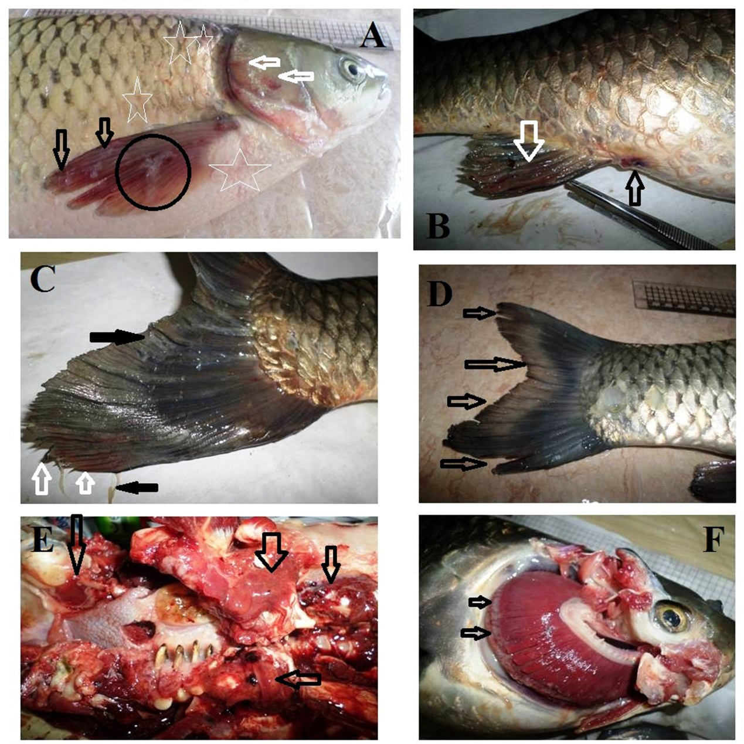
Figure 1. Grass carp naturally infected with bacterial pathogens showing:
- Hemorrhages all over the body (stars) especially on operculum (white arrows), pectoral fin (black arrows) and excessive mucus secretions on pectoral fin (circle).
- Hemorrhages in anal fin (white arrow) and hyperemia of the anal opening (black arrow).
- Hemorrhages in caudal fin (white arrows) and excessive mucus secretions (black arrows).
- Caudal fin erosions (black arrows).
- Congestion of the oral cavity (black arrows).
- Congested gills and excess mucus secretions (black arrows).
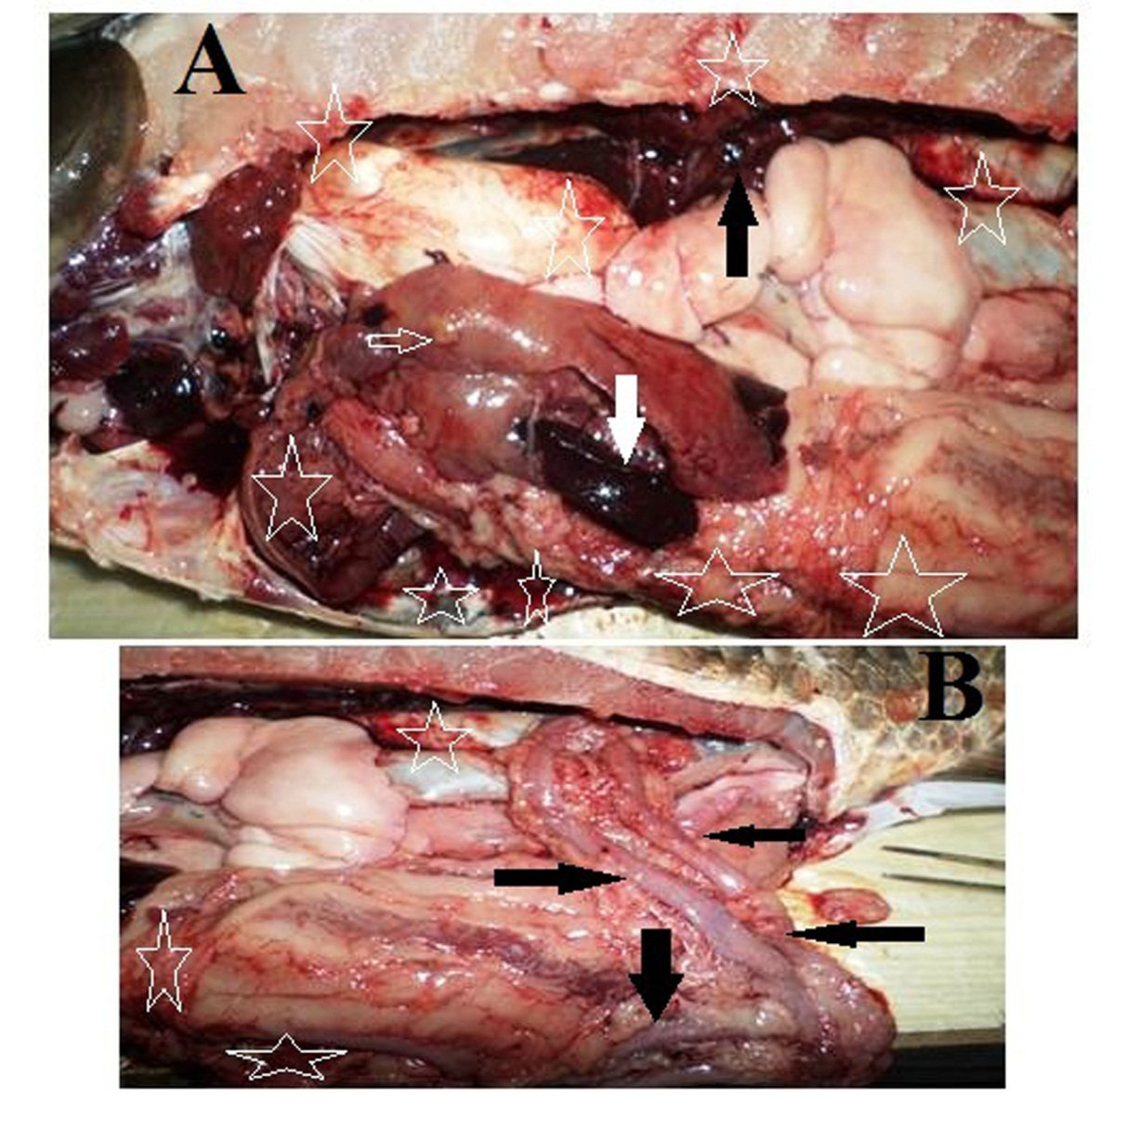
Figure 2. Grass carp naturally infected with bacterial pathogens showing:
- Congested kidney (black arrow), hypertrophy and congestion of the spleen (white arrow), fatty liver (white border arrow) and hemorrhages all over the abdominal cavity (stars).
- Hyperemia of the intestine (arrows) and hemorrhages all over the abdominal cavity (stars).

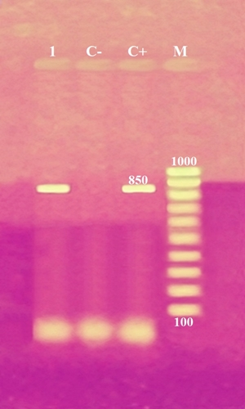
Figure 3. Agarose gel electrophoresis of 16S rRNA (850bp) as species specific genes for PCRdetection of P. fluorescens isolated from grass carp.
Lane M: 100 bp ladder as molecular size DNA marker.
Lane C+: Control positive P. fluorescens for16S rRNA gene.
Lane C-: Control negative.
Lane 1: Positive P. fluorescens strain.

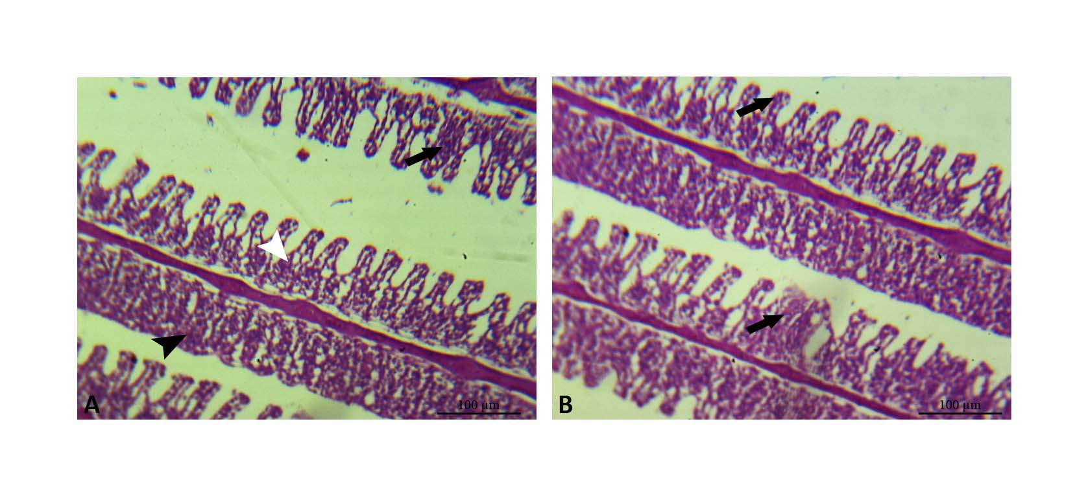
Figure 4. Gills of grass carp infected with P. fluorescens. A: the secondary lamellae showing hypertrophy and hyperplasia of epithelial layer (black arrow) in addition to adhesion of adjacent lamellae (black arrow head). B: the secondary lamellae showing dilatation of blood vessels (telangiectasia) at the tip of lamellae (black arrow).
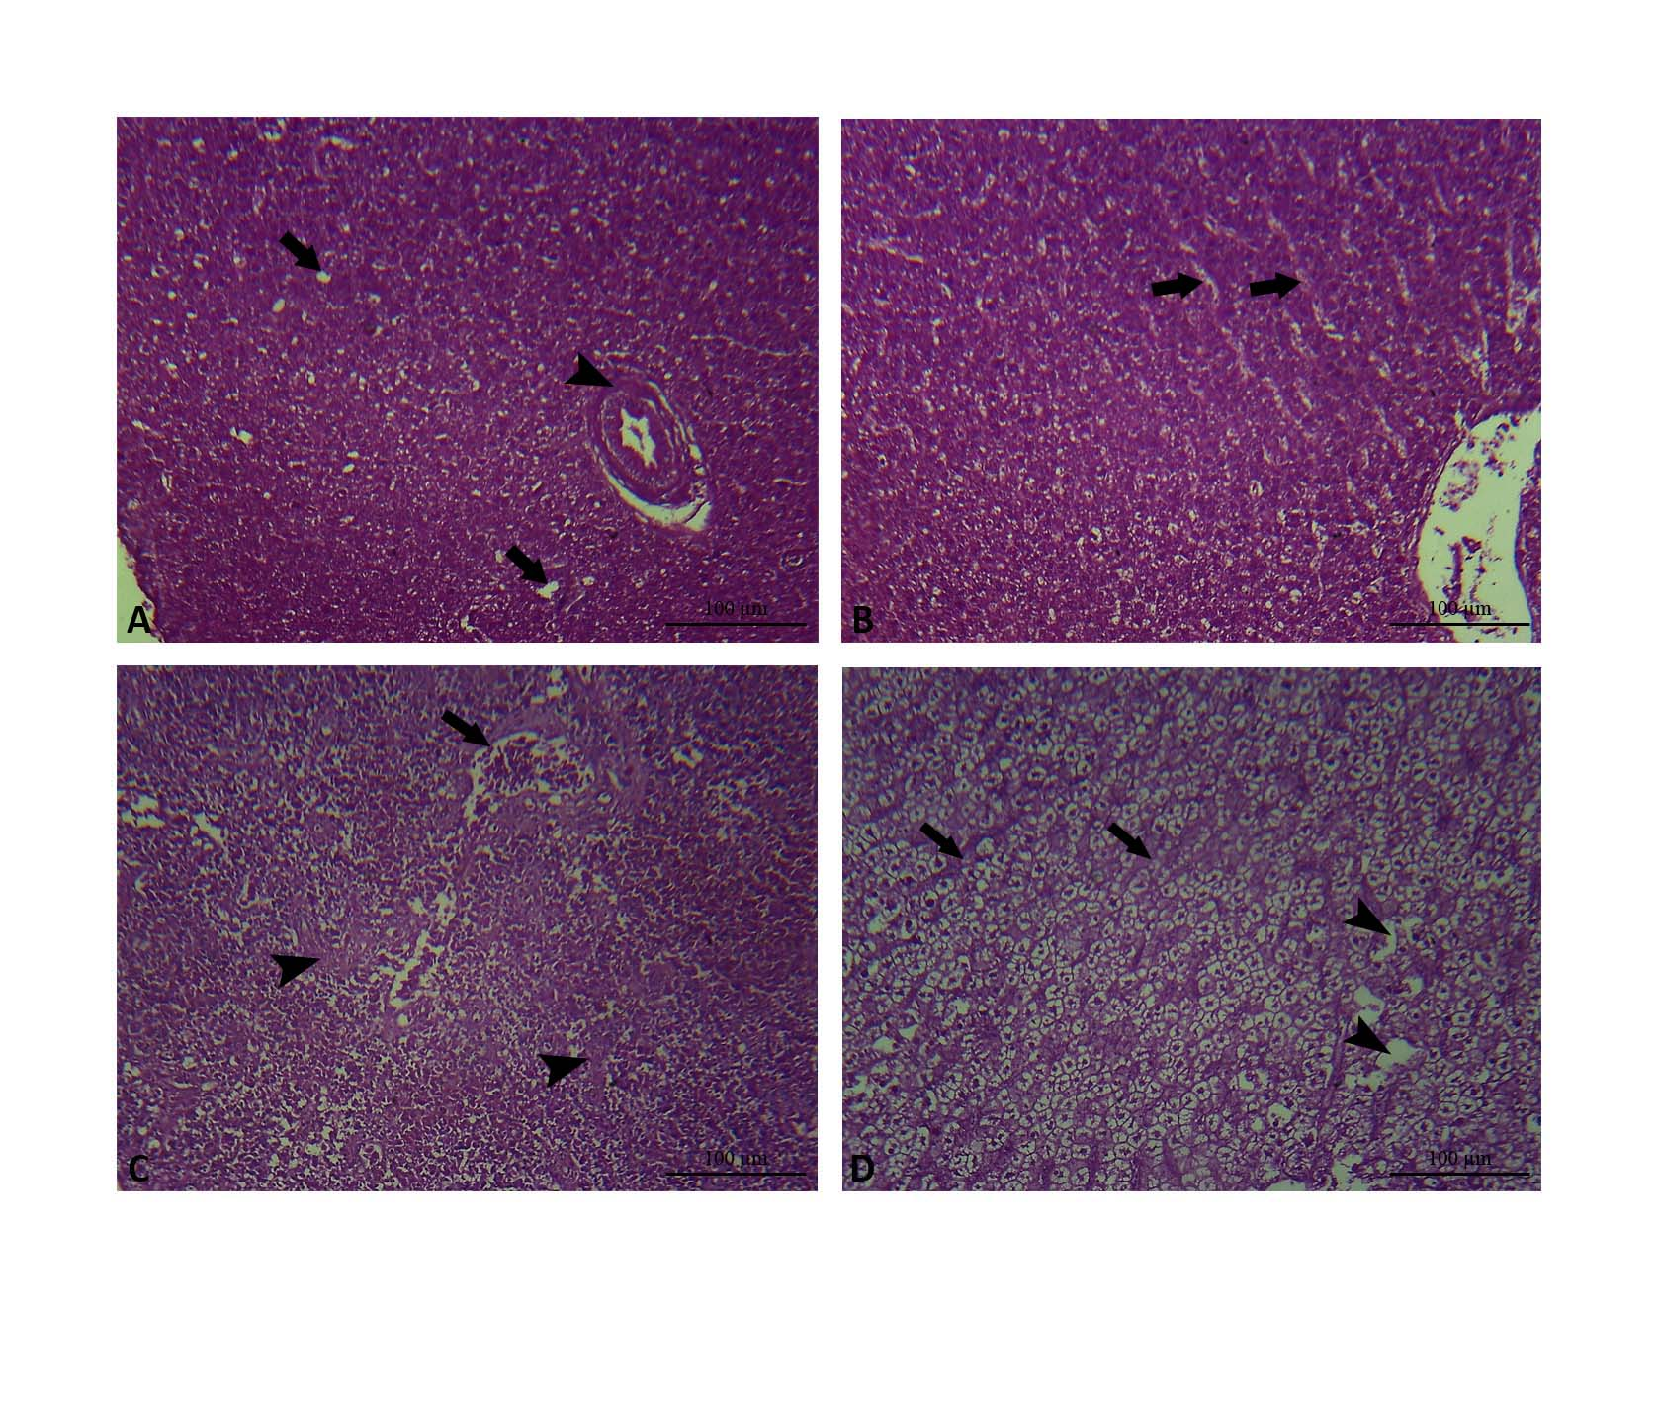 Figure 5. Liver of grass carp infected with P. fluorescens. A: the hepatic tissue showing fibrosis in the wall of bile duct (black arrow head) and hepatocellular vacuolation (black arrow). B: the hepatic tissue showing congestion of hepatic sinusoids (black arrow). C: the hepatic tissue showing fibrosis and congestion of blood vessels (black arrow) in addition to hepatocellular degeneration (black arrow head). D: the hepatic tissue showing hepatocellular vacuolation (black arrow head) and dilated hepatic sinusoids (black arrow).
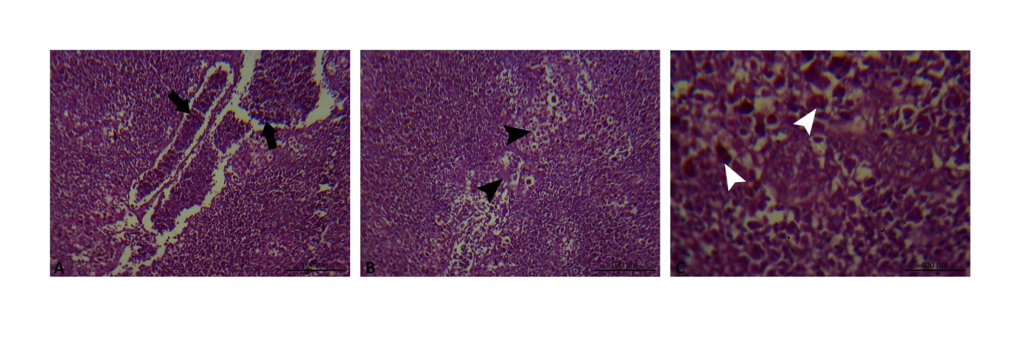
Figure 6. Spleen of grass carp infected with P. fluorescens. A: the spleen showing dilatation and congestion splenic blood vessels (black arrow). B: the spleen showing necrosis and depletion of lymphoid tissue (black arrow head). C: the spleen showing increase of melanomacrphage center (white arrow head).
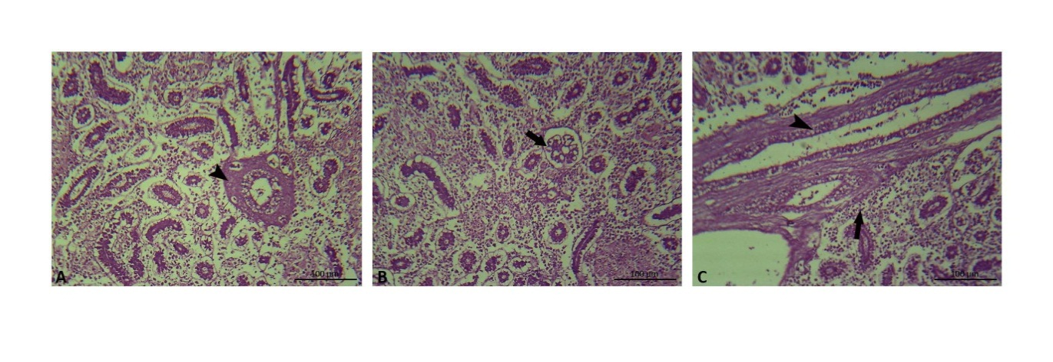 Figure 7. Kidney of grass carp infected with P. fluorescens. A: the kidney showing peritubular fibrosis (black arrow head). B: the kidney showing dilatation in glomerular capillaries (black arrow). C: the kidney showing vacuolation and necrosis of renal tubules (black arrow head) in addition to mononuclear cell infiltration (black arrow).

