Nitrite Quantification of Processed Meat Products Commonly Consumed in Mansoura City with Their Health Risk Assessment
By

Samah Moustafa Mohammed¹, Samir Mohammed Abd-Elghany^{1*}, Mamdouh Mohamed Abou El Magd², Hazem Ramadan³ & Elhadi Emhammed Mohamed Gunbaej⁴
- Food Hygiene and Control Department, Faculty of Veterinary Medicine, Mansoura University
- Forensic Medicine and Toxicology Department, Faculty of Veterinary Medicine, Mansoura University.
- Hygiene and Zoonoses Department, Faculty of Veterinary Medicine, Mansoura University
- Research, Consulting and Training Center, Sabratha University, Libya

*Corresponding author: drsamir@mans.edu.eg Tel:+201069496710

ABSTRACT
A total of 125 random meat products samples (25of each of locally processed beef luncheon, locally processed chicken luncheon, imported canned beef luncheon, imported canned chicken luncheon, imported corned beef) collected from different supermarkets distributed in Mansoura City, Egypt were analyzed for determination of nitrite content (ppm) using spectrophotometer. The nitrite was detected in all (100%) examined samples with higher levels occurred in imported canned chicken luncheon followed imported corned beef. The mean±SE values of the different metal detected in locally processed beef luncheon, locally processed chicken luncheon, imported canned beef luncheon, imported canned chicken luncheon and imported corned beef 23.80±2.44 ppm, 37.82±4.24 ppm, 19.74±1.05 ppm, 56.94±5.47 ppm and 61.93±8.09 ppm, respectively. Interestingly, the levels of nitrite detected in all tested samples were within the maximum permissible limits except 8 % of canned chicken luncheon and 32% of imported corned beef samples had nitrite by levels exceeded the maximum permissible limits set by the Egyptian government. The estimated daily intakes (EDI) of detected nitrite were lower than their acceptable daily intake (ADI) stated for it in all tested samples except for imported canned chicken luncheon and imported corned beef, their EDI exceeded the ADI. Target hazard quotient together with hazard index values of nitrite were below 1.0 in all examined samples. Health risk assessment based on EDI suggesting that there were significant health risks on public from the consumption of some meat products like imported canned chicken luncheon and imported corned beef marketed in Mansoura City, Egypt.
Running title: Nitrite Content of Meat Products Distributed in Mansoura City
Keywords: nitrite; residues; meat products; risk assessment

1. INTRODUCTION
Nowadays, traditional meat preservation methods as drying, brining, smoking, fermentation and refrigeration, has not become enough to protect meat against microbial spoilage and ensure its safety. Consequently, they had been replaced by new preservation techniques based on using chemical preservatives such as sodium chloride, sugar, nitrite, spices, phosphates and sodium ascorbate or sodium erythorbate leading to appearance of new meat products called processed meat (Zhou et al., 2010). Processed meats are meat that have been preserved by curing, smoking and adding chemical preservatives to improve palatability and increases the shelf life of meat. They include deli meat, bacon, hot dogs, sausages, luncheon, salami, beef jerky, pastrami and ham as well as canned meat and corned beef. Although processed meat are considered a rich source of an animal protein essential for human nutrition, they cause not only industrial risk factor, but also various health problems affect consumers' health with increase the risk of cancer (Larsson and Wolk, 2012).
Curing of meat is a method of preservation that improves palatability and increases the shelf life of meat (Silva and Lidon 2016). Sodium nitrite (NaNO₂) and potassium nitrite (KNO₂) preservatives are commonly added to meat products for extending the durability of the product and improving its appearance, flavor and structure without reducing its nutritional value giving it a pinkish-reddish characteristic features and unique flavor (Grossi et al., 2014). Moreover, nitrite display antioxidant functions by nitrosylhemochromogen production that declined catalytic activity through the immobilization of the iron complex and restricted the initiation of lipid oxidation. As well as the production of nitric oxide, which serves as a free radical acceptor and suppress lipid oxidation by ending the free radical chain reaction (Aberle et al., 2001 and Sindelar and Milkowski, 2011).
The addition of nitrite also contributes to meat safety by preventing food spoilage and foodborne pathogens within meat products including Clostridium botulinum that causes botulism which is of particular importance because of the harmful toxins that may lead in severe cases to the death (Pegg and Shahidi, 2000 and Saad et al., 2013). Despite the benefits and multi-functional properties of nitrite, it has been often a source of the doubt due to its health hazards (Santarelli et al., 2008). The carcinogenic risk is one of the most important problems of nitrite due to the formation of N-nitrosamine compounds that react with the secondary amines in the acidic environment of the stomach. This reaction increased the risk of colorectal, stomach and pancreatic cancer as well as cardiovascular diseases and other causes of death (Larsson and Wolk, 2012 and Rohrmann et al., 2013). It also causes conversion of hemoglobin to methmyoglobin, which impaired the blood oxygen transport and in the long period, it caused methemoglobinemia mainly in children, which could lead to tissue hypoxia and death (Katabami et al., 2016).
Due to the health hazards associated with the ingestion of excess amount of nitrites in meat products and the few international published studies about the nitrites contents in these meat products that widely consumed in Egypt up till now, therefore, the present study was designed to determine the levels of nitrite content in meat products to ensure that levels are within the maximum Egyptian acceptable limit for residual nitrite in cured meat products (100 ppm) and to assess the risks associated with the consumption of such cured meat products contaminated with unacceptable limits of residual nitrite on the human health.
2. MATERIALS AND METHODS
2.1. Collection of samples:
A total of 125 random samples of cured meat products distributed as 25 each of locally processed beef luncheon, locally processed chicken luncheon, canned beef luncheon, canned chicken luncheon and corned beef samples purchased randomly from different supermarkets distributed in Eldakahlia Province. The samples were packed in clean polyethylene bags, marked and transferred to the laboratory of food hygiene and control department in the Faculty of Veterinary Medicine, Mansoura University wherein determination of their nitrite content (ppm) were performed by the use of spectrophotometer.
2.2. Samples preparation and digestion:
Residual nitrite level (mg NaNO₂/kg sample) was determined according to standards ISO/DIS 2918.26 (ISO, 1975). Briefly, ten grams of each sample was weighted then homogenized with 100 ml of water then transferred to a 200 ml conical flask. Then 5 ml of saturated borax solution was added to the flask, and then the flask was heated at a temperature of 70 °C for 15 minutes on the boiling water bath with shaking repeatedly. The flask and its contents were allowed to be cooled at room temperature and 2 ml of Potassium Ferrocyanide were added successively, followed by 2 ml of zinc acetate with thoroughly mixing after each addition, then water was added to the mark with mixing for dilution. The water flask was allowed to stand for 30 minutes at room temperature. The supernatant liquid was decanted carefully and filtered through fluted filter paper for obtaining clear solution. An aliquot of 25 ml of the filtrate was transferred to a 100 ml volumetric flask and water was added to make up to 60 ml. Ten ml of sulphanilamide solution was add followed by 6 ml of cone HC1 and the solution was left in the dark for 5 minutes. Two ml of N -Napthylethylenediamine solution was added and left for 5-10 minutes in the dark then diluted to mark with water. The absorbance of the solution was measured in a 1 ml cell using a spectrophotometer (Model UV- 2150) at a wavelength of 538 nm. Standard calibration curve was used to determine the concentration of nitrite in the samples.

2. 3. Analysis and calculation of nitrite content (Follett and Ratcliff, 1963):
Standard solutions of 2.5, 5 and 10 mg/L of NaNO2 were prepared from a stock solution of 1000 mg/L. In order to ensure the accuracy, the blank reagents solutions as well as the purified water should read zero ppm on the calibrated spectrophotometer before standards and samples were measured. A calibration curve was established by plotting absorbance against the corresponding concentration. Using the equation of the calibration curve (Figure 1), the nitrite in test samples was determined. Determinations were done in triplicates.
Nitrite content expressed as NaNo₂ (ppm) =$\frac{cx2000}{MXV}$
Where:
V = volume in ml of an aliquot portion of filtrate taken for the test
M = mass in g of the sample taken
C = concentration of sodium nitrite in mg/L read from the calibration curve that corresponds with the absorbance of the solution prepared from the sample.
2.4. Statistical analysis:
Data was collected, arranged, summarized and then analyzed using the computer program SPSS/PC+ (2003). All the obtained results were evaluated statistically according to t-test and analysis of variance "ANOVA" test. Results were considered statically significant when P < 0.05.
2.5. Health-risk assessment of consumption of processed meat products
2.5.1. Estimated Daily Intake (EDI) of nitrite (Yarmohammadi et al., 2015):
Estimated Daily Intake (EDI) (mg/day/person) = $\frac{cxDI}{BW}$
Where:
C = nitrite levels in meat products (mg/kg)
DI = an average daily intake rate of meat products (kg/day) which was 0.0857 kg/day for red meat (FAO, 2003) and 0.1kg/day for chicken meat (Mahmoud and Abdel-Mohsein, 2015).
BW = average body weight which was 60.7 kg for adult (kg) according to WHO (2007)
2.5. Hazard index (HI) of nitrite (Moazeni et al., 2014):
Hazard index (HI) = $\frac{EDI }{RFD}$
Where:
EDI = Estimated Daily Intake in current study (mg/kg/day)
RFD = Oral Reference dose (mg/kg/day) which is 0.1 mg/kg/day for nitrite (ATSDR, 2017).

2.6. Target hazard quotient (THQ) of nitrite (Casoni et al., 2019):
Target hazard quotients (THQ) = $\frac{EFrX EDtotX MIR XMC}{RfD XBWX AT}X10-3$
Where:
EFr = the exposure frequency (3 time in week/year=156 days).
ED_{tot} = the exposure duration (70 years).
MIR = the meat ingestion rate (g/day).
MC = the mean concentration of nitrite (mg/kg).
RFD = oral reference dose (mg/kg/day).
BW = the average adult body weight.
AT = averaging time for non-carcinogens (365 days/year X EDtot).
10⁻³ = the unit conversion factor.

3. RESULTS AND DISCUSSION:
3.1. Nitrite concentrations (ppm) in locally processed beef and chicken luncheon samples:
In the present study, levels of nitrite content in examined locally processed luncheon ranged from 12.80 to 59.90 ppm for beef luncheon and 16.60 to 78.40 for chicken luncheon with mean values of 23.80±2.44 ppm and 37.82±4.24 ppm, respectively (Table 1 & Figure 2).
Nearly similar results were reported by Thomson et al. (2007) who found that the nitrite content of luncheon was 24.6 ppm and by Leth et al. (2008) who found that the levels of nitrite in luncheon meat was 28 mg/kg. On the other hand, higher level was reported by Tolba et al. (1994) who observed that nitrite content in beef luncheon was 118.9 ppm and by Aiedia (1995) who found that the estimated nitrite level in tested luncheon was 134.7± 8.05 ppm. Furthermore, Edris et al. (2013) found that the mean values of nitrite content in analyzed 20 random samples of luncheon collected from different supermarkets in Menoufia governorate was 98.65±3.41 ppm.
From the achieved results, it could be noticed that all 25 samples (100%) of each locally processed beef and chicken luncheon samples contained nitrite by levels within permissible limit for nitrite (100 ppm) used in meat products established by ES (2010) (Table 2 & Figure 3). This result of nitrite in examined luncheon samples was in agreement with that reported by Hamed (2001) and Zahran and Kassem (2011) who found that 100% of tested luncheon products had nitrite levels within permissible limits. On the contrary, Edris et al. (2013) found that 45% of tested luncheon had nitrite values above the maximum permissible limit and Ez-El dain and El-Nemr (2016) recorded that 29% of examined luncheon had nitrite content above the maximum permissible limit.

3. 2. Nitrite concentrations (ppm) in imported canned beef and chicken luncheon samples:
It was shown from Table (1) and Fig. (2) the levels of nitrite content in examined imported canned luncheon ranged from 14.10 to 27.30 ppm for beef canned luncheon and from 18.10 to 119.2 ppm for chicken canned luncheon with mean values of 19.74±1.05 ppm and 56.94±5.47 ppm, respectively.
The result was nearly similar to that reported by EI- Nawawi et al. (1998) who quantified the mean nitrite levels in canned luncheon from Egypt as 45.5 ppm and by Vuida-Martos et al. (2009) who found that the mean value of nitrite levels in canned luncheon were 45.5±4.3 ppm. Many research works applied for detection of nitrite in canned beef and chicken luncheon samples showed higher nitrite levels than our study such as EL- Khawas (1996) who noted that the nitrite content in examined canned luncheon was 97.255±12.66 ppm and by Ahmed (2004) who found that the mean value of nitrite level in the examined canned luncheon beef was 159.96±6.73 ppm and El-Gohary (2008) who recorded that the mean nitrite contents of canned luncheon in Egypt was 72.8 (30.8-110.8) ppm. Lower results were reported by Babji et al. (1984) who found that the mean value of nitrite contents in imported canned chicken luncheon in Malaysia was 36 ppm and by Abd El-Daym (2005) who found that the mean value of nitrite in canned luncheon was 3.69 mg/kg.
By comparison the determined nitrite contents in the tested samples with their permissible limit used in meat products (100 ppm) established by ES (2010), it was indicated that all of 25 samples (100%) of imported canned beef luncheon samples had nitrite content within the permissible limit for sodium nitrite as described in Table (2) and Figure (2). This result was in agreement with that reported by Dhaw and Amani (2003) who quantified 20 canned beef luncheon samples in Egypt and found that all samples contained nitrite contents within the Egyptian permissible limits set by Egyptian organization for standardization and quality control.
Meanwhile, there were 23 samples (92%) out of 25 canned chicken luncheon samples contained nitrite by values within permissible limit and only 2 samples (8%) had nitrite by values above the permissible limit for nitrite used in meat products (100 ppm) established by ES (2010) as described in Table (2) and Figure (3). The present findings was disagreed with that reported by Dharmsingh et al. (2018) who found that the level of nitrites were more than acceptable limit in 45.4% of tested chicken pakoda and in 27.2% of tested chicken burger and chicken popcorn samples collected from different restaurants and retail outlets in India.

3.3. Nitrite concentrations (ppm) in imported corned beef samples:
The obtained results clarified that the level of nitrite in examined imported corned beef samples ranged from 19.80 to 145.00 ppm with a mean value of 61.93 ppm as shown in Table (1) and Figure (2). This result was nearly similar to that reported by Naasif (1989) who enumerated the mean nitrite levels in corned beef in Egypt as 58.95 ppm. Meanwhile, lower findings were reported by Babji et al. (1984) who measured the mean values of nitrite contents in corned mutton beef in Malaysia as 32.7 ppm, by Dennis et al. (1990) who found that the range of nitrite levels in corned beef was 1.5 to 41.5 mg/kg and by Jansen et al. (2018) who showed that nitrite content in corned beef ranged from 13.95 to 34.40 ppm.
Higher results were reported by Rekka (2002) who estimated the mean value of nitrite in the corned beef sample by 91.25 ppm in Egypt, Ahmed (2004) who recorded the mean value of nitrite level in the examined corned beef as 186.27±4.42 ppm, El-Gohary (2008) who recorded the nitrite content of corned beef in Egypt by spectrophotometer as 100.89 (36.9-175.4) ppm and by Govari and Pexara (2015) who showed that corned beef contained nitrite at range from 70.34 to 109.75 ppm.
The obtained results in Table (2) and Figure (3) indicated that 17 samples (68%) out of examined 25 imported corned beef samples had nitrite by levels within permissible limit and 8 samples (32%) were above maximum permissible limit for nitrite used in meat products (50 ppm) proposed by ES (2010) which was. This result was nearly similar to that reported by Edris et al. (2013) who found that 25% of canned corned beef collected from different supermarkets in Menoufia governorate were above the permissible limit. Meanwhile, Govari and Pexara (2015) showed that 100% of examined corned beef contained nitrite exceeded the maximum permissible limit of nitrite.

  - Health-risk assessment associated with consumption of tested processed meat products containing nitrite:
Despite the benefits and multi-functional properties of nitrite in meat products, it can pose a health risk to the consumers. The health risks from consumption of excessive amount of nitrite in meat products marketed in Mansoura City were assessed based on the EDI, HI and THQ.

3.4.1.Estimated daily intake (EDI):
It was stated that nitrite could be gotten and utilized in two forms, the first one as the pure chemical sodium nitrite, while the second form as a curing salt or pre-blend in which the sodium nitrite was distributed in and diluted by conventional salt (sodium chloride) (Borchert and Cassens, 1998). An acceptable daily intake (ADI) for nitrite was 0 - 0.07 mg/kg bw based on heart and lung toxicity in a long-term national toxicology program study in rats (EFSA, 2017).
The average consumption rate of meat products by a 60.7 kg bw person per day in Egypt was 0.0857 kg/day for meat products manufactured from beef meat or 0.1/kg/day for meat products manufactured from chicken meat. The values of EDI of nitrite from consumption of meat products tested in the present study as shown in Table (3) and Figure (4) were 0.034, 0.062, 0.028, 0.094 and 0.087 mg/kg bw/day in locally processed beef luncheon, locally processed chicken luncheon, imported canned beef luncheon, imported canned chicken luncheon and imported corned beef, respectively. This represented about 48.57, 88.57, 40, 134.28 and 124.28% of. The comparison of the EDI for the nitrite detected in meat products with the acceptable daily intake (ADI) of sodium nitrite in meat products recommended by JECFA (2002) which are equivalent to 0.07 mg/kg bw/day nitrite ions revealed that the EDI of nitrite in locally processed beef luncheon, locally processed chicken luncheon, imported canned beef luncheon, imported canned chicken luncheon and imported corned beef represented 48.57, 88.57, 40, 134.28 and 124.28%, respectively from ADI values recommended for nitrite.
The estimated daily intake of nitrite from the consumption of locally processed beef luncheon, locally processed chicken luncheon and imported canned beef luncheon were relatively low and represented low proportion compared to ADI stated by JECFA (2002). Meanwhile, these results declared that the estimated daily intake of nitrite from the consumption of imported canned chicken luncheon and imported corned beef was relatively high and exceeded the ADI recommended by the same previous organization which represented 134.28 % and 124.28% of ADI, respectively resulting in adverse health effects to the consumers from consumption of such products.
Higher EDI of nitrite were reported by Habermeyer et al. (2015) and Penttila et al. (1990) who measured daily intake values of nitrite as 1.83 mg/day in meat products. Lower results of estimated nitrite daily intake were reported by Leth et al. (2008) who found that the mean EDI of sodium nitrite was 0.007 mg/kg body weight for men and 0.003 mg/kg body weight for women in the age of 15–75 years, which was within the permissible limit of acceptable daily intake and by Yarmohammadi et al. (2015) who proved that amounts of nitrite intake consumed by the growing age group from sausage and salami were 0.0084 and 0.0032 mg/kg BW that equal to 8.28% of acceptable daily intake of nitrite.

3.4.2. Hazard Index (HI):
The values of HI of nitrite estimated in the present study from consumption of locally processed beef luncheon, locally processed chicken luncheon, imported canned beef luncheon, imported canned chicken luncheon and imported corned beef were 0.34, 0.62, 0.28, 0.94 and 0.87, respectively (Table 4 and Fig. 5) and all values were below 1 suggesting that there is was no health hazard on consumers from the intake of nitrite in the examined meat products samples marketed in Mansoura City. As hazard index (HI) value of nitrite more than 1 had a significant risk level, while a HI value less than 1 had no health hazard on consumers (Moazeni et al., 2014).
This was in agreement with that reported by Kassim (2015) who proved that risk assessment of nitrite for an average body weight of 65 Kg from consumption of corned beef sold in Nigeria was not significantly high to cause severe health problems. Nitrites cause higher toxicity and thought to be responsible for several adverse health because in the environment it can form nitrogenous compounds by microorganisms present in the soil, water, saliva and even in the gastrointestinal tract (Song et al., 2015).
Nitrite is not considered to be carcinogens per se. However, the toxicological and carcinogenic aspects of nitrite associated with the adverse health effect of methemoglobin formation, especially in infants considered to be at elevated risk for methemoglobinemia (Greer and Shannon, 2005). Moreover, dietary nitrites can form endogenous nitrosation, which acts as carcinogenic agents (i.e. in combination with certain amines or amides) under acidic conditions or during food processing procedures (Parthasarathy and Bryan, 2012).
    - Target Hazard Quotient (THQ):
Several methods have been proposed for estimation of the health risks through consumption of toxic chemicals in contaminated foods. The risks may be divided into carcinogenic or non-carcinogenic. For carcinogenic risk, the observed or predicted exposure levels of toxic chemicals are compared to thresholds for adverse effects, as determined by dose-effect relationships. Current non-cancer risk assessment methods are typically based on the THQ. This method of risk assessment has recently been used in many research studies and has been shown to be useful and valid. If THQ values tested were above 1, it suggesting that there is a health risk from consumption of food contaminated with such chemical, but if THQ values were < 1, it suggesting that health risk is insignificant (Wang et al., 2005).
The THQ values of nitrite detected through consumption of processed meat products by adult Egyptian consumers are presented in Table (4) and Figure (6). The THQ values of locally processed beef luncheon, locally processed chicken luncheon, imported canned beef luncheon, imported canned chicken luncheon, and imported corned beef were 0. 14, 0. 26 , 0. 12, 0. 40 and 0. 37, respectively. The THQ of nitrite in all tested meat products samples were lower than 1.0, which means that consuming such meat products in Mansoura City, Egypt couldn’t pose a health risk to consumers due to nitrite residues.

Conclusion: It can be concluded that consumption of some processed meat products like imported canned chicken luncheon and imported corned beef marketed in Mansoura City, Egypt may constitute potential health risk due to some of the samples examined contained heavy metals by levels exceeded the regulated MPLs and estimated daily intake (EDI) of nitrite in these products exceeded their acceptable daily intake (ADI), therefore, a strict control measures should be followed to ensure that nitrite levels added to processed meat products did not exceed the recommended limits for human consumption.
4. REFERENCES
Abd El–Daym, W. F. A. 2005. Food poisoning agents in some meat products. Ph.D. Thesis, Faculty of Veterinary Medicine, Zagazig University.
Aberle, E. D., Forrest, J. C., Gerrard, D. E., Mills, E. W., Hedrick, H. B., Judge, M. D., Merkel, R. A. 2001. Principles of Meat Science. Kendall/Hunt, Dubuque, Iowa, pp. 354.
Agency for Toxic Substances and Diseases Registry (ATSDR) 2017. Case Studies in Environmental Medicine Nitrate/nitrite Toxicity. Atlanta. GA.
Ahmed, A. F. 2004. Studies on cooked meat and chicken products. Ph.D. Thesis, Faculty of Veterinary Medicine, Zagazig University. Benha Branch.
Aiedia, H. A. M. 1995. Quality investigation into room kept traditional meat products in Egypt. Ph.D. Thesis, Fac. Vet. Med. Cairo University.
Babji, A. S., Aishah, S., Aminah, A. 1984. Nitrite Content of Some Foods in Malaysia. Pertanika. 7(2): 39-41.
Borchert, L., Cassens, R. 1998. Chemical hazard analysis for sodium nitrite in meat curing. Madison, University of Wisconsin American meat institute foundation:1-6.
Casoni, D., Badiu, R. R., Frentiu, T. 2019. Spectrophotometric determination and assessment of POTENTIAL health risk of nitrite from meat and processed meat products. Studia Universitatis Babes-Bolyai, Chemia. 64(2): 265-277.
Dennis, M. J., Key, P. E., Papworth, T., Pointer, M., Massey, R. C. 1990. The determination of nitrate and nitrite in cured meat by HPLC/UV. Food Addit. Contam. 7(4): 455-461.‏
Dharmsingh A., Debnath C., Banerjee A. 2018. Detection of nitrite in processed and ready to eat meat products in and around Kolkata. Ind. J. Animal Health. 57(1): 67-72
Dhaw, J. R., Amani, Y. 2003. Detection of the level of some toxic heavy metals and preservatives in some meat products and its relation to public health. J. Environ. Sci. 6: 40.‏
Edris S. M., Ibrahim, H.M., Hassanin, F. S., Nayel, M. S. 2013. Studies on nitrites as a chemical preservatives in some meat products. Benha Vet. Med. J. 24 (1): 298-308.
El- Gohary, A. E. E. 2008. Some chemical additives in canned meat. M.V.M.SC .Thesis, Faculty of Veterinary Medicine, Zagazig University.
El- Nawawi, F. A., El- Sherif, A., El-Khawas, K. M. S. 1998. Chemical analysis of canned meat products in relation to public health aspects. Vet. Med. J.-Giza. 46 (4): 355-362.
El- Sayed, H. 1998. Adulteration of some local processed meat products. Mans. J. Agricul. Sci. 23(5): 2023-2031.‏
El-Khawas, K. M. S. 1996. Public health aspects of canned meat. M.V.Sc. Thesis, Faculty of Veterinary Medicine. Zagazig University.
ES (Egyptian standards) 2005. Egyptian Standard Specification for sodium nitrite used in food products. Egyptian Organization for Standardization and Quality Control, ESS/3597.
ES, 2010. Egyptian Standard Specification for sodium nitrite used in food products. Egyptian Organization for Standardization and Quality Control, ESS/3597.
European Food Safety Authority (EFSA) Panel on Food Additives and Nutrient Sources added to Food (ANS), Mortensen, A., Aguilar, F., Crebelli, R., Di Domenico, A., Dusemund, B., and Lambré, C. (2017): Re‐evaluation of potassium nitrite (E 249) and sodium nitrite (E 250) as food additives. Efsa journal. 15(6): e04786.
Ez- El dain A. M., El-Nemr, S. A. 2016. Assessment of nitrate and nitrite residual levels in some meat products. Egyp. J. Chem. Environ. Health. 2 (2): 611-616
Fath El-Bab, G. F.A., Sayed, E. M. 2005. Some bacterial and chemical investigate on Chicken and beef luncheon. Vet. Med. J. Giza. 53(3): 855-862.
Follett, M. J., Ratcliff, P. W. 1963. Determination of nitrite and nitrate in meat products. J. Sci. Food Agricul. 14(3):138-144.
FAO (Food and Agriculture Organization of the United Nations) 2003. Nutrition Country Profiles-Egypt. FAO, Rome, Italy.
Govari, M., Pexara, A. 2015. Nitrates and Nitrites in meat products. J. Hell. Vet. Med. Soci. 66(3): 127-140.
Greer F. R., Shannon M., 2005. Infant methemoglobinemia: the role of dietary nitrate in food and water. Pediatrics. 116: 784-786.
Grossi, A. B., do Nascimento, E. S. P., Cardoso, D. R., Skibsted, L. H. 2014. Proteolysis involvement in zinc–protoporphyrin IX formation during Parma ham maturation. Food Res. Int. 56: 252-259.
Habermeyer, M., Roth, A., Guth, S., Diel, P., Engel, K. H., Epe, B., Knorr, D. 2015. Nitrate and nitrite in the diet: how to assess their benefit and risk for human health. Molec. Nutr. food res. 59(1): 106-128.
Hamed, M. I. A. 2001. Chemical evaluation of non-meat ingredients in some meat products. M.V.M.SC .Thesis, Faculty of Veterinary Medicine, Cairo University.
ISO/DIS 2918.26, International Standard 2918 (1975). Meat and meat products: Determination of nitrite content. Ref. No. ISO 2918:1975. Genevè: International Organization for Standardization1975.
Jansen, S., Dera, R. T. S., Ruth, M. S. M., Syofyasti, M. N., Yosy, C. S. 2018. Analysis of nitrite and nitrate in the corned beef and smoked beef by Using Visible Spectrophotometry method. In IOP Conference Series: Earth Environ. Sci. 205 (1): 1-6.‏
JECFA (Joint FAO/WHO Expert Committee on Food Additives) 2002. Evaluation of certain food additives and contaminants. Fifty-ninth report of JECFA. Joint FAO/WHO Expert Committee on Food Additives, WHO Technical Reports Series 913: 20–32.
Kassim, A. G. 2015. Health risk assessment of nitrate and nitrite via consumption of selected canned food source. Int. J. Res. Ayur. Pharm. 6(3): 348-353.
Katabami, K., Hayakawa, M., Gando, S. 2016. Severe methemoglobinemia due to sodium nitrite poisoning. Case rep. emerg. Med. 2016: 1-3.
Larsson, S.C., Wolk, A. 2012. Red and processed meat consumption and risk of pancreatic cancer: meta- analysis of prospective studies. Brit. J. Canc. 106: 603-607.
Leth, T., Fagt, S., Nielsen, S., Andersen, R. 2008. Nitrite and nitrate content in meat products and estimated intake in Denmark from 1998 to 2006. Food Addit. Contam. 25(10): 1237-1245.
Mahmoud, M. A. M., Abdel-Mohsein, H. S. 2015. Health risk assessment of heavy metals for Egyptian population via consumption of poultry edibles. Adv. Anim. Vet. Sci. 3(1): 58-70.
Moazeni, M., Ebrahimi, A., Atefi, M., Mahaki, B., Rastegari, H. A. 2014. Determination of nitrate and nitrite exposure and their health risk assessment in 21 brands of bottled waters in Isfahan's market in 2013. Int. J. Environ. Health Eng. 3(2): 71-75.
Naasif, M. R. 1989. Quality control of canned meat. M. V. M. Sci. Thesis, Faculty of Veterinary Medicine, Alexandria University.
Parthasarathy, D. K., Bryan, N. S. 2012. Sodium nitrite: The “cure” for nitric oxide insufficiency. Meat Sci. 92(3): 274-279.
Pegg, R.B., Shahidi, F. 2000. Nitrite curing of meat: the N-nitrosamine problem and nitrite alternatives. In: Trumbull, The color of meat. Malden: Food Nutr. Press Inc: 23–66.
Penttilä, P. L., Räsänen, L., Kimppa, S. 1990. Nitrate, nitrite, and N-nitroso compounds in Finnish foods and the estimation of the dietary intakes. Zeitschrift für Lebensmittel-Untersuchung und Forschung. 190(4): 336-340.
Rekka, M. H. A. 2002. Studies on some chemical substances in some meat products in relation to public health hazard. M.V.M. Sci. Thesis, Faculty of Veterinary Medicine, Zagazig University.
Rohrmann, S., Overvad, K., Bueno-de-Mesquita, H. B., Jakobsen, M. U., Egeberg, R., Tjønneland, A., Palli, D. 2013. Meat consumption and mortality-results from the European Prospective Investigation into Cancer and Nutrition. BMC medicine. 11(1): 63.
Saad, S. M. Edris, Ibrahim, H. M., Hassanin, F. S., Nayel, M. S. 2013. Studies on nitrites as a chemical preservatives in some meat products. Benha Vet. Med. J. 24 (1): 298-308.
Santarelli, R. L.; Pierre, F., Corpet, B. E. 2008. Processed meat and colorectal cancer: a review of epidemiologic and experimental evidence. Nutr. Canc. 60: 131-144.
Silva, M. M., Lidon, F. 2016. Food preservatives–An overview on applications and side effects. Emirates J. Food Agricul. 366-373.
Sindelar, J. J., Milkowski, A. L. 2011. Sodium nitrite in processed meat and poultry meats: a review of curing and examining the risk/benefit of its use. Amer. Meat Sci. Associ. White Paper Series. 3: 1-14.
Song, P., Wu, L., Guan, W. 2015. Dietary nitrates, nitrites, and nitrosamines intake and the risk of gastric cancer: a meta-analysis. Nutr. 7(12): 9872-9895.
Thomson, B. M., Nokes, C. J., Cressey, P. J. 2007. Intake and risk assessment of nitrate and nitrite from New Zealand foods and drinking water. Food Addit. Contam. 24(2): 113-121.
Tolba, K. S., Abdel-Aziz, A. S., Niaz- Z. 1994. Chemical analysis of locally manufactured meat products. Vet. Meat J. 42:79.
Viuda‐Martos, M., Fernández‐López, J., Sayas‐Barbera, E., Sendra, E., Navarro, C., Pérez‐Álvarez, J. A. 2009. Citrus co‐products as technological strategy to reduce residual nitrite content in meat products. J. Food Sci. 74 (8): 93-100.
Wang, X., Sato T., Xing B., Tao S. 2005. Health risks of heavy metals to the general public in Tianjin, China via consumption of vegetables and fish. Sci. Total Environ. 350 (1–3): 28–37.

WHO (World Health Organization) 2007. Weight-for-age (5-10 years). Retrieved October 2014 from Growth reference 5-19 years
Yarmohammadi, A., Mirlohi, M., Paknahad, Z., Gholi, Z. 2015. Nitrite assessment in highly used processed meat products in growing age group in Isfahan city. International J. Environ. Health Eng. 4(3): 1-5.
Yi, Y., Yang, Z., Zhang, S. 2011. Ecological risk assessment of heavy metals in sediment and human health risk assessment of heavy metals in fishes in the middle and lower reaches of the Yangtze River basin. Environ. Pollut. 159(10): 2575-2585.
Zahran D. A., Kassem, G. M. A. 2011. Residual nitrite in some Egyptian meat products and the reduction beam irradiation. Adv. J. Food Sci. Tech. 3(5): 376-370.
Zhou, G. H., Xu, X. L., Liu, Y. 2010. Preservation technologies for fresh meat–A review. Meat Sci. 86(1): 119-128.‏
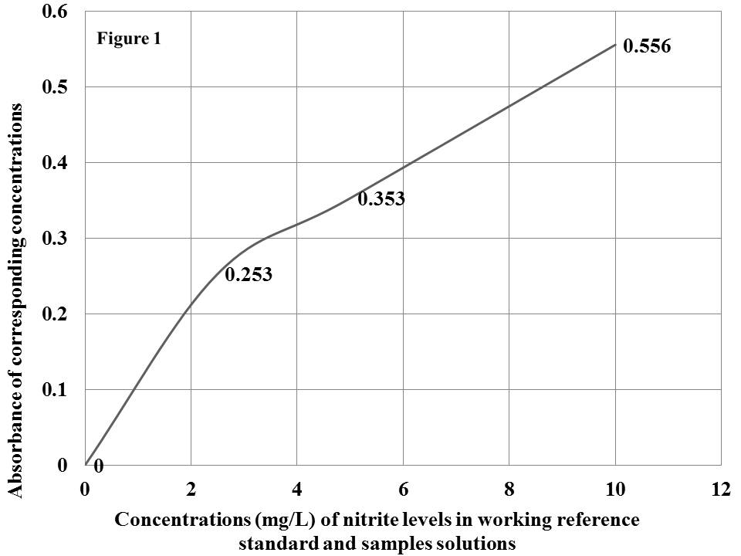

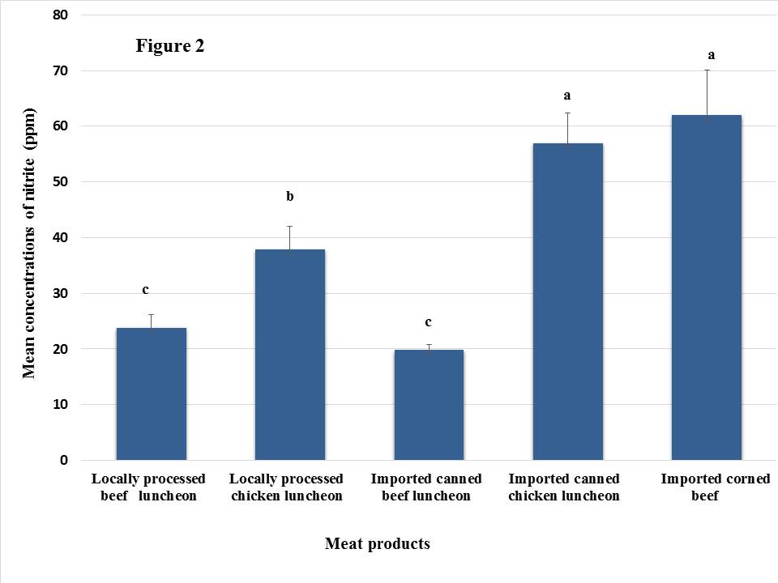

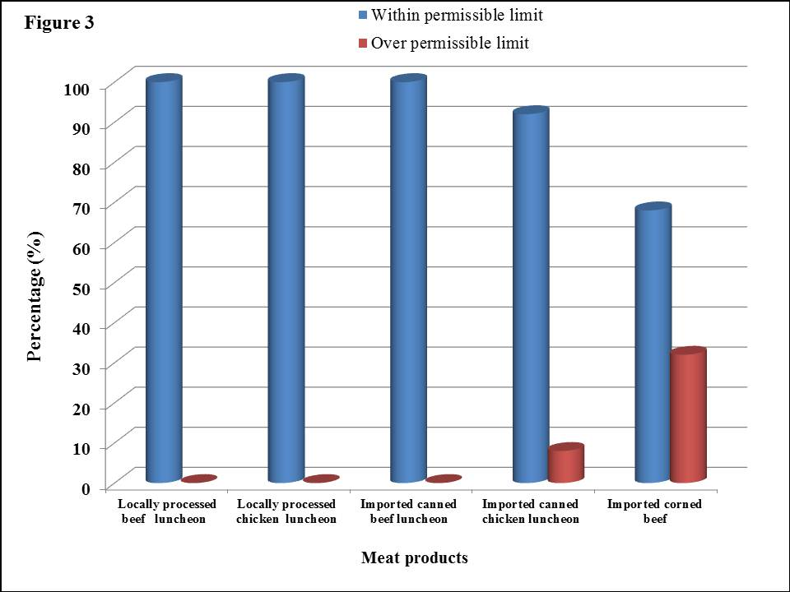
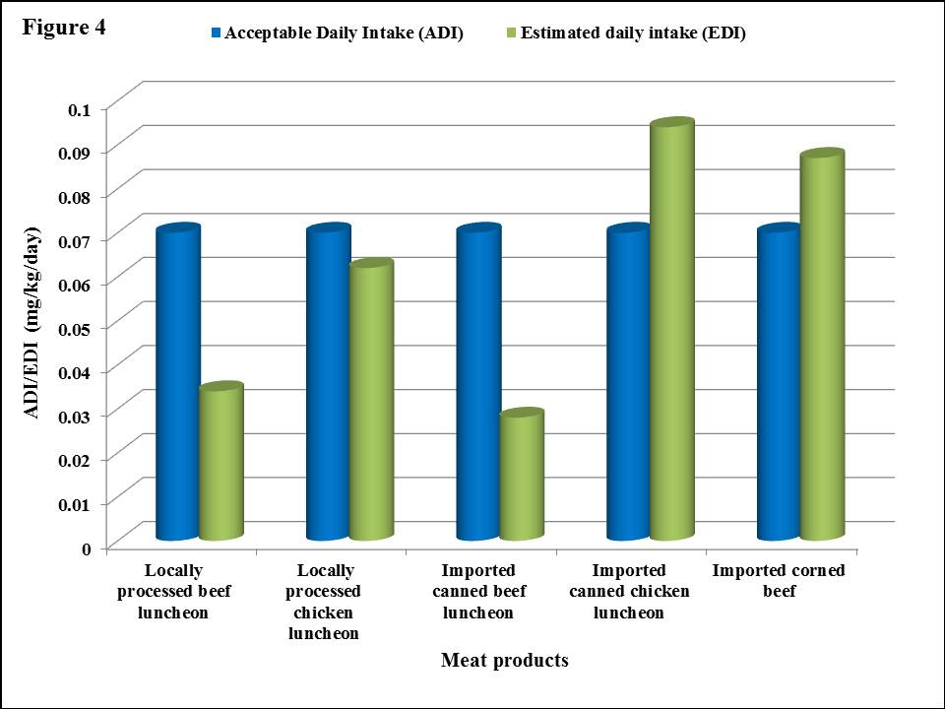

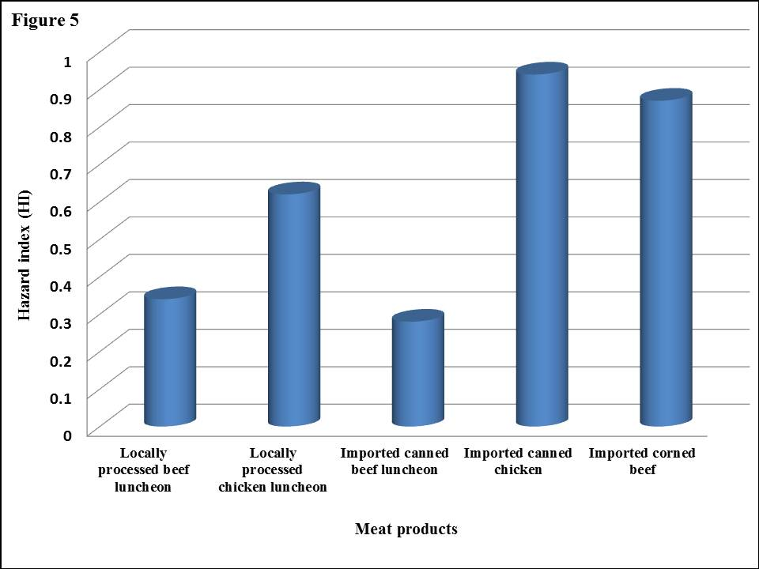
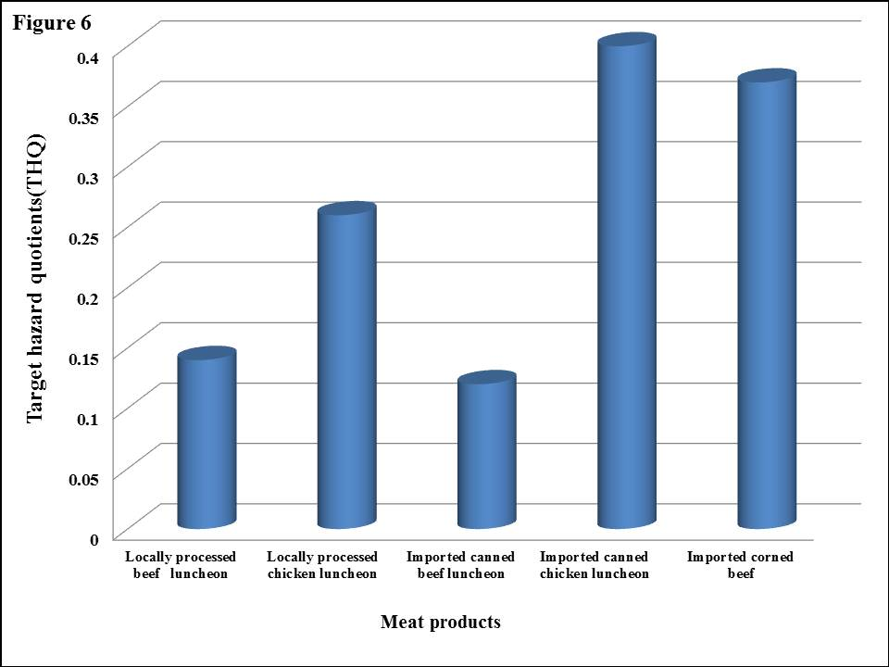

TABLE 1. Nitrite concentrations (ppm) in investigated processed meat products (n=25 for each products).
Meat products | Positive samples |  | Min. (ppm) | Max. (ppm) | Mean±SE (ppm)
 | Number | %
Locally processed beef luncheon | 25 | 100 | 12.80 | 59.90 | 23.80^{c}±2.44
Locally processed chicken luncheon | 25 | 100 | 16.60 | 78.40 | 37.82^{b}±4.24
Imported canned beef luncheon | 25 | 100 | 14.10 | 27.30 | 19.74^{c}±1.05
Imported canned chicken luncheon | 25 | 100 | 18.10 | 119.2 | 56.94ª±5.47
Imported corned beef | 25 | 100 | 19.80 | 145.0 | 61.93ª±8.09
Means with the same column have the same superscript-letter indicates a non-significant difference (P > 0.05). Min. = Minimum, Max. = Maximum, SE = Standard Error of Mean

TABLE 2. Comparison of detected nitrite contents from different processed meat products (n=25 for each products) to their maximum permissible limits (MPLs).
Meat products | MPLsª (ppm) ª | Within MPL | Exceed MPL
Locally processed beef luncheon | 100 | 100% (25/25) | 0% (0/25)  (0/200)
Locally processed chicken luncheon | 100 | 100% (25/25) | 0% (0/25)
Imported canned beef luncheon | 100 | 100% (25/25) | 0% (0/25)
Imported canned chicken luncheon | 100 | 92% (23/25) | 8% (2/25)
Imported corned beef | 50 | 68% (17/25) | 32% (8/25)
ªES, Egyptian Standards (2010).

TABLE 3. Estimated daily intake (EDI) of detected nitrite from processed meat products in comparison to their acceptable daily intake (ADI).

Products | ADIª (mg/Kg/day) | Mean conc. of nitrite (ppm) | EDI (mg/kg/day) in comparison to ADI
 |  |  | EDI | % ADI
Locally processed beef luncheon | 0-0.07 | 23.80 | 0.034 | 48.57%
Locally processed chicken luncheon | 0-0.07 | 37.82 | 0.062 | 88.57%
Imported canned beef luncheon | 0-0.07 | 19.74 | 0.028 | 40%
Imported canned chicken luncheon | 0-0.07 | 56.94 | 0.094 | 134.28%
Imported corned beef | 0-0.07 | 61.93 | 0.087 | 124.28%
Average daily consumption rate of processed meat products by 60.7 kg person in Egypt (0.0857 kg for beef meat products and 0.1 kg for chicken meat products /day/person).
ªJECFA (2002) stated that ADI of of sodium nitrite as 0-0.07 mg/kg bw/day expressed as nitrite ion.

TABLE 4. Hazard index (HI) and target hazard quotient (THQ) of nitrite due to consumption of processed meat products.

Meat Products | RfDª (mg/kg/day) | EDI of nitrite (mg/kg/day) | HI | THQ
Locally processed beef luncheon | 0.l | 0.034 | 0.34 | 0. 14
Locally processed chicken luncheon | 0.l | 0.062 | 0.62 | 0. 26
Imported canned beef luncheon | 0.l | 0.028 | 0.28 | 0. 12
Imported canned chicken luncheon | 0.l | 0.094 | 0.94 | 0. 40
Imported corned beef | 0.l | 0.087 | 0.87 | 0. 37
RfD = the oral reference dose.
ªATSDR (2017) stated that RfD of nitrite is 0.l mg /kg BW/day.

Figure legends

Figure 1. the calibration curve on spectrophotometer.

Figure 2. Mean concentrations of nitrite (ppm) in different processed meat products.
Means with different superscript-letter have a significant difference at P>0.05.

Figure 3. Comparison of detected nitrite contents from different processed meat products (n=25 for each products) to their maximum permissible limits (MPLs).

Figure 4. Estimated daily intake (EDI) of detected nitrite from processed meat products in comparison to their acceptable daily intake (ADI).

Figure 5. Hazard index (HI) of nitrite due to consumption of processed meat products.

Figure 6. Target hazard quotient (THQ) of nitrite due to consumption of processed meat products

الملخص العربي

تقدير كمية النتريت في مصنعات اللحوم الاكثر استهلاكا في مدينة المنصورة مع تقييم المخاطر الصحية لها
سماح مصطفى محمد، سمير محمد عبد الغنى، ممدوح محمد ابو المجد، حازم رمضان، الهادي أمحمد محمد قنبيج

فى هذه الدراسة تم فحص عدد 125عينة من مختلف منتجات اللحوم المصنعة ؛ بواقع 25 عينة من كل من اللانشون البيف المحلى واللانشون الفراخ المحلى واللانشون البيف المستورد واللانشون الفراخ المستورد واللحم البيف المعلب المستورد المجمعة من مختلف الاسواق المنتشرة فى مدينة المنصورة لتحليلها ومعرفة نسبة النيتريت فيها و ذلك باستخدام جهاز المطياف الضوئى. وقد اسفرت النتائج على ان متوسط كميات النتريت فى اللانشون البيف الحلى واللانشون الفراخ المحلى اللانشون البيف المستورد واللانشون الفراخ المستورد واللحم البيف المعلب المستورد هى 23.80±2.44 ,37.82±4.24 ,19.74±1.05 و56.94±5.47 و61.93±8.09 على التوالى ومن الفحص تبين وجود النتريت في جميع المنتجات المفحوصة بنسبة لاتتعدى المواصفات القياسية المصرية ماعدا 8% من عينات اللانشون الفراخ المستورد و 32% من عينات اللحم البيف المستورد فكانت تحتوى على كميات من النيتريت تتعدى الحد المسموح به طبقا للمواصفات القياسية المصرية مما يشكل خطورة على صحة الانسان من تناول هذه المنتجات وذلك على المدى الطويل من الاستهلاك . على الجانب الاخر كانت الكميات اليومية المستهلكة من النيتريت (EDI) أقل من تلك المسموح باستهلاكها يوميا (ADI) المنصوص عليه في جميع العينات المختبرة باستثناء عينات اللانشون الفراخ المستورد وعينات اللحم البيف المستورد ، حيث تجاوزت الكمية المستهلكة يوميا من النيتريت (EDI) تلك المسموح باستهلاكها يوميا (ADI) مما يشير إلى وجود مخاطر صحية كبيرة على الجمهور من استهلاك بعض منتجات اللحوم مثل لانشون دجاج المعلب المستوردة ولحوم البقر المعلبة المستوردة التي يتم تسويقها في مدينة المنصورة.

