Effect of Partial and Complete Typhlectomy on Hematological and Biochemical Analysis in Dogs

Hadeer, E. Khaled, Howaida M. Abu-Ahmed, Ahmed O. Korritum, Samir R. Nouh
Department of Surgery, Faculty of Veterinary Medicine, Alexandria University
Corresponding author E. mail: dr_hadeer201313@yahoo.com

Abstract

Cecal resection is indicated for impaction, inversion, perforation, neoplasia or severe inflammation. Depending on the disease process and its extent, the cecum can be removed from the colon partially or completely. Studies on the dogs’ cecum are meager as cecal affection didn't reveal a specific clinical signs on the living animal. Many publications studied the descriptive anatomy of this structure to explain its role as a part of the gastrointestinal tract.This study aimed to perform 2 operative techniques; partial typhlectomy and complete typhlectomy and clinical evaluation of dogs’ physiological parameters and Hematobiochemical changes following operations. The experimental work was carried out on 8 dogs, divided into 2 groups 4 each: (1) partial tyhplectomy, (2) complete tyhplectomy, Clinical parameter measurement include body temperature, respiratory rate and pulse rate which were taken on 0 day before operation and every day till day 5 after the surgical operation and on days 7,14,21,30. Five blood samples were collected on days 0 and days 3, 7, 14, 21 after surgery. CBC made for monitoring the hematological changes on the blood picture after the surgery and for biochemical changes measuring liver function by SGOT and SGPT, and kidney function by BUN & Creatinen. Blood picture and biochemical analysis showed significant changes in both group while creatinine showed non-significant changes and the partial typhelectomy showed better or advanced degree of repair than that observed in case of complete typhlectomy. In conclusion, partial typhlectomy should be the first choice for cecal affection surgery than complete typhlectomy.

Key Words: tyhplectomy, cecum, hematological, biochemical, dogs

- INTRODUCTION

Large intestine segmented into cecum, ascending colon, transverse colon, descending colon, and rectum. The location of ascending colon and cecum at the termination of the ileum. In dogs, the cecum is an S-shaped and blind pouch located to the right of the mesenteric root. Cecum consisting from three parts which are; base, body and apex. ( Abd-EL-hady et al., 2013)

The digestive system shows variation among species and the structure variation depends on the animal either carnivore or herbivore or omnivore. (Akers, et al., 2013). It is not true to describe the cecum in dog as the first part of large intestine because it is observed that the ileum which the terminal part of the small intestine only communicate with the colon ,and the cecum described as diverticulum of the proximal portion of colon. (Evans et al., 2013). The importance of cecum is that it is the site of water and electrolyte absorption, and also for microbial digestion of soluble and insoluble carbohydrates. These functions of the cecum and ascending colon require the ingesta to be mixed constantly retaining for long enough time to complete the digestion of cellulose. (Dabareiner et al., 1997).

The cecal resection is indicated for impaction, inversion, perforation, or neoplasia or severe inflammation. Depending on the disease process and its extent, the cecum can be removed from the colon (partial or complete typhlectomy) Typhlectomy is surgical ablation or resection of the cecum. (Fossum., 2018)
Typhlectomy prognosis has been found to be curative in dogs. (Westgarth et al.,2013) And the prognosis of the animal was favorable after the surgery, with improving the clinical symptoms. (Hubert et al,. 2000 ; Scurtu et al., 2014 and Boland et al.,2017)
Partial typhlectomy has a good prognosis with surgical correction without delay. Reduction through colotomy has a high success rate. (Martin et al., 1999)
In comparison to the available literature of equine cecum studies on dog cecum are meager. Despite of this fact, many literatures try to explain the secret of this structure in the animal body, as the cecal affection didn't reveal a specific clinical signs on the living animal. Many publications were seen dealing with the descriptive anatomy of this structure to explain its role as a part of the gastrointestinal tract.(Abd-EL-hady et al., 2013)
So, the presented study aimed to elucidate on different surgical intervention on cecum performing 2 operative techniques; partial typhlectomy by partial resection of a part of the cecum (50% of its length) and complete typhlectomy by complete removal of the cecum. And clinical evaluation of dogs’ physiological parameters and Hematobiochemical changes following operations.

2. Material and Methods

2.1. Animals groups:-
For this experimental work, eight apparently healthy mongrel dogs (7 males and 1 non pregnant female) were used, dogs divided into 2 groups 4 in each group (n=4): (1) partial typhlectomy. (2) Complete typhlectomy. The animals weighting 25 to 30 kg and their age ranged from 1 to 3 years, the study was performed in the surgery department of Faculty of Veterinary Medicine-Alexandria University, clinical examination was done for the dogs after their arrival and they were housed in an individual’s cages. All dogs were fed on diet including bread, milk, rice and chicken and its bones and cooked meat with free access to water.

2.2. Operative technique:-
Dogs were sedated with xylazine hydrochloride (1 mg/kg intramuscular route; xylaject® Adwia co., Egypt), then the animal were aseptically prepared for surgery. 15 minutes later dogs were anesthetized with ketamine hydrochloride (10 mg/kg intramuscular route; Ketamax 50® Troikaa co., India).
Ventral abdominal midline, incision was made through the skin and subcutaneous tissues to expose the linea alba which was grasped with a toothed forceps, then with the scalpel with the blade facing up made a cutting surface , the point of scalpel was stabbed through the linea alba. Once a small hole was made through the linea alba into the abdomen a blunt scissor was used to complete the incision.
The peritoneum was punctured by scalpel and continues the opening by blunt scissors. The abdominal wall was routinely incised and the intestinal loops were carefully manipulated from the junction between small and large intestine till reaching the cecum (diverticulum blind end) which extracted and placed above laparotomy pad to reduce the contamination.
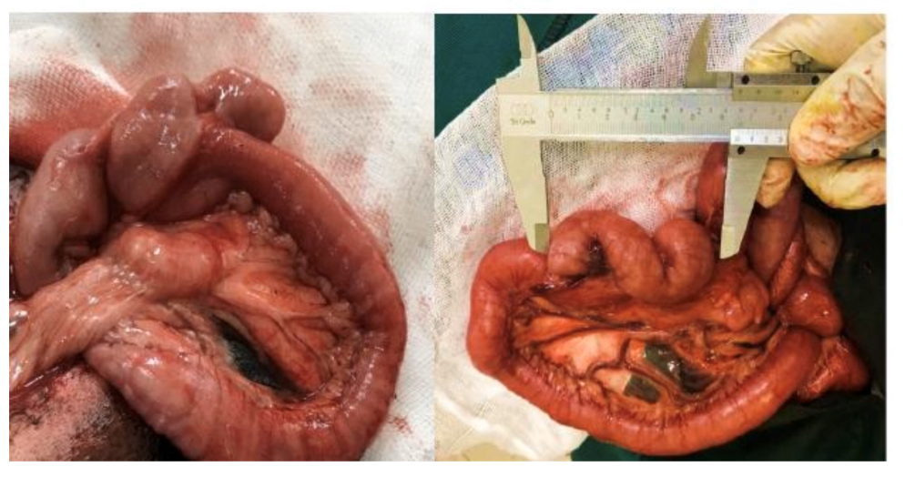
Fig.(1): Cecum extracted and placed above laparotomy pad. And measured at its location by manual Vernier Caliper.
2.2.1. Partial typhlectomy
Double ligation of cecal branches of the ileocecal artery in the ileocecal mesenteric attachment (ileocecal fold) was performed. Detachment of the ileocecal fold and freeing the blind end part of cecum (apex of cecum) at antimesenteric border, a clamp was placed across the rested body of cecum and then resect 50% of whole cecum length. The intestinal content was discarded and occlude the lumen.
The defect was then sutured by double layer inverting suture pattern using vicryl® 2-0, then the surgical site was covered with an omental patch (omentalisation) immediately after performing intestinal surgery.
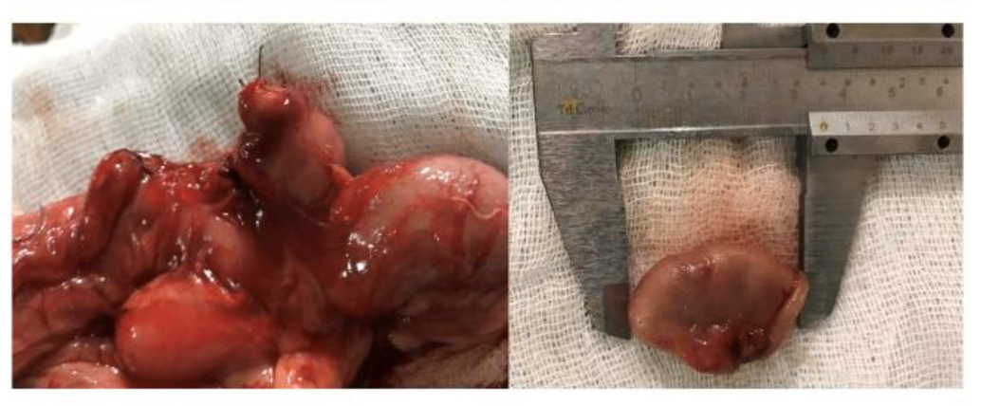 (a) (b)
Fig.(2): (a) the cecal defect sutured by double layer inverting suture pattern using vicryl 2-0. (b) The half resected cecum and its length was measured by manual Vernier Caliper.
2.2.2. Complete typhlectomy
Double ligation of cecal branches of the ileocecal artery in the ileocecal mesenteric attachment (ileocecal fold) was performed. Dissection of the ileocecal fold and freeing the cecum from the ileum and colon from its base. A clamp was placed across it.
At antimesenteric border, the whole cecum was transected at the junction with the ascending colon. The intestinal content was discarded from the ascending colon and ileum adjacent to the cecocolic orifice and occlude the lumen. The defect was then closed by double layer inverting suture pattern using vicryl® 2-0. then the surgical site was covered with an omental patch (omentalisation) immediately after performing intestinal surgery.
For both technique abdominal wound was closed as usual using vicryl® -0- ; the muscle and peritoneum together closed by double layer of simple continuous suture pattern then subcutaneous tissue by single layers simple continuous pattern and finally closing the skin by polypropylene® -0- (Ethicon) using cruciate pattern and skin disposal staples. The surgical site covered by cover pad and stitching to skin.
The resected part of cecum in partial typhlectomy and The detached cecum length in complete typhlectomy was measured by manual Vernier Caliper. (Vernier caliper
0-150mm® STECO., China).
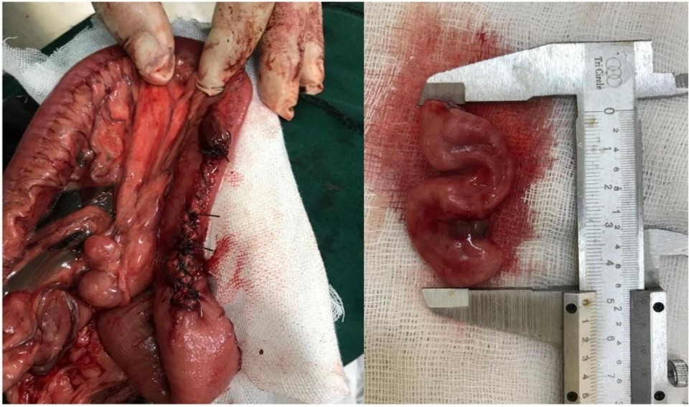
(a) (b)
Fig.(3): (a) The complete typhlectomy defect closed by double layer inverting suture pattern using vicryl 2-0. (b) The detached “S” shaped cecum and its length was measured by manual Vernier Caliper.
2.3. Post-operative care
A protective elizabethan collar over the neck of the animal was used to prevent self-mutilation. (Dog collar clic® Vbuster., Denmark)

Food was withheld for 2 days after the operation. A fluid therapy was administrated using Anhydrase glucose (Glucose 5 %®), Calcium chloride dehydrate, potassium chloride, sodium chloride (Ringer’s lactate®) and Sodium chloride (Normal saline®) solutions (FIPCO., Egypt) given intravenously in a maintenance dose (30 x Body weight + 70). Penecilline streptomycine (Pen-strep®) as antibiotic was given in a dose 1mg/10kg I/M (Norbook co.,) for a 5 successive days, Sodium phosphate (B.P.Vet.2003) (dexamethasone®) as Steroidal Anti-inflammatory in dose 0.5ml/10kg I/M (Adwia co., Egypt) once daily for 3-4 days. ketoprofen (ketofan®) in 1 mg/kg/IM dose (European pharmaceuticals co., Egypt) as a pain killer was given if needed after the operation.

Povidone-iodine (Betadine10 %®) (Mundipharma co., Egypt) as antiseptic solution was applied to the surgical wound till the removal of stitches after 14 days. The second day after operation the animal was given access to the water with gradual increase in its amount , and on the third day we started to introduce the easily digested food begin with (Cerelac ®) and then gradually with milk and rice and bread till the end of first week then after this week the animal returned to the normal diet.

2.4. Clinical evaluation:-
2.4.1. Physiological parameters measurement:
Body temperature, respiratory rate and pulse rate were recorded on 0 day before operation and every day till day 5 after operation and on days 7,14,21,30.

2.4.2. Hematological and Biochemical analysis:
Five blood samples were collected on days 0 (control sample) and days 3,7,14, 21 after surgery from the cephalic vein. A complete blood count (CBC) was made for monitoring the hematological changes on the blood picture after the surgery and for biochemical changes of serum glutamate oxaloacetate transaminase (SGOT) and serum glutamate pyruvate transaminase (SGPT) (liver function tests), and blood Urea nitrogen (BUN) and Creatinen (kidney function tests).
2.5. Statistical analysis:

Data collected were analyzed using one-way analysis of variance (ANOVA)
With Duncan by SPSS® version 16.0. A statistical probability (P value) less than 0.05 indicated a statistically significant difference between groups. (Steel and torrie., 1980).

3. RESULTS

All dogs in both groups recovered smoothly from anesthesia. No complications during and post-surgery. No evidence of wound infection was reported. Dogs started to eat from Day 3 after surgery and showing a good appetite till the end of experiment.
Clinical examination of dogs after surgical operation:

3.1. Body temperature, pulse rate and respiratory rate

3.1.1. Body Temperature

Group1: body temperature slightly increased on day 2 post surgery, followed by significant decreased on day 3 till day 5 then significantly increased till the end of the experiment.
Group2: body temperature showed significant decrease from 2nd day post-surgery until day 14 followed by significant increase on day 21 then significant decrease on day 30.

3.1.2. Pulse Rate:

Group1: pulse rate was significantly decreased from 2nd day post-surgery until day 7 then returned to the baseline value at the end of experiment.
Group2: significant increase in pulse rate was observed all over the experiment and the highest values were recorded on day 2 and 14 post surgery.

3.1.3. Respiratory Rate:

Group1: respiratory rate remained unchanged till day 4 post surgery. Followed by significant decrease on both 5th and 7th day then returned to the pre-operative value again on day 14.
Group2: respiratory rate showed significant increase from 2nd day post-surgery and continued till 5th day. From day 7 began to decrease till reach the baseline value at the end of experiment.

Table (1): Showing mean ±SD of Body temperature, Pulse rate and Respiratory rate in different times in two groups:

 | Body Temperature |  | Pulse Rate |  | Respiratory Rate
 | Group 1 | Group 2 | Group 1 | Group 2 | Group 1 | Group 2
Day zero | 38.43±0.23^{AB} | 39.65±0.21^{A} | 86.67±12.86^{B} | 64.00±8.00^{I} | 20.00±0.00^{A} | 22.67±4.62^{G}
Day 2 | 38.50±0.26^{AB} | 38.63±0.85^{CD} | 82.67±12.22^{D} | 93.33±13.09^{B} | 20.00±0.00^{A} | 41.33±16.63^{A}
Day 3 | 38.47±0.21^{AB} | 38.83±0.25^{BC} | 73.33±6.11^{G} | 82.67±9.24E | 20.00±0.00^{A} | 32.00±14.42^{D}
Day 4 | 38.37±0.31^{AB} | 38.30±0.26^{D} | 80.00±8.00E | 77.33±4.62^{F} | 20.00±0.00^{A} | 38.67±18.90^{B}
Day 5 | 38.23±0.50^{B} | 38.47±0.29^{CD} | 77.33±11.55^{F} | 74.67±4.62^{H} | 16.00±9.24^{B} | 37.33±14.05^{C}
Day 7 | 38.75±0.64^{A} | 38.27±0.25^{D} | 80.00±14.42E | 76.00±18.33^{G} | 12.00±10.58^{C} | 28.00±12.00E
Day 14 | 38.75±0.70^{A} | 38.60±0.36^{CD} | 86.00±14.14^{C} | 96.67±15.01^{A} | 20.00±2.83^{A} | 28.00±12.00E
Day 21 | 38.75±0.27^{A} | 39.17±0.57^{B} | 88.00±5.66^{A} | 86.00±5.29^{D} | 20.00±0.00^{A} | 24.00±6.93^{F}
Day 30 | 38.75±0.17^{A} | 38.53±0.15^{CD} | 86.00±2.83^{C} | 90.00±11.14^{C} | 16.00±5.66^{B} | 21.33±4.62^{H}

- Reported values are the mean ± SD of Four replicates.
- Means in the same column followed by different Upper case letters are significantly different (p<0.05).
- Means with similar letters are not significantly different at (P<0.05).

3.2. Hematological and Biochemical analysis:

3.2.1.Hematological analysis:

A. Effect on Hb, RBCs, haematocrite, MCV and MCH on different periods of the experiment

Haemoglobin (Hb):

Group1: Hb level showed significant decrease on day 3 till end of experiment. But Hb level still within the pysiological limit.
Group2: Hb level showed significant decrease on day 3 and 7. Then began to increase gradually from day 14 to become around the baseline value by the end of experiment.

RBCs (Red Blood Cells):

Group1: RBCs level showed significant decrease from 3rd day of operation till day 14. Then began to increase at day 21 post surgery but never returned to the baseline value.
Group2: RBCs level showed also significant decrease from 3rd day of operation till day 14. then increased again to become around the baseline value.

Haematocrite:

Group1: Hematocrit value showed significant decrease all over the observation period and never returned to the baseline value.
Group2: Hematocrit showed significant decrease all over the observation period.

MCV (Mean Corpuscular Volume):

Group1: MCV showed significant fluctuation between decrease and increase till end of experiment. But still around the baseline value.
Group2: MCV showed significant increase till reach its highest value on day 14 till the end of experiment.

MCH (Mean Corpuscular Haemoglobin):

Group1: MCH value showed significant increase on day 14 and 21 but staying within baseline value.
Group2: MCH value showed significant increase on day 21 post surgery.

Table (2): Showing mean ±SD of Hb, RBCs, Haematocrite, MCV, MCH in different times in studied groups:

 | Hb |  | RBCs |  | Haematocrite |  | MCV |  | MCH
 | Group 1 | Group 2 | Group 1 | Group 2 | Group 1 | Group 2 | Group 1 | Group 2 | Group 1 | Group 2
Day zero | 14.17±0.67^{A} | 13.40±1.36^{B} | 6.23±0.31^{A} | 6.02±0.71^{A} | 39.23±1.10^{A} | 41.70±4.81^{A} | 62.83±3.96^{C} | 69.17±1.50^{B} | 22.70±1.91^{C} | 23.53±0.61^{C}
Day 3 | 13.70±1.61^{B} | 11.53±0.91^{D} | 5.90±0.72^{AB} | 4.96±0.19^{C} | 36.43±3.06^{B} | 34.03±0.90E | 62.00±3.99^{D} | 68.17±1.14^{D} | 23.30±1.11^{B} | 23.10±1.90^{D}
Day 7 | 13.20±0.78^{C} | 11.63±1.46^{D} | 5.77±0.59^{BC} | 5.02±0.28^{C} | 35.53±1.62^{C} | 34.73±1.29^{D} | 61.83±3.71^{D} | 68.73±2.45^{C} | 23.00±1.85^{BC} | 22.93±1.65^{D}
Day 14 | 13.20±1.40^{C} | 12.20±0.53^{C} | 5.40±1.27^{C} | 5.12±0.07^{C} | 36.30±5.94^{B} | 35.47±3.17^{C} | 66.95±5.02^{A} | 71.80±5.60^{A} | 24.30±1.41^{A} | 24.33±1.62^{B}
Day 21 | 13.25±1.04^{C} | 13.87±0.71^{A} | 5.55±1.63^{BC} | 5.59±0.47^{B} | 35.10±8.06^{D} | 38.90±2.89^{B} | 63.80±4.24^{B} | 71.77±5.89^{A} | 24.10±1.56^{A} | 26.70±4.69^{A}

- Reported values are the mean ± SD of Four replicates.
- Means in the same column followed by different Upper case letters are significantly different (p<0.05).
- Means with similar letters are not significantly different at (P<0.05).

B. Effect on WBCs and platelets on different periods of the experiment:

WBCs:

Group1: WBCs showed significant increase on day 3 and day 7. Then followed by significant decrease on day 14 till day 21 post surgery.
Group2: WBCs showed marked significant increase on day 3, 7 and 21 post surgery.

Platelets:
Group1: platelets showed fluctuation between significant decrease and increase throughout the observation period. The highest value was observed on day 7 while the lowest one was observed on day 14.
Group2: platelets also showed fluctuation between increase and decrease where the highest value was observed on day 7.

Table (3): Showing mean ±SD of WBCs and Platelets in different times in studied groups:

 | WBC |  | Platelets
 | Group 1 | Group 2 | Group 1 | Group 2
Day zero | 15.50±1.76^{C} | 12.97±0.40^{D} | 457333±88007^{B} | 493667±47878^{B}
Day 3 | 21.60±3.17^{A} | 17.80±5.21^{A} | 392000±107196^{C} | 482000±40149^{C}
Day 7 | 17.80±3.22^{B} | 15.43±3.96^{B} | 588000±111216^{A} | 652666±62516^{A}
Day 14 | 13.60±6.93^{D} | 10.97±3.17E | 196500±205768E | 473333±52051E
Day 21 | 12.40±6.93E | 14.50±4.64^{C} | 312500±536880^{D} | 481333±28005^{D}

- Reported values are the mean ± SD of Four replicates.
- Means in the same column followed by different Upper case letters are significantly different (p<0.05).
- Means with similar letters are not significantly different at (P<0.05).

3.2.2. Biochemical analysis:

Blood Urea nitrogen (BUN):

Group1: BUN showed significant increase from day 3 while the highest value was recorded on day 7 post surgery.
Group2: BUN showed significant decrease from day 7 till the end of the experiment.

Creatinine:

Group1: creatinine showed non-significant decrease until day 21 post surgery.
Group2: creatinine showed non-significant changes until the end of the experiment.

SGOT (Serum glutamic oxaloacetic transaminase) - (AST):

Group1: SGOT was significantly increased all over the observation period and highest value was recorded on day 3 post surgery
Group2: SGOT showed remarkable significant increase on day 3 then began to decrease from day 7 till day 21 but still significantly higher than the baseline value.

SGPT (Serum glutamic pyruvic transaminase) - (ALT):

Group1: SGPT showed significant changes as it showed significant increase on day 7 then decrease significantly on day 14 and day 21.
Group2: SGPT increased significantly from day 3 to day 14 and decrease significantly on day 21.

Table (4): Showing mean ±SD of BUN, Creatinine, SGOT and SGPT in different times in studied groups:

 | BUN |  | Creatinine |  | SGOT |  | SGPT
 | Group 1 | Group 2 | Group 1 | Group 2 | Group 1 | Group 2 | Group 1 | Group 2
Day zero | 36.67±14.05^{D} | 37.33±19.63^{A} | 0.94±0.19^{A} | 1.01±0.07^{A} | 35.00±5.57E | 48.67±10.26E | 57.00±19.08^{B} | 64.33±7.23^{D}
Day 3 | 42.67±7.02^{C} | 37.33±6.43^{A} | 0.84±0.21^{A} | 0.90±0.11^{A} | 54.00±9.70^{A} | 87.00±2.65^{A} | 56.33±13.01^{C} | 80.67±4.19^{A}
Day 7 | 49.33±25.32^{A} | 31.67±16.86^{B} | 0.75±0.12^{A} | 0.90±0.07^{A} | 44.67±7.50^{B} | 63.00±5.93^{C} | 90.00±9.24^{A} | 79.33±4.19^{B}
Day 14 | 28.00±7.07E | 26.00±5.29^{D} | 0.71±0.18^{A} | 0.86±0.28^{A} | 37.00±1.31^{D} | 63.67±7.21^{B} | 45.50±4.95^{D} | 70.67±4.23^{C}
Day 21 | 47.50±6.36^{B} | 28.50±3.77^{C} | 0.76±0.08^{A} | 0.90±0.13^{A} | 40.00±5.46^{C} | 62.33±2.17^{D} | 38.50±3.54E | 48.67±4.69E

- Reported values are the mean ± SD of Four replicates.
- Means in the same column followed by different Upper case letters are significantly different (p<0.05).
- Means with similar letters are not significantly different at (P<0.05).

4. Discussion

The results of the physiological parameters measurement of dogs before and after the surgical operation revealed that all animals showed significant alteration in body temperature, pulse rate and respiratory rate throughout the whole length of experiment. These results agreed with what was reported by (Zayed et al.,2014) who stated that all animals showed full recovery after typhlectomy and all clinical signs returned to normal value. Disagreed with the same author in that body temperature, pulse and respiratory rate return to normal on second day after operation.
In the present study, the hematological and biochemical analysis in animals post-operatively showed that:
Hb level in Group1 showed significant decrease on day 3 till end of experiment but still within the physiological limit. While in Group2 showed significant decrease till a week then began to increase gradually from two weeks to become around the baseline value by the end of experiment. RBCs count in both Group1 and group2 showed significant decrease till two weeks but then in group1 began to increase on day 21 post surgery but never returned to the baseline value. While in Group2 increased again to reach around the baseline value. Haematocrite level showed significant decrease all over the observation period and never returned to the baseline value. MCV level in Group1 showed significant fluctuation between decrease and increase till the end of the experiment but still around the baseline value. While in Group2 showed significant increase till reach its highest value after two weeks till the end of experiment. MCH level in group1 showed significant increase till end of experiment but staying within baseline value. While in Group2 showed remarkable decrease after one week followed by significant increase till the end of experiment. The results of control sample before typhlectomy agreed with. (Westgarth et al., 2013) who stated that before typhlectomy and preparation for general anesthesia a control blood sample was taken for a complete blood count, serum biochemical profile and found to be within normal limits. While the results of complete blood count after surgery could imply the decrease shown in values to anemia which related to the loss of blood where the animal was subjected to surgery as it consider a major surgical operation. That also in agreement with (Reyes et al., 2001) who reviwed the loss of blood in open surgery resulted in blood count decrease. And also agreed with (Ward et al., 1994) who stated the several post-operative complications were treated including anemia, peritonitis, thrombophlebitis and hypo proteinemia. Also agreed with (Gratwick et al., 2018) who reported a mild anaemia in hematology analysis. While disagreed with (Bhat et al., 2013) who reported that PCV and Total RBCs count almost remain similar either in healthy dogs and/or dogs suffering from diarrhoea.
WBCs count in Group1 showed significant increase till a week, and then followed by significant decrease after two weeks till the end of experiment. While in Group2 showed marked significant increase on day 3, 7 and 21 after surgery. Platelets showed fluctuation between significant decrease and increase throughout the observation period. In Group1 the highest value was observed after a week while the lowest one was observed after two weeks. And in Group2 where the highest value was observed on day 7. These results agreed with (Bhat et al., 2013) who reported significant increase of leukocytes total count after surgery compared to control sample. And agreed with (Gratwick et al., 2018) who stated that there was increase in total white cell count after operation, And also agreed with (Matthews et al., 2008) who stated that complete blood count in dogs after surgery showed increase in WBCs count on the day next to surgery then followed by a progressive decrease on the following 5 days. While disagreed with (Matthews et al., 2008 and Gratwick et al., 2018) who stated that by a week WBCs count returned to normal value. Incision infection or unevental recovery may cause persistent elevation in WBCs count.
BUN (blood urea nitrogen) in Group1 showed significant increase from day 3 while the highest value was recorded after a week post-surgery. While in Group2 showed significant decrease after a week till the end of the experiment. Creatinine level in Both Group1 and Group2 showed non-significant changes throughout the whole experiment. Which agreed with (BHAT et al., 2013) that reviewed the increase of blood urea nitrogen and refer the reason to possible cause of entrites.
SGOT(Serum glutamic oxaloacetic transaminase)-(AST) in Group1 was significantly increased all over the observation period and the highest value was recorded on day 3 post surgery. While Group2 showed remarkable increase on day 3 then began to decrease after a week till the end of experiment but still significantly higher than the baseline value. SGPT (Serum glutamic pyruvic transaminase)-(ALT) in Group1 showed significant changes as it showed significant increase after a week then decreased significantly after two weeks till the end of experiment. While in Group2 increased significantly till two weeks and decrease significantly at end of observation period. These results disagreed with (Bhat et al., 2013) who reported that aspartate amino-transferase (AST) and Alanine aminotransferase (ALT) showed non-significant increase. (Tan et al,. 2003) who reported in human that liver dysfunction in most cases had no apparent clinical signs after recovery. And the alteration and elevation of hepatic enzymes level after surgery was transient and may be related to general anesthesia or secondary to surgery.

5. Conclusion

In conclusion, the partial typhelectomy showed better or advanced degree of repair (curation) than that observed in case of complete typhlectomy with improving the clinical symptoms till full recovery and least complication.

6. Acknowledgements

I wish to express my sincere thanks to my dearest friend veterinary doctor, Miral Gamal-Eldin Abdel-Wahab, at the department of Food Technology, Arid Land Cultivation Research Institute, city of scientific research institute and technological applications for helping in paper statistical work and support.

7. References

Abd-EL-hady, A., Misk, N., Haridy, M., Zayed, M. 2013. Morphometric and histological studies of the cecum in Mongrel dogs. Life Sci. J. 10: 3172-3178.
Akers, R. M., Denbow, D. M. 2013. Anatomy and physiology of domestic animals, JWS.

Bhat, A. A., Wadhwa, D. R., Singh, S. P., Singh, I. 2013. Haematological and biochemical analysis in canine enteritis. Vet. World. 6: 380-383.

Boland, L., Lindsay, S., Brunel, L., Podadera, J., Bennett, P. 2017. Caecocolic intussusception associated with a caecal polyp and concurrent hepatocellular carcinoma in a cat. JFMS. 3: 2055116917706652.

Dabareiner, R. M., White II, N. A. 1997. Diseases and surgery of the cecum. VET. CLIN. N. AM-EQUINE. 13: 303-315.

Evans, H. E., De Lahunta, A. 2013. Miller's anatomy of the dog E-Book, Elsevier Health Sciences.

Fossum, T. W. 2018. Small Animal Surgery E-Book, Elsevier Health Sciences.

Gratwick, Z., Donnellan, C., Page, P., Viljoen, A., Williams, J., Lyle, C. 2018. Caecal intussusceptions and typhlocolitis in horses with severe Gastrodiscus aegyptiacus infestation. Equine Vet. Educ. 30: 247-254.
Hubert, J. D., Hardy, J., Holcombe, S. J., Moore, R. M. 2000. Cecal amputation within the right ventral colon for surgical treatment of nonreducible cecocolic intussusception in 8 horses. Vet. Surg. 29: 317-325.

Martin, J. B., Freeman, D., Ross, M., Richardson, D., Johnston, J., Orsini, J. 1999. Cecocolic and cecocecal intussusception in horses: 30 cases (1976-1996). JAVMA. 214: 80-84.

Matthews, A. R., Penninck, D. G., Webster, C. R. 2008. Postoperative ultrasonographic appearance of uncomplicated enterotomy or enterectomy sites in dogs. Vet. Radiol Ultrasound. 49: 477-483.

Reyes, C., Weber, K., Gagner, M., Divino, C. 2001. Laparoscopic vs open gastrectomy. Surg. Endosc. 15: 928-931.
Scurtu, I., Mircean, M., Giurgiu, G. 2014. Caecal inversion in a dog. Bulletin UASVM CN. Veterinary Medicine. 71: 204-207.
Steel, R.G., Torrie, J.H.,1980. Principles and procedures of statistics. London: McGraw Hill.
Tan, M., Xu, F.-F., Peng, J.-S., Li, D.-M., Chen, L.-H., LV, B.-J., Zhao, Z.-X., Huang, C., Zheng, C.-X. 2003. Changes in the level of serum liver enzymes after laparoscopic surgery. World J. Gastroenterol. WJG. 9: 364.

Ward, J., Fubini, S. 1994. Partial typhlectomy and ileocolostomy for treatment of nonreducible cecocolic intussusception in a horse. JAVMA. 205: 325-328.

Westgarth, S., Singh, A., Vince, A. R. 2013. Subclinical cecal impaction in a dog. CVMA. 54: 171.
Zayed, M., Haridy, M., Misk, N., Abd-EL-hady, A.-N., Sakai, H., Yanai, T. 2014. Surgical and Histopathological Evaluation of Suture Materials for Closure of Colonic Wounds after Experimental Typhlectomy in Dogs. AJAVA. 9: 578-586.

