NEUROBEHAVIOURAL EFFECT OF ZINC OXIDE NANOPARTICLES AND ITS CONVENTIONAL FORM ON ADULT MALE RATS AND THEIR PUPS
Mahmoud A. Khedr^{1*}, Mohamed A. Mandour¹, Rashed R. Rashed¹, Amira A. Goma¹, Sara E. El-kazaz ¹
¹Department of Animal Husbandry and Animal Wealth Development, Faculty of Veterinary Medicine, Alexandria University, Egypt
*Corresponding author email: mahmoudkhedr504@yahoo.com
Running title: Neurobehavioural Effect of Zinc Oxide Nanoparticles

Abstract:
Zinc is involved in many protein structures, which had a role in some neurological functions. The present study was designed to investigate the effect of zinc oxide nanoparticles and its conventional one on memory and learning ability of adult male rats and their offspring. Thirty adult male rats were randomly distributed into 5 groups (6 rats, each). First group (control group) was injected with Tween 80 (10%), second and third groups, received two doses of Zinc oxide nanoparticles (ZnONPs), 5 and 10 mg/kg bwt respectively. Fourth and fifth groups, administrated two doses of conventional Zinc oxide (CZnO), 5 and 10 mg/kg bwt, respectively. Rats in all groups were injected intraperitoneally by 1ml/rat for 16 days period, every other day. A series of neurobehavioural tests including open field, elevated plus maze and Morris water maze test were conducted. The obtained results indicated that the ZnONPs lower dose improved locomotor behaviour during open field test and had an anxiolytic effect in the elevated plus maze, but higher doses were not beneficial. It can be concluded that the zinc oxide nanoparticles are better than conventional zinc oxide.

Key words: Zinc oxide nanoparticles, Conventional Zinc oxide, learning ability, memory, locomotor behaviour, anxiety.

Introduction
Zinc had an essential role in memory and learning during development for its influence on blood-brain-barrier permeability (Yorulmaz et al., 2013). Thus, its deficiency can lead to memory deficits in animal models (Suh et al., 2009). It was also involved in the protection against oxidative stress, so, prevent the development of neurological disorders (Takeda, 2001). Furthermore, prenatal and early postnatal maternal zinc deficiency in developing brains could lead to neurological abnormalities (Wang et al., 2001). Supplementation with conventional zinc oxide was found to be helpful in decreasing anxiety in rats (Sobhanirad et al., 2008).

Nanoparticles with ≤100 nm in diameter have unique properties in comparison to their corresponding traditional as its large surface-to-volume ratio (Talebi et al., 2013). Moreover, the zinc oxide nano form had a unique physical and chemical properties (Radzimska and Jesionowski 2014). That’s why zinc oxide nanoparticles can pass some of the barriers, to efficient targeting of cells and molecules in many diseases (Suri et al., 2007). Recent studies discussed the effectiveness of zinc oxide nanoparticles (ZnONPs) in the treatment of mental disorders due to the behavioural and physiological improvements observed in the lipopolysaccharide depressed mice (Zhao et al., 2009). Furthermore, it had been suggested that ZnONPs could modulate synaptic transmission in vitro (Bondarenko et al., 2013). Moreover, it also modulates ionic homeostasis and functions of neurons thus, they have a neuroprotection effect on the central nervous system. In addition, ZnONPs had an important role during development processes of CNS diseases through mediating neuronal excitability or even release of neurotransmitters (Xie et al., 2012). Thus, the aim of the current study was to evaluate the effects of zinc oxide nano form in comparison with its conventional on neurobehavioural ability of adult male rats and their pups.

Materials and Methods
1. Chemicals
Zinc oxide nanoparticles (ZnONPs) ˂ 50 nm was purchased from Sigma-Aldrich co. (USA), conventional zinc oxide (CZnO) from Oxford Lab Chem co. (India) and Tween 80 obtained from Alpha Chemika co. (India).
2. Characterization of Zinc oxide nanoparticles (ZnONPs)
The shape and diameter of the particles were determined by the transmission electron microscopy (TEM) at Faculty of Science, Alexandria University, Egypt. The NPs were dispersed in 100 mg/l distilled water, which was stirred then ultrasonicated for 15 min. Three milliliters from the dispersion were deposited on copper grids immediately. The grids were directly inserted into the TEM after they were dried. The images were taken, and diameter of each isolated particle was determined (De Souza et al., 2018).
3. Animals
Thirty Sprague-Dawley adult male rats (3-4 months; 120-130 g) provided from the Medical Research Institute, Alexandria University, Egypt. They were housed in wire mesh cages (30x50x40 cm), at the animal premises of the Department of animal husbandry and animal wealth development, Faculty of Veterinary Medicine, Alexandria University, Egypt. Rats were kept under the natural light cycle without using an artificial lighting program. Adlibitum feeding and watering were received by the animals. The commercial ration used was (Al-Fath co. Egypt) broiler starter containing 21% crude protein, 4.11% fat and 2.44% crude fiber. All rats were acclimatized for two weeks. One hundred and sixty-two rat pups were obtained from mating treated males with untreated receptive females (n=30). They were kept with their dams until weaning age in plastic cages (37x30x14cm) that contains 3-4 cm wood shaving as a bedding material under the same conditions.
4. Experimental Design
Experimental procedures were conducted in accordance with the Alexandria University Institutional Animal Care and Use Committee guidelines (ALEXU-IACUC, 3012019). This research was conducted with strict rules to preserve and safeguard the animal welfare without subjecting them to any degree of suffering or stress. Male rats were randomly distributed into 5 groups (6 rats, each). First group (control group) was injected with Tween 80 (10%). Second and third groups, received two doses of Zinc oxide nanoparticles (ZnONPs), 5 and 10 mg/kg bwt respectively. Fourth and fifth groups, administrated two doses of conventional Zinc oxide (CZnO), 5 and 10 mg/kg bwt, respectively according to Torabi et al. (2013). Rats in all groups were injected intraperitoneally by 1ml/rat for 16 days period, every other day. All drugs were dispersed in 10% Tween 80. All neurobehavioural tests were performed to both adult male rats and pups.
5. Neurobehavioural Tests
5.1. Open Field Test (OFT)
Open field test was used to evaluate locomotor and exploratory behaviours in animals. The apparatus consists of a square arena (40 cm long × 45 cm wide × 45 cm high) divided into 16 equal squares by black-colored grids. Each rat was placed at one corner of the peripheral squares and allowed to explore for 5 min. The following parameters were recorded: number of lines crossed either periphery and/or centrally, number of rearing, grooming number (licking and scratching), number of defection and urination and freezing time. The floor was wiped thoroughly after each rat. Fewer times of crossing and more rearing indicate anxiety behaviour (Xie et al., 2012).
5.2. Elevated Plus Maze (EPM)
Elevated plus maze was used to measure anxiety in animals. The maze consisted of two open arms (50 × 10 cm) and two closed arms of the same size but with 40 cm high side walls. The arms were connected by a central (10 × 10 cm) arena, and the open arms were surrounded by 0.5 cm high edge. The EPM was elevated above the floor by 50 cm. Rats were placed in the center with their head facing one open arm and left exploring for 5 min. The following parameters were recorded: latency to enter open or closed arms, time spent in the open or closed arms, number of entries into open or closed arms, percentage of time spent in open or closed arms, and percentage of open or closed arms entries according to Torabi et al. (2013).
5.3. Morris Water Maze (MWM)
Morris water maze (MWM) was used to evaluate the spatial learning and memory. The MWM consisted of a tank of 120 cm in diameter and 60 cm in height, filled with water to the depth of 45 cm. Black nontoxic ink was added to make the water opaque. The tank was divided into four equal quadrants (I, II, III, and IV) by two imaginary perpendicular lines crossing in the center of the tank. A black platform (5 cm in diameter) was located in the center of quadrant III the target quadrant. The platform was submerged 1-2 cm below the water surface. The MWM consisted of two sections: place navigation and spatial probe.

In the place navigation section: rats were trained to learn the position of the hidden platform. Rats were placed into water facing the wall from the preset starting points. Subsequent starting points proceeded in a clockwise manner for the four trials. Rats were allowed to swim for 60 s or until they located the platform. During the spatial probe, the platform was removed from the tank. Rats were allowed to swim again for 60 s from the quadrant opposite to the target quadrant. The following parameters were determined: escape latency, latency to reach target quadrant, target quadrant spent time and number of trials reaching target quadrant (Xie et al., 2012).
6. Statistical analysis
All data were analyzed by one-way analysis of variance proc GLM, using SAS (Statistical Analysis system 2002, version 9, SAS Institute, Cary, NC. USA.). Data were expressed as means ±S.E.M. and P values<0.05 were considered significant in all tests, unless stated otherwise. Analysis of significant main effects of experimental treatment was performed using least square difference test.
Results
1. Characterization of ZnONPs
TEM analysis showed crystalline and polygonal particles of individual diameter ranging from 25.00 to 46.75 nm shown in Fig.1. This diameter was consistent with that reported by manufacturer (< 50 nm).

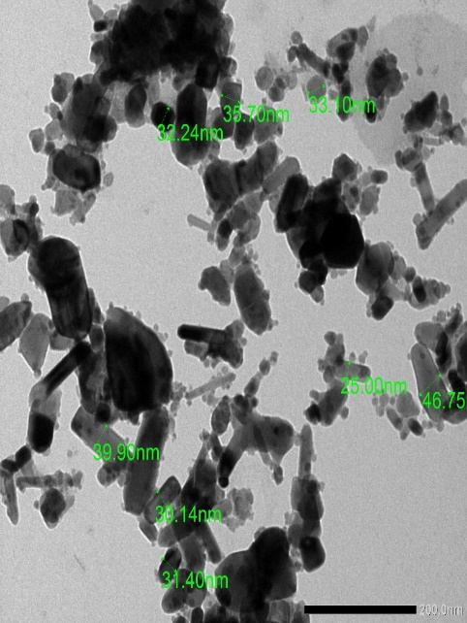
Fig.1. Transmission Electron Microscope (TEM) image showing the shape and diameter of ZnONPs less than 50 nm.

2. Neurobehavioural Tests of adult male rats
2.1. Open Field Test
The obtained results in Fig. (2) showed a significant decrease in the lines crossed centrally and number of rearing in all treated groups by ZnONPs and conventional respectively than control rats.

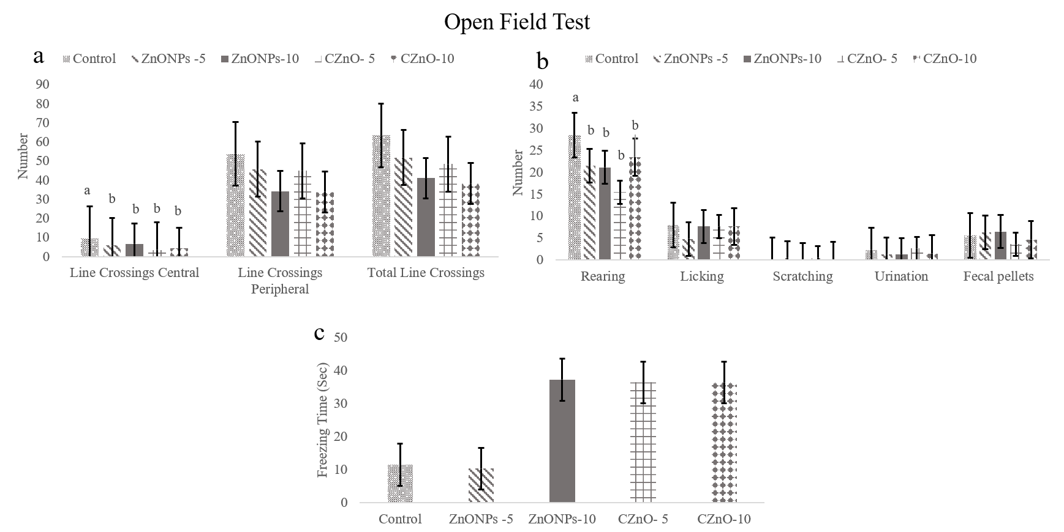
Fig.2. Effect of different doses of zinc oxide in both forms on the Open Field test for adult male rats (a) number of line crossings central, peripheral and total line crossings (b) number of rearing, licking, scratching, urination and fecal pellets (c) freezing time (Sec). All the values were expressed as mean + SEM. Different small letters indicate significant at p < 0.05, SEM: standard error of mean; ZnONPs-5: Zinc oxide nanoparticles (5 mg/kg bwt), ZnONPs-10: Zinc oxide nanoparticles (5 mg/kg bwt), CZnO-5: Conventional zinc oxide (5 mg/kg bwt) CZnO-10: Conventional zinc oxide (10 mg/kg bwt).

2.2. Elevated Plus Maze test
Results revealed that all parameters were non significantly (P>0.05) difference between all treated groups indicating that nano and conventional zinc oxide did not affect anxiolytic behaviour of adult rats (Fig.3).

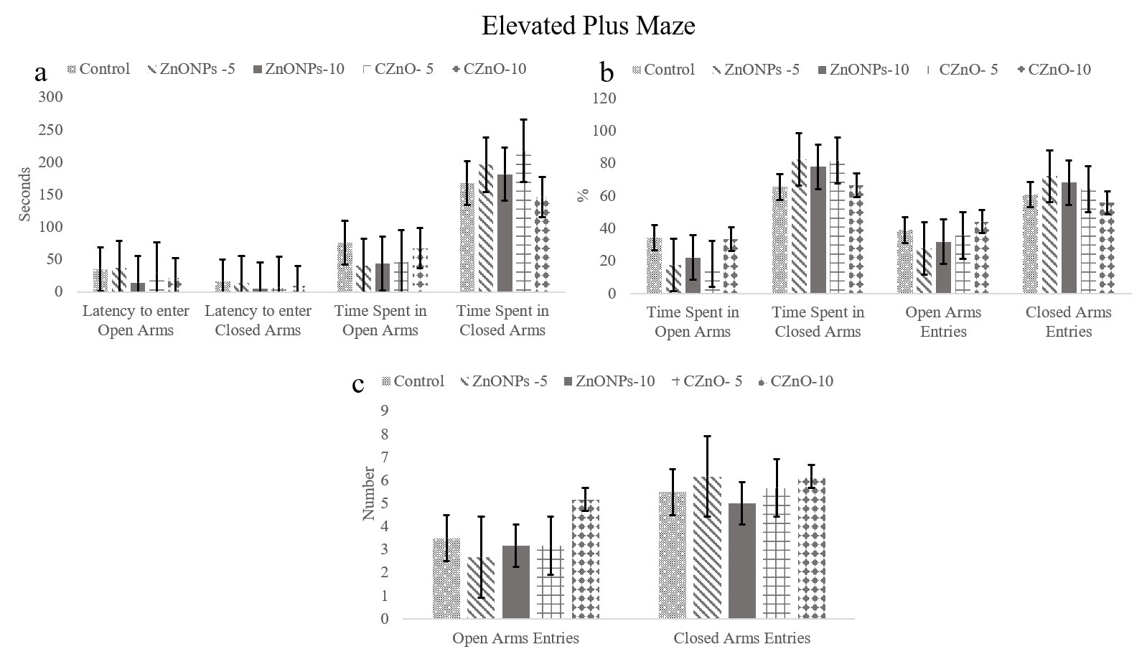
Fig.3. Effect of different doses of zinc oxide in both forms on the Elevated Plus Maze test for adult male rats (a) latency to enter open or closed arms and time spent (Sec) in open or closed arms (b) Percentage (%) of time spent in open or closed arms from total time spent and open or closed arms entries from the total entries (c) Number open or closed arms entries. All the values were expressed as mean + SEM. SEM: standard error of mean; ZnONPs-5: Zinc oxide nanoparticles (5 mg/kg bwt), ZnONPs-10: Zinc oxide nanoparticles (5 mg/kg bwt), CZnO-5: Conventional zinc oxide (5 mg/kg bwt) CZnO-10: Conventional zinc oxide (10 mg/kg bwt).

2.3. Morris Water Maze test:
Fig.4. indicated that the number of trials reaching target quadrant was significantly increased in rats received ZnoNPs (10 mg/kg bwt) than other groups. Moreover, it revealed an increment in rats treated by ZnoNPs (10 mg/kg bwt) and conventional zinc oxide (10 mg/kg bwt) than those administered ZnoNPs (5 mg/kg bwt).

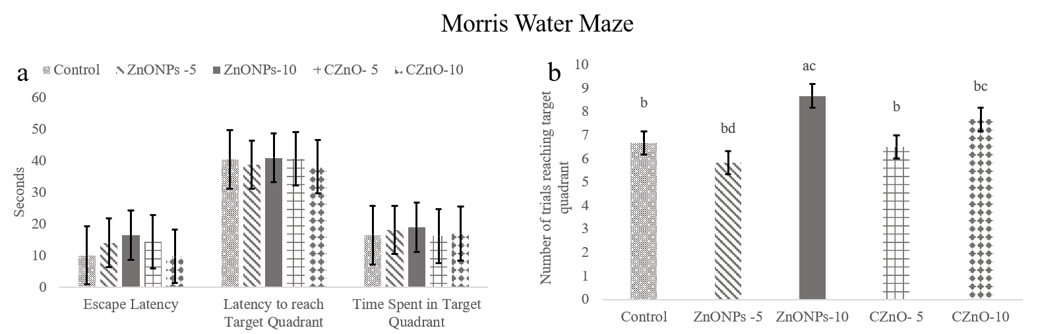
Fig.4. Effect of different doses of zinc oxide in both forms on the Morris Water Maze test for adult male rats (a) escape latency, latency to reach target quadrant and time spent (Sec) in target quadrant (b) number of trials reaching target quadrant. All the values were expressed as mean + SEM. Different small letters indicate significant at p < 0.05, SEM: standard error of mean; ZnONPs-5: Zinc oxide nanoparticles (5 mg/kg bwt), ZnONPs-10: Zinc oxide nanoparticles (5 mg/kg bwt), CZnO-5: Conventional zinc oxide (5 mg/kg bwt) CZnO-10: Conventional zinc oxide (10 mg/kg bwt).

3. Neurobehavioural Tests of pups
3.1. Open Field Test
The open field test results shown in Fig. (5) deducted that number of lines crossed centrally showed a significant increment in pups of male rats received ZnONPs (10 mg/kg bwt) and control pups than others. Furthermore, number of fecal pellets significantly increased in pups of all treated groups than control one. However, urination number significantly decreased in pups of male rats administered ZnONPs (10 mg/kg bwt) than other groups. On contrary, licking number significantly decreased in pups of male rats treated by CZnO (5 mg/kg bwt) than those administered both doses of ZnONPs.

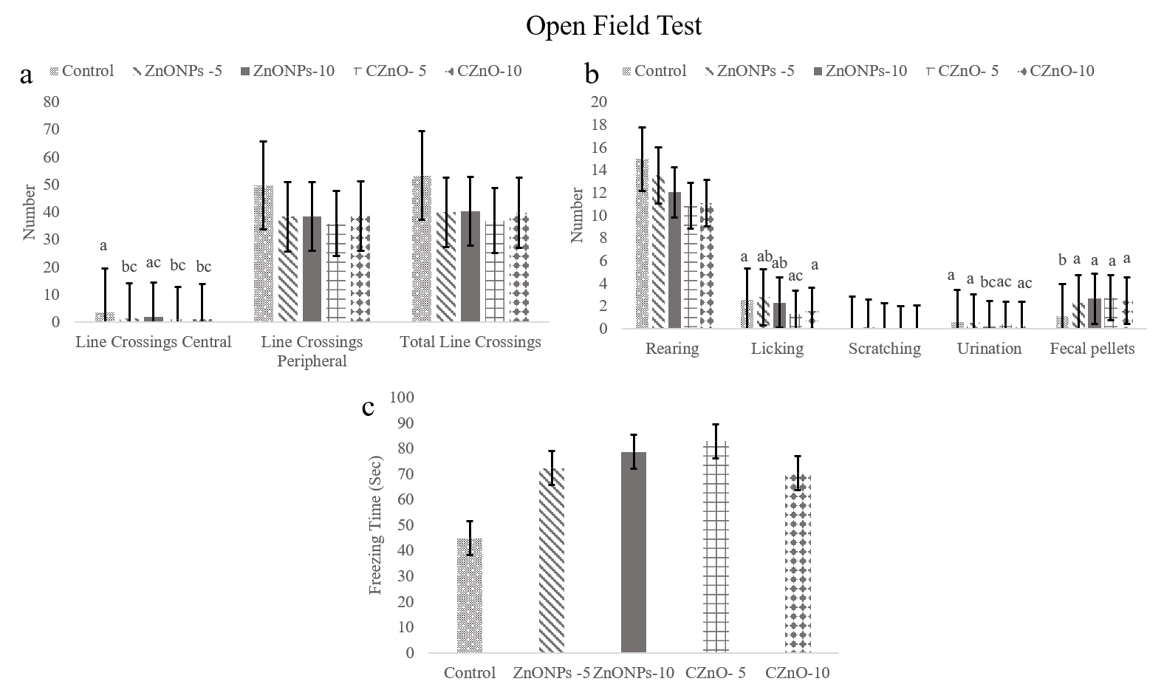
Fig.5. Effect of different doses of zinc oxide in both forms on the Open Field test for pups (a) number of line crossings central, peripheral and total line crossings (b) number of rearing, licking, scratching, urination and fecal pellets (c) freezing time (Sec). All the values were expressed as mean + SEM. Different small letters indicate significant at p < 0.05, SEM: standard error of mean; ZnONPs-5: Zinc oxide nanoparticles (5 mg/kg bwt), ZnONPs-10: Zinc oxide nanoparticles (5 mg/kg bwt), CZnO-5: Conventional zinc oxide (5 mg/kg bwt) CZnO-10: Conventional zinc oxide (10 mg/kg bwt).

3.2. Elevated Plus Maze test
Fig. (6) revealed that time spent in open arms and its percentage from total time significantly increased in pups of males treated by ZnONPs (5 mg/kg bwt) than pups of other groups. However, time spent in closed arms and its percentage from total time revealed a significant decrease in pups of the same group than others. Moreover, percentage of open arms entries significantly increased in pups of male rats treated by both doses of ZnONPs than pups of other groups. Whereas, percentage of closed arms entries significantly increased in pups of male rats administered CZnO (10 mg/kg bwt) than pups of male rats received ZnONPs (5 mg/kg bwt). Furthermore, the number of open arms entries showed an increment in pups of male rats treated by both doses of ZnONPs than those both doses of CZnO. In addition, number of closed arms entries revealed a decrease in pups of male rats treated by CZnO (5 mg/kg bwt) than pups of those administered ZnONPs by both doses.

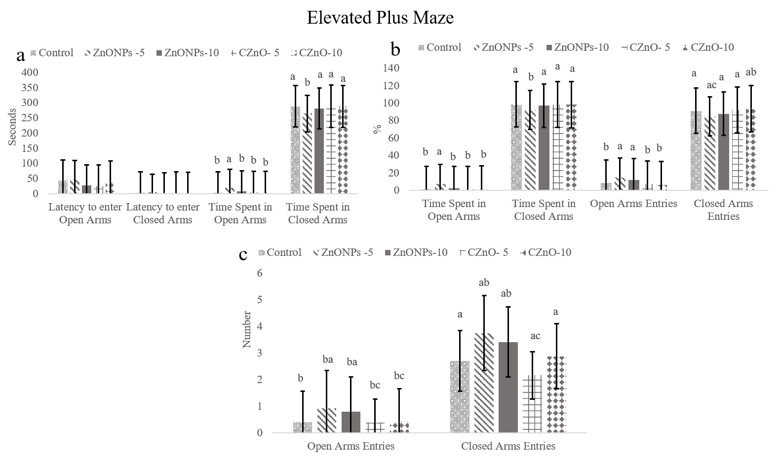
Fig.6. Effect of different doses of zinc oxide in both forms on the Elevated Plus Maze test for pups (a) latency to enter open or closed arms and time spent (Sec) in open or closed arms (b) Percentage (%) of time spent in open or closed arms from total time spent and open or closed arms entries from the total entries (c) Number open or closed arms entries. All the values were expressed as mean + SEM. Different small letters indicate significant at p < 0.05, SEM: standard error of mean; ZnONPs-5: Zinc oxide nanoparticles (5 mg/kg bwt), ZnONPs-10: Zinc oxide nanoparticles (5 mg/kg bwt), CZnO-5: Conventional zinc oxide (5 mg/kg bwt) CZnO-10: Conventional zinc oxide (10 mg/kg bwt).

3.3. Morris Water Maze test:
The Morris water maze results shown in Fig. (7) indicated a longer escape latency of pups of male rats received ZnONPs (5 mg/kg bwt) than others. However, it decreased in pups of those treated by CZnO (5 mg/kg bwt) than other groups. Moreover, pups of those received CZnO (10 mg/kg bwt) and ZnONPs (10 mg/kg bwt) showed shorter latency than those pups of male rats administered ZnONPs (5 mg/kg bwt). On the other hand, time spent in target quadrant decreased in pups of male rats administered ZnONPs (5 mg/kg bwt) and CZnO (10 mg/kg bwt) than those of other groups. On contrary, number of trials reaching target quadrant revealed an increase in pups of male rats treated by CZnO (5 mg/kg bwt) than pups of other groups.

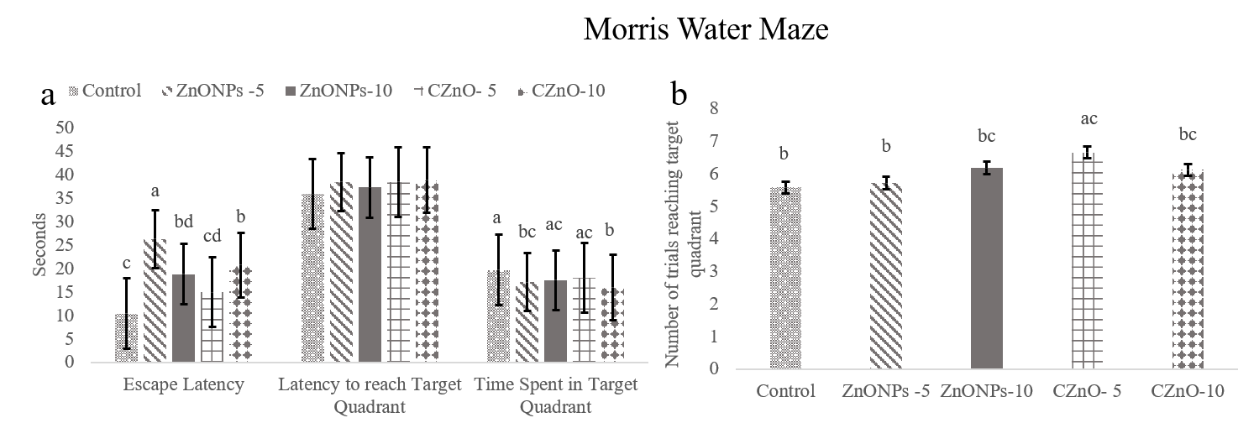
Fig.7. Effect of different doses of zinc oxide in both forms on the Morris Water Maze test for pups (a) escape latency, latency to reach target quadrant and time spent (Sec) in target quadrant (b) number of trials reaching target quadrant. All the values were expressed as mean + SEM. Different small letters indicate significant at p < 0.05, SEM: standard error of mean; ZnONPs-5: Zinc oxide nanoparticles (5 mg/kg bwt), ZnONPs-10: Zinc oxide nanoparticles (5 mg/kg bwt), CZnO-5: Conventional zinc oxide (5 mg/kg bwt) CZnO-10: Conventional zinc oxide (10 mg/kg bwt).

Discussion
The involvement of Zinc in the myelination of nerves and in the release of the neurotransmitters as gama-aminobutyric acid and glutamate, which considered as modulators for the neuronal excitability was revealed (Hardy et al., 2011), therefore, its deficiency had been associated with learning/memory deficits (Tahmasebi et al. 2009). The obtained results for adults showed a significant decrease in the number of lines crossed centrally and rearing in all treated groups in the open field test. Furthermore, there was non-significant difference between all treated groups and control in escape latency, latency to target quadrant and time spent in it, although, number of trials reaching target quadrant in the Morris water maze was significantly increased in rats received ZnONPs (10 mg/kg bwt) than other groups.

These agreed with those reported by De Souza et al. (2018) who stated that both doses of ZnONPs (5.625 and 300 mg/kg) decreased the ratio of central crossed squares/total crossed squares during the open field test. They explained this, that the ZnONPs have the ability to impair the function of anxiety-related neurological circuits due to its bioaccumulate in the central nervous system. While, disagreed with Xie et al. (2012) who found that ZnONPs (5.6 mg/kg) significantly increase the number of crossings and rearings. Although, agreed with them as they also found no significant difference between ZnONPs and control in the time spent in target quadrant. Moreover, Amara et al. (2014) found that ZnONPs (25 mg/kg bwt) did not alter the time spent in the target quadrant in the Morris water maze. Furthermore, it was also reported that ZnO-treated group took a similar period of time of control group to find the new location of the hidden platform (Deguil et al., 2010).

On the other hand, there were a non-significant anxiolytic effect for the treatment in adult male rats, similarly to, Ben-Slama et al. (2015) who stated that ZnONPs did not affect the anxiety level of rats during elevated plus maze test indicating the absence of correlation between zinc accumulation in brain and behavioral performances. Moreover, Hafez and Gad (2018) reported that ZnONPs treatment in adult rats did not affect anxiety index during elevated plus maze test. The results concerning pups indicated that ZnONPs (10 mg/kg bwt) increased number of lines crossed centrally, fecal pellets and licking number, while, decreased urination number in the open field test, so higher dose could be not beneficial to learning ability of pups. This finding was explained by Peng et al. (2011) who indicated that the higher doses only saturate the serum zinc level but had a reduced anxiolytic effect. Moreover, the exposure to high dose of ZnONPs disrupt trace elements homeostasis in rat brain, which could promote an emotional behavior impairment (Amara et al., 2013). Furthermore, chronic exposure to higher concentration of zinc, leads to oxidative stress (Attia et al., 2018).

This agreed with, Darbandi and Momeni (2018) who reported that chronic exposure to zinc leads to a decline in cognitive performance by enhancing, apoptosis of pyramidal neurons. On contrary, Zahra et al. (2017) found that mice treated by ZnONPs do not differ from control group in the open field test. The Elevated plus maze revealed that ZnONPs (5 mg/kg bwt) showed an increase in time spent in open arms and its percentage, number of open arm entries and its percentage but decreased in time spent in closed arms and its percentage and percentage of closed arm entries. Whereas, ZnONPs (10 mg/kg bwt) showed an increase in percentage of open arm entries, number of open arm entries and number of closed arm entries.

This anxiolytic effect of ZnONPs might be due to the release of zinc from ZnONPs which is responsible for reducing the anxiety level via a reduction in the release of glutamate and blocking of NMDA receptor and/or via increase in the release of GABA and disrupting the balance between glutamate and an GABA in the CNS (Torabi et al., 2013). These results also agreed with them as they stated that percentage of time spent in open arms increased in rats received ZnONPs (5 mg/kg). Moreover, they also reported that all doses of CZnO (5, 10 and 20 mg/kg) did not affect the percentage of open arm entries. While, disagreed with them, in which they deducted that percentage of time spent in open arms increased at those administered CZnO (10 and 20 mg/kg) and that all doses of ZnONPs (5, 10 and 20 mg/kg) did not affect significantly the percentage of open arm entries.

Furthermore, Kesmati et al. (2019) found that ZnONPs (2.5 and 5 mg/kg) improved anxiety-like behaviours in rats during the elevated plus maze test. On contrary, De Souza et al. (2018) reported that there was no anxiogenic or anxiolytic effects for ZnONPs (5.625 and 300 mg/kg bwt) in rats during elevated plus maze test. Moreover, Rafieirad and Charic (2019) stated that the anxiety level significantly decreased in rats received ZnONPs (5 mg/kg bwt) compared to control group. The Morris water maze of pups indicated that ZnONPs (5 mg/kg bwt) increased escape latency, while, had a decrease in time spent in target quadrant. However, those of ZnONPs (10 mg/kg bwt) had a shorter escape latency than those of ZnONPs (5mg/kg bwt). Moreover, CZnO (10 mg/kg bwt) showed short escape latency and a decrease in time spent in target quadrant. Furthermore, those of CZnO (5 mg/kg bwt) showed an increase in number of trials reaching target quadrant and a decrease escape latency.

These agreed with Han et al. (2011) who stated that administration of ZnONPs (4 mg/kg) attenuated spatial learning and memory ability in rats by alteration of synaptic plasticity in rats. Furthermore, Kesmati et al. (2016) found that ZnONPs (2.5 and 5 mg/kg) decreased memory which might be due to the increase of zinc ions in glutamatergic synapse pathways and excessive inhibition of NMDA receptors, that reduces the long-term potentiation and memory. In contrast, Piechal et al. (2012) stated that there was an improvement in spatial learning and memory processes after zinc supplementation during ontogenesis in rat pups indicated by a decrease in escape latency and spending longer time in target quadrant. Moreover, Yu et al. (2013) reported that there was no difference between the zinc supplemented rats and control in indices of learning in Morris water maze.

On conclusion, the ZnONPs lower dose could improve locomotor behaviour and had an anxiolytic effect but higher doses were not beneficial. Also, zinc oxide nanoparticles had a better effect on neurobehaviours of rats than conventional zinc oxide. On contrary, prenatal exposure to ZnONPs could impaired spatial cognition and memory in rat offspring.

Acknowledgements
The authors would like to acknowledge and thank the workers at Faculty of Veterinary medicine, Alexandria University, Egypt who participate to accomplish this work.

References

Amara, S., Slama, I.B., Omri, K., Ghoul, J.E., El Mir, L., et al. 2013. Effects of nanoparticle zinc oxide on emotional behavior and trace element homeostasis in rat brain. Toxicol Ind Health.31:1202-1209.
Amara, S., Ben-Slama, I., Mrad, I., Rihane, N., Jeljeli, M., El-Mir, L., Ben-Rhouma, K., Rachidi, W., Se`ve, M., Abdelmelek, H., Sakly, M. 2014. Acute exposure to zinc oxide nanoparticles does not affect the cognitive capacity and neurotransmitters levels in adult rats. Nanotoxicology. 8: 208–215.
Attia, H., Nounou, H., Shalaby, M. 2018. Zinc oxide nanoparticles induced oxidative DNA damage, inflammation and apoptosis in rat‘s brain after oral exposure. Toxics. 6:2.

Ben-Slama, I., Mrad, I., Rihane, N., EL Mir, L., Sakly, M., Amara, S. 2015. Sub-Acute Oral Toxicity of Zinc Oxide Nanoparticles in Male Rats. J. Nano. Med. Nano. Technol. 6:3.
Bondarenko, O., Juganson, K., Ivask, A., Kasemets, K., Mortimer, M., Kahru, A. 2013. Toxicity of Ag, CuO and ZnO nanoparticles to selected environmentally relevant test organisms and mammalian cells in vitro: a critical review. Arch. Toxicol. 87:1181–1200.
Darbandi, N., Momeni, H. 2018. Effect of zinc oxide nanoparticles on memory retrieval, hippocampal CA1 pyramidal neurons and some serum oxidative stress factors in male wistar rats. Urmia. Med. J. 29:450–463.
Deguil, J. Chavant, F., Lafay-Chebassier, C., Pe´rault-Pochat, M.C., Fauconneau, B., Pain, S. 2010. Neuroprotective effect of PACAP on translational control alteration and cognitive decline in MPTP Parkinsonian mice. Neurotox. Res. 17:142–55.
De Souza, J.M., Mendes, B.D., Guimarães, A.T., Rodrigues, A.S., Chagas, T.Q., Rocha, T.L., Malafaia, G. 2018. Zinc oxide nanoparticles in predicted environmentally relevant concentrations leading to behavioral impairments in male swiss mice. Science of the Total Environment. 613–614: 653–662.
Han, D., Tian, Y., Zhang, T., Ren, G., Yang, Z. 2011. Nano-zinc oxide damages spatial cognition capability via over-enhanced long-term potentiation in hippocampus of Wistar rats. International Journal of Nanomedicine. 6:1453-61.
Hardy, A.B., Serino, A.S., Wijesekara, N., Chimienti, F., Wheeler, M.B. 2011. Regulation of glucagon secretion by zinc: lessons from the b cell specific Znt8 knockout mouse model. Diabetes Obes Metab.13:112–7.
Hafez, M.H., Gad, S.B. 2018. Zinc oxide nanoparticles effect on oxidative status, brain activity, anxiety-like behavior and memory in adult and aged male rats. Pak. Vet. J. 38: 311-315.
Kesmati, M., Konani, M., Torabi, M., Khajehpour, L. 2016. Magnesium oxide nanoparticles can reduce anxiety induced by morphine withdrawal in adult male mice, Phy. Pharm. 20: 197–205.
Kesmati, M., Torabi, M., Pourreza, N., Tayebkhah, M., Asadi, F. 2019. Effects of anxiolytic doses of ZnO nanoparticle on ECG parameters in restraint and non-restraint ovariectomized female rats. Nano. Med. Res. J. 4:253-260.
Peng, X., Palma, S., Fisher, N.S., Wong, S.S. 2011. Effect of morphology of ZnO nanostructures on their toxicity to marine algae, Aquat. Toxicol. 102: 186-196.
Piechal, A., Blecharz-Klin, K., Pyrzanowska, J. Tyszkiewicz, E.W. 2012. Maternal Zinc Supplementation Improves Spatial Memory in Rat Pups. Biol. Trace. Elem. Res. 147:299–308.
Radzimska, A.K., Jesionowski, T. 2014. Zinc oxide—from synthesis to application: a review. Materials. 7:2833–2888.
Rafieirad, M., Charic, S.V. 2019. Effect of zinc oxide nanoparticles along with vitamin C on motor activity and anxiety in adult male rat. J. Bas. Res. Med. Sci. 6:12-18.
Sobhanirad, S., Valizade, R., Moghimi, A., Tahmasebi, A. 2008. Evaluation of the anxiolytic effects of zinc supplemented diet in the elevated plus-maze test. Res. J. Biol. Sci. 3: 964-967.
Suh, S.W., Won, S.J., Hamby, A.M., Yoo, B.H., Fan, Y., Sheline, C.T., et al. 2009. Decreased brain zinc availability reduces hippocampal neurogenesis in mice and rats. J. Cereb. Blood. Flow Metab. 29:1579–88.
Suri, S.S., Fenniri, H., Singh, B. 2007. Nanotechnology-based drug delivery systems. J Occup. Med. Toxicol. 2: 1.
Takeda, A. 2001. Zinc homeostasis and functions of zinc in the brain. Biometals. 14: 343–351.
Tahmasebi, B.S., Naghdi, N., Shahbazi, M., Farrokhi, A., Bagherzadeh, F., Kazemnejad, A., Javadian, M. 2009. The effect of severe zinc deficiency and zinc supplement on spatial learning and memory. Biol. Trace. Elem. Res. 130:48–61.

Talebi, A.R., Khorsandi, L., Moridian, M. 2013. The effect of zinc oxide nanoparticles on mouse spermatogenesis. J. Assist. Reprod. Genet. 30: 1203-1209.
Torabi, M., Kesmati, M., Harooni, H.E., Varzi, H.N. 2013. Different Efficacy of Nanoparticle and Conventional ZnO in an Animal Model of Anxiety. Neurophysiology. 45: 299–305.
Wang, F.D., Bian, W., Kong, L.W., Zhao, F.J., Guo, J. S., Jing, N.H. 2001. Maternal zinc deficiency impairs brain nestin expression in prenatal and postnatal mice. Cell. Res. 11: 135–141.
Xie, Y., Wang, Y., Zhang, T., Ren, G., Yang, Z. 2012. Effects of nanoparticle zinc oxide on spatial cognition and synaptic plasticity in mice with depressive-like behaviors. J. Biomed. Sci. 19:14.
Yorulmaz, H., Seker, F.B., Demir, G., Yalcin, I.E., Oztas, B. 2013. The effects of zinc treatment on the blood-brain barrier permeability and brain element levels during convulsions. Biol. Trace. Elem. Res.151:256–62.
Yu, X.D. Ph.D., M.D., Jin, L.M. M.D., Zhang, X.H. M.D., Yu, X.G. M.D. 2013. Effects of maternal mild zinc deficiency and zinc supplementation in offspring on spatial memory and hippocampal neuronal ultrastructural changes. Nutrition. 29: 457–461.
Zahra, J., Iqbal, S., Zahra, K., Javed, Z., Shad, M.A., Akbar, A., Ashiq, M.N., Iqbal F. 2017. Effect of Variable Doses of Zinc Oxide Nanoparticles on Male Albino Mice Behavior. Neurochem. Res. 42:439–445.
Zhao, J., Xu, L., Zhang, T., Ren, G., Yang, Z. 2009. Influences of nanoparticle zinc oxide on acutely isolated rat hippocampal CA3 pyramidal neurons. Neurotoxicology. 30:220-30.

