Laboratory microbiological and chemical analysis for detection of water pollution in fresh water fish farms
Amal M.A. Khalifaª; Ghada A. El-Gammalª; Sabreen E. Fadl^{b}; Mohamed S. El Gohary^{c} and Mohamed El-S. Barakat^{d}.
ªMicrobiology Unit, Animal Health Research Institute– Kafrelsheikh, Agriculture research center (ARC), Egypt.
^{b}Biochemistry Dep., Faculty of Veterinary Medicine – Matrouh University, Matrouh, Egypt.
^{c}Fish Diseases Unit, Animal Health Research Institute – Kafrelsheikh, Agriculture research center (ARC), Egypt.
^{d}Biochemistry Unit, Animal Health Research Institute – Kafrelsheikh, Agriculture research center (ARC), Egypt.
Abstract
This work carried out to analyze the microbiology and physicochemical parameters of water in some Nile tilapia fish farms in Kafrelsheikh Governorate. Total bacterial and total Coliforms count were carried out, as well as the presence of E.faecalis, E.coli, and E.coli O₁₅₇ in both fish and farms water. The level of total bacterial count in water varied between 4.3x10⁴ and 1.3x10⁶ CFU/ml. The most probable number (MPN) of total Coliforms ranged between <3 and >1100/ml between different sampling sites. E.faecalis verified in 28% and 38% of fish, and, water samples respectively E.coli isolated in 18% and 34% from fish water samples. E.coli O₁₅₇ verified in 2% of fish samples and does not present in water samples. Sero-grouping of E.coli isolates revealed that E.coli belongs to five sero-groups (O₆, O₂₇, O₁₂₅, O_{126,} and O₁₅₇). Results of microbiology were confirmed by results of physicochemical parameters of the water samples where values of pH, conductivity, salinity, ammonia, nitrite, sulphate, chlorine, chloride, total solids, total suspended solids, and total dissolved solids in farms number two, six, and ten when compared with other farms were significantly (P<0.05) increased in the same farms, which contain high Coliform count.
Multiple antibiotic resistance was recorded in 18/28 E.faecalis isolates (64.3%) and in all E.coli isolates 20/20 (100%). Eight randomly selected isolates of E.faecalis were confirmed by polymerase chain reaction (PCR) using specific 16Sr RNA showed that seven from the eight examined isolates were positive with a product band (310 bp). In addition, the two isolates of E.coli O₁₅₇ were harboring rfbE gene with a product band (134 bp). It could be concluded that, microbial and chemical evaluation of water in fish farms is the best witness for levels of water pollution and risk of usage of agriculture wastewater. Besides the development of antimicrobial resistance by different bacteria calling for concern to public health hazard.
Key words: Bacterial indicators, Chemical indicators, Fish farms, Water pollution, Kafrelsheikh Governorate.
Introduction
Aquaculture is globally important industry as it provides essential food to a growing world population (Soliman and Yacout, 2016). Egypt considered as the ninth in fish farming production in the world and the first in Africa with a market value of over 12.18 billion dollars (CAPMAS, 2014). The main farmed fish is Nile tilapia and Egypt comes in the second stage after China in producing farmed tilapia. The main fish producing area in Egypt is the Kafrelsheikh governorate, which produces about 55% of farmed fish (Macfadyen et al., 2011). In, the Nile Delta of Egypt, agriculture drainage canals are the essential water supply for most farms that considered the main source of pesticide residues, metals, and fertilizers that may contaminate farmed fish (Authman et al.,2013), also makes most fish farms in Egypt suffering from poor water quality (El-Barbary and Hal, 2016).Water quality is one of the main factors that directly influence the productivity and health of farmed fish (Souza et al.,2015),Fakir water quality leads to decrease fish production, increase the risk of disease outbreaks and have a negative effect on human health for both fisheries and consumers (Mur, 2014).There are several water parameters including physical parameters such as temperature, color, turbidity; chemical parameters as PH, dissolved oxygen and ammonia; and microbiological parameters monitored by both isolations of indicator bacteria and quantification of bacteria. Indicators of environmental contamination (Souza et al., 2015).
The indicator microorganisms such as total Coliforms, E.coli, and fecal streptococci commonly applied to estimate the level of contamination of water and food. The fecal streptococci especially the enterococci constitute one of the most efficient indicators for fecal contamination in water (APHA, 1998). Information about the effect of sewage pollution on water quality is scarce. Therefore, the aim of this study was to evaluate the fecal pollution in different fish farms in Kafrelsheikh Governorate via the microbiological monitoring in conjunction with the water chemistry data.
MATERIALES AND METHODS
STUDY AREA:
The area of this research located around Fish Exchange in Riyadh Center at Kafrelsheikh Governorate as shown in the map:
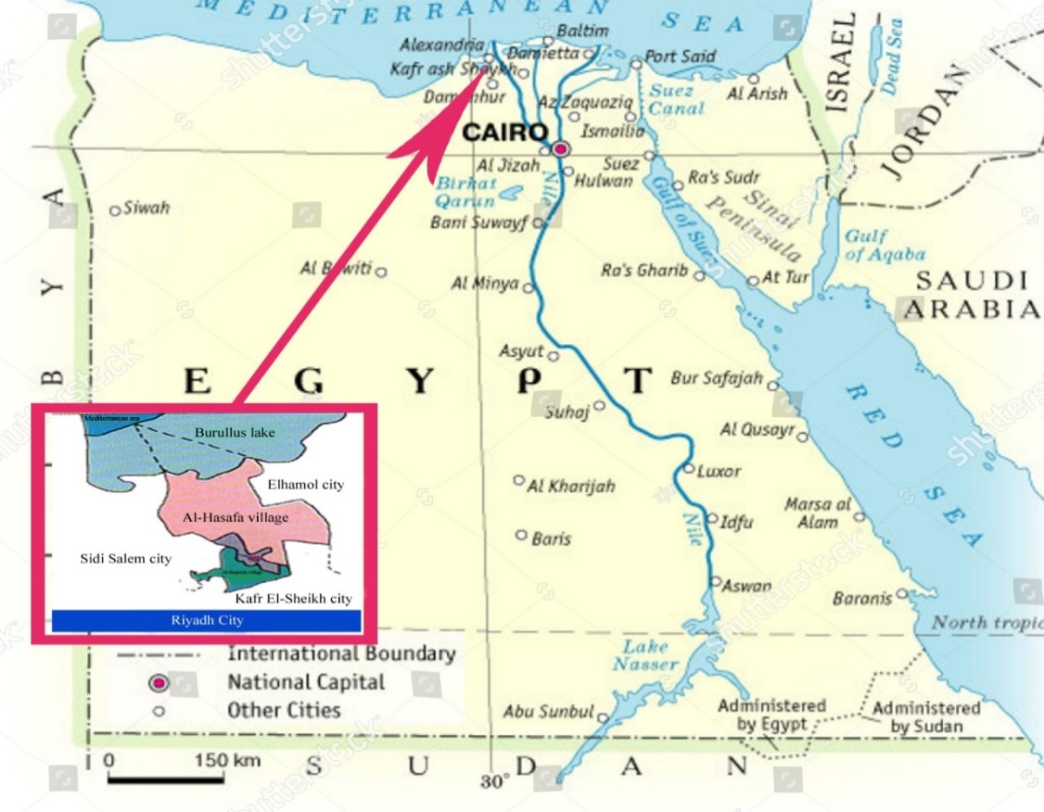
SAMPLING:
1- Water samples: The water samples collection was done below the water surface by about 15–20 cm at different sites in each pond at every sampling (five water samples per farm representing five ponds in each farm from the examined ten farms for physicochemical parameters and for bacteriological examination) using glass bottles (500 ml) previously sterilized and labeled. The glass bottles transported to the laboratory on the same day for analysis. For bacteriological analysis, the five water samples examined separately and averaged for both total bacterial and total coliform counts. The physicochemical properties of the water samples carried out on each farm at five different locations for temperature and PH where the water samples collected by using Whitman PHA 260 pH-meter. The other physicochemical parameters carried out according to APHA (1998).
2-Fish samples:
Hundred fish (Oreochromis niloticus) collected alive and transported in a sterile polythene bag supplied with aerated chlorine-free tap water from fish farms to the laboratory of Animal Health Research Institute Kafrelsheikh branch. The collected fish showing at least one or more of the external signs of exophthalmic opaque eyes, distended abdomen, hemorrhage on the skin, and tail erosion. The fish was washing by using 70% ethanol to reduce the number of organisms on fish skin before sample collection. A pooled sample from the brain, liver, spleen, kidney, gills, and intestine collected and put in a tube of enrichment Tryptic soy broth, for further isolation of bacteria.
Clinical and postmortem examination of naturally infected fish:
All naturally infected fish subjected to full clinical and postmortem examinations as described by Austin et al., (2012).

Bacteriological examination:
- 1-Total bacterial count: Appropriate sample dilutions (10⁻¹- 10⁻⁴) made using sterile physiological saline (0.9% NaCl). About 0.1 ml of two consecutive serial dilutions were inoculated onto plate count agar plates (PCA, Oxoid, UK) in duplicate using the spread plate method (APHA 1985). After incubation at 37°C for 48 hr., bacterial population numbers calculated as CFU/ml of sample.
2- Total Coliforms count:
The total Coliforms count done by the Most Probable Number (MPN) technique, for Coliforms bacteria according to (APHA, 1985). Briefly, a number of tenfold serial dilution of water sample was done (10⁻¹, 10⁻², 10⁻³)using (0.9% NaCl), one ml of each dilution transferred with sterile pipettes into three test tubes containing MacConkey broth (9ml), with an inverted Durham's tubes and then incubated at 37ºc for 48 hr.. MPN calculated based on the proportion of confirmed gas production in MacConkey broth tubes for three consecutive dilutions using tables from Blodgett (2001).
3- Isolation of E. Faecalis from fish and water samples: Under aseptic condition samples (fish & water) were primarily cultivated on tryptic soy broth (TSB) at 37 ^{O}C for 24hr then streaked onto enterococci selective differential agar medium (ESD) (Efthy miou et al. 1974). Tryptic soy agar (TSA) and blood agar plates then the streaked plates incubated for 24 hours at 37^{O}C. All purified isolates identified by studying colony growth characteristics, stained with Gram’s stain and examined microscopically to demonstrate of morphology, arrangement, and staining reaction of microorganism the motility of each isolate was tested. The bacteria isolates identified according to schemes of biochemical reactions (Holt et al. 1994).
Antibiotic susceptibility testing for E. faecalis isolates:
The susceptibility profile of all isolated 28 E. faecalis isolates (isolated from 100 examined fish) to 10 commercial antibiotic disks (Oxoid, Basingstoke, UK) was determined by the disk diffusion method. The disks used, (Streptomycin (S) 10ug, Erythromycin (E)15ug, Vancomycin (VA) 30ug, Amoxicillin with Clavulanic (AMC) 30ug, Gentamicin (CN) 10ug, Doxycycline (DO) 30ug, Ampicillin (AMP) 10ug, Amikacin (AK) 30ug, Nalidixic acid (NA) 30ug, and Norfloxacin (NOR) 10ug). Zones of inhibition formed around the discs measured and antibiotic sensitivity assayed from the length of the diameter of the zones (in mm). Zone diameters were interpreted according to (Wayne, 2010).
4-Isolation and identification of E. coli& E. coli O157 from fish and water samples:
Samples were incubated at 37ºC (for 24 hrs.) after inoculation onto tryptic soy broth (TSB).
For E. coli: Loopful from the tryptic broth was cultured onto MacConkey's agar plates (Oxoid, UK). Suspected lactose fermented colonies were picked up after incubation for 24 hours at 37ºC then subcultured on Eosin methylene blue (EMB). The subcultured colonies incubated at 37°C overnight and then examined for the characteristic E. coli colonies.
For E. coli O157: Loopful from the incubated broth streaked onto Cefixime Tellurite-Sorbitol MacConkey agar. The streaked colonies examined for nonsorbitol-fermenting (grey/white), after overnight incubation at 37°C. Pure colonies kept in semi-solid agar for further biochemical identification according to (Quinn et al., 2002).
Sero-grouping of E. coli:
Ten isolates that identified biochemically as E. coli chosen randomly, and subjected to serological identification (Edward et al., 1972) in Animal Health Research Institute, Dokki, Giza using Polyvalent and monovalent diagnostic E. coli antisera.
Antibiotic susceptibility testing for E.coli isolates:
All 20 E.coli isolates(isolated from fish) were tested for 8 different antimicrobial agents (Oxoid, Basingstoke, UK): Amoxicillin with Clavulanic (AMC) 30 μg; Nalidixic acid (NA) 30 ug; Streptomycin (S) 10 ug; Gentamicin (CN) 10 ug;Cefotaxime (CTX) 30ug;, Amikacin (AK)30 μg, Ciprofloxacin ( CIP) 5 μg, and Doxycycline (DO) 30 μg. The plates incubated for 24 hr at 37°C and inhibition zones were measuredand interpreted according to (Wayne, 2010).
Molecular detection of 16SrRNA Specific for E. faecalis& rfb E gene specific for E. coli O157:
DNA extraction:DNA extraction from isolates was performed using the QIAamp DNA Mini kit (Qiagen, Germany, GmbH) with modifications from the manufacturer’s recommendations. Briefly, 200 µl of the isolate suspension incubated with 20 µl of proteinase K and 200 µl of lysis buffer at 56^{O}C for 10 min. After incubation, 200 µl of 100% ethanol added to the lysate. The sample then washed and centrifuged following the manufacturer’s recommendations. Nucleic acid eluted with 100 µl of elution buffer provided in the kit.
Oligonucleotide Primer. Primers used were supplied from Metabion (Germany) are listed in Table (1).
PCR amplification:
UniplexPCR:Primers were utilized in a 25- µl reaction containing 12.5 µl of Emerald Amp Max PCR Master Mix (Takara, Japan), 1 µl of each primer of 20 pmol concentration, 4.5 µl of water and 6 µl of DNA template. The reaction performed in an applied biosystem 2720 thermal cycler.
Analysis of the PCR Products.
The products of PCR were separated by electrophoresis on 1.5% agarose gel (Applichem, Germany, GmbH) in 1x TBE buffer at room temperature using gradients of 5V/cm. For gel analysis, 20 µl of the PCR products were loaded in each gel slot. A Gelpilot 100 bp Ladder (Qiagen, Germany, GmbH) used to determine the fragment sizes. The gel photographed by a gel documentation system (Alpha Innotech, Biometra) and the data analyzed through computer software.
Statistical analysis:
Statistical analysis carried out by using SPSS 13.0 for Windows [Computer Software].

Table (1): Primers sequences, target genes, amplicon sizes and cycling conditions.
Target agent | Target gene | Primers sequences | Amplified segment (bp) | Primary  Denaturation | Amplification (35 cycles) |  |  | Final extension | Reference
 |  |  |  |  | Secondary denaturation | Annealing | Extension
E. fecalis | 16S rRNA | GTT TAT GCC GCA TGG CAT AAG AG | 310 | 94˚C  5 min. | 94˚C  30 sec. | 50˚C  30 sec | 72˚C  30 sec | 72˚C  7 min. | Zolettiet al., 2006
 |  | CCG TCA GGG GAC GTT CAG
E. coli O157 | rfbE | GTAAATATGTGGGAACATTTGG | 134 | 94˚C  5 min. | 94˚C  30 sec. | 52˚C  30 sec | 72˚C  30 sec | 72˚C  7 min. | Heijnen and Medema, 2006
 |  | GGCCTTTAAAATGTAAACAACGG

RESULTS

The clinical signs revealed swimming near the surface of the water, small hemorrhages, erosion, and ulcers 2-3mm distributed on different parts of the skin, base of the tail, fins, and mouth, loss of scales. Ophthalmic lesions as unilateral or bilateral opacity, hemorrhage of the eye, and some cases showed exophthalmia (pop eye) (Figure 2). Postmortem examination of naturally infected fish showed severe congestion in mouth lips; the anal opening protruded and showed congestion and ulceration, and pinpoint hemorrhagic ulcers in the ventral aspect of the gill cover. The gills were pale and showed small white necrotic foci. The liver enlarged congested or gray in color, with white pinpoint necrotic foci on the peripheral margin and the gall bladder enlarged and engorged with bile. The spleen was enlarged, hemorrhaged or dark brown in color with pinpoint white necrotic foci. The intestine was hemorrhagic and filled with fluids. The abdomen in some cases enlarged and filled with fluids (Ascites). The kidney congested and enlarged (Figure 3).
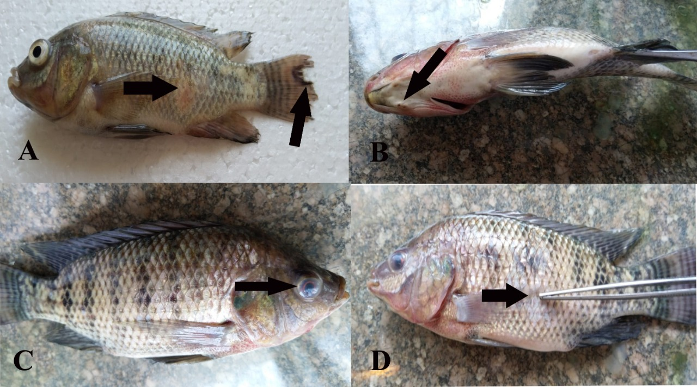
Figure (2): Showed naturally infected tilapia fish showing exophthalmia, ulcerative area and eroded fins (a), hemorrhage around head with pulgged operculum (b)Exophthalmia and corneal opacity (c), detached scales and ulceration(d).
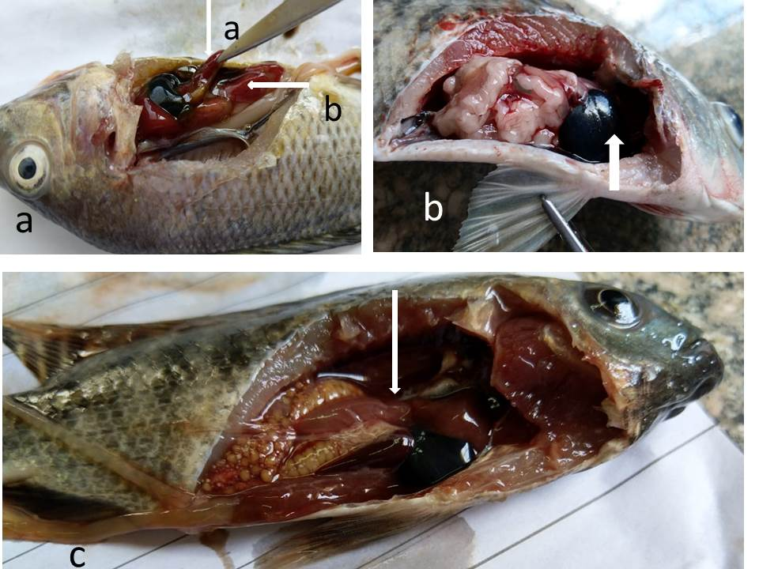
Figure (3):Naturally infected tilapia fish showing congested and enlarged liver and spleen (arrows, a), distended gall bladder (b), pale liver, intestine filled with exudates, eroded gills and abdomen filled with bloody fluid (c).
ascites (c).
Results of physicochemical properties of water samples:
Table (2) showed the physicochemical properties of the water samples, which taken from 10 farms (5 samples from each farm) at Kafrelsheikh Governorate. There were significant (P<0.05) increases in values of PH, conductivity, salinity, ammonia, nitrate, nitrite, sulphate, chlorine, chloride, total solids, total suspended solids, and total dissolved solids in farms number two, six, and ten when compared with other farms. Meanwhile, temperature increased in the same groups without significance.

Table (2): Physicochemical properties of water samples from tilapia fish farm at Kafrelsheikh Governorate
Farms  Parameters | 1 | 2 | 3 | 4 | 5 | 6 | 7 | 8 | 9 | 10 | Lawson (1995)
PH | 7.04±0.10^{b} | 7.62±0.02ª | 7.03±0.09^{b} | 7.1±0.06^{b} | 7.17±0.02^{b} | 7.63±0.01ª | 7.21±0.12^{b} | 6.98±0.01^{c} | 7.31±0.30^{b} | 7.61±0.01ª | 6.5-8
Conductivity mg/L | 1048±0.12^{g} | 5299±0.20^{b} | 1842±0.43^{d} | 1895±0.51^{d} | 1426±0.31^{f} | 5745±0.34ª | 1381±0.17^{f} | 1654±0.22e | 1432±0.40^{f} | 4726±0.09^{c}
Salinity ppt  Dissolved oxygen | 1.1±0.02 e  8.1+0.02 a | 6.1±0.01 ª  7.6+0.01 e | 2±0.00 ^{c}  8.1+0.01 a,b | 2±0.01 ^{c}  8+0.01 b.c | 1.5±0.03 ^{d}  8.2+0.03 a | 6.3±0.10ª  7.7+0.01 d | 1.4±0.05 ^{d}  8.2+0.05 a | 1.7±0.03^{cd}  7.9+0.03 c,d | 1.43±0.01^{d}  8.1+0.01 a,b | 5.4±0.00^{b}  7.8+0.02 d | Less 5  5 to saturation
Temperature  ^{O}C | 26.9±0.03 | 28±0.10 | 27.1±0.15 | 28±0.19 | 27±0.34 | 28.2±0.15 | 27.3±0.22 | 27±0.03 | 27.8±0.15 | 28±0.27 | 24-32^{O}C
Ammonia(ionized) mg/L | 0.21±0.06^{b} | 0.39±0.01ª | 0.22±0.12^{b} | 0.18±0.10^{b} | 0.19±0.07^{b} | 0.40±0.07ª | 0.20±0.08^{b} | 0.17±0.01^{b} | 0.19±0.10^{b} | 0.38±0.02ª | Less than 0.2
Nitrate mg/L | 0.45±0.03^{b} | 0.92±0.04ª | 0.35±0.10^{b} | 0.39±0.08^{b} | 0.42±0.03^{b} | 0.85±0.07ª | 0.37±0.09^{b} | 0.43±0.06^{b} | 0.38±0.03^{b} | 0.93±0.10ª | 0-0.3
Nitrite mg/L | 0.004±0.00^{bc} | 0.008±0.00ª | 0.005±0.00^{b} | 0.003±0.00^{c} | 0.005±0.00^{b} | 0.008±0.00ª | 0.004±0.00^{bc} | 0.003±0.00^{c} | 0.004±0.00^{bc} | 0.007±0.00ª | 0.1
Sulfate mg/L | 113±0.40^{d} | 169±0.29ª | 119±0.35^{c} | 131±0.61^{b} | 116±0.70^{ed} | 177±0.34ª | 117±0.53^{c} | 120±0.70^{c} | 121±0.58^{c} | 173±0.28ª | Less than50
Total alkalinity mg/L | 142.6±0.75^{c} | 146.7±0.64^{c} | 182.4±1.01ª | 165.3±0.87^{b} | 179.4±1.00ª | 181.4±0.93ª | 156.8±0.81^{b} | 169.8±0.83^{b} | 173.9±0.86^{b} | 142.1±0.43^{c} | 10-400
Alkaline bicarbonate mg/L | 142.6±0.75^{c} | 146.7±0.64^{c} | 182.4±1.01ª | 165.3±0.87^{b} | 179.4±1.00ª | 181.4±0.93ª | 156.8±0.81^{b} | 169.8±0.83^{b} | 173.9±0.86^{b} | 142.1±0.43^{c}
Alkaline carbonate mg/L | Nile | Nile | Nile | Nile | Nile | Nile | Nile | Nile | Nile | Nile
Chlorine mg/L | 0.03±0.00^{c} | 0.07±0.00ª | 0.05±0.00^{b} | 0.05±0.00^{b} | 0.04±0.00^{bc} | 0.07±0.00ª | 0.05±0.00^{b} | 0.04±0.00^{bc} | 0.04±0.00^{bc} | 0.06±0.00^{ab} | 1
Chloride mg/L | 0.02±0.00e | 0.07±0.00ª | 0.03±0.00de | 0.04±0.00^{cd} | 0.04±0.00^{cd} | 0.06±0.00^{b} | 0.04±0.00^{cd} | 0.03±0.00de | 0.02±0.00e | 0.06±0.00^{b} | 0.25
Total solid mg/L | 1.49±0.01^{c} | 6.2±0.02ª | 1.82±0.00^{b} | 2.09±0.01^{b} | 1.89±0.05^{b} | 6.68±0.00ª | 1.96±0.03^{b} | 2.2±0.03^{b} | 1.18±0.04^{d} | 7.18±0.01ª | 500-1500
Total suspended solids mg/L | 0.546±0.05^{d} | 2.88±0.04^{b} | 0.37±0.03e | 0.63±0.02^{d} | 0.73±0.07^{d} | 3.23±0.00^{b} | 0.84±0.06^{c} | 0.86±0.01^{c} | -0.03±0.05^{f} | 4.05±0.03ª | Less than 80
Total dissolved solid mg/L | 0.944±0.10^{d} | 3.32±0.09ª | 1.45±0.09^{b} | 1.46±0.18^{b} | 1.16±0.11^{cd} | 3.45±0.12ª | 1.12±0.15^{cd} | 1.34±0.12^{c} | 1.21±0.10^{cd} | 3.13±0.08ª | Less than 400
Values expressed as mean ± standard errors. Means in the same row (a-g) with different subscript letters significantly differ at (p≤0.05)
Results of microbial examination:
Table (3): Total bacterial and coliform count of water samples from 10 fish farms (5 samples /farm).

Farm | TBC cfu/ml | TC MPN/ml
1 | 1.14×10 ⁶ | 35
2 | 2.04×10 ⁵ | 460
3 | 4.3×10 ⁴ | 3>
4 | 8.4 ×10 ⁴ | 3>
5 | 3.59× 10 ⁵ | 3>
6 | 1.25× 10 ⁶ | 1100<
7 | 1.01 ×10 ⁶ | 3>
8 | 1.1 ×10 ⁵ | 150
9 | 5.4 ×10 ⁴ | 15
10 | 4.3× 10 ⁵ | 460

Table (4): Incidence of some fecal indicator from fish (n=100) and water (n=50) samples
Isolated bacteria | Fish sample |  | Water sample
 | No. | % | No. | 100%
E. fecalis | 28 | 28 | 19 | 38
E. coli | 18 | 18 | 17 | 34
E. coli O157 | 2 | 2 | 0 | 0

Table (5): Antimicrobial sensitivity test for isolated E. faecalis (n=28)

Resistance |  | Intermediate |  | Sensitive |  | Antimicrobial
% | No. | % | No. | % | No.
100 | 28 | 0 | 0 | 0 | 0 | Naldixic acid
64.3 | 18 | 28.6 | 8 | 7.1 | 2 | Streptomycin
57.1 | 16 | 42.9 | 12 | 0 | 0 | Erythromycin
28.6 | 8 | 21.4 | 6 | 50 | 14 | Amikacin
28.6 | 8 | 0 | 0 | 71.4 | 20 | Amoxicillin & clavulanic acid
28.6 | 8 | 35.7 | 10 | 35.7 | 10 | Gentamycin
7.1 | 2 | 0 | 0 | 92.9 | 26 | Ampicillin
7.1 | 2 | 7.1 | 2 | 85.7 | 24 | Doxycycline
7.1 | 2 | 21.5 | 6 | 71.4 | 20 | Norfloxacin
7.1 | 2 | 3.6 | 1 | 89.3 | 25 | Vancomycin

.
Table (6): Antimicrobial sensitivity test for isolated E. coli (n=20)
Antimicrobial agent | Sensitive |  | Intermediate |  | Resistant
 | No | % | No | % | No | %
Amikacin | 0 | 0% | 0 | 0% | 20 | 100%
Amoxycillin&Clavulinic acid | 0 | 0% | 0 | 0% | 20 | 100%
Naldixic acid | 0 | 0% | 0 | 0% | 20 | 100%
Cefotaxime | 0 | 0% | 0 | 0% | 20 | 100%
Ciprofloxacin | 2 | 10% | 2 | 10% | 16 | 80%
Doxycycline | 2 | 10% | 6 | 30% | 12 | 60%
Gentamycin | 4 | 20% | 6 | 30% | 10 | 50%
Streptomycin | 2 | 10% | 8 | 40% | 10 | 50%
N. B: The two O157 E.coli isolates were resistant to all antimicrobials
Table (7): Multiple antibiotic resistance pattern of E. faecalis isolates (n=28
No. of isolates | Resistance phenotype pattern
2 | NA,S,E,AK,AMC,CN,AMP,DO,NOR,VA
6 | NA,S,E,AK,AMC,CN
8 | NA,S,E
2 | NA,S
10 | NA

Table (8): Multiple antibiotic resistance pattern of E. coli isolates (n=20)
Resistance phenotype pattern | No. of isolates
AK,AMC,NA,CTX,CIP,DO,CN,S | 10
AK,AMC,NA,CTX,CIP,DO,CN | 2
AK,AMC,NA,CTX,CIP | 4
AK,AMC,NA,CTX | 4

Multiple antibiotic resistance recorded in all E.coli isolates (20/20)100%.

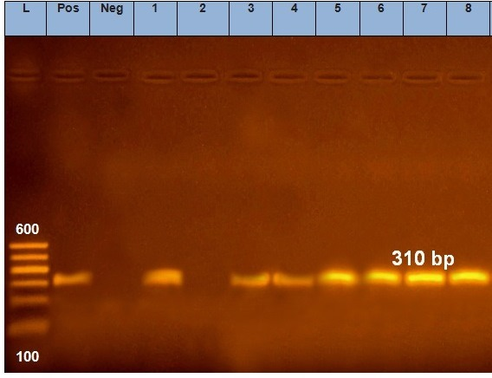

Figure (4): Detection of 16s rRNA specific for eight Enterococcus faecalis strains

Lane L: 100-600 bp ladder
Pos: positive control
Neg: negative control
Lanes 1,3,4,5,6,7,8 are positive for E.faecalis (310 bp)
Lane 2 is negative for E.faecalis

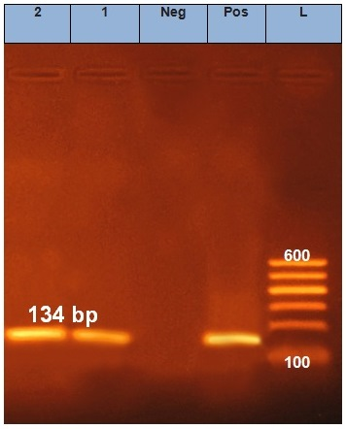
Figure (5): Detection of rfb E gene specific for two E.coli O 157 strains

Lane L: 100-600 bp ladder
Pos: positive control
Neg: negative control
Lanes 1, 2 are positive for rfb E gene (134 bp)

DISCUSSION
Most fish infectious diseases are opportunistic (Yanong and Floyd 2002). Therefore, the presence of the pathogen in the fish environment is insufficient to cause a disease outbreak. Therefore, stress has a vital role in the occurrence of fish outbreaks as a result of opportunistic microbes. Water pollution stresses farmed fish and increases susceptibility to infectious diseases resulting in high mortalities (Sarmento et al. 2004). Normally natural water has a small concentration of nitrates with very low levels of nitrites. Nitrites convert into nitrates by bacterial action and some other nutrients, which increase with agriculture drainage water (Abou El-Gheit et al. 2012). Kafrelsheikh fish farms suffer from poor water quality due to the contamination of aquaculture water with the Kitchener canal. The water of this canal comes from the agricultural water of El-Gharbia Governorate, the outlet of the industry, and sewage wastewater of Kafrelsheikh city (Gad and Fadl 2015). Also, some stressors including high water temperature, high stocking densities, high ammonia, and nitrite concentrations have been associated with microbial outbreaks (AboEL-Gheit et al. 2012). In the present study, the physicochemical properties of water samples from fish farms come in harmony with that of microbial isolation from water and fish samples. Samples of water number two, six, and ten significantly increased in the value of PH, which was suitable for bacterial growth (Sila 2019). Székely et al. (2013), Sunagawa et al. (2015), and Liu et al. (2015) reported salinity, temperature, and pH, respectively influence microbial community structure in different ecosystems. The increase in water temperature may be attributed to the season of water collection (summer). In the summer season, the water level decrease and insoluble pollutants increase. These results are in accordance with Haque et al. (2019). Also, LeChevallier (2003) recorded when water temperatures are warm, bacterial growth may be very rapid. On the other hand, results of salinity, ammonia, nitrate, nitrite, sulfate, chlorine, and chloride levels were increased. These results confirmed by the measurement of TS, TSS, and TDS. Same results obtained by Abou El-Gheit et al. (2012) and Gorlach-Lira et al. (2013). In general, when comparing the results of physicochemical parameters with permissible limits of Lawson (1995) found that all physicochemical parameters within permissible limits. These results may be attributed to the treatment of the wastewater used for aquaculture.
On the other hand, the usage of wastewater for aquaculture indicates microbial pollution. The presence of indicator microorganisms in given numbers indicate inadequate safety (Mossel et al. 1995). Today the most common measured bacterial indicators are total coliforms (TC) and Enterococci (EC). Recently, E. coli and Enterococci established as preferred indicators (Noble et al. 2003). The Mesophilic aerobic bacteria (MAB) or Total Bacterial Count (TBC) are used as a general indicator of the bacterial population (Allen et al. 2004). The results of total bacterial count nearly are consistent with Ajayi and Okoh (2014). Lower results recorded by Al-Harbi and Uddin (2003), Gorlach-lira et al. (2013), and Valenzuel Armenta et al. (2018). Higher results recorded by Yehia and Sabae (2011) in El-Salam canal water and Donia et al. (2017).
The distribution of Mesophilic bacteria varies with water layers as in water collected at 50 cm depth, which are near the water surface contain abundant amount of dissolved oxygen and organic matter. These conditions make the aerobic bacteria reproduce very quickly resulting in a large number of heterophilic bacteria (Mathias et al. 1994). These findings support the results of the present study that indicated a high total bacterial count. Also, the high bacterial load may be owing to the pond water temperature. It was nearly optimum for most Mesophilic bacteria present in natural systems (Mow-Robinson and Rheinheimer 1985).
Coliforms are not the normal flora of bacteria in fish, but pollution occurs as a result of human excreta deposition in the water of fish farms (Mandal et al. 2009). The most probable number (MPN) values for total coliforms varied extremely from farm to another. It was oscillating from <3 to >1100 MPN/ml water showing an increase in the indicator bacteria. The same results were observed by Toroglu and Toroglu (2009) in Golbasi lake. But lower and higher populations were recorded by Yehia and Sabae (2011) and Donia et al. (2017), respectively. Recently, Enterococci considered one of the major concerns causing vital nosocomial infections leading to serious human’s illness (Igbinosa and Beshiru (2019). Such as urinary tract infections, meningitis (Tebruegge et al. 2011), and endocarditis (Dahl and Brun, 2013). These infections are hard to be treated because of the rising incidence of antibiotic resistance (Arumugam et al. 2017). E. faecalis recovered at a rate of 28% and 38% from fish and pond water samples, respectively. Different results were reported by Abdel-Aziz et al. (2003) who found that E. faecalis was recovered from Nile tilapia and rearing pond water samples with 43.3% and 30%; 0% and 85%; and 60% and 5% in extensive, semi-intensive, and intensive operating fish farms, respectively. The higher result of isolation detected by GorLach-Lira et al. (2013) where E. faecalis recovered in 56% water samples. Also, Alexo-Poulos et al. (2011) revealed E. faecalis from all water samples from different Greek sea fish farms. The results of microbial isolation from fish are in harmony with the results of Khaphagy et al. (2009). The higher and lower results recorded by El-Ekiaby et al. (2014) and Abou El-Gheit et al. (2012), Osman et al. (2016), and El-Kader and Mousa-Balabd (2017), respectively.
Enterococci have demonstrated the intrinsic gaining of antimicrobial resistance to different antibiotics from the environment (Beshiru et al. 2017). The isolates were resistant to Nalidixic acid, Streptomycin, Erythromycin with 100%, 64.3%, and 57.1%, respectively. Most proper antibiotics were Ampicillin, Vancomycin, Doxycycline, Norfloxacin, and Amoxicillin with Clavulanic 92.9%, 89.3%, 85.7%, 71.4%, and 71.4% sensitivity, respectively. These results are in parallel to some extent with Osman et al. (2016). Disagree with Arumugam et al. (2017) who found that, E. faecalis isolates were highly resistant to Ampicillin, Vancomycin, and Gentamicin. More than half of isolates were resistant to erythromycin with 57.1%. A nearly similar result reported by Igbinosa and Beshiru (2019). E. faecalis isolates showed multiple antibiotic resistance (64.3%), a similar finding was reported by those of Igbinosa and Beshiru (2019) meanwhile, the lower percentage was recorded by Elal Mus et al. (2017) as E. faecalis isolates showed (3.4%) multidrug resistance. 16S rRNA Present in bacteria known as a standard marker to differentiate the bacterial species (Nagpal et al. 1998). In the current study the confirmatory diagnosis using PCR for detection of E. faecalis 16Sr RNA with a specific band at 310 bp, confirmed that 7 from the eight studied isolated proved to be positive, this is supported by Ozer et al. (2011).
E. coli does not present naturally in the fish microbiota, but it could be isolated from their gut due to the contamination of aquatic environments (Gruzman et al. 2004). E. coli has pathogenic strain emerging as having zoonotic potential (Cardozo et al. 2018). The result of E. coli from fish and water samples revealed 18% and 34%, respectively. E. coli O₁₅₇ isolated from fish with 2% and does not recover from any of the water samples. Nearly the same results of isolation reported by Shokr et al. (2018). Higher results of isolation reported by Glal et al. (2013) at Kafrelsheikh Governorate and Kambire et al. (2017). In contrast to these results, Cardozo et al. (2018) reported that there is no water sample positive for E. coli where the water flow at the nurseries and rivers is large. On the other hand, Gorlach-Lira et al. (2013) isolated E. coli with 48% from water samples. The result of E. coli O₁₅₇ isolation from water is in accordance with Mlejnková and sovová (2013). Disagree with Nicholson et al. (2004) who said that E. coli O157 in pond water was most often. The result of E. coli O157 from fish samples similar result of isolation of Barbosa et al., (2014) who detected it in the gastrointestinal tract of Nile tilapia in Brazil. Unlike the result of Pao et al. (2008) who did not isolate E. coli O157 from any of tilapia in the USA. The presence of E. coli O157 in fish is of great concern as it can cause cross-contamination with other foodstuff resulting in foodborne disease outbreaks (Lynn et al. 2005). Also, it can result in a complication called haemolytic uremic syndrome (HUS) (Kuehne et al. 2016). The serogrouping of some randomly selected E. coli isolated revealed five serogroups (O₆, O₂₇, O₁₂₅, O₁₂₆, and O₁₅₇). The most predominant serotype was O₁₂₅. This result is in accordance with Shokr et al. (2018).
The random of antibiotics used for promoting growth and treating infections, in the long run, led to the development of resistant bacterial strains to antibiotics, which considered a hazard to public health (Akand et al. 2009). E. coli was resistant to Amikacin, Amoxicillin with Clavulanic, Nalidixic acid, and Cefotaxime with 100% each. Also, resistant to Ciprofloxacin and Doxycycline with 80% and 60%, respectively. Gentamicin and Streptomycin showed 50% resistance for each. These results disagree with that of Saqr et al. (2016). On the other hand, there was a multiple antibiotic resistance in all E. coli isolates (100%). This calls for great concern as it discovered that many human pathogenic bacteria resistant to antibiotics have a fish origin (Rolain 2013). Lower results for multiple antibiotic resistance found by Jose and Cabrena (2017). The high background levels of computing microorganisms including other E. coli serotypes made a difficulty to confirm E. coli O157 from enrichment culture. So, there was a need for other techniques as PCR based assay for E. coli O157 determination. Bertrand and Roig (2007) used a specific and sensitive PCR assay based on the rfbE to detect E. coli O_{157.} The two isolates of E. coli O₁₅₇ confirmed by detecting the rfbE gene (O₁₅₇ antigen gene). The two isolates (100%) gave the product of the rfbE gene. The same results reported by El-Leithy et al. (2012) who detected the rfbE gene in 98% of E. coli O₁₅₇ isolates.
Conclusion
It could be concluded that periodic bacteriological and chemical analysis of fish farm water is of much importance in aquaculture for monitoring levels of pollution. This monitoring done indication about water quality to avoid the hazard, which could occur to the fish and consumer. In addition, the fish water environment has become a reservoir for multidrug-resistant pathogenic bacteria. This study was the main witness, in this case, indicating the high level of biological contamination by agriculture waste, effluent water used for irrigation purposes and sewage pollution, calling for great concern to protect water resources for aquaculture purposes through detection of aquatic microbes and possible control of these microbes.

References
Abdel-Aziz, E. S, Dardiri, M. A., Ali, M. N. 2003. Clinical and pathological investigations on enterococcusis in Oreochromis niloticus cultured under different fish culture systems. J. Egypt. Vet.Med. Asso. 62 ,217-239.

Abou El-Gheit, E. N., Abdo, M. H., Mahmoud, S. A. 2012. Impacts of blooming phenomenon on water quality and fishes in Qarun Lake, Egypt. Int. J. Env. Sci. and Eng. 3, 11-23.
Ajayi, A. O.,and Okoh, A. I. 2014. Bacteriological study of pond water for aquaculture purposes. J of Food, Agri. & Env. 12(2):1260-1265.
Akond, M. A., Alam, S., Hassan, S. M. R., Shirin, M. 2009. Antibiotic resistance of Escherichia coli isolated from poultry and poultry environment of Bangladesh. Int. J. Food saf. 11, 19-23.
Alexopoulos, A., Plessas, S., Voidarou, C., Noussias, H., Stavropoulou, E., Mantzourani, I., Tzora, A., Skoufos, I., Bezirtzoglou, E. 2011. Microbial ecology of fish species ongrowing in Greek sea farms and their watery environment. Anaerobe, 17(6): 264-266.
Al‐Harbi, A. H., and Uddin, N. 2003. Quantitative and qualitative studies on bacterial flora of hybrid tilapia (Oreochromisniloticus× O. aureus) cultured in earthen ponds in Saudi Arabia. Aqua.Res.34(1) :43-48.
Allen, M. J., Edberg, S. C., Reasoner, D. J. 2004. Heterotrophic plate count bacteria—what is their significance in drinking water?. Int .J. Food microbiol. 92(3):265-274.
APHA, 1985. Standard Methods for the Examination of Water and Wastewater.
APHA-American Public Health Association. 1998. Standard methods for the examination of water and wastewater. USA: APHA.
Arumugam, U., Stalin, N., Rebecca, G. P. 2017.Isolation, molecular identification and antibiotic resistance of Enterococcus faecalis from diseased Tilapia. Int. J. Curr. Microbiol. Appl. Sci, 6, 136-146.
Austin, B., Austin, D. A., Austin, B., Austin, D. A. 2012. Bacterial fish pathogens (p. 652). Heidelberg. Springer.
Authman, M. M., Abbas, H. H., Abbas, W. T. 2013. Assessment of metal status in drainage canal water and their bioaccumulation in Oreochromis niloticus fish in relation to human health. Environ. Monitor. and assessm. 185(1): 891-907.
Barbosa, M. M. C., Pinto, F. D. R., Ribeiro, L. F., Guriz, C. S. L., Ferraudo, A. S., Maluta, R. P., Rigobelo, E. C., Ávila, F. A., Amaral, L. A. 2014. Sorologia suscetibilidade antimicrobianaemisolados de Escherichia coli de pesque-pagues. Arquivos do InstitutoBiológico, 43-48.
Bertrand, R., and Roig, B. 2007. Evaluation of enrichment-free PCR-based detection on the rfbE gene of Escherichia coli O157—application to municipal wastewater. Water res. 41(6): 1280-1286.
Beshiru, A., Igbinosa, I. H., Omeje, F. I., Ogofure, A. G., Eyong, M. M., Igbinosa, E. O. 2017. Multi-antibiotic resistant and putative virulence gene signatures in Enterococcus species isolated from pig farms environment. Microb. Patho.104, 90-96.
Blodgett, R. 2001. Bacteriological analytical manual online, appendix 2, most probable number from serial dilutions.
CAPMAS, C. 2014. Population Clock [Online]. Central Agency for Public Mobilization and Statistics CAPMAS.
Cardozo, M. V., Borges, C. A., Beraldo, L. G., Maluta, R. P., Pollo, A. S., Borzi, M. M., Santos, L. F., Kariyawasam, S., Ávila, F. A. D. 2018. Shigatoxigenic and atypical enteropathogenic Escherichia coli in fish for human consumption. Braz. J. Microbiol. .49(4): 936-941.
Dahl, A., &Bruun, N. E. 2013. Enterococcus faecalis infective endocarditis: focus on clinical aspects. Expert review of cardiovascular therapy, 11(9): 1247-1257.
Donia, G., Hafez, A., Wassif, I. 2017. Studies on Some Heavy Metals and Bacterial Pollutants in Tilapia Fish of El Salam Canal, Northern Sinai, Egypt. Egypt. J. Aquatic Biol. and Fisheries .21(4):67-84.
Edward, P. R. & Ewing, W. H. 1972. Edwards and Ewing's Identification of Enterobacteriacae. 3rd ed. Burgess, Minneapolis.
Efthymiou, C. J., Baccash, P., Labombardi, V. J., Epstein, D. S. 1974. Improved isolation and differentiation of enterococci in cheese. Appl. Environ. Microbiol., 28(3): 417-422.
Elal Mus, T., Cetinkaya, F., Cibik, R., Soyutemiz, G. E., Simsek, H., Coplu, N. 2017. Pathogenicity determinants and antibiotic resistance profiles of enterococci from foods of animal origin in Turkey. ActaVeterinariaHungarica, 65(4): 461-474.
El-Barbary, M. I., & Hal, A. M. 2016. Isolation and molecular characterization of some bacterial pathogens in El-Serw fish farm, Egypt. Egypt.J.Aquatic Biol. and Fisheries, 20(4): 115-127.
El-Ekiaby, W. T., Abou El-Atta, M. E., Moustafa, M. S. AbdEl Fattah, L. S. 2014. Case study on mass mortalities in caged cultured monosex Nile tilapia (Oreochromisniloticus) in El-Fayuom governorate, Egypt. Abbassa Int. J. Aqua., 7(2):381-409.
El-Kader, M. F. A., &Mousa-Balabel, T. M. 2017. Isolation and molecular characterization of some bacteria implicated in the seasonal summer mortalities of farm-raised Oreochromis niloticus at Kafr El-Sheikh and Dakahlia Governorates. Alex. J. Vet. Sci. 53(2):107-113.
El-Leithy, M. A., El-Shatoury, E. H., El-Senousy, W. M., Abou-Zeid, M. A., El-Taweel, G. E.2012. Detection of Six E. coli O157 Virulence Genes in Water Samples Using Multiplex PCR. Egypt. J.Microbiol. 47, 171-188.
Gad, D. M., & Fadl, S. E. 2015. Heavy Metals at KafrElsheikh Governorate and the use of algae in fish cultured.
Galal, H. M., Hakim, A. S., Dorgham, S. M. 2013. Phenotypic and virulence genes screening of Escherichia coli strains isolated from different sources in delta Egypt. Life Sci. J. 10(2): 352-361.
Gorlach-Lira, K., Pacheco, C., Carvalho, L. C. T., MeloJúnior, H. N., Crispim, M. C. 2013. The influence of fish culture in floating net cages on microbial indicators of water quality. Braz. J. Biol. 73(3): 457-463.
Guzmán, M. C., de los Angeles Bistoni, M., Tamagnini, L. M., González, R. D. 2004. Recovery of Escherichia coli in fresh water fish, Jenynsiamultidentata and Bryconamericusiheringi. Water res.38 (9): 2368-2374.
Haque, M. A., Jewel, M. A. S., Sultana, M. P. 2019. Assessment of physicochemical and bacteriological parameters in surface water of Padma River, Bangladesh. Appl.Water Sci. 9(1): 10.
Heijnen, L., & Medema, G. 2006. Quantitative detection of E. coli, E. coli O157 and other shiga toxin producing E. coli in water samples using a culture method combined with real-time PCR. J. Water and Health, 4(4): 487-498.
Holt, J. G., Krieg, N. R., Sneath, P. H., Staley, J. T., Williams, S. T. 1994 . Bergey’s manual of determinative bacteriology 9th edition. A Waverly Company Williams and Wilkins. Baltimore.
Igbinosa, E., & Beshiru, A. T. 2019. Antimicrobial resistance, virulence determinants and biofilm formation of Enterococcus species from ready-to-eat seafood. Frontiers in microbiol. 10, 728.
Jose, M. A. I., & Cabrera, E. C. 2017. Multiple Antimicrobial Resistance of the Escherichia coli isolates from Nile tilapia sold in wet markets in Metro Manila and their Conjugative Transferability of drug resistance.Presented at the DLSU Research Congress 2017 De La Salle University, Manila, Philippines June 20 to 22, 2017.
Kambire, O., Adingra, A. A., Yao, K. M., Koffi-Nevry, R. 2017. Prevalence of virulence genes associated with diarrheagenicpathotypes of Escherichia coli isolates from water, sediment, fish, and crab in Aby Lagoon, Côte d’Ivoire. Int.l J. Microbiol.
Khafagy, A., Eid, H., Abou El-Atta, M., Abd El-Fattah, L. 2009. Isolation of Enterococcus faecalis from tilapia in Lake Temsah in Ismailia governorate. SCVMJ, IVX (2), 45-54.
Kuehne, A., Bouwknegt, M., Havelaar, A., Gilsdorf, A., Hoyer, P., Stark, K., Werber, D. 2016. HUS Active Surveillance Network Germany. Estimating true incidence of O157 and non-O157 Shiga toxin-producing Escherichia coli illness in Germany based on notification data of haemolyticuraemic syndrome. Epidemiol Infect, 144(15): 3305-3315
.Lawson,T.B. 1995. Fundamentals of Aquaculture Engineering.NewYork:Chapman and Hall.
LeChevallier, M. W. 2003. Conditions favouring coliform and HPC bacterial growth in drinking water and on water contact surfaces. Heterotrophic Plate Count Measurement in Drinking Water Safety Management. Geneva, World Health Organization, 177-198.
Liu, S., Ren, H., Shen, L., Lou, L., Tian, G., Zheng, P., Hu, B. 2015. PH levels drive bacterial community structure in sediments of the Qiantang River as determined by 454 pyrosequencing. Frontiers in microbiol., 6, 285.
Lynn, R. M., O'Brien, S. J., Taylor, C. M., Adak, G. K., Chart, H., Cheasty, T., Willshaw, G. A., Smith, H. R. 2005. Childhood hemolytic uremic syndrome, United Kingdom and Ireland. Emerging infectious Dis. 11(4): 590.
Macfadyen, G., Nasr-Allah, A. M., Kenawy, D. A. R., Ahmed, M. F. M., Hebicha, H., Diab, A., Hussein, S., Abouzied, R., Naggar, G. E. 2011. Value-chain analysis of Egyptian aquaculture.
Mandal, S. C., Hasan, M., Rahman, M. S., Manik, M. H., Mahmud, Z. H., Islam, M. S. 2009. Coliform bacteria in Nile tilapia, Oreochromis niloticus of shrimp-Gher, pond and fish market. World J. Fish and Marine Sci. 1(3): 160-166.
Mathias, J. A., Charles, A. T., Baotong, H. 1994. Integrated fish farming. In Proceedings of a Workshop Held in Wuxi, Jiangsu Province, PR of China.
Mlejnková, H., & Sovová, K. 2013. Impact of fishpond manuring on microbial water quality. ActaUniversitatisAgriculturaeetSilviculturaeMendelianaeBrunensis, 60(3): 117-124.
Mossel, D. A. A., Corry, J. E., Struijk, C. B., Baird, R. M. 1995. Essentials of the microbiology of foods: a textbook for advanced studies. John Wiley & Sons.
Mow-Robinson, J. M., &Rheinheimer, G. 1985. Comparison of bacterial populations from the Kiel Fjord in relation to the presence or absence of benthic vegetation. Botanica marina, 28(1): 29-40.
Mur, R. 2014. Development of the aquaculture value chain in Egypt: Report of the National Innovation Platform Workshop, Cairo, 19-20 February 2014.
Nagpal, M. L., Fox, K. F., Fox, A. 1998. Utility of 16S–23S rRNA spacer region methodology: how similar are interspace regions within a genome and between strains for closely related organisms?. J. Microbiol. Methods . 33(3): 211-219.
Nicholson, F. A., Chambers, B. J., Moore, A., Nicholson, R. J., Hickman, G. 2004. Assessing and managing the risks of pathogen transfer from livestock manures into the food chain. Water and Env.J. 18(3): 155-160.
Noble, R. T., Moore, D. F., Leecaster, M. K., McGee, C. D., Weisberg, S. B. 2003. Comparison of total coliform, fecal coliform, and enterococcus bacterial indicator response for ocean recreational water quality testing. Water res. 37(7): 1637-1643.
Osman, K. M., Ali, M. N., Radwan, I., ElHofy, F., Abed, A. H., Orabi, A., Fawzy, N. M. 2016. Dispersion of the vancomycin resistance genes vanA and vanC of Enterococcus isolated from Nile tilapia on retail sale: a public health hazard. Frontiers in microbiol, 7, 1354.
Özer, S., Börekçi, G., Bulduklu, P., Çiftci, A., Kanık, A., Onuk, E. E. 2011. Evaluation of Fluorescence in situ Hybridization (FISH) and Polymerase Chain Reaction (PCR) for Identification of Enterococcus spp. in Fish and Water. Israeli J. Aquaculture-Bamidgeh, 63, 1-8.
Pao, S., Ettinger, M. R., Khalid, M. F., Reid, A. O., Nerrie, B. L. 2008. Microbial quality of raw aquacultured fish fillets procured from Internet and local retail markets. J .Food protect. 71(8): 1544-1549.
Quinn, P. J., Markey, B. K., Leonard, F. C., Hartigan, P., Fanning, S., Fitzpatrick, E. 2002. Veterinary microbiology and microbial disease. John Wiley & Sons.
Rolain, J. M. 2013. Food and human gut as reservoirs of transferable antibiotic resistance encoding genes. Frontiers in microbiol. 4, 173.
Saqr, S., Khaliel, R., Ibrahim, M. S. 2016. Antibiotic resistance and virulence genes of E. coli isolated from fresh Nile tilapia (Oreochromisniloticus) in El-Behera Governorate, Egypt. Alex. J. Vet. Sci. 48(2).
Sarmento, A., Guilhermino, L., Afonso, A. 2004. Mercury chloride effects on the function and cellular integrity of sea bass (Dicentrarchuslabrax) head kidney macrophages. Fish & shellfish immunol. 17(5): 489-498.
Shokr, N. M., Mahmoud, A., Ibrahim, M. S. 2018. Detection of E. coli in Nile tilapia from retail in Gharbiya Governorate. Alex. J. Vet. Sci.. 59(2).
Sila, O. N. A. 2019. Physico-chemical and bacteriological quality of water sources in rural settings, a case study of Kenya, Africa. Scientific African, 2, e00018.
Soliman, N. F., &Yacout, D. M. 2016. Aquaculture in Egypt: status, constraints and potentials. Aquaculture int. 24(5): 1201-1227.
Souza, G. M. D. D., Pretto-Giordano, L. G., Vilas-Bôas, G. T., Carvalho, T. O. D., Silva-Souza, A. T. 2015. Microbiological Evaluation of Water and Fillets in the Production Chain of Nile tilapia (Oreochromisniloticus). J Aquac Res Development. 6(344), 2.
Sunagawa, S., Coelho, L. P., Chaffron, S., Kultima, J. R., Labadie, K., Salazar, G., Cornejo-Castillo, F. M. 2015. Structure and function of the global ocean microbiome. Science, 348(6237), 1261359.
Székely, A. J., Berga, M., Langenheder, S. 2013. Mechanisms determining the fate of dispersed bacterial communities in new environments. The ISME J. 7(1): 61.
Tebruegge, M., Pantazidou, A., Clifford, V., Gonis, G., Ritz, N., Connell, T., Curtis, N. 2011. The age-related risk of co-existing meningitis in children with urinary tract infection. PLoS One, 6(11), e26576.
Toroglu, E., &Toroglu, S. 2009. Microbial pollution of water in Golbasi lake in Adiyaman, Turkey. J. Environ. Biol, 30(1), 33-38.
Valenzuela-Armenta, J. A., Díaz-Camacho, S. P., Cabanillas-Ramos, J. A., de Jesus Uribe-Beltrán, M., de la Cruz, M. D. C., Osuna-Ramírez, I., Báez-Flores, M. E. 2018.Microbiological Analysis Of Tilapia And Water In Aquaculture Farms From Sinaloa . Biotecnia, 20(1): 20-26.
Wayne, P. A. 2010. Clinical and Laboratory Standards Institute (CLSI); 2010. Performance standards for antimicrobial susceptibility testing, 20.
Yanong, R. P. E. & Floyd, R. F. 2002. Streptococcal infections of fish. Florida Cooperative Extension Service. IFAS, University of Florida, pp. 1-5. Circular, FA0 57.
Yehia, H. M., &Sabae, S. Z. 2011. Microbial pollution of water in El-Salam canal, Egypt. American-Eurasian J. Agri & Environ.Sci. 11, 305-309.
Zoletti, G. O., Siqueira Jr, J. F., Santos, K. R. N. 2006. Identification of Enterococcus faecalis in Root-filled Teeth With or Without Periradicular Lesions by Culture-dependent and—Independent Approaches. J. endodontics, 32(8): 722-726.

الملخص العربي

التحاليل الميكروبيولوجية و الكيميائية المعملية لتحديد ملوثات المياه في مزارع اسماك المياه العذبة
أمل محمد عبد الستار1، غادة احمد الجمال1، صابرين عزت فضل2، محمد سيداحمد الجوهرى3، محمد السيد بركات4

- وحدة البكتريولوجي- معهد بحوث الصحة الحيوانية- معمل فرعى كفر الشيخ - مركز البحوث الزراعية - مصر.
- قسم الكيمياء الحيوية –كلية الطب البيطرى- جامعة مطروح
- وحدة أمراض الأسماك – معهد بحوث الصحة الحيوانية- معمل فرعى كفر الشيخ- مركز البحوث الزراعية - مصر.
- -وحدة الكيمياء الحيوية - معهد بحوث الصحة الحيوانية- معمل فرعى كفرا لشيخ- مركز البحوث الزراعية - مصر.

تم تنفيذ هذا البحث لتحليل الميكروبيولوجي والمعايير الفيزيائية والكيميائية للمياه في بعض المزارع السمكية في محافظة كفر الشيخ ، حيث تم تحليل إجمالي عدد البكتيريا الكلية ، وكذلك وجود E. faecalis، E. coli ، و E. coli O157في كل من الأسماك والماء. تراوح مستوى إجمالي عدد البكتيريا في الماء بينcfu/ml .&4.3x10⁴ and 1.3x10⁶ تراوحت MPN من مجموع القولونيات بين <3 و> 1100 / مل بين مواقع أخذ العينات المختلفة. تم التحقق من وجود بكتيرياE. faecalisبنسبة 28 ٪ و 38 ٪ من عينات الأسماك والماء على التوالي. تم عزل E. coli في 18 ٪ و 34 ٪ من عينات مياه السمك . تم التحقق من E. coli O157 في 2٪ من عينات الأسماك ولا يتعافى من عينات المياه. كشفت مجموعة سيرا من عزلات E. coli أن E. coliتنتمي إلى خمس مجموعات مصلية (O6 و O27 و O125 و O126 و O157). تم تأكيد نتائجالبكتيريولوجى من خلال نتائج المعلمات الفيزيائية والكيميائية لعينات المياه حيث كانت قيم PH ، الملوحة ، الامونيا ، النترات ، النتريت ، الكبريتات ، الكلور ، الكلوريد ، المواد الصلبة الكلية ، إجمالي المواد الصلبة العالقة ، والمواد الصلبة الذائبة الكلية زائدة بشكل ملحوظ (P<0.05) زيادة في نفس المزارع ، والتي تحتوي على عدد كبير من القولونيات.ويمكن استنتاج ان التقييم الميكروبي والكيميائي لمياه المزارع هو خير شاهد علي مدي تلوث المياه وأن اكتساب البكتيريا مقاومة للمضادات الحيوية المختلفة يدعو للقلق فهي تعتبر خطرا علي الصحة العامة .

