Molecular characterization of vibrio species isolated from fish using PCR technique.
Eslam Abd El-Latif Asran⃰, Samy Abd El-Salam Khalil⃰ ⃰, Yasr Nasr Awad*** and Mona mostafa Hussein****.

* Animal Health Research Institute, Kafr El-Sheikh Branch,
**Department of Microbiology, Faculty of Veterinary Medicine, Alexandria University,
*** Animal Health and Zoonotic Diseases Department, Faculty of Veterinary medicine, Alexandria University,
**** Animal Health Research Institute, Cairo.

Abstract

A total of 100 fish samples (Oreochromis niloticus) were collected as 25 fish apparently health and 75 fish appeared to be clinically diseased fish. Samples of kidney, heart, liver, gills and skin lesions are collected and cultured on TCBS medium. Eighty three samples show biochemically positive to vibrio species.10 random samples amplified to 16srRNA gene by PCR technique for more accurate identification resulting in 8 isolates were positive to 16srRNA.The 8 isolates amplified to suspected species specific primers. Resulted in 4 V.parahaemolyticus (50%), 2 V. harveyi (25%) ,1 V. anguillarum (12.5%) and 1 V. alginolyticus (12.5%). Each species amplified to PCR technique for more identification to virulence genes. V.parahaemolyticus amplified to tdh and trh; V. harveyi to Partial hly and Vhh; V. alginolyticus amplified to trh and tdh and V.anguillarum amplified to virA and angM. This study proved that PCR protocols could be useful tools for rapid and simultaneous detection of different Vibrio species virulence factors. Also using of 16srRNA gene in molecular characterization (PCR) of Vibrio is the fastest and most accurate method to identify all isolates of Vibrio.
Key Words: Vibriosis, vibrio species, PCR, 16srRNA and Virulence factors.
Introduction
Vibriosis is one of the major worldwide infectious diseases affecting fishes, bivalves and crustaceans. The disease occurs principally in marine and brackish water fishes causing significant losses, however outbreaks among freshwater fish culture facilities and aquarium have been also recorded (Hacking and Budd, 1971). The human infection source may be fish kept either for food or as a hobby as follows: (i) through contact with infected fish or (ii) orally by consumption infected fish or related products or food contaminated with water or other constituents of water environment. Apart from factors relating to the living environment (exposure), the development of an infectious disease is markedly affected by internal factors such as the physiological status of consumer, particularly by immunosuppression and stress as in the case of HIV/AIDS (Von Reyn et al., 1996; Notermans and Hoornstra, 2000 and Acha and Szyfres, 2003).
A total of 143 species has been described in the Vibrionaceae and they are classified into six genera: Aliivibrio ,Enterovibrio , Grimontia ,Photobacterium ,Salinivibrio and Vibrio (Pacini, 1854). From the members of the genus Vibrio, 12 species have so far been reported to be pathogenic to humans, where eight of these may be associated with foodborne infections of the gastrointestinal tract. Most of these foodborne infections are caused by V. parahaemolyticus and V. cholerae and to a lesser extent by V. vulnificus (Oliver and Japer, 1997).
All members of the genus Vibrio are Gram-negative rods ranging in size and morphology from coccobacilli to definite rod-shape cells that may exhibit some degree of curvature, i.e., vibrioid. Under conditions of nutrient depletion or in the natural environment, including estuaries and the ocean, where oligotrophic conditions occur, vibrios will occur as small coccoid forms, representing a strategy for survival for survival (Singleton et al., 1982).
V. anguillarum was firstly isolated in Japan in 1975 may have resulted from contaminated eels imported from Prance. V.anguillarum renamed to Listonella anguillarum by McDowell and Colwell (1985). V. alginolyticus suggested to be a secondary invader of "red spot", a disease caused by V. anguillarum (Burke and Rodgers, 1981).
V. parahaemolyticus has been firstly reported in Japan in the 1950s, now it recognized as one of the leading causes of seafood-related bacterial gastroenteritis worldwide and accounts for almost 50% of all food poisoning outbreaks in Taiwan, Japan, and Southeast Asia. Martinez-Urtaza et al., 2004; Alam et al., 2009)
V. harveyi infection produces signs of lethargy and lack of appetite, with shallow to deep ulcers, eventually leading to 80% mortality in Red Sea Surgeonfish Acanthurus sohal. Skin depigmentation, hemorrhagic spots, and rotting fins were also reported. Postmortem examinations revealed congested liver, spleen, intestine, stomach, and kidney, with enlargement of the gallbladder. Hashem and El-Barbary (2013) .
The aim of this study was identify different vibrio species isolated from tilapia niloticus collected from different fish markets at Kafr ElSheikh governorate and application of PCR for more accurate identification and detection of virulence associated genes in different vibrio spp.
2. Material and Methods
1. 2. Samples collection:
A total of 100 fish samples (Oreochromis niloticus) were collected (25 fish apparently health and 75 fish appeared to be clinically diseased fish) from fish markets at Kafr ElSheikh governorate and transported immediately to department of Microbiology, Animal Health Research Institute in Kafr ElSheikh governorate. Fish samples are examined clinically for any abnormalities including haemorrhages, skin ulceration, fin erosion and abdominal distention. Bateriological isolation of Vibrio species were done from samples of kidney, heart, liver, gills and skin.
2.2. Isolation and Microbiological Identification of Vibrio spp.:
The collected samples were cultivated according to Eleonor et al. (1997.)
3.2. Biochemical characters of isolated colonies:
The biochemical testes applied according to West and Colwell (1984) and Ravikumar and Vijayakumar (2017).
3.3. Molecular Identification of suspected Vibrio isolates:
Ten randomly selected Vibrio isolates, which identified biochemically used to be identified by PCR. The Vibrio spp. identified through Oligonucleotide primer sequences explained in tables (1,2,3,4 and 5) with PCR condition as in table (6,7,8,9 and 10).
The Oligonucleotide primer sequences used in this study :
Table (1):The Oligonucleotide primer sequences used for identification of all Vibrio spp.:
Primer | Target gene | Oligonucleotide sequences | Product size (bp) | References
All species  16S rRNA | 63f | 5’- CAGGCCTAACACATGCAAGTC -3’ | 700 bp | (Marchesi et al., 1998)
 | 763r | 5’- GCATCTGAGTGTCAGTATCTGTCC -3’
Table (2):The Oligonucleotide primer sequences used for identification of Vibrio alginolyticus:-
v. alginolyticus  VP | VP32 | 5- AATCCTTGAACATACGCAGC -3 | 320 or 387 | (Lee et al., 1995).
 | VP33 | 5 - TGCGAATTCGATAGGGTGTTAACC -3
trh | L. trh | 5 - GGCTCAAAATGGTTAAGCG -3 | 250 bp | (Cohen et al., 2007).
 | R. trh | 5 - CATTTCCGCTCTCATATGC -3
tdh | L.tdh | 5 - CCATCTGTCCCTTTTCCTGC -3 | 373 bp | (Cohen et al., 2007).
 | R.tdh | 5 - CCAAATACATTTTACTTGG -3
Table (3):The Oligonucleotide primer sequences used for identification of Vibrio anguillarum:-
Vibrio Anguillarum  Van | Van-ami8 | 5- ACATCATCCATTTGTTAC -3 | 429 bp | Gyeong-Eun et al. (2007)
 | Van-ami417 | 3- CCTTATCACTATCCAAATTG  -5
angM 453 | angM 453 f | 5- TGAAGTTGAGCCTCGTAA -3 | 453 bp | Lu, (2010)
 | angM 453 R | 3- TCAGACCTGTTGATTCGT -5
virA 314 | virA 314 f | 5- TCAGAGAGGATTGATAGGT -3 | 314 bp | Lu, (2010)
 | virA 314 R | 3- ACACTTATGGGATGTAACAC -5

Table (4):The Oligonucleotide primer sequences used for identification of Vibrio harveyii:-

v. harveyii  Vh_toxR | Vh_toxR- F | 5- TTCTGAAGCAGCACTCAC -3 | 390 bp | Conejero and Hedreyda (2003)
 | Vh_toxR-R | 3- TCGACTGGTGAAGACTCA -5
Partial hly | Partial hly-f | 5- GAGTTCGGTTTCTTTCAAG -3 | 647 bp | Haldar et al., (2010)
 | Partial hly-R | 3- TGTAGTTTTTCGCTAATTTC -5
Vhh | Vhh-F | 5- TTCACGCTTGATGGCTACTG -3 | 234 bp | Ruwandeepika et al., (2010)
 | Vhh-R | 3- GTCACCCAATGCTACGACCT -5
Table (5):The Oligonucleotide primer sequences used for identification of Vibrio Parahaemolyticus:-
v. Parahaemolyticus  toxR | toxR- f | 5’- GTCTTCTGACGCAATCGTTG -3’ | 366 bp | (Kim et al., 1999)
 | toxR- R | 5’- ATACGAGTGGTTGCTGTCATG -3’
tdh | tdh -F | 5′-GTAAAGGTCTCTGACTTTTGGAC-3′ | 251 bp | Tada et  al. 1992)
 | tdh -R | 5′-TGGAATAGAACCTTCATCTTCACC-3′
trh | Trh-F | 5′- TTGGCTTCGATATTTTCAGTATCT -3′ | 373 bp | Tada et  al. 1992)
 | Trh-R | 5′- CATAACAAACATATGCCCATTTCCC -3′

Thermo cycling program for all gene primers used in this study:
Table (6): Thermo cycling program for 16S rRNA primer:
Gene | Initial denaturation | Amplification
 |  | Denaturation | Annealing | Extension | Final extraction
16S rRNA (30 cycle) | 95 °C for 10 min | 95 °C for 1 min | 55 °C for 1 min | 72 °C for 1.5 min | 72 °C for 5 min
Table (7): Thermo cycling program for v. alginolyticus gene primers:
Gene | Initial denaturation | Amplification
 |  | Denaturation | Annealing | Extension | Final extraction
v. alginolyticus  VP32, VP33 (35 amplification cycles) | 94 ℃ for 5 min | 94 ℃ for 1 min | 60 ℃ for 1 min | 72 ℃ for 1 min | 72 ℃ for 10 min
Trh (30 amplification cycles) | 94 ℃ for 5 min | 94 ℃ for 1 min | 54 ℃ for 1 min | 72 ℃ for 1 min | 72 ℃ for 10 min
Tdh((30 amplification cycles) | 94 ℃ for 5 min | 94 ℃ for 1 min | 54 ℃ for 1 min | 72 ℃ for 1 min | 72 ℃ for 10 min
Table (8): Thermo cycling program for v. Anguillarum gene primers:
Gene | Initial denaturation | Amplification
 |  | Denaturation | Annealing | Extension | Final extraction
Vibrio Anguillarum  Van-ami8 ,  Van-ami417 ( 25 cycles( | 95°C for 10 min | 95°C for 30 s | 56°C for 30 s | 72°C for 30 s | 72°C for 7 min
angM 453 (30cycle) | 94◦C for 5min | 94◦C  for 1min | 52–60◦C for 30 s | 72◦C  for 1min | 72◦C  for 7min
virA 314 (30 cycles) | 94◦C for 5min | 94◦C  for 1min | 52–60◦C for 30 s | 72◦C  for 1min | 72◦C  for 7min
Table (9): Thermo cycling program for v. harveyii gene primers:
Gene | Initial denaturation | Amplification
 |  | Denaturation | Annealing | Extension | Final extraction
v. harveyii  Vh_toxR(35 cycles) | 95 ℃ for 5 min | 95 ℃ for 45 s | 58◦C for 45 s | 72◦C  for 45 s | 72 ℃ for 10 min
hly | 95 ℃ for 5 min | 95 ℃ for 45 s | 58◦C for 45 s | 72◦C  for 45 s | 72 ℃ for 10 min
Vhh | 95 ℃ for 5 min | 95 ℃ for 45 s | 58◦C for 45 s | 72◦C  for 45 s | 72 ℃ for 10 min
Table (10): Thermo cycling program for v. Parahaemolyticus gene primers:
Gene | Initial denaturation | Amplification
 |  | Denaturation | Annealing | Extension | Final extraction
v. Parahaemolyticus  toxR (20 cycles) | 94◦C for 10min | 94 °C for 1 min | 63 ℃ for 1.5 min | 72 °C for 1.5 min | 72 ℃ for 10 min
tdh (30 cycles) | 94 °C for 1 min | 94 °C for 1 min | 55 °C for  1 min | 72 °C for 1 min | 72 °C for 7 min
Trh (30 cycles) | 94 °C for 1 min | 94 °C for 1 min | 55 °C for  1 min | 72 °C for 1 min | 72 °C for 7 min

Electrophoresis detection of PCR products is a simple and highly effective method for separating, identifying and purifying DNA fragments using an agarose concentration appropriate for the size of the DNA fragments to be separated (Sambrook and Russell, 2001).

3. RESULTS
Fish samples cultivated on different laboratory media (tryptic soya broth with the addition of 3%NaCl, trypticase soya agar with the addition of 1-3%NaCl, thiosulphate citrate bile salt sucrose(TCBS) agar and blood agar media. The suspected isolates show turbidity on TSB and yellow and green colonies on TCBS. Microscopic examination of the suspected isolates show Gram negative rode-shape bacteria. The biochemical tests results showed in table (3).
Table (3): biochemical results of suspected isolates:
Biochemical test | V. alginolyticus | V. parahaemolyticus | V. harveyi | V. angullarum
Gram stain | - | - | - | -
Growth on TCBS | Y | G | LG | Y
Oxidase | + | + | + | +
catalase | + | + | + | +
Vogesproskauer | + | - | V | +
Motility | + | + | + | +
Arginine | - | - | - | +
Salt tolerance(1%) | + | + | + | +
ONPG | - | - | - | +
Citrate utilization | + | + | + | +
Ornithine  decarboxylase | V | + | - | -
Carbohydrate fermentation
Mannitol | + | + | V | +
Sucrose | + | - | V | +
Glucose | + | + | V | +
Salicin | - | - | - | -
Cellobiose | - | + | V | +
sensitivity to  0/129 (10 µg) | + | - | + | +
0/129 (150 µg) | + | + | + | +
Growth at 4°C | - | - | -
Growth at 42°C | + | + | - | -
Results of polymerase chain reaction(PCR)assay:
1. Results of molecular characterization of genus vibrio:
10 random suspected isolates (3 from apparently health and 7 from diseased fish samples) amplified for 16SrRNA (Universal 16S primer) as showed in Fig.(1, a &b ). The 10 suspected isolates amplified showed 8 isolates positive to 16SrRNA produced clear lighted bands at 663-bp as (1from apparently health and 7 diseased samples).
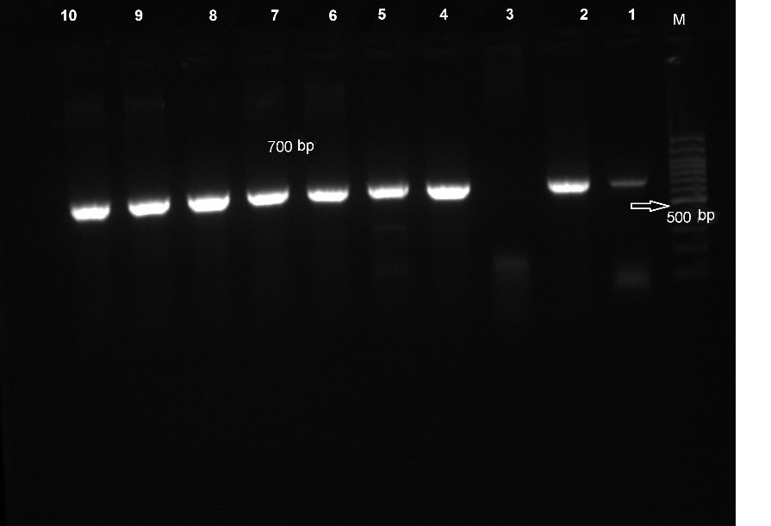
Fig.(1, a) : Agarose gel electrophoresis of PCR of 16SrRNA(700 bp) for characterization of vibrio species.
Lane M: 100bp ladder as molecular size DNA marker.
Lane 1 &2 :control positive vibrio spp.
Lane 3: control negative DNA free sample.
Lane 4,5,6,7,8,9&10: positive vibrio spp.
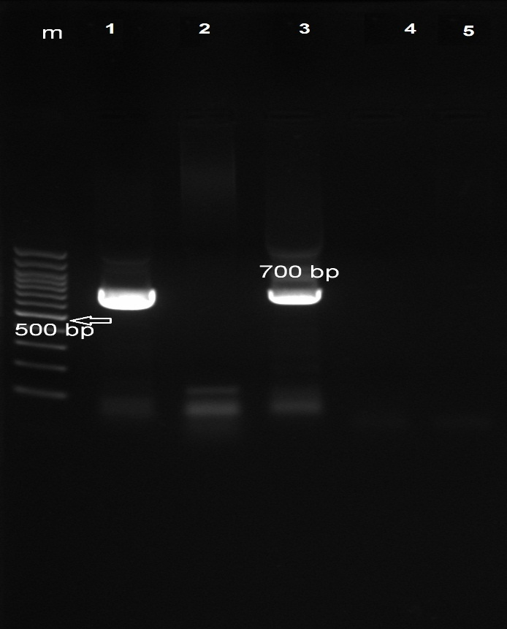
Fig.(1, b) : Agarose gel electrophoresis of PCR of 16SrRNA(700 bp) for characterization of vibrio species.
Lane M: 100bp ladder as molecular size DNA marker.
Lane 1:control positive vibrio spp.
Lane 5: control negative DNA free sample.
Lane 3: positive vibrio spp.
Lane 2&4: negative samples for vibrio spp.

- Results of species specific detection of different Vibrio spp.:
Table (12): results of species specific detection of different Vibrio spp.:
 | V. alginolyticus | V. parahaemolyticus | V. harveyi | V. angullarum | Total
No | 1 | 4 | 2 | 1 | 8
% | 12.5% | 50% | 25% | 12.5% | 100%

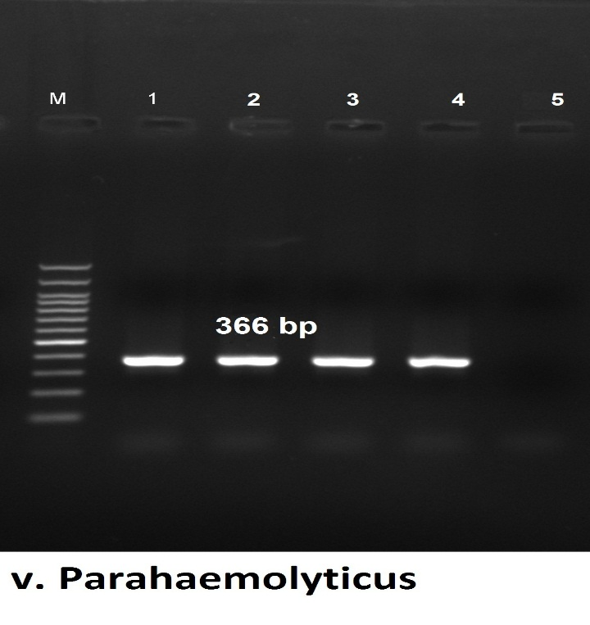
Fig.(2) : Agarose gel electrophoresis of PCR of toxR (366 bp) for characterization of vibrio parahaemolyticus.
Lane M: 100bp ladder as molecular size DNA marker.
Lane 1,2,3&4: positive for species specific primer of V. parahaemolyticus.
Lane 5: control negative DNA free sample.
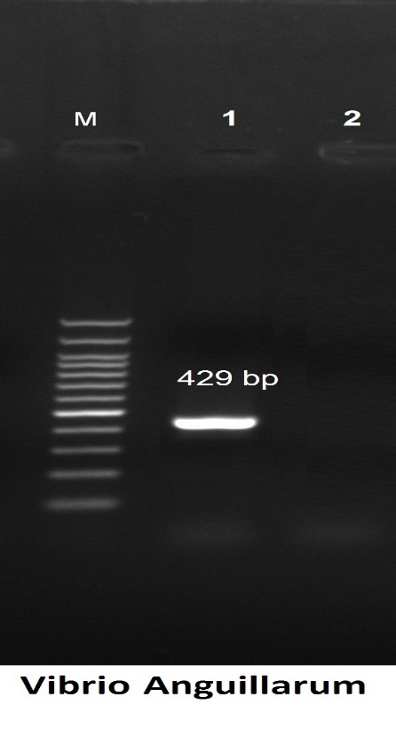
Fig.(3) : Agarose gel electrophoresis of PCR of toxR (429 bp) for characterization of vibrio anguillarum.
Lane M: 100bp ladder as molecular size DNA marker.
Lane 1: positive for species specific primer of V. anguillarum toxR (429 bp) .
Lane 2: control negative DNA free sample.

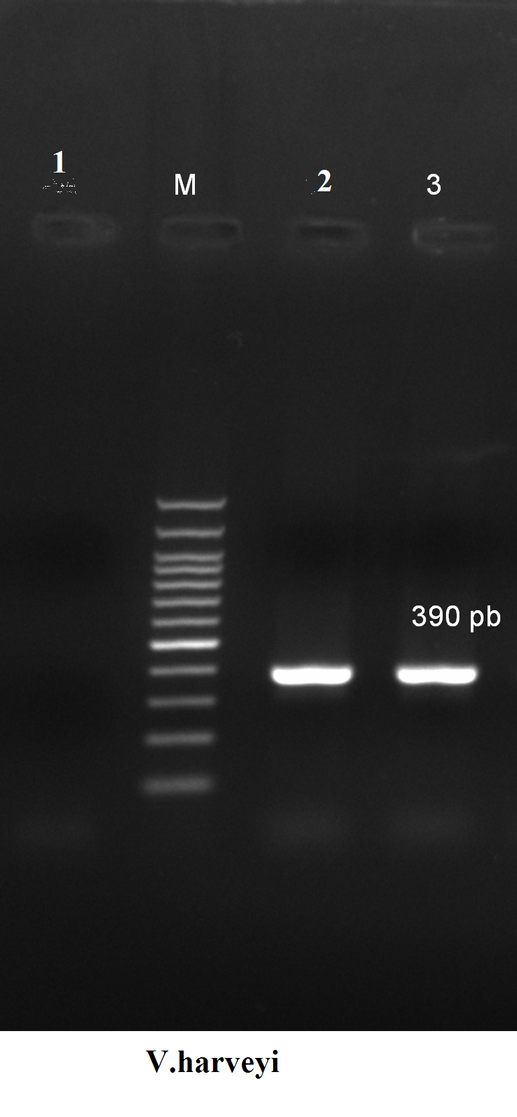
Fig.(4) : Agarose gel electrophoresis of PCR of Vh_toxR (390 bp) for characterization of V.harveyi.
Lane M: 100bp ladder as molecular size DNA marker.
Lane1: control negative DNA free sample.
Lane 2& 3: positive for species specific primer of V.harveyii( Vh_toxR (390 bp).

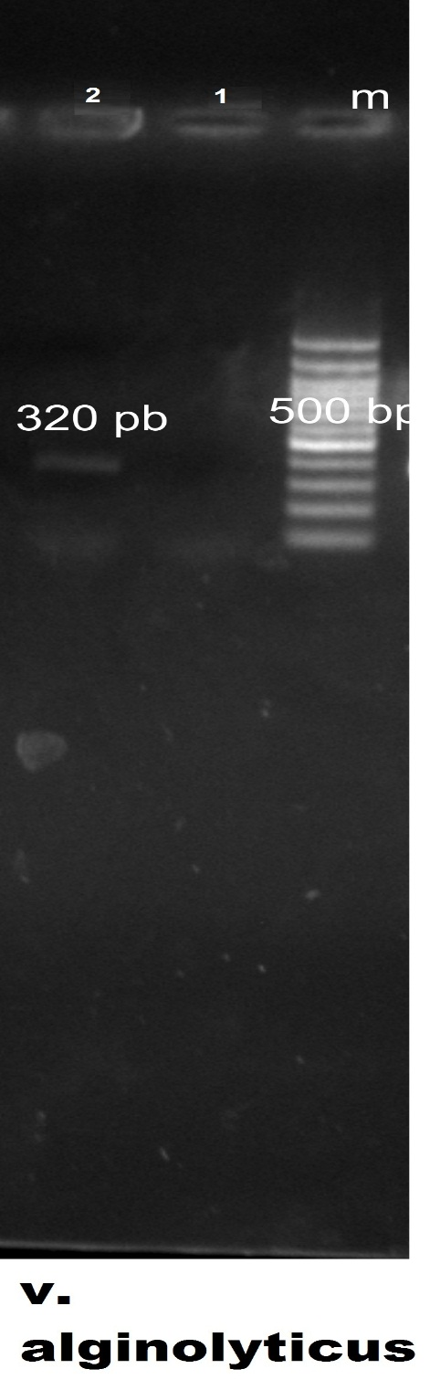
Fig.(5) : Agarose gel electrophoresis of PCR of VP (320 bp) for characterization of vibrio alginolyticus.
Lane M: 100bp ladder as molecular size DNA marker.
Lane1: control negative DNA free sample.
Lane 2: positive for species specific primer of V. alginolyticus (VP (320 bp).

- Detection of virulence genes of isolated vibrio spp.:

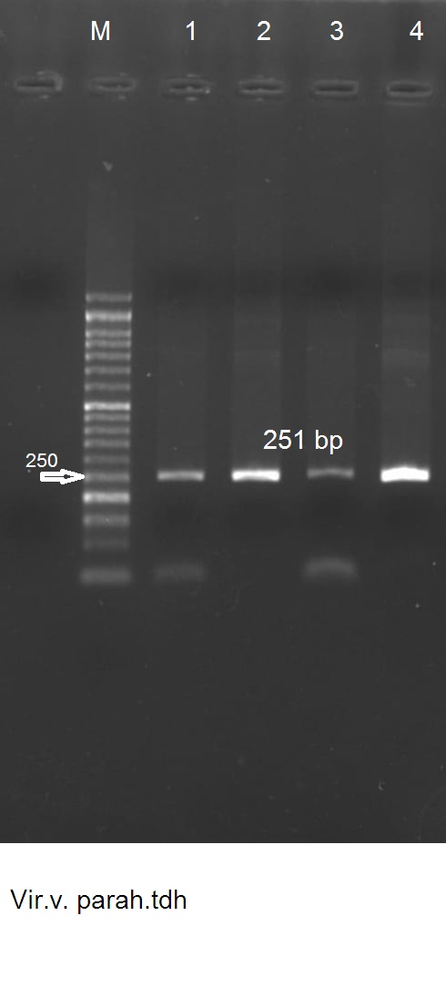
Fig.(6): Agarose gel electrophoresis of PCR of V. Parahaemolyticus virulence factors (tdh at 251 bp ).
Lane M: 100bp ladder as molecular size DNA marker.
Lane1&2&3&4: positive for tdh at 251 bp.

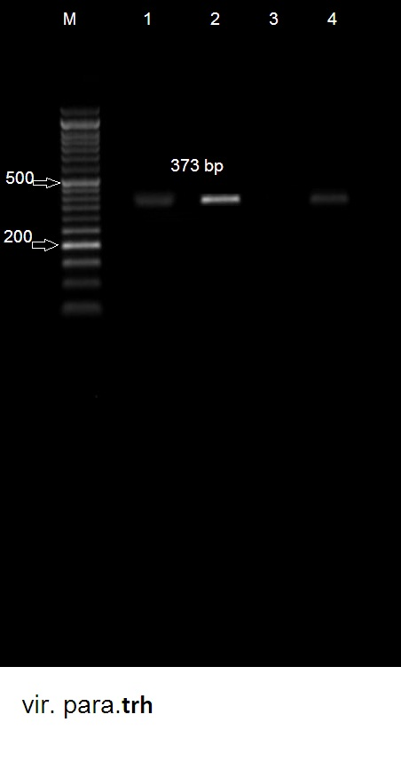
Fig.(7): Agarose gel electrophoresis of PCR of V. Parahaemolyticus virulence factors (trh at 373 bp ).
Lane M: 100bp ladder as molecular size DNA marker.
Lane1,2&4: positive for trh at 373 bp.
Lane 3 : negative for trh at 373 bp.

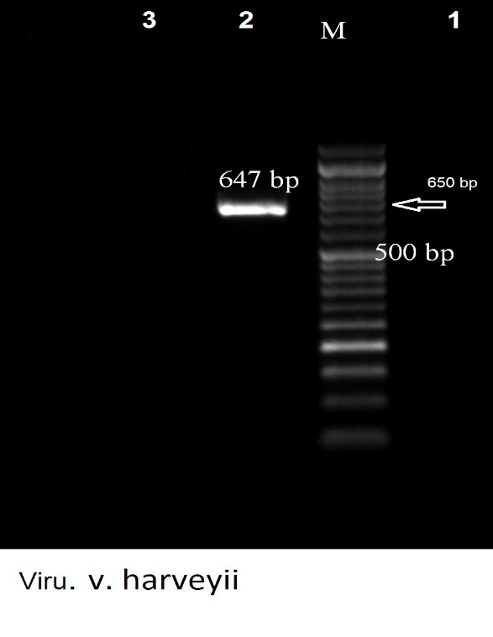
Fig.(8): Agarose gel electrophoresis of PCR of V. harveyii virulence factors (Partial hly at 647 bp).
Lane M: bp ladder as molecular size DNA marker.
Lane1: control negative DNA free sample.
Lane 2: positive for Partial hly at 647 bp .
Lane 3: negative for Partial hly .
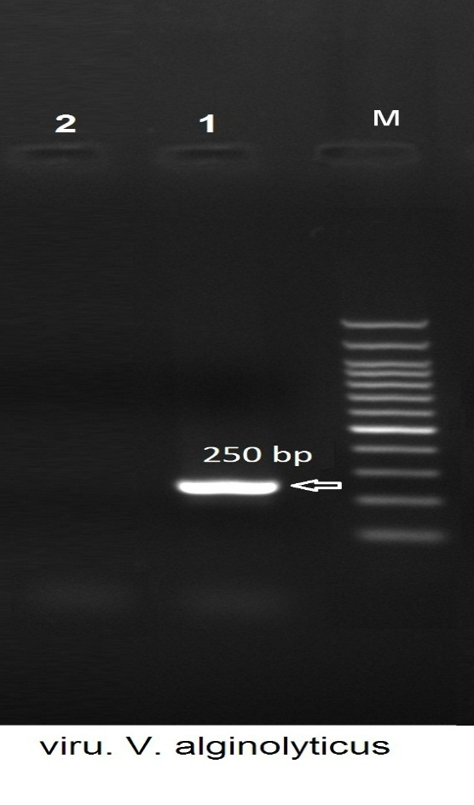
Fig.(9): Agarose gel electrophoresis of PCR of V. alginolyticus virulence factors (trh at 250 bp)
Lane M: bp ladder as molecular size DNA marker.
Lane 1: positive for trh at 250 bp virulence factors.
Lane2: control negative DNA free sample.
4. DISCUSSION :
Vibriosis is one of the most important serious infectious bacterial disease that infect estuarine and marine fish and crustacean causing severe economic losses. Also it is one of the most zoonotic disease which transmitted to human from fish and other aquaculture.
This study aimed to identify vibrio species isolated from fish by phonotypical and biochemical characterization. Also to make molecular confirmation of the isolated vibrio bacteria and molecular differentiation and identification of different vibrio species and detect the virulence factors of each.
In our investigation we collect 100 fish samples (tilapia nilotica or Oreochromis niloticus) between April 2019 to February 2020 from Kafr ElSheikh governorate fish markets as: 75fish which showed signs of disease and 25 apparent healthy fish.The samples transported immediately to the department of Microbiology at Animal Health Research Institute, Kafr ElSheikh lab. For examination.
In our study, We collect the target organs from all of 100 samples and cultivated it on Trypticase soya broth with addition of 3% NaCL for 24h at 37 ⁰C. Then subculture to TCBS for 24h at 37 ⁰C and examined phenotypically as showed in table (4.1), 75 samples collected from diseased fish and 25 samples collected from apparent healthy fish. About 90 isolates (72 isolates from diseased fish and 18 from apparent healthy) show yellow and green colonies on TCBS typically like vibrio colonies according to Sabir et al. (2013) and Austin and Austin (1987). Cultures should be examined quickly after removal from the incubator as the yellow coloration of the colonies may revert to a green color when left at room temperature (PHE, 2014). Using of Gram’s stain, the 90 suspected isolates stained for microscopic examination that showed rod or curved gram negative bacteria. Singleton et al. (1982 ) documented that under conditions of nutrient depletion or in the natural environment, including estuaries and the ocean, where oligotrophic conditions occur, vibrios will occur as small coccoid forms, representing a strategy for survival for survival.
The biochemical tests applied according to West and Colwell (1984) and Jayasree et al. (2006) for the 90 suspected isolates showing resulted in 83 isolates showed biochemically positive to vibrio spp. as: 17 V.alginolyticus (4 from apparently health and13 from diseased fish samples), 15 V.anguillarum (9 from apparently health and 6 from diseased fish samples) , 21 V. harveyi and 30 V. parahaemolyticus from diseased fish. Isolated as 13 from apparent healthy and 70 from diseased fish.as explained in table (4.2) and (4.3).
Biochemical tests doesn’t seem accurate or firm enough to confirm tested vibrio strains. Molecular identification using PCR provides a rapid, effective, sensitive and confirmatory method in Vibrio identification (Walter et al., 1991). In order to enrich Vibrio specific 16S rRNA fragments so as to describe Vibrio community and provide the basis for the utilization of high throughput monitoring techniques, two primers that amplify Vibrio 16S rRNA fragments in combination were designed and tested in the present study.
16S rRNA gene used to identify genus Vibrio which contains a large number of closely related bacterial species differing in nucleotide sequence from less than 1% up to 6% as recorded by Bergey et al. (1984). In our investigation, 10 random suspected isolates examined for 16S rRNA gene produced light band at 700 bp as mentioned by Marchesi et al., (1998).
Species specific genes used for confirmatory detection of vibrio species and for differentiation of them from other closely related vibrio species. According to Lee et al., (1995) Vibrio alginolyticus detected by VP32 and VP33 gene that produced light band at 320 or 387 bp, Vibrio anguillarum show light band at 429 bp with Van-ami8 and Van-ami417 gene as descripted by Gyeong-Ehun et al. (2007), Vh_toxR used as mentioned by Conejero and Hedreyda, (2003) to identify vibrio harveyi that produced light band at 390 bp and vibrio Parahaemolyticus identified by light band at 366 bp for toxR gene that studied by Kim et al., (1999). As in table (4.5), the ten examined suspected isolates show 8Vibrio species (80%) from examined samples (1from apparently health (12.5%) and 7 from diseased fish samples(87.5%)). These results were disagreed with the results obtained by Abd-El-Gaber et al.(1997) who isolated Vibrio species from naturally infected Oreochromis niloticus with a percentage of 42% and also the results were higher than the results obtained by Al-Sunaiher et al.(2010) who isolated Vibrio species from naturally infected Oreochromis niloticus with a percentage of 32% and Radwan.(1995) who recovered Vibrio species with an incidence of 25% of naturally infected Oreochromis niloticus fish. According to table (4.5),PCR results show 8isolates positive to vibrio as 1 isolates (12.5%) Vibrio alginolyticus, 1 isolates (12.5%) Vibrio anguillarum, 2 isolates (25%) vibrio harveyi and 4 isolates (50%) vibrio Parahaemolyticus. Arunagiri et al.(2016) isolate three Vibrio species (Vibrio cholerae, Vibrio Parahaemolyticus and Vibrio alginolyticus) and identified them by studying cultural, morphological and biochemical characteristics with the incidence percentage 0f 22.41% and 17.24% for Vibrio cholera and Vibrio Parahaemolyticus respectively who disagree our results. And 12.07% for V.alginolyticus this similar to our results. Vibrio harveyi isolated in our study with percentage of 25%. This result near to that documented by Adeleye et al. (2010) who isolated it with percentage of 27.3%. But lower than Shimaa et al.(2015) who recorded it by 56%. The results not similar to El-Hady et al.(2015) who isolated V. anguillarum, V. harveyi, V. vulnificus and V. ordalii from Oreochromis niloticus by the percentage of 32%, 20%, 20% and 28% respectively. And from Ctenopharyngodon idellus isolated V. ordalii and V. harveyi by 50% to 50% that similar to our V.harveyii percentage. The results not similar to Utsalo (2008) who studied the prevalence of Vibrio spp. in crabs, shrimps, clams and tilapia harvested from the Cross river estuary in Nigeria. Vibrio organisms were recovered from 49.6% of the shrimps, 27.0% of the crabs, 13.1% of the clams and 6.6% of the tilapia fish with an overall recovery rate of 26.6% from these seafood harvest. Of the 96 Vibrio spp. 3 (3.3%) were V. cholerae Ol ET tor Ogawa, 29 (29.9%) were V. cholerae non-Ol, 22 (22.7%) were V. alginolyticus and 43 (44.3%), V. parahaemolyticus. may be present in V.parahaemolyticus with or with out tdh gene.
The only one V.anguillarum strain amplified to 2 virulence factors; the cell surface component gene (virA) and trans-acting transcriptional activator (angM) that must produced light band at 314 bp and 453 bp respectively according to Lu, (2010) ,but in our study, the V. anguillarum strain produced negative results to both virulence genes as in fig. (6a& 6b). This results similar to Gao et al. (2018) who detected that in the 6 months starved V.anguillarum cells, (angM and virA) genes were not detected using the same primers. Also detected that the stress factors affected on virulence of the bacterial cells and in our study may be the storage of the strains (from isolation till PCR amplification which take few months )act as a stress factor.
The 2 V.harveyii strains amplified to Partial hly and Vhh virulence gene that must produced light bands at 647 bp and 234 bp respectively according to Haldar et al., (2010) and Ruwandeepika et al., (2010), but only one strain produced light band at 647 bp for Partial hly and both of them are negative for Vhh virulence gene as in fig. (7a& 7b).. This indicated that the V. harveyi can caused disease with or with out (vhh -Vibrio harveyi haemolysin and partial hly- haemolysin gene).
Also the single V. alginolyticus amplified to trh and tdh virulence genes which detected by light bands at 250 bp & 373 bp respectively according to Cohen et al., 2007. In our investigation, only trh virulence factor founded and indicated by light band at 250 bp as in fig. (8a& 8b).
On conclusion,V. parahaemolyticus, V. harveyi, V. angullarum and V. alginolyticus are the most causative Vibrio spp. affecting tilapia nilotica fish producing sever pathological finding leading to economic losses.
The V. parahaemolytics the dominant pathogenic one followed by V. harveyi,V. alginolyticus then V. angullarum.
PCR provides a rapid, effective, sensitive and confirmatory method in Vibrio identification.
16S rRNA gene used to identify genus Vibrio which contains a large number of closely related bacterial species differing in nucleotide sequence.
Species specific genes used for confirmatory detection of vibrio species and for differentiation of them from other closely related vibrio species. As Vibrio alginolyticus detected by VP32 and VP33 gene ,Vibrio anguillarum detected byVan-ami8 and Van-ami417 gene ,Vh_toxR used to identify vibrio harveyi and vibrio Parahaemolyticus identified by toxR gene.
The detection of virulence genes in each species is so important to detect the ability of the bacteria to produce the disease.
Vibrio species are important pathogen affect fish and fish production.
6. ACKNOWLEDGMENTS :
Profound gratitude and appreciation are devoted to all members of our laboratory for discussions, encouragement and support to complete this study.
5. REFERENCES :
Abd-El-Gaber, G. A., Naguib, M., Abd-El-Aziz, E. S. A.1997. Vibrio species infections in Oreochromis niloticus and Mugil cephalus: sodium chloride tolerance. Pathogenicity, serological relatedness and antibiograms sensitivity of recovered Vibrios. Vet. Med. J. Giza., 45: 87-99.
Adeleye, I. A., Daniels, F. V., Enyinnia, V. A. 2010. Characterization and Pathogenicity of Vibrio Spp. Contaminating Sea foods In Lagos, Nigeria.
Al-Sunaiher, A. E., Ibrahim, A. S. S., Al-Salamah, A. A. 2010. Association of Vibrio species with disease incidence in some cultured fishes in the kingdom of Saudi Arabia. WASJ, 8(5):653-660.
Arunagiri, K., Sivakumar, T., Murugan, T. (2016). Study of Vibrio species and its occurance frequency in collected seafood samples. Asian J. Pharm. Clin. Res., 9: 229-231.
Austin, B., Austin, D. A.1987. Bacterial fish pathogens, diseases in farmed and wild fish.15th ed. Ellis Howrwood Limited, England. 263-287.
Bergey, D.M., Holt, J.G., Krieg, N.R. 1984. Bergey’s Manual of systematic bacteriology. Baltimore, MD: Williams & Wilkins c1992.
Burke,J., Rodgers, L. 1981. Identification of pathogenic bacteria associated with the occurrence of red spot in sea mullet, Mugil cephalus L., in south - eastern Queensland. - J. Fish Dis. 4:153-159.
Cohen, N., Karib, H., Ait Saïd, J., Lemee, L., Guenole, A., Quilici, M. L. 2007. Prévalence des vibrions potentiellement pathogènes dans les produits de la pêche commercialisés à Casablanca (Maroc). Revue Méd. Vét. 158: 562-568.
Conejero, M. J. U., Hedreyda, C.T. 2003. Isolation of partial toxR gene of Vibrio harveyi and design of toxR-targeted PCR primers for species detection. J. Appl. Microbiol. 95: 602611.
Eleonar, V., Alapide Tendenica, L.A. and Dureza, P. 1997. Isolation of Vibrio species from Penaeus monodon (Fabricius) with red disease syndrome. Aquaculture.154:107-114.
El-Hady, A. M., El-khatib, R. N., Abdel- Aziz, E. S. 2015. Microbiological studies on Vibrio species isolated from some cultured fishes. Anim. Health Res. J. 3 (1).
Gao, X., Pi, D., Chen, N., Li, X., Liu, X., Yang, H., Wei, W. , Zhang, X. 2018. Survival, Virulent Characteristics, and Transcriptomic Analyses of the Pathogenic Vibrio anguillarum Under Starvation Stress. Front. Cell. Infect. Microbiol. 8:389.
Gyeong-Eun, H., Dong-Gyun, K., Ju-Yoon, B., Sun-Hee, A., Sungchul, C.B., In-Soo, K. 2007. Species- Specific PCR Detection of The Fish Pathogen, Vibrio anguillarum, Using The amiB Gene, Which Encodes N-Acetylmuramoyl-L-alanine Amidase, FEMS Microbiol. Lett., 269 : 201-206.
Hacking, M.A., Budd, J. 1971. Vibrio infection in tropical fish in freshwater aquarium. J. Wild Dis., 7: 273-280.
Haldar, S., Neogi, S. B., Kogure, K., Chatterjee, S., Chowdhury, N., Hinenoya, A., Asakura, M., Yamasaki, S. 2010. Development of a haemolysin gene-based multiplex PCR for simultaneous detection of Vibrio campbellii, Vibrio harveyi and Vibrio parahaemolyticus. Lett., Appl., Microbiol., 50:146 -152.
Hashem, M., El-Barbary, M. 2013. Vibrio harveyi infection in Arabian Surgeon Fish (Acanthurus sohal) of Red Sea at Hurghada, Egypt. Egypt. J. Aquat. Res. 39:199–203.
Jayasree, L., P. Janakiram, Madhavi, R. 2006. Characterization of Vibrio spp. Associated with Diseased Shrimp from Culture Ponds of Andhra Pradesh (India). JWAS. 37: (4).
Kim, Y.B., Okuda, J., Matsumoto, C., Takahashi, N., Hashimoto, S., Nishibuchi, M. 1999. Identification of Vibrio parahaemolyticus at the species level by PCR targeted to the toxR gene. J.C.M. 37:1173–1177.
Lee, C.Y., Pan, S. F., Chen, C.H. 1995. Sequence of a cloned pR72H fragment and its use for detection of Vibrio parahaemolyticus in shellfish with the PCR. Appl. Environ. Microbiol., 61: 1311-1317.
Lee, K. K.1995: Pathogenesis studies on Vibrio alginolyticus in the grouper, Epinephelus malabaricus, Bloch et Schneider. Microbiol Pathol. 19(1):39-48.
Lu, X. 2010. Development of Multiplex PCR for Simultaneous Microarray Detection of Six Virulence Factors of Vibrio anguillarum and Primary Exploration of Innovative Detection Technologies. Qindao: Ocean University of China.
MARCHESI, J.R., SATO T., WEIGHTMAN A.J., MARTIN T.A., FRY J.C., HIOM S.J., DYMOCK D., WADE W.G. 1998. Design and evaluation of useful bacterium-specific PCR primers that amplify genes coding for bacterial 16S rRNA. Appl. Environ. Microbiol. 64: 795-799.
McDowell, M., Colwell, R.R.1985. Phylogeny of Vibrionaceae and recommendation for two new genera, Listonella and Shewanella. Syst. Appl. Microbiol., 6:171-182.
Oliver, J.D., Japer, J.B.1997. Vibrio species. In: Doyle, M.P.; Beuchat, L.R.and Montville, T.J. Food Microbiology – Fundamentals and Frontiers. Washington DC: ASM Press..228-264.
Pacini, F.1854. Osservazione microscopiche e deduzioni patologiche sul cholera asiatico. Gazette Medicale de Italiana Toscano Firenze 6:405–412.
PHE, Public Health England. 2014. UK Standards for Microbiology Investigations Identification of Vibrio species. Issued by the Standards Unit, Microbiology Services, PHE Bacteriology – Identification, ID. 19 :(2.2):1 – 23.
Radwan, I.A.1995. Bacteriological characterization of Gram-negative bacteria isolated from fishes. A thesis Ph.D.Microbiology.Fac.Vet.Med., Beni-Suef, Cairo Univ.
Ravikumar, V., Vijayakumar, R. 2017. Prevalence, distribution and phenotypic identification of Vibrio sp. in fishes caught off Chennai, Indian Ocean. IJCR. 9( 06): 51698-51705.
Ruwandeepika, H.A.D., Defoirdt, T., Bhowmick, P.P., Shekar, M., Bossier, P., Karunasagar, I. 2010. Presence of typical and atypical virulence genes in vibrio isolates belonging to the Harveyi clade. J.Appl. Microbiol. 109: 888899.
Sabir, M., Mustapha, E. M. , Nozha C. 2013. Vibrio Alginolyticus: An Emerging Pathogen of Foodborne Diseases. IJST. 2 (4).
Sambrook, J., Russell, D. W. 2001. Molecular cloning: a laboratory manual, 3rd edition.
Shimaa, A. H. E., Riad, H. K., Talaat, T.S., Mahmoud, E., Hany, M.R.A. 2015. Occurrence, characterization and antibiotic resistance patterns of bacterial communities encountered in mass kills of pond cultured indian prawn (Fenneropenaeus indicus) at Damietta governorate, Egypt, IJFAS. 2(4):271-176.
Singleton, F. L., Attwell, R., Jangi, S., Colwell, R. R. 1982. Effects of temperature and salinity on Vlbrio cholerae growth. Appl. environ. Microbiol. 44: 1047-1058.
Tada, J., Ohashi, T., Nishimura N. et al. 1992. Detection of the thermostable direct hemolysin gene (tdh) and the thermostable direct hemolysin-related hemolysin gene (trh) of Vibrio parahaemolyticus by polymerase chain reaction. Mol Cell Probes 6:477–487.
Torky, H. A., Gaber, S. A., Mona, M. H., Nourhan, H. G. 2016. Molecular Characterization of Vibrio Harveyi in Diseased Shrimp. Alex. J. Vet.Sci. 51(2): 358-366.
Utsalo, S.J. 2008. Men and the invisible world of microbes; the transactions and the legacies thereof. University of calabar 41st inaugural lecture. 19-20.
Walter, E. H., P. K. Stacye, W. T. Mary, F. Peter, A. K. Charles, et al. 1991. Polymerase chain reaction identification of Vibrio vulnificus in artificially contaminated oysters. Appl. Environ. Microbiol., 57: 707-711.
West, P. A., Colwell, R. R. 1984. Identification and classification of Vibrionaceae - an overview. In: Vibrios in the environment. Ed. by R. R. Colwell. Wiley, New York, 285-363.

