Microscopical study of white and red pulp of spleen of young porcain (Sus scrofa) spleen
By
Mahmoud,M. Elghoul and Karam,R.Mohamed
Lecturer of Histology and Cytology
Department of Histology and Cytology, Faculty of Veterinary Medicine Alexandria University, Egypt.
Abstract
The spleen of six young porcain aging (2 month) each spleen were examined grossly and studied using light and transmission electron microscopy. The spleen is an important lymphoid organ of immunological defence. The type of pig spleen is sinusal type spleen, it has a role in many hematological functions as storage, filtration and maturation of reticulocytes. The splenic parenchyma of young pig consisted of white and red pulp. The whit pulp formed of few sporadic lymphocytes and seldomly lymphatic nodules. Were found occasionally a single ovoid mass of lymphoid nodule (Peri-arterial Lymphatic Sheath) was few in pig spleen Ellipsoids (Pericapillary Macrophage Sheath) were not clearly defined in the marginal zone which is also not well demarcated. The red pulp occupied the majority of pig spleen it consisted of splenic cords and few mall sized blood sinusoids lined by flat endothelial cells containing different blood cells as neutrophils and blood platlets. The histology of the spleen was describe in different animals species but to the best of our knowledge there is no available literature concerned with the histology of the Egyptian pig spleen so we aimed in our study to illustrate the main histological and electron microscopical structure of splenic parechyma.

Key words: Pig, spleen, sinusoid, Transmission electron microscope

Introduction
Pigs are domesticated animals, of the genus Sus and of the family Scrofa (wild pig) is the native to North Africa (Lowery 1974 and Whitker 1988). The blood parasites were removed from parasitized erythrocytes and phagocytized in the spleen, (Schnizer et al., 1972 and Chen and Weiss, 1972). Generally, spleen is an important largest lymphoid organ of immunological defence (Pabst, 1993). The spleen has also several haematological functions as, storage and filteration of the blood (Prankerd, 1963), maturation of reticulocytes (Crosby, 1959), (Shattil and Cooper, 1972) dispose of the defective blood cells (Weiss and Tavassoli, 1970), storage of blood platelets (Aster, 1966, Weiss 1983 and Cormack, 1987). The splenic parenchyma consisted of white pulp and red pulp, the white pulp serve as a lymphoreticular tissue consisting of lymphocytes, plasma cells and macrophages on a reticular network. Mainly the white pulp was composed of two components, peri-arterial lymphatic sheath and splenic nodules. The red pulp was found between the white pulp and trabeculae. It consisted of splenic cords, splenic sinusoids, terminal capillaries, sheathed capillaries and pulp arterioles in the spleen of large whiteYorkshire Pig (Nikhil Shringi et al 2018).

Material and Methods

Preparation for transmission electron microscopy:
Fresh specimens of six young pigs spleen were obtained from the abattoir abdlkader Alexandria, Egypt. 1 mm was cut from different sites of each spleen, fixed in 6% solution of phosphate buffered glutraldehyde at pH 7.4 for 6 hrs. Then tissues were washed in several changes of cold (4º C) 0.1 M phosphate buffer every 15 minutes for 2 hrs. The tissues were post fixed in 1% solution of osmium tetroxide in cold (4 ºC) 0.1 M phosphate buffer (pH 7.2) for 2 hrs. Then they were rapidly dehydrated through ascending grades of ethyl alcohol then transferred to propylene oxide and placed overnight in 1 : 1 mixture of propylene oxide and epoxy araldite (Hayat, 1986). Semithin sections ( 1 µm) were cut firstly and stained with toludine blue and viewed with light microscope to select a suitable area for electron microscopical examination. The ultrathin sections (60 – 100 nms) were cut using LKB ultra microtome, and then they were stained with uranyl acetate followed by lead citrate (Hayat, 1986).Then examined by Joel CX electron microscope operating at 100 K.V.S.
The present study was done on five spleen of pig (Sus scrofa). Samples were grossly examined for any pathological changes and only the apparently healthy ones were selected,
Results
The parenchyma of young pig spleen was composed of white and red pulp enclosed by connective tissue capsule (Fig.1). The whit pulp formed of few sporadic lymphocytes and seldomly found lymphatic nodules, occasionally single ovoid mass of lymphoid nodule formed of aggregated lymphocytes could seen .Eccentric arteries were observed in the nodule and periarterial lymphoid sheath around the centeral artery (Fig.2). The marginal zone is not well demarcated and it contained sheathed arteriol and infiltrated by different types of blood cells including lymphocytes, erythrocytes and plasma cell the peri-arterial lymphatic sheath was rarely seen in pig spleen and ellipsoids (Pericapillary Macrophage Sheath) were not clearly defined in the marginal zone (Fig.3). The red pulp of pig spleen occupied the majority of the spleen than the white pulp. The spleen of pig concerned of a sinusal type spleen as it contain few and small sized blood sinusoids filled with moderate amount of blood (Fig.4). The electron microscopical study showed the that the white pulp have lymphocytes with different sizes and some of them have pale stained nuclei and the other have dark nuclei with irregular corregated nuclear envelope their cytoplasm have numerous mitochondria (Fig.5). Some of the blood cells are found as neutrophils that characterised by several electron dense granules in the cytoplasm and irregular lobulated nucleus (Fig 6). The splenic sinusoid are lined by flat endothelial cells (Fig 7). Numerous splenic cords were observed between the sinusoids with prominent fenestrated basement membrane. The red pulp of young spleen showed numerous blood cells mainly as blood platlets which are cytoplasmic fragments without nuclei ,and having a mottled appearance due to the presence of electrone dense granules in the cytoplasm (Fig.8).
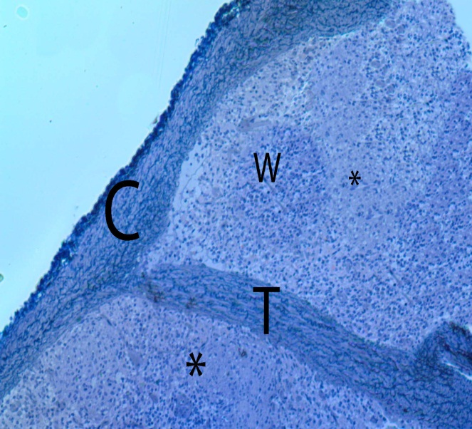 | 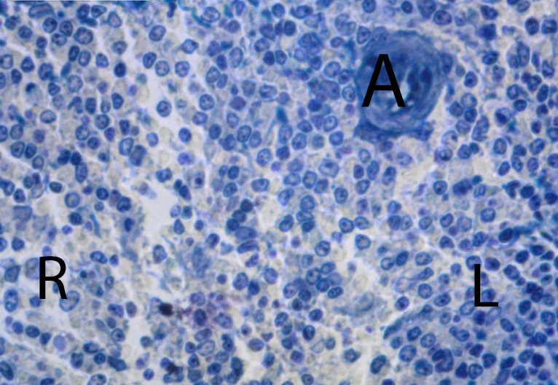
Fig.(1) Light photomicrograph of spleen of pig denoting the connective tissue capsule (C) ,connective tissue trabecular (T) enclosing the white pulp (W) and red pulp (Astriks) with occasionally absence of lymph nodules Toludin blue stain. (Mic. Mag. X 100). | Fig.(2) Light photomicrograph of pig spleen showing that white pulp formed of peri-arterial lymphatic sheath around the centeral artery (A) and lymph nodules (L)., and showing the red pulp (R) Toludin blue stain. (Mic. Mag. X 400)
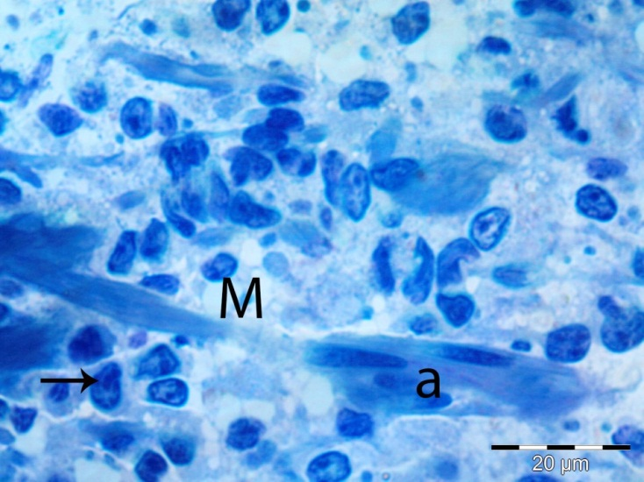 | 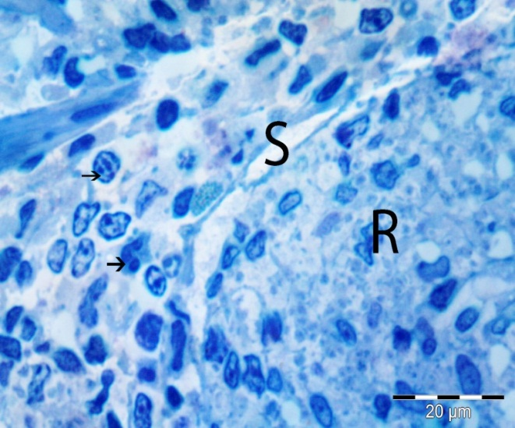
Fig.(3) Photomicrograph of white pulp of pig spleen showing the marginal zone of whit pulp contaning sheathed arteriol (a) ,Plasma cell (Arrow). Toludin blue stain. (Mic. Mag. X 400) | Fig (4) Light photomicrograph showing a blood sinusoid (S) in the red pulp (R) containg blood cells (arrows) Toluidine blue stain. (Mic. Mag. X 400)
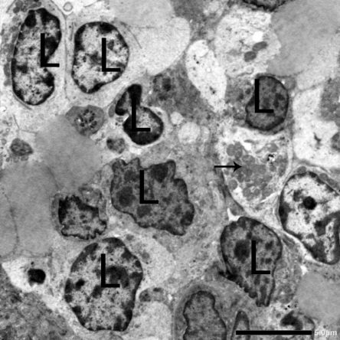 | 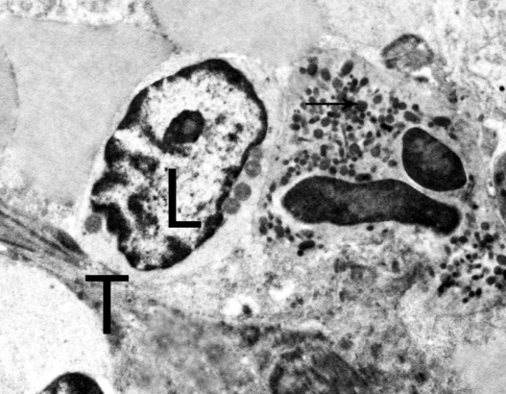
Fig. (5). Transmission electron micrograph of the red pulp of pig spleen showing different lymphocytes with dark nuclei and irregular corrugated nuclear envelope and other pale stained nuclei, Note mitochondria in the cytoplasm of lymphocytes (Arrow) Mic.Mag.X1500. | (Fig.6) Transmission electron micrograph of of pig spleen showing trabecular C.T, one lymphocytes (L) with pale nucleus. Neutrophils with irregular lobulated nucleus and several electrone dense granules (Arrows) Mic.Mag.X2000
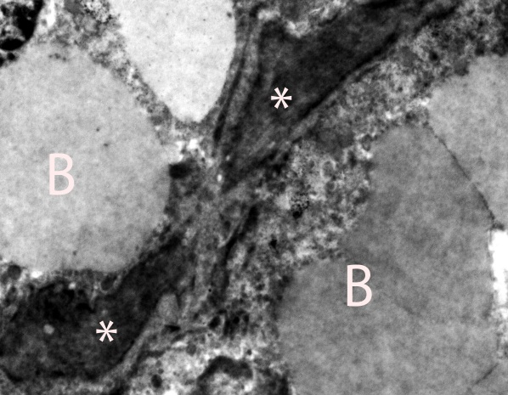 | 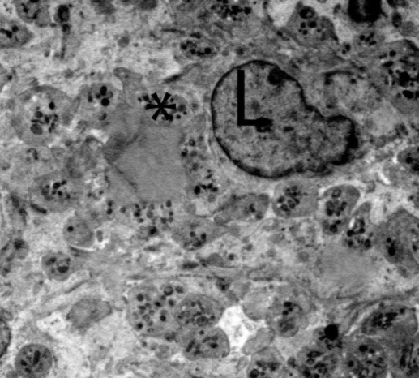
Fig. (7) Transmission electron micrograph of the red pulp of pig spleen showing the endothelial cells lining the blood sinusoid (whit Asterisk) filled with blood (B) Mic.Mag.X2500. | Fig. (8) Transmission electron micrograph of the red pulp of pig spleen showing one lymphocytes (L) blood platelets (thrombocyte). Platelets They have no nuclei and have several electrone dense cytoplasmic fragments (Astrik) Mic.Mag.X1500.

Discussion
The current work showed that the pig spleen formed of whit and red pulpand this result is in agreement with previous studies in different species by Raghavan (1964) in ox, Banks (1981) in domestic animals, Nicander et al. (1993) in domestic animals and Sinha et al. (2013) in Black Bengal goats Nickel et al. (1979) in domestic animals Awal et al. (1992) in indigenous cattle showed that the white pulp of pig spleen consisted of lymphocytes, plasma cells and macrophages. The white pulp was composed of two components, which were lymphatic nodules and peri-arterial lymphatic sheath. The nodule was composed of aggregations of ovoid mass of lymphatic tissue containing mainly lymphocytes of various sizes. In agreement with Dellmann and Brown (1979) in pig and fox and Firdous et al. (2013) in fox the white pulp of pig spleen had less abundant in lymphatic nodules, occasionally one lymphoid nodule with eccentric arteries were observed. Devi H (2012) in Marwari goat Banks (1981) and Dellmann and Brown (1987) in domestic animals, Ikpegbu et al. (2014) in African palm squirre andl Sinha et al (2013) in horse, cow, and pig mentioned that the red pulp found in the space between the white pulp and trabeculae this result comed in agreement with the results the present workin pig. In aggrement with Bareedy et al., (1982) and Abd El Aal. (1994) in camel spleen the blood sinusoids of pig spleen were lined by flat endothelial cells and a prominent fenestrated basement membrane. The spleen of pig as considered of a sinusal type spleen and this comes in agreement with Snook (1950) and Brown and Dellmann (1976) in spleen of the horse, dog and pig. The present work revealed that the blood platlets found in the red pulp of pig spleen which have no definite nucleus and having a mottled appearance due to the presence of electron dense cytoplasmic fragments this comes in agreement with Raskin and Valernciano (2000) in Asiatic black bear.
Conclusion
The present study in the spleen of the Egyptian wild pig (Sus scrofa) proved that it is a sinusal type with more area of red pulp than the whit pulp and with a whit pulp with mainly consisting of diffused lymphocytes and lymphoid nodules were rarely seen in the white pulp. Also th marginal zone between white and red pulp were not clearly demarkated.

References
Aster. 1966 Pooling of platelets in the spleen,. role in pathogenesis of hypersplenic thrombocytopenia. Clin-Invest., 45:645-657.
Abdel Aal, E, 1994 .Some histological and histochemical studies on the spleen of the dromedary camel (Camelus dromedarius). M.Sc. thesis, Faculty of Veterinary Medicine Moshtohor, Zagazig University, Egypt
Awal MA, Shahjahan M, Mia AK, Islam MN, Khan MAB, 1992. Histology of the spleen of indigenous cattle in Bangladesh. The Bangladesh Vet.; 9(1-2):98-102.
Banks WJ. 1981. Applied Veterinary Histology. Williams and Wilkins, Baltimore/London., 327-339.
Bajpai UK. Gross. 1992. Histological and Certain Histochemical Observations on the spleen (Capra hircus). M.V.Sc. Thesis submitted to C.S. Azad Univ. of Agri. and Tech., Kanpur.
Banks WJ. 1981. Applied Veterinary Histology. Williams and Wilkins, Baltimore/London., 327-339.
Bareedy, M. Auis,H. Ewais,M. and Ammer, S. 1982 Some anatomical and histological studies on the spleen of one humped camel (camelus dromearis). Egypt. J.Histol, S: 75-83.
Chen, L . Weiss, L. 1972. Electrone microscopy of the red pulp of human spleen. American Journal of anatomy 134.425-485.
Cormack, D. Ham histology. 9th ed. Philadephia, Toronto: J. B. Lippincott. Co.255-261, 1987.
Chen, L. Weiss, L. 1973.The role of sinus wall in the passage of the erythrocytes through the spleen. Blood 41. 529-537.
Dellmann HD, Brown EM. 1987. Text Book of Veterinary Histology. 3rd, Ed., 176-182. Lea and Fibiger Philadelphia. London.
Devi H. 2012 Gross and histological studies on the spleen of Marwari goat (Capra hircus). M.V.SC.Thesis submitted to C.V.A.S., Bikaner.
Firdous AD, Maya S, Ashok N. 2013. Histomorphology of the Spleen in the Fox (Vulpes bengalensis) J. Vet. Anat.; 6(1): 69-75.
Hayat, M. 1986. Basic Techniques for Transmission Electron Microscope. Academic press, Baltimore, 2nd Ed.
Ikpegbu E, Nlebedum U, Okechukwu N. Agbakwuru I. 2014. The Spleen of the African palm squirrel epixerus ebii : A micromorpholgical observation. J. Vet. Adv.; 4(6): 570-575.
Lowery G.H, Jr. 1974. The mammals of Louisiana and its Adjacent wateis. Louisiana States University press.565p.
Mayer, P.:Z. Wiss .Mikrosk., 20:409. Cited after Bancroft, J. and stevens, A. 1982.Theory and practice of Histological Techniques.2 nd Ed., Churchill livingstone.Edinberg, London, Melbourne and New york. 110-11, 1903.
Nicander L, Brown EM, Dellmann HD, Landsverk T. 1993. In Text Book of Veterinary Histology.4th Ed. Ed. By Dellmann, H.D.129-133.Lea and Febiger,Philadelphia,.
Nickel R, Schummer A, Seiferle E. 1979. The viscera of the domestic mammals.2nd Ed. Verlag Paul Parey, Berlin Hamburg.; 204-210.
-Nikhil Shringi, Rakesh Mathur, Vikas Kumar, Kavita Rohlan and Subha
Ganguly 2018. Histological studies on the spleen of large white Yorkshire Pig (Sus scrofa) Journal of Entomology and Zoology Studies; 6(1): 1142-114.
Raghavan D. 1964. Anatomy of the ox. First Ed.pp.377- 379.Indian Council of Agricultural Research, New Delhi,.
Raskin and Valernciano 2000. Cytochemistry of normal leucocytes 327,346 In B.F Feldman J.G zinkland N.CJain (eds) sehalm: veterinary Haematology 5ed lippincotti willimams and wilkins, Philadiphia.
Sinha B, Ingole SP, Chaurasia D, Giri D, Kumar P. 2013. Gross and histometrical study of spleen in black bengal goats. Indian Journal of Small Ruminants.; 19:179-181.
Shattil, S. and Cooper, R. 1972.Maturation of microreticulocytes membrane in vivo. J, Lab. Clin. Med., 79:215-227.
Schnizer B, Sodman T, Mead M, Contacos P. 1972. Pitting function of the spleen in malaria: ultrastructural observations. Science 177, 175-184,.
Snook, T 1950. A comparative study of the vascular arrangements in mammalian spleen. American Journal of Anatomy 87, 31-78.
Pabst, R. 1993.. Anatomische and physiologische Voraussetzungen zur Erhaltung der postoperativen Milzfunktion nach milzerhaltenden Eingriffen. Chirurgische Gastroenterologie 9 (suppl. 2), 19-22.
-Prankerd, T. 1963. The spleen and anaemia Br.Med. J., 2: 517-524.
Trautmann A, Fiebiger J. 1957. Fundamentals of histology of domestic animals. Translated and revised by Hable, R.E. and Biberstein, E.L.Comstock Publishing Associates, Ithaca, New York.; 129-135.
Weiss, L. and Tavassoli, M. 1970 Anatomical hazard to the passage of the lymphocyte through the spleen. Semin. Hematol. 7:372-383,.
Weiss L. 1983. The spleen. In: Weiss, L. (editor). Histology. Cell and tissue biology 5th ed. London and Basingstoke: The Macmillan Press .
Whitaker J.O. Jr. 1988. The Auduban Society field guid to North America Mammals. Alfied A. Knopf, Inc. New York.

