Molecular characterisation, pathogenesis and immunological effect of avian influenza H9N2 virus isolated from broiler chickens in Egypt during 2019

Farida H. Mohamed¹, Fatma Amer² , Dalia M.Omar³ , Ebtissam N Alshamy¹ and Nahed Y. Abd elaziz²
1. Immunity department, Animal Health Research Institute (AHRI), Giza 12618, Agriculture Research Center (ARC), Egypt.
2. Reference Laboratory for Veterinary Quality Control on Poultry Production, Animal Health Research Institute (AHRI),, Agriculture Research Center (ARC), Giza 12618, Egypt.
3. The Central Laboratory for Evaluation of Veterinary Biologics (CLEVB), Agriculture Research Center (ARC), Cairo , Egypt.

ABSTRACT
Many commercial flocks in Egypt were infected with the low pathogenic avian influenza virus (LPAIV) subtype H9N2, resulting in severe economic losses, particularly when combined with other viral and bacterial diseases. The current study aimed to investigate the genetic evolution of LPAIV (H9N2) in broiler farms in Egypt during 2019 and evaluate its effect on the viral pathogenesis, cytokine response, innate immunity and oxidative state in specific pathogen free (SPF) chicks. Sixty tracheal swabs were collected from broilers and tested by RRT-PCR and the HA gene were sequenced for the genetic evolution. Then this isolated virus was experimentally studied in a total of 20 SPF chicks (21 days old) that were divided into two equal groups. Group-1(G1) was negative control and group-2 (G2) was experimentally infected with the isolated LPAIV (H9N2). The obtained results revealed that all isolated LPAIV (H9N2) in this study were belong to G1-like Eurasian sub-lineages (A/quail/Hong Kong/G1/97-like) and clustered with Israeli strains in group B with specific mutation specific for Egyptian AIV-H9N2 isolated in 2018-2019 forming new subgroup-I. The experimental infection with LPAIV (H9N2) (G2) in SPF chickens, induced mild clinical signs, moderate histopathological changes in lung and spleen, shedding of higher mean LPAIV (H9N2) titre in trachea, up regulation of both the pro-inflammatory (IL-6) and the anti-viral (IFN-γ) cytokines, significant decrease of the serum levels of lysozyme and disturbance of the oxidative state where the serum nitric oxide (NO) and the malondialdehyde (MDA) levels were significantly increased and the antioxidants glutathione (GSH) and superoxide dismutase (SOD) were significantly decreased. In conclusion, the LPAIV (H9N2) was continually circulated in broiler chicken farms and highly evolved. The induced oxidative stress in LPAIV (H9N2) infection could be contributed to the viral pathogenesis, up-regulation of pro-inflammatory and anti-viral cytokines and down-regulation of the innate immune response.
Keyworlds: LPAIV(H9N2), molecular characterization, pathogenesis, cytokines, immune response.
- INTRODUCTION
Avian influenza (AIV) of the family orthomyxoviridae is segmented single-strand RNA. It is divided into A, B, and C. Only type A can infect the birds (Wood et al., 1993). It is classified into 18 H (H1 to H18) and 11 N subtypes (N1 to N11) (Tong et al., 2013). It is classified according to the pathogenicity into HPAIV and LPAIV. The HPAIV causes high mortality and high economic losses but the LPAIV H9N2 cause mild respiratory infection in poultry flocks and high mortality rate especially when accompanied with secondary viral and bacterial infection (Alexander, 2000).
Avian influenza (H9N2) has been recorded worldwide in the last few years. It is first recorded in Asia (Cameroon et al., 2000) then it was recorded in the Africa and Middle East (Roussan et al., 2009). It was first isolated in Egypt in May 2011(El-Zoghby et al., 2012). It was cluster to the Qa/HK/G1/97 lineage with close related to Israeli viruses then it circulated in Egypt in all governorates in all domestic birds (Abdel-Moneim et al., 2012; ELbayoumi et al., 2013; El Miniawy et al., 2014, Awad et al., 2016 and El-Shall et al., 2019).
The diagnosis of avian influenza was dependent on the virus isolation but it takes a long time and not sensitive but in recent years the real-time RT-PCR (RRT-PCR) was developed for rapid and sensitive detection of influenza viral RNA (Rahman et al., 2015).
The avian influenza H9N2 enhances the pathogenesis of secondary bacterial and viral infection as I.B, E.COLI, Mycoplasma, staphylococcus causing high mortality and economic losses. (Azizpour et al., 2014; Bano et al., 2003; Sid et al., 2015). These may be due to change of innate immune response or increase the cytokine especially Interleukin-6 and gamma interferon (IFN-γ) that is involved in the mediation of both innate and adaptive immune responses and increase the inflammation that enhances tissue damage (Choy and John 2017; Kim et al., 2015) and increase the pathogenicity of the secondary infection (Debets-Ossenkopp et al., 1982; Engelich et al., 2002; Navarini et al., 2006).
The cellular metabolism of host cells may be impaired during influenza virus infection, resulting in an increase in reactive species (RS) production and change in RS scavenging antioxidant systems, triggering redox homeostasis deregulation and oxidative stress (Chen et al., 2020). In influenza infection, uncontrolled RS development damages DNA, proteins, lipids, and other cellular structures (Rehman et al., 2018). Reactive species (RS) are also known as reactive oxygen and nitrogen species (ROS and RNS, respectively). The RNS is primarily made up of NO, which is formed by NO syntheses (NOS), from L-arginine, and oxygen (Vliet et al., 1998). One of the consequences of RS damage may be an increase in lipid per oxidation (Sochaski et al., 2002). Malondialdehyde (MDA) is the end product of polyunsaturated fatty acid lipid per oxidation. It's the most researched biomarker for lipid per oxidation and oxidative stress in damaged tissue (Baltacioglu et al., 2014).
The antioxidant systems of several enzymes and non-enzymes, such as superoxide dismutases (SODs) and glutathione (GSH), play a key role in suppressing the oxidative stress caused by RNA viruses, like influenza virus. They maintain redox homeostasis by suppressing or preventing the development of free radicals or reactive species (RS) in cells (Reshi et al., 2014).
However, little information is available about the relation between pathogenicity of LPAIV (H9N2) infection in chicken and the induced disturbances in the innate immunity and oxidative state. Therefore the present study aimed to study the genetic evolution and pathogenesis of LPAIV (H9N2) isolated from broiler chicken in Egypt during 2019 and its effect on cytokines response (IL-6 and IFN-γ), innate immunity in correlation with the oxidative state in SPF chickens.

- MATERIALS AND METHODS
  - Sampling from broiler chicken farms.
Sixty A/H9N2 tracheal swab samples were collected from diseased broiler chicken farms aged from 12-45 day old suffered from mild respiratory signs with mortality rate ranged from 20-30% suffered from cough, sneezing, depression, ruffled feather and decrease in egg production. They were collected during 2019 from Cairo, Giza, Alexandria, Assiut, El-Minia, Kafr El-Sheik, and El-Fayoum Egyptian governorates (Table.1). The tracheal swabs were collected in sterile phosphate-buffered saline (PBS) with penicillin, streptomycin, and amphotericin B (OIE, 2014) and stored in -80 till examination.
  - Isolation of H9N2 virus
A 0.2 ml of sample suspension was injected in the SPF emberyonated chicken eggs (ECE) aged 9 to 11 days according to standard protocols (OIE, 2015). The allantoic fluid was harvested and tested for the Hemagglutination activity by HA assay (OIE, 2015) and stored in -80 till use.
  - Reverse transcriptase Real time PCR for H9N2 virus.
The collected samples were examined by carrying out the Reverse transcriptase Real-time PCR (RRT-PCR). The extraction occurred by Qiamp viral RNA mini kit (Qiagen, Germany) following the manufacturer's protocol and then examine for AIV type A (Spackman, et al., 2002) and typing by H9 primers by RRT-PCR using Qiagen one-step kit (Qiagen, Germany) (Ben Shabat et al., 2010).
  - HA gene of LPAIV (H9N2) amplification and sequencing of H9N2 virus isolates.
Four isolates were selected for genetic characterization of the HA gene of LPAI (H9N2). The RNA virus was extracted from the isolates using a QIAmp viral RNA mini kit (Qiagen, Hilden, Germany), the cDNA was synthesis by SuperScript™ III (Thermo Fisher Scientific, MA, USA) as kit manufacture. The HA gene of A/H9N2 was amplified by using Phusion® high fidelity DNA polymerase (Thermo Fisher Scientific, MA, USA) by gene-specific primer according to kit manufacture (Naguib, et al., 2015) and the PCR product was detected by agarose gel electrophoresis. By using the QIAquick Gel Extraction Kit (Qiagen, Hilden, Germany), the positive amplified product was purified. The BigDye Terminator v3.1 Cycle Sequencing Kit was used for the sequencing (Applied Biosystems, California, USA) and An ABI 3500 Genetic Analyzer was used to gather the nucleotide sequence. (Life Technologies, California, USA).
  - Genetic and phylogenetic analysis
Studying strains and other related strains from genebank were used to align and analyze nucleotide and amino acid sequences. The CLUSTAL-W program and the DNASTAR software MegAlign module were used to align the sequences (Lasergene version 7.2; DNASTAR, Madison, WI, USA). Mega7 software was used to create a phylogenetic tree using maximum likelihood methodology (Kumar et al., 2016). DNASTAR software was used to calculate pair-wise nucleotide percent identity.
  - Experimental design and sampling
    - Ethical approval
The current research was performed following the regulations of the Public and Ethics Health committee in Egypt. The animals and protocols used was approved by the Animal Care and Use Committee in Egypt (The Central Laboratory for Evaluation of Veterinary Biologics).
    - Virus.
Egyptian strain (A-chicken-Egypt-FFN2-2019) was selected randomly from the Egyptian H9N2 positive samples that were isolated in this study. The virus was propagated in SPF at 9-11 days according to (OIE, 2015). The EID₅₀ was measured using a standard protocol (OIE, 2014; Reed and Muench, 1938). The harvested allantoic fluid was tested using reverse transcription-polymerase chain reaction for other common avian viruses such as Newcastle disease virus, infectious bronchitis virus, and AIV H5N1 virus to ensure it was negative.
    - Experimental design.
Twenty SPF chicks were divided into two equal groups (10 chicks/group). At 21 days of age, dropping of 20 ul of LPAI (H9N2) (10⁶ EID₅₀/ml) in nostrils and eyes (G2) and the second group act as a negative control (G1). The clinical signs, mortality, and gross lesions were observed for 14 days after the challenge. Serum samples were collected from chicks at 1st, 3rd, 7th, and 14th day post infection (dpi) to estimate the level of NO, MDA, GSH, SOD, and lysozyme. All chicks were reared in a controlled environment conditions and were offered feed and water ad libitum during the experimental period.
    - Virus shedding and Cytokines (IL-6 and IFN-γ) quantification. Tracheal swabs were collected at 2nd, 4th, 7th, 14th dpi in PBS and kept at -80 till examination for virus shedding quantification, and lungs were collected at 2nd and 14th dpi on RNA later for Cytokines mRNA relative quantification. The viral RNA were extracted from swabs using Qiamp viral RNA mini kit (Qiagen, Germany) following the manufacturer's protocol and the Cytokines mRNA were extracted from the lung by QIAamp RNeasy Mini kit (Qiagen, Germany, GmbH) by adding RLT buffer (600 µl) containing 10 μl β-mercaptoethanol per 1 ml to 30 mg of the tissue sample. For homogenization of samples, the tubes were inserted into the adaptor sets, which were fixed into the clamps of the Qiagen tissue Lyser. A two-minute high-speed (30 Hz) shaking phase was used to cause disruption. The steps were completed according to the Purification of Total RNA from Animal Tissues protocol of the QIAamp RNeasy Mini kit (Qia) and one volume of 70% ethanol was applied to the cleared lysate. qRT-PCR was used to titrate viral RNA using a standard curve for a known titer of challenged strain, a Qiagen one stage kit (Qiagen, Germany), and H9 specific primers (Ben Shabat et al., 2010). Furthermore, the same kits were used to measure IL-6 and IFN- in the lungs, and the results were standardized to the chicken 28SrRNA house-keeping gene (Kaiser et al., 2000; Eldaghayes et al., 2006).
    - Histopathological examination.
The lung and spleen tissues from the two groups were collected at the 14th dpi, put in 10% formalin, dehydrated in multiple grades of alcohol, embedded in paraffin, sectioned at 4u thickness, and stained with H&E stain (Bancroft, et al., 2012).
    - Measuring of serum nitric oxide (NO).
It was carried out on all serum samples after deproteinization of the serum following the method of Yang et al. (2010).
    - Evaluating of serum malondialdehyde (MDA), glutathione reduced (GSH) and superoxide dismutase (SOD).
They were calculated following the manufacturer's instructions of Biodiagnostic according to Ohkawa et al.1979; Beutler et al., 1963 and Nishikimi et al., 1972 respectively.
    - Lysozyme Assay.
It was studied by agarose gel plate lyses method (Peeters and Vantrappen, 1977).
    - Statistical analysis.
The obtained data were presented as means and standard errors by conducting One-way ANOVA using Statistical Package for Social Science 20 (SPSS20) software and comparison between groups at least significant difference (LSD) (p < 0.05)

- RESULTS
  - Clinical signs and Gross lesion of tested flocks.
The tested flocks were suffered from cough, sneezing, runny nose, depression, ruffled feather and decrease in egg production. With mortality rate ranged from 20-30%. The post mortem lesions were mild congestion in the lung and trachea with catarrhal and fibrinopurulent inflammations.
  - Isolation and detection of H9N2 subtype by RRT-PCR.
In this study, 30 out from 60 tested samples were positive for HA after isolation in ECE with mean log2 7-8 HAU and 20 tested flocks were confirmed positive by RRT-PCR (33.33%) from Cairo, Giza, Alexandria, Assuit, El-Minia, Kafr El-Sheik, and El-Fayoum (Table.1).
Table.1: Result of RRT-PCR of tested broiler farms in different governorates in Egypt
Number of positive sample for H9 | No of tested flocks | Governorates
7 | 20 | Cairo
4 | 10 | Giza
2 | 5 | EL-Minia
3 | 4 | Assuit
2 | 10 | Alexandria
1 | 6 | Kafr El-Sheik
1 | 5 | El-Fayoum

  - Molecular characterization of HA gene of H9N2 subtype.
We selected four isolates to be sequenced. The amino acid (A.A.) phylogenetic analysis of HA gene of LPAIV (H9N2) observed that the Egyptian viruses in this study were belong to G1-like Eurasian sub-lineages (A/quail/Hong Kong/G1/97-like) and clustered with Israeli strains in group B. They were cluster with 2018- 2019 Egyptian viruses published in genebank in new subgroup I with bootstrap value 80 as shown in (Fig.1). The sequence was published in the National Center for Biotechnology with accession number in (Table 2).

Table.2 Accession number and epidemiological data of H9N2 sequenced viruses
GenBank Accession numb of HA gene | Governorate | Code
MW741567 | Giza | A/chicken/Egypt/FFN1/2019 | 1
MW741569 | Cairo | A/chicken/Egypt/FFN2/2019 | 2
MW741568 | Assuit | A/chicken/Egypt/FFN3/2019 | 3
MW741570 | Alexandria | A/chicken/Egypt/FFN4/2019 | 4

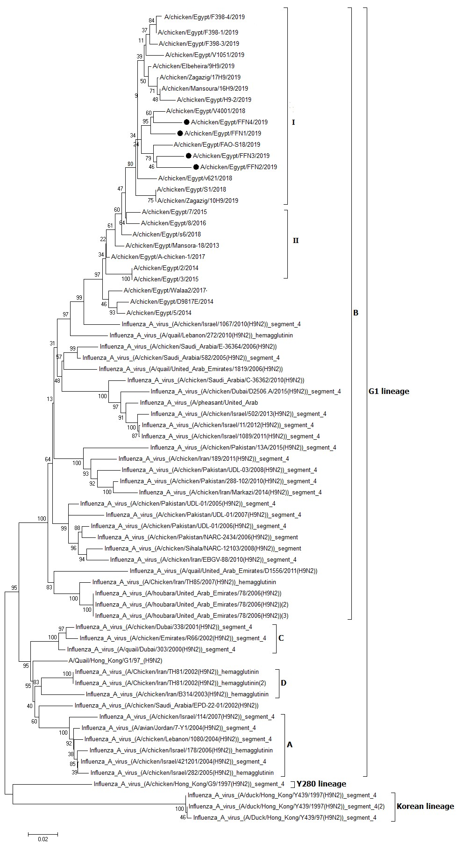Fig.1. The A.A Phylogenitic tree of HA protein of H9N2 viruses. The H9N2 viruses in our study are indicated with a black dot.

The A.A. identity percent of the HA gene of LPAIV H9N2 Egyptian viruses in this study were 93.7%-95.8% when compared with other Egyptian viruses during 2014-2015 and 94.8-.97.4% when compared with Egyptian viruses during 2018-2019 as shown in (Fig.2). The mutation analysis of the current study compared with the A/quail/Hong Kong/G1/97-reveal that M58K, T121I/V, I134M, T145S, N179T as specific to all Egyptian viruses and N41G, I75V, V212I, V267L/I, K294R, resemble Egyptian viruses in 2018-2019. Also, the A/chicken/Egypt/Egypt/FFN3/2019, A/chicken/Egypt/Egypt/FFN4/2019 had Q234L in the receptor-binding site. All Egyptian viruses in this study had PARSSR/GLF cleavage site and ²³²NGLIGR²³⁷ in the left receptor binding site and ¹⁴⁶GTSKS¹⁵⁰ in the right receptor binding site.

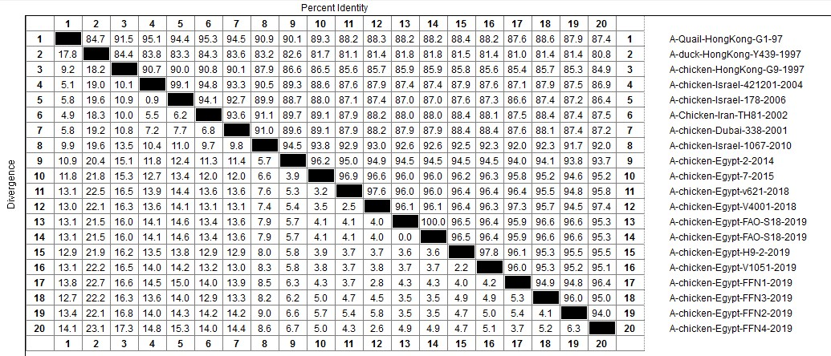
Fig. [2]: A.A. Identities and divergence of Sequenced viruses in comparison to other selected strains from Egypt, Israel, Iran, and Hongkong

  - Pathogenesis of avian influenza H9N2 virus
    - Virus:
The Egyptian strain (A/chicken/Egypt/FFN2/2019) was isolated and titrated in 9-11 day SPF chicks. It was titrated 10⁶ EID50. It confirmed positive for H9 subtype by RRT-PCR and negative for infectious bronchitis virus, Newcastle disease virus, and AIV H5N1 virus.
    - Clinical signs, gross lesions of the LPAIV (H9N2) challenged chickens:
After the challenge, The LPAIV (H9N2) infected group (G2) showed no mortalities, mild respiratory signs (rales, nasal discharge, sneezing, cough), depression, and ruffled feathers and the post mortem examination revealed mild congestion in the lung whereas the spleens were normal. While the negative control group (G1) had no clinical signs.
    - Histopathological examination.
The lungs and spleens of the infected group with the LPAIV (H9N2) virus (G2) showed moderate numerous changes in comparison with the normal group (Fig. 3). The Lungs showed moderate focal mononuclear cell infiltration in the pulmonary parenchyma and perivascular haemorrhage and oedema with marked vacuolar degenerative in the wall of the pulmonary blood vessels. And the spleen showed dilated sinusoid and blood vessels, perivascular odema.
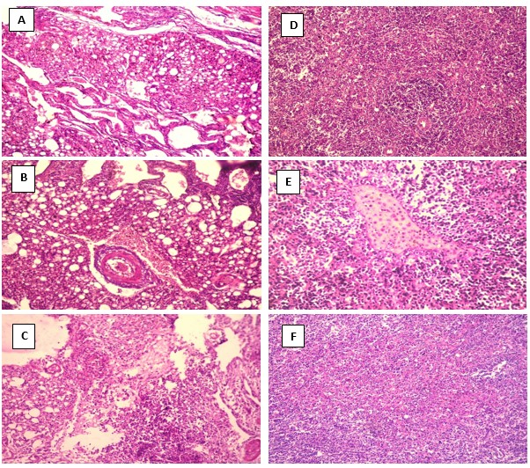
Fig [3]: Histopathological lesions in SPF chicken experimentally infected with LPAIV (H9N2) viruses. A,B & C are lung tissues ( (H&E X 200). A: normal lung tissue (G1). B: lung tissue from infected group (G2) showing perivascular hemorrhage and odema with marked vacuolar degenerative in the wall of the pulmonary blood vessels. C: lungs from G2 showing moderate focal mononuclear cells infiltration in the pulmonary parenchyma. D, E & F : are spleen tissues. D: normal spleen from G1 (H&E X 200). E: spleen from G2 showing dilated sinusoid and blood vessels and perivascular odema (H&E X 400). F: spleen from G2 showing moderate white pulp lymphoid cells depletion (H&E X 200).

    - Result of tracheal virus shedding by qRRT PCR.
Real-time PCR was used to quantify virus shedding from the trachea in comparison to a standard curve created by the challenge strain (LPAIV H9N2). The mean of H9N2 virus shedding was 6.2 x 10² and 9.4x10² from 100% of chicks in the infected group at 2nd , 4th dpi respectively. And was 7.1 x 10² from 15% of chicks in the infected group at 7th dpi, then disappeared at 14 dpi.

  - Results of cytokine mRNA gene expression of IL-6 and IFN-γ .
In H9N2-infected chickens, mRNA expression of lung cytokines (IL-6 and IFN-) genes was induced at higher levels than in uninfected chickens. At 2nd dpi, infected chickens group revealed significant upper regulation of IL-6 and tend to be higher expressed than IFN-γ genes. Then these values significant down-regulated at 14th dpi (Fig. 4)

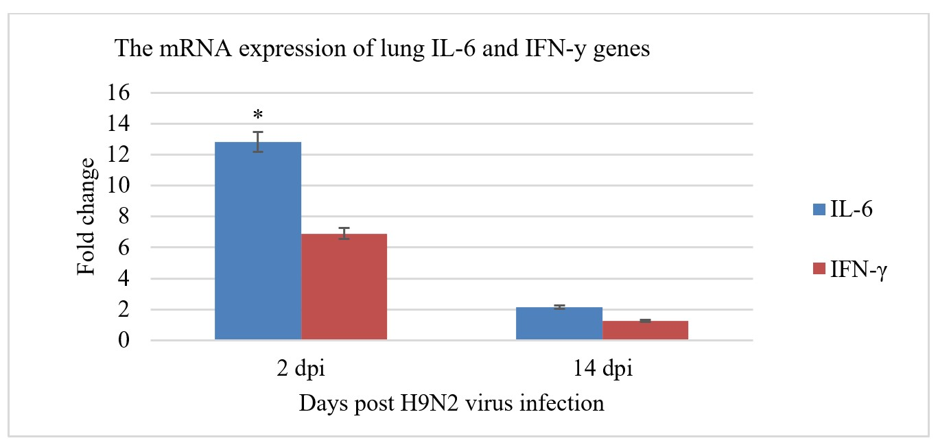

Fig [4]: Real-time RT-PCR for mRNA expression of IL-6 and IFN-γ genes in chicken lungs from H9N2 infected group. 2−ΔΔCt method is used to calculate the relative expression fold change. Data is shown as means with error bar (n = 3). Column with an asterisk indicates significantly different than the other column within the same time point (p < 0.05).

  - Serum MDA and NO levels.
The levels of serum NO and MDA were shown in Fig. (5), which declared that, infection with H9N2 in SPF chicks (G2) induced significantly higher levels of NO than normal group at 3rd and 7th dpi. While the levels of MDA were significantly increased at 3rd , 7th and 14th dpi in comparing to the normal group.
  - Serum antioxidants levels (GSH and SOD).
The levels of the antioxidants enzymes were shown in Fig. (5), which revealed that H9N2 infection induced significant lower values of GSH at 3rd , 7th and 14th dpi. Also the levels of serum SOD were significantly decreased than the normal group at 3rd and 7th dpi.
  - Serum lysozyme levels.
The levels of serum lysozyme (Fig.5) showed that, H9N2 infection (G2) induced significantly decreased lysozyme levels compared to normal group at 3rd , 7th and 14th dpi.

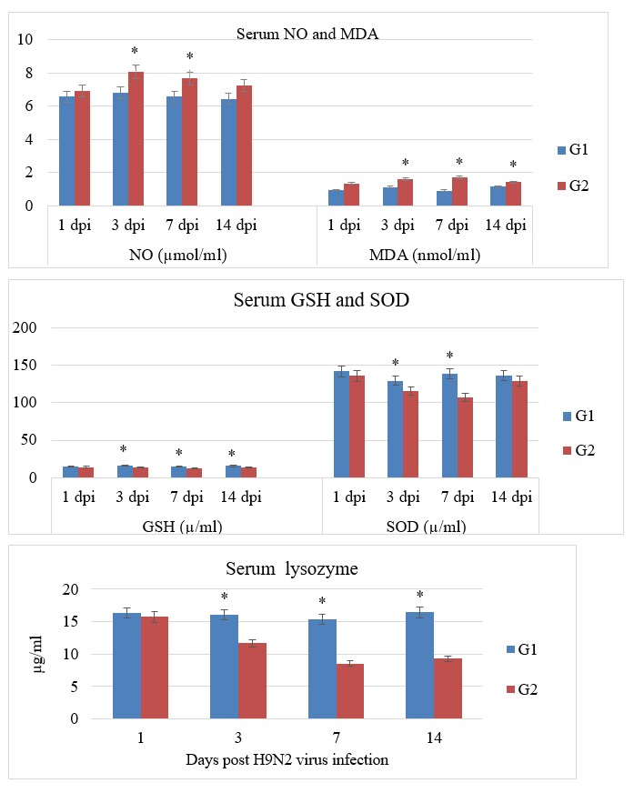

Fig [5]: The effect of LPAIV (H9N2) infection on the serum levels of NO & MDA, GSH & SOD and lysozyme. G1 is normal non-infected chickens and G2 is infected chickens. Data is shown as means with error bar (n = 3). Column with an asterisk indicates significantly different than the other column within the same time point (p < 0.05).

- DISCUSSION
The H9N2 was first appeared in 1966 (Homme and Easterday, 1970) and it affect multiple species including chicken, quail, duck, geese, turkey and can infect human in the last time and it is categorized as a low pathogenic virus (Wu et al., 2008; Xu et al., 2007; Nagarajan et al., 2009; Yu et al., 2008; Li et al., 2003). It first appeared in Egypt in November 2011 from quail belong to the G1 lineage (El-Zoghby et al., 2012) then it circulated in domestic poultry causing high mortality in case of co-infected by other viruses and bacteria as IBV, NDV, IBD, E.coli, and mycoplasma (Abdel- Moneim et al., 2012; Arafa et al., 2012; Shakal et al., 2013). It was evolved rapidly (Samy et al., 2017; Abdel-Hamid et al., 2016; Adel et al., 2019).

This study aimed to find out more about the genetic variability, pathogenesis, and infectivity of Egyptian LPAIV (H9N2) isolates during 2019 and its immunological and oxidative effect in SPF chickens.

We collected sixty suspected samples suffered from mild respiratory manifestation from seven governorates. The LPAIV (H9N2) was continually circulated in Egypt with high incidence. Out of 60 tested flocks, there were 20 positive flocks (33.33%) during 2019 as recorded in many studies that increase the incidence of LPAIV (H9N2) in the broiler farms in the last years ranged from 10% (Shalaby et al., 2014), 15% (Soliman, 2014), 32% (Abdel-Hamid et al., 2016), 9.8% (Awad et al., 2016), 15.90% (El-Shall et al., 2019) and 76.5% (Adel et al., 2019).

We detected the genetic evolution of the HA gene of LPAIV (H9N2) sequencing HA gene of four selected strains. They were related to G1-like Eurasian sub-lineages (A/quail/Hong Kong/G1/97-like) and clustered with Israeli strains in group B as previously recorded (Abdel- Moneim et al., 2012; Monne et al., 2013; Shakal et al., 2013; Naeem et al., 2007) with acquiring a specific mutation that characterized the 2018-2019 Egyptian LPAIV H9N2 viruses forming new subgroup- I.

The cleavage site in this study was PARSSR/GLF. It is significant of the low pathogenic avian influenza as previously described (Kawaoka and Webster, 1998). We recorded mutation in the receptor-binding site in all Egyptian strains was L234 while in A/chicken/Egypt/Egypt/FFN3/2019, A/chicken/Egypt/Egypt/FFN4/2019 was Q234. The Q234 is preferring to 2, 3 linked sialic acid avian type but the L234 was linked to human 2,6 sialic acid (human receptor) as previously recorded (Wan and Perez, 2007). All Egyptian viruses in this study had T212I that affect human transmission as recorded by Liu et al., 2020.

Viral replication is crucial for disease pathogenesis and has a significant impact on the infection's outcome. In the current study, the viral tracheal shedding of the newly evolved H9N2 virus was studied in the experimentally infected group (G2) from 1 to 14 dpi which revealed that the virus titer was increased particularly at 4 dpi (9.4x10² ) which was agreed with Mahana et al. (2019).

Also, the obtained data of H9N2 infection in SPF chicks (G2) showed mild clinical signs as previously recorded by (Abdel-Hamid et al., 2016) inspit of many studies recorded that LPAIV (H9N2) alone had no clinical signs but the clinical signs observed when co-infection occurred by viral or bacterial pathogen (Mahana et al. 2019; Kishida et al., 2004). Whereas, the histopathological examination in G2 revealed moderate pathological lesions in lung and spleen which agreed with the findings of Abdel-Hamid et al., (2016) who found that LPAIV (H9N2) caused severe histopathlological changes in the respiratory and lymphoid organs which lead to immunosuppression. While, Hassan et al. (2017) and Mahana et al. (2019), found mild changes in lung and spleen in chicken experimental infected with LPAIV (H9N2) strains. This variation in the severity of the symptoms and histopathologic features possibly because of difference in many factors such as the dose and quantity of the virus inoculation, virus isolate genetic variation and the using of SPF or commercial broiler chickens in the experiments (Abdel-Hamid et al., 2016).

The viral pathogenicity was not simply linked to the magnitude of viral replication and associated with the capability of viral strains to provoke proinﬂammatory cytokines which may be implicated in both the clearance of virus and the pathological tissue damage (Kobasa et al., 2004). In the current study, the moderate lung and spleen tissue pathological changes were accompanied with higher levels of IL-6 and IFN-γ especially at 2 dpi. These results agreed with Wang et al. (2016), who stated that the increased pro-inflammatory cytokine (IL6) was positively correlated with the damage effect of AIV H9N2, because the IL-6 can trigger the inﬂammation and the pulmonary tissue damage. Also the significantly increases in IFN-γ in G2 was previously reported by Nang et al., (2011), who found that H9N2 infections effectively stimulated inflammatory cytokines response including IFN-γ in trachea, lung and intestine of chickens as The IFN-γ is an important cytokine during viral infection.
Innate immune cells are stimulated in all viral infections, triggering the development of RS such as NO and suppressing the synthesis of antioxidants such as SOD and GSH and resulting in a redox imbalance (Reshi et al., 2014). This was clear in LPAIV (H9N2) group, where the NO and MDA were significantly increased than the normal group. The increased levels of NO were come in accordance with Burggraaf et al., 2011 and Wasilenko et al., 2008, who observed that the expression of NO and/or iNOS was increased in H5N1 influenza-infected chickens and ducks. NO production, on the other hand, can be beneficial as an antiviral effector mechanism against viruses, but it can also be injurious by leading to respiratory tract and lung inflammation, as seen in G2, through the production of toxic reactive nitrogen intermediates such as reactive nitrogen oxide, peroxynitrite which can lead to oxidation and nitration of protein amino acid residues, lipid peroxidation, and DNA cleavage, both of which can lead to cellular dysfunction and death (Brennan et al., 2002)
The increased levels of MDA due to LPAIV (H9N2) infection in G2 were agreed with Zhang et al. (2017), who reported that H9N2 infection in BALB/C mice increased the level of MDA, the final product of lipid peroxidation from the damaged tissues, which is triggered by damaging effect of the increased RNS production (NO) (Gallab et al., 2016). This was obvious in G2 where the increased NO was correlated with increased MDA in association with moderate damage in the lung and spleen tissues.
This increased oxidative parameters (NO & MDA), viral pathogenicity and cytokines response in G2 may arise due to the effect of inﬂuenza A virus (AIV) infection (i.e. H9N2) in activating the nicotinamide adenine dinucleotide phosphate (NADPH) oxidase enzyme that produces ROS within the endosomes and consequently activate the oxidant-sensitive pathways, such as p38 and NF-κB, that implicate inﬂuenza virus replication and pro-inﬂammatory response (Lin et al., 2016). This may explain the significant increased levels of IL-6 and IFN-γ occurred in G2 in correlation with the significant increased levels of MDA and NO.
Antioxidation reactions, which involve the antioxidant processes of many enzymes and non-enzymes, such as superoxide dismutases (SODs) and glutathione (GSH), maintain redox homeostasis in normal cells (Reshi et al., 2014). In this study, the antioxidants (GSH & SOD) were significantly decreased in G2 than the normal group. This result come in accordance with Lin et al. (2016), who found that, GSH production were decreased in A549 cells due to AIV (H5N1) infection which disrupts the redox balance and encouraging the propagation of the virus progeny and host cell death.
Also the decreased SOD observed in G2 was agreed with Qi et al. (2016), who found a decrease in antioxidants activity, including SOD, in primary chicken oviduct epithelial cells due to the effect of H9N2 non-structural protein-1 (NS1) which is considered to be a determining factor for H9N2 viral virulence and pathogenicity (Hale et al., 2008). This disturbance of cellular oxidative state may also related to the viral protein PB1-F2, the key virulence factor of AIV, that stimulates the mitochondrial ROS generation through lowering the SOD level in alveolar epithelial A549 cells and induce apoptosis of phagocytes and other cells of innate immune system (Shin et al., 2015), which may point to the cause of down regulation of serum lysozyme production and the lymphocytic depletion in the spleen tissue in G2 in association with the induced oxidative stress.
Lysozyme is considered as a vital constituent in the innate immune system. Although it was known for its ability to cleave the peptidoglycan of the bacterial cell wall, also it can inactivate some viruses such as murine and human noroviruses (Takahashi et al., 2015). Also its effect on the inﬂuenza viruses were similar to the inhibition effect of the lactoferrin (Creager et al., 2018). However the induced oxidative imbalance occurred in G2 may impair the innate immunity as the levels of the lysozyme in G2 were significantly decreased in comparing with the normal group. This result was supported by Pang et al. (2000) who reported that, different strains of AIV had a significantly reduced lysozyme secretion from sputum neutrophils that could reduce the ability to control bacterial colonization in the respiratory tract and facilitate the secondary bacterial infection following influenza virus infection. The lysozyme downregulation in G2 may resulted from defective formation of phagolysosomes in AIV infection and thus defective lysozyme secretion (Pang et al. (2000), in addition to the immunosuppressive effect of the increased RS as in G2 on the innate immune cells functions (Paiva and Bozza 2014). Furthermore, less production and activity of antioxidant enzymes (GSH & SOD) in H9N2 group may downregulate the immune response and thus lysozyme production, as these antioxidants are required in high amounts for immune cells than other cells (Reshi et al., 2014). Although the low pathogenicity nature of the isolated H9N2 infection however, the induced lung and spleen tissue damage, oxidative disturbance, upregulation of inflammatory cytokines and downregulation of the innate immunity may cause serious problem and enhanced the secondary bacterial infection and trigger the morbidity and mortality particularly when co-infected with other viruses.
CONCLUSION
The LPAIV (H9N2) was continually spread in Egypt and evolved by acquires new mutation forming new subgroup I with 2018-2019 Egyptian strains. The LPAIV (H9N2) isolated during 2019 induced mild signs with moderate pathological changes in lung and spleen and causing oxidative stress in chicken through increasing the serum NO and subsequently the MDA and decreasing the serum antioxidants such as the GSH and SOD. This oxidative imbalance could be contributed to the viral pathogenicity and the induction of moderate histopathological lesions associated with up-regulation of pro-inflammatory and anti-viral cytokines and down-regulation of the innate immune response as the lysozyme level has significantly decreased that increase the possibility of co-infection with bacterial and viral pathogens causing high economic losses. Further investigation is needed to target the oxidative stress induced by LPAIV (H9N2) infection in chicken with the supplementation of RS scavenging antioxidants to try to alleviate the inﬂuenza virus pathology and immune suppression.
REFERENCES

Adel, A. Mady, W., Mosaad, Z., Amer, F., Shaaban, A., Said, D., Maged, M., Arafa, A., Morsi, M., Hassan, M. 2019. Molecular and Epidemiological overview on Low Pathogenic Avian Influenza H9N2 in Egypt between 2015 and 2016. Hosts and Viruses.6.(2).30.41.

Abdel-Hamid,S., Ellakany, H., Hussien, H.A., Elbestawy, A. R., Abdel, K.M. 2016. Pathogenicity of an Avian Influenza H9N2 Virus isolated From Broiler Chickens in Egypt. Alex. J. Vet. Sci. 51(2): 90-100

Abdel-Moneim, A.S., Afifi, M.A., El-Kady, M.F. 2012. Isolation and mutation trend analysis of influenza A virus subtype H9N2 in Egypt. Virol J. 9: 173-182.

Alexander, D.J. 2000. A review of avian influenza in different bird species. Vet Micro 74 : 3–13.

Arafa, A., Hagag, N., Yehia, N., Zantary, A.M., Naguib, M.M., Nasef, S.A. 2012. Effect of cocirculation of highly pathogenic avian influenza H5N1subtype with low pathogenic H9N2 subtype on the spread of infections. Avian Dis 56:849-857.

Awad,A.M., Ali, A.B., Abd El-Hamid, H. S., El-Naggar, A. L., sediek, M.E. El- Shall, N.A., El-Samahy.H. S. 2016. Epidemiological Studies on H5N1 and H9N2 Avian Influenza Viruses during late 2013 and 2015 in Egypt. AJVS. Vol. 51(2):164-173.

Azizpour, A., Goudarzi, H., Charkhkar, S., Momayez, R., Hablolvarid., M. 2014. Experimental study on tissue tropism and dissemination of H9N2 avian influenza virus and Ornithobacterium rhinotracheale co-infection in SPF chickens. Journal of Animal and Plant Sciences, 24, 1655-1662.

Baltacioglu, E., Yuva, P., Aydin, G., et al. 2014. Lipid peroxidation levels and total oxidant/antioxidant status in serum and saliva from patients with chronic and aggressive periodontitis. Oxidative stress index: a new biomarker for periodontal disease? J Periodontol, 85:1432–1441.

Bancroft, J.D.,Suvarna, K., Layton, C. 2012. Bancroft’s theory and practice of histological techniques.7th ed.ISBN:978-0-7020-5032–9.

Bano, S., Naeem, K., MaliK, S. 2003. Evaluation of pathogenic potential of avian influenza virus serotype H9N2 in chickens. Avian Dis. 47, 817-822.

Ben Shabat, M., Meir, R., Haddas, R., Lapin, E., Shkoda, I., Raibstein, I., Perk, S., Davidson, I. 2010. Development of a real-time TaqMan RT-PCR assay for the detection of H9N2 avian influenza viruses. J. Virol. Methods 168 (1-2): 72-7.

Beutler, E., Duron, O., Kelly, M.B. 1963. J. Lab Clin. Med., 61, 882.

Brennan, M. L., Wu, W., Fu, X., Shen, Z., Song, W., Frost, H., Vadseth, C., Narine, L., Lenkiewicz, E., Borchers, M. T., Lusis, A. J., Lee, J. J., Lee, N. A., Abu-Soud, H. M., Ischiropoulos, H., Hazen, S. L. 2002. A tale of two controversies: defining both the role of peroxidases in nitrotyrosine formation in vivo using eosinophil peroxidase and myeloperoxidasedeficient mice, and the nature of peroxidase-generated reactive nitrogen species. J. Biol. Chem. 277(20):17415–17427.

Burggraaf, S., Bingham, J., Payne, J., Kimpton, W. G., Lowenthal, J. W., Bean, A. G. D. 2011. “Increased inducible nitric oxide synthase expression in organs is associated with a higher severity of H5N1 inﬂuenza virus infection,” PLoS One 6 (1) article e14561.

Cameron, K.R., Gregory, V., Banks, J., Brown, I.H., Alexander, D.J., Hay, A.J., Lin, Y.P. 2000. H9N2 subtype influenza A viruses in poultry in Pakistan are closely related to the H9N2 viruses responsible for human infection in Hong Kong. Virology 278 : 36–41

Chen, K., Minakuchi, M., Wuputra, K., Ku, C., Pan, J., Kuo, K., Lin, Y., Saito, S., Lin, C., Yokoyama, K. 2020. Redox control in the pathophysiology of influenza virus infection. BMC Microbiology, 20:214.

Choy, E., John, S. 2017. Interleukin-6 as a multifunctional regulator: inflammation, immune response, and fibrosis. J Scleroderma Relat Disord 2(2): S1-S5

Creager, H., Kumar, A., Zeng, H., Maines, T., Tumpey, T., Belser, J. 2018. Infection and Replication of Inﬂuenza Virus at the Ocular Surface. J. Virol. 92 (7) e02192-17

Debets-Ossenkopp, Y., Mills, E,. van Dijk, W., Verbrugh, H., Verhoef,. J. 1982. Effect of influenza viras on phagocytic cells. Eur. J. Clin. Microbiol. 1: 171-177.

ELbayoumi, M.K., Mahgoub, K.M., Hoda, M.M., Eman, R.H., Zeinab M.S., Girh, A., Asmaa M.M.. Hanaa A.E.S., Nagwa, S.R., Ali, M.A.A., Kutkat M.A. 2013. Molecular Detection of H5N1, H9N2 and Newcastle Disease Viruses Isolated from Chicken in Mixed Infection in Egypt. World Appl. Sci. J. 27 (1): 44 – 50.

Eldaghayes, I., Rothwell, L., Williams, A., Withers, D., Balu, S., Davison, F., Kaiser, P., 2006. Infectious bursal disease virus: strains that differ in virulence differentiallymodulate the innate immune response to infection in the chicken bursa. Viral Immunol. 19: 83–91.

El-Miniawy, H.F., Kawkab, A.A., El-Sanousi, A.A., Marwa, M.S.K. 2014. Effect of Aflatoxin Induced Immunosuppression on Pathogenesis of H9N2 Avian Influenza Virus. Pakistan Vet. J., 34 (2): 234 - 238.

El-Shall, N. A., Sedeik, M. E., El-Nahas, A. F., Abdel-salam, R.A.,
Awad, A. M. 2019. Epidemiological Surveillance of Some Avian Respiratory Viral Disease in Broiler Chickens. AJVS. 61 (1): 185-194.

El-Zoghby, E.F., Arafa, A.S., Hassan, M.K., Aly, M.M., Selim, A., Kilany, W.H., Selim, U., Nasef, S., Aggor, M.G., Abdelwhab E.M., Hafez, H.M. 2012. Isolation of H9N2 avian influenza virus from bobwhite quail (Colinus virginianus) in Egypt. Arch. Virol. 157: 1167–1172.

Engelich, G,. White, M., Hartshorn, K.L. 2002. Role of the respiratory burst in co-operative reduction in neutrophil survival by influenza A virus and Escherichia coli. J. Med. Microbiol. 51: 484-490

Ghallab, N., Hamdy, E., Shaker, O. 2016. Malondialdehyde, superoxide dismutase and melatonin levels in gingival crevicular ﬂuid of aggressive and chronic periodontitis patients. Aust. Dent. J. 61: 53–61

Hale, B. G., Randall, R. E., Ortín, J., Jackson, D. 2008. The multifunctional NS1 protein of influenza A viruses. J. Gen. Virol. 89: 2359–2376.

Hassan, K.E., Ali, A., Shany Salama, A.S., El-Kady, M.F. 2017. Experimental co-infection of infectious bronchitis and low pathogenic avian inﬂuenza H9N2 viruses in commercial broiler chickens. Res Vet Sci. 115:356–62.

Homme, P.J., Easterday, B.C. 1970. Avian influenza virus infections. I. Characteristics of influenza A-turkey-Wisconsin-1966 virus. Avian Dis 14(1): 66-74

Kaiser, P., Rothwell, L, Galyov, E.E., Barrow, P.A., Burnside, J., Wigley, P. 2000. Differential cytokine expression in avian cells in response to invasion by Salmonella typhimurium, Salmonella enteritidis and Salmonella gallinarum. Microbiology. 146:3217–26

Kawaoka, Y., Webster, R.G. 1998. Proc. Natl. Acad. Sci. USA 85, 324–328

Kim, K.S., Jung, H., Shin, I.K., Choi, B.R., Kim, D.H. 2015. Induction of interleukin1 beta (IL1b) is a critical component of lung inﬂammation during inﬂuenza A (H1N1) virus infection. J Med Virol., 87:1104–12.

Kishida, N., Sakoda, Y., Eto, M., Sunaga, Y., Kida, H., 2004. Co-infection of Staphylococcus aureus or Haemophilus paragallinarum exacerbates H9N2 influenza A virus infection in chickens. Arch. Virol., 149: 2095 – 2104.

Kobasa, D., Takada, A., Shinya, K., Hatta, M., Halfmann, P., Theriault, S., Suzuki, H., Nishimura, H., Mitamura, K., Sugaya, N., Usui, T., Murata, T., Maeda, Y., Watanabe, S., Suresh, M., Suzuki, T., Suzuki, Y., Feldmann, H. and Kawaoka, Y. 2004. Enhanced virulence of inﬂuenza A viruses with the haemagglutinin of the 1918 pandemic virus. Nature, 431, 703–707.

Kumar, S., Stecher, G., Tamura, K., 2016. MEGA7: molecular evolutionary genetics analysis version 7.0 for bigger datasets. Mol Biol Evol. 33:1870–1874.

Li, K.S., Xu, K.M., Peiris, J.S., Poon, L.L., Yu, K.Z., Yuen, K.Y. et al. 2003. Characterization of H9 subtype influenza viruses from the ducks of southern China: a candidate for the next influenza pandemic in humans?.J. Virol. 77 (12): 6988–6994.

Lin, X., Wang, R., Zou, W., sun, X., Liu, X., Zhao, L., Wang, S., Jin, M. 2016. The Inﬂuenza Virus H5N1 Infection Can Induce ROS Production for Viral Replication and Host Cell Death in A549 Cells Modulated by Human Cu/Zn Superoxide Dismutase (SOD1) Overexpression Viruses, 8, 13

Liu, Y., Li, S., Sun, H., Pan, L., Cui, X., Zhu, X., Feng, Y., Li, M., Yu, Y., Wu, M., Lin, J., Xu, F., Yuan, S., Huang, S., Sun, H., Liao, M. 2020. Variation and Molecular Basis for Enhancement of Receptor Binding of H9N2 Avian Influenza Viruses in China Isolates. Front. Microbiol. 11:602124.

Mahana, O., Arafa, A., Erfan, A., Hussein, H.S., Shalaby, M. A. 2019. Pathological changes, shedding pattern and cytokines responses in chicks infected with avian inﬂuenza-H9N2 and/or infectious bronchitis viruses. Virus Dis. 30(2):279–287.

Monne, I., Hussein, A.H., Fusaro, A., Valastro, V., Hamoud, M.M., Khalefa, R.A., Dardir, S.N., Radwan, M.I., Capua, I., Cattolia, G. 2013. H9N2 influenza A virus circulates in H5N1 endemically infected poultry population in Egypt. Influenza Other Respir Viruses 7(3), 240–243.

Naeem, K., Siddique, N., Ayaz, M., Jalalee, M.A. 2007. Avian influenza in Pakistan:outbreaks of low- and high-pathogenicity avian influenza in Pakistan during 2003-2006. Avian Dis 51(1): 189-193.

Nagarajan, S., Rajukumar, K., Tosh, C., Ramaswamy, V., Purohit, K., Saxena, G., Behera, P., Pattnaik, B., Pradhan, H.K., Dubey, S.C. 2009. Isolation and pathotyping of H9N2 avian influenza viruses in Indian poultry. Vet Micro 133: 154 – 163.

Naguib, M..M., Arafa, A.S., ElKady, M.F., Selim, A.A., Gunalan, V.,Maurer Stroh, S., Goller, K.V., Hassan, M.K., Beer, M., Abdelwhab, E.M., Harder. T.C. 2015. Evolutionary trajectories and diagnostic challenges of potentially zoonotic avian influenza viruses H5N1 and H9N2 co-circulating in Egypt. Infect. Genet. Evol., 34: 278-291

Nang, N.T., Lee, J.S., Song, B.M., Kang, Y.M., Kim, H.S., Seo, S.H. 2011. Induction of inﬂammatory cytokines and Toll-like receptors in chickens infected with avian H9N2 inﬂuenza virus. Vet Res., 42 (1): 64.

Navarini, A.A., Recher, MLang, . K.S. Georgiev, P. Meury, S. Bergthaler, A. Flatz, L. Bille, J. Landmann R., Odermatt. B. 2006. Increased susceptibility to bacterial superinfection as a consequence of innate antiviral responses. PNAS, 103 (42): 15535-15539.

Nishikimi, M., Roa, N.A., Yogi, K. 1972. Biochem. Bioph. Res. Common., 46: 849 – 854

Ohkawa, H., Ohishi, W., Yagi, K. 1979. Anal . Biochem, 95, 351

OIE, Manual (2014): Avian influenza Manual of Diagnostic Tests Chapter 2.3.4.

O.I.E. Terrestrial Manual, Chapter 2.3.4. (2015), - Avian influenza (infection with avian influenza viruses) OIE Terrestrial Manual 2015, World Organisation for Animal Health (OIE), Paris, France (2015) :1-23

Paiva, C. N., Bozza, M. T. 2014. Are reactive oxygen species always detrimental to pathogens?. ARS. 20 (6):1000–1037.

Pang, G., Clancy, R., Cong, M., Ortega, M., Zhigang, R., Reeves, G. 2000. Influenza Virus Inhibits Lysozyme Secretion by Sputum Neutrophils in Subjects with Chronic Bronchial Sepsis. Am J Respir Crit Care Med. 161: 718–722

Peeters, T.L., Vantrapen, G.R. 1977. Factors influencing lysozyme determination by lysoplate method. Clin Chim Acta. 74(3):217–55.

Qi, X., Zhang, H., Wang, Q., Wang, J. 2016. The NS1 protein of avian influenza virus H9N2 induces oxidative-stress-mediated chicken oviduct epithelial cells apoptosis. J. Gen. Virol. 97: 3183–3192.

Rahman, H.M., Giasuddin, M., Islam, R.M., Hasan, M., Mahmud, S.M., Hoque, A.M., Biswas, K.P., Chowdhury, H.E. 2015. Bio-molecular Diagnosis of Avian Influenza Virus from Different Species of Birds in Bangladesh. Immunol. and Infect. Dis., 3 (1): 7 – 10.

Reed, L.J., Muench, H. A. 1938. Simple method of estimating fifty percent end points. Am J Hyg. 27(3): 493–497.

Rehman, Z., Meng, C., Sun, Y., Safdar, A., Pasha, R., Munir, M., Ding, C. 2018. Oxidative Stress in Poultry: Lessons from the Viral Infections. Oxid. Med. Cell. Longev. 5123147.

Reshi, M. L., Su, Y. C., Hong, J. R. 2014. RNA viruses: ROS mediated cell death. Int. J. Cell Biol. 467452.

Roussan, D.A., Khawaldeh, G.Y., Al Rifai, R.H., Totanji, W.S., Shaheen, I.A. 2009. Avian influenza virus H9 subtype in poultry flocks in Jordan. Prev Vet Med 88:77–81.

Samy, A., Mady, W. Haggag, N.M. Mohamed, S.H.. Al-Shamy E.N., Hassan. M.K. 2017. Immune-related gene expression in response to different strains of Egyptian low pathogenic H9N2 infection in chicken peripheral blood mononuclear cells. Br. J viro. 3(6): 166-176.

Shakal, M.A., Youssef, Y.I., El Zeedy, S.A., Ibrahim, S.M., Al Baroudi, B.M. 2013. Surveillance on Avian Influenza H5N1 and H9N2 Subtypes In Egypt 2012- 2013. Poult Fish Wildl Sci. 2: 111.

Shalaby, G.A., Erfan, E.A., Reheem, M.F., Selim, A.A., Al Husseny, H.M., Nasef, A.S., 2014. Avian Influenza Virus and Newcastle Virus Surveillance And Characterization In Broiler And Layer Chicken Flocks In Egypt. Assiut Vet. Med. J., 60: 142

Shin, N., Pyo, C. W., Jung, K. I., ChoI, S. Y. 2015. Influenza A virus PB1-F2 is involved in regulation of cellular redox state in alveolar epithelial cells. Biochem Biophys Res Commun. 459: 699–705.

Sid, H., Benachour, K., Rautenschlein. S. 2015. Co-infection with multiple respiratory pathogens contributes to increased mortality rates in Algerian poultry flocks. Avian Dis. 59: 440-446.

Sochaski MA, Bartfay WJ, Thorpe SR, et al. 2002. Lipid peroxidation and protein modiﬁcation in a mouse model of chronic iron overload. Metabolism, 51:645–651.

Soliman, M.M., 2014. Molecular characterization of recent isolates of influenza virus strains in Egypt. M.V.Sc (Virology). Facult. Vet. Med., Beni sueif Univ
Spackman, E., Ip, H.S., Suarez, D.L., Slemons, R.D., Stallknecht, D.E. 2002. Analytical validation of a real-time reverse transcription polymerase chain reaction test for Pan-American lineage H7 subtype Avian influenza viruses. J. Vet. Diagn. Invest. 20: 612–616.

Takahashi, H., Nakazawa, M., Ohshima, C., Sato, M., Tsuchiya, T., Takeuchi, A., Kunou, M., Kuda, T., Kimura, B. 2015. Heat-denatured lysozyme inactivates murine norovirus as a surrogate human norovirus. Sci Rep 5:11819.

Tong, S.X., Zhu, X., Li, Y., Shi, M., Zhang, J., Bourgeois, M. 2013. New world bats harbor diverse influenza A viruses. PLoS Pathog., 9 (10): e1003657

Vliet, A., Van Der, M., Hristova, C. E., Cross, J. P., Eiserich, Goldkorn, T. 1998. Peroxynitrite induces covalent dimerization of epidermal growth factor receptors in A431 epidermoid carcinoma cells. J. Biol. Chem. 273(48): 31860–31866.

Wan, H., Perez, D.R. 2007. Amino acid 226 in the hemagglutinin of H9N2 influenza viruses determines cell tropism and replication in human airway epithelial cells. J. Virol. 81:5181–5191

Wang, J., Cao, Z., Guo, X., Zhang, Y., Wang, D., Xu, S., Yin, Y. 2016., Cytokine expression in 3 chicken host systems infected with H9N2 inﬂuenza viruses with different pathogenicities. Avian Pathol, 45(6):630–639.

Wasilenko, J. L., Lee, C. W., Sarmento L., et al. 2008. NP, PB1, and PB2 viral genes contribute to altered replication of H5N1 avian inﬂuenza viruses in chickens. J. Virol. 82(9): 4544–4553.

Wood, G.W., Mccauly, J.W., Bashiruddin, J. B., Aalexander, D.J. 1993. Deduced amino acid sequences of the haemagglutinin cleavage site of avian influenza A viruses of the H5 and H7 subtypes. Arch. Virol. 130: 209 -217.

Wu, R., Sui, Z.W., Zhang, H.B., Chen, Q.J., Liang, W.W., Yang, K.L., Xiong, Z., Liu, Z.W., Chen, Z., Xu, D.P. 2008. Characterization of a pathogenic H9N2 influenza A virus isolated from central China in 2007. Arch. Virol. 153:1549–1555.

Xu, K.M., Li, K.S., Smith, G.J., Li, J.W., Tai, H., Zhang, J.X., Webster, R.G., Peiris, J.S., Chen, H., Guan, Y. 2007. Evolution and molecular epidemiology of H9N2 influenza A viruses from quail insouthern China, 2000 to 2005. J. Virol. 81: 2635-2645.

Yang, X., Sun, Q., Raza, Asim, A., Jiang, X., Zhong, B., Shahzad, M., Zhang, F., Han, Y., Lu, S. 2010. Nitric oxide in both bronchoalveolar lavage fluid and serum is associated with pathogenesis and severity of antigen-induced pulmonary inflammation in rats. J Asthma, 47(2):135–44.

Yu, H., Hua, R.H., Wei, T.C., Zhou, Y.J., Tian, Z.J., Li, G.X., Liu, T.Q., Tong, G.Z. 2008. Isolation and genetic characterization of avian origin H9N2 influenza viruses from pigs in China. Vet. Microbiol. 131: 82–92.

Zhang, R., Ai, X., Duan, Y., Xue, M., He, M., Wang, M., Xu, T., Xu, C., Liu, B., Lia, C., Wang, Z., Wang G., Tian S., Liu H. 2017. Kaempferol ameliorates H9N2 swine influenza virus-induced acute lung injury by inactivation of TLR4/MyD88-mediated NF-κB and MAPK signaling pathways. Biomed Pharmacother. 89: 660-672.

