MODIFIED MORGAN POCKET TECHNIQUE FOR CHERRY EYE REPAIR IN 31 DOGS
Cecelia Omowunmi Oguntoye¹, Dorcas Oyueley Kodie¹, Zainab Olaitan Oni¹, Noah Segun Oyetayo¹ and Oghenemega David Eyarefe¹*
¹Department of Veterinary Surgery and Radiology, Faculty of Veterinary Medicine, University of Ibadan, Ibadan, Oyo State, Nigeria
*Corresponding author: Phone number: +2347064468932; E-mail address: odeyarefe@gmail.com

ABSTRACT
Prolapse of the gland of the third eyelid (cherry eye) is one of the most common canine-related ophthalmic conditions presented to veterinary clinics and hospitals. In most poor resource settings, veterinarians embark on excision of the gland due to possible lack of skill, necessary ophthalmic tools and a misconception of the post-operative complications associated with excision of the gland. Currently, repositioning of the prolapsed gland is the gold standard for management. The Morgan’s Pocket Technique (MPT) is one of the preferred methods for repositioning the gland. This paper presents some modifications of the MPT, which involved making two elliptical incisions above and below the point of rent or laxity on the gland’s conjunctival tissue following proper visualisation of the gland using a magnifying loop, and creating a pocket for proper situation of the gland. The anaesthetic protocol adopted for the procedures as well as vital instruments and gadgets have also been highlighted. The medical records of 31 dogs (44 eyes) managed for cherry eye at the Veterinary Teaching Hospital, University of Ibadan, Nigeria from May 2013 to April 2021 were reviewed. Cherry eye was most prevalent in brachycephalic dogs with Boerboel having the highest presentation of 45.2% among others. Seventeen out of the 31 dogs were male, representing 54.8% while the rest were female. Majority of the dogs (93.5%) were below 2 years. The condition was unilateral in 18 dogs (58.1%), while 13 (41.9%) were bilateral. Before modification of the MPT in July 2018, surgery was repeated for 5 out of 23 eyes (21.7%). Following modification, no recurrences were recorded. The authors therefore recommend the modification of the MPT as well as paying attention to suture size, pattern and placement to prevent recurrence and complications.
Keywords: anaesthesia, cherry eye, keratoconjunctivitis sicca, Morgan’s Pocket Technique, ophthalmic instruments
- INTRODUCTION
Prolapse of the gland of the third eyelid, commonly referred to as ‘cherry eye’ due to the appearance of a small pink/reddish ball-like protrusion at the medial canthus of the eye, is a common ophthalmic condition in dogs (Crispin, 2005). It occurs at any age, but most commonly in young dogs less than 2 years old and can be unilateral or bilateral (Hendrix, 2013). Although no sex predisposition has been established, higher incidence in males than females has been reported (Mazzucchelli et al., 2012). It has also been noted that unilateral presentations may be followed by a prolapse of the second eye’s gland later (Plummer et al., 2008).
The specific aetiology of the gland prolapse is still unclear but has been attributed to a defect in the retinaculum or laxity of connective tissue that anchors the gland to the periorbital tissues (Hendrix, 2013). A likelihood of an antigen-stimulated gland enlargement has also been suggested (Peruccio, 2018). The condition is common in brachycephalic dog breeds (Pekingese, Neopolitan Mastiff, Cocker Spaniel, Beagle, Bulldog, Basset Hound) which has led to a suggestion of possible genetic predisposition in these breeds (Herrera, 2005).
The gland of the third eyelid contributes up to a third of tear film (Saito et al., 2001). When the gland prolapses, overexposure results in self-trauma from irritation, secondary inflammation and infection (Hendrix, 2013) that ultimately leads to Kerato-conjunctivitis Sicca (KCS) (Almeida et al., 2004). Over the years, several techniques have been described for the management of cherry eye in dogs. Before the 1980’s, the management option of choice was total excision of the gland (Helper, 1981). This approach, however, resulted in the patients developing KCS after few years (Miller, 2008). The total gland excision method is still being practiced in many developing countries due to possible lack of skill, necessary ophthalmic tools and a wrong perception of the post-operative complications associated with gland excision (Arora et al., 2014; Gupta et al., 2016). The Morgan’s Pocket Technique (MPT) is one of the preferred methods for repositioning the gland as it is relatively easier to perform and effective (Crispin, 2005; Gómez, 2012; Hendrix, 2013; Yaygingul et al., 2019). However, the description in literature is inadequate and predisposed to complications resulting in recurrence and need for repetition of surgery. This paper is therefore aimed at emphasising the efficiency of the MPT after modification and highlighting critical points in the surgical approach to management including anaesthesia protocol, and vital instruments and gadgets required for successful management.
MATERIALS AND METHODS
  - Patients’ records
The medical records of 31 dogs (44 eyes) presented to the Veterinary Teaching Hospital, University of Ibadan, Nigeria from May 2013 to April 2021 and managed by the authors were reviewed. The signalment and history of the patients (breed, sex, age, affected eye(s) and recurrence) were recorded, tabulated, and analysed using Microsoft office 365 Excel spreadsheet for Windows version 10.
  - Instruments
An ophthalmic pack consisting of Halsted Mosquito haemostatic forceps, eye speculum, Backhaus towel clamps, thumb forceps (toothed and non-toothed), Allis tissue forceps, Castroviejo scissors, Castroviejo needle holder, Bird Parker scalpel blade holder size 3 with scalpel blade 15 (Fig. 1) was used for the surgeries. Other gadgets included: SL Series binocular surgical loupe (Fig. 2) (Alltion (Wuzhou) Co, Ltd, China) and a medical operating headlamp (Kd-202A) (Shanghai Med Eco Industry Co., Ltd, China).

  - Anaesthesia
The patients were premedicated with either 0.1% Atropine Sulphate (Shanxi Shuguang Pharmaceutical Co., Ltd, China) at dosage of 0.04mg/kg and 2% Xylazine HCl (Xylased® 1 Bioveta, Czech Republic) at dosage of 1mg/kg or 0.2% Acepromazine (Novartis Animal Health UK Ltd, UK) at 0.05mg/kg and 5% Tramadol (Tramaden®, Labrate Pharmaceutical, India) at 4mg/kg. Anaesthesia was induced and maintained with 1% Propofol (Troypofol®, Troikaa Pharmaceutical Ltd., India) at dosage 4mg/kg (repeated bolus injection) administered intravenously through a pre-placed scalp vein set (21/23 G) and washed into the system via a Ringers’ Lactate infusion line. Prophylactic doses of Amoxicillin (Pamoxil, Yanzhou Xier Kangari Pharmaceutical Co. Ltd., China) were administered via intramuscular injection.
  - Patient Aseptic Preparation
The patients were placed on sternal recumbency. The peri-orbital area was cleaned and sterilised with povidone iodine solution and the eyes were flushed several times with normal saline to remove all debris including mucoid secretions. The eyeball(s) was lubricated with artificial tears (Medtech Products Inc., South Africa) and orbital area draped with ophthalmic drapes.
  - Surgical Procedure
An eye speculum was used to retract the upper and lower eyelids (Fig. 3a). The third eyelid was exteriorized gently, and two stay sutures (medial and lateral) were placed and held in place with Halsted mosquito forceps to expose the bulbar surface of the third eyelid (Fig. 3b). With the aid of a magnifying loop, the rent (point of laxity) in the conjunctiva of the prolapsed gland was identified and two elliptical incisions were made above and below that point with a size 15 scalpel blade. In cases where no point of laxity or rent could be visualised, incisions were made above and below the gland, making sure to leave enough of the conjunctiva for closure. The conjunctiva and connective tissue around the gland were undermined by blunt and sharp dissection with an Iris or Castroviejo scissors to create a pocket for the gland (Fig. 3c). The gland was repositioned in the pocket by applying slight downward pressure and the excess conjunctiva tissue was excised. The conjunctiva defect was closed with size 6/0 or 5/0 Polyglactin 910 (Meril Endo Surgery Pvt Ltd, India) in 2 rows of simple continuous suture pattern (Fig. 3d) with the knots at the beginning and end of the suture line placed at the palpebral surface of the third eyelid (Fig. 3e, 3f). Normal saline was used to irrigate the incision site after which artificial tears were applied to the eye. The procedure was repeated for the other eye where the condition was bilateral.
  - Post-operative care
Artificial tears were prescribed for the patient for twice daily application on the affected eye(s). Elizabethan collar was applied to prevent self-trauma until the inflammation subsided.
- RESULTS
3.1 Breed, age and sex distribution of dogs presented for cherry eye management.
For the study period (May 2013 - April 2021), a total of 31 dogs, comprising of 7 different breeds (Boerboel, Bull mastiff, Cane corso, Crossbreed, Lhasa Apso, Neopolitan mastiff and Rottweiler) were presented for cherry eye (Table 1). Boerboels had the highest presentation of 45.2% (13 dogs) followed by Lhasa Apso with 19.4% (6 dogs). The Rottweiler and Cane Corso represented 12.9% each (4 dogs each) while the other 3 breeds represented 3.2% each (1 dog each) (Fig. 4). Seventeen out of the 31 dogs were male, representing 54.8% while the rest 45.2% (14) were female with majority of the dogs (29 dogs representing 93.5%) below 2 years.
3.2 Yearly distribution of dogs with cherry eye.
Over the study period, the highest number of dogs managed for cherry eye was recorded in 2019 (7 dogs representing 22.58%) followed by 6 dogs (19.35%) in 2020. The lowest numbers were recorded in 2013 and 2014 with 1 dog each (3.23%). Two dogs (6.45%) each were managed in 2015 and 2020 while 2016, 2017 and 2018 recorded 3 (9.68%), 4 (12.90%) and 5 (16.13%) dogs respectively (Fig. 5).
3.3 Unilateral or bilateral distribution of cherry eye in affected dogs.
The condition was unilateral in 18 dogs (8 dogs had the condition in the right eye, and 10 in the left) representing 58.1%, while 13 (41.9%) were bilateral making up 44 eyes.
3.4 Failure rate before modification of the MPT
A total of 16 dogs (23 eyes) were managed between May 2013 and May 2018. Out of the 23 eyes managed, the procedure was repeated for 5 due to recurrence leading to a failure rate of 21.7%. Following modifications to the MPT in July 2018, 15 dogs (21 eyes) were managed without any recurrence (0% failure rate).
- DISCUSSION
Prolapse of the third eyelid gland occurs in many dog breeds, with a greater preponderance among brachycephalic breeds (Herrera, 2005; Edelmann et al., 2013; Guandalini et al., 2017). In this study, 6 out of the 7 breeds managed for cherry eye were brachycephalic breeds. The observed high incidence among the boerboel breed may be attributed to a higher population due to preference for the breed’s size, body coat and agility necessary for security purposes as mentioned by Eyarefe and Adetunji (2018). The observed predominance of the condition among dogs less 2 years supports the reports of previous studies (Dehghan et al., 2012; Mazzucchelli et al., 2012; Gupta et al., 2016; Kelawala et al., 2016; Singh et al., 2017).
Management of cherry eye in dogs has developed over the years from more conservative management options (such as manipulating the gland back into position (Blogg, 1979; Gross, 1983; Gómez, 2012) to surgical interventions ( Twitchell, 1984; Kaswan and Martin, 1985; Morgan et al., 1993). The challenge with most management methods have been recurrence of the condition which necessitated the modification of existing techniques (Plummer et al., 2008; Prémont et al., 2012; Sapienza et al., 2014; Multari et al., 2016). The total gland excision method, although discouraged in developed climes for its predisposition to KCS (Almeida et al., 2004) is still being practiced by some clinicians in developing countries. Some authors have reported a preference for the total gland excision method due to the immediate aesthetic outcome, and avoidance of postoperative complications such as gland tissues swelling and gland prolapse recurrence associated with repositioning techniques (Chaudhary et al., 2009; Rais et al., 2015; Gupta et al., 2016; White and Brennan, 2018). Others have also reported that they have not observed any significant difference in tear production post-gland -excision (Arora et el., 2014; Gupta et al., 2016) despite studies that had reported a gradual reduction of tear production over several years post-gland excision (Miller, 2008). Repositioning of the gland is therefore still the gold standard for cherry eye management. Among several techniques described in literature for repositioning the prolapsed gland, the MPT is the most preferred by clinicians due to its effectiveness and ease of procedure (Crispin, 2005; Gómez, 2012; Hendrix, 2013; Connah, 2019). The conventional procedure described by Morgan et al. (1993) basically involves making two parallel incisions above and below the prolapsed gland on the bulbar surface of the third eyelid and closing the defect with an appositional suture pattern (Fossum, 2018). The authors observed this sketchy description often led to recurrence and repetition of procedure. Prior to the modification of the MPT by the authors, 5 out of 23 eyes (representing 21.7%) managed between May 2013 and May 2018 recorded recurrence after more than a month post-surgery which necessitated repetition of the procedure. This failure rate urged the authors to revise the technique and institute modifications for better outcome. Consequently, no recurrences were recorded in the 21 cases managed after modification of the MPT. The authors observed failure in the earlier managed cases to be due to inability to properly visualise the point of rent or laxity of the conjunctival tissue as well as a shallow pocket which resulted in excessive tension on the suture line. The first and perhaps most important modification, was an incision above and below the point of rent or laxity on the conjunctival connective tissue. A magnifying loop (Fig. 2) was needed to properly identify this area. Secondly, a deep pocket was made by blunt and sharp dissection of the connective tissue. This helped the gland to sit properly in the created pocket and prevented exertion of tension on the suture line.
Surgical management of cherry eye may result in complications including intraoperative cornea drying, corneal ulcerations, inflammation and tissue reaction to suture materials, suture dehiscence and recurrence of the condition (Peruccio, 2018). To prevent these complications, duration of surgery, type and size of suture material, as well as implementation of the aforementioned modifications should be considered. Small sized (5/0 or 6/0) synthetic absorbable suture materials that elicit minimal tissue reaction (Polyglactin 910) are preferred. Placement of the start and end knots on the palpebral surface of the third eyelid also helps to reduce chances of suture-associated corneal ulceration. The authors also recommend the use of artificial tears prior to and after surgery to prevent corneal drying. The use of post-operative topical antibiotic and corticosteroid drops or ointments have been suggested in literature to reduce inflammation and prevent infection (Tripathi et al., 2014). However, the authors only applied artificial tears post-operatively and administered prophylactic antibiotics (suspended after the procedure) which yielded good results (Fig. 6).
General considerations for anaesthetic choice in ocular patients include the patient’s physical status, the ophthalmic procedure to be performed and knowledge of ocular physiology, and pharmacology of the drugs (Gross et al., 2011). Ketamine hydrochloride is a one of the most available general anaesthetic agents for veterinary practice in many developing countries. This is because of its ease of administration, relative safety and ability to stimulate the cardiovascular system (Clarke et al., 2014) especially in poor resource settings where inhalation anaesthetics are less used because of the expensive nature of the delivery apparatus (Curro, 1998; Oguntoye and Eyarefe, 2017). Ketamine, however, tends to increase intraocular pressure even when co-administered with benzodiazepines (Clarke et al., 2014). The presence of nystagmus, as well as persistent corneal and palpebral reflexes are often associated with its use (Gross et al., 2011), making ketamine an unpreferred anaesthetic drug by the authors for cherry eye repair. In the authors experience, propofol proved a better general total intravenous anaesthetic agent for cherry eye repair when given as repeat bolus injections or constant rate infusion for both anaesthetic induction and maintenance with a suitable analgesic. Propofol is a short acting, non-barbiturate anaesthetic with a wide safety margin and is currently popular for anaesthetic induction and short-term procedures (Thomas and Lerche, 2011). It is an effective hypnotic agent, decreases intraocular pressure, has good muscle relaxant properties and thus relaxes extraocular muscles unlike the brisk palpebral reflex and possible increased intraocular pressure associated with ketamine (Thomas and Lerche, 2011; Bayan and Konwar, 2014; Allgoewer, 2018; Fossum, 2018). Xylazine or acepromazine-buprenorphine/tramadol neuroleptanalgesics have been used by the authors as premedication and either buprenorphine or tramadol for intra- and post-operative analgesia. All thirty-one dogs (physical status 1) had smooth and uneventful recoveries with the anaesthetic protocols used.
- CONCLUSION
The results of this study show that proper visualisation of the gland and identification of the point of rent or laxity on the gland’s conjunctival tissue, technique for creating the pocket and repositioning the gland as well as size, pattern and placement of sutures are vital for preventing recurrence and complications. The elucidative surgical description provided in this paper should encourage performance of the MPT by small animal veterinarians in poor resource settings and further discourage the excision of the gland with its attendant complications.

- ACKNOWLEDGMENTS
The authors would like to acknowledge Mrs Olubusola M Adekunle, Mr RO Lasisi, Mrs Bolatito Ogundiran and Mr AJ Davidson, the staff of the Surgery Clinic, Veterinary Teaching Hospital, University of Ibadan, Nigeria for their immense contribution to the care of the patients.
- REFERENCES
Allgoewer I. Principles of Ophthalmic Surgery. In: Maggs D, Miller P, Ofri R, editors. Slatter’s Fundamentals of Veterinary Ophthalmology, St. Louis: Elsevier; 2018, p. 89-100.
Almeida, D.E., Mamede, F.V., Duque Ortiz, J.P., Laus, J.L. 2004. Iatrogenic keratoconjunctivitis sicca in a dog. Cienc. Rural. 34(3): 921-924.
Arora, N., Chaudhary, R.N., Pandey, A.K., Potliya, S, Singh, K. 2014. Surgical management of cherry eye in dogs. Intas Polivet. 15(1): 129-130.
Bayan, H., Konwar, B. 2014. Clinical evaluation of ketamine-propofol anaesthesia in dog. Indian J. Field Vet. 10(2): 41-43.
Blogg, J.R. 1979. Surgical replacement of a prolapsed gland of the third eyelid ('cherry eye’). A new technique. Aust. Vet. Pract. 9: 75.
Chaudhary, P., Varshney, J.P., Desai, S.N., Deshmukh, V.V. 2009. Cherry eye in puppies and its surgical correction via repositioning of prolapsed third eyelid gland. Intas Polivet. 10: 345-350.
Clarke K, Trim C, Hall L. Veterinary Anaesthesia. 11th ed. London: Elsevier; 2014
Connah, J. 2019. Is an anchoring or pocket technique best for surgical repair of cherry eye in dogs? Vet Evidence. 4(1).
Crispin, S.M. Notes on Veterinary Ophthalmology. Oxford: Blackwell Publishing Ltd; 2005.
Curro, T.G. 1998. Anesthesia of pet birds. Semin. Avian. Exot. Pet. Med. 7(1): 10-21.
Dehghan, M.M., Pedram, M.S., Azari, O., Mehrjerdi, H.K., Azad, E. 2012. Clinical evaluation of the pocket technique for replacement of prolapsed gland of the third eyelid in dogs. Turk. J. Vet. Anim. Sci. 36(4): 352-356.
Edelmann, M.L., Miyadera, K., Iwabe, S., Komáromy, A.M. 2013. Investigating the inheritance of prolapsed nictitating membrane glands in a large canine pedigree. Vet. Ophthalmol. 16(6): 416-422.
Eyarefe, O.D., Adetunji, A.G. 2018. Dog breeds acquisition and owners’ awareness of associated surgical conditions in Nigeria. J. Vet. Med. Anim. Health. 10(7): 173-179.
Fossum, T.W. Small Animal Surgery. 5th ed. Philadelphia: Elsevier Inc; 2018.
Gómez, J.B.R. 2012. Repairing nictitans gland prolapse in dogs. Vet. Rec. 171: 244-245.
Gross ME, Giuliano EA, Raffe MR, Carpenter RE, Carroll GL, Martin DD, Marretta SM, Pettifer GR, Grubb TL, Hardie EM, Lukasik VM, Cornick- Seahorn JL, Grimm LM, Marks SL. Anaesthetic considerations for special procedures. In Grimm KA, Tranquilli WJ, Lamont LA, editors. Essentials of Small Animal Anesthesia and Analgesia, West Sussex: Wiley Blackwell; 2011.
Guandalini, A., Di Girolamo, N., Santillo, D., Andreani, V., Corvi, R., Bandini, M., Peruccio, C. 2017. Epidemiology of ocular disorders presumed to be inherited in three large Italian dog breeds in Italy. Vet. Ophthalmol. 20(5): 420-426.
Gupta, A.K., Kushwaha, R.B., Bhadwal, M.S., Sharma, A., Dwivedi, D.K., Arafath, I. 2016. Management of cherry eye using different surgical techniques-a study of 10 dogs. Intas Polivet, 17(2): 411-413.
Helper, L. The canine nictitating membrane and conjunctiva. In Gelatt KN, editor. Textbook of Veterinary Ophthalmology, Philadelphia: Lea & Febiger; 1981, p. 330-331.
Hendrix DVH. Diseases and surgery of the canine conjunctiva and nictitating membrane. In Gelatt KN, Gilger BC, Kern TJ, editors. Veterinary Ophthalmology, Ames: Wiley Blackwell; 2013, p. 945-975.
Herrera, D. 2005. Surgery of the Eyelids. World Small Animal Veterinary Association World Congress Proceedings.
Kaswan, R.L., Martin, C. L. 1985. Surgical correction of third eyelid prolapse in dogs. J. Am. Vet. Med. Assoc. 186(1): 83.
Kelawala, D.N., Parulekar, E.A., Ratnu, D.A., Parikh, P.V., Patil, D.B. 2016. Surgical management of prolapse of nictitans gland-A clinical study of 12 dogs. Intas Polivet. 17(2): 408-410.
Mazzucchelli, S., Vaillant, M.D., Wéverberg, F., Arnold-Tavernier, H., Honegger, N., Payen, G., Vanore, M., Liscoet, L., Thomas, O., Clerc, B., Chahory, S. 2012. Retrospective study of 155 cases of prolapse of the nictitating membrane gland in dogs. Vet. Rec. 170(17): 443.
Miller PE. Lacrimal system. In Maggs DJ, Miller PE, Ofri R, editors. Slatter’s Fundamentals of Veterinary Ophthalmology, St. Louis: Saunders; 2008, p. 166.
Morgan, R., Duddy, J., McClurg, K. 1993. Prolapse of the gland of the third eyelid in dogs: a retrospective study of 89 cases (1980 to 1990). J. Am. Anim. Hosp. Assoc. 29: 56-60.
Multari, D., Perazzi, A., Contiero, B., De Mattia, G., Iacopetti, I. 2016. Pocket technique or pocket technique combined with modified orbital rim anchorage for the replacement of a prolapsed gland of the third eyelid in dogs: 353 dogs. Vet. Ophthalmol. 19(3): 214-219.
Oguntoye, C.O., Eyarefe, O.D. 2017. Nigerian Veterinarians’ attitude and response to small animal pain management. J. Vet. Med. Anim. Health. 9(12): 334-341.
Peruccio, C. Diseases of the third eyelid. In Maggs DJ, Miller PE, Ofr, R, editors. Slatter’s Fundamentals of Veterinary Ophthalmology, St. Louis: Elsevier; 2018, p. 178-185.
Plummer, C.E., Källberg, M.E., Gelatt, K.N., Gelatt, J.P., Barrie, K.P., Brooks, D.E. 2008. Intranictitans tacking for replacement of prolapsed gland of the third eyelid in dogs. Vet. Ophthalmol. 11(4): 228-233.
Prémont, J.E., Monclin, S., Farnir, F., Grauwels, M. 2012. Perilimbal pocket technique for surgical repositioning of prolapsed nictitans gland in dogs. Vet. Rec. 171(10): 247.
Rais, A., Sankhala, L.N., Saini, R.K., Shringi, A., Gahlot, M. 2015. Surgical management of cherry eye in rottweiler dog. Int. J. Environ. Sci. Technol. 4(3): 999-1001.
Saito, A., Izumisawa, Y., Yamashitat, K., Kotani, T. 2001. The effect of third eyelid gland removal on the ocular surface of dogs. Vet. Ophthalmol. 4(1): 13-18.
Sapienza, J.S., Mayordomo, A., Beyer, A.M. 2014. Suture anchor placement technique around the insertion of the ventral rectus muscle for the replacement of the prolapsed gland of the third eyelid in dogs: 100 dogs. Vet. Ophthalmol. 17(2): 81-86.
Singh, K., Gopinathan, A., Sangeetha, P., Sarangom, S.B., Kallianpur, N., Shivaraju, S., Maiti, S.K., Kumar, N. (2017). Morgan’s pocket technique for the surgical management of cherry eye in dogs: A report of 14 cases. Indian J. Anim. Res. 51(4): 795-797.
Thomas JA, Lerche P. Anesthesia and Analgesia for Veterinary Technicians. St Louis: Elsevier; 2011.
Tripathi, R.M., Kashyap, D.K., Giri, D.K. 2014. Surgical management of cherry eye in a dog. Intas Polivet. 15(1): 131-132.
Twitchell, M.J. 1984. Surgical repair of a prolapsed gland of the 3rd eyelid in the dog. Mod. Vet. Pract. 65(3): 223.
White, C., Brennan, M. 2018. An evidence-based rapid review of surgical techniques for correction of prolapsed nictitans glands in dogs. Vet. Sci. 5(3): 75.
Yaygingul, R., Bozkan, Z., Bilgen Şen, Z., Kibar Kurt, B., Bulut, O., & Belge, A. (2019). Surgical Treatment of Prolapse of the Third Eyelid Gland in Dogs using Modified Morgan Pocket Technique. Indian J. Anim. Res. https://doi.org/10.18805/ijar.B-1131.
Table 1: Table showing signalment of the 31 dogs managed for cherry eye at the VTH, UI from May 2013 to April 2021.
S/NO | BREED | SEX | AGE (Months) | AFFECTED EYE(S)
 | Boerboel | F | 7 | Bilateral
 | Boerboel | M | 5 | Right*
 | Boerboel | F | 18 | Bilateral*
 | Rottweiler | M | 5 | Left
 | Lhasa Apso | M | 72 | Bilateral
 | Boerboel | M | 4 | Bilateral
 | Rottweiler | F | 4 | Left
 | Canecorso | F | 8 | Left
 | Rottweiler | M | 13 | Left *
 | Boerboel | M | 5 | Bilateral
 | Bull Mastiff | M | 2.5 | Bilateral*
 | Canecorso | F | 5 | Right
 | Canecorso | M | 5 | Right
 | Lhasa Apso | M | 5 | Bilateral
 | Cross | F | 6 | Bilateral*
 | Boerboel | M | 12 | Right
 | Boerboel | M | 8 | Left
 | Boerboel | F | 9 | Bilateral
 | Canecorso | M | 5 | Bilateral
 | Boerboel | F | 24 | Left
 | Boerboel | F | 6 | Bilateral
 | Boerboel | M | 15 | Left
 | Lhasa Apso | F | 2.5 | Bilateral
 | Rottweiler | F | 20 | Left
 | Boerboel | F | 6 | Bilateral
 | Neopolitan mastiff | M | 5 | Left
 | Lhasa Apso | M | 7 | Right
 | Boerboel | F | 9 | Right
 | Lhasa Apso | M | 8 | Right
 | Boerboel | F | 2.5 | Left
 | Lhasa Apso | M | 13 | Right
* Prolapse reoccurred
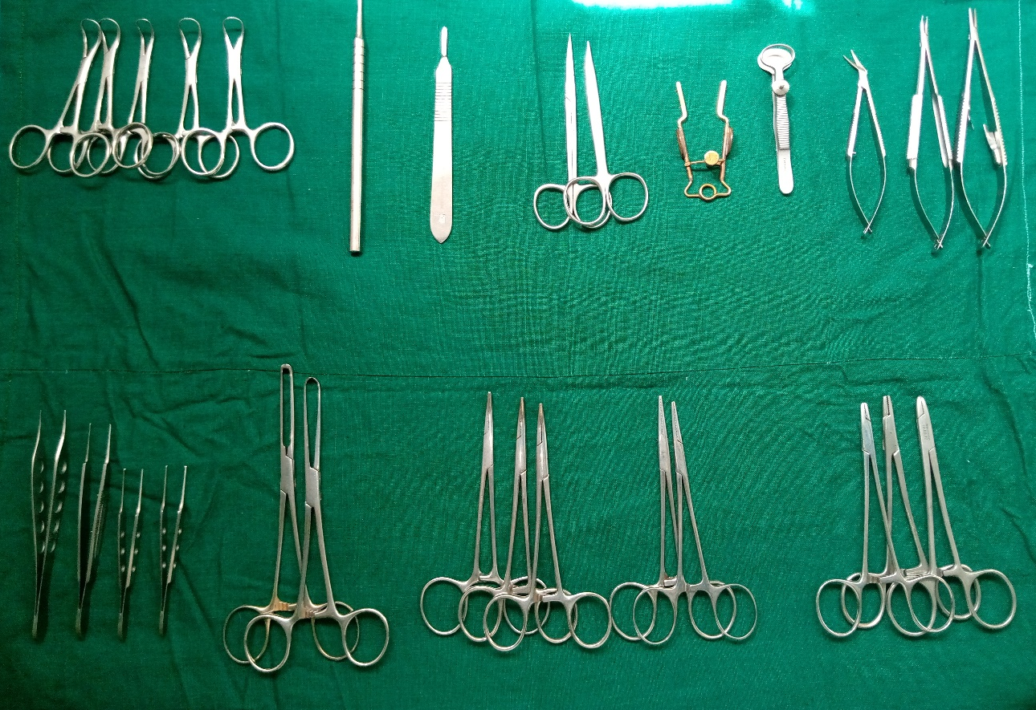
Fig. 1: Image of ophthalmic instruments used for the surgeries.
Comprising of a: Backhaus towel clamps, b: straight Halsted Mosquito forceps, c: Bird Parker scalpel size 3, d: Iris scissors, e: eye retractor, f: eye forceps, g: Castroviejo scissors and needle holders, h: non-toothed and toothed thumb forceps, i: Allis tissue forceps, j: curved Halsted mosquito forceps, k: straight Halsted mosquito forceps, l: small-sized needle holders.
i
j
k
l
h
g
f
e
d
b
c
a

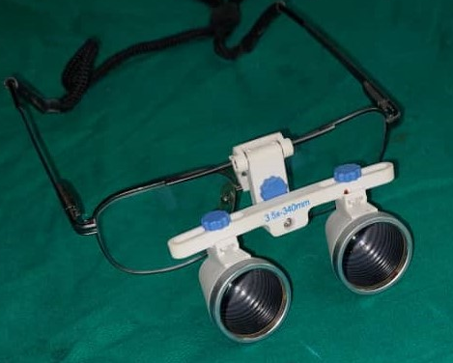
Fig. 2: Image of magnifying loop used for the procedures.
Fig. 2: Surgeon wearing a magnifying loop in preparation for surgery.
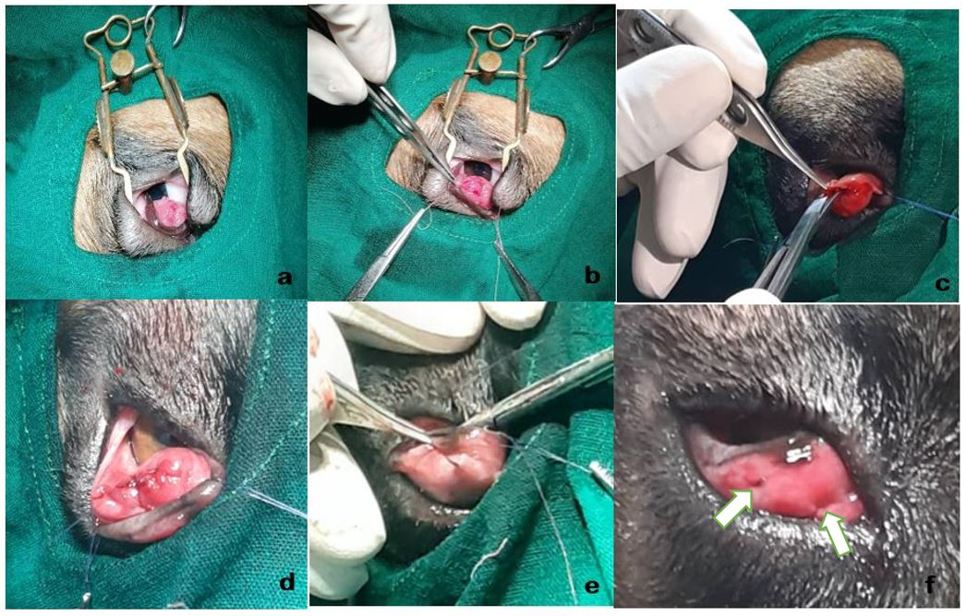
Fig. 3: Intraoperative images showing step by step procedure.
3a: The upper and lower eyelids were retracted with an eye speculum.
3b: Two stay sutures (medial and lateral) were placed and held in place with Halsted mosquito forceps to expose the bulbar surface of the third eyelid and 2 elliptical incisions were made above and below the point of protrusion of the gland.
3c: The conjunctiva and connective tissue around the gland was undermined by blunt and sharp dissection with Iris or Castroviejo scissors to create a pocket for the gland 3d: The gland was repositioned, and conjunctiva was closed with size 6/0 or 5/0 Polyglactin 910 or Vicryl in 2 rows of simple continuous suture pattern.
3e: The first and last suture bites were taken at the palpebral surface of the third eyelid.
3f: The knots were placed at the palpebral surface of the third eyelid (indicated by arrows) to prevent irritation to the cornea.

Fig. 4: Breed distribution of cherry eye patients managed at the VTH, UI.
Bar chart showing breed distribution of the 31 dogs presented to the VTH, UI between May 2013 and April 2021 for management of cherry eye.

Fig. 5: Yearly distribution of cherry eye patients managed at the VTH, UI.
Bar chart showing yearly distribution of the 31 dogs presented to the VTH, UI between May 2013 and April 2021 for management of cherry eye.
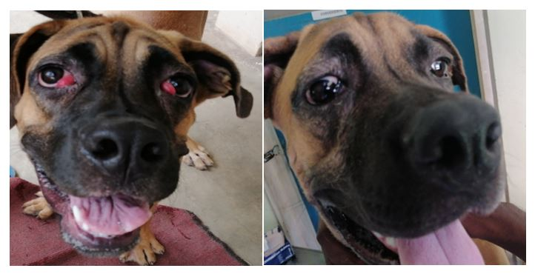
Fig. 6: Image showing a boerboel managed for bilateral cherry eye before surgery (left) and 2 weeks after repositioning the gland (right) with the modified Morgan Pocket Technique (MPT) described by the authors.

