Persistent organochlorine pesticides in fresh Nile tilapia fish from Assiut city, Egypt and their health effects on human.

Abeera Mahmoud El-Sayedª, Wafaa H. Mohamed^{b} and Ahmed A. Sharkawy^{c}

E-mail of corresponding author, dr.abeera.elsayed@sohag.edu.eg

a) Fellow-Sohag University Hospital, Faculty of medicine, Sohag University, Egypt.
b) Department of Forensic Medicine and Toxicology, Faculty of Veterinary Medicine, Aswan University, Egypt.
c) Department of Forensic Medicine and Toxicology, Faculty of Veterinary Medicine, Assiut University, Egypt.

Abstract:
The present study investigated some residues of organochlorine pesticides in the highly consumed types of fish in Egypt, tilapia. 75 Nile tilapia (Oreochromis niloticus) were collected from fishing sites in three areas, Caesarea, Qualidia, and El-wasta in Assiut city to detect the extent of the pollution in the city. The residues were analyzed by Gas chromatography–mass spectrometry. Average concentrations of pesticide residues in the muscle of tilapia were estimated. The results showed the presence of different types of organochlorine pesticides in Caesarea, Qualidia, and El-wasta areas in varying degrees. In conclusion, organochlorine pesticide residue levels have not exceeded the maximum residual limit. Overall, the highest levels of pesticide residues were found in Caesarea and El-wasta than Qualidia area.
Keywords: Organochlorine pesticide residues, tilapia fish, Assiut.

1. Introduction:
Nowadays many types of pesticides in Egypt have been used in agriculture and affect public health. Drainage water from lands treated with pesticides is pushed into several major pipes that discharged their waters into the River Nile or lakes. Therefore, exposure of the human population is through the drinking water and via the food supply. Contamination with these substances is a fatal problem facing the world. However, their effects are increasing in developing countries due to the lack of monitoring programs regarding the presence of pesticides residues in foods (Malhat and Nasr, 2011).Some reports show that liver and kidney diseases have raised in the past few years in Egypt. However, during the last 20 years in Egypt pesticides have made severe problems following chronic exposure to their residues. There are no consistent monitoring programs in Egypt for the identification and determination of pollutants in the environment, although Egypt is the fourth largest importer of pesticides among developing countries (Yamashita et al., 2000).

Fish is an appropriate indicator for monitoring environmental pollution. The presence and distribution of organochlorine pesticides (OCPs) in fish especially edible fish species are important from a biological and human health perspective. Bioaccumulation occurs in fish for contaminants that they ingest with their food or bio concentration of chemicals directly from water (Gobas et al., 1999).

OCPs are anthropogenic persistent contaminants in the environment, accumulate in fatty tissues and their concentrations increase as they go up the food chain (WHO, 1999). They have lipophilic nature and accumulate along trophic levels inducing many adverse impacts in different organisms (Fleming et al., 2006). Organochlorine exposure in humans may occur through different routes by inhalation, ingestion and dermal. Exposure to organochlorines occurs during adulthood as well as during the prenatal and neonatal periods. Organochlorines pass through placental transfer to the developing fetus and the neonate through lactation. Organochlorine compounds have many adverse effects on human health, such as hormone-related conditions, cancer of reproductive organs, neurotoxicity and immunotoxicity. Organochlorines can induce key genes such as cytochrome P-450 1A1 gene which act on the metabolism of steroids and xenobiotic (Kleanthi et al., 2008).

In Egypt, OCPs as DDT and lindane have been barred in 1980, and in 1996, a Ministerial Decree prohibited many pesticides including aldrin, dieldrin, endrin, chlordane, heptachlor, DDT, lindane, endosulfan, and heptachlor epoxide for protecting the human health and environment from OCPs. In 2002, Egypt contracted the Stockholm Convention on Persistent Organic Pollutants (POPs) and ratified it in 2003 (Barakat et al., 2013). Sources of these pesticides may originate from previous or illegal use. Therefore, this study was designed to monitor the levels of OCPs residues in fish samples involving the most famous and highly consumed types of fish (tilapia) in Assiut city, Egypt, and to make a comparison between these levels with the international maximum residual limits.

2. Materials and Methods:
2.1. Sampling:
The sampling sites include three areas, Caesarea, Qualidia, and El-wasta in Assiut city, The study included a total of 75 Nile tilapia (Oreochromis niloticus) were collected from fishing sites in the previously mentioned areas. The tilapia fish were examined for detection and determination of organochlorine residues. The average fish size is about (250 ± 50 g) for individual fish. From each fish sample nearly 200 g was obtained in glass containers and placed into an ice chest. Fish samples were immediately transferred to the laboratory and stored at−4 °C in a refrigerator until analyses were conducted. Average concentrations of organochlorine residues in the muscle of tilapia and mackerel (n = 15 pooled samples with five fish) were estimated.

2.2. Standards and reagents:
The analytical pesticide standards of the organochlorine pesticides included p,p-DDE, methoxychlor, lindane, hexachlorbenzene (HCB), heptachlor, heptachlor-epoxide, endrin, endosulfan, aldrin and dieldrin. Pesticide standards were purchased from Sigma (Poole, UK). Individual standard solutions of pesticide were set by dissolving 10 mg of each compound in 10 mL hexane. A mixed standard solution was prepared from the individual stock solutions with a concentration of 100 mg/L. Calibration standards were prepared by diluting 100 mg/L of the mixed standard solution to give concentrations of 0.1, 0.2, 0.5, 1.0 and 2.0 mg/L in hexane. All stock and working solutions were kept at 4 °C and used only for 3 months and 1 week, respectively. The used solvents were acetone, n-hexane, and acetonitrile, which were purchased from (Sigma-Aldrich, UK). Anhydrous sodium sulfate and sodium chloride were also used. All the reagents were of the highest purity grades.

2.3. Sample extraction:
Ten grams of minced fish sample mixed with 3.0 mL of water and was placed into centrifuge tube then the mixture was vortexed for 1 min. A 20 mL aliquot of acetonitrile was added and the resulting mixture was vortexed for 15 min. 5 g of sodium chloride was added to the mixture and vortexed for another 2 min, and then centrifuged for 5 min at 4000 rpm. 10 mL of the extraction solution was composed in a 100 mL flask, which was kept in the freezer at−24 °C for 20 min. Cold extracts at −24 °C were immediately filtered with filter paper to remove the frozen lipids. The filtered extract was concentrated to 1 mL by rotary evaporation (Chen et al., 2009).

2.4. GC analysis:
One-microliter extract was injected in the pulsed splitless mode of an Agilent 7890 gas chromatography equipped with a 5975 insertion source mass detection system (Agilent Technologies, USA). The analytical capillary column was a J & W Scientific, DB-1701. The experimental conditions were as follows: injection temperature was 260ºC, the oven temperature was 150-270 ºC and detector temperature was 230 ^{º}C. The carrier gas used was helium with a flow rate of 1 ml min/1. Organochlorine residues were identified by comparing sample peak relative retention times with those obtained for standards. The area of the corresponding peak in the sample was compared and quantified with that of the standard.

2.5. Statistical analyses:
The data were expressed as mean ± SE. The data was compared with the maximum permissible limits stated by EC (2005) and FAO/WHO (2016).

3. Results:
The results of this study were summarized in tables 1-4 and figure 1-3.
OCPs residues in three different areas were as follow:
In the Caesarea area, the detected OCPs include aldrin, endrin, heptachlor, HCB, lindane, methoxychlor and p,p DDE. The mean values of these pesticides were 0.045±0.012, 0.083±0.012, 0.115±0.025, 0.194±0.043, 0.019±0.005, 2.533±0.548 and 0.032±0.006 ppb, respectively (table 1).

In the Qualidia area, aldrin, dieldrin, endrin, heptachlor, lindane, methoxychlor and p,p DDE were detected. The values were 0.008±0.002, 0.609±0.063, 0.040±0.010, 0.083±0.013, 0.014±0.004, 0.605±0.058 and 0.021±0.006 ppb, respectively (table 2).

In the El-wasta area, endosulfan, endrin, heptachlor, heptachlor-epoxide, HCB, and p,p DDDE are the OC pesticides that could be detected. Their mean values are 4.232±0.718, 0.217±0.052, 0.063±0.013, 3.958±0.484, 1.223±0.360 and 0.024±0.002 respectively (table 3).

4. Discussion:
In the present study, ten OCPs (Aldrin, dieldrin, endosulfan, endrin, heptachlor, heptachlor-epoxide, HCB, lindane, methoxychlor, and p,p DDE) were analyzed in a total of 75 Nile tilapia fish collected from the three different areas in Assiut city, Egypt. Residues of these banned compounds were detected in fishes, which was sufficient to confirm that these compounds are still in use.In the current study, the OCPs detected in tilapia fish were Aldrin, endrin, heptachlor, HCB, lindane, methoxychlor and p,p DDE in the Caesarea area and aldrin, dieldrin, endrin, heptachlor, lindane, methoxychlor, p,p DDE in Qualidia area and Endosulfan, endrin, heptachlor, heptachlor-epoxide, HCB and p,p DDDE in El wasta area. OC pesticide residue levels have not exceeded the maximum residual limit (EC, 2005, FAO/WHO, 2016).

These results in agreement with a previous study by Yahia and Elsharkawy (2014) who detected some OC pesticides in tilapia and catfish samples collected from two different areas in Assiut city but their values also not exceeded the maximum allowable concentration limit.

The presence of the pollutants in the environment depends mainly on its ecological origin (Perugini et al., 2004). A study shows that pesticide poisoning leads to deaths and chronic diseases representing one million per year worldwide (Environews, 1999). Many of the OCPs are carcinogens and neurotoxic (Kaiser, 2000). Also, exposure to pesticides leads to neuromuscular problems and drug metabolism stimulation (Subramaniam and Solomon, 2006). Heptachlor is a neurotoxicant and causes cell death (Hong et al., 2014).

Lindane is an organochlorine insecticide and fumigant used in lotions, creams and shampoos for the control of lice and mites in humans. In this study, among analyzed OCPs, heptachlor and lindan were the predominant contaminants in fish muscle which is similar to that recorded by Zhou et al. (2007) who found OCPs like DDE, c-HCH and heptachlor as major pollutants in fish muscle.

DDT and its metabolites DDD and DDE are very highly persistent in the environment, with a half-life reach of 15 years (EPA, 1989) and very highly toxic to several aquatic species (WHO, 1989). Similar to our result, previous study with wild tilapia have detected that DDE is the most predominant DDT metabolite in fish muscle (Darko et al., 2008). However, the presence of DDE in the environment, rather than DDT, illustrated that no novel input of DDT has found in these sites. The current studies noticed a decrease in residues levels in the Nile River and coastal lakes, showing restriction effectiveness ruled on using of DDT and lindane since the mid-1980s (Yahia and Elsharkawy, 2014).

In our study, the other detected OCPs were alderin, dielderin, endosulfan, endrin, HCB, and methoxychlor present in various concentrations in tilapia. Dieldrin is an insecticide that has been used to control tsetse flies and used on fruit, soil and seed (ATSDR, 2002). HCB is used as a fungicide (Vizethum and Goerz, 1979) and it is a byproduct of chlorinated hydrocarbons production (Villanueva et al., 1974). The existence of HCB in fish lasted for short time (Villanueva et al., 1974) and much less toxic than DDT and other organochlorine compounds. HCB has dioxin like activity with low levels (Sinclair et al., 1997), and may lead to toxicity in combination with other polyhalogenated hydrocarbons. The effects caused by endosulfan are of great concern because its residues stay for longer periods in the environment and bio-accumulates in plants and animals leading to contamination of food (Briz et al., 2011).

Aldrin, dieldrin, endrin, heptachlor, and its epoxide were found in bolti fish and catfish samples collected from governorates as Beni-Suef and Fayoum. (Dogheim et al., 1990). However, chlordane, dieldrin, and HCB wereused as insecticides and are still extensivelydetected in the environment (El-Kady et al., 2017). Regarding OCPs hazards on humans, they increase the risk of incidence of different types of cancer (Wolff et al., 1993). TCDD, methoxychlor and alachlor inhibit the synthesis and increase degradation of thyroid hormones. Exposure to persistent organic pollutants, mainly OCPs strongly related to type 2 diabetes. A study performed in Costa Rica showed that occupational exposure to dialdrin might lead to an increase the incidence of Parkinson’s disease in the population (Steenland et al., 2014).

In infants, prenatal exposure to DDT, HCB and mirex induced a decrease in the birth weight of infants in China (Guo et al., 2014). A report in Brazil indicated that OC compounds have anti-androgenic effects in men and estrogenic effects in women (Freire et al., 2014). A positive correlation was reported between OC pesticides and deficiency of vitamin D in humans (Yang et al., 2012). Hence, the use of chemical pesticides should be restricted and the use of bio-pesticides should be increased. Awareness of people should be brought up in concern with hazards of pesticides.

Conclusion:
The results of this study revealed the presence of some types of OCPs in fish collected from Caesarea, Qualidia and El-wasta areas in Assiut city, Egypt on different levels. In general, these results showed the highest levels of OCPs were in Caesarea and El-wasta than Qualidia. This gives an indication of the extent of chemical contamination of fish in these areas. Most of these pesticides have been banned in most countries of the world but the results of the study have indicated that they are still in use as they being found in fish in assiut city, Egypt. Repeated consumption of these fish for long time can result in huge health effects on the consumers even taken in small quantities. So, regular continuous monitoring of such pesticides should be done.

Conflict of interest:
The authors have no conflict of interest to declare

References:
ATSDR, 2002. Agency for Toxic Substances and Disease Registry.Toxicological profile for aldrin and dieldrin. US Department of Health and Human Services, Public Health Service, Atlanta, GA.

Barakat, A. O., Khairy, M., Aukaily, I. 2013. Persistent organochlorine pesticide and PCB residues in surface sediments of Lake Qarun, a protected area of Egypt. J Chemosphere, 90(9): 2467-2476.

Briz, V., Molina-Molina, J-M., Sánchez-Redondo, S., Fernández, M. F., Grimalt, J. O., Olea, N., Rodríguez-Farré, E., Suñol, C. 2011. Differential estrogenic effects of the persistent organochlorine pesticides dieldrin, endosulfan, and lindane in primary neuronal cultures. J Toxicol. Sci. 120(2): 413-427.

Chen, S., Yu, X. He, X., Xie, D., Fan, Y., Peng, J. 2009. Simplified pesticide multiresidues analysis in fish by low-temperature cleanup and solid-phase extraction coupled with gas chromatography/mass spectrometry. J Food Chemistry, 113(4): 1297-1300.

Darko, G., Akoto, O., Oppong, C. 2008. Persistent organochlorine pesticide residues in fish, sediments and water from Lake Bosomtwi, Ghana. J Chemosphere, 72(1): 21-24.

Dogheim, S. M., Nasr, E. N, Almaz, M. M., EL-Tohamy, M. M. 1990. Pesticide residues in milk and fish samples collected from two Egyptian governorates. JAOAC. 73(1): 19-21.

EC, 2005. European commission, EU Pesticides database.

El-Kady, A. A., Wade, T. L., Sweet, S. T., Sericano, J. L. 2017. Distribution and residue profile of organochlorine pesticides and polychlorinated biphenyls in sediment and fish of Lake Manzala, Egypt. Environ. Sci. Pollut. Res. Int. 24(11): 10301-10312.

Environews, F., 1999. Killer environment. Environ. Health Perspect. 107(2): A62-A63.

EPA, 1989. Environmental Fate and Effects Division, Pesticide Environmental Fate One Line Summary: DDT (p,p0). Washington, DC.
.
FAO/WHO, 2016. Manual on development and use of FAO and WHO specifications for pesticides. First edition- thrid revision.

Fleming, L., Broad, K., Clement, A., Dewailly, E., Elmir, S., Knap, A., Pomponi, S. Smith, S., Gabriele, H. S., Walsh, P. 2006. Oceans and human health: emerging public health risks in the marine environment. Mar. Pollut. Bull. 53(10-12): 545-560.

Freire, C., Koifman, R. J., Sarcinelli, P.N., Rosa, A. C. S., Clapauch, R., Koifman, S. 2014. Association between serum levels of organochlorine pesticides and sex hormones in adults living in a heavily contaminated area in Brazil. Int. J. Hyg. Environ. Health, 217(2-3): 370-378.

Gobas, F. A., Wilcockson, J. B., Russell, R. W., Haffner, G. D. 1999. Mechanism of biomagnification in fish under laboratory and field conditions. J Environ. Sci. and Tech. 33(1): 133-141.

Guo, H., Jin, Y., Cheng, Y., Leaderer, B., Lin, S., Holford, T. R., Qiu, J., Zhang, Y., Shi, K., Zhu, Y., Niu, J., Bassig, B. A., Xu, S., Zhang, B., Li, Y., Hu, X., Chen, P., Zheng, T. 2014. Prenatal exposure to organochlorine pesticides and infant birth weight in China. J Chemosphere, 110: 1-7.

Hong, S., Hwang, J., Kim, J. Y., Shin, K. S., Kang, S. J. 2014. Heptachlor induced nigral dopaminergic neuronal loss and Parkinsonism-like movement deficits in mice. Exp. Mol. Med. 46(2): e80.

Kaiser, J. 2000. Endocrine disrupter. Panel cautiously confirms low-dose effects. Science, 290(5492): 695-697.

Kleanthi, G., Katerina, L., Evaggelia, P., Andreas, L. 2008. Mechanisms of actions and health effects of organochlorine substances: a review. Health Sci. J. 2(2): 81-85.

Malhat, F., Nasr, I., 2011. Organophosphorus pesticides residues in fish samples from the River Nile tributaries in Egypt. Bull. Environ. Contamin. Toxicol. 87: 689-692.

Perugini, M., Cavaliere, M., Giammarino, A., Mazzone, P. Olivieri, V., Amorena, M. 2004. Levels of polychlorinated biphenyls and organochlorine pesticides in some edible marine organisms from the Central Adriatic Sea. J Chemosphere, 57(5): 391-400.

Sinclair, P. R., Walton, H. S., Gorman, N., Jacobs, J. M., Sinclair, J. F. 1997. Multiple roles of polyhalogenated biphenyls in causing increases in cytochrome P450 and uroporphyrin accumulation in cultured hepatocytes. Toxicol. Appl. Pharmcol. 147(2): 171-179.

Steenland, K., Mora, A., Barr, D., Juncos, J., Roman, N., Wesseling, C. 2014. Organochlorine chemicals and neurodegeneration among elderly subjects in Costa Rica Environ. Res. 134: 205-209.

Subramaniam, K., Solomon, J. 2006. Organochlorine pesticides BHC and DDE in human blood in and around Madurai, India. Indian J. Clin. Biochemistry, 21(2): 169-174.

Villanueva, E. C., Jennings, R. W., Burse, V. W., Kimbrough, R.D. 1974. Evidence of chlorodibenzo-p-dioxin and chlorodibenzofuran in hexachlorobenzene. J Agric. Food Chem. 22(5): 916-917.

Vizethum, W., Goerz, G. 1979. Induction of the hepatic microsomal and nuclear cytochrome P-450 system by hexachlorobenzene, pentachlorophenol and trichlorophenol. J Chem. Biol. Interac. 28(2-3): 291-299.

WHO, 1989. Environmental health criteria 83, DDT and its derivatives environmental effects. World Health Organization, Geneva.

WHO, 1999. Basic food safety for health workers, Geneva. http://www.who.int/foodsafety/publications/capacity/healthworkes/en/index.
html.

Wolff, M., Toniolo, P., Lee, E., Rivera, M., Dubin, N. 1993. Blood levels of organochlorine residues and risk of breast cancer. J. Natl. Cancer Inst. 85(8): 648–652.

Yahia, D., Elsharkawy, E. E. 2014. Multi pesticide and PCB residues in Nile tilapia and catfish in Assiut city, Egypt. J Sci. Total Environ. 466-4467: 306-314.

Yamashita, N., Urushigawa, Y., Masunaga, S., Walash, M. I., Miyazaki, A. 2000. Organochlorine pesticides in water, sediment and fish from the Nile River and Manzala Lake in Egypt. Intern. J. Environ. Anal. Chem. 77(4): 289-303.

Yang, J.-H., Lee, Y.-M., Bae, S.-G., Jacobs, D. R., Lee, D.-H. 2012. Associations between organochlorine pesticides and vitamin D deficiency in the US population. J PLoS One, 7(1): e30093.

Zhou, R., Zhu, L., Kong, Q. 2007. Persistent chlorinated pesticides in fish species from Qiantang River in East China. J Chemosphere, 68: 838-847.

Table 1: Concentrations (μg/kg) of organochlorine residues in the examined tilapia fish in the Caesarea area.

Organochlorine pesticides | Examined Tilapia fish
Aldrin | 0.045 ± 0.012
Dieldrin | Not detected
Endosulfan | Not detected
Endrin | 0.083 ± 0.012
Heptachlor | 0.115 ± 0.025
Heptachlor-epoxide | Not detected
HCB | 0.194 ± 0.043
Lindane | 0.019 ± 0.005
Methoxychlor | 2.533 ± 0.548
p,pDDE | 0.032 ± 0.006

Table 2: Concentrations (μg/kg) of organochlorine residues in the examined tilapia fish in the Qualidia area.
Organochlorine pesticides | Examined Tilapia fish
Aldrin | 0.008 ± 0.002
Dieldrin | 0.609 ± 0.063
Endosulfan | Not detected
Endrin | 0.040 ± 0.010
Heptachlor | 0.083 ± 0.013
Heptachlor-epoxide | Not detected
HCB | Not detected
Lindane | 0.014 ± 0.004
Methoxychlor | 0.605 ± 0.058
p,pDDE | 0.021 ± 0.006

Table 3: Concentrations (μg/kg) of organochlorine residues in the examined tilapia fish in the El-wasta area.
Organochlorine pesticides | Examined Tilapia fish
Aldrin | Not detected
Dieldrin | Not detected
Endosulfan | 4.232 ± 0.718
Endrin | 0.217 ± 0.052
Heptachlor | 0.063 ± 0.013
Heptachlor-epoxide | 3.958 ± 0.484
HCB | 1.223 ± 0.360
Lindane | Not detected
Methoxychlor | Not detected
p,pDDE | 0.024 ± 0.002

Table 4: Frequency distribution of the OCPs residues in the examined tilapia compared with the recommended permissible limits (PL).
OCPs | PL  (μg/Kg) | Not detected |  |  | Within PL |  |  | Exceed PL
 |  | Cae | Qua | Was | Cae | Qua | Was | Cae | Qua | Was
No | 200⁽²⁾ | ----- | ----- | ND | WPL | WPL | ----- | No | No | No
Dieldrin | 200⁽²⁾ | ND | ----- | ND | ----- | WPL | ----- | No | No | No
Endosulfan | 50⁽¹⁾ | ND | ND | ----- | ----- | ----- | WPL | No | No | No
Endrin | 50⁽¹⁾ | ----- | ----- | ----- | WPL | WPL | WPL | No | No | No
Heptachlor | 200⁽²⁾ | ----- | ----- | ----- | WPL | WPL | WPL | No | No | No
Heptachlor-epoxide | 200⁽²⁾ | ND | ND |  |  |  | WPL | No | No | No
HCB | 5⁽¹⁾ | ----- | ND | ----- | WPL | ----- | WPL | No | No | No
Lindane | 10⁽¹⁾ | ----- | ----- | ND | WPL | WPL | ----- | No | No | No
Methoxychlor | 10⁽²⁾ | ----- | ----- | ND | WPL | WPL | ----- | No | No | No
p, p DDE | 1000⁽¹⁾ | ----- | ----- | ----- | WPL | WPL | WPL | No | No | No
Cae: Caesarea, Qua:qualidia, Was: wasta, ND: not detected, WPL: within the permissible limit, EX: exceeded the permissible limit. EC (2005), ⁽¹⁾ FAO/WHO (2016) ^{(2).}

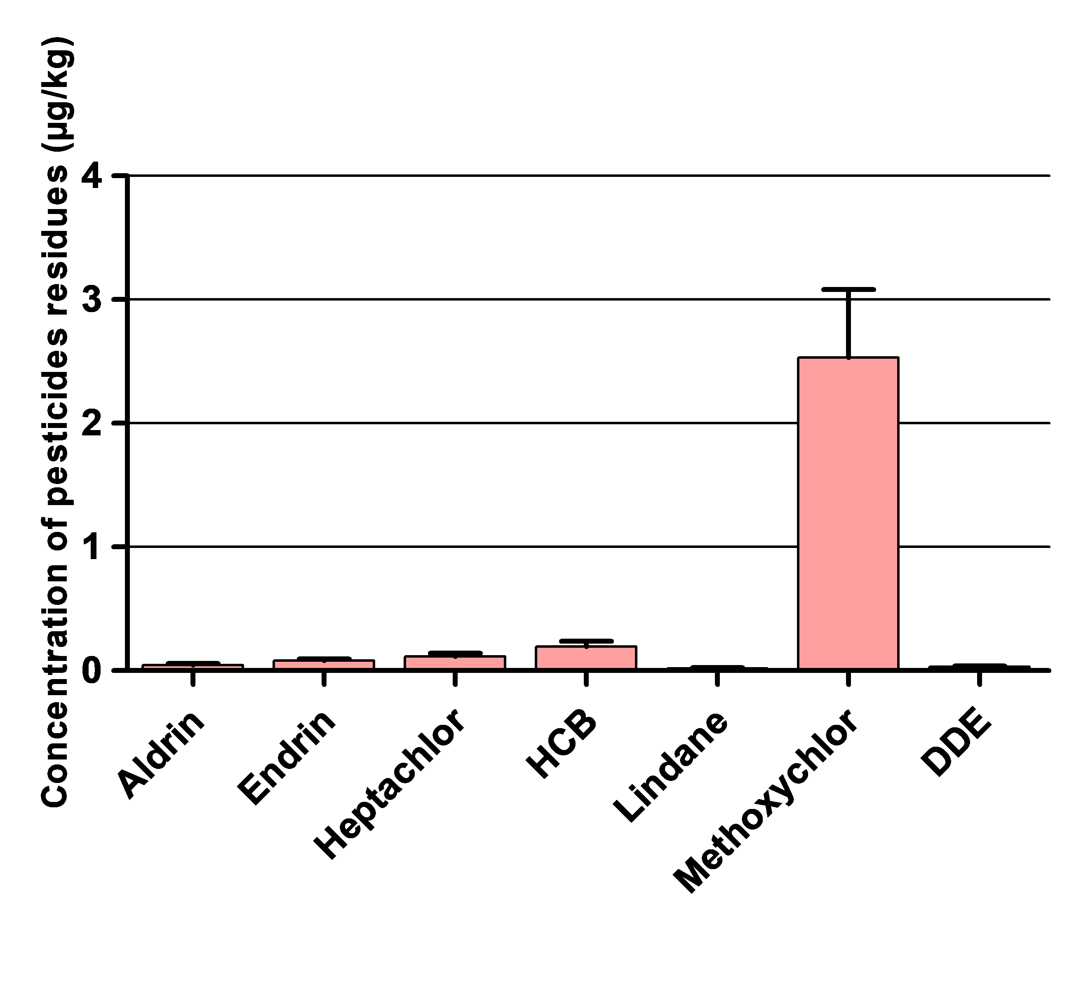
Fig. 1: Levels of the OC pesticides residues detected in tilapia fish in the Caesarea area
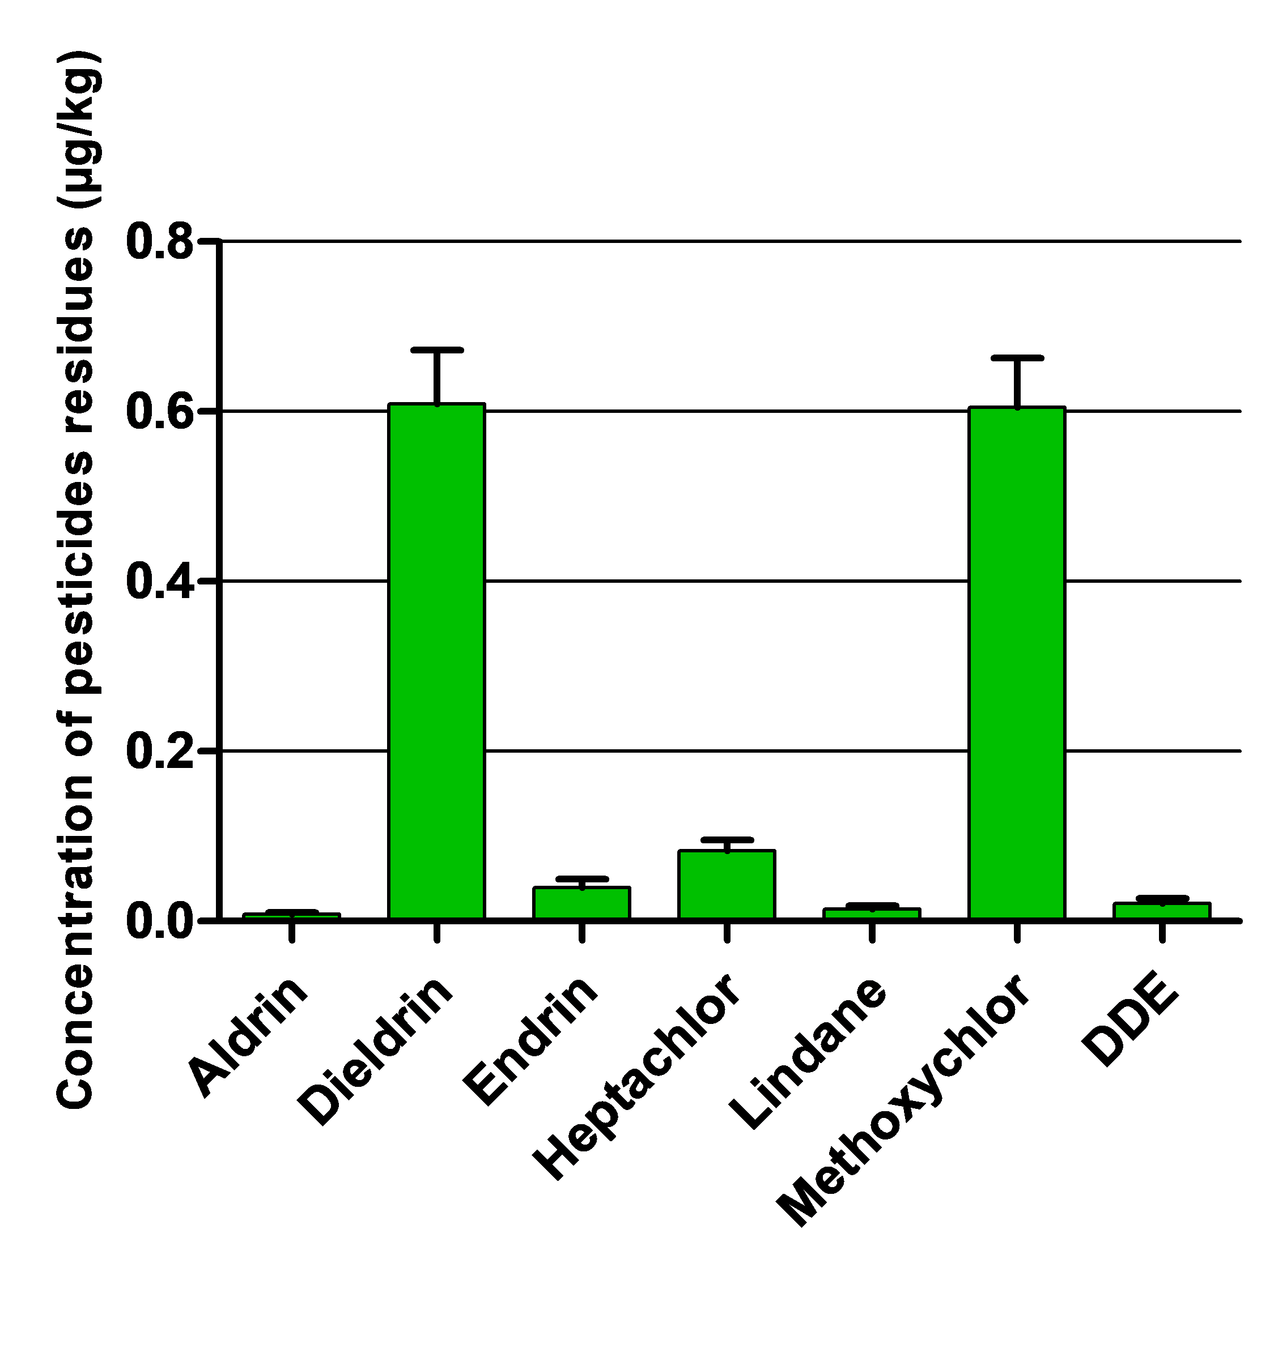
Fig. 2: Levelsof the OC pesticides residues detected in tilapia fish in Qualidia area.

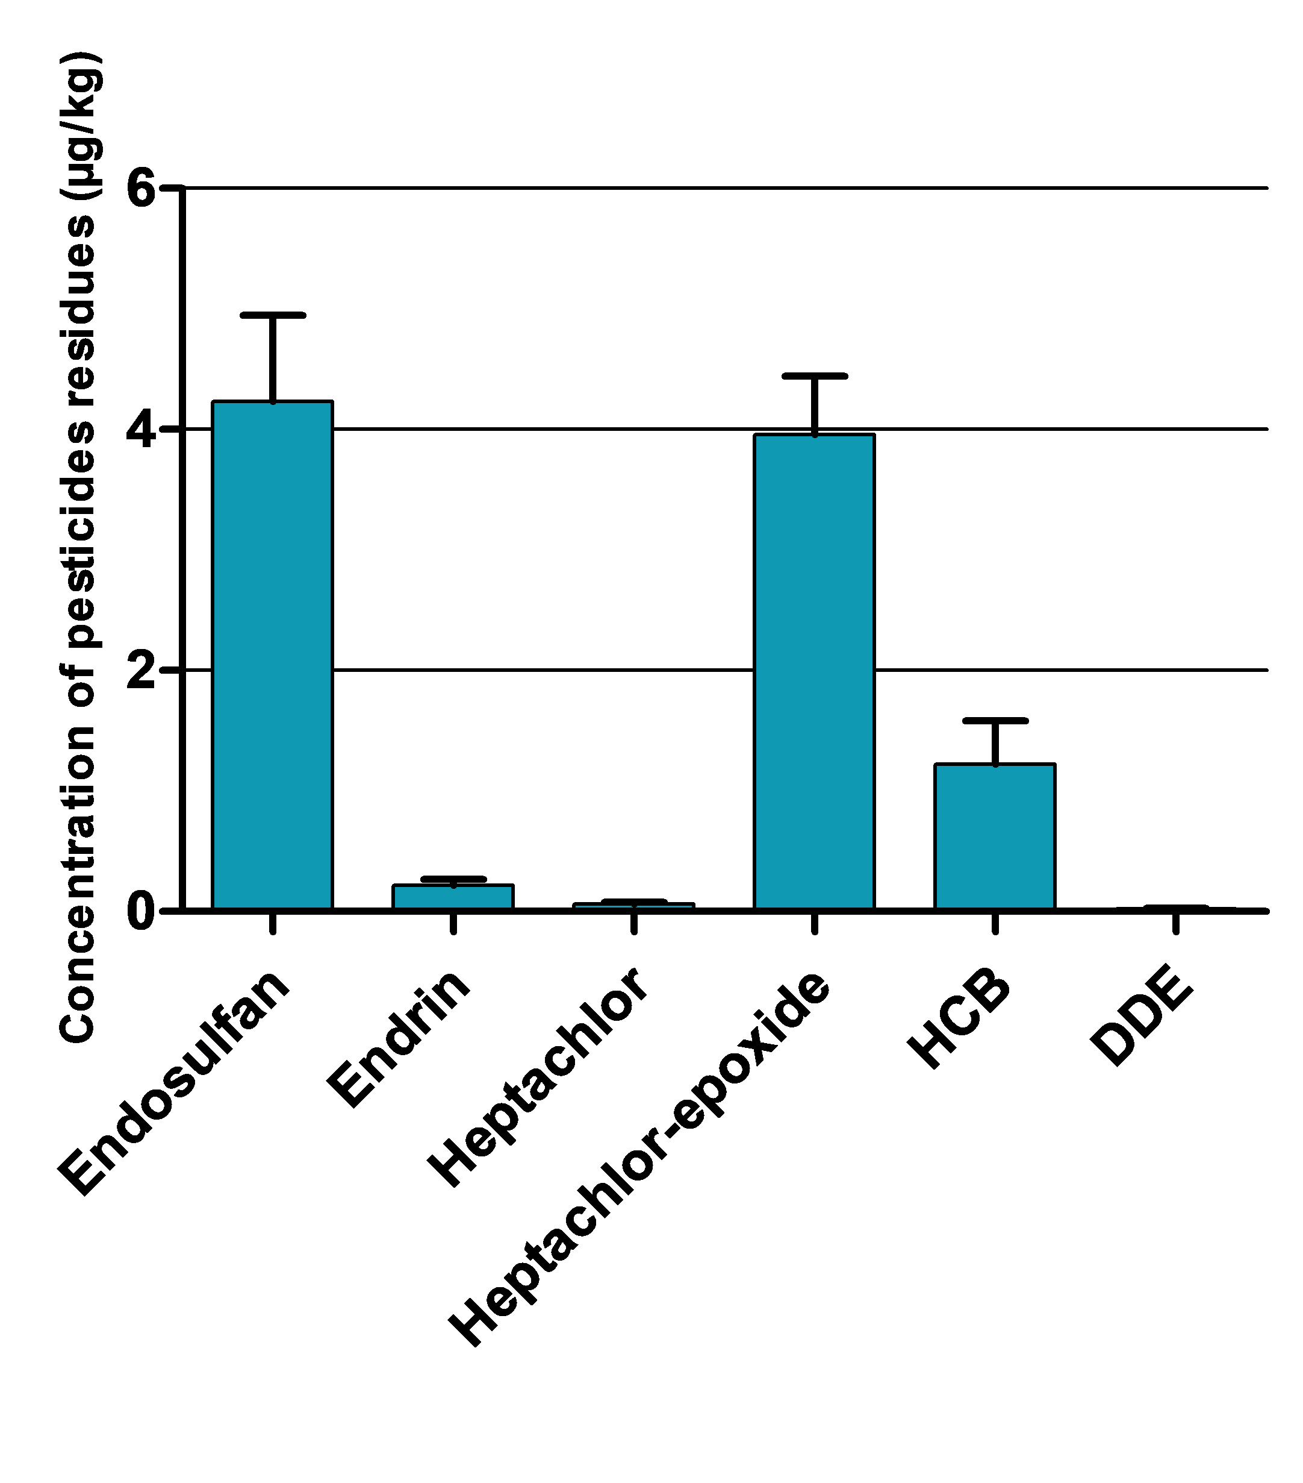
Fig. 3: Levels of the OC pesticides residues detected in tilapia fish in El-wasta area.

