Pattern of Antibody Response to Trypanosoma evansi Infection: A step for production of high affinity antibodies

El-Awad M. El Hassan¹, Omar A. Al-Jabr¹ and Sabry M. El-Bahr^{2,3,}*

Department of Microbiology¹, Biomedical Sciences², College of Veterinary Medicine, King Faisal University, Al-Ahsa, 31982, P.O. Box: 400, Saudi Arabia
³Department of Biochemistry, Faculty of Veterinary Medicine, Alexandria University, Alexandria, Egypt

*Corresponding author. Prof. Dr. Sabry M. El-Bahr, Department of Biochemistry, Faculty of Veterinary Medicine, Alexandria University, Alexandria, Egypt
E-mail: sabryelbahr@hotmail.com

Pattern of Antibody Response to Trypanosoma evansi Infection: A step for production of high affinity antibodies

ABSTRACT
The aim of this study is to determine the pattern of immune response during Trypanosoma evansi infection as a preliminary step for production of high affinity antibodies for use in immunoassays. Antibody response to Typanosoma evansi infection in mice was monitored during a short and a long immunization protocols. Both protocols yielded immunoglobulin M (IgM) and immunoglobulin G (IgG) responses. Observed initial antibody response was of an IgM type and later replaced by an IgG response. The IgM response was similar in both immunization protocols. It first detected on day 4, reached a peak level on day 6 and declined thereafter until it disappeared on day 37-post infection. The IgG response in the short protocol was first detected on day 17-post infection, reached a peak level on day 23 and maintained a high level up to the end of the experiment on day 45 post-infection. The IgG response in the long protocol was first detected on day 10-post infection, reached a peak level on day 42 and maintained this level to the end of the experiment. The current study suggests for the first time the pattern of immune response during Trypanosoma evansi infection as a preliminary step for production of high affinity antibodies.

Keywords: Trypanosoma evansi, immunization, IgM, IgG, high affinity antibodies, immunoassays.

1. INTRODUCTION
Trypanosomosis caused by Typanosoma evansi is one of the major parasitic diseases affecting camels in Saudi Arabia. The parasite and anti-parasite antibodies are detected in dromedary camels in many parts of the country (Diab et al 1984, Kasim 1984, El-Metenawy 1998, Omer et al 1998, Al-Khalifa et al 2009 and Al-Salameen et al 2020).
Accuracy in diagnosing this disease is highly important for treatment, as well as tracking the prevalence of infection and avoidance of drug misuse (Singh et al 2014). Immunoassays for detection of circulating Typanosoma evansi antigens in infected animals are ideal diagnostic tests since antigen-positivity indicates existing infection. These assays necessitate the use of high affinity anti-Typanosoma evansi antibodies. The immune response to the infecting trypanosomes involves both humoral and cellular responses and the growth of the parasite in infected animals is mainly controlled by antibodies directed to the variable surface glycoproteins as well as other molecules embedded in the surface coat (Awukew et al, 2017).
Information regarding the class of antibody response to Typanosoma evansi infection is important in setting up immunization protocols for production of high affinity anti- Typanosoma evansi antibody for use in immunoassays. The immunization regime greatly influences the type of response and antibody characteristic. The duration of the protocol determines the class of antibody produced (Greenfield, 2014). IgM antibodies usually produced with a short period of immunization and a single infection (Theodos et al, 1990), while IgG antibodies generally produced through longer immunization protocol involving multiple inoculations of living trypanosomes (Masterson et al 1988) and boosting with soluble trypanosome extracts (Alves et al 1983, Theodos et al, 1990).
Two immunization protocols previously used to produce monoclonal antibodies to T. brucei and T. rhodesiense were compared in this pilot study: a short protocol as described by Theodos et al (1990) and a long protocol as described by Masterson et al (1988).

2. MATERIALS AND METHODS
2.1. Trypanosomes
Typanosoma evansi trypanosomes (TR 2165) originally isolated from naturally infected camels in Al-Ahsa area, Saudi Arabia (El Hassan, 2017) were used in this study.

2.2. Immunization protocols
Two groups, each containing five adult male albino mice weighing ~250 mg, were used in this study. One group (A) infected I.P. with 2.6x10⁶ trypanosomes per mouse and treated as described by Theodos et al (1990), with Berenil at a dose rate of 335µg/mouse for three consecutive days starting three days post-infection. Group (B) mice infected as above but treated two days later as described by Masterson et al (1988), with a single dose of 5mg Berenil/kg body weight. This group boosted thirty days post-infection with 2.6x10⁶ trypanosomes per mouse and treated next day with Berenil as above. In both groups 100µl tail blood was collected from each mouse for preparation of serum on days 4, 6, 10, 17, 23, 37, 42 and 45 post-infection.

2.3. Monitoring antibody response
2.3.1. Indirect fluorescent antibody test (IFAT) with living trypanosomes as
antigen
Sera collected from both groups of mice were tested by IFAT for antibody response to surface antigens using live trypanosomes as antigen as described by Doyle et al (1990) using FITC-labelled sheep anti-mouse IgM or IgG. At least fifty parasites examined per sample. The number of fluorescent trypanosomes recorded as a percentage of the total number of trypanosomes.

2.3.2. IFAT using formalin-fixed trypanosomes
Immunofluorescence utilizing formalin-fixed, air-dried Typanosoma evansi trypanosomes was used to monitor the IgG response to parasites in group (B) mice following challenge with 2.6x10⁶ homologous trypanosomes. Serum collected from group (B) mice on days 37, 42 and 45 post-infection was diluted 1/10 in PBS and FITC-labelled sheep anti-mouse IgG diluted 1/20 in PBS was used in this test.

2.3.3. Agglutination test
Sera collected from both groups of mice on days 4, 6, 10, and 23 post-infection were tested for agglutinating antibodies, over a 2-fold dilutions range from 1/2 to 1/1024, by incubation with homologous Typanosoma evansi population.

3. RESULTS
3.1. Antibody response in mice of the short immunization protocol (group A)
The anti-IgM conjugate labelled 16.4% of the live trypanosomes four days after infection, reaching a peak labelling at day 6 and fell to an undetectable level by 37 days after infection (Table 1).
The anti-IgG conjugate did not label any trypanosomes until 17 days after infection when 75% of the living trypanosomes were labelled. A 100% labelling was reached six days later with a slight fall thereafter but maintained a high level up to day 45 after infection (Table 1).
Agglutinating antibodies levels in the immunized mice were similar in pattern to IgM levels with peak levels occurring at day 10. Levels of agglutinating antibodies fell to 1/64 by day 23 after infection (Table 4 & Figure 1).

3.2. Antibody response in mice of the long immunization protocol (group B)
Using living trypanosomes as IFAT antigen, IgM response in this group was similar to that seen in Group A. The peak activity of anti-IgM conjugate detected on day 6, then, gradually fell to undetectable levels 37 days after infection (Table 2). The action of IgG conjugate was, detected slightly earlier in this group by day 10 after infection. The activity increased reaching 100% labelling by 42 days post-infection, a level that was maintained until the end of the experiment on day 45 (Table 2).
When formalin-fixed trypanosomes used as IFAT antigen, 100% labelling was detected with all sera collected from group (B) following challenge with trypanosomes on day 30 (Table 3). Agglutinating antibodies in Group (B) were not detected before day 6 after infection, but a higher level of these antibodies was, maintained compared to group (A) mice (Table 5 & Figure 2).

4. DISCUSSION
In the present study, both immunization protocols produced IgM and IgG responses. Similar patterns of antibody developed in both groups of mice. An initial IgM response which later replaced by an IgG response. The overall pattern of the IgM response was similar in both immunization protocols where it first detected on day 4, reached a peak level on day 6 and waned thereafter until it disappeared on day 37 post-infection.
Little difference observed in the pattern of IgG response elicited by both immunization protocols. IgG response in Group (A) detected later than in Group (B) and reached a peak on day 23 post-infection. Group (B) mice showed a steady increase in the level of the IgG over the course of the experiment. The gradual increase in the number of labelled trypanosomes could, either be attributed to the difference in antigenicity of trypanosomes used in the test or more likely to a gradual maturation of epitope recognition by these antibodies since new variable antigen types (VAT) usually arise at 4-5 days intervals (Gray, 1965). Trypanosomes used in the present study had grown in mice for only three days.
The challenge of Group B mice on day 30 post-infection appeared to have boosted the IgG as would be, expected following a challenge with the same antigen (Greenfield, 2014).
A slight difference in the percentage of labelled trypanosomes by the anti-IgG conjugate was observed between formalin-fixed and live trypanosomes in IFAT test where a 100% labelling observed with formalin-fixed trypanosomes. Although formalin fixation stabilizes surface coat antigens while preserving their antigenicity (Nantulya and Doyle, 1977), non-surface antigens will also, be exposed following drying and fixation of the parasites. While with, live trypanosomes only the surface antigens will be, exposed to the serum in the test.
The immunoglobulin response reported in the present study is accordance with those reported in other hosts for trypanosomes infection. The persistence of IgM antibodies up to three weeks post-infection as indicated by the level of agglutinating antibodies is similar to that reported by Seed et al (1969) and Zahalsky and Weinberg (1976) during the period of primary infection in rabbits infected with T. b. gambiense and rats or cattle infected with T. b. brucei. Onah et al (1999) detected an initial IgM response that replaced later by IgG₁ particularly in self-cure sheep. Following treatment, the IgM response was replaced by IgG₁ in the rest of the experimental sheep. The predominant high level of IgG antibodies from 17 days post-infection compared to the level of IgM antibodies occurred regardless of the second challenge with trypanosomes is in agreement with predominant IgG response during primary infection reported by Campbell et al (1978), Nantulya et al (1979) and Uche (1989), for T. b. rhodesiense, T. b. brucei and Typanosoma evansi infections respectively.
In production of anti-Typanosoma evansi antibodies particularly monoclonal antibodies, the authors recommend IFAT utilizing formalin-fixed trypanosomes for screening the hybridomas, since it should be able to detect both surface and non-surface trypanosome antigens. It also has the additional advantage that fresh trypanosomes are not needed for performing the test, and fixed trypanosomes can be kept for longer periods without affecting the antigenicity of the trypanosome components (Nantulya and Doyle, 1977). The latter feature is an important criterion when large number of hybrid supernatant have to be tested as occurs in post-fusion screening.
The immunization protocol used for mice in Group (B) is also, recommended for production of anti-Typanosoma evansi antibodies. This choice based on a number of criteria: Firstly, the IgG response was elicited earlier by this group than by Group (A). Secondly, in production of monoclonal antibodies challenging with trypanosomes will activate more B lymphocytes which will improve the efficiency of the fusion of spleen cells. Fusion usually requires recently activated B cells (Goding, 1980) and recommended on day 3 after the final immunization (Oi et al, 1978). To bias class-specific antibodies, IgG antibodies were chosen because they contain high level of specific antibodies of high affinity to the immunogen (Greenfield, 2014). The latter is an important criterion to consider when antibodies are to be used in immunoassays.
Agglutination test was used in this study as a confirmatory test for IgM response since these antibodies are known as efficient agglutinators compared to IgG antibodies (Bellanti, 1985). Results obtained with this test generally confirm those of the IgM response. The current study suggests for the first time the pattern of immune response during Trypanosoma evansi infection as a preliminary step for production of high affinity antibodies.

5. REFERENCES
Al-Khalifa, M.S., Hussein, H.S., Diab, F.M., Khalil, G.M. 2009. Blood parasites of livestock in certain regions in Saudi Arabia. Saudi J. Biol. Sci. 16: 63–67.
AL-Salameen, M.A., El Hassan, E.M., Salem, M.A., Al-Jabr, O.A., Housawi, F.M. 2020. Prevalence of Trypanosoma evansi in dromedary camels (Camelus dromedarius) in Al-Ahsa area of Eastern Saudi Arabia. Sci. J. KFU (Basic and Applied Sciences) 21: 194-198.
Alves, M.J., Allison, A.C., Nussenzweig, V. 1983. Monoclonal antibodies to Trypanosoma cruzi inhibit motility and nucleic acid synthesis of culture forms. Infect. Immun. 39: 377-382.
Awukew, A., Terefe, G., Demisie, T., Eshetu, E. 2017. Immune responses to animal trypanosomosis: A review. J. Sci. Innov. Res. 6: 142-150.
Bellanti, J.A. 1985. Immunology III. Philadelphia. W.B. Saunders Company.
Campbell, G.H, Esser, K.M., Phillips, S.M. 1978. Trypanosoma rhodesiense infection in congenitally athymic (nude) mice. Infect. Immun. 20: 714-720.
Diab, F.M., Al-Asgah, N.A., Al Khalifa, M.S., Hussein, H.S. 1984. Ticks and blood parasites from indigenous domesticated animals in Saudi Arabia. In: The Seventh Symposium on the Biological Aspects of Saudi Arabia, College of Agriculture and Veterinary Medicine, KSU Qasim Branch, Saudi Arabia 20–2/03/1984.
Doyle, J.J., Hirumi, H., Hirumi, K., Lupton, E.N., Cross, G.A.M. 1980. Antigenic variation in clones of animal-infective Trypanosoma brucei derived and maintained in vitro. Parasitol. 80: 359-369.
EL Hassan, E.M. 2017. A preliminary characterization of a possible non-surface variant specific 42kda antigen in Trypanosoma evansi. J. Camel Pract. Res. 24(2): 141-150.
El-Metenawy, T.M. 1998. Studies on parasites infecting camels (Camelus dromedarius) in Al-Qasim region, Saudi Arabia. Suez Canal Vet. Med. J. 1(2): 341–349.
Goding, T.W. 1980. Antibody production by hybridomas. J. Immunol. Meth. 39: 285- 308.
Gray, A.R. 1965. Antigenic variation in a strain of Trypanosoma brucei transmitted by Glossina morsitans and G. palpalis. J. Gen. Micro. 41: 195-214.
Greenfield, E.A. 2014. Antibodies: A Laboratory Manual, Second edition. Cold Spring Harbor Laboratory Press.
Kasim, A. A. 1984. Detection of Trypanosoma evansi in the Arabian camel. J. College Sci. KSU. 15(2): 423–427.
Masterson, W.J., Taylor, D., Turner, M.J. 1988. Topologic analysis of the epitopes of a variant surface glycoprotein of Trypanosoma brucei. J. Immunol. Baltmore 140: 3194-3199.
Nantulya, V.M., Doyle, J.J. 1977. Stabilization and preservation of the antigenic specificity of Trypanosoma (Trypanozoon) brucei variant specific surface antigens by mild fixation techniques. Acta Trop. 34: 313-320.
Nantulya, V.M., Musoke, A.J., Barbet, A.F., Roelants, G.E. 1979. Evidence for reappearance of Trypanosoma brucei variable antigen types in relapse populations. J. Parasitol. 65: 673-679.
Oi, V.T., Jone, P.P., Goding, J.W., Herzenberg, L.A. 1978. Properties of monoclonal antibodies to mouse Ig allotypes, H-2 and Ia antigens. Curr. Top. Micro. Immunol. 81: 115-129.
Omer, O. H., Magzoub, M., Haroun, E. M., Mahmoud, O. M., Abdel Hamid, Y.M. 1998. Diagnosis of Trypanosoma evansi in Saudi Arabian camels (Camelus dromedarius) by the passive haemagglutination test and Ag-ELISA. Zentralbl. Veterinarmed. B 45(10): 627–633.
Onah, D.N., Hopkins, J., Luckins, A.G. 1999. Changes in peripheral blood lymphocyte subpopulations and parasite-specific antibody response in Trypanosoma evansi infection in sheep. Parasitol. Res. 85: 263-269.
Seed, J.R., Cornille, R.L., Risby, E.L., Gam, A.A. 1969. The presence of agglutinating antibody in the IgM immunoglobulin fraction of rabbit antiserum during experimental African trypanosomiasis. Parasitol. 59: 283-292.
Singh, V., Shyma, K.P., Gupta, J.P. 2014. Changing trends in diagnosis of trypanosomosis in animals. Indian J. Anim. Sci. 84(8): 811-818.
Theodos, C.M., Reinitz, D.M., Mansfield, J.M. 1990. Regulation of B cell response to the variant surface glycoprotein (VSG) molecule in trypanosomiasis 1. Epitope specificity and idiotypic profile of monoclonal antibodies to the VSG of Trypanosoma brucei rhodesiense. J. Immunol. Baltmore 144: 4011-4021.
Uche, U.E. 1989. Immunological studies of Trypanosoma evansi infections in rabbits. Ph.D. thesis, Univ. Edinburgh, Scotland.
Zahalsky, A.C., Weinberg, R.L. 1976. Immunity to monomorphic Trypanosoma brucei: Humoral response. J. Parasitol. 62: 15-19.

Table 1: Percentage of labelled living trypanosomes by anti-IgM and anti-IgG conjugates in Group A mice.
Days post-infection | Percentage of anti-IgM conjugate labelled trypanosomes | Percentage of anti-IgG conjugate labelled trypanosomes
4 | 16.4 | 0
6 | 85.5 | 0
10 | 78.2 | 0
17 | 45.0 | 75
23 | 40.0 | 100
37 | 0 | 90
42 | 0 | 92
45 | 0 | 98

Table 2: Percentage of labelled living trypanosomes by anti-IgM and anti-IgG conjugates in Group B mice.
Days post-infection | Percentage of anti-IgM conjugate labelled trypanosomes | Percentage of anti-IgG conjugate labelled trypanosomes
4 | 20 | 0
6 | 95.5 | 0
10 | 90.9 | 9.1
17 | 50.0 | 70.5
23 | 40.0 | 85.0
37 | 0 | 92.0
42 | 0 | 100
45 | 0 | 100

Table 3: Percentage of labelled formalin-fixed trypanosomes by anti-IgG conjugates in Group B mice.
Days post-infection | Percentage of anti-IgG conjugate labelled trypanosomes
37 | 100
42 | 100
45 | 100

Table 4: Agglutinating antibodies titer in Group A mice.
Days post-infection | Agglutinating antibody titer
4 | 1/32
6 | 1/128
10 | 1/256
23 | 1/64

Table 5: Agglutinating antibodies titer in Group B mice.
Days post-infection | Agglutinating antibody titer
4 | 0
6 | 1/512
10 | 1/1024
23 | 1/1024

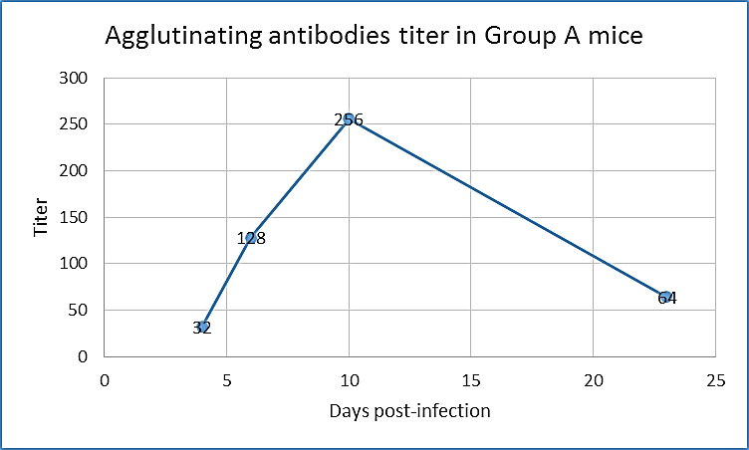
Figure 1: Agglutinating antibodies titer in Group A mice.

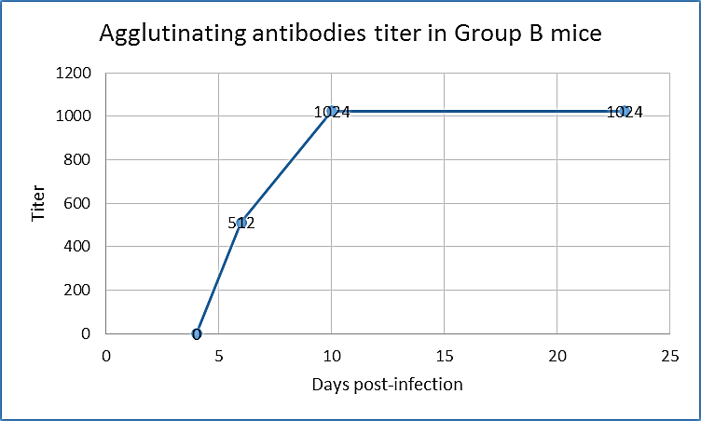
Figure 2: Agglutinating antibodies titer in Group B mice.

