Modulatory effect of Lawsonia inermis Linn. leaves on andrological parameters and histopathological changes of testes in Streptozocine induced diabetic Wistar rats
Aremu A.^{1,2*}, Oridupa O. A.², Akorede G. J.¹, Basiru A.³ and Ahmed O. A⁴
- Department of Veterinary Pharmacology and Toxicology, Faculty of Veterinary Medicine, University of Ilorin, Nigeria. Email. +2348063491036. aremu.a@unilorin.edu.ng
- Department of Veterinary Pharmacology and Toxicology, Faculty of Veterinary Medicine, University of Ibadan, Nigeria.
- Department of Veterinary Physiology and Biochemistery Faculty of Veterinary Medicine, University of Ilorin, Nigeria.
- Department of Veterinary Microbiology Faculty of Veterinary Medicine, University of Ilorin, Nigeria.

Abstract
Diabetes mellitus (DM) has been known to be a major health challenge that have harmful effects on the quality of life globally as a result of its numerous complications. One of the most prevalent secondary complication of the disease is male reproductive system dysfunction. Oral hypoglycaemic drugs are used for managing diabetes but their use has been reported to possess side effects on male reproductive organ leading to significant alteration of spermatogenesis. Lawsonia inermis Linn are used in the treatment of both infectious and non-infectious diseases like poliomyelitis, measles, menorrhagia, vaginal discharge and leucorrhoea.
Lawsonia inermis leaves were sectioned using N-hexane, ethyl acetate and methanol. Fractions obtained were assessed for their modulatory effect. Thirteen groups of diabetic rats (n=5) were orally administered 25, 50 and 100 mg/kg of each of the three partitioned fraction, metformin (500 mg/kg), glibenclamide (5 mg/kg), while untreated hyperglycaemic and normoglycaemic rats received distilled water for 28 days.
Sperm parameters showed significant (p<0.05) decreased motility in most treatment group compared to normoglycaemic control but significant improvement was observed in sperm parameters when compared to untreated diabetic control. The sperm volume and live/dead ratio of diabetic treated rats showed little or no significant alteration in all the administered dosage compared to both diabetic and non-diabetic controls. Methanol fraction at 100 mg/kg presented non-significant (p>0.05) decreased total abnormal sperm cell compared to normoglycemic control. Diabetic and non-diabetic control had a greater number of spermatozoa with tailless head abnormality compared to Lawsonia inermis treatment groups.
Histopathology result of diabetic untreated testes showed histological abnormality represented by degenerated seminiferous tubules when compared to normoglycemic control cases. Treatment groups with fractions of Lawsonia inermis presents normal histological appearance.
We concluded that this study showed that Lawsonia inermis has significant modulatory or ameliorative effect on various sperm abnormalities and testicular degeneration seen in diabetic ones.
Keywords: Diabetes mellitus, Lawsonia inermis, Andrological parameters, Histopathology
Running title: Lawsonia inermis improves sperm parameters in diabetes

1.0 Introduction
Diabetes continues to increase globally with estimate of over five hundred million population and implication of this projection is increased number of men in their reproductive age (WHO, 2016). Various organ damage has been reported as complications usually seen in clinical diabetes (WHO, 2016). Retinopathy leads to cataract and blindness while nephropathy results to diminish renal function and chronic kidney disease (Tomlison et al., 1992). Foot ulcer, amputations, tactile allodynia, impotence and stroke may be sequel to neuropathic complications. Diabetes is mostly linked with long-term cardiovascular damage in humans and the associated risk includes coronary artery disease, atherosclerosis, heart failure, peri-vascular disease and myocardial infarction (Tomlison et al., 1992). Diabetes Mellitus (DM) has harmful effect in the efficiency of reproductive function in male (Ceriello, 2002). Damage to male reproductive organ is one of the most dangerous complications encountered in diabetes because metabolism of glucose is very important during spermatogenesis. This metabolism is vital in maintaining basic activity of the cell together with other specific functions such as motility, quality, integrity and fertilizing ability of the sperm cell (Omolaoye and Plessis, 2018). Study have confirmed that every 25% of type II diabetic patient in a population have hypogonadism (decrease level of testosterone) which leads to different conditions such as erectile dysfunction, low sex drive and sperm count thereby increasing the chance of infertility (Omolaoye and Plessis, 2018). The damaging effect of DM on erection, ejaculation function, reduced sperm volume, sperm counts, sperm motility and sperm morphology have been reported (Alves et al., 2013). Spermatozoa make use of energy following maturation from epididymis. So, regarding this, the sperm cell utilizes glucose as a fuel for glycolysis and phosphorylation that is primarily used in generation of adequate energy (Kandror and Pilch, 1996). There are messenger proteins that play an important role of supplying energy to various cells through active process by sodium-dependent glucose transporters (SGLT) and passive process of glucose transporter (GLUT). The passive carrier in GLUTs is directly linked to diabetes because they ensure glucose transportation and differentiation in various tissues (Mallidis et al., 2007). Glucose is passively transported across the barrier between the blood and the testis and this process is mainly facilitated by GLUTs. This is an important process during spermatogenesis. Reports have confirmed the presence of GLUTs in mature spermatozoa serving as a carrier for immediate source of energy for proper activity (motility) and function (fertilization) (Mallidis et al., 2007).
Various oral hypoglycaemic drugs like biguanides and sulphonylurea are the first line of therapy for managing diabetes mellitus but their use has been reported to possess side effects on male reproductive organ leading to significant alteration of spermatogenesis thereby decreasing sperm quality that will leads to reduced fertility in chronic patients (Alves et al., 2014). There is an increasing demand for natural herbs that possess significant modulatory activity on male reproductive system (Banihani, 2016).
Medicinal plants are being widely used, either as single drug or in combination in health care delivery system (Sofowora et al., 2013). Lawsonia inermis Linn. is commonly known as henna, which is recognized in traditional system of medicine. It consists of various categories of phytoconstituents like flavonoids, coumarins, triterpenoids, steroids and xanthones (Borade et al., 2011) Henna is a very useful plant and the leaves has been employed in staining different body parts like hand, nails and beard (Chengaiah et al., 2001). The aim of this study is to evaluate the modulatory activities of solvent partitioned fractions of Lawsonia inermis Linn leaves on andrological parameters and histopathological changes of the testes in streptozocine induced diabetic Wistar rat model.

2.0 Methodology
2.1.1 Plant Harvesting, Identification and Preparation
Leaves of Lawsonia inermis Linn was harvested from a farm land in Oke-oyi in Ilorin East area council of Kwara state, North Central, Nigeria. Taxonomically, it was both identified and authenticated at University of Ibadan Herbarium and a specimen was deposited and assigned a voucher number UIH-22460. The leaves of Lawsonia inermis Linn were dried at room temperature (25ºC) under shade in a room for four weeks. The leaves were blended to powdery form using a blender with brand name Panasonic^{(R)} Japan. The powdery leaves of Lawsonia inermis Linn was used for crude and solvent partitioned fraction using standard method as described by sofowora, 2013.
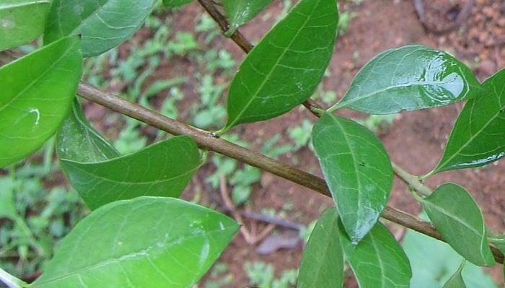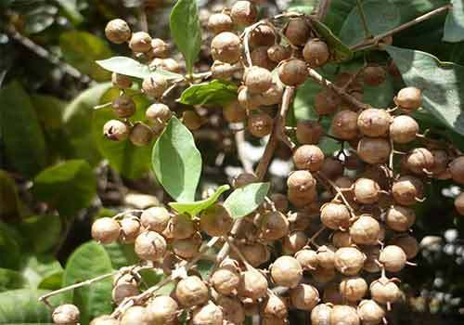
L. inermis leaves L. inermis flowers L. inermis seeds
Figure 2.1.1. Lawsonia inermis Linn
Source: ©The Herbal Resource

2.1.2 Extraction and Separation of Lawsonia inermis Linn leave
Five kilograms of powdery leave of Lawsonia inermis Linn was soaked in 3-litre of N-hexane, ethyl acetate and methanol for 72 hours. Mixture was gently decanted and filtered using filtered paper. The filtrate was immediately evaporated at temp 40°C using a rotary evaporator with brand name Buchhi^{(R)}. The concentrate (wet residue from different solvent) was dried and stored 4ºC in the refrigerator as described by Vongsak et al., 2013.
2.1.3 Fractionation of crude methanolic extract of Lawsonia inermis Linn leaves
The crude methanol extract of Lawsonia inermis Linn leaves (200g) was subsequently extracted with N-hexane, ethyl acetate and methanol in order of increasing polarity.
2.1.4 Phytochemical screening
Dry solid samples of crude methanolic extract were assayed for phytochemical content following the methods described by Trease and Evans (1989).
2.2.0 Experimental animal and Ethical Consideration
Adult male Wistar rats obtained from Experimental Animal House, Faculty of Veterinary Medicine, University of Ibadan, Ibadan and were used for this study. This work was ethically approved by ACUREC who is the regulatory body in charge of animal use in University of Ibadan. ACUREC issue a full approval with assigned number: UI-ACUREC/18/0063. All stress factors such as handling, feeding, housing, environmental conditions were adequately provided and the animals were humanly handled.

2.2.1 Experimental Animals
Male Wistar rats between 130-180g, (total 65) were used for this experiment. Experimental rats were housed using international standard and were maintained at ideal conditions under appropriate temperature and humidity. The experimental rats were fed with vital^{(R)} feed (standard animal feed). Feed and water were provided ad libitum. The blood sugar of all the experimental rats were assessed using fine test glucometer (United Kingdom) prio to the start of experiments.
2.3 Diabetes induction
Experimental diabetes was induced using streptozocine (STZ) (sigma®). STZ was dissolved in distil water and injected intraperitonially at 65mg/kg.
2.4 Experimental animal design
Experimental rats randomly grouped to thirteen having 4-5 rats per group and each group was treated for 28 days as thus;
Control: Normoglycaemic control treated with distil water
Diabetic untreated: Hyperglycaemic control (diabetic and untreated).
Diab+Li+Meth-25mg: Diabetic and treated at a dosage 25 mg/kg methanol extract of Lawsonia inermis Linn. leave
Diab+Li+Meth-50mg: Diabetic and treated at a dosage 50 mg/kg methanol extract of Lawsonia inermis Linn. leave
Diab+Li+Meth-100mg: Diabetic and treated at a dosage 100 mg/kg methanol extract of Lawsonia inermis Linn. leave
Diab+Li+Nx-25mg: Diabetic and treated at a dosage 25 mg/kg N-hexane extract of Lawsonia inermis Linn. leave
Diab+Li+Nx-50mg: Diabetic and treated at a dosage 50 mg/kg N-hexane extract of Lawsonia inermis Linn. leave
Diab+Li+Nx-100mg: Diabetic and treated at a dosage 100 mg/kg N-hexane extract of Lawsonia inermis Linn. leave
Diab+Li+EA-25mg: Diabetic and treated at a dosage 25 mg/kg Ethyle acetate extract of Lawsonia inermis Linn. leave
Diab+Li+EA-50mg: Diabetic and treated at a dosage 50 mg/kg Ethyle acetate extract of Lawsonia inermis Linn. leave
Diab+Li+EA-100mg: Diabetic and treated at a dosage 100 mg/kg Ethyle acetate extract of Lawsonia inermis Linn leave
Diab+Metformin: Diabetic and treated at a dosage of 500 mg/kg metformin.
Diab+Gliben: Diabetic and treated at a dosage 50 mg/kg glinbencamide.
2.5 Constitution and Administration of Lawsonia inermis leaves extract
The stock concentration of the three fractions were prepared by mixing 2ml of distil water to 0.5g of extract so as to dissolve it. These preparations were administered orally at different doses indicated above of the rats in the test groups for 4 weeks. The control groups were treated using distil water.
2.6.0 Sperm collection and Animal sacrifice
Sperm were collected from caudal part of the epididymis on a clean glass slide for sperm analysis. The anaesthetized rats were humanly killed after five minutes. Testes was taken for histopathology.
2.6.1 Andrological analysis
Sperm was extracted from the testes of all the rats and were analyzed for morphology (abnormal sperm cell) and sperm characterization (volume count, motility and live/dead ratio) using standard method.
2.6.2 Evaluation of epididymal sperm count
One epididymis from each of the rats in various groups were carefully removed, dried with blotting paper and immediately homogenized in 1 mL of 0.5% formol saline. one ml of the aliquot solution was diluted to a ratio of 1:1200 using erythrocyte diluting pipette. Counting was done using improved Neubauer counting chamber and cells were counted using a light microscope at magnification of x 20 as described by Yarube et al., (2009).
2.6.3 Evaluation of sperm motility
Sperm motility motility was assayed adopting the method used by Sonmez et al., (2005), caudal epididymis from each rat was dissected and cut into small pieces. This was later transferred into petri dishes which contains a prewarmed 0.5 mL of Tris buffer solution. The sperm cells were then allowed to swim out within five minutes at 37⁰C. An aliquot of this solution was then observed under light microscope using magnification of 400 folds. The percentage of sperm motility was calculated using the number of live sperm cell over the total number of sperm cells including both motile and immotile. The sperm cells that were not moving were considered to be immotile while the rest which displays some movements were considered motile.
2.6.4 Evaluation of sperm morphology
A smear was made from the suspension which was allowed dry. It was fixed using methanol and glacial acetic acid using 3:1. This was stained using haematoxylin (H) for 15 minutes before washing. This was followed by eosin (E) staining for 10 minutes. The slide was washed and dried at 40ºC and was observed using a light microscope at magnification X100 (Wyrobek 1979).
2.7 Histopathological procedures
The testes were carefully removed from the experimental rats and fixed with 10% neutral buffered formalin to preserve the structural and molecular component. After fixing, specimens were exposed to different graded mixture of both ethanol and water. Specimen were cleared in xylene then replaced with embedding paraffin and this was maintained at a temperature of 58 to 60ºC.
The paraffin will harden the tissue upon removal from the oven. 5 μm of the tissue was sectioned, floated in water and then transferred on to a glass slide. The sectioned tissues were stained with H&E. Stained and washed slides of various organs were viewed using light microscope at X40 magnification (Histological guide).
2.8 Data analysis
All generated data were recorded as Mean ±SD of all the measured values. All the data analysed using ANOVA and were subjected to further test using Dunnet’s Post-Hoc multiple comparison test. GraphPad Prism software statistical package, version 5.03 (San Diego, U.S.A) was used for all analysis. p-value of p≤ 0.05, p≤ 0.01 and p≤ 0.001were considered as significant values following standard method.

3.0 Results
3.1 Phytochemical screening
Phytochemical analysis of Lawsonia inermis Linn. leaves showed orders of phytochemicals such as Saponin, Tannins, Flavonoid, Cardiac Glycoside, Terpenoids steroid, Anthraquinones, and Alkaloids (Table 1).

Table 1: Phytochemical screening (qualitative) of methanol extract of Lawsonia inermis Linn leave
Test crude methanol extract
Saponins ++ve
Tannins ++ve
Flavonoids ++ve
Cardiac glycosides ++ve
Terpenoids +ve
Steroids +ve
Anthraquinones +ve
Alkaloids +ve
Interpretations-ve: Absent, +ve: Present, ++ve: Abundantly present

3.2.1 Spermatozoa characterization and morphology
The sperm parameters showed significant (p<0.05) decreased motility in group meth-50mg/kg (65.00±7.07) compared to normoglycaemic control. Similar trend was observed in sperm count of N-hexane treatment groups that decreased significantly (p<0.01) in all the administered dosage 25mg/kg (65.00±5.77), 50mg/kg (62.50±5.00) and 100mg/kg (62.50±5.00). Ethyle acetate also presented significant (p<0.05) decreased motility at 25mg/kg (67.50±9.57) and 100mg/kg (66.67±5.77). Metformin treated group showed significant (p<0.05) decreased motility compared to normoglycaemic untreated control. All the rats in various groups treated with either the extract of Lawsonia inermis Linn or conventional anti-diabetes drugs presents non-significant decreased sperm motility compared to hyperglycemic untreated control (Table 2)
Sperm count of hyperglycemic untreated decreased non-significantly compared to non-diabetic untreated control. Sperm count of all the treated groups either with the extract or conventional drugs showed significant (p<0.01) decreased sperm count compared to normoglycemic control (Table 2)
The sperm volume and live/dead ratio of diabetic treated rats showed little or no significant alteration in all the administered dosage either with the extract or standard ant-diabetic drug compared to both diabetic and non-diabetic controls (Table 2).

Table 2: Sperm characteristic of diabetic Wistar rats treated with different solvent portioned fraction of Lawsonia inermis Linn leave and oral hypoglycaemic agents
Grp/index | Sperm motility | Sperm count | Sperm volume | Live/dead ratio
Control | 80.00±0.00 | 135.80±6.45 | 6.18±0.02 | 97.25±1.50
Diab+untreated | 78.50±2.89 | 120.80±6.60 | 5.38±0.05 | 98.13±1.00
Diab+li+Meth-25mg | 72.50±5.00 | 119.30±15.48 | 5.10±0.15 | 97.25±1.50
Diab+li+Meth-50mg | 65.00±7.07ª | 110.00±12.73 | 5.20±0.00 | 96.50±2.12
Diab+li+Met-100mg | 71.67±2.89 | 91.67±2.89^{c} | 5.17±0.06 | 97.00±1.73
Diab+li+Nx-25mg | 65.00±5.77^{b} | 101.30±12.47^{b} | 5.18±0.05 | 96.50±1.73
Diab+li+Nx-50mg | 62.50±5.00^{b} | 95.75±9.32^{c} | 5.18±0.05 | 95.75±1.50
Diab+li+Nx-100mg | 62.50±5.00 ^{b} | 94.50±8.66 ^{b} | 5.18±0.05 | 96.50±1.73
Diab+li+EA -25mg | 67.50±9.57ª | 95.75±16.74 ^{b} | 5.18±0.05 | 96.50±1.73
Diab+li+EA-50mg | 72.00±4.77 | 110.00±9.46ª | 5.18±0.04 | 96.20±1.64
Diab+li+EA-100mg | 66.67±5.77ª | 103.70±15.04^{b} | 5.20±0.00 | 96.00±1.73
Diab+Metformin | 65.00±5.77^{b} | 95.75±16.94 ^{b} | 5.18±0.05 | 93.25±5.68
Diab+Gliben | 72.50±5.00 | 104.00±4.24^{b} | 5.18±0.04 | 97.25±1.50
Data rep as Mean ±SD: n=5
^{a b c} Significant ªP≤0.05 ^{b} P≤0.01 ^{c}P≤0.001

3.3 Sperm morphology
3.3.1Total abnormal
Abnormal sperm cell increased non-significantly (p<0.05) in all treated rats except the meth-100mg/kg (11.97±0.65) which present non-significant (p>0.05) decreased abnormal sperm cell compared to normoglycemic control. The diabetic and non-diabetic control had a greater number of spermatozoa with tailless head abnormality when compared to treatment groups except glibenclamide group that increased non-significantly (1.19±0.32) (Table 3).
3.3.2 Headless tail
Headless tail spermatozoa presented non-significant decreased abnormality in all treatment groups except glibenclamide that decreased significantly (p<0.05) (1.06±0.24) compared to normoglycaemic control (Table 3).
3.3.3 Rudimentary tail
Spermatozoa with rudimentary tail was slightly decrease in both control groups (1 and 2) while slight increase was seen in meth-50mg/kg (0.62±0.17). N-hexane, ethyl acetate and metformin also showed slight increased rudimentary tail abnormality when compared to normoglycaemic control. Untreated diabetic rats present decreased bent tail (2.04±0.23) compared to normoglycaemic untreated and the treatment groups (Table 3).
3.3.4 Curved tail
Curved tail abnormality decreased non-significantly (p>0.05) in Meth-100mg/kg (1.97±0.39) while hexane treatment increased significantly (p<0.05) compared to diabetic and non-diabetic untreated groups. All other treated groups increased non-significantly compared to normoglycaemic control (Table 3).
3.3.5 Curve mid-piece
Occurrence of curved mid-piece spermatozoa abnormality decrease non-significantly (p>0.05) (1.98±0.46) in diabetic untreated group while all treatment groups either with the extract or hypoglycemic agent showed non-significant increased curved mid-piece abnormality compared to normoglycemic control (Table 3).
3.3.6 Bent mid-piece
Population of sperm cell with bent mid-piece was significantly (p<0.01) higher in rats treated with Nx-25mg/kg (2.88±0.26). All groups treated either with the extract or conventional drugs increased non-significantly compared to normoglycemic and hyperglycaemic control (Table 3).
3.3.7 Looped tail
Looped tail abnormality decreased non-significantly in Nx-25mg/kg (0.43±0.24) compared to diabetic untreated group. All other treatment groups showed non-significant (p>0.05) increased looped tail abnormality compared to normoglycemic control (Table 4).

Table 3: Sperm morphology of diabetic Wistar rats treated with different solvent portioned fraction of Lawsonia inermis Linn leave and oral hypoglycaemic agents
Grp/index | Rudimen tail | Tailless head | Headless tail | Bent tail | Curved tail | Curve mid-piece | Bent mid-piece | Looped tail | Total abnormal
Control | 0.49±0.20 | 1.16±0.29 | 1.11±0.33 | 2.49±0.21 | 2.15±0.23 | 2.26±0.23 | 2.27±0.24 | 0.42±0.22 | 11.82±1.56
Diab+untreated | 0.50±0.20 | 1.18±0.33 | 1.25±0.23 | 2.54±0.23 | 2.30±0.30 | 2.98±0.46 | 2.47±0.21 | 0.49±0.20 | 11.94±0.58
Diab+li+Met-25mg | 0.49±0.21 | 0.99±0.28 | 1.18±0.32 | 2.22±0.61 | 2.54±0.28 | 2.47±0.20 | 2.53±0.30 | 0.55±0.24 | 10.01±0.94
Diab+li+Met-50mg | 0.48±0.17 | 0.99±0.33 | 1.12±0.54 | 2.27±0.38 | 2.61±0.15 | 2.86±0.19 | 2.48±0.02 | 0.50±0.35 | 11.93±0.81
Diab+li+Met-100mg | 0.49±0.25 | 1.15±0.39 | 1.23±0.24 | 2.13±0.26 | 1.97±0.39 | 2.22±0.26 | 2.30±0.11 | 0.49±0.25 | 11.97±0.65
Diab+li+Nx-25mg | 0.55±0.24 | 1.16±0.31 | 1.17±0.32 | 2.70±0.48 | 2.88±0.51ª | 2.70±0.17 | 2.88±0.26^{b} | 0.43±0.24 | 14.49±1.51
Diab+li+Nx-50mg | 0.55±0.23 | 1.12±0.33 | 1.05±0.37 | 2.72±0.45 | 2.59±0.42 | 2.60±0.22 | 2.47±0.19 | 0.49±0.20 | 13.62±1.03
Diab+li+Nx-100mg | 0.43±0.24 | 1.12±0.32 | 1.12±0.33 | 2.55±0.43 | 2.79±0.23 | 2.73±0.36 | 2.42±0.11 | 0.49±0.28 | 14.35±0.92
Diab+li+EA-25mg | 0.50±0.23 | 1.04±0.37 | 1.04±0.23 | 2.38±0.58 | 2.45±0.33 | 2.63±0.19 | 2.63±0.21 | 0.48±0.19 | 13.23±1.11
Diab+li+EA-50mg | 0.49±0.24 | 1.14±0.28 | 1.09±0.33 | 2.27±0.53 | 2.38±0.14 | 2.57±0.14 | 2.42±0.41 | 0.54±0.20 | 12.88±1.56
Diab+li+EA-100mg | 0.49±0.24 | 1.14±0.39 | 1.16±0.39 | 2.49±0.44 | 2.49±0.23 | 2.65±0.29 | 2.74±0.01 | 0.50±0.25 | 14.03±1.33
Diab+Metformin | 0.55±0.23 | 1.13±0.31 | 1.06±0.38 | 2.53±0.30 | 2.54±0.33 | 2.72±0.29 | 2.72±0.19 | 0.55±0.23 | 13.05±1.82
Diab+Gliben | 0.43±0.23 | 1.19±0.32 | 1.06±0.24^{b} | 2.37±0.60 | 2.55±0.32 | 2.61±0.15 | 2.49±0.21 | 0.43±0.24 | 13.50±1.80
Data rep as Mean ±SD: n=5
^{a b c} Significant ªP≤0.05 ^{b} P≤0.01 ^{c}P≤0.0
3.8 Histopathologic of testes

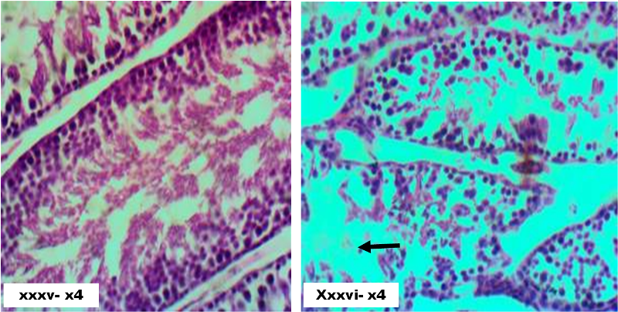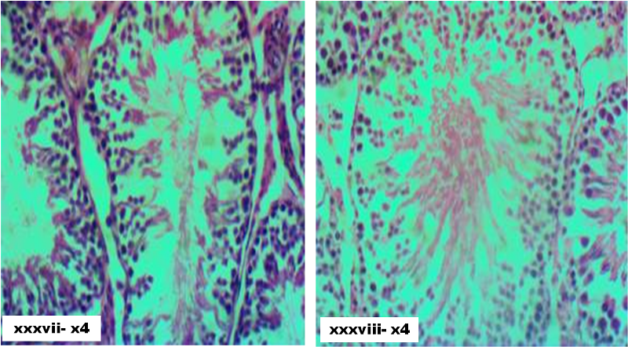
Figure xxxv. Testes in un-induced and untreated (H&E) showing no visible lesion (NVL) H&E.X40
Figure xxxvi. Testes induced with STZ untreated showed degenerated seminiferous tubules with sloughing H&E.X40
Figure xxxvii. Testes induced with STZ and treated with 25mg/kg methanol extract of henna plant showing mild to moderate degree of testicular degeneration. H&E.X40
Figure xxxviii. Section of testes induced with STZ and treated with 50mg/kg methanol extract of henna plant (H&E) showing mild degree improvement H&E.X40
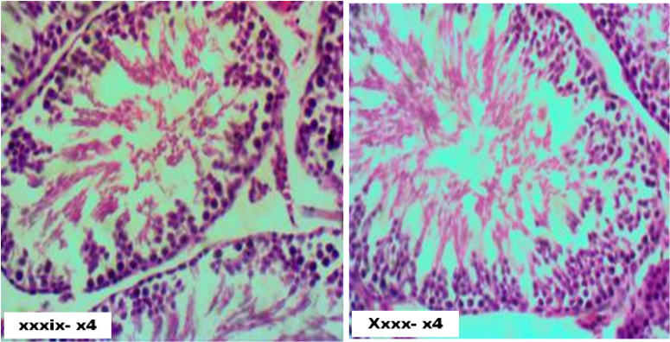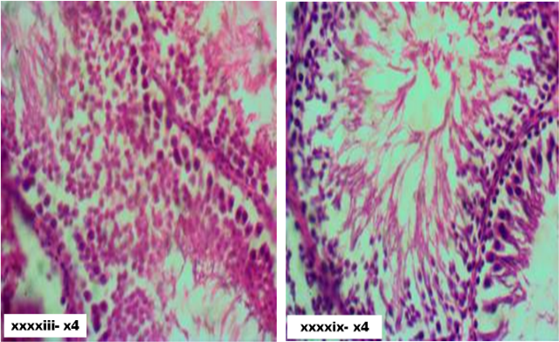
Figure xxxxii. Section of testes induced with STZ and treated with 100mg/kg N-hexane extract of henna plant showing no observable lesion H&E.X40
Figure xxxxiii. Section of testes induced with STZ and treated with 25mg/kg ethyle acetate extract of henna plant showing thickening and hyalinization of basement membrane of the ST. H&E.X40
Figure xxxxix. Section of testes induced with STZ and treated with 50mg/kg ethyle acetate extract of henna plant showing no observable lesion H&E.X40

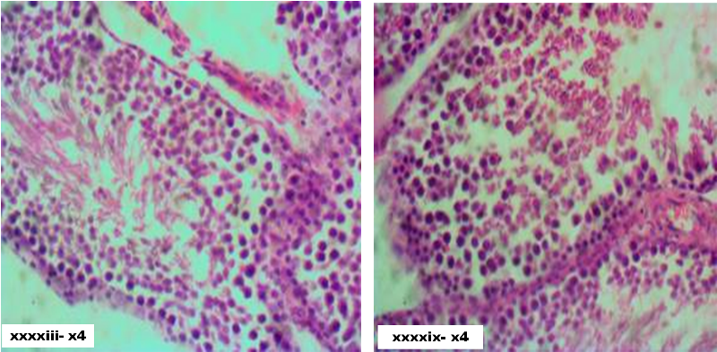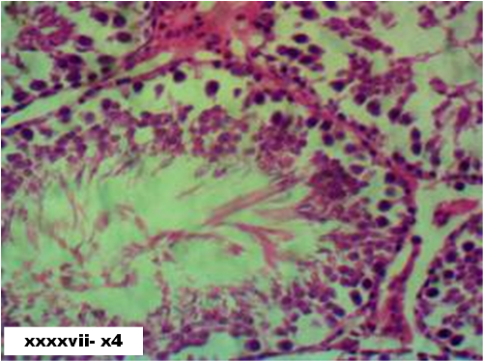
Figure xxxxv. Section of testes induced with STZ and treated with 100mg/kg ethyl acetate extract of henna plant showing interstitial edema and necrosis H&E.X40
Figure xxxxvi. Section of testes induced with STZ and treated with metformin showing interstitial edema and congestion. H&E.X40
Figure xxxxvii. Section of testes induced with STZ and treated with glibenclamide) (H&E) showing thickening and hyalinization of basement tubules. H&E.X40

4.0 Discussion
4.1 Phytochemical analysis of Lawsonia inermis Linn. Leave
Phytochemical analysis of crude methanolic extract of Lawsonia inermis Linn. leaves used for this present study contained major constituents like Flavonoids, Anthraquinones, Alkaloid, Saponin, Tannins and Steroidal glycosides. These observed constituents are in agreement with work described by Khan and Nasreen, 2010 who confirms the phytochemical constituent of Lawsonia inermis Linn leaves (Khan and Nasreen, 2010).
4.2 Andrological parameters
Diabetes mellitus leads to reversible reduction in most sperm characteristics such as sperm volume, motility and morphology. This abnormality is mainly attributed to alteration of carbohydrate metabolism in the entire reproductive tract (Parveen et al., 2003). The information available suggested that diabetes mellitus changes most sperm parameters as a result of induction of molecular changes that are necessary for sperm function and quality (Mallis et al., 2011).
This present study noted that diabetic untreated hyperglycemic rats had significant reduction in sperm characteristics showing a significant increase live/dead ratio. The treatments groups either with the extract or conventional hypoglycemic drugs showed a non-significant alteration in most of the sperm parameters.
Primary sperm abnormality is usually observed in male subjects as result of aberrations to one or two pathways of spermatogenesis leading to immotile sperm cell lacking the primary function of fertilization (Saba et al., 2009). Sperm cell abnormality observed in diabetic rats treated with Lawsonia inermis Linn. are of both primary and secondary abnormality. The presence of rudimentary tail sperm abnormality is usually termed primary abnormality (Saba et al., 2009). Occurrence of this abnormality in all the groups treated showed reduced abnormality when compared to hyperglycemic control. A similar result was noticed in most treatment groups upon comparism with normoglycemic group. Implication of this primary abnormalities is that, it will result to infertility which is usually seen in long time diabetic patient (Zamjanis, 1997). The leaves of Lawsonia inermis Linn. reduced this effect as seen in various treated groups. This result was in conformation with assertion of Bala et al., (2015) who stated that more than 59% of the spermatozoa should possess normal size and shape so as to ensure fertilization (Bala et al., 2015).
Secondary spermatozoa abnormalities usually result from fundamental problem associated with sperm maturation especially when they mature from pathologic seminiferous tubules (Thomas and Thomas, 2001). The result of this current diabetes study using Lawsonia inermis Liin leaves as treatment showed that hyperglycemic untreated rats have the highest secondary abnormalities in tailless head, headless tail, bent mid piece, looped tail and curved mid piece when compared to all treated groups and normoglycemic control. The percentage of headless tail spermatozoa decreases in most of the treatment groups even though significant reduction is observed in glibenclamide treatment. Spermatozoa with bent tail abnormality reduced drastically in all treatment. Curved tail abnormality followed opposite trend as it decreases in methanol fraction treatment while that of hexane fraction increases significantly. All the treatment groups presented increased curved mid-piece. Looped tail sperm abnormality was observed to reduced N-hexane fraction of Lawsonia inermis Linn at 25mg/kg. The tail and mid-piece abnormalities accounted for most reported reproductive deficiency and it is usually correlated with reduced sperm motility leading to infertility (Goyal et al., 2018)
Methanol fraction of Lawsonia inermis Linn leaves had the lowest percentage total abnormalities in all the treatment groups and even lower than the normoglycemic control. This particular observation showed that L. inermis decreased percentage abnormalities thereby making it a good treatment for preventing diabetes-induced infertility. This result contradicts the report of Tulsiani et al., (1998) who stated that there is significant increase in abnormalities of spermatozoa when treated with medicinal plant and the majority of this abnormalities occurs during the process of sperm maturation (Tulsiani et al., 2007).
4.3 Results of histopathology
Diabetes mellitus have been directly linked to dysfunction of male reproductive system. Various report confirmed that diabetes mellitus can abnormally affects both spermatogenesis and steroidogenesis (Alvez, et al., 2013). The histopathology result of the testes of diabetes untreated rats presents an abnormality in form of degenerated seminiferous tubules when compared to normoglycemic control. Lawsonia inermis treated rats presents normal histoarchitectural properties like non-diabetic control without observable lesion. This result agrees with Khaidatul et al., who concluded that Gynura procumbens improves the histological changes of testes in alloxan induced diabetic rats (Khaidatul et al., 2018).
5.0 Conclusion
Various results obtained from this study showed that Lawsonia inermis has significant modulatory activity on various sperm abnormalities and testicular degeneration seen in diabetic complications thus can be employed in the management of diabetic induced infertility usually seen in male patients with chronic diabetes mellitus.
6.0 Acknowledgement
We wish to acknowledge the contribution of technologist named; Mr Moshood Bolaji and Mr Afolabi A. for various laboratory analysis and sectioning of histological slides

7.0 References
Alves, M.G., Martins, A.D., Vas, C.V., Correia, S., Moreira, P.I. Oliveira, P.F. and Socorro, S. 2013. Molecular mechanisms beyond glucose transport in diabetes-related male infertility. Biochim Biophys Acta v.1832 :626 :626-635
Alves, M.G., Martins, A.D., Vas, C.V., Correia, S., Moreira, P.I., Oliveira, P.F. and Socorro, S. 2014. Metformin and male reproduction: effects on Sertoli cell metabolism. Br. J. Pharmacol, 171: 4:1033-1042.
Bala, R., Gupta, V.C., Kumar, V. 2015. A Study to Evaluate Effect of Yashad Bhasm in Oligospermia. World Jol Pharm and Pharm Sci. 4(1): 516-520
Banihani, S. A. 2016. Effect of metformin on semen quality. Review. Braz J. Pharm sci. 52(4) 113.
Borade, A. S, Kale, B. N and Rajkumar V. (2011); A phytopharmacological review on Lawsonia inermis (Linn.). International journal of pharmacy and life sciences Vol. (2)1: 536-541
Ceriello, A. 2002. Oxidative stress and glycemic regulation. J.Met. 49(2):27-29.
Chengaiah, B., Rao, K.M. Kumar, K.M. Alagusundaram M. and Chetty, C.M. 2010. Medicinal importance of natural dyes: A review. Inter. J. Pharm Tech Res. 2: 144-154.
Goyal, M. S., Iannotti, L. L. I. and Raichle, M. E. 2018. Brain nutrition; Life span approach (review). Annu Rev Nutr. 21; 38: 381-399. doi: 10.1146/annu rev-nutr-082117-051652
Histology Guide © Faculty of Biological Sciences, University of Leeds
Kandror, K. V. and Pilch, P. F. 1996. Compartmentalization of protein traffic in insulin-sensitive cells. Ame j. physio. 96:271.
Khaidatul, A., Kamaruzaman, W., Aizat M. and Mahanem, M. N. 2018. Gynura procumbens improved fertility of diabetic rats: Preliminary study of sperm proteomic. Hindawi Evidence-Based Comp. Alter Medi. 92:1539.
Khan, Z.S. and Nasreen, S. (2010): Phytochemical analysis, antifungal activity and mode of action of methanol extracts from plants against pathogens. J. Agri Tech. 6:793-805.
Mallidis, C., Agbaje, I., Rogers, D., Glenn, J., McCullough, S. and Atkinson, A. B. 2011. Distribution of the receptor for advanced glycation end products in the human male reproductive tract: Prevalence in men with diabetes mellitus. Human repro. 22(8):2169-2177
Omolaoye, S. T. and Plessis, S. S. 2018. Diabetes mellitus and male infertility; A review. Asi Pac j. repro. 7(1):6-14
Parveen, S., Das, S., Kundra, C.P. and Pereira, B.M. 2003. A comprehensive evaluation of the reproductive toxicity of Quassia amara in male rats. Repro Tox. 17(1):45-50
Saba, A.B., Oridupa, O.A., Oyeyemi, M.O. and Osanyigbe, O.D. 2009. Spermatozoa morphology and characteristics of male Wistar rats administered with ethanolic extract of Lagenaria breviflora Robert. Afr J. Biotec. 8(7):1170- 1175
Sofowora A. Ogunbodede E and Onayade A. (2013): The role and place of medicinal plant in the strategies for diseases prevention. African journal of traditional complementary and alternatives medicine 10(5): 210-229
Sofowora, A. (1993): Phytochemical Screening of Medicinal Plants and Traditional Medicine I Africa, Spectrum Books Ltd, Ibadan, Nigeria.
Thomas, MJ. and Thomas, JA. Toxic responses of the reproductive system. In: Casarett & Doull’s Toxicology- The basic science of poisons (6th ed), McGraw-Hill Medical Publishing Division, New York. 2001. 677-681
Tomlinson, K.C., Gardiner, S.M., Hebden, R.A. and Bennett, T. 1992. Functional consequences of streptozotocin-induced diabetes mellitus, with particular reference to the cardiovascular system. Pharm Res. 44:103-50.
Tulsiani, D. R. P., Zeng, H. and Abou-Haila 2007. Biology of sperm capacitation: evidence for multiple signaling pathways. Soc Repro. Fert supple 63:257-72
Vongsak, B., Sithisarn, P., Mangmool, S., Thongpraditchote, S., Wongkrajang, Y. and Gritsanapan, W. (2013): “Maximizing Total Phenolics, Total Flavonoids Contents and Antioxidant Activity of Moringa Oleifera Leaf Extract by the Appropriate Extraction Method” in Industrial Crops and Products, Vol. 44. pp. 566-571.
World Health Organization (WHO) (2016): Diabetic fact sheet No. 312
Zemjanis, R. Collection and evaluation of semen. In: Diagnostic. and Therapeutic Techniques in Animal Reproduction. William and Wilkins company, Baltimore, USA, 1977 p. 242

