D-limonene and vitamin E combinatory therapy stimulate erythropoiesis and repair of β-cells atrophy in alloxan–induced diabetic rats
Ramota Iya Lawal^{1, 2}, Tagang Aluwong¹, Musa Muhammed Suleiman², Lateef Ariyo Adeniran³, *Onakpa Michael Monday⁴ and Ajagbonna Olatunde Peter⁴
¹Department of Veterinary Physiology, Faculty of Veterinary Medicine, Ahmadu Bello University, Zaria, Nigeria

²Department of Veterinary Pharmacology and Toxicology, Faculty of Veterinary Medicine, Ahmadu Bello University, Zaria, Nigeria

³Department of Veterinary Physiology and Biochemistry, Faculty of Veterinary Medicine, University of Abuja, Nigeria

⁴Department of Veterinary Pharmacology and Toxicology, Faculty of Veterinary Medicine, University of Abuja, Nigeria

Corresponding Author: * onakpa.monday@uniabuja.edu.ng

ABSTRACT
Diabetes mellitus is a major public health problem worldwide. Oxidative stress plays a pivotal role in the pathogenesis of diabetes as it is one of the inevitable outcomes of the cellular process. The present study aims to investigate the putative antihyperglycemic, antihyperlipidemic and antioxidant efficacy of limonene and vitamin E in comparison with metformin, a standard drug for therapy of diabetes. Diabetes was induced by a single intraperitoneal injection of 150 mg/kg of alloxan. There was a significant (P<0.05) increase in body weight of rats treated with limonene, vitamin E and combinatory therapy of limonene and vitamin E compared to the untreated diabetic group which showed decrease in weight. Combinatory therapy treatment of limonene and vitamin E showed significant difference (P<0.05) when compared with the groups treated with limonene, vitamin E and metformin. The combinatory therapy also reduced blood glucose levels, significantly (P < 0.05) compared to non-diabetic treated group treated with limonene and the group treated with metformin. Treatment with limonene and vitamin E, significantly (P< 0.05) ameliorated diabetic effect on MDA concentration and SOD activity. Pathological lesions observed in the pancreas treated with limonene, vitamin E and combinatory therapy of limonene and vitamin E showed normal tissue architecture compared to group treated with metformin. It was concluded that limonene and vitamin E exerted significant anti-diabetic and anti-hyperglycaemic effects in alloxan-induced diabetic rats.
Keywords: D-limonene; erythropoiesis; diabetes; histopathology; oxidative biomarkers; antioxidant enzymes.

1.0 INTRODUCTION
Diabetes mellitus is a metabolic disorder characterized by chronic hyperglycemia with disturbances of carbohydrate (Asmelash et al., 2019), fat and protein metabolism due to abnormalities in insulin secretion and/or action (Balaji et al., 2019). The hyperglycemia associated with diabetes leads to a long term damage, dysfunction and failure of several organs, especially the eyes, kidneys, nerves, heart and blood vessels (Pavithra et al., 2018). Diabetes mellitus is one of the leading causes of death because of its high prevalence, and morbidity (Balakumar et al., 2016). Globally, about 200 million people suffered from diabetes in 2010 and it is expected to reach 300 million by 2025 (Deng et al., 2016). Even though immense developments have occurred in drug discovery, the control of diabetes is still a major challenge in the field of medicine (Henninot et al., 2018).
Hormone therapy such as insulin and synthetic oral hypoglycemics such as thiazolidinediones, sulfonylureas, and α-glucosidase inhibitors currently in use are associated with a number of undesirable side effects (Abbas et al., 2019). Metformin is the first-line drug for treatment of type 2 diabetes mellitus, with an excellent safety profile, high efficacy in glycaemic control and clear but incompletely understood cardio-protective benefits (Foretz et al., 2019). Recent researches have therefore focused on herbal sources for newer antidiabetic agents that are effective and safe (Shinde et al., 2019). There has therefore, been a growing interest in replacing synthetic anti-diabetic drugs with natural antioxidants from plant sources because of the association of diabetes with an increased formation of free radicals and decreased antioxidant potential (Mollania and Sahabi 2022). Studies have shown that plants contain a variety antioxidant compounds (Ivanišová et al., 2021) which can reduce the production of advanced glycated bye-products and other diabetic complications associated with oxidative stress (Nowotny et al., 2015).
Limonene (p-Mentha-1,8-diene) is a major component of oils obtained from citrus plants such as orange, lemon and grape fruit which has two isomers: D and L (Ravichandran et al., 2018) with the D-limonene being the active form (Mahdavi et al., 2022). It is commonly used as an additive in food, soaps and perfumes (Anandakumar et al., 2021). Limonene takes its name from lemon, like other citrus fruits, it contains considerable amount of this compound, which contribute to their odor (Paw et al., 2020). The principal metabolites of limonene are (+) - and (-) trans-carveol, a product of 6-hydroxylation and (+) - and (-) perillyl alcohol, a product of 7-hydroxylation by CYP2C9 and CYP2C19 cytochrome in human liver microsomes (Miyazawa et al., 2002). Limonene has been reported to possess anti-cancer activity especially in the treatment of gliomas, it inhibits lipid peroxidation and prevents free radical induced damage and stressed-induced hypertension (Onyekere et al., 2021).
It has been reported that d-limonene significantly reduced blood glucose in diabetic rats (Anandakumar et al., 2021), alleviated insulin resistance in rats with high fat diet (Valerii et al., 2021) and in the relieve of gastroesophageal reflux diseases and heartburn (Chebet et al., 2021).
Vitamin E is a lipid soluble, chain breaking antioxidant vitamin with anti-inflammatory properties (Manosso et al., 2022). In vitro studies indicated that vitamin E may improve insulin action and insulin secretion by protecting peripheral tissues and cells from free radical mediated damage, which may help delay the development of diabetes mellitus (Ahangarpour et al., 2019).
Antioxidants are beneficial in the prevention of the diabetic complications which forms a good model of chronic oxidative damage and antioxidant supplementation (Sharifi-Rad et al., 2020). There is a relationship between depletion of antioxidants and development of diabetic complications but antioxidant supplementation (vitamin E) could decrease this risk (Pavithra et al., 2018).
Despite the development of new drugs and their scientific validation, researches still continue to evaluate anti-diabetic activities of newer drugs or compounds isolated from natural sources with little or no adverse effects. There is paucity of information regarding intervention and treatment of diabetes mellitus using Limonene and vitamin E in wistar rats. The aim of this study was to evaluate the anti-diabetic effects of limonene and vitamin E in diabetic rats.
2.0 MATERIALS AND METHODS
2.1 Location of the Experiment
The pharmacological evaluation was carried out in the Department of Veterinary Pharmacology and Toxicology, Faculty of Veterinary Medicine, Ahmadu Bello University, Zaria, Nigeria. Zaria is a city in Northern Nigeria and it is located in Kaduna State. Zaria which used to be known as Zazzau at an earlier time is located within latitude 11º3’N and 11º15’N and longitude 7º 42’E and 8º45’E of the Greenwich Meridian. Zaria is 80 km north of Kaduna along the federal high way leading to Kano (Umoh and Odoba, 1999).
2.2 Chemical/Materials/Equipment
Limonene and vitamin E were purchased from Sigma Chemicals (St Louis, MO, USA). The equipment and materials used in the current research included analytical weighing balance (Metler®), Accu-Chek® (Roche Diagnostic, Germany) active glucometer, Accu-Chek active strips, top-loading balance, spectrophotometer (Spectrolab, USA), rotary evaporator, hot oven, refrigerator, beakers, conical flasks, volumetric flasks (Pyrex®), test tubes, test tube racks, ceramic pestles and mortars, graduated measuring cylinders, distilled water, olive oil, cotton wool, syringes, surgical blades, and disposable gloves. The chemicals and reagents were methanol, methylated spirit, 1,1-Diphenyl-2-Picrylhydrazyl Radical (DPPH), and ferric tripyridyltriazine (Fe (III)-TPTZ). The drugs used were ascorbic acid, alloxan and glibenclamide.
2.3 Experimental Animals
Apparently healthy adult male Wistar rats weighing an average of 200 g were obtained from the Animal House, Department of Veterinary Pharmacology and Toxicology, Ahmadu Bello University, Zaria. The animals were conditioned to the laboratory environment in rat cages for two weeks before the commencement of the experiment. All rats were given access to standard rat diet and water ad libitum. The animal experiments were done according to international guidelines for animal experimentation. The Ahmadu Bello University animal research ethics committee reviewed and certified the experimental protocol in conformity with the guidelines that are in compliance with conventional guidelines of the use of laboratory animal in biomedical research. There was maximum care to adhere to the committee directive.
2.4 Induction of hyperglycaemia and experimental design
Forty male normoglycaemic Wistar rats were fasted for 24 hours and hyperglycaemia in each rat was induced in each fasted rat by administering alloxan monohydrate (150 mg/kg) intraperitonially as 5% w/v in distilled water. The animals were allowed to drink 10% glucose overnight to overcome the drug-induced hypoglycaemia. Blood glucose level of each rat given the alloxan was monitored daily by taking a drop of blood from the tail and applying it on a glucometer. Rats with blood glucose levels above 200 mg/dL were considered diabetic and used for the study (Silmara et al., 2014).
2.5 Experimental design and collection of serum and tissue samples
The rats showing high blood sugar levels were randomly divided into five groups of eight rats each with the sixth group not been diabetic. The first group served as a neutral non-diabetic non-treated control and received only normal saline (5 ml/kg). All rats in groups 2-5 were induced with diabetes and treated as follows; rats in group 2 were not treated and serve as untreated diabetic negative controls. Group 3 was treated with limonene at 10mg/kg (Tanaji et al., 2014). Group 4 was treated with vitamin E at (50 mg/kg), Group 5 received both Limonene and vitamin E (5 mg/kg / 25 mg/kg) and finally rats in group 6 were administered metformin (100 mg/kg) and served as treated controls. All treatments were given orally at 24-hour interval for 28 days (Priyankar et al., 2015). The body weight and feed intake of each rat was measured daily (Oloyede et al., 2015). On day-29 that is 24 hours after the last treatment; Blood samples was collected for haematological examination, rats were fasted for 12 hrs and then sacrificed by severing the jugular vein, 10 ml of blood was collected from the jugular vein and allowed to clot, centrifuged at 1000 × g for 10 minutes. The serum was kept at -20ᵒC. The liver and kidneys of each rat were observed in situ, separated and washed thoroughly with phosphate buffer saline (PBS) to remove any trace of blood and were preserved in 10 % buffered formalin for histological sectioning.

2.6 Determination of serum lipid
Serum total cholesterol (TC), triglycerides (TG) and high-density lipoprotein cholesterol (HDLc) was estimated using commercial kits as described by the manufacturer. Low-density lipoprotein cholesterol (LDLc) and very low-density lipoprotein cholesterol (VLDLc) was calculated using the formula outlined by Kim et al. (2010) and Srinivasan and Subramaniyan (2014).
2.6.1 Evaluation of the effect of treatment on malondialdehyde concentration
The level of thiobarbiturate acid (TBA) reactive substance, MDA, as an index of lipid peroxidation in the sera samples, was analyzed using the double heating method of Tsikas, 2017. The principle of the method was based on spectrophotometric measurement of the colour produced during the reaction of thiobarbituric acid (TBA) with MBA. Briefly, 2.5 ml of 100 g/L mm,m,, trichloacetic acid solution was added each to 0.5 mL of erythrocyte packet, sera, in centrifuge tube and placed in boiling water bath for 15 min. After cooling in tap water, the mixture was centrifuged at 1000 g for 10 min, and 2 ml of the supernatant was obtained and added to 1 ml of 6.7 g/L TBA solution in a test tube and placed in a boiling water bath (100 °c) for 15 min. The solution was cooled in tap water and its absorbance read using a UV spectrometer, PG instrument Ltd., Alma Park, Wibtoft, Leicestershire, LE 175BE, United Kingdom) at 532 nm. The concentration of MDA was calculated by the absorbance coefficient of MDA-TBA complex, 1.56 × 105 cm-+, and expressed in nano-moles per gram.
2.6.2 Evaluation of the effect of treatment on SOD activity
The activity of SOD was measured using the Northwest life Science Specialist SOD kit based on the method of monitoring the auto-oxidation rate of haematoxylin originally described by Olaifa et al. (2021) with modifications to enhance reliability. In the presence of SOD enzyme at specific assay pH of 7.4, the rate of auto-oxidation was inhibited and the percentage of inhibition which was linearly proportional to the amount of SOD present within a specific range. Samples SOD activity were determined by measuring ratios of auto-oxidation rates in the presence and absence of the sample and expressed as McCord-Fridovich “cytochrome c”. Briefly, 230µL of assay buffer was added to each test well, and another 10µL of assay buffer (for blank) or 10 µL of sample (serum) was added and then shake to mix and incubate for 2 minutes. 10 µL of Haemotoxylin Reagent was added to begin the reaction using a multi-channel pipette. It was then mixed quickly using the instrument’s shaker function and immediately began to record the absorbance at 560 nm every 10 seconds or smaller time interval for at least 5 minute using a microtitre plate reader (RT-2100C Microplate Reader Rayto Life and Analytical Science Co., Ltd, China).
2.7 Histopathology
The formalin preserved organs collected at the end of the studies include liver, pancreas and kidney from each group and pharmacological trials were processed according to the method described by Chung et al., 2018 for histological examination. The samples were preserved in the refrigerator. The tissues were dehydrated by dipping in a series of 70 % 80 % 90 % 95 % and 100 % alcohol in that order and leaving the tissues in each solution of alcohol for an hour. The tissues were infiltrated with molten paraffin wax at 50 °C, blocked in paraffin and labeled appropriately. Sections of the tissues were cut at thickness of 5-6 μm using a microtome. The tissue sections were mounted on glass slides and allowed to dry, after which each tissue was deparaffinised and stained with haematoxylin and eosin (H and E). The prepared slides were viewed under a light microscope at different magnifications for any cellular morphological changes.
2.8 Data analysis
Values were expressed as mean± SEM. Data were subjected to one-way analysis of variance (ANOVA), followed by Tukey’s post-hoc comparison test to compare differences between the experimental groups. Values of p<0.05 were considered significant. Graphpad Prism 5.0 for windows was used for the analyses (Graph pad Software, San Diego, CA, USA) (Brown, 2005).
3.0 RESULTS
Induction of diabetes with alloxan produced a significant increase in blood glucose within 3 days (Figure 4.3). The blood glucose levels in diabetic control rats increased (p < 0.05) from 402.0 ± 40.5 to 447.4 ± 38.4 mmol/l within 28 days as compared to 106.8 ± 6.5 to 127.2 ± 18.51 mol/L in normal control rats. Treatment of diabetic rats with limonene 10 mg/kg and vitamin E 25 mg/kg produced a dose dependent decrease in the level of blood glucose. The anti-hyperglycaemic effect of limonene and vitamin E (5 mg/kg and 25mg/kg respectively) was discernible within one week of treatment comparable to standard anti-diabetic drug, metformin, and was maintained throughout the study period of 28 days.
3.1 Effect of limonene and Vitamin E on body weight
Figure 4.1 shows the effect of d-limonene and vitamin E on body weight in alloxan-induced diabetic rats. Diabetic untreated control rats showed a progressive loss in body weight from (158.0 ± 1.7 to 114.8 ± 18.7)g within 28 days of the experiment when compared to normal control rats at (111.4 ± 2.0 to 144.6 ± 25.5) g, which is statistically significant (p < 0.05). Oral administration of limonene 10 mg/kg (131.4 ± 5.5 to 145 .6 ± 5.9) and vitamin E 25 mg/kg (127.2 ± 6.3 to 142.2 ± 12.0)g, combine therapy of limonene and vitamin E (5 mg/kg and 25mg/kg respectively), standard metformin 100 mg/kg therapy (143.6 ± 8.0 to 176.2 ± 7.4), all shows improvement in body weight.

Fig .4.1: Effect of limonene and vitamin E on body weight in alloxan-induced diabetes rats across groups for 28 days. Normal saline (NS) and Non-diabetic (ND) Limonene (LIM) Vitamin E (VIT), Metformin (MET).

Values are presented as mean ± SEM. P<0.05 show significant difference when compared with normal saline untreated control group.

3.2 Effect of limonene and vitamin E on feed intake in alloxan-induced diabetes
Feed intake of the diabetic control (143.0 ± 40.9 to 257-2 ± 19.3) g significantly increased (p < 0.05) within 28 days of treatment compared to the normal control animals (132.4 ± 8.8 to 232.6 ± 19.7) g, while treatment group with limonene (155.6 ± 36.9 to 227.0 ± 7.6) g, vitamin E (145.6 ± 38.6 to 215.8 ± 18.4) g and combine therapy of limonene and vitamin E (152.6 ± 38.6 to 215.8 ± 215.8 ± 18.4) g, all shows decreased feed intake which was in conformity with standard metformin treatment (133.6 ± 44.3 to 231.6 ± 16.8) g.

Fig 4.2: Effect of limonene and vitamin E on feed intake in alloxan-induced diabetes rats across groups for 28 days. Normal saline (NS), Non-diabetic (ND), Limonene (LIM), Vitamin E (VIT), and Metformin (MET).
Values are presented as mean ± SEM. P<0.05 show significant difference when compared with normal saline untreated control group

3.3 Effect of limonene and vitamin E on blood glucose in alloxan-induced diabetes rats
Glucose levels in diabetic untreated rats significantly increased P<0.05 (402.0 ± 40.5 to 447.4 ± 38.4) mmol/l within 28 days. Treatment with d-limonene (208.8 ± 30.9 to 139.4 ± 19.5) mmol/l and vitamin E (356.6 ± 33.8 to 197.6 ± 37.8) mmol/l shows glucose levels and maximum effect was noticed in the combination therapy of limonene and vitamin E (312.8 ± 28.7 to 120.4 ± 4.9) mmol/l, which is in conformity with metformin treatment group (302.0 ± 37.2 to 138.8 to 25.3) mmol/l.

Figure 4.3: showing effect of limonene and vitamin E on glucose level in alloxan-induced diabetes rats across groups for 28 days. Normal saline (NS), Non-diabetic (ND), Limonene (LIM), Vitamin E (VIT), and Metformin (MET).
Values are presented as mean ± SEM. P<0.05 show significant difference when compared with normal saline untreated control group.

3.4 Effect of limonene and vitamin E on haematological parameters
Haematological indices are depicted in Table 4.4 Induction of diabetes led to a significant decrease (P<0.05) in white blood cell (WBC) level (11.0 ± 0.5) UL⁻¹× 10⁻³, compared to WBC (21.9 ± 2.1) UL⁻¹× 10⁻³ of normal saline control group. Groups treated with limonene (19.1 ± 2.3) UL⁻¹× 10⁻³ and vitamin E (14.5 ± 0.4) UL⁻¹× 10⁻³, and combine therapy of limonene and vitamin E (16.0 ± 1.2) UL⁻¹× 10⁻³, shows increase levels of WBC, which was in conformity with group treated with metformin (22.4 ± 1.6) UL⁻¹× 10⁻³. There was no significant difference between groups.
Reduction was also observed in red blood cell (RBC) of untreated diabetic control (6.9 ± 0.2) 10⁶/ µL compared to normal saline control (7.6 ± 0.2) 10⁶/ µL, groups treated with limonene (6.9 ± 0.3), vitamin E (6.8 ± 0.2) 10⁶/ µL, and group treated with limonene and vitamin E (6.8 ± 0.1) 10⁶/ µ

Table 1.Effect of limonene and Vitamin E on heamatological parameters of alloxan induced diabetic rats.
Treatment |  |  | Heamatology
 | RBC  (10⁶/ µL) | WBC  (UL⁻¹× 10⁻³) | PCV (%) | NEU  (UL⁻¹× 10⁻³) | LYMP  (UL⁻¹ × 10⁻³) | MONO  (UL⁻¹ × 10⁻³) | EOSN  (UL⁻¹ × 10⁻³) | PLT  (UL⁻¹ × 10⁻³)
Grp1 | 7.6±0.2 | 21.9±2.1 | 41.6±1.0 | 19.0±3.7 | 51.0±5.13 | 5.4±1.96 | 1.2±0.2 | 604.0±28.4
Grp2 | 6.9±0.2 | 11.0±0.5 | 38.2±1.9 | 32.6±2.3 | 66.8±3.0 | 8.8±0.6 | 1.00±0.0 | 504.2±5.7
Grp3 | 7.9±0.3 | 19.1±2.3 | 41.4±1.2 | 24.8±1.6 | 53.0±2.6 | 5.0±0.0 | 1.00±0.0 | 541.0±14.6
Grp4 | 7.8±0.2 | 19.5±0.4 | 44.8±2.5 | 21.4±1.0 | 52.4±1.6 | 5.4.0±0.0 | 1.0±0.0 | 511.6±18.8
Grp5 | 7.8±0.1 | 20.04±1.2 | 42.0±2.5 | 21.6±2.6 | 51.6±2.23 | 5.4±0.4 | 1.0±0.0 | 506.5±31.6
Grp6 | 8.1±0.1 | 22.4±1.6 | 40.6±2.9 | 20.0±1.1 | 53.8±3.6 | 51.0±0.0 | 1.00±0.0 | 512.2±48.4
Grp1: nondiabetic rats; Grp 2: diabetic rats not treated; Grp 3: diabetic rats treated with limonene; Grp 4: diabetic rats treated with vitamin E; Grp 5 diabetic rats treated with limonene and vitamin E and Grp 6: diabetic rats treated with metformin. Data are presented as mean± SD; n=6, statistically significant (p<0.05)

Figure 1. Effect of limonene and vitamin E on body weight in alloxan-induced diabetes rats across groups for 28 days. Normal saline (NS) and Diabetic untreated (DU) Limonene (LIM) Vitamin E (VIT), Metformin (MET). Values are presented as mean ± SEM. P< 0.05.

Figure 2. Effect of limonene and vitamin E on feed intake in alloxan-induced diabetes rats across groups for 28 days. Normal saline (NS), Diabetic Untreated (DU), Limonene (LIM), Vitamin E (VIT), and Metformin (MET). Values are presented as mean ± SEM. P< 0.05

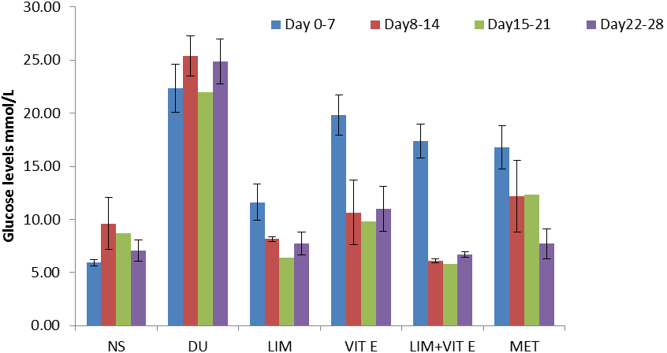
Figure 3. Effect of limonene and vitamin E on glucose level in alloxan-induced diabetes rats across groups for 28 days. Normal saline (NS), Diabetic untreated (DU), Limonene (LIM), Vitamin E (VIT), and Metformin (MET). Values are presented as mean ± SEM. P< 0.05.

Figure 4. Showing effect of limonene and vitamin E on serum MDA concentration level in alloxan-induced diabetes rats across groups for 28 days. Normal saline (NS), Non-diabetic (DU), Limonene (LIM), Vitamin E (VIT), and Metformin (MET). Values are presented as mean ± SEM. p<0.05 show significant difference when compared with normal saline untreated control group.

Figure 5. Showing effect of limonene and vitamin E on serum SOD activity in alloxan-induced diabetes rats across groups for 28 days. Normal saline (NS), Non-diabetic (DU), Limonene (LIM), Vitamin E (VIT), and Metformin (MET). Values are presented as mean ± SEM. P<0.05 show significant difference when compared with normal saline untreated control group.

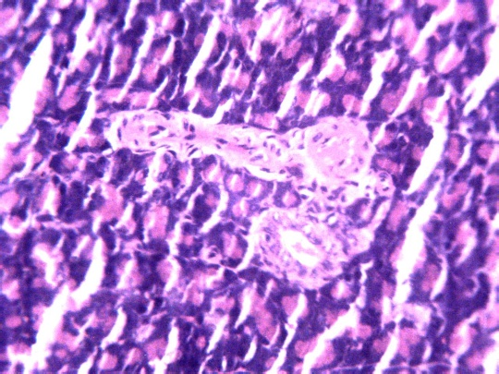
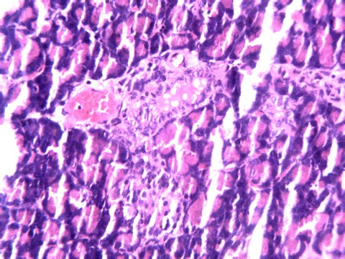
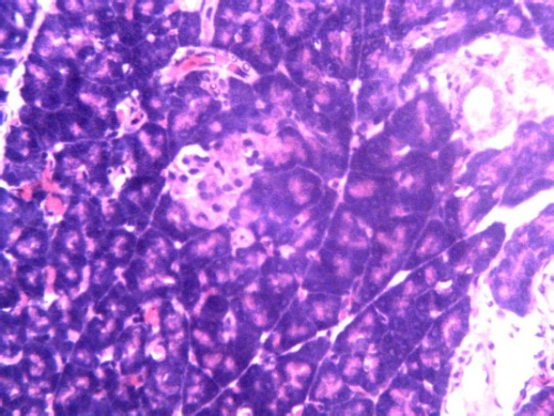
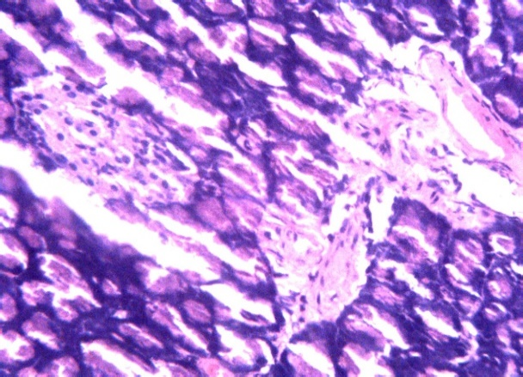
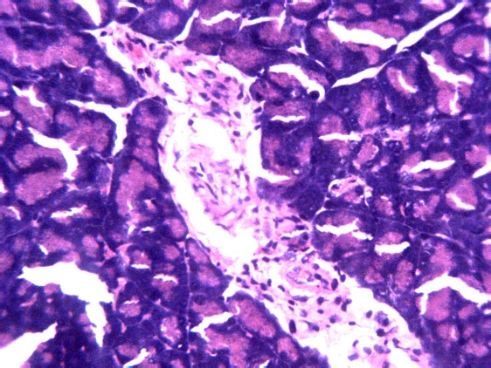
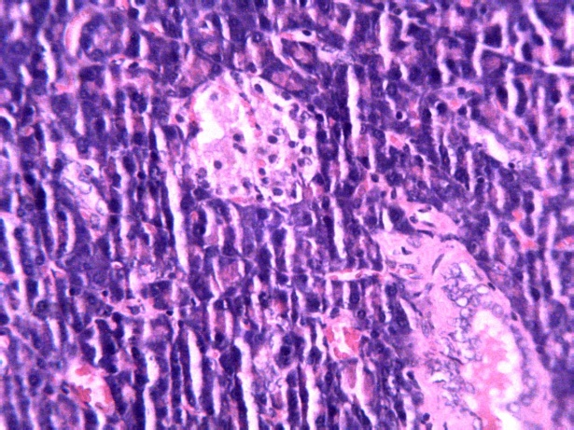
1
2
3
4

5
6

Figures 6. Plate 1 Photomicrograph section of pancreas of non-diabetic rats treated with normal saline showing normal islets of β-cell (arrow). H & E x 250 Plate 2. Photomicrograph section of pancreas of alloxan induced diabetic rat showing depleted islets β-cell (arrow). H & E x 250. Plate 3. Photomicrograph section of pancreas of alloxan induced diabetic rat treated with limonene showing normal Islets cells (arrow). H & E x 250. Plate 4. Photomicrograph section of pancreas of alloxan induced diabetic rat treated with vitamin E showing normal islets β-cell (arrow) (H and E x 250). Plate 5. Photomicrograph section of pancreas of alloxan induced diabetic rat treated with limonene and vitamin E showing normal islets β-cell (arrow). H and E x 250. Plate 6. Photomicrograph section of pancreas of alloxan induced diabetic rat treated with metformin showing normal islets β-cell. H & E x 250.
C
C
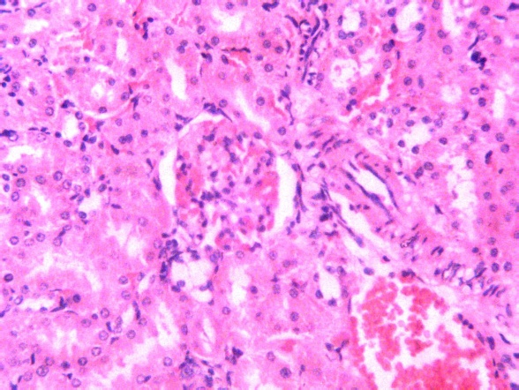
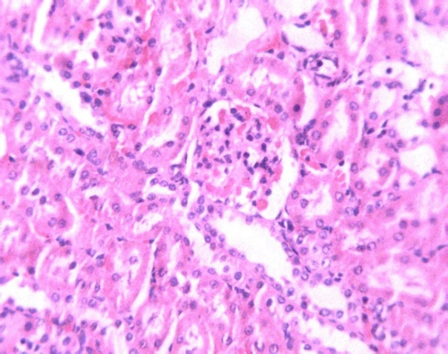
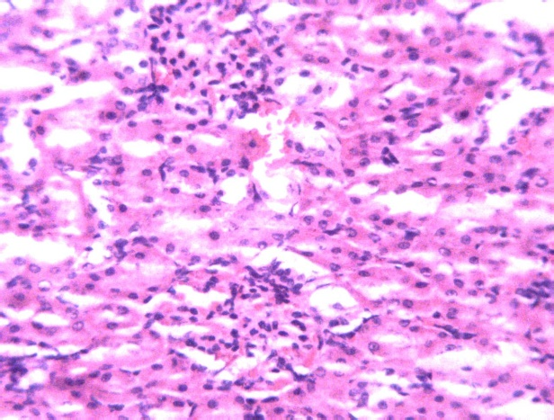
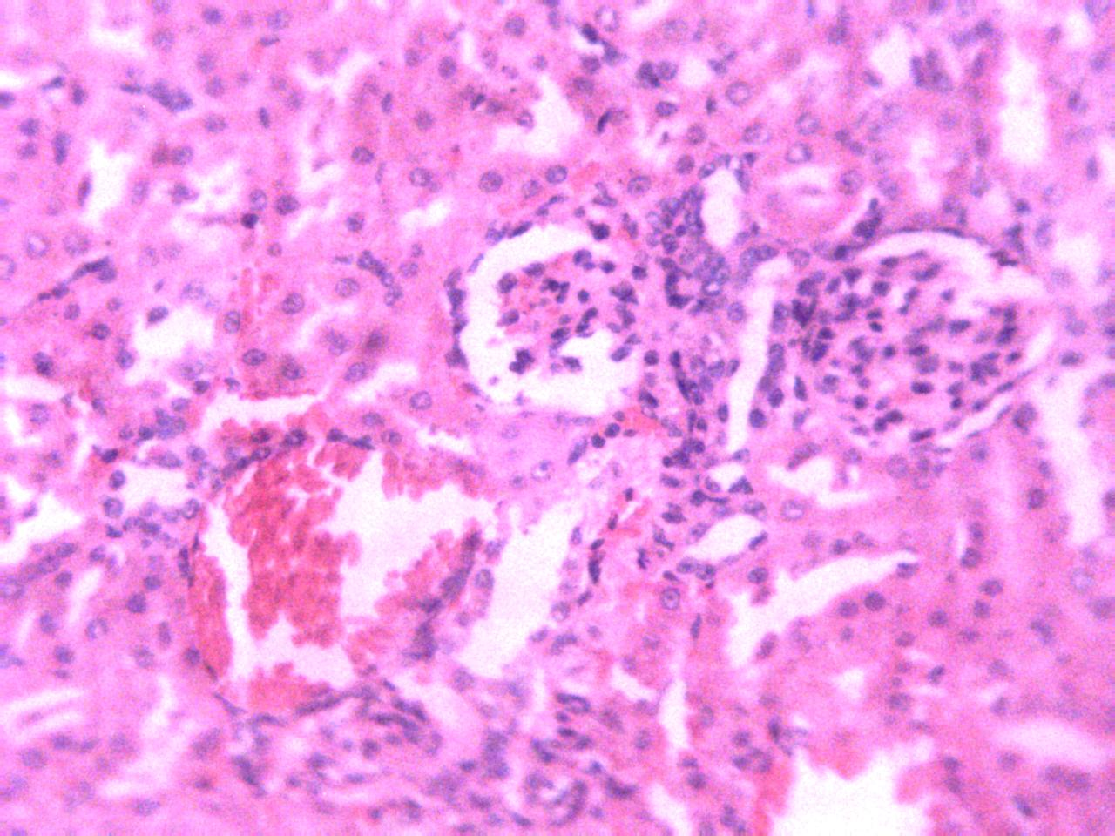
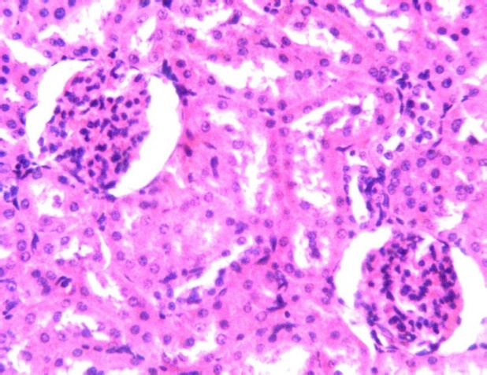
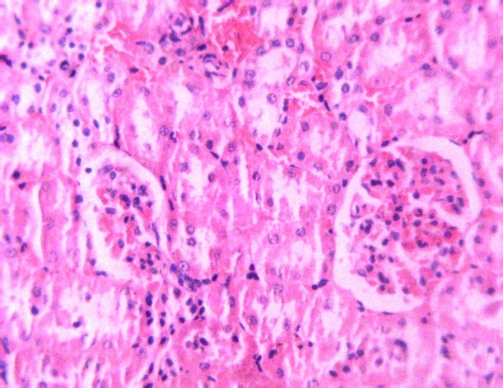
I
3
4
5
6
2
I

Figure 7. Plate 1 Photomicrograph section of kidney of non- diabetic rat treated with normal saline showing normal tissue architecture. H & E x 250. Plate 2. Photomicrograph section of kidney of alloxan-induced diabetic rat showing tissue congestion (arrow). H & E x 250. Plate 3. Photomicrograph section of kidney of diabetic rat treated with limonene showing normal tissue architecture and extensive dilation of Bowman’s capsule. H & E x 250. Plate 4. Photomicrograph section of kidney of diabetic rat treated with vitamin E showing normal tissue architecture and extensive dilation of Bowman’s capsule. H & E x 250. Plate 5. Photomicrograph section of kidney of diabetic rat treated with limonene and vitamin E showing normal tissue architecture. H & E x 250. Plate 6. Photomicrograph section of kidney of diabetic rat treated with metformin showing normal tissue architecture. H & E x 250.

4.0 Discussion
The present study was designed to evaluate the anti-diabetic efficacy of D-limonene and vitamin E in alloxan-induced diabetic rats. Alloxan-induced diabetes is characterized by severe loss of body weight (Ajiboye et al., 2018), the decrease in body weight despite increase feed intake is due to the loss or degradation of structural proteins, since structural proteins are known to contribute to the body weight (Rajkumar et al., 1991). A significant loss in body weight was observed in the diabetes group of rats, which is similar to works of (Elekofehinti et al., 2013 and Bashir et al., 2015). Hyperglycaemia induced by alloxan was associated with polydipsia and loss in body weight (Yadav et al., 2002; Yang et al., 2021).
In this study, d-Limonene and vitamin E restored the depressed hepatic glycogen levels possibly by increasing the level of insulin. Similar effect was also observed with metformin, which in addition to its insulin releasing effect also possesses inherent antioxidant properties (Chugh et al., 2001; Elmali et al., 2004).When diabetic rats were treated with d-limonene and/or vitamin E, the weight loss improved significantly in the combinatory therapy of both limonene and vitamin E. The improvement might be as a result of the ability of d-limonene and vitamin E to reduce hyperglycaemia, which is similar with works of Anandakumar et al., (2021) who reported improved weight loss in diabetic rats after administration of limonene and linalool in streptozotocin-induced diabetic rats.
The present study shows that d-limonene and vitamin E produced a dose-dependent decrease in blood glucose level which is similar to the findings of (Tanaji et al., 2014) that was comparable to standard anti-diabetic drug (metformin) and this effect was also reflected by the gain in body weight and decrease in feed consumption to values comparable to normal rats. This study shows D-Limonene, vitamin E, and metformin showed rapid normalization of blood glucose levels, while hyperglycaemia was maintained in alloxan treated group throughout the duration of the study. There is a possibility that d-limonene, vitamin E and metformin bring about release of insulin from the surviving cells, thereby, resulting in normalization of blood glucose levels. Induction of diabetes with alloxan was associated with decrease in hepatic glycogen, which could be attributed to the decrease in the availability of the active form of enzyme glycogen synthetase probably because of low levels of insulin (Ramu et al., 2016).
The role of oxidative stress and altered antioxidant levels in the pathogenesis of diabetic complications is well established (Ola et al., 2018). Persistent hyperglycaemia leads to increased production of free radicals through glucose auto-oxidation and protein glycation (Zhang and Tan, 2000).
Anaemia is a much more common disease in type 2 diabetes patients, contributing to the pathogenesis of diabetes complications (Pari and Umameheswari, 2000) and (Pari and Venkateswarens, 2002). The link between chronic diseases and anaemia is well characterized (Weiss et al., 2005). The occurrence of anaemia in diabetes mellitus has been reported due to the increased levels of RBC, which correlates with hyperglycaemia (Oyedemi et al., 2011).
Oxidation of these proteins and hyperglycaemia in diabetes mellitus causes an increase in the production of lipid peroxides that lead to haemolysis of RBC (Arun and Ramesh, 2002). The level of RBCs and its related indices were appreciably improved after administration of limonene and/or vitamin E in combination over a period of 28 days which is similar with the findings of (Das and Prabhu, 2022). This gives an indication that both flavonoids can stimulate the formation or secretion of erythropoietin, which stimulates stem cells in the bone marrow to produce red blood cells (Aboraya et al., 2022; Das and Prabhu, 2022).
Peripheral blood leukocytes are composed of polymorphonuclear cells, including monocytes as well as lymphocytes. Result shows that diabetes in rats was accompanied by increase neutrophils and leukocyte, which is similar with work of (Keskin, et al. 2016) which is due to the susceptibility to infection. The raised leukocyte count may also reflect low-grade inflammation. The decrease in the WBC count, in diabetic treated rats is also similar to work of (Innocenzi, et al., 2019).
Alloxan-induced diabetes has been found to be associated with decreased activity of superoxide dismutase, and an increase in the levels of MDA, which is similar with the works of (Fidail et al., 2016). D-Limonene and vitamin E afforded antioxidant protection by decreasing the levels of MDA, thereby, reducing the damage caused by ROS. The antioxidant protection afforded by D-limonene and vitamin E could be due to its anti-hyperglycaemic effect as also reported for other anti-diabetic agents like insulin and metformin (Zhang and Tan, 2000; Mahdi et al., 2003).Thus, this studies shows that D-limonene and vitamin E could be effective in treatment of diabetes due to its anti-hyperglycaemic and antioxidant properties.
Limonene and vitamin E showed significant reduction in levels of TC, TG and LDH which is different from works of (Raheleh et al., 2016) where there was no reduction in the levels of TC, LDH and TG which was attributed to reduction in dosage of streptozocin.
The histopathology studies showed the ameliorative effect of Limonene and/or vitamin E in combination on the β-cell of pancreas in diabetic rats. The results were compared with metformin a standard oral hypoglycaemic drug. These encouraging findings suggest that limonene and vitamin E may be used as a propitious bioactive compound in the development of therapeutic agents against type 1 diabetes mellitus

4.1 Conclusion
The study reveals that D-liponene and/or Vitamin E positively modulate the hyperglycemia along with antioxidant and antihyperlipidemic properties against alloxan induced diabetic rats in a dose dependent manner. Hepatic enzyme and lipid profile, biochemical and oxidative stress parameter changes are significantly altered in alloxan induced diabetic rats. D-limonene might be protective against diabetes induced effects in blood, liver and kidneys of rats. However, future studies are needed to investigate the precise mechanism underlying the pharmacological action of D-liponene and/or Vitamin E as this could offer potential insight into the cellular mechanisms responsible for complications of diabetes and developing new strategies for treatment.
We recommend further studies on the synergistic capabilities of limonene D and vitamin E in relation to their pharmacodynamics, pharmacometrics and pharmacokinetic attributes in other to generate required data to make scientific inference. More research on the toxicity of the new combinatory agent on other organs is also required.

References

Abbas, G., Al Harrasi, A., Hussain, H., Hamaed, A., & Supuran, C. T. (2019). The management of diabetes mellitus-imperative role of natural products against dipeptidyl peptidase-4, α-glucosidase and sodium-dependent glucose co-transporter 2 (SGLT2). Bioorganic chemistry, 86, 305-315.

Aboraya, D. M., El Baz, A., Risha, E. F., & Abdelhamid, F. M. (2022). Hesperidin ameliorates cisplatin induced hepatotoxicity and attenuates oxidative damage, cell apoptosis, and inflammation in rats. Saudi Journal of Biological Sciences, 29(5), 3157-3166.
Ahangarpour, A., Sayahi, M., & Sayahi, M. (2019). The antidiabetic and antioxidant properties of some phenolic phytochemicals: A review study. Diabetes & Metabolic Syndrome: Clinical Research & Reviews, 13(1), 854-857.

Ajiboye, B. O., Ojo, O. A., Adeyonu, O., Imiere, O., Oyinloye, B. E., & Ogunmodede, O. (2018). Ameliorative activity of ethanolic extract of Artocarpus heterophyllus stem bark on alloxan-induced diabetic rats. Advanced pharmaceutical bulletin, 8(1), 141.

Anandakumar, P., Kamaraj, S., & Vanitha, M. K. (2021). D‐limonene: A multifunctional compound with potent therapeutic effects. Journal of Food Biochemistry, 45(1), e13566.

Arun, G.S. and Ramesh, K.G. (2002). Improvement of in-sulin sensitivity by perindopril in spontaneously hypertensive and streptozotocin diabetic rats. Indian Journal of Pharmacology, 34: 156-64.

Asmelash, D., Abdu, N., Tefera, S., Baynes, H. W., & Derbew, C. (2019). Knowledge, attitude, and practice towards glycemic control and its associated factors among diabetes mellitus patients. Journal of diabetes research, 2019.

Balaji, R., Duraisamy, R., & Kumar, M. P. (2019). Complications of diabetes mellitus: A review. Drug Invention Today, 12(1).

Balakumar, P., Maung-U, K., & Jagadeesh, G. (2016). Prevalence and prevention of cardiovascular disease and diabetes mellitus. Pharmacological research, 113, 600-609.

Bashir, A.S., Leelavinothan, P., Ayyasamy, R. and Ramasamy, C. (2015). Trans-anethole a terpenoid ameliorates hyperglycemia by resulting key enzymes of carbohydrate metaboilism in streptozotocin induced diabetes rats. Biochimie, 112: 57-65.

Brown, A. M. (2005). A new software for carrying out one-way ANOVA post hoc tests. Computer methods and programs in biomedicine, 79(1), 89-95.

Chebet, J. J., Ehiri, J. E., McClelland, D. J., Taren, D., & Hakim, I. A. (2021). Effect of d-limonene and its derivatives on breast cancer in human trials: a scoping review and narrative synthesis. BMC cancer, 21(1), 1-11.

Chugh, S.N., Dhawan, R., Kishore, K., Sharma, A., Chugh, K. (2001). Glibenclamide vs. gliclazide in reducing oxidative stress in patients of noninsulin dependent diabetes mellitus—a double blind randomized study. Journal Association of Physicians of India 49: 803–807.

Chung, A. P. Y., Gurtu, S., Chakravarthi, S., Moorthy, M., & Palanisamy, U. D. (2018). Geraniin protects high-fat diet-induced oxidative stress in Sprague Dawley rats. Frontiers in nutrition, 5, 17.

Das, N., & Prabhu, P. (2022). Emerging avenues for the management of cerebral malaria. Journal of Pharmacy and Pharmacology, 74(6), 800-811.

Deng, C., Wang, X., & Liao, Y. (2016). Current recommendations on managing tuberculosis patients with diabetes & its epidemiology. Microbial pathogenesis, 92, 43-45.

Elekofehinti, O.O., Kamdem, J.P., Kade, I.J., Rocha, J.B.T. & Adanlawo, I.G. (2013). Hypoglycaemic, antiperoxidative and antihyperlipidaemic effects of saponins from Solanum anguiviLam, fruits in alloxan-induced diabetic rats. South Africa Journal of Botany, 88: 56-61.
Elmalí, E., Altan, N., & Bukan, N. (2004). Effect of the sulphonylurea glibenclamide on liver and kidney antioxidant enzymes in streptozocin-induced diabetic rats. Drugs in R & D, 5(4), 203-208.

Fedail, J. S., Ahmed, A. A., Musa, H. H., Ismail, E., Sifaldin, A. Z., & Musa, T. H. (2016). Gum arabic improves semen quality and oxidative stress capacity in alloxan induced diabetes rats. Asian Pacific Journal of Reproduction, 5(5), 434-441.

Foretz, M., Guigas, B., & Viollet, B. (2019). Understanding the glucoregulatory mechanisms of metformin in type 2 diabetes mellitus. Nature Reviews Endocrinology, 15(10), 569-589.

Henninot, A., Collins, J. C., & Nuss, J. M. (2018). The current state of peptide drug discovery: back to the future?. Journal of medicinal chemistry, 61(4), 1382-1414.

Innocenzi, E., De Domenico, E., Ciccarone, F., Zampieri, M., Rossi, G., Cicconi, R., et al., (2019). Paternal activation of CB2 cannabinoid receptor impairs placental and embryonic growth via an epigenetic mechanism. Scientific reports, 9(1), 1-13.

Ivanišová, E., Tokár, M., Mocko, K., Bojňanská, T., Mareček, J., & Mendelová, A. (2021). Antioxidant activity of selected plant products. Journal of Microbiology, Biotechnology and Food Sciences, 2021, 1692-1703.

Keskin, E., Dönmez, N., Kılıçarslan, G., & Kandır, S. (2016). Beneficial effect of quercetin on some haematological parameters in streptozotocin-induced diabetic rats. Bull Environ Pharmacol Life Sci, 5, 65-68.
Kim, D. J., Jeon, G., Sung, J., Oh, S. K., Hong, H. C., & Lee, J. (2010). Effect of grape seed oil supplementation on plasma lipid profiles in rats. Food Science and Biotechnology, 19(1), 249-252.
Mahdavi, S. A., Sadeghi, R., Faridi, A., Hedayati, S., Shaddel, R., Dima, C. et al., (2022). Nanodelivery systems for d-limonene; techniques and applications. Food Chemistry, 132479.
Manosso, L. M., Camargo, A., Dafre, A. L., & Rodrigues, A. L. S. (2022). Vitamin E for the management of major depressive disorder: possible role of the anti-inflammatory and antioxidant systems. Nutritional Neuroscience, 25(6), 1310-1324.
Mahdi, A.A., Chandra, A., Singh, R.K., Shukla, S., Mishra, L.C. and Ahmad, S. (2003). Effect of herbal hypoglycemic agents on oxidative stress and antioxidant status in diabetic rats. Indian Journal of Biochemistry, 18: 8–15.

Miyazawa, M., Shindo, M., & Shimada, T. (2002). Metabolism of (+)-and (−)-limonenes to respective carveols and perillyl alcohols by CYP2C9 and CYP2C19 in human liver microsomes. Drug metabolism and disposition, 30(5), 602-607.

Mollania, F., & Sahabi, H. (2022). Investigating the ability of Securigera securidaca extract in biological synthesis of selenium nanoparticles, pancreatic α-amylase inhibition, antioxidant and phenolic capacity and in vivo studying the anti-diabetic effects of extract on pseudo-diabetic rats. Nanotechnology for Environmental Engineering, 7(1), 1-10.

Nowotny, K., Jung, T., Höhn, A., Weber, D., & Grune, T. (2015). Advanced glycation end products and oxidative stress in type 2 diabetes mellitus. Biomolecules, 5(1), 194-222.

Ola, M. S., Al-Dosari, D., & Alhomida, A. S. (2018). Role of oxidative stress in diabetic retinopathy and the beneficial effects of flavonoids. Current Pharmaceutical Design, 24(19), 2180-2187.

Olaifa, F. H., Ayo, J. O., Aluwong, T., & Rekwot, P. I. (2021). The Effect of Epicatechin-(4β-8)-Catechin on Some Biomarkers of Fatigue in Packed Donkeys (Equus Asinus) during the Dry Season in Northern Nigeria. Journal of Applied Animal Welfare Science, 1-14.

Oloyede, H.B., Bello, T.O., Ajiboye, T.O. and Salawu, M.O. (2015). Antidiabetic and antidyslipidaemic activities of aqueous leaf extract of Discoreophyllum cumminsii (Staph) diels in alloxan-induced diabetic rats. Journal of Ethnopharmacology, 157: 309 - 319.
Onyekere, P. F., Nnamani, D. O., Peculiar-Onyekere, C. O., & Uzor, P. F. (2021). Limonene. In Green Sustainable Process for Chemical and Environmental Engineering and Science (pp. 219-227). Elsevier.

Oyedemi, S.O., Yakubu, M.T. & Afolayan, A.J. (2011). Antidiabetic activities of aqueous leaves ex-tract of Leonotis Lleonurus in streptozotocin induced diabetic rats. Journalof Medicine Plant Research, 5: 119-25.

Pari, L. & Umamaheswari, J. (2000). Antihyperglycemia activity of Musa sapretun flowers: effect on lipid peroxidation in alloxan diabetic rats. Phytotherapy Research,14: 136-138.

Pari, L. & Venkateswaren, S. (2002). Hypoglycemic activity of Scopariviadalis extract in alloxan induced hyperglycemic rats. Phytother Research, 14: 136-138.

Pavithra, D., Praveen, D., Chowdary, P. R., & Aanandhi, M. V. (2018). A review on role of Vitamin E supplementation in type 2 diabetes mellitus. Drug Invent. Today, 10 (2), 236-240.

Paw, M., Begum, T., Gogoi, R., Pandey, S. K., & Lal, M. (2020). Chemical composition of Citrus limon L. Burmf peel essential oil from North East India. Journal of Essential Oil Bearing Plants, 23(2), 337-344.
Priyankar, R. & Geetha V. (2015). Relationship between periodontitis and diabetes. Journal of Pharmacological Science and Research. 7(11): 938-939.
Raheleh, A., Pooneh, M., Sanaz, D., Sara, D., Mahsa, D., Fatemah, Z., et al., (2016). Hypoglycemia effect of aquatic extract of tevia in pancrease of diabetic rats: PPAR_{Y} – dependent regulation or antioxidant potential. Avicenia Medical Biotechnology, 8(2): 65-74.

Rajkumar, L., Srinivasan, N., Balasubraman, K. & Govindarajulu, P. (1991). Increased degradation of dermal collagen in diabetic rats. IndianJournal of Exploratory Biology. 29: 1081-1083.
Ramu, R., Shirahatti, P. S., Nayakavadi, S., Vadivelan, R., Zameer, F., Dhananjaya, et al., (2016). The effect of a plant extract enriched in stigmasterol and β-sitosterol on glycaemic status and glucose metabolism in alloxan-induced diabetic rats. Food & function, 7(9), 3999-4011.
Ravichandran, C., Badgujar, P. C., Gundev, P., & Upadhyay, A. (2018). Review of toxicological assessment of d-limonene, a food and cosmetics additive. Food and Chemical Toxicology, 120, 668-680.

Sharifi-Rad, M., Anil Kumar, N. V., Zucca, P., Varoni, E. M., Dini, L., Panzarini, E. et al., (2020). Lifestyle, oxidative stress, and antioxidants: Back and forth in the pathophysiology of chronic diseases. Frontiers in physiology, 11, 694.

Shinde, P., Banerjee, P., & Mandhare, A. (2019). Marine natural products as source of new drugs: A patent review (2015–2018). Expert opinion on therapeutic patents, 29(4), 283-309.
Silmara, B., Jurandir, F., Comar, F., Suzuki, K., Marcio, S.M., Juliana, O., et al., (2014). Beneficial effects of hydroethanolic extract of Smallanthus sonchifolius leaves on the metabolic changes in diabetic rats. International Journal of Pharmacological and Biological Sciences. 5(3): 183 - 196.
Srinivasam, P. & Subramaniyan, V. (2014). Anti-diabetic, hypolidemic and histopathological analysis of Gymnma sylvestre leaves extract on streptozocin induced diabetic rats. Biomedicine and Preventive Nutrition, 4(3): 425 - 430.
Tsikas, D. (2017). Assessment of lipid peroxidation by measuring malondialdehyde (MDA) and relatives in biological samples: Analytical and biological challenges. Analytical biochemistry, 524, 13-30.

Umoh, V. J., & Odoba, M. B. (1999). Safety and quality evaluation of street foods sold in Zaria, Nigeria. Food control, 10(1), 9-14.

Valerii, M. C., Turroni, S., Ferreri, C., Zaro, M., Sansone, A., Dalpiaz, A. et al., (2021). Effect of a Fiber D-Limonene-Enriched Food Supplement on Intestinal Microbiota and Metabolic Parameters of Mice on a High-Fat Diet. Pharmaceutics, 13(11), 1753.

Weiss, G., Goodnough, L.T. & Scherberich, J.E. (2005). Proinflammatory blood monocytes:main effector and target cells in systemic and renaldisease;background and therapeutic implications. International Journal of Clinical Pharmacology, 41: 459-64.

Yadav, S., Vats, V., Dhunno, Y. & Grover, J.K. (2002). Hypoglycaemic and antihyperglycemic activity of Murraya Koenigii leaves in diabetic rats. Journal of Ethnopharmacology, 82: 111-116.

Yang, S., Qu, Y., Chen, J., Chen, S., Sun, L., Zhou, Y., et al., (2021). Bee Pollen Polysaccharide From Rosa rugosa Thunb.(Rosaceae) Promotes Pancreatic β-Cell Proliferation and Insulin Secretion. Frontiers in Pharmacology, 12.

Zhang, X.F., & Tan, B.K.H. (2000). Antihyperglycaemic and antioxidant properties of andRographis Paniculata in normal and diabetic rats. Clinical and Experimental Pharmacology and Physiology, 27: 358–363.

