Methicillin-Resistant Staphylococcus Auras (MRSA) from poultry meat products regarding mecA Gene, antibiotic Sensitivity, and biofilm Formation.
¹Ola M. Magdy, ² Reda Tarabees, ¹Heba Badr, ¹Heba M. Hassan, and ²Alaaddin M Hussien
¹ RLQP, Animal Health Research Institute, Agriculture Research Center, Nadi El-Seid St., P.O. Box 246, Dokki, Giza 12618, Egypt.
²Microbiology Dept., Faculty of Veterinary Medicine, EL-Sadat University, Egypt, 12211.

¹ Corresponding Author: Ola Mohammed Magdy
Tel: +202 01019836077
E-mail: dr.ola19@yahoo.com

ABSTRACT
The uprising problem of the Presence of Multi Drug Resistant (MDR) pathogenic bacteria is an emerging obstacle facing food safety. This study purposed to evaluate the antibiotic-resistant profile regarding the Presence of MRSA and biofilm production. After collection of 225 samples (30 chicken fillet, 30 chicken nuggets, 30 chicken shawarma, 15 chicken luncheon, 60 chicken stock cubes and 60 imported frozen chicken meat) from local markets in Cairo and Giza (Egypt), they were examined bacteriologically for staphylococcus aureus using mannitol salt agar and blood agar, The occurrence of staphylococci was 127/225 (56.4%). 16.8% of the samples were S.aureus (38/225), while, 39.5% (89/225) were coagulase-negative staphylococci. S. aureus recovered from 8.3% of frozen chicken meat, 13.3% of chicken fillet, 23.3% of chicken nuggets, 46.6% of chicken shawarma, 33.3% of chicken luncheon, and 5% of chicken stock cubes. Resistance against 13 antibiotics was determined using Kirby-Bauer disc diffusion test, 100%, 78.9%, and 52.6% of the isolates were resistant to penicillin G, tetracycline, and amoxicillin. Clavulanic acid respectively, while 26.3% were resistant to methicillin. On the other hand, the isolates showed high sensitivity to vancomycin, clindamycin, and chloramphenicol with percentages 97.3%, 81.5%, and 68.4% respectively. The resistant strains to methicillin were tested by PCR for the presence of mecA gene, the result was 100% (10/10) positive for mecA gene. The isolates were phenotypically tested for the ability of biofilm formation using the Tube method that divided S. aureus isolates into 4 grades: strong biofilm former, moderate biofilm former, weak biofilm former, and non-biofilm former with percentages18.4%, 15.7%, 13.1%, and 52.6% respectively. To conclude, the increased prevalence of S.aureus in chicken meat products pinpoints the unhygienic condition of food processing, moreover, the occurrence of MDR S. aureus in chicken meat products might lead to alarming public health threats so there is an alerting need for rational use of antibiotics.
Keywords: Antibiotic resistance, biofilm production, chicken products, mecA gene, S. aureus.

1. INTRODUCTION
S. aureus is well recognized for its capability of inducing diseases that are mostly related to gastrointestinal disorders, moreover, as various infections in animals and humans (Hennekinne et al., 2012). S. aureus is responsible for various diseases related to the respiratory tract, joint infections, sepsis, soft tissue infections, toxic shock syndrome, and urinary tract infections (Paterson et al., 2014; García-Álvarez et al., 2011). Moreover, S. aureus is predominantly associated to food poisoning and considered as the 3rd main cause worldwide (Sasidharan et al., 2011; Achi and. Madubuike 2007). As a result, S. aureus has got a considerable interest in its role as a foodborne pathogen (Zhang et al. 2013). The prevalence of S. aureus food poisoning is slightly higher in poultry and meat products (Mead etal.1995; Balaban and Rasooly. 2000; Genigeorgi, 1989: Kitai et al. 2005).
Antibiotics are used basically to enhance the quality of animal health and decrease the susceptibility of food-borne diseases. However, the extensive use of antibiotics participates in increasing the prevalence of antibiotic-resistant bacteria that seriously affect both animal and human health (Mathew et al., 2007). The high incidence of resistance of S. aureus bacteria isolated from animal resources to particular groups of antimicrobial agents such as cephalosporins, penicillin, macrolides, aminoglycosides, tetracyclines, and fluoroquinolones has been reported by considerable researches (Safarpoor et al. 2017; Momtaz et al 2013)
Staphylococcal β-lactam resistance has two main mechanisms, the first one is the production of β-lactamase enzyme (most common is penicillin-resistance), while the other mechanism is related to methicillin resistance due to acquisition of mecA gene which encodes a penicillin-binding protein (PBP2a) that has a poor affinity to beta-lactam antibiotics (Abbas et al., 2021).
S. aureus binds to the host cell through its surface proteins which act as virulence factors. These proteins allow attachment to laminin and fibronectin, moreover, most strains express coagulase protein reaction and a clumping factor, that enhance attachment to blood clots, after the adhering, the bacteria multiply to create a biofilm that makes it more resistant to antibiotics and disinfectants (Todar, 2009). Biofilm has a strong effect on increasing the bacterial resistance to antibiotics, moreover, S. aureus commonly has a significant capability of biofilm formation which mainly exists in food of animal origin (Ou et al 2020)
The ongoing investigation aimed to assess the Presence of S. aureus isolated from chicken meat products and its antibiotic-resistant profile utilizing the Kirby-Bauer disc diffusion test, also to detect the presence of mecA gene among isolates, in addition, to evaluate the biofilm production and its relation to the exitance of MDR S. aureus.

2. MATERIALS and METHODS
2.1. Samples collection:
About 225 samples were collected from frozen chicken meat (n:60), chicken fillet (n:30) chicken nuggets (n: 30), chicken shawarma (n:30), chicken luncheon (n:15), and chicken stock cubes (n:60). Collection of samples were done under aseptic condition and safety precautions (Kitai et al., 2005 and Middleton et al., 2005)
Each sample was collected and marked then placed in an icebox and transferred to the laboratory as soon as possible to be examined bacteriologically.
2.2. Isolation and identification of Staphylococci:
Each sample was enriched in buffer peptone water (1:10) and incubated aerobically at 37°C for 24hr., then inoculated on mannitol salt agar (MSA) as a selective and differential characteristic media. After incubation at 37°C for 24hr, identical colonies were picked and subjected to gram staining and biochemical test based on coagulase test, catalase test, and oxidase test, and streaked on blood agar according to (Quinn et al. 2002). Colonies of staphylococci generally were 1-3 in diameter and frequently circular, smooth, and opaque with a creamy consistency, yellow colonies on MSA represent mannitol fermentation of staphylococci including coagulase-positive S. aureus while the pink colonies for other staphylococcus spp., on the other hand, most strains of S. aureus were β-hemolytic on blood agar (Quinn et al. 2002). For further examination, the pure cultures were stored at 4°C after inoculation on nutrient agar slant medium.
2.3. Antimicrobial sensitivity test:
the antibiotic sensitivity of isolated Staphylococcus aureus was determined by diffusion method according to (Koneman et al.,1979) by representatives of different groups of antibiotics provided by (Oxoid): Penicillin G(P 10 I.U), Chloramphenicol (C 30µg), Gentamicin (G 10µg), Erythromycin (E 15µg), Clindamycin (DA 2µg), Doxycycline (DO 30µg), Amoxycillin+ Clavulanic acid (AMC 30 (30+15µg)), Tetracycline (TE 30µg), Vancomycin (VA 30µg), Methicillin (MET 5µg), Ampicillin Sulbactin (A/S (10\10µg)), Rifampin (RIF 5µg) and Ciprofloxacin (CIP 5 µg). The antibiotic discs were distributed on Mueller Hinton agar that was streaked with the bacterial suspension of the isolates (0.5 Mac Farland), then incubated for 24h
at 35°C. After measuring the inhibition zones, the results were evaluated by (CLSI/NCClS 2018).
2.4. Detection of mecA gene in the Staphylococcus aureus:
Extraction of DNA according to QIAamp DNA mini kit Catalogue no.513. Oligonucleotide Primers were used for the detection of mecA gene with nucleotide sequence as shown in Table 1 was supplied from Metabion (Germany). The PCR amplification was applied in a 25µl reaction containing 12.5µl of Emerald AMP Max master mix (Takara, Japan), 1µl of each primer of 20 pmol concentrations, 4.5µl of water, and 6µl of DNA template. The reaction was done in an applied biosystem 2720 thermal cycler with specific conditions as shown in Table 2. The PCR product was separated by gel electrophoresis using 1.5% agarose gel stained with ethidium bromide and examined under ultraviolet light using a Gel documentation system for analysis of the PCR product using a ladder 100bp (100-1000).

2.5. Detection of biofilm formation using tube method (Christensen et al., 1982)
The tube method is considered a qualitative method to detect biofilm formation. A loopful of the culture was inoculated on 10 ml TSBglu in test tubes and incubated aerobically at 36°C ± 1 for 24hrs, after discarding the content, the tubes were rinsed using 9ml phosphate buffer saline pH 7.2 and then removed, after that 10ml of freshly prepared sodium acetate (2%) was added to each tube for biofilm fixation then removed after 10mins, then10ml crystal violet (0.1%) was then added for staining for 30min. at room temperature, after discarding the stain, the tubes were washed again and left to dry in an inverted position at room temperature. Biofilm formation was detected by the presence of the visible film on the wall and bottom of the tube. The interpretation was done regarding results of the control strain and graded visually as non, weak, moderate, and strong biofilm former respectively.

3. RESULTS
3.1. Staphylococcus aureus isolated from different poultry products samples:
phenotypic identification of 225 samples collected from frozen chicken meat, chicken nuggets, chicken fillet, chicken luncheon, chicken shawarma, and chicken stock cubes for the presence of staphylococci revealed 127/225 (56.4%), 16.8 % of the samples were staphylococcus aureus (38/225) (Fig. 1,2), while, 39.5 % were coagulase-negative staphylococci (CNS) (89/225) (Fig. 3). Staphylococcus aureus recovered from 8.3 % (5/60) of frozen chicken meat, 13.3 % (4/30) of chicken fillet, 23.3 % (7/30) of chicken nuggets, 46.6 % (14/30) of chicken shawarma, 33.3% (5/15) of chicken luncheon and 6.6 % (3/60) of chicken stock cubes as shown in Table 3. and Fig.4.

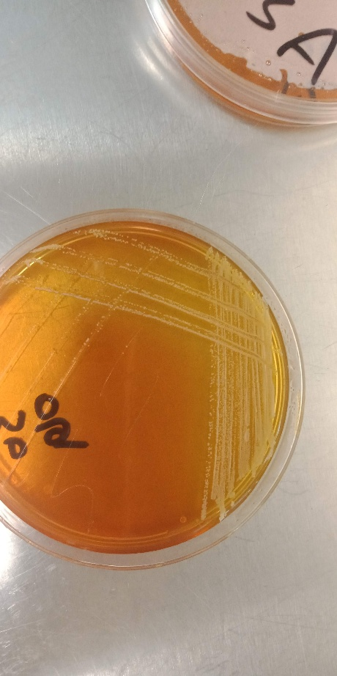
Fig. 1: S. aureus colonies on mannitol salt agar medium.
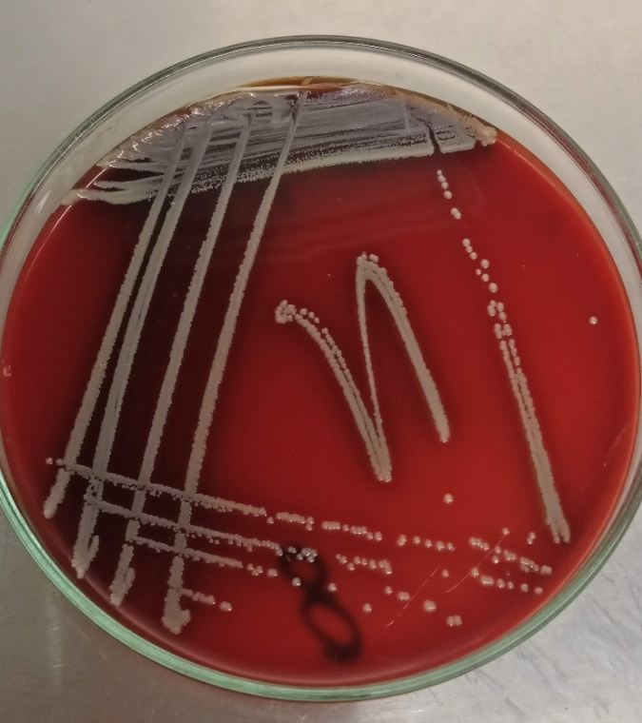
Fig. 2: S. aureus on blood agar

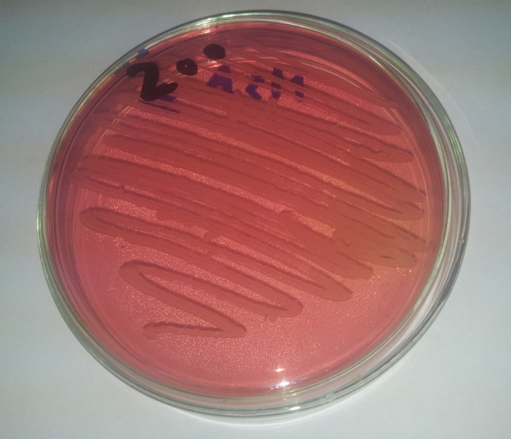
Fig. 3: CNS on mannitol salt agar medium.

Fig. 4: shows the occurrence of staphylococci in the examined samples
3.2. Antibacterial sensitivity test of S. aureus isolates:
Thirty-eight S. aureus isolates were tested for antibacterial sensitivity test (Fig. 5, 6, 7) showing high sensitivity for vancomycin and clindamycin with percentages of 97.3% and 81.5% respectively. It is clear that (37/38), 97.3% of the isolates were sensitive to vancomycin, also (26/38) 68.4% of isolates were sensitive to chloramphenicol. While (38/38)100%, (30/38)78.9%, and (20/38)52.6% of the isolates were resistant to penicillin G, tetracycline, and amoxicillin-clavulanic acid respectively. Methicillin-resistant Staphylococcus aureus (MRSA) represents (10/38) 26.3% of the isolates, on the other side resistant to methicillin represents 26.3% (10/38) of S. aureus isolates as shown in Table 4. There are 29 (76.3%) isolates resistant to 3 or more of the antibiotic groups which were considered as Multi-Drug Resistant (MDR) S. aureus. as shown in Table 5.
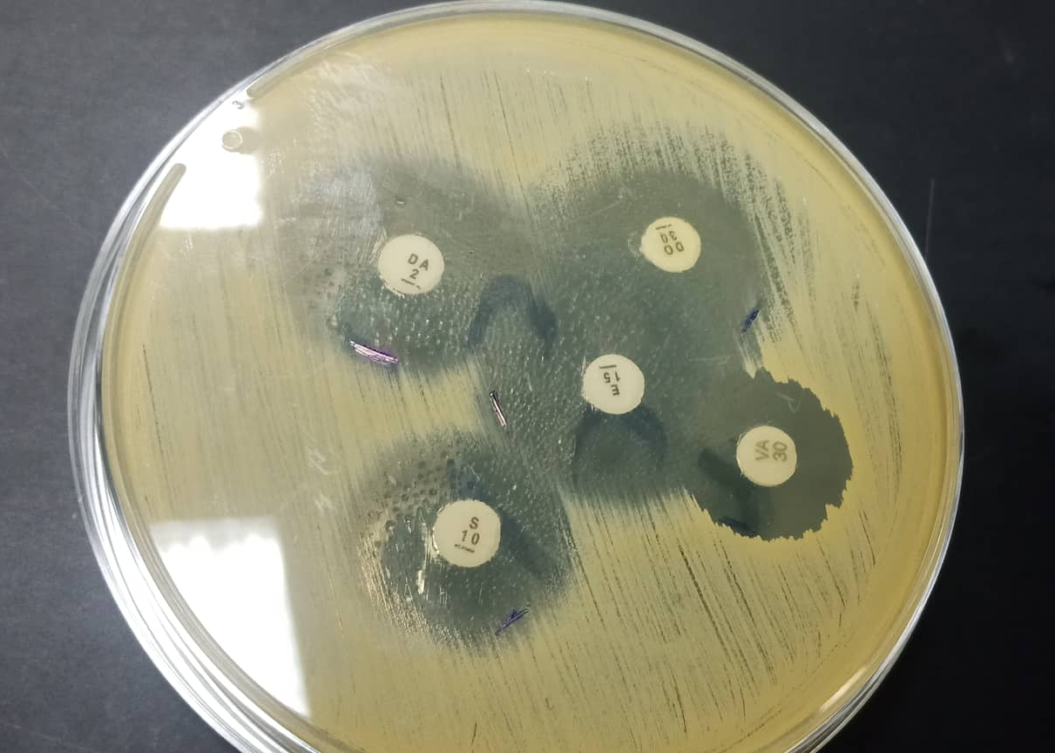
Fig. 5: Shows sensitivity of S. aureus to more than antibiotic (vancomycin, erythromycin, clindamycin, doxycycline and gentamicin).
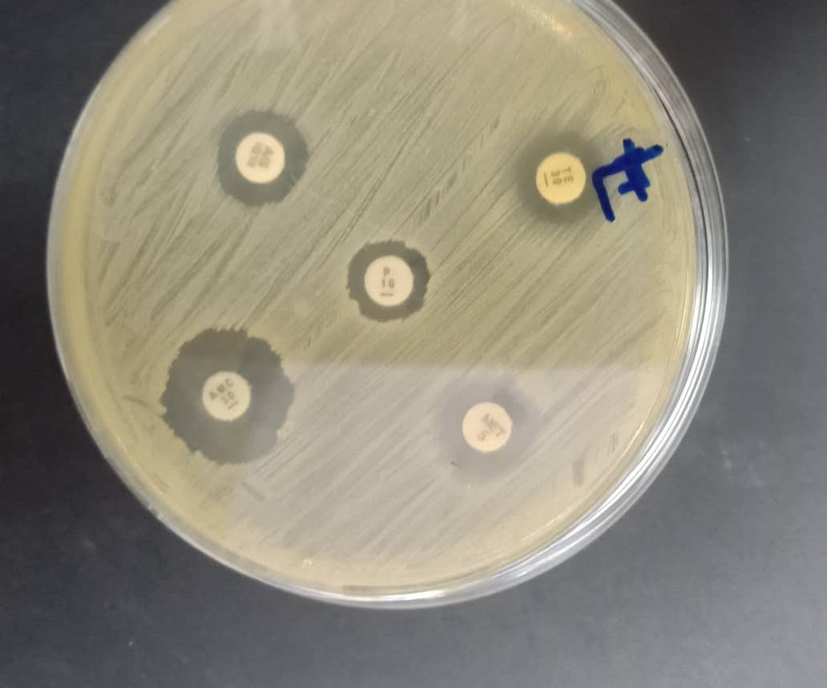
Fig. 6: Shows resistance of S. aureus to more than one antibiotic (penicillin G, amoxicillin clavulinic acid, ampicillin sulbactin and tetracycline).
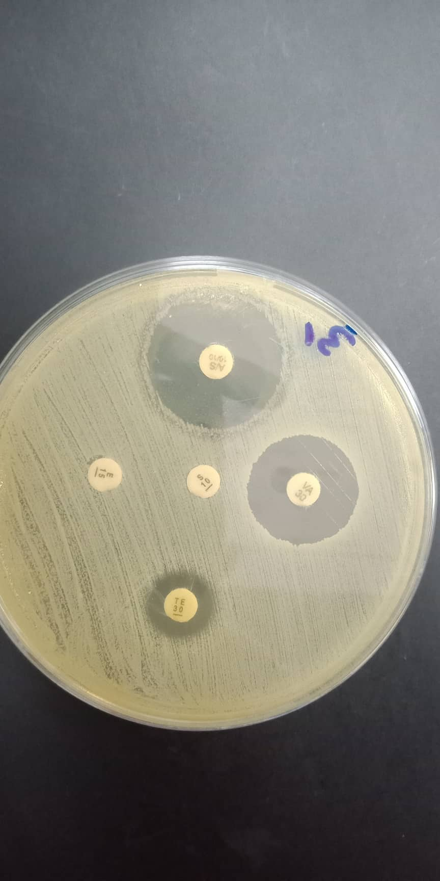
Fig. 7: Shows resistance of S. aureus to more than one antibiotic (gentamicin, tetracycline and penicillin G) and shows sensitivity to ampicillin sulbactin and vancomycin.
3.3. Detection of methicillin-resistant S. aureus (MRSA) using PCR:
Examination of the 10 isolates that showed phenotypic resistance to methicillin for the presence of mecA gene by PCR. The 10 isolates were found to harbor the mecA gene as shown in Fig. 8.

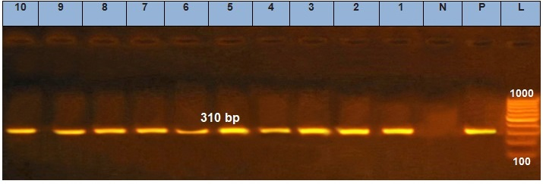
Fig. 8: (PCR) result of mecA gene among S. aureus isolates.
a) Lane L: DNA marker, lane N: Control negative, lane P: Control positive, lane (1-10): positive for mecA gene at 310bp amplification.
3.4. Evaluation of the biofilm formation of S. aureus isolates using Tube Method:
All S. aureus isolates were divided into different grades after the application of Tube method, the interpretation showed that 18/38 (47.4%) of the isolates were biofilm former which was classified as follows: 7/38 (18.4%) strong biofilm former followed by moderate biofilm former and weak biofilm former with percentages 6/38 (15.7) %, 5/38(13.1%) respectively, while 20/38 (52.6%) were non-biofilm former.
3.5. Correlation between biofilm formation and presence of Multi-Drug Resistance:
It was clear that about 72.2% (13/18) of the biofilm former S. aureus were MDR as shown in Table 6.

4. DISCUSSION
Chicken meat production has increased globally in a significant way, and it is predicted to be the largest meat source by 2023. (Skarp et al. 2016), moreover, chicken meat is well recognized as a cheaper source of protein than other meat types (Salinas et al. 2012). Genus Staphylococcus comprises various species that are widely distributed in nature and found mostly, it is naturally present in the skin and mucous membranes of poultry (Sato et al. 1972). So, S. aureus is considerable reason of poultry disease and that may contaminate foods as a result (Mead and Dodd 1990), this contamination mainly leads to foodborne illnesses due to the Presence of Staphylococcal enterotoxins (Do Carmo et al. 2004), poultry meat and red meat and their products are the main type of food that cause this kind of food illnesses (Kitai et al. 2005). The current study aimed to reveal the occurrence of S. aureus in chicken meat products and to appraise the antibiotic resistance profile, MRSA, and biofilm production in S. aureus isolated from chicken.
Out of 225 samples collected from different poultry meat products (frozen chicken meat, chicken nuggets, chicken fillet, chicken luncheon, chicken shawarma, and chicken stock cubes), staphylococci revealed 127/225 (56.4%), staphylococcus aureus represents 16.8% (38/225), while, 39.5% (89/225) were coagulase-negative staphylococci. A slightly high level of contamination (18.52%), was identified as S. aureus out of 200 chicken samples obtained from Harcourt, Rivers State (Oritsetimeyin, 2019) in addition to (Akbar and Anil 2013) who isolated S. aureus from 18.18% of the examined chicken meat samples.
The spread of multidrug-resistant (MDR) bacteria in the last few years has evoke a serious problem, rather than the extensive use of antibiotics in livestock breeding is a possible source of MDR bacteria. Consequently, food from animal sources is considered a possible way for transmission of MDR bacteria from animals to human beings (Van Cleef et al. 2011). In the current study, it is noticed that the highest sensitivity of 97.3% and 81.5 % were for vancomycin and clindamycin respectively, and about 100%, 78.9%, and 52.6% of the isolates were resistant to penicillin G, tetracycline and amoxicillin-clavulanic acid respectively. These results agree with (Gundogan et al. 2005) that found all S. aureus strains were sensitive to vancomycin, and agree with (Citak and Duman, 2011) who found all S. aureus isolates were sensitive to vancomycin, furthermore, it agree with (Reeves et al. 1991) who found all of 300 S. aureus isolates but one were sensitive to clindamycin, and disagree with (Mkize et al. 2017) whose results illustrated that 61.9% of S. aureus isolated from broiler chicken (abattoir origin) were resistant to vancomycin. It also disagrees with (Simjee et al. 2007) who found 48% resistance against clindamycin among staphylococci isolated from poultry litter collected from 24 farms across Georgia. On the other hand, (Asima et al. 2019) reported a significant resistance of the S. aureus isolates which was highest to penicillin, ciprofloxacin, tetracycline, and erythromycin with percentages (90.97%), (61.80%), (45.14%) and (11.11%) respectively. Staphylococcus species isolated by (Gundogan and Ataol, 2013) displayed high resistant rate against ampicillin followed by tetracycline, erythromycin, methicillin, and gentamicin (31.6%), (26.3%), (20.6%), (17.2%), and (12.4%) respectively. (Citak and Duman 2011) found 40.2 and 36.9% of S. aureus were resistant to tetracycline and erythromycin, respectively. Most of the S. aureus isolates were resistant to one or more of the microbial agents, with none being resistant to vancomycin, as recorded by (Citak and Duman 2011).
It is clear that in chickens, the frequency of S. aureus harboring multiple antibiotic resistance genes is high, meaning that food can be considered a reservoir of bacteria-containing genes potentially contributing to the evolution of antibiotic resistance in staphylococci. Recently Multidrug-resistant bacteria (MDR) are forming a challenge not only for the health care system but also in livestock breeding (Zarfel et al. 2014). the ongoing study recorded MDR in a significant percentage, about 29/38 (76.3%) of S. aureus isolates were considered as Multi-Drug Resistant (MDR), this finding is closely related to (Waters et al. 2011) who recorded MDR in 47% of S. aureus isolated from meat and poultry samples in the US. And (Parvin et al. 2021) reported all isolated S. aureus from frozen chicken meat were Multidrug-Resistant.
Globally, methicillin-resistant Staphylococcus aureus (MRSA) is responsible for considerable mortality, morbidity, and health care expenditure in both hospitals and the community (Weese, 2010). Methicillin resistance gene mecA is located on SCCmec cassettes. These are mobile genetic elements responsible for the transfer of resistance genes, but with lower transfer frequency than plasmids or transposons carrying ESBL genes (Shore and Coleman 2013). Methicillin-resistant staphylococci is a major concern to public and animal health in veterinary medicine and along the meat and milk production line (Weese, 2010). The present study provides data on MRSA among chicken products. In the present study, there were 10 samples were resistant to methicillin disc and 10 samples were positive for the mecA gene. The MRSA occurrence rates mentioned above are in contrast to the low MRSA prevalence in Tulsa, Oklahoma (Abdalrahman et al. 2015) as just 2 chicken samples out of 114 samples 2/114 (1.8%) were positive for (MRSA). On the other hand, we could find this result is almost the same as (Geha et al. 1994) who found that 100% of oxacillin-resistant staphylococcal isolates are positive for the mecA gene.
One of the most significant virulence factors of S. aureus is biofilm formation (Hall et al. 2004) as it is proven that biofilm-mediated infections have a serious negative effect on both human and animal health (Mohammadi et al. 2021). In addition to its direct relation to the Presence of MRSA among the biofilm producer S. aureus (Bimanand et al. 2018). In the exciting study, by using the tube method test the biofilm formation findings revealed 47.4% (18/38) of the S. aureus were biofilm former classified as follow: 18.4% (7/38) strong biofilm former followed by 15.7% (6/38) moderate biofilm former then 13.1% (5/38) weak biofilm former. This finding is harmonized with (Halim et al. 2018) who detected 42.7% of the S. aureus isolates were biofilm former using the Tube Method, and contrary to (lin et al. 2019) who found 94.4% of the S. aureus expressed weak or non-biofilm production
5. Conclusion
The existence of Staphylococcus species in the examined samples emphasizes the need for improved hygiene practices during food processing. Our results also indicate that most of the S. aureus isolates were resistant to one or more antibiotics. The increasing prevalence of resistance in the isolates from animal origin may have important therapeutic implications. More restrictive policies on the use of antibiotics on animals may improve the current situation. Otherwise, further studies are required to investigate the relation between the high (MRSA) prevalence and biofilm formation. In conclusion, chicken carcasses may constitute a reservoir for disseminating antibiotic-resistance staphylococci into the community.
6. Acknowledgement
We thank all members of bacteriology unit in RLQP for discussion, encouragement and support in the course of the study.

7. REFERENCES.
Abbasi, K., Tajbakhsh, E., Momtaz, H. 2021. Antimicrobial Resistance and Biofilm Encoding Genes Amongst the Staphylococcus aureus Bacteria Isolated from Meat and Meat Products. Egypt J Vet Sci. 52(1): 55-62.
Abdalrahman, L. S., Stanley, A., Wells, H., Fakhr, M. K. 2015. Isolation, virulence, and antimicrobial resistance of methicillin-resistant Staphylococcus aureus (MRSA) and methicillin-sensitive Staphylococcus aureus (MSSA) strains from Oklahoma retail poultry meats. Int. J. Environ. Res. public health. 12(6): 6148-6161.
Achi, O.K., Madubuike C.N. 2007. Prevalence and antimicrobial resistance of S. aureus isolated from retail ready-to-eat foods in Nigeria. Res. J. Microbiol. 2(6): 516-523.
Akbar, A., Anal, A. K. 2013. Prevalence and antibiogram study of Salmonella and Staphylococcus aureus in poultry meat. Asian Pac. J. Trop. Biomed. 3(2): 163-168.
Asima, Z., Maliha, G., Randhir, S., Simranpreet, K. 2019. Prevalence, multidrug resistance, and molecular typing of methicillin-resistant Staphylococcus aureus (MRSA) in retail meat from Punjab, India. Glob. Antimicrob. Resist. 16: 152-158.
Balaban, N., Rasooly. A. 2000. Staphylococcal enterotoxins. Int J Food Microbiol. 61(1):1-10.
Bimanand, L., Taherikalani, M., Jalilian, F.A., Sadeghifard, N., Ghafourian, S., Mahdavi, Z., Mohamadi, S., Sayehmiri, K., Hematian, A., Pakzad, I. 2018. Association between biofilm production, adhesion genes, and drug resistance in different SCCmec types of methicillin-resistant Staphylococcus aureus strains isolated from several major hospitals of Iran. Iran J. Basic Med. Sci. 21(4): 400–403.
Christensen, G.D., Simpson, W.A., Bisno, A.L. 1982. Adherence of slime-producing strains of Staphylococcus epidermidis to smooth surfaces. Infect Immun. 37(1): 318-326.
Citak, S., Duman, T. 2011. Staphylococcus aureus and coagulase-negative Staphylococcus from raw chicken samples in Turkey: Prevalence and antimicrobial resistance. J Food Agric Environ. 9(1).‏
Clinical and Laboratory Standards Institute [CLSI]. 2018. Performance Standards for Antimicrobial Disk and Dilution Susceptibility Tests for Bacteria Isolated from Animals. CLSI supplement VET08. 4th edn. Wayne, PA: Clinical and Laboratory Standards Institute.
CLSI. 2016. Clinical and Laboratory standard Institute, M02- A12, M07- A10, and M11- A8.
Do Carmo, L. S., Cummings, C., Roberto Linardi, V., Souza Dias, R., Maria De Souza, J., De Sena, M. J., Jett, M. 2004. A case study of a massive staphylococcal food poisoning incident. Foodborne Pathog. Dis. 1(4): 241-246.‏
García-Álvarez, L., Holden, M. T., Lindsay, H., Webb, C. R., Brown, D. F., Curran, M. D., Holmes, M. A. 2011. Methicillin-resistant Staphylococcus aureus with a novel mecA homologue in human and bovine populations in the UK and Denmark: a descriptive study. The Lancet infect. dis. 11(8): 595-603.
Geha, D.J., Uhl, J.R., Gustaferro, C.A., Persing, D.H. 1994. Multiplex (PCR) for identification of methicillin-resistant staphylococci in the clinical laboratory. J Clin Microbiol. 32(7):1768-1772.
Genigeorgis, C. A. 1989. The present state of knowledge on staphylococcal intoxication. Int. J. Food Microbiol. 9(4): 327-360.
Gundogan, N., Ataol, O. 2013. Biofilm, protease and lipase properties, and antibiotic resistance profiles of staphylococci isolated from various foods. Afr. J. Microbiol. Res.7(28): 3582-3588.
Gundogan, N., Citak, S., Yucel, N., Devren, A. 2005. A note on the incidence and antibiotic resistance of Staphylococcus aureus isolated from meat and chicken samples. Meat Sci. 69(4): 807-810.
Halim, R. M. A., Kassem, N. N., Mahmoud, B. S. 2018. Detection of biofilm-producing staphylococci among different clinical isolates and its relation to methicillin susceptibility. Open Access Maced. J. Med. Sci. 6(8): 1335.
Hall-Stoodley, L., Costerton, J.W., Stoodley, P. 2004. Bacterial biofilms: From the natural environment to infectious diseases. Nat. Rev. Microbiol. 2(2):95–108.
Hennekinne, J. A., De Buyser, M. L., Dragacci, S. 2012. Staphylococcus aureus and its food poisoning toxins: characterization and outbreak investigation. FEMS Microbiol. Rev. 36(4): 815-836.
Kitai, S., Shimizu, A., Kawano, J., Sato E., Nakano, C., Uji T., Kitagawa, H. 2005. Characterization of methicillin-resistant Staphylococcus aureus isolated from retail raw chicken meat in Japan. J. Vet. Med. Sci. 67(1): 107-110.
Koneman, E. W., Allen, S. D., Sowell, V. R., Sommers, H. M. 1979. Color atlas and textbook of diagnostic microbiology. J.B. Lippincott Company, Philadelphia. Toronto. J. Infect. Dis. 123: 97-98.
Lin, Q., Sun H, Yao, K., Cai, J., Ren, Y., Chi, Y. 2019. The prevalence, antibiotic resistance, and biofilm formation of Staphylococcus aureus in bulk ready-to-eat foods. Biomolecules. 9(10): 524.
Mathew, A.G., Cissell, R., Liamthong, S. 2007. Antibiotic Resistance in Bacteria Associated with Food Animals: A United States Perspective of Livestock Production. Foodborne Pathog. Dis. 4(2): 115-133.
McClure, S. D. C., Jennifer G., James D., Sargent J. D. 2006. Ownership of Alcohol-Branded Merchandise and Initiation of Teen Drinking. Am. J. Prev. Med. 30(4): 277-283.
Mead, G. C., Gibson C., Tinker D. B. 1995. A model system for the study of microbial colonization in poultry defeathering machines. Lett. Appl. Microbiol. 20(2):134-136.
Middleton, J. R., Fales, W. H., Luby, C. D., Landsay, O. J., Sanchez, S., Kinyon, J. M., Wu, C. C., Maddox, C. W., Hartmann, F. 2005. Surveillance of Staphylococcus aureus in veterinary teaching hospitals. J. Clin. Microbiol. 43(6): 2916-2919.
Mkize, N., Zishiri, O. T., Mukaratirwa, S. 2017. Genetic characterization of antimicrobial resistance and virulence genes in Staphylococcus aureus isolated from commercial broiler chickens in the Durban metropolitan area, South Africa. J. S. Afr. Vet. Assoc. 88(1): 1-7.
Mohammadi, M. C., Anzabi, Y., Shayegh, J. 2021. A comparison of the frequency of biofilm-forming genes (icaABCD) in Methicillin-Resistant S. aureus strains isolated from Human and Livestock. Arch. Razi Inst. 76(6): 1655-1663.
Momtaz, H., Dehkordi, F.S., Rahimi, E., Asgarifar, A., Momeni, M. 2013. Virulence genes and antimicrobial resistance profiles of Staphylococcus aureus isolated from chicken meat in Isfahan province, Iran. J. App. Poultry. Res. 22(4):913- 921.
Oritsetimeyin, V. A. 2019. Evaluation of Microbial Isolates from Frozen Chicken Products Sold in Port Harcourt Metropolis and Determination of their Antibiotic Susceptibility Patterns. Acta sci. pharm. sci. 3(4): 07-13.
Ou, C., Shang, D., Yang, J., Chen, B., Chang, J., Jin, F., Shi, C. 2020. Prevalence of multidrug-resistant Staphylococcus aureus isolates with strong biofilm formation ability among animal-based food in Shanghai. Food Control. 112(2020): 107106.‏
Parvin, M. S., Ali, M. Y., Talukder, S., Nahar, A., Chowdhury, E. H., Rahman, M. T., Islam, M. T. 2021. Prevalence and multidrug resistance pattern of methicillin resistant S. aureus isolated from frozen chicken meat in Bangladesh. Microorganisms. 9(3): 636.‏
Paterson, G. K., Harrison, E. M., Holmes, M. A. 2014. The emergence of mecC methicillin-resistant Staphylococcus aureus. Trends Microbiol. 22(1): 42-47.
Podkowik, M., Bystroń, J., Bania, J. 2012. Genotypes, antibiotic resistance, and virulence factors of staphylococci from ready-to-eat food. Foodborne Pathog. Dis. 9(1): 91-93.
Quinn, L.M., Dickens, R.A., Hime, G.R., Coombe, M.L., Bowtell, D.D.L., Richardson, H.E. 2002. The Drosophila homolog of the c-myc transcriptional repressor FIR inhibits growth and proliferation. A. Dros. Res. Conf. 43: 205A.
Reeves, D. S., Holt, H. A., Phillips, I., King, A., Miles, R. S., Paton, R., Andrews, J. M. 1991. The activity of clindamycin against Staphylococcus aureus and Staphylococcus epidermidis from four UK centers. J. Antimicrob. Chemother. 27(4): 469-474.
Safarpoor Dehkordi, F., Gandomi, H., Basti, A.A., Misaghi, A., Rahimi, E. 2017. Phenotypic and genotypic characterization of antibiotic resistance of methicillin-resistant Staphylococcus aureus isolated from hospital food. Antimicrob. Resist. Infect. Control. 6(1): 1-13.
Salinas, Y., Ros-Lis, J. V., Vivancos, J. L., Martínez-Máñez, R., Marcos, M. D., Aucejo, S., Lorente, I. 2012. Monitoring of chicken meat freshness by means of a colorimetric sensor array. Analyst. 137(16): 3635-3643.‏
Sasidharan, S., PrFateha B., Yoga L.L. 2011. Antimicrobial drug resistance of S. aureus in dairy products. Asian Pac. J. Trop. Biomed. 1 (2): 130-132.
Sato, G., Miura, S., Terakado, N. 1972. Classification of chicken coagulase-positive staphylococci into four biological types and relation of the types to additional characteristics including coagulase-antigenic type. Jpn. J. Vet. Res. 20(4): 91-110.‏
Shore, A. C., Coleman, D. C. 2013. Staphylococcal cassette chromosome mec: recent advances and new insights. Int. J. Med. Microbiol. 303(6-7): 350-359.
Simjee, S., McDermott, P. F., White, D. G., Hofacre, C., Berghaus, R. D., Carter, P. J. Maurer, J. J. 2007. Antimicrobial susceptibility and distribution of antimicrobial-resistance genes among Enterococcus and coagulase-negative Staphylococcus isolate recovered from poultry litter. Avian dis. 51(4): 884-892.
Skarp, C. P. A., Hänninen, M. L., Rautelin, H. I. K. 2016. Campylobacteriosis: the role of poultry meat. Clin. Microbiol. Infect. 22(2): 103-109.‏
Todar, K. 2009. Todar’s Online Textbook of Bacteriology. 2008. The Kenneth Todar University of Wisconsin-Madison Dept. of Bacteriology.
Van Cleef, B. A., Monnet, D. L., Voss, A., Krziwanek, K., Allerberger, F., Struelens, M. Kluytmans, J. A. 2011. Livestock-associated methicillin-resistant Staphylococcus aureus in humans, Europe. Emerg. Infect. Dis. 17(3): 502.
Waters, A. E., Contente-Cuomo, T., Buchhagen, J., Liu, C. M., Watson, L., Pearce, K., Price, L. B. 2011. Multidrug-resistant Staphylococcus aureus in US meat and poultry. Clin. Infect. Dis. 52(10): 1227-1230.‏
Weese, J. S. 2010. Methicillin-resistant Staphylococcus aureus in animals. ILAR Journal. 51(3): 233-244.
Zarfel, G., Galler, H., Luxner, J., Petternel, C., Reinthaler, F. F., Haas, D. Feierl, G. 2014. Multiresistant bacteria isolated from chicken meat in Austria. Int. J. Environ. Health Res. 11(12): 12582-12593.
Zhang, C., Shen, Y., Dong, M. 2013. Distribution, polymorphism and temporal expression of egc in Staphylococcus aureus isolates from various foods in China. Food Control. 29(1): 279-285.‏

Table 1: Oligonucleotide primers sequences.
Reference | Amplicon(bp) | Primer sequence (5'-3') | Gene
(McClure et al., 2006) | 310 bp | 5'GTA GAA ATG ACT GAA CGT CCG ATA A3' | mecA
 |  | 3'CCA ATT CCA CAT TGT TTC GGT CTA A5'

Table 2: Temperature and time conditions of the PCR amplification
Gene mecA | Primary denaturation | Secondary denaturation | Annealing | Extension | No. of cycles | Final extension
Temperature | 94˚C | 94˚C | 50˚C | 72˚C | 35 | 72˚C
Time | 5 min. | 30 sec. | 30 sec. | 30 sec. |  | 7 min.

Table 3: Occurrence of Staphylococcal spp. in the examined samples.
Type of samples | No. of examined samples | S. aureus
 |  | No. | %
Frozen chicken meat | 60 | 5 | 8.3
Chicken fillet | 30 | 4 | 13.3
Chicken nuggets | 30 | 7 | 23.3
Chicken shawarma | 30 | 14 | 46.6
Chicken luncheon | 15 | 5 | 33.3
Chicken stock cubes | 60 | 3 | 6.6
Total | 225 | 38 | 16.8

Table 4: Antibacterial sensitivity test of the 38 staphylococcus aureus isolates
 | Sensitive |  | Intermediate |  | Resistant
 | No. | % | No. | % | No. | %
P | 0 | 0 | 0 | 0 | 38 | 100
MET | 12 | 31.6 | 16 | 42.1 | 10 | 26.3
G | 22 | 57.9 | 10 | 26.3 | 6 | 15.8
E | 21 | 55.2 | 11 | 28.9 | 6 | 15.8
DA | 31 | 81.5 | 3 | 7.9 | 4 | 10.5
DO | 20 | 52.6 | 14 | 36.8 | 4 | 10.5
TE | 2 | 5.2 | 5 | 13.1 | 30 | 78.9
VA | 37 | 97.3 | 1 | 2.6 | 0 | 0
AMC 30 | 18 | 47.3 | 0 | 0 | 20 | 52.6
A/S | 24 | 63.1 | 9 | 23.7 | 5 | 13.1
Rif 5 | 24 | 63.1 | 3 | 7.9 | 11 | 28.9
Cip 5 | 27 | 71 | 4 | 10.5 | 7 | 18.4
C 30 | 26 | 68.4 | 1 | 2.6 | 11 | 28.9

Table 5: correlation between no. of resistant S. aureus isolates and the no. of resisted antibiotic groups:
No. of antibiotic groups | No. of resistant S. aureus isolates
1 | 4
2 | 5
3 | 14
4 | 7
5 | 3
6 | 4
8 | 1

Table 6: Correlation between biofilm formation and presence of Multi Drug Resistance
 | Strong biofilm former | Moderate biofilm former | Weak biofilm former
No. of biofilm former S. aureus | 7 | 6 | 5
No. of MDR S. aureus | 5 | 5 | 3

