Magnetic resonance imaging and Morphological Study on the Celiac Trunk of the Egyptian Barn Owl (Tyto Alba).
Ramadan Sary and Samar M. EL-Gammal
Department of Anatomy and Embryology, Faculty of Veterinary Medicine, Cairo University
*corresponding author: Dr. Ramadan Sary, Department of Anatomy and Embryology, Faculty of Veterinary Medicine, Cairo University Tel.: +2 01017618618, +2 01123148245,
Email: ramadansary88@gmail.com
Abstract
The current work was performed to describe the detailed morphology of the Celiac Trunk of the Egyptian Barn owl (Tyto Alba) to support the application of surgical therapeutic approaches in the coelomic cavity. Five apparently healthy Barn owls were used, the specimens were carried out from Giza Zoo and local animal markets in Giza districts to the Department of anatomy in veterinary medicine, Cairo University. Three carcasses were injected with latex to observe the distribution of Celiac Trunk and two for MRI. The celiac artery was a short trunk, erupted from the right lateral aspect of the descending aorta ventral to the 5th thoracic vertebra. The celiac artery terminated by dividing, on a mid- level with the spleen, into two main branches; left and right. Prior to its division, the celiac artery gave off the dorsal proventricular and splenic arteries.
Keywords: Egyptian Barn owl (Tyto Alba), Celiac Trunk, MRI, Dorsal Proventricular Artery, Splenic Artery
- Introduction
The Barn owls (Tyto Alba) belonged to family Tytonidae. They are worldwide spread in all countries except Antarctica and some distant islands (Umar and Atabo, 2019). In Egypt, Barn Owls are located in some regions in the Seuz Canal, the oases of Dakhla and Kharga, in the Nile Delta, specifically in Fayoum and along the west coast of the Mediterranean Sea (Kitat, 2019). They predate mainly on small mammals, insects and other birds. These owl species are known for their characteristic heart-shaped face, large head, a mix of buff and gray on the head, back, and upper wings, while the rest of the body is white in color on the face, body, and under wings. The Celiac artery in hooded crow originated from descending aorta, it gave off the peroventricular artery, splenic arteries then terminated with the right and left celiac arteries. The right celiac artery detached the right hepatic, left hepatic, gastroduodenal and the right gastric arteries (Hassan, S. and El-Sayed A.K., 2018). In all ten of the crow examined The celiac artery is the first visceral branch of the descending aorta originated from the right lateral side of the descending aorta on a level between the last 5th to 6th vertebral rib in the proximity of the very beginning of the proventriculus. It was ascertained that the crow had seventh pairs of ribs (costae). It extended caudoventrally between the spleen and proventriculus for about 2 cm and terminated on level middle of the spleen into two main branches left and right (Nawal A. Noor, 2017). The inferior periventricular artery, the left gastric, inferior gastric, left hepatic and gastroduodinal artery arise from the left celiac artery; while the splenic, right hepatic, ileocecal, pancreaticodoudinal, right superior gastric and right inferior gastric were originated from the right celiac artery (Baumel et al., 1993). The celiac artery of Sparrow hawk originated from the Aorta and supplied the proventriculus, gizzard, liver, pancreas and small intestines (Doğuer and Erençin, 1964; Malinovsky and Novotna, 1977; Baumel et al., 1993; Dursun, 2002). The dorsal periventricular artery was raised from the left side of the celiac artery; it coursed ventrally along the right aspect of the proventriculus. It gave off 1-2 esophageal branches that passed cranially to the esophagus, and then continued as the dorsal gastric artery. The dorsal gastric artery was the direct continuation of the dorsal proventricular artery; it crosses the right side of the proventriculus to supply the isthmus and the dorsolateral muscles of the ventriculus. Its terminal branches anastomosed with that of the left and right gastric arteries (H. M. Rezk and S. H. El-Bably, 2013).

- Materials and Methods
This study was carried out on five apparently healthy Barn owls that were brought from the Giza Zoo and local animal markets in Giza, in well ventilated metal cages.
Work procedures:
  - Bird preparation:
Before exsanguination, owls were, firstly, intramuscular injection of 0.25cc of xylazine 2% (xylazine hydrochloride) for proper relaxation and avoiding vasoconstriction. Secondly, injection of heparin (CalHeparin, 5000 I.U. ampoule) in the brachial vein to avoid blood clotting.
  - Latex neoprene injection technique: After euthanasia of the three owls, the sternum and ribs were removed carefully for heart exposure. The ventricular apex of the heart was cut and a Nelaton catheter of size 6F (MA MEDICAL Company) was introduced to the left ventricle of the heart to reach the descending aorta for injection of the celiac artery of the owls with 60% latex neoprene colored with red Rotring® ink ( Tompsett and Wakelly, 1965). The specimens were then kept in containers of 10% formalin solution, 2% phenol and 1% glycerin for 1-2 days before dissection, at room temperature (25 ºC) to allow solidification of the latex. The specimens were dissected to show the distribution of the arteries and their branching. Photographs were taken to record the observations. The nomenclature of the illustrated arteries was that recommended by the Nomina Anatomica Avium (Baumel et. al., 1993).
  - MRI of the abdomen was performed using 0.3 T magnets. The images were obtained in three planes: transverse (axial), sagittal, and coronal with various sequences.

- Results

The gastrointestinal tract of the Barn Owl is mainly supplied by the branches of the Descending Aorta (Fig.1, 2, 3 and 4/1); Celiac Trunk (Fig. 1, 2, 3 and 4/2), Cranial Mesenteric Artery (Fig.1/8, 2/14, 3 and 4/3), Caudal Mesenteric and Internal Iliac Arteries.

3.1 celiac artery:
The celiac artery (Fig. 1, 2, 3 and 4/2) was a short trunk, erupted from the right lateral aspect of the descending aorta (Fig. 1, 2, 3 and 4/1) ventral to the 5th thoracic vertebra. It coursed to the right of the median plane, in proximity to the beginning of the proventriculus (Fig.1 and 2/B); it passed caudoventrally in relation to the visceral surface of the right lobe of the liver (Fig.1 and 2/E'), between the proventriculus (Fig.1 and 2/B) and the spleen (Fig.3/7) for 2 cm. The celiac artery terminated by dividing, on a mid- level with the spleen (Fig.3/7), into two main branches; left and right. Prior to its division, the celiac artery gave off the dorsal proventricular (Fig.1, 2/3 and 3, 4/4) and splenic arteries (Fig. 1, 3 and 4/2).

3.2 A.proventriculus dorsalis:
The dorsal proventricular artery (Fig.1, 2/3 and 3, 4/4) originated from the left lateral aspect of the celiac artery (Fig. 1, 2, 3 and 4/2). The former artery ran on the dorsal surface of the proventriculus (Fig.1 and 2/B) where it released fine branches to the wall of the glandular stomach (Fig.5/4, 6/6 and 7/5), then extended over the dorsal aspect of the gastric isthmus as the dorsal gastric artery (Fig.2/10).
3.3 The splenic artery:
The splenic artery (Fig. 3 and 4/6) arises from the cranial aspect of celiac artery; it gave several branches to the spleen.

3.4 Ramus sinister arteriae celicae:
The left branch of the celiac artery (figs. 1/4) was a slender vessel, about 1.5 cm long, emanated from the bifurcation of the celiac artery (Fig. 1, 2, 3 and 4/2), after the origin of the splenic arteries (Fig. 3 and 4/6). The left branch progressed cranioventrally to the visceral surface of the left lobe of the liver (Fig. 1/E) and the left side of the proventriculus (Fig.1 and 2/B) reaching the gizzard (Fig.1 and 2/C) where it continued as the left gastric artery. Along its course, the left branch of the celiac artery gave off; ventral proventricular (Fig.1/5), left hepatic and ventral gastric arteries (Fig.1/6). The pancreatico-duodenal artery (Fig.1/9 and 3/8) was the direct continuation of the left celiac artery which supplied the pancreas (Fig.1/P) and duodenum (Fig.1/D).

3.5 Ramus dexter arteriae celicae:
The right celiac artery passed in between the proventriculus (Fig.1 and 2/B) and gizzard (Fig.1 and 2/C) and right lobe of liver (Fig.1/E'), it gave off gastroduodenal artery; right gastric artery and right hepatic arteries. The right gastric artery gave off ventral proventricular artery (Fig.2/5), dorsal gastric artery (Fig.2/10) and ventral gastric artery (Fig.2/9) to the gizzard.
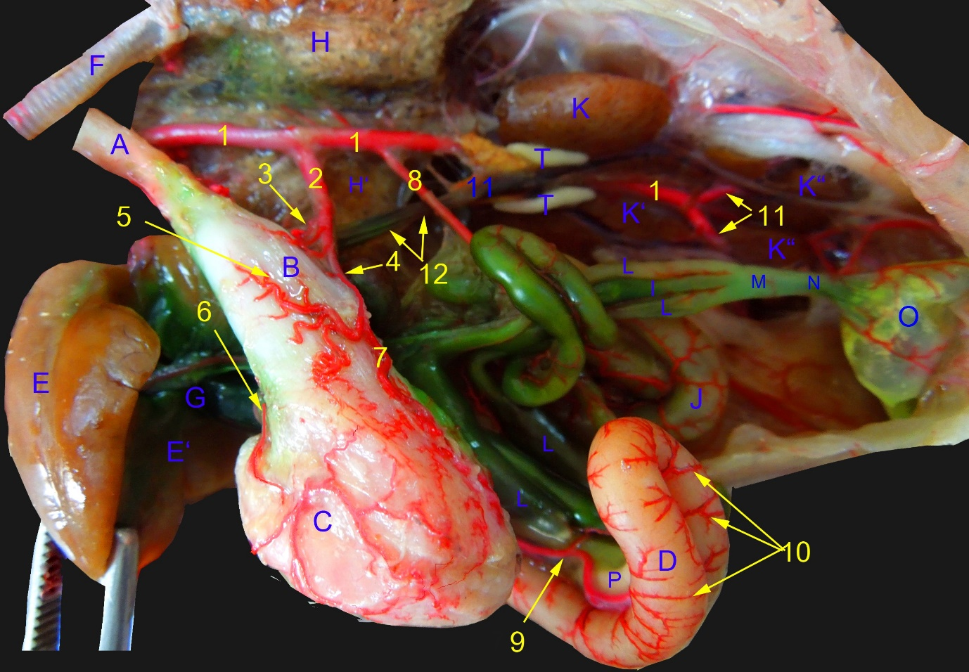
Fig. 1: A photograph showing the distribution of the branches of the descending aorta to the GI tract of the Barn owl.
- Aorta descendens 2- A.celiaca 3- A.proventriculus dorsalis 4- Ramus sinister arteriae celicae 5- A.proventricularis ventralis
- A.gastrica ventralis 7- A.gastrica sinistra 8- A.mesenterica craniali 9- A.pancreaticoduodenalis 10- Rr.duodenales
- A.ischiadica 12- Vena cava caudalis
- Esophagus B- Proventriculus C- Gizzard D- Doudenum E- Left lobe of liver E' Right lobe of liver F- Trachea
- Gall bladderLeft lobe of lung H'- Right lobe of lung I- Ileum J- Jejunum K- Cranial lobe of kidney K'- Middle lobe of kidney K''- Caudal lobe of kidney L- Ceca M- Ileocecocolic junction N- Colon/ Rectum/ Colorectum O- Cloaca
- Pancreas T- Testes

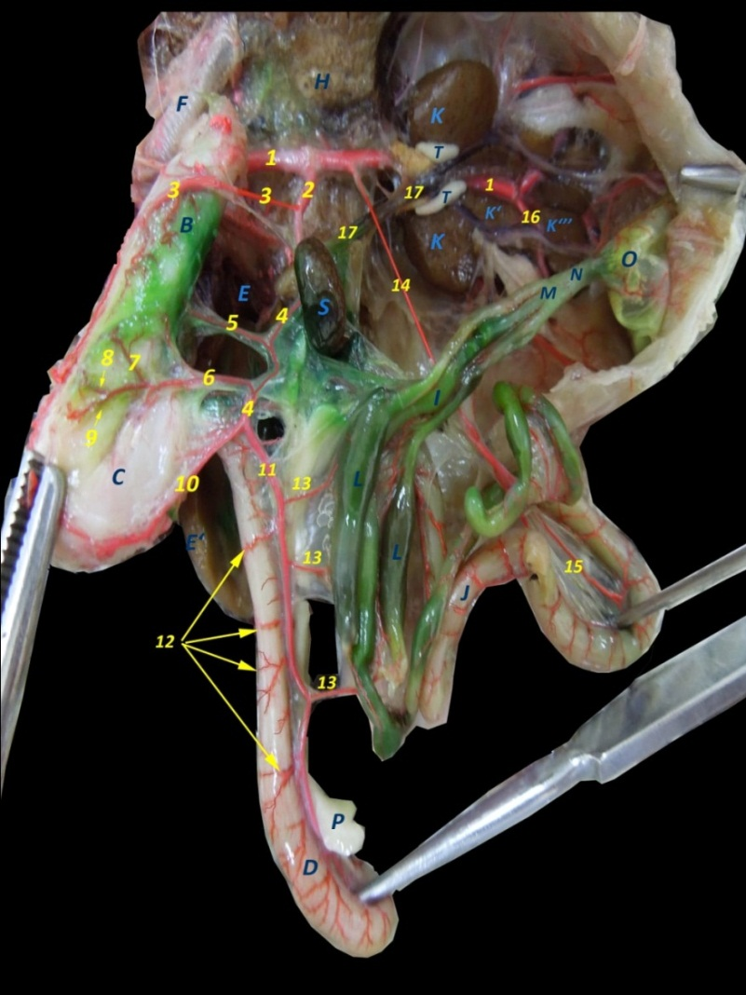
Fig. 2: A photograph showing the distribution of the branches of the right branch of the celiac artery.
1- Aorta descendens, 2- A.celiaca, 3- A.proventriculus dorsalis, 4- Ramus dexter arteriae celicae, 5- A.proventricularis ventralis, 6- A.gastrica dextra, 7- Rr.isthmi, 8- A.gastrica dexter dorsalis, 9- A.gastrica dexter ventralis, 10- A.gastrica dorsalis, 11- A.pancreaticoduodenalis, 12- Rr.duodenales, 13- Aa. Ileocecales, 14- A.mesenterica cranialis, 15- Aa.jejunales, 16- Aa.iliaca externa, 17- Vena cava caudalis

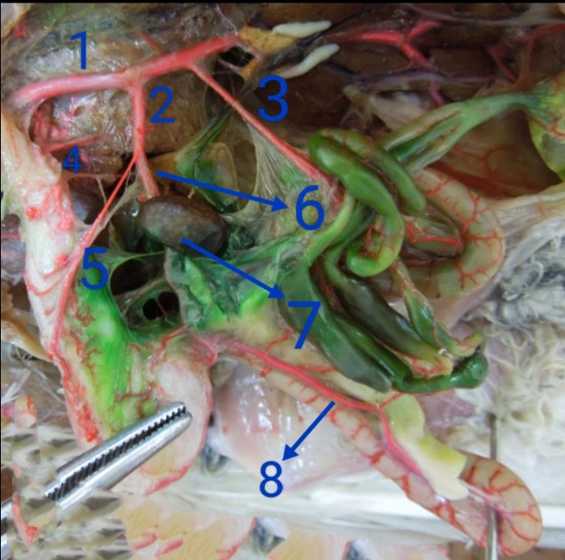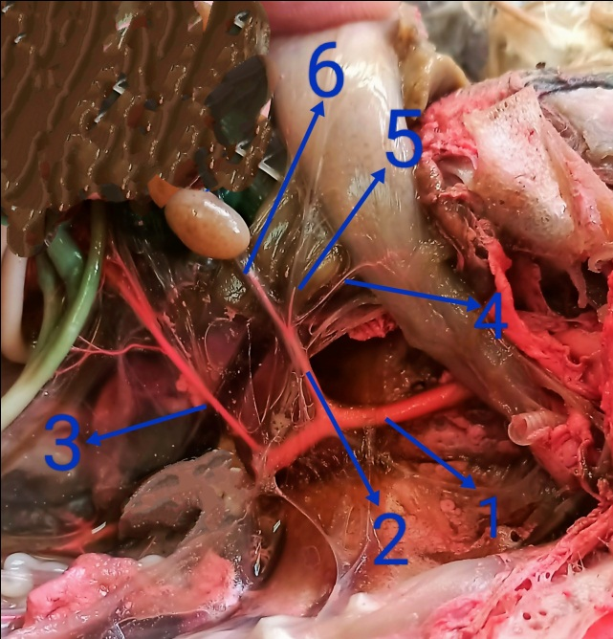
Fig. 4: A photograph showing the branches of the
Celiac trunk before its division.
1- Descending aorta, 2- celiac trunk, 3- cranial mesenteric artery, 4- A. proventriculus dorsalis, 5- Ramus sinister arteriae celicae 6- splenic artery,

Fig. 3: A photograph showing the distribution of the branches of the celiac trunk of the Barn owl.
- Descending aorta, 2- celiac trunk, 3- cranial mesenteric artery, 4- A. proventriculus dorsalis, 5- Ramus sinister arteriae celicae 6- splenic artery, 7- spleen, 8- A. pancreaticoduodenalis

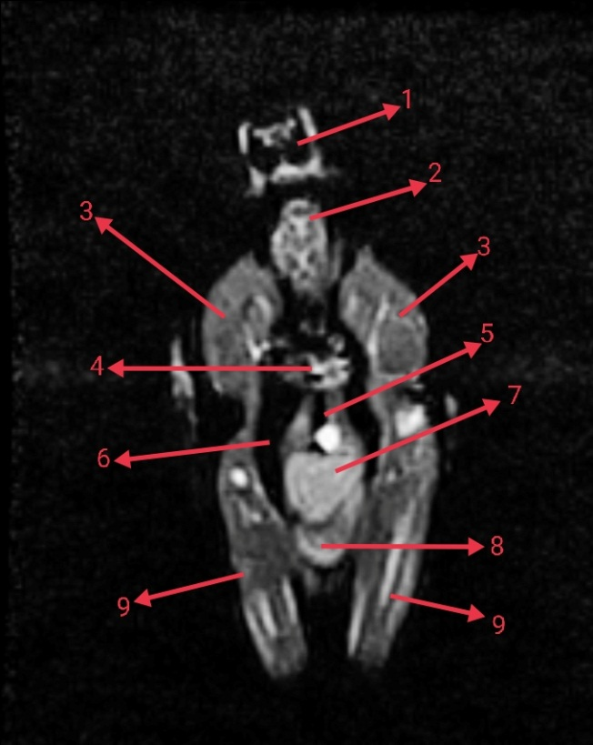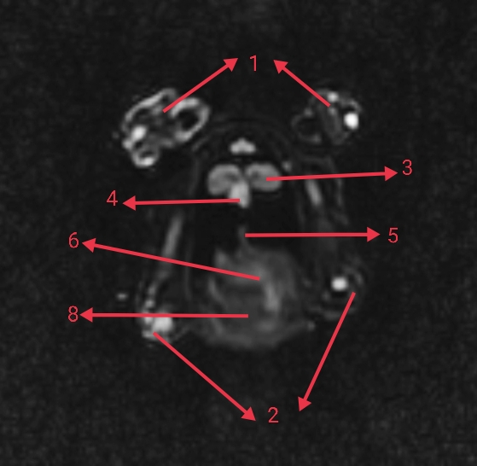
Figure 6: A photograph showing MRI of the abdomen axial (transvers) section.
- Wing, 2- hind limb, 3- lung, 4- heart, 5- esophagus, 6- stomach, 8- intestine

Figure 5: A photograph showing MRI of the abdomen coronal section.
- Head, 2- neck, 3- pectoral muscle, 4- heart, 5- esophagus, 6- air sacs, 7- stomach, 8- intestine, 9- hind limb

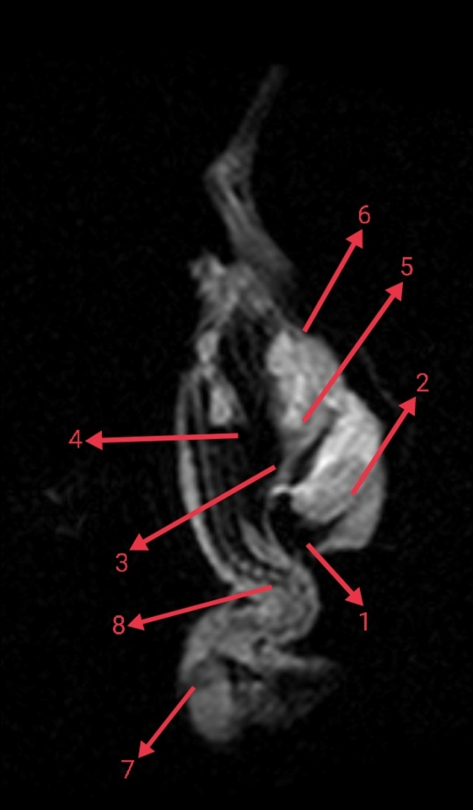
Figure 7: A photograph showing MRI of the abdomen sagittal section.
- Lung, 2- pectoral muscle, 3- esophagus, 4- air sacs, 5- stomach, 6- intestine, 7- head, 8- neck

- DISCUSSION

4.1- The Egyptian Barn Owl differed from the Hooded Crow and the Sparrow hawk in that the ventral proventricular artery, the left hepatic artery and the ventral gastric arteries were originated from the left celiac artery while they were originated from the right celiac in Hooded Crow and the Sparrow hawk as observed by (Hassan, S. and El-Sayed A.K., 2018).

4.2- As in Hooded Crow and Sparrow hawk the celiac artery of The Egyptian Barn Owl was a short trunk, erupted from the right lateral aspect of the descending aorta ventral to the 5th thoracic vertebra. It coursed to the right of the median plane, in proximity to the beginning of the proventriculus; it passed caudoventrally in relation to the visceral surface of the right lobe of the liver, between the proventriculus and the spleen for 2 cm. The celiac artery terminated by dividing, on a mid- level with the spleen, into two main branches; left and right. Prior to its division, the celiac artery gave off the dorsal proventricular and splenic arteries, this similarly observed with (Hassan, S. and El-Sayed A.K., 2018, Nawal A. Noor, 2017, Doğuer and Erençin, 1964, Malinovsky and Novotna, 1977, Baumel et al., 1993 and Dursun, 2002).
4.3- In agreement with (H. M. Rezk and S. H. El-Bably, 2013), the dorsal proventricular artery originated from the left lateral aspect of the celiac artery. The former artery ran on the dorsal surface of the proventriculus where it released fine branches to the wall of the glandular stomach, then extended over the dorsal aspect of the gastric isthmus as the dorsal gastric artery. In accordance to, the right celiac artery gave off gastroduodenal artery and right hepatic arteries. The gastroduodenal artery supplies the pylorus and 1st part of duodenum and gave off the dorsal gastric artery to the craniodorsal sac of the gizzard (Hassan, S. and El-Sayed A.K., 2018).
- Conclusion
This study provided anatomical information about the celiac trunk of The Egyptian Barn Owl and its branches and the organs who supply, this will help in clinical diagnosis of GIT problems through using Magnetic resonance imaging (MRI), also provided a guide for pet clinics which deal with wild birds.

- References

Baumel J.J., King S.A., Breasile J.E., Evans H.E., Berge J.C.V. 1993. Handbook of avian anatomy (Nomina anatomica avium). The Nuttall Ornithological Club, Cambridge. P. 407-436.
Doğuer, Erençin. 1964. Evcil kuşların komparatif anatomisi. Ankara University Press. P. 68-77.
Dursun N. 2002. Anatomy of domestic birds. Ankara Medisan Publishing. P. 140-141.
Hassan, S., El-Sayed A.K. 2018. Gross Anatomy of the Celiac, Cranial Mesenteric and Caudal Mesenteric Arteries in Hooded Crow (Corvus cornix). J. Vet. Anat. Vol. 11, N. 2, P. 41 - 55
H. M. Rezk, S. H. El-Bably. 2014. Gross Anatomical Studies on the Celiac Artery in The Domestic Fowl (Gallus gallus domesticus). J. Vet. Anat. Vol 7 No 1, P. 127 - 141

Kitat S. El-Sayed. 2019. The Veneration of the Owl in Græco-Roman Egypt. IJHCS, vol. 5 (2): pp 1-20.

Malinovsky L., Novotna M. 1977. Branching of the celiac artery in some domestic birds, III. A comparison of the pattern of the celiac artery in three breeds of the domestic fowl. Anatomischer Anzeiger. V. 141(2). P. 137-146.
Nawal A. Noor. 2017. Macroanatomic investigations on the course and distribution of the celiac artery in Hooded crow (Corvus cornix) with special reference to the arterial supply of the stomach. JVMR. 24 (2): 222-234

Tomsett, D. H., C. W. Wakeley. 1965. Anatomical Techniques. Edin-burgh and London.
1st Edition. E & Living Stone Ltd.

Umar, A. A., Atabo, S. M. 2019. GROSS MORPHOLOGY AND MORPHOMETRIC STUDIES OF DIGESTIVE TRACT OF BARN OWL (Tyto alba). Animal Review, vol. 6 (1): pp 1-4.

