Spatiotemporal Localization Patterns of Different Lectins in Developing Rat Kidney Postnatally

Sahar F. Mahmoud ¹, Ahmed M. Rashwan^{2,3*}

¹Department of Histology and Cytology, Faculty of Veterinary Medicine, Damanhour University 22511, Egypt
²Department of Anatomy and Embryology, Faculty of Veterinary Medicine, Damanhour University 22511, Egypt
³Department of Life Science Frontiers, Center for iPS Cell Research and Application, Kyoto University, Japan

Corresponding Author:
Ahmed Rashwan
Dept. of Life Science Frontiers, Center for iPS Cell Research and Application, Kyoto University, Japan
Phone: +818062035728
Email: ahmed.rashwan@cira.kyoto-u.ac.jp

Disclose and conflicts of interest: none to be declared by all authors

ABSTRACT
Our study was designed to determine the spatiotemporal pattern of different lectins in developing rat kidneys postnatally, which was unprecedented before. We used immunohistochemistry to examine the localization of three different lectins, Concanavalin (Con A), Wheat germ agglutinin (WGA), and Peanut agglutinin (PNA), in rat kidneys of both sexes at neonatal day 1 and postnatal 1, 2, and 8 weeks. The intensity of the Con A lectin decreased with age, from intense at birth to moderate in the proximal convoluted tubules (PCT) and absent in the distal convoluted tubules (DCT) by 8 weeks. Renal corpuscles showed intense reactions to Con A in immature glomeruli at birth and intense reactivity in podocytes at 8 weeks of age in rats. Con A was intense in collecting tubules (CT) and collecting ducts (CD) of all ages. The intensity of the WGA lectin increased with age, from no reaction at birth to moderate reactions in PCT and DCT at 8 weeks. WGA was intense in immature glomeruli at birth, but only in podocytes at 8 weeks. The CT and CD showed mild to moderate reactions to WGA in all ages of rat kidneys. The PNA lectin in PCT decreased in intensity with age, from a moderate reaction at birth to no reaction at 2 and 8 weeks. The PNA lectin in DCT increased in intensity with age, from a moderate reaction at birth to an intense reaction at 8 weeks. The PNA in the renal corpuscle decreased in intensity with age, from a moderate reaction in immature glomeruli at birth to no reaction at other ages. The CT and CD showed an intense reaction to PNA in all ages of rat kidneys. We conclude that there were differences in the lectin distribution and intensity between developing and adult rat kidneys, and this variation may be related to the function of each lectin.

Keywords: Rat; Lectins;Con A; WGA; PNA; Kidney

- INTRODUCTION
Lectins are proteins that bind to certain sugars in glycoproteins in a reversible manner. They've been used as probes to detect carbohydrate moieties on the cell's surface or in intracellular cytoplasmic organelles (Roth, 1996). The lectins, which are the biological equivalents of carbohydrates, play crucial roles in a variety of biological processes that are essential for many physiological functions, including glomerular filtration, nutritional metabolism, cell communication, immune defense, cell-cell adhesion, signaling events, microbial infection, cancer metastasis, and others (Watanabe et al., 2013; Muramoto, 2017).
The lectin distribution in the nephron is largely species-specific for each animal; however, some common features can also be found between different mammals. Moreover, specific lectin configurations are restricted to a small portion of nephron segments in some species (Valtin, 1972; Hatten et al., 1979). Various lectin patterns have been described in numerous investigations in a variety of mammalian species (Holthofer, 1983). On the other hand, there is no information on the spatiotemporal patterns of several lectins in developing rat kidneys postnatally. We have previously examined the distribution of one unique lectin called Jacalin in growing rat kidneys (Rashwan et al., 2022). However, the distribution of other lectins in developing rat kidneys has not been investigated yet.
Nephrogenesis was rapid in the rat kidney and occurred during birth and the first 8 days, and it was finished by the end of the 11th day (Kavlock and Gray, 1982). Nephron tubule differentiation continues up until weaning, and functional maturity happens substantially later (Gregor et al., 1999). The neonatal kidney's ability to manage acid-base balance, concentrate urine, and reabsorb filtered nutrients is still functionally primitive since nephrogenesis does not completed at birth and soon after (Hughson et al. 2003). The nutritional state of the mother is one of the factors that affects nephrogenesis. Smaller renal size and fewer numbers of nephrons were observed in the offspring of rats fed low-protein diets during pregnancy (Langley-Evans et al., 1999).
Con A lectin recognizes mannose residues in glycoconjugates and binds to all segments of the nephron; it showed varied binding patterns in the adult mouse kidney (Debray et al., 1981). Con A binding sites are only detected on the brush border as well as basement membranes of proximal tubules, and it had positive cytoplasmic reactions in both CD and CT. Con A exhibited intense mesangial binding in the glomeruli and had an intense reaction in endothelial and interstitial cells in the adult mouse kidney (Debray et al., 1981; Glick and Santer, 1982).
Laitinen et al. (1987) described the localization pattern of Con A lectin in embryonic and adult mice; at 11 days embryo, Con A was seen in the early tubules, primary vesicles, and primary condensates. While in adult mouse kidneys, Con A binding activity was intense in the PCT and mesangial area of the glomeruli. Yabuki et al. (2012) studied the Con A lectins in the adult stage only in the kidneys of dogs and detected that the parietal layer of Bowman capsules had mild to moderate signals while Con A reactivity was weak in the capillary endothelium and glomeruli. Con A was widely distributed from the tubules of the cortex to the CTs and CDs of the medulla in the kidneys of adult dogs.
WGA lectin bound to all nephron segments along the cell and basement membranes, as well as endothelial and interstitial cells of the glomerulus, because it recognizes both N-acetyl glucosaminyl moieties and sialic acid. In the adult mouse kidney, the most obvious positive areas are the surface of the glomerular podocytes and the brush border of the straight part of the proximal tubules. Surface positivity from podocytes is eliminated after neuraminidase treatment of the sections, proving that sialic acids were essential for these reactivities in the kidneys of an adult mice (Goldstein and Hayes, 1978; Monsigny et al., 1979). Since sialic acids are important components of the glomerular polyanions, which are necessary for adequate glomerular filtration (Latta, 1980; Reeves et al., 1980). Sialic acid is the primary WGA receptor in the kidneys so WGA lectin act as a marker for glomerular filtration in all species (Holthofer, 1983). The WGA lectin was moderate in PCT and faint in DCT in adult rat (Holthofer,1983). Le Hir and Dubach (1982) found that in adult rabbit kidney, there was intense reaction of WGA lectin only in PCT and not DCT. Laitinen et al. (1987) found that in the embryonic stage of mice, WGA was moderate in PCT and mild in DCT and CT. The WGA lectin was weak in the glomeruli at embryonic days (E)13 and then increased in intensity at E17. While in adults, WGA was intense in PCT and the podocytes of the glomeruli. Yabuki et al. (2012) reported in the adult canine kidney that WGA was distributed in all nephron tubes and showed reactivity in glomeruli, where positive signals were observed in Bowman’s capsules and capillary walls.
Many studies attempted to compare the localization of various lectins in normal and diseased animals, as Yabuki et al. (2018), who observed a change in the pattern of lectin binding and an intense reaction of WGA and Con A lectin in the capillary wall of glomerulonephritis dogs compared to normal dogs.
The PNA lectin binds to galactose-N-acetyl galactosamine and its reaction varies depending on the species (Goldstein and Hayes, 1978; Holthofer, 1983). PNA lectin was not present in the glomeruli of many animals, reacted very weakly in mesangial cells of the glomeruli of the cow, and was located in the Bowman's capsule of the mouse kidney (Holthofer, 1983). PNA lectin reacted moderately in PCT of rats and guinea pigs but not in DCT and moderately in DCT of goats, cows, and humans but was absent in PCT, indicating that PNA bound to either proximal or distal tubules in various mammals (Holthofer, 1983). Laitinen et al. (1987) found that in the embryonic stage of mice, the PNA was weak in primary vesicles, moderate in PCT, and faint in DCT. The PNA lectin was moderate in glomeruli at E13 and then disappeared at E17. While in adults, PNA lectin was intense in PCT, moderate in CD, faint in DCT, and absent in the glomeruli. PNA was negative in PCTs and present in DCT, CD, thick ascending limbs, and the loop of Henle in adult dog kidneys (Yabuki et al., 2012).
However, most of the studies mentioned above were conducted on adult rodent and mammal kidneys; there is no information available regarding Con A, WGA, and PNA throughout the neonatal and postnatal rat kidney. We aim to track the distribution of Con A, WGA, and PNA in the rat kidney during postnatal developmental stages. The current work seeks to determine the functional significance of these molecules in developing rat kidneys.

Abbreviations list
Con A, concanavalin A; WGA, wheat germ agglutinin; PNA, peanut agglutinin; PCT, proximal convoluted tubule; DCT, distal convoluted tubule; CD, collecting duct; CT, collecting tubules; E, embryonic days.
2. MATERIALS and METHODS
2.1. Ethical standards
All study was conducted by following the National Institutes of Health Guidelines for the Care and Use of Laboratory Animals. The approval number of our investigation was (DMU/VetMed-2021-/0162) which was produced by the Ethics Animal Care Committee of Damanhour University in Egypt.

2.2. Animals and tissue preparation
20 Sprague-Dawley rats of different ages (neonatal day 1, postnatal one week, two weeks and eight weeks; five rats for each age) were used in this study. Following ether inhalation, the animals were euthanized by cervical dislocation. The right and left kidneys were immediately picked up, and three tissue specimens were collected from each kidney. Only a few samples exhibited obvious pathological issues, which we eliminated and discarded; these samples had no impact on our findings. The specimen was then fixed for 48 hours in 4% paraformaldehyde dissolved in 0.1 phosphate-buffered saline (PBS) at 4°C for histology and immunohistochemical analysis.
2.3. Light microscopic examination
The fixed kidney specimens were prepared using the traditional paraffin embedding method, which involves dehydrating the specimens through ascending grades of ethanol, clearing the specimens with three changes of xylene, and then embedding them in paraffin wax at 65 °C. Four-µm thick sections were stained by Hematoxylin and Eosin as previously described by Bancroft and Layton (2013).
2.4. Immunohistochemistry For lectins
Sections of 4 μm-thick paraffin are prepared, then the slides are deparaffinized with xylene, rehydrated with descending grades of ethyl alcohol, and finally washed with distilled water. For antigen retrieval, we used trypsin 0.05% at 37 °C for 2 minutes, followed by washing with distilled water. To inactivate endogenous peroxidase, we utilized 0.3% H2O2 in methanol for 20 minutes. We used 1% bovine serum albumin (Vector Laboratories, USA) in PBS to inhibit the non-specific reactions for 60 min at room temperature.
2.4.1. Lectins staining
The slides were incubated with biotinylated lectins at 4 °C overnight (Table 1). At room temperature, an avidin-biotin complex solution was used for 30 minutes. Diaminobenzidine solution (DAB) was applied for 4 minutes for color development. The reaction was stopped by distilled water, and the sections were counterstained by Mayer's hematoxylin.
The sections were taken under the microscope (Leica DM500) by using a digital camera (Leica, Leica EC3, Germany).

Concentration | Name | Lectins group
10µ/ml | Concanavalin A | Con A | Glucose binding lectins
5µ/ml | Wheat germ agglutinin | WGA | Glucosamine binding
5µ/ml | Peanut agglutinin | PNA | Galactose binding lectins
Table 1: List of the lectins utilized in the present research

3. RESULTS
The development of the rat kidney was not completed at birth; nonetheless, it continued in the early postnatal period and matured at two-week-old. The development was divided into three stages, which are detailed below.
3.1. Postnatal development of rat kidney (from 1 day to 8 weeks)
3.1.1. Neonatal stage (1 day)
Rat kidneys at one-day-old had an immature cortex, which is composed of the subcapsular zone (nephrogenic zone), where the different stages of nephron development happen as the comma-shaped body, immature glomeruli, and epithelial cysts, and there were also a ureteric bud and undifferentiated renal tubules (Fig. 1A). The juxtamedullary zone is located in the deep cortex near the medulla and contains mature renal corpuscles, which are surrounded by Bowman's space, DCT with a wide lumen, and PCT with a narrow lumen (Fig. 1C).The intercortical zone in the cortex had an extension of rays of tubules, which will form medullary rays (Fig. 1C). The medulla had immature CD and CT, surrounding undifferentiated mesenchymal tissues, and an immature loop of Henle, which was lined by simple squamous epithelium (Fig. 1B). We also found large differentiated CD and CT at birth, which were lined with low cuboidal epithelium (Fig. 1D). We can sometimes observe all stages of tubular and glomerular development in the rat kidney at birth.
3.1.2. Post-natal immature stage (1 week)
The rat kidney continues in its development but is still in an immature stage, as we found in the subcapsular zone that it had immature glomeruli, a comma-shaped body, and undifferentiated renal tubules (Fig. 2A). Mature renal corpuscles, PCT and DCT, are located deep in the cortex near the medulla (Fig. 2C). The medulla had immature CD, CT, the loop of Henle, and surrounding undifferentiated mesenchymal tissue (Fig. 2B). The immature medulla also had a large differentiated CD and CT (Fig. 2D).
3.1.3. Post-natal mature stage (2 weeks and 8 weeks)
The rat kidney became mature at two-week-old old and had a mature cortex and medulla. The mature cortex had a well-developed renal corpuscle, which was located at the subscapular cortex and also beside the medullary rays (Fig. 3A, 3C), and the same result was seen at 8-week-old (Fig. 3E). The renal corpuscle is made up of glomeruli in Bowman's space and is bordered by Bowman's capsule (Fig. 3C, 3E). The renal cortex had mature PCT and DCT and disappearance of immature nephrons in both ages (Fig. 3C, 3E). The mature medulla had a large CT, CD, and the loop of Henle in both ages (Figs. 3B, 3D and 3F).
3.2. Concanavalin (Con A) in different ages
3.2.1. Neonatal stage (1 day)
The Con A lectin in the rat kidney at birth had intense reactivity in early immature glomeruli, the ureteric bud, and early undifferentiated tubules (Fig. 4A). However, mature glomeruli were located deep in the cortex and had no Con A reactivity (Fig. 4C), whereas differentiated PCT and DCT had moderate Con A reactivity (Fig. 4C). The medulla also had intense reactivity to Con A in early undifferentiated and large differentiated CD and CT (Fig. 4B, 4D), while there was no reactivity in surrounding undifferentiated mesenchymal tissues.
3.2.2. Post-natal immature stage (1 week)
Con A had moderate reactivity toward early immature glomeruli, undifferentiated renal tubules, and a comma-shaped body, while Con A had an intense reaction in the ureteric bud at one-week-old (Fig. 5A). In the deep cortex, we also found mature glomeruli with no Con A reaction and moderate reactions in PCT and DCT (Fig. 5C). The medulla had moderate reactivity to Con A in undifferentiated CT and surrounding mesenchymal tissues (Fig. 5B). Con A had an intense reaction in the differentiated CT in the medulla but no reactivity in the little mesenchymal tissue (Fig. 5D).
3.2.3. Mature stage (2 weeks)
The Con A lectin in the cortex had mild signals in mature renal corpuscles and moderate reactivity in PCT and DCT (Fig. 6A). The medulla had moderate reactions to Con A in the large CD and small CT (Fig. 6B).
3.2.4. Mature stage (8 weeks)
The Con A lectin in the mature cortex had an intense reaction in the podocyte cell nucleus of the glomeruli in the renal corpuscle, moderate reactivity in PCT, and no reaction in DCT (Fig. 6C). The adult medulla had an intense reaction to Con A in CT (Fig. 6D).
It appears that Con A is more significant at birth than at the adult stage because the intensity of the Con A lectin in the renal tubules of the cortex decreases with age. Con A was present in immature glomeruli in order to preserve the most vital nutrients at birth. Con A is likewise highly concentrated in the podocytes for glomerular filtration in an 8-week-old rat (Table. 2).
3.3. Wheat germ agglutinin (WGA) in different ages
3.3.1. Neonatal stage (1 day)
WGA lectins elicited a strong reaction in immature glomeruli, which are found in the subcapsular zone of the renal cortex, but not in undifferentiated tubules (Fig. 7A). The medulla had moderate reactivity to WGA lectins in the large CD and CT at birth (Fig. 7B).
3.3.2. Post-natal immature stage (1 week)
WGA lectins had no reactivity in immature glomeruli and mild reactivity in undifferentiated tubules, ureteric buds, and comma shaped bodies (Fig. 8A). The medulla had a mild reaction to WGA lectin in undifferentiated CT (Fig. 8B).
3.3.3. Mature stage (2 weeks)
WGA lectins showed no reactivity in mature renal corpuscle or PCT but had strong reactivity in DCT (Fig. 9A). The mature medulla had a mild reaction to WGA in the large CD (Fig. 9B).
3.3.4. Mature stage (8 weeks)
WGA lectins had intense reactivity in podocytes of the renal corpuscle and moderate reactivity in PCT and DCT (Fig. 9C). The medulla had moderate reactivity to WGA lectins within the large CD (Fig. 9D).
The WGA lectin is more important in the adult stage because its intensity in the renal tubules of the cortex increased with age, going from no reaction at birth to a strong reaction in the DCT at 2-week-old and a moderate reaction in the PCT and DCT at an 8-week-old rat. Due to the significance of WGA lectin in glomerular filtration, the renal corpuscle displayed an intense reactivity in immature glomeruli at birth and an extreme reaction of lectins in podocytes at 8-week-old rat (Table. 3).
3.4. Peanut agglutinin (PNA) in different ages
3.4.1. Neonatal stage (1 day)
PNA lectins had a moderate reaction in immature glomeruli, the comma-shaped body, undifferentiated tubules, and ureteric buds (Fig. 10A). PNA had an intense reaction in the CT, CD, and mesenchymal tissues of the immature medulla at birth (Fig. 10B).
3.4.2. Post-natal immature stage (1 week)
PNA lectins had no reactivity in immature glomeruli, moderate reactivity in undifferentiated tubules, and an intense reaction in the upper comma-shaped body and ureteric buds (Fig. 11A). PNA had an intense reaction in immature CT, CD, and undifferentiated mesenchymal tissues of the immature medulla (Fig. 11B).
3.4.3. Mature stage (2 weeks)
PNA lectins had no reactivity in renal corpuscle or PCT and moderate reactivity in DCT (Fig. 12A). PNA had an intense reaction in CD and CT of mature medulla (Fig. 12B).
3.4.4. Mature stage (8 weeks)
PNA lectins showed no reactivity in renal corpuscle or PCT but a strong response in DCT (Fig. 12C). PNA had an intense reaction in CD and CT of mature medulla (Fig. 12D).
The intensity level of PNA lectin varies between PCT and DCT. PNA diminishes with age in PCT and rises during development in DCT. PNA participates little in glomerular filtration during birth but does not participate thereafter due to its absence at other ages (Table. 4).

Table 2: Con A lectin distribution and intensity in the renal tubular system

CT and CD | RC | DCT | PCT
Intense | Intense in IG  Absent in RC | Intense | Intense | 1 day
Intense | Moderate in IG | Moderate | Moderate | 1 week
Intense | Mild | Moderate | Moderate | 2 weeks
Intense | Intense in podocytes | Absent | Moderate | 8 weeks

Table 3: WGA lectin distribution and intensity in the renal tubular system

CT and CD | RC | DCT | PCT
Moderate | Intense in IG | Absent | Absent | 1 day
Mild | Absent in IG | Mild | Mild | 1 week
Mild | Absent in RC | Intense | Absent | 2 weeks
Moderate | Intense in podocytes | Moderate | Moderate | 8 weeks

Table 4： PNA lectin distribution and intensity in the renal tubular system

CT and CD | RC | DCT | PCT
Intense | Moderate in IG | Moderate | Moderate | 1 day
Intense | Absent | Moderate | Moderate | 1 week
Intense | Absent in RC | Moderate | Absent | 2 weeks
Intense | Absent | Intense | Absent | 8 weeks

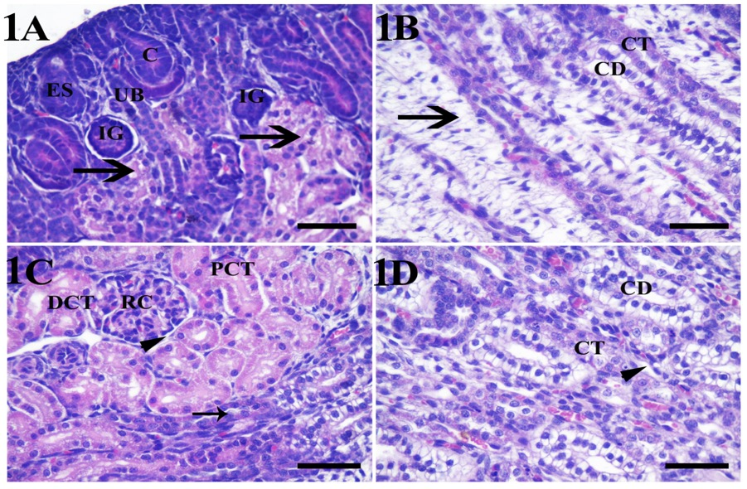

Figure 1: Photomicrograph of rat kidney stained by hematoxylin and eosin at one-day-old. 1A: Immature cortex with comma-shaped body (C), immature glomeruli (IG), epithelial cyst (ES), ureteric bud, and undifferentiated renal tubules (arrows) at the subcapsular zone.1B: Showing the immature medulla with CD, CT, and surrounding mesenchymal tissues (arrow). 1C: Showing the deep cortex with a mature renal corpuscle (RC), which is surrounded by Bowman's space (arrowhead), the DCT with a wide lumen, the PCT with a narrow lumen, and the extension of medullary rays in the cortex (arrow). 1D: Showing the medulla with the CD lined by cuboidal epithelium, the CT lined by low cuboidal epithelium, and the loop of Henle (arrowhead), which is lined by simple squamous epithelium. Scale bar= 50 µm.

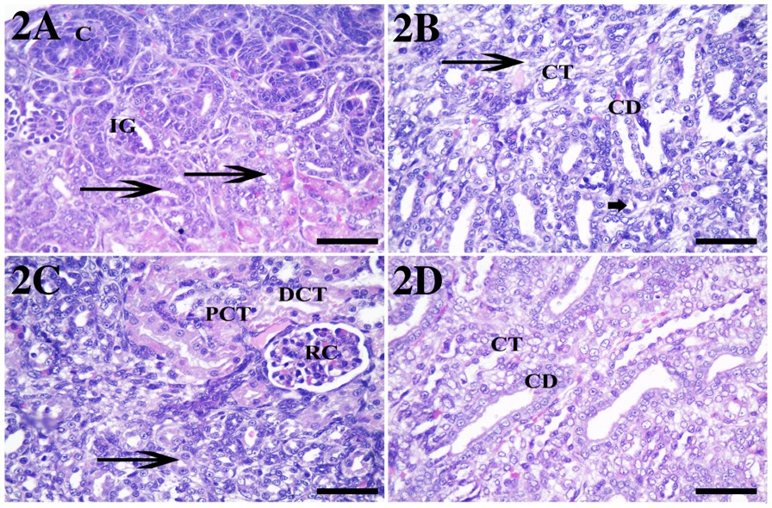
Figure 2: Photomicrograph of rat kidney stained by hematoxylin and eosin at one-week-old. 2A: Showing the cortex with immature glomeruli (IG), a comma-shaped body (C) at the subcapsular cortex, and undifferentiated renal tubules (arrows). 2B: Showing the medulla with immature CD, CT, a loop of Henle (short arrow), and surrounding undifferentiated mesenchymal tissue (arrow). 2C: mature RC deep in the cortex near the medulla (arrow), PCT, and DCT are shown. 2D: Showing large, differentiated CD and CT. Scale bar= 50 µm.

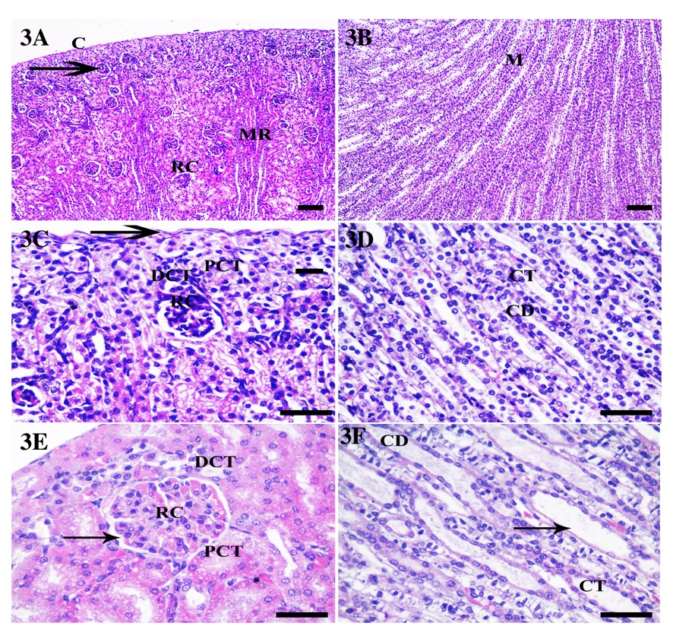

Figure 3: Photomicrograph of rat kidney stained by hematoxylin and eosin at two-week-old (3A-F) and eight-week-old (3E-F). 3A: Mature cortex with the renal corpuscle (arrow) located at the subscapular cortex (C) and the renal corpuscle (RC) deep in the cortex beside the medullary rays (MR). 3B: Showing the mature medulla (M) with large CD and CT. 3C: Showing mature renal corpuscle at subcapsular cortex (arrow) and disappearance of immature nephrons, mature PCT and DCT. 3D: Showing a mature medulla with CD and CT. 3E: Showing the cortex and renal corpuscle with the bowman's space (arrow), DCT, and PCT. 3F: Showing the adult medulla with a large CD, CT, and loop of Henle (arrow). 3A and 3B (low power), 3C-F (high power). Scale bar= 50 µm.

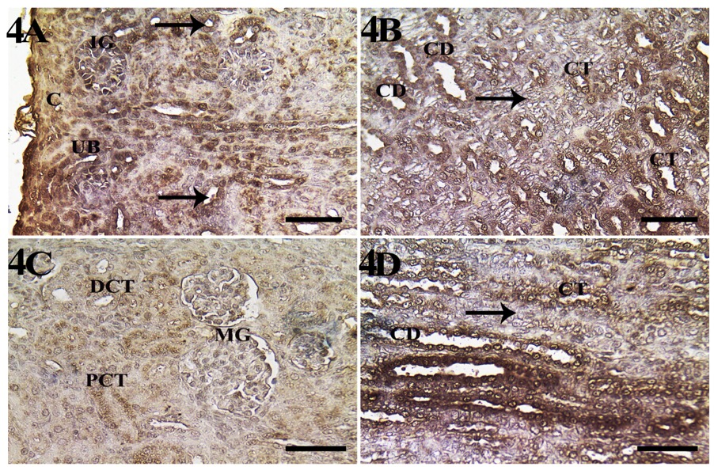

Figure 4: Photomicrograph of rat kidney stained by Con A lectins at one-day-old rat. 4A: Showing early immature glomeruli (IG) with intense reactivity located under the capsule (C), intense reactivity in the ureteric bud (UB), and early undifferentiated tubules (arrows). 4B: The medulla exhibits intense reactivity in early undifferentiated CD and CT while surrounding undifferentiated mesenchymal tissues show no reactivity (arrow).4C: Showing mature glomeruli (MG) deep in the cortex with no reactivity while displaying moderate reactivity in differentiated PCT and DCT. 4D: The medulla is highly reactive in large differentiated CD and CT but not in mesenchymal tissues (arrow). Scale bar = 50 µm.

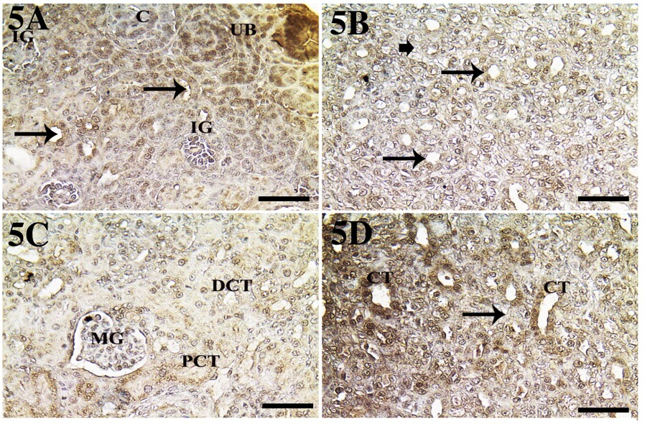

Figure 5: Photomicrograph of rat kidney stained by Con A lectin at one-week-old. 5A: Showing moderate reactivity in immature glomeruli (IG), undifferentiated renal tubules (arrows), and a comma-shaped body (C), while the intense reaction is in the ureteric bud (UB). 5B: the medulla with moderate reactivity in undifferentiated CT (arrows) and surrounding mesenchymal tissues (short arrow). 5C: Showing mature glomeruli (MG) with no reaction while showing moderate reaction in PCT and DCT. 5D: Differentiated CT shows an intense reaction in the medulla but no reactivity in the mesenchymal tissue (arrow). Scale bar = 50 µm.

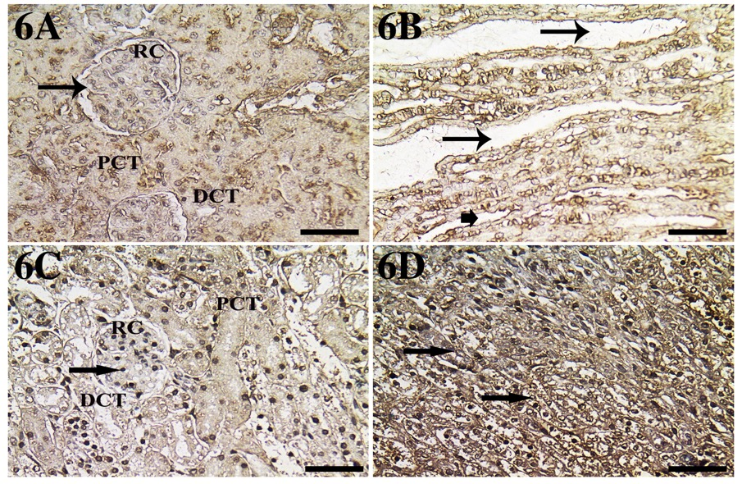

Figure 6: Photomicrograph of rat kidney stained by Con A at two-week-old (6A, 6B) and eight-week-old (6C, 6D). 6A: Showing the cortex with mild immunoreactivity in mature renal corpuscle (RC), surrounded by Bowman's space (arrow), and moderate reactivity in PCT and DCT. 6B: Medulla with moderate immunoreaction in large CD (arrows) and small CT (short arrow). 6C: Adult renal cortex with renal corpuscle (RC), an intense reaction in the podocyte cell’s nucleus (arrow), moderate in PCT, and no reaction in DCT. 6D: Adult medulla with intense reaction in CT (arrows). Scale bar= 50 µm.

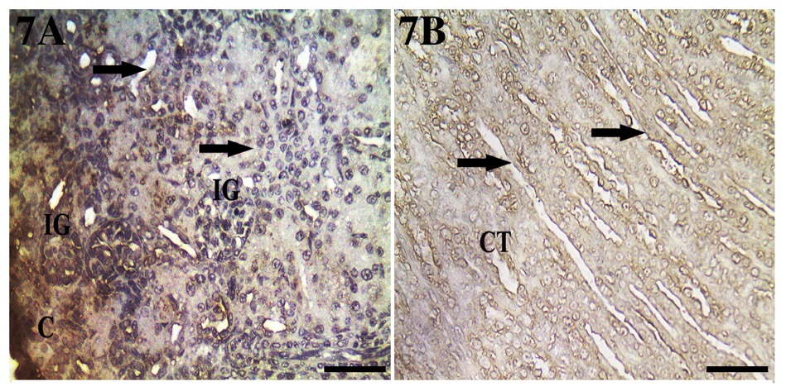

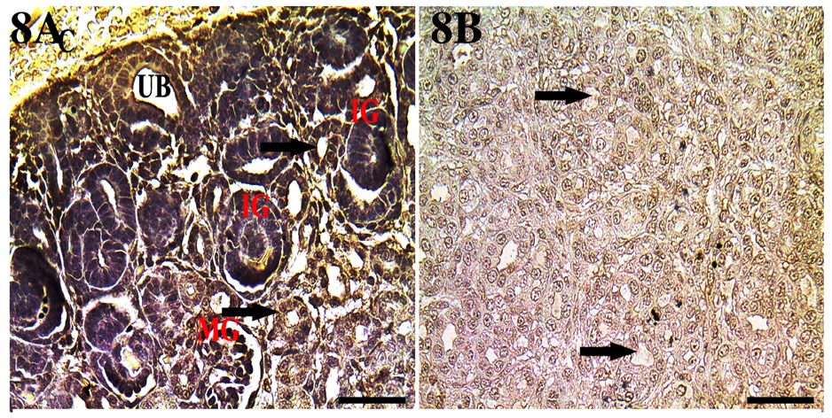
Figure 7: Photomicrograph of rat kidney stained by WGA at one-day-old. 7A: Showing immature glomeruli (IG) reacted strongly in the subcapsular zone (C), while undifferentiated tubules (arrows) had no signal in the immature cortex. 7B: Medulla showing moderate reactivity in the large CD (arrows) and CT. Scale bar= 50 µm.

Figure 8: Photomicrograph of rat kidney stained by WGA at one-week-old. 8A: Showing immature glomeruli (IG) with no reactivity, undifferentiated tubules (arrows) with mild reactivity, a ureteric bud (UB), and a comma-shaped body (C). 8B: Showing the medulla with undifferentiated CT (arrows). Scale bar= 50 µm.

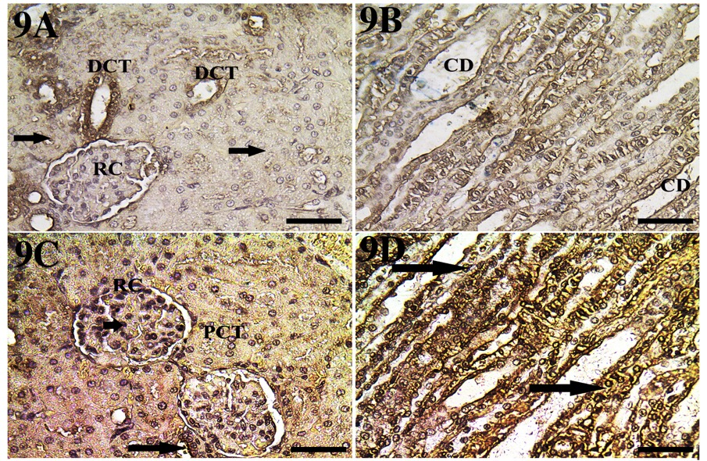

Figure 9: Photomicrograph of rat kidney stained by WGA at two-week-old (9A, 9B) and eight-week-old (9C, 9D). 9A: Showing mature cortex with mature renal corpuscle (RC) without reactivity, as well as PCT (arrows), while there is intense reactivity in DCT. 9B: Showing the mature medulla with mild reactivity in large CD. 9C: Showing podocytes with intense reactivity (short arrow) in the renal corpuscle (RC) and moderate reactivity in the PCT and DCT (arrow). 9D: Medulla with moderate reaction in a large CD (arrows). Scale bar= 50 µm.

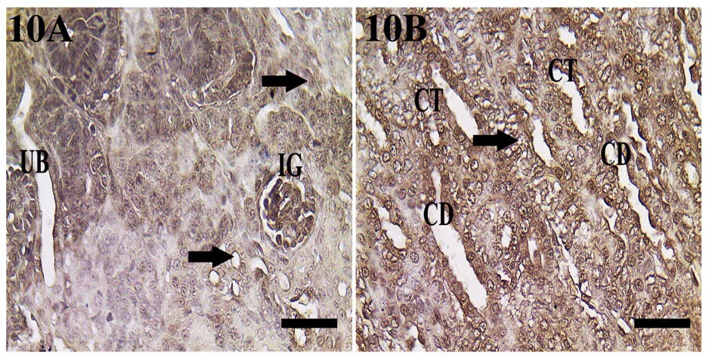
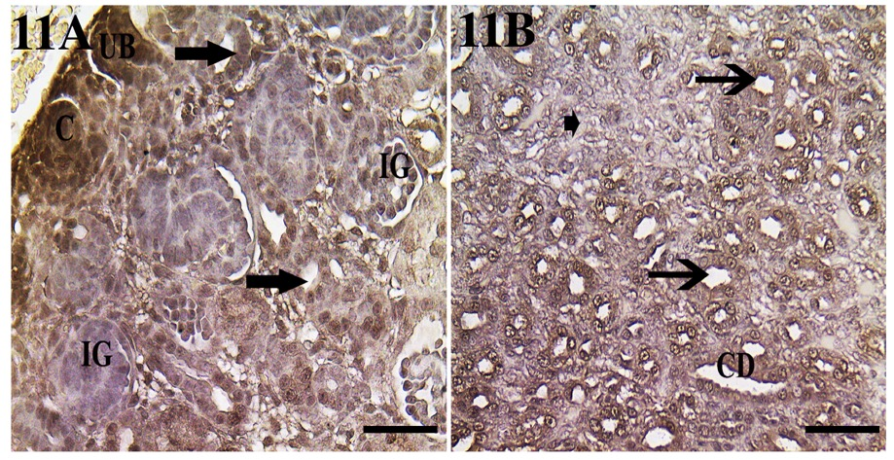
Figure 10: Photomicrograph of rat kidney stained by PNA at one-day-old. 10A: Showing immature cortex with moderate reactivity in immature glomeruli (IG), comma-shaped body (C), undifferentiated tubules (arrows), and ureteric bud (UB). 10B: Showing the immature medulla with intense reactivity in CT, CD, and mesenchymal tissues (arrow). Scale bar= 50 µm.

Figure 11: Photomicrograph of rat kidney stained by PNA at one-week-old. 11A: Showing immature cortex with intense reaction in the upper comma-shaped body (C), ureteric bud (UB), and moderate reaction in undifferentiated tubules (arrows), while no reactivity is seen in immature glomeruli (IG). 11B: Showing an immature medulla with immature CT (arrows), CD, and undifferentiated mesenchymal tissues (short arrow). Scale bar= 50 µm.

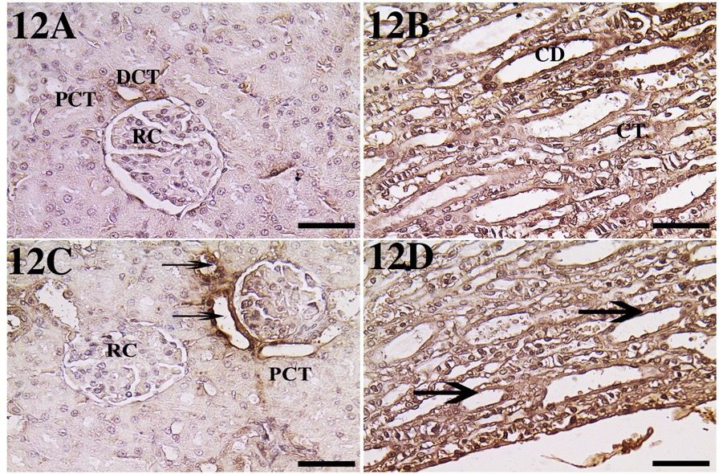

Figure 12: Photomicrograph of rat kidney stained by PNA at two-week-old (12A, 12B) and eight-week-old (12C, 12D). 12A: Showing the cortex with no reactivity in DCT and the renal corpuscle (RC), which is surrounded by Bowman's space and has moderate reactivity in DCT. 12B: Showing the medulla with an intense reaction in CD and CT.12C: Showing the cortex with no reactivity in the renal corpuscle (RC) and PCT and intense reactivity in DCT.12D: Showing the medulla with intense reactivity in CT and CD (arrows). Scale bar= 50 µm.

4. DISCUSSION
Our research demonstrated that kidney development proceeded throughout the pre-mature stage from the neonatal stage at 1 day to 2 weeks in rats, where the subcapsular zone had immature forms of the renal developmental stages like developing vesicles, comma-shaped bodies, and S-shaped bodies in the nephrogenic zone, and the juxtamedullary zone contained mature glomeruli and renal corpuscles surrounded by well-developed renal tubules. Our results are consistent with those of Marquez et al. (2002) and El-Bestawy et al. (2017), who reported that these zones were present in newborn rats from two to seven days.
Our finding showed that the Con A lectin in the premature rat kidney at birth had intense reactivity in early immature glomeruli, the ureteric bud, and early undifferentiated tubules, while Laitinen et al. (1987) found that Con A had only a moderate reaction in mouse embryos. Our data revealed that the Con A had an intense reaction in PCT and DCT at birth, then the reaction became moderate in 1 and 2 weeks in rats, which is consistent with the finding of Laitinen et al. (1987) in mouse embryos. The Con A lectin in the mature rat kidney at 8-week-old had a moderate reaction in PCT and no reaction in DCT, which is in contrast with Laitinen et al. (1987), who reported that Con A had an intense reaction in PCT and a moderate reaction in DCT in adult mice.
We revealed that Con A had an intense reaction in immature glomeruli of a neonatal rat at birth in order to preserve the most vital nutrients at birth while newborn rats suckled from their mothers, contrary to Laitinen et al. (1987), who detected only a moderate reaction in a mouse embryo. Our finding showed that Con A had an intense reaction in podocytes in the glomeruli of adult rats for glomerular filtration, which is in contrast with Debray et al. (1981), who showed that Con A was intense only in mesangial cells in adult mice. Our result in the renal corpuscle is in contrast with the findings of Yabuki et al. (2012), who detected that Con A was weak in the capillary endothelium and glomeruli. We observed that Con A lectin had an intense reaction in the CD and CT of the medulla throughout the postnatal development of the rat kidney, which is in contrast to Laitinen et al. (1987), who found that Con A had a moderate reaction in the embryonic stage and a mild reaction in adult mice.
According to our findings, the WGA lectin was absent in the PCT of rat kidney at birth, then increased to a moderate reaction in 8-week-old, which is consistent with WGA lectin results in adult rats (Holthofer, 1983) and adult dogs (Yabuki et al., 2012). Our results in the PCT of adult rats are in contrast with those of Le Hir and Dubach (1982), who found that WGA was intense in the PCT of adult rabbits. Our results also contrasted with those of Laitinen et al. (1987), who found that WGA lectin had a moderate reaction in embryos and an intense reaction in the PCT of adult mice.
Our results revealed that the WGA lectin was absent in the DCT of the rat kidney at birth, then increased to an intense reaction in 2-week-old, which is in contrast with the faint results of WGA lectin in adult rats (Holthofer, 1983) and the intense results of the WGA reaction in adult dogs (Yabuki et al., 2012). The WGA lectin had a mild reaction in embryos and a weak reaction in the DCT of adult mice (Laitinen et al., 1987), which is in contrast with our results.
We reported that WGA lectin was intense in immature glomeruli of the rat kidney at birth and also intense in mature glomeruli in podocytes at 8-week-old, which is consistent with the results of WGA lectin in mouse embryos and adults (Laitinen et al., 1987). Our results are in contrast with those of Yabuki et al. (2012), who recorded a mild to moderate reaction to WGA lectin in the Bowman capsule of an adult dog. According to our finding, the WGA lectin was moderate in CD and CT all over the age range of the rat, which is consistent with Laitinen et al. (1987) in mouse embryos and adults, and our results in medulla tubules are in contrast with intense results of WGA lectins in an adult dog (Yabuki et al., 2012).
Our findings showed that PNA lectin was moderate in PCT of rat kidneys at birth and 1-week-old, and this result is consistent with Laitinen et al. (1987) in mouse embryos. PNA lectin disappeared at 2 and 8-week-old rat, which is in agreement with the results of Yabuki et al. (2012) in a dog. Our results in adult rats are in contrast with the intense reaction of PCT in adult mice (Laitinen et al., 1987) and the moderate reaction of PNA in adult rats (Holthofer, 1983). PNA lectin was moderate in the DCT of rat kidney at birth and intense at 8-week-old, and our result contrasts with the absence of PNA in the DCT of adult rats (Holthofer, 1983) and the faint reaction of PNA lectin in mouse embryos and adults (Laitinen et al., 1987). Our results concur with those of Yabuki et al. (2012), who reported that PNA lectin caused an intense reaction in the DCT of adult dogs.
In our study, we observed that PNA lectin was moderate in the immature glomeruli of the rat kidney at birth and not present at other ages, which is consistent with the results of Holthofer (1983), who reported that PNA lectin was not present in the glomeruli of different species. Our results in glomeruli at this premature age are consistent with Laitinen et al. (1987), who reported that PNA lectin had a moderate reaction at E13 and was absent at E17. Our findings in the Bowman capsule contrast with those of Yabuki et al. (2012) in dogs, who found a moderate to intense reaction to the PNA lectin in the Bowman capsule of an adult dog. We reported that the PNA lectin in rats was intense in CD and CT all over the age range, which is consistent with Yabuki et al. (2012) in an adult dog, and our results in the medulla tubules of rats are in contrast with moderate results of PNA lectins in embryonic and adult mice (Laitinen et al., 1987).

5. CONCLUSION
There are different levels of lectin intensity and different distribution patterns in the developing and adult rat kidney, and this difference may be related to the function and importance of each lectin (Tables 2, 3, and 4). In the glomeruli, Con A and WGA had a substantial impact in glomerular filtration at birth because newborn rats suckle from their mothers and maintaining essential nutrients is crucial for them.; therefore, Con A and WGA were highly concentrated in immature glomeruli. Additionally, we reported that Con A and WGA lectins played a significant role in completing function of glomerular filtration in adult rat kidneys because they were highly abundant in glomerular podocytes at 8-week-old. The PNA had a moderate role in immature glomeruli at birth and had no role at the adult stage.
In the cortical renal tubules, Con A had an intense reaction in PCT and DCT at birth, but the signals eventually decreased, indicating that Con A expression was more crucial at birth than in the adult stage. In contrast to that, the WGA in the tubules of the cortex had no role at birth, as there were no reactions, but it was highly significant at the adult stage. The PNA played a minor role in the renal tubules of the cortex at birth and at one-week-old, and it had no role in adulthood. In medulla renal tubules, both PNA and Con A had a significant role in the CD and CT, but WGA had only a mild or moderate role in the renal medulla. In conclusion, a study of different lectins at different ages would be critical to understanding the function and role of each lectin and nephron segment.

6. REFERENCES
Bancroft, J.D., Layton, C. 2013.The Hematoxylin and Eosin. In Suvarna, S.K., Layton, C., Bancroft, J.D., editors. Theory Practice of Histological Techniques. 7th ed. Philadelphia: Churchill Livingstone of Elsevier.
Debray, H., Decout, D., Strecker, G., Spik, G., Montreuil, J. 1981. Specificity of twelve lectins towards oligosaccharides and glycopeptides related to N-glycosylproteins. Eur J Biochem. 117(1): 41–55.
El-Bestawy, E., Hegab, A., Abdel Hamid, R., Sewelam, A. 2017. Postnatal developmental changes of the kidneys of the albino rat. EJHM. 69 (6): 2711-2721.
Glick, M. C., Santer, U. V. 1982. Expression of glycoproteins on membranes of human tumor cells. Prog Clin Biol Res.102 pt A:371-383.
Goldstein, I. J., Hayes, C. E. 1978. The lectins: carbohydrate-binding proteins of plants and animals. Adv Carbohydr Chem Biochem.35:127–340.
Gregor, G., Marcussen, N., Nilsson, A., Sundelin, B., Friberg, P. 1999. Postnatal time frame for renal vulnerability to enalapril in rats. J Am Soc Nephrol. 10:1550–1560.
Hatten, M. E., Schachner, M., Sideman, R. L 1979. Histochemical characterization of lectin binding in mouse cerebellum. Neuroscience. 4(7): 921–935.
Holthöfer, H. 1983. Lectin binding sites in kidney. A comparative study of 14 animal species. J Histochem Cytochem. 31(4): 531–537.
Hughson, M., Farris, A.B., Douglas-Denton, R., Hoy, W.E., Bertram, J.F.2003. Glomerular number and size in autopsy kidneys: The relationship to birth weight. Kidney Int. 63: 2113–2122.
Kavlock, R., Gray, J.1982. Evaluation of renal function in neonatal rats. Biol Neonate. 41: 279-288.
Laitinen, L., Virtanen, I., Saxén, L.1987. Changes in the glycosylation pattern during embryonic development of mouse kidney as revealed with lectin conjugates. J Histochem Cytochem. 35(1): 55–65.
Langley-Evans, S.C., Welham, S.J.M., Jackson, A. A.1999. Fetal exposure to a maternal low protein diet impairs nephrogenesis and promotes hypertension in the rat. Life Sci. 64:965–974.
Latta, H., Fligiel, S. 1985. Mesangial fenestrations, sieving, filtration, and flow. Lab Invest. 52:591–597.
Le Hir, M., Dubach, U. C. 1982. The cellular specificity of lectin binding in the kidney. I. A light microscopical study in the rat. Histochemistry. 74:521-530.
Marquez, M.G., Cabrera, I., Serrano, D.J. and Sterin Speziale, N. 2002. Cell proliferation and morphometric changes in the rat kidney during postnatal development. Anat Embryol. 205(5-6):431-440.
Monsigny, M., Sene, C., Obrenovitch, A., Roche, A. C., Delmotte, F., Boschetti, E.1979. Properties of succinylated wheat-germ agglutinin. Eur J Biochem. .98(1):39-45.
Muramoto, K. 2017. Lectins as bioactive proteins in foods and feeds, FSTR.23(4):487-494.
Rashwan, A., Noreldin, A., Mahmoud, S., Elewa, Y., Nomir, A. 2022.Ghrelin and Jacalin Localization in Developing Rat Kidney. J Morphol Sci. 39:81-87.
Reeves, W.H., Kanwar, Y.S., Farquhar, M.G. 1980. Assembly of the glomerular filtration surface. Differentiation of anionic sites in glomerular capillaries of newborn rat kidney. J Cell Biol. 85:735–753.
Roth, J.1996. Protein glycosylation in the endoplasmic reticulum and the golgi apparatus and cell type-specificity of cell surface glycoconjugate expression: analysis by the protein A-gold and lectin-gold techniques. Histochem Cell Biol.106: 79-92.
Valtin, H. 1972. Structural and functional heterogeneity of mammalian nephrons. Am J Physiol. 233(6): 491–501.
Watanabe, Y., Naganuma, T., Ogawa, T., Muramoto, K. 2013. Lectins of marine origin and their clinical applications. ‘Antitumor potential and other emerging medicinal properties of natural compounds’ Ed. By E.F. Fang and T.B. Ng, Springer. 33-54.
Yabuki, A., Hamamoto, T., Rahman, M. M., Yamato, O. 2018. Changes in lectin-binding patterns in the kidneys of canines with immune-complex mediated glomerulonephritis. J Vet Med Sci. 80(10):1562–1566.
Yabuki, A., Mitani, S., Mizukami, K., Yamato, O. 2012. Nephron segment identification in the normal canine kidney by using lectin histochemistry. Res Vet Sci. 93(2): 560–564.

