Detection of uidA, stx1, and stx2 genes in Escherichia coli O157:H7 isolated from cattle faecal matter and river water
Ismaila O. Sule ¹*, Mutiat B. Odebisi-Omokanye¹, Olutoyin C. Adekunle ², Jemilat O. Abdulkareem³, Ibraheem O. Adebesin ¹ Olawuyi M. Awofisayo ¹, Shamah A. Agboola ¹, Wasilat O. Abdulwaheed ¹
¹Department of Microbiology, University of Ilorin, Ilorin, Nigeria
² Department of Medical Microbiology and Parasitology, Osun State University, Nigeria
³ Department of Microbiology, Federal University Lokoja, Kogi State, Nigeria
*Corresponding author’s E-mail address: suleism@unilorin.edu.ng;

ABSTRACT
Cattle can harbour enterohaemorrhagic Escherichia coli O157:H7 serotype in their faecal matters. This study aimed to isolate E. coli O157:H7 from the intestinal digesta, cattle dungs and water; and assess the antibiotic susceptibility and production of shiga toxins by the isolates. The counts of viable bacteria and faecal coliforms in 13 each of intestinal digesta and cattle dung and the 12 water samples were determined using nutrient agar and Eosin methylene blue agar respectively. Sorbitol MacConkey agar (SMAC) was used to screen for E. coli O157:H7 among the 38 E. coli isolates. PCR amplification of uidA genes was used to authenticate the isolates as enterohaemorrhagic E. coli O157:H7 serotype while amplification of stx1 and stx2 showed the production of shiga toxins. The antibiotic susceptibility patterns of the isolates were determined using standard disk diffusion method. The count of viable bacteria and faecal coliform was highest in the intestinal digesta followed by cattle dungs. There was 100% susceptibility to ofloxacin coupled with 100% resistant to augmentin by all the 8 E. coli O157 and 10 non-O157 isolates. The E. coli O157 isolates were more susceptible to ciprofloxacin, gentamicin, ampicillin and cefuroxime than non-O157 isolates but were less susceptible to nitrofurantoin and ceftazidime than non-O157. Eight (44.4%) out of the 18 presumptive E. coli O157 on SMAC amplified uidA genes and were confirmed as E. coli O157. They were isolated only from intestinal digesta and cattle dung. The prevalence of stx1 and stx2 genes among the E. coli O157 was 37.5% and 12.5% respectively. It is concluded from this study that intestinal digesta and cattle dung harboured E. coli O157: H7 some of which possessed shiga toxin.
Keywords: Cattle faeces, E. coli O157:H7, Shiga toxins, uidA genes, amplification
1. INTRODUCTION
Cattle dungs are the undigested residues of food consumed by these animals. It is usually dark brown in colour. It harbours a rich microbial diversity, containing different species of bacteria, protozoa and yeasts (Randhawa and Kullar, 2011; Behera and Ray, 2021). Cattle are raised for many reasons including milk, cheese, beef, hide and skin etc.
The extensive use of chemical fertilizers for replenishment of nutritional deficiencies to increase crop yield produce detrimental effects such as increase in soil acidity, mineral imbalance and soil degradation (Ayoola and Makinde, 2008). Cattle dung can be used as a substitute for chemical fertilizers as well as a conditioner for soil (Yadav et al., 2013; Be´langer et al., 2014).
Escherichia coli is a normal flora in the intestinal tract of both healthy animals and humans. It serves as a reliable indicator of faecal contamination. It is a diverse bacterial group with pathogenic strains classified into groups such as enteropathogenic, enteroinvasive, enterohaemorrhagic, enterotoxigenic, and enteroadherent/enteroaggregative. E. coli O157:H7 belongs to the enterohaemorrhagic group. It is present in the gastro-intestinal tract (GIT) of cattle, sheep, goat etc. It is transmitted through the consumption of food and water contaminated by faecal matter of animal carriers, from person to person, and direct contact with carrier animals or faeces or digesta from the intestinal tract (Cortes-Sanchez and Salgado-Cruz, 2017). Contamination of water sources may be from agricultural waste, animal excreta, and industrial effluents, and sewage disposal (Scraper et al., 2002). This strain has low infective dose and high pathogenicity. It has been incriminated in gastroenteritis. Accumulation of faecal materials can act as a collection basin for these pathogens which may enter water system by the direct contamination through the seepage or surface runoff (Avery et al., 2004).
The uidA genes found in E. coli 0157:H7 has a G residue rather than the T residue found in wild type E. coli at position 92 of its structural gene. This highly conserved base change in the uidA allele is a powerful marker of O157:H7 strains. The pathogenicity of E. coli O157:H7 is due to the presence of a 60-MDa plasmid (Bosilevac and Koohmaraie (2011) and the production of toxins including the shiga toxins, stx1 and stx2 (Jamshidi et al., 2016).
The development of antibiotics resistance in some bacterial pathogens is rampant because of the clinical use of antibiotics. The excessive use of antibiotics in farm animals’ management to treat diseases, suboptimal dosage, use of antibiotics in the animal feeds have led to the incidence of antibiotic resistance bacteria, which can be transferred to human through the food chain (Cortes-Sanchez and Salgado-cruz, 2017).
The objectives of this research were to determine the counts of viable bacteria, total and faecal coliform in the faeces, intestinal digesta and river waters; characterize the isolates as E. coli; screen the possible isolates as being E. coli O157:H7 strain, detect the presence of uidA, stx1 and stx2 genes in the positive isolates; and determine the antibiotic susceptibility patterns of the isolates.
2. MATERIALS AND METHODS
2.1 Collection of faecal and water samples
Thirteen samples each of the cattle dungs and the intestinal digesta of the slaughtered cattle were collected into sterile polythene bags using sterile handtrowel (Grauke et al., 2002). Furthermore, 12 water samples were collected into the sterile sampling bottle using standard method (Sule and Bello, 2021).
2.2 Bacteriological analysis of samples
Ten grammes (10g) of the cattle dung/intestinal digesta was weighed aseptically into 90ml sterile distilled water in a conical flask to obtain10⁻¹ dilution. Then, 1ml from 10⁻¹ dilution was added to 9ml of sterile distilled water in a test tube to obtain 10⁻² dilution. The process of serial dilution was repeated up to 10⁻⁶ dilution. For the water sample, 10ml of the raw water was used for the 10⁻¹ dilution in place of the faecal material.
Viable bacteria and faecal coliform were isolated and enumerated using nutrient agar (NA) and eosin methylene blue agar medium (EMB) respectively. Aliquot (0.1ml) from different dilutions was introduced on the surface of sterile set plates of EMB. The inoculum was spread on the plate with the aid of sterile L-shaped glass spreader. The viable bacterial count was determined using pour plate technique. The plates were incubated inverted at 37ºC for 48 hours. The colonies formed were counted and expressed in cfu/g or ml. The colonies (E. coli) with greenish metallic sheen on EMB were subcultured and kept in a refrigerator at 4 – 8ºC until they were needed (Alalade et al., 2018).
2.3 Characterization of isolates
The putative E. coli were confirmed through Gram staining and biochemical tests such as oxidase, catalase, methyl red, voges-proskauer, indole, citrate utilization, oxidation- fermentation and sugar fermentation (lactose and glucose). The isolates that were positive as E. coli were further screened if they were E. coli O157:H7 by cultivating them on Oxoid Sorbitol MacConkey agar (SMAC) supplemented with Cefixime-tellurite where they produced white colonies (Muller and Ehlers, 2005).

2.4 Antimicrobial susceptibility test
The colonies were standardized using 0.5 McFarland’s standard. The standardized culture was streaked on sterile Mueller Hinton agar using sterile swab stick. Rapid labs multiple antibiotic discs, CM-128NR100 were placed on the agar and pressed firmly on the plate and subsequently incubated at 37ºC for 24 hours before the diameter of inhibition was taken. The susceptibility of the isolates to each antibiotic was interpreted as susceptible, intermediately susceptible and resistant using the guidelines of CLSI (2020). The antibiotics used were Ceftazidime (CAZ) 30µg, Cefuroxime (CRX) 30µg, Gentamicin (GEN) 10µg, Ciprofloxacin (CPR) 5µg, Ofloxacin (OFL) 5µg, Amoxycillin/Clavulanate (AUG) 30µg, Nitrofurantoin (NIT) 300µg and Ampicillin (AMP) 10µg.
2.5 Multiple antibiotic resistance (MAR) index
It was obtained by dividing the number of antibiotics each isolate showed resistance by the total number of antibiotics tested (Sule et al., 2020).
2.6 Extraction of DNA
The isolates were cultivated in sterile nutrient broth at 37ºC for 48 hours. The bacterial genomic DNA was extracted from the broth culture using the Quick-DNA Fungal/Bacterial Miniprep Kit (Zymo Research, Catalogue No. D6005).
2.7 Synthesis of primer
The primers synthesized have oligonucleotide sequences as presented in Table 1 according to Cebula et al. (1995) and Feng and Monday (2000). Inqaba Biotechnical Industry (Pty) Ltd., Pretoria, South Africa synthesized the primers used for PCR amplification with quotation number NG2019/19366.
Table 1: Oligonucleotide sequences and sizes of amplified fragments
Genes | Oligonucleotide sequences (5’ – 3’) | Fragment sizes
stx1 (F) | CAGTTAATGTGGTGGCGAAGG | 348bp
stx1 (R) | CACCAGACAATGTAACCGCTG
stx2 (F) | ATCCTATTCCCGGGAGTTTACG | 548 bp
stx2 (R) | GCGTCATCGTATACACAGGAGC
uidA (F) | GCGAAAACTGTGGAATTGGG | 252 bp
uidA (R) | TGATGCTCCATCACTTCCTG

2.8 PCR amplification of genes
The extracted genomic DNA was used for PCR. The cocktail of the PCR was as follows: 2.5ul of 10x PCR buffer, 1ul of 25mM MgCl₂, 1ul each of forward and reverse primer, 1ul of DMSO, 2ul of 2.5mM DNTPs, 0.1ul of 5u/ul Taq DNA polymerase, 3ul of 10ng/ul DNA and 13.4ul nuclease free water. The cycling parameters of the PCR was set up as follows: initial denaturation at 94ºC for 5 minutes, thereafter 36 cycles of denaturation at 94ºC for 30 seconds, annealing at 55ºC for 30 seconds, elongation at 72ºC for 45 seconds, final elongation step at 72ºC for 7 minutes and held at 10ºC. Viewing of the amplified fragments were observed on safe view stained 1.5% agarose electrophoresis gels. The ladder used for loading was 50bp from NEB and the hyper ladder from Bioline (Sule et al., 2022).
3. RESULTS
3.1 Bacteriological loads of faecal materials and water samples
The count of heterotrophic bacteria (HB) and faecal coliform (FC) isolated from the intestinal digesta ranged from 4.7 x 10⁵ - 1.3x 10⁷cfu/g and 1.6 x 10⁵ – 2.2 x 10⁶cfu/g respectively. For the cattle dungs, HB and FC ranged from 7.5 x 10⁴ – 4.8 x 10⁶cfu/g and 5.0 x 10⁴ – 1.0 x 10⁶cfu/g respectively (Table 2). Furthermore, the HB and FC of the river water ranged from 4.4 x 10⁴ – 9.6 x 10⁶ cfu/ml and 1.0 x 10¹ – 1.0 x 10³cfu/ml respectively (Table 3).
3.2 Characterization of isolates
All the 38 E. coli isolates were Gram negative, oxidase positive, catalase positive, indole and methyl red positive, voges-proskauer and citrate negative, ferment lactose and glucose with the production of acid and gas, and fermentative utilization of glucose when cultivated in Hugh and Leifson medium. The E. coli obtained from the intestinal digesta and cattle dung was 13(34.2%) each whereas 12(31.6%) was obtained from the water samples. Eighteen of the E. coli isolates produced white colonies on SMAC and were putatively identified as E. coli O157:H7. These were 8 (44.4%) from intestinal digesta and 5 (27.8%) each from cattle dung and water sample.
3.3 Antibiotic susceptibility patterns and MAR index of isolates
The antibiotic susceptibility patterns of the 8(44.4%) E. coli O157 and the 10(56.6%) non-O157 is presented in Table 4. All the E. coli O157 and non-O157 were susceptible and resistant to ofloxacin and augmentin respectively.
Two (25%) E. coli O157 were susceptible to ciprofloxacin while 6 (75%) were intermediately susceptible to it. For the non- O157, 2(20%), 7(70%) and 1(10%) were susceptible, intermediately susceptible and resistant to ciprofloxacin. Seven (87.5%) of E. coli O157 and 1(12.5%) were susceptible and intermediately susceptible to gentamicin respectively. Non-E. coli O157 isolates had 6(60%), 1(10%) and 3(30%) susceptible, intermediately susceptible and resistant to gentamicin. The MAR index of E. coli O157 and non-O157 isolates ranged from 0.13 to 0.50 and 0.38 to 0.75 respectively (Tables 4).
3.4 PCR amplification of genes
Only 8 (44.4%) of the 18 tentatively identified E. coli O157 on SMAC amplified uidA genes at 252bp and were confirmed as E. coli O157. These isolates were E1, E4, E6, E7 and E8 from intestinal digesta as well as E9, E11 and E12 from cattle dung (Figure 1).
Out of the 8 E. coli O157, only 3 (37.5%) showed amplification for stx1 and produced the expected band at 348bp (Figure 2). These isolates were E9, E11 and E12 gotten from cattle dung. Only 1 (12.5%) of the E. coli O157 (E11) amplified stx2 gene and produced the expected band at 548bp (Figure 3).

Table 2: Bacteriological counts of the intestinal digesta and cattle dung
Locations | Count (cfu/g)
 | Intestinal digesta |  | Cattle dung
 | HB | FC | HB | FC
A | 1.4 x 10⁶ | 1.1 x 10⁶ | 3.7 ×10⁵ | 2.5 × 10⁵
B | 4.7 x 10⁵ | 2.7 x 10⁵ | 7.2 ×10⁵ | 5.0 × 10⁵
C | 8.1 x 10⁵ | 2.2 x 10⁵ | 4.0 ×10⁶ | 7.0 × 10⁵
D | 1.0 x 10⁶ | 2.9 x 10⁵ | 4.5 ×10⁵ | 4.0 × 10⁵
E | 3.0 x 10⁶ | 2.2 x 10⁶ | 9.0 ×10⁵ | 6.0 × 10⁵
F | 2.7 x 10⁶ | 1.6 x 10⁵ | 4.8 $×10$⁶ | 1.9 × 10⁵
G | 3.8 x 10⁶ | 2.2 x 10⁶ | 3.5 ×10⁵ | 2.5 × 10⁵
H | 3.0x 10⁶ | 1.2 x 10⁶ | 8.5 ×10⁴ | 6.0 × 10⁴
I | 8.1 x 10⁶ | 1.3 x 10⁶ | 9.0 ×10⁵ | 5.0 × 10⁵
J | 2.6 x 10⁶ | 1.2 x 10⁶ | 9.2 ×10⁵ | 9.0 × 10⁵
K | 1.3 x 10⁷ | 2.0 x 10⁶ | 1.1 ×10⁶ | 1.0 × 10⁶
L | 2.3 x 10⁶ | 2.0 x 10⁶ | 7.5 ×10⁴ | 5.0 × 10 ⁴
M | 1.3 x 10⁶ | 9.7 x 10⁵ | 1.6 ×10⁵ | 1.5 × 10⁵
HB- Heterotrophic bacteria; FC- Faecal coliform; A- Wara Village I, Ilorin; B- Tipper Garage I, Ilorin; C- Akerebiata I, Ilorin; D-Oja-Tuntun I, Ilorin; E- Akerebiata II, Ilorin; F- Oja-Tuntun II, Ilorin; G-Wara Village II, Ilorin; H-Tipper Garage Ilorin, II; I- Mandate I, Ilorin; J- Mandate II, Ilorin; K-Tipper Garage III, Ilorin; L -Wara Village III, Ilorin; M -Akerebiata III, Ilorin
Table 3: Bacteriological counts of water from river at different locations in Ilorin, Nigeria

Sample sites | Counts (cfu/ml)
 | Bacteria | Faecal coliform
Oja-Tuntun | 2.7 x 10⁶ | 1.0 x 10¹
Surulere | 2.6 x 10⁶ | 1.0 x 10¹
Abata-Shuban | 2.9 x 10⁶ | 1.0 x 10³
Oke-Foma | 4.4 x 10⁴ | 1.0 x 10¹
Oloje | 1.5 x 10⁵ | 1.0 x 10²
Opomalu | 8.4 x 10⁶ | 1.0 x 10²
Unity | 6.6 x 10⁵ | 1.0 x 10²
Coca cola | 6.0 x 10⁴ | 1.0 x 10²
Amilegbe | 2.3 x 10⁶ | 1.0 x 10³
Akerebiata | 1.8 x 10⁶ | 1.0 x 10³
Shao-Garage | 5.6 x 10⁵ | 1.0 x 10¹
Ita-Amodu | 9.6 x 10⁶ | 1.0 x 10¹

Table 4: Antibiotic susceptibility patterns of E. coli O157 and non-O157
Isolates | Source | Zone of inhibition (mm) |  |  |  |  |  |  |  | MAR  Index
 |  | NIT | AMP | CAZ | CRX | GEN | CPR | OFL | AUG
E1 | D | 29(S) | 12(R) | 25(S) | 20S) | 20(S) | 25(I) | 24(S) | 12(R) | 0.25
E2* | D | 17(S) | 11(R) | 22(S) | 13(R) | 21(S) | 22(I) | 25(S) | R | 0.38
E3* | D | 21(S) | R | 31(S) | R | 20(S) | 22(I) | 24(S) | R | 0.38
E4 | D | 29(S) | 6(R) | 13(R) | 18(S) | 14(I) | 22(I) | 20(S) | R | 0.38
E5* | D | R | R | 12(R) | R | 20(S) | 22(I) | 24(S) | R | 0.63
E6 | D | 29(S) | 15(I) | 25(S) | 20(S) | 15(S) | 24(I) | 29(S) | 12(R) | 0.13
E7 | D | R | 15(I) | 14(R) | 20(S) | 18(S) | 22(I) | 18(S) | 12(R) | 0.38
E8 | D | 30(S) | R | 12(R) | R | 20(S) | 26(S) | 22(S) | R | 0.5
E9 | C | 15(I) | 12(R) | R | 13(R) | 16(S) | 25(I) | 23(S) | R | 0.5
E10* | C | 27(S) | 13(R) | 14(R) | 12(R) | 21(S) | 27(S) | 27(S) | 13(R) | 0.5
E11 | C | 16(I) | 10(R) | R | 20(S) | 16(S) | 26(S) | 26(S) | 12(R) | 0.38
E12 | C | 21(S) | 12(R) | R | 21(S) | 18(S) | 22(I) | 22(S) | 12(R) | 0.38
E13* | C | 24(S) | 11(R) | 15(R) | R | 14(I) | 25(I) | 23(S) | 7(R) | 0.5
E14* | W | 25(S) | R | 25(S) | 20(S) | 12(R) | 26(S) | 26(S) | 7(R) | 0.38
E15* | W | 24(S) | R | 20(I) | 21(S) | 11(R) | 24(I) | 24(S) | R | 0.38
E16* | W | 16(S) | R | R | R | 18(S) | 24(I) | 22(S) | R | 0.5
E17* | W | 25(S) | R | R | R | 20(S) | 13(R) | 22(S) | R | 0.63
E18* | W | 10(R) | R | R | R | R | 22(I) | 22(S) | R | 0.75
R – Resistance, S – Susceptible, I – Intermediately susceptible, NIT – Nitrofurantoin (300µg), AMP – Ampicillin (30µg), CAZ-Ceftazidime (30µg), CRX – Cefuroxime (30µg), GEN – Gentamicin (10µg), CPR – Ciprofloxacin (5µg), OFL – Ofloxacin (5µg), AUG – Augmentin (30µg). * - Non- E. coli O157, D – Intestinal digesta, C- Cattle dung, W- Water

M E1 E4 E6 E7 E8 E9 E11 E12
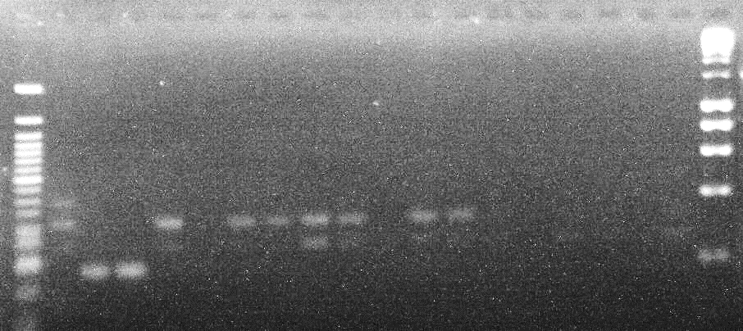
252bp

Figure 1: Agarose gel electrophoresis image of the amplified uidA genes
M=50bp Molecular ladder; E= E. coli 0157:H7

M E9 E11 E12
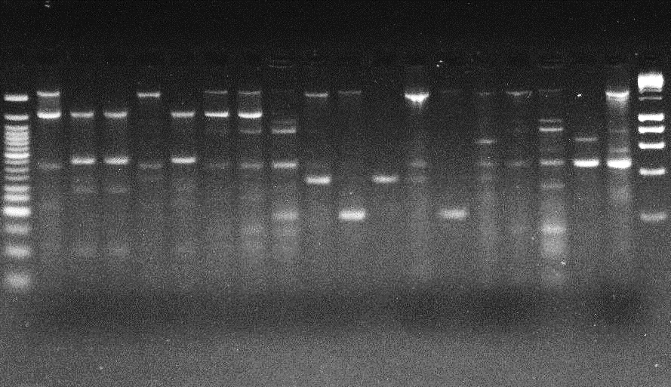
348bp

Figure 2: Agarose gel electrophoresis image of the amplified stx1 genes
M=50bp Molecular ladder; E= E. coli isolates

M E11
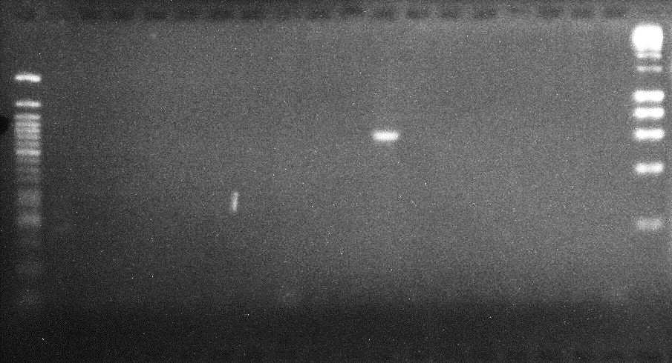
548bp

Figure 3: Agarose gel electrophoresis image of the amplified stx2 gene
M= 50bp Molecular ladder; E= E. coli isolates

4. DISCUSSION
The range of counts of viable bacteria and faecal coliform obtained from the intestinal digesta of slaughtered cattle was higher than those isolated from cattle dungs. This is expected as the gastro-intestinal tract of cattle and other ruminants are known to harbour E. coli. In a similar study, Grauke et al. (2002) obtained count of E. coli O157:H7 as high as 10⁵cfu/g in cattle faeces. Water samples from the river produced the least counts since these isolates would need to survive in the aquatic environment after being released or discharged through the sewage, manure contamination and defaecation.
The isolates were either susceptible, intermediately susceptible or resistant to each antibiotic. There was 100% susceptibility to ofloxacin coupled with 100% resistant to augmentin by all the 8 E. coli O157 and 10 non-O157 isolates. The E. coli O157 isolates were more susceptible to ciprofloxacin, gentamicin, ampicillin and cefuroxime than non-O157 isolates but were less susceptible to nitrofurantoin and ceftazidime than non-O157. In a study, Bakhtiari et al. (2020) found that 96.5, 87.6 and 45.1% of their isolates were susceptible to nitrofurantoin, gentamicin, and ciprofloxacin respectively. Wardoyo et al. (2021) reported that 92.6, 86.5, and 81.4 % of their E. coli isolates were resistant to ampicillin, cefuroxime and augmentin respectively. Joseph et al. (2017) reported resistance of 77.2 and 51.7% to cefuroxime and augmentin respectively. Majority of the isolates (94.4%) in this study were resistant to at least 2 antibiotics. Their MAR index was greater than 0.2.
The use of selective medium (SMAC) in this study prior to PCR amplification of uidA has allowed for 44.4% confirmation of the 18 E. coli isolates as E. coli O157. More E. coli O157 was detected in the intestinal digesta than from the cattle dung. This can be explained by the fact that after the faecal matters are expunged from the animal’s rectal, it is more prone to environmental contamination from soil and water. More of the E. coli O157 isolates amplified stx1 (37.5%) than stx2 (12.5%). Fagan et al. (1999) in their study of isolation of E. coli 0157:H7 from cattle faeces got 19.4% (35 of 180) and 6.7% (12 of 180) amplification for stx1 and stx2 genes respectively. Gholami-Ahangaran et al. (2021) isolated E. coli in the intestinal content and meat of Turkey but none of them carried stx1 or stx2 genes. Alalade et al. (2018) reported the detection of E. coli 0157:H7 possessing stx2 in two wells and one stream, representing 3.75% of their water samples. However, in this study, none of the putative E. coli from the river water samples amplified the uidA gene; they were confirmed as non- 0157:H7. The non-amplification of uidA gene by the E. coli isolates from water is not unexpected as the level of E. coli O157: H7 in cattle intestinal material or dung is the region of 10³ (Stein and Katz, 2017) and become diluted to negligible or non- detection level when excreted into the water body. Muller and Ehlers (2005) have reported water borne transmission of E. coli O157:H7 from recreational and drinking water. E. coli O157:H7 producing shiga toxins has been reported as the causative agent of haemolytic uremic syndrome (Jamshidi et al., 2016). According to Cebula et al. (1995), the uidA primer used in this study will not allow amplification of wild E. coli because of the double mismatch it has in it design.
Fode-Vaughan et al., 2003 used similar stx1 forward primer but a different stx1 reverse primer and obtained band at 513 base pair instead of at 348bp. This observation supported the fact that stx 1 can be amplified by different arrays of stx 1 reverse primers and at different regions. Hence, in our study the multiple bands seen can be attributed to multiple amplifications and the PCR conditions used in this study. Inspite of this, Cebula et al. (1995) and Feng and Monday (2000) have reported that amplification at 348bp are due to amplification of stx1 genes
5. CONCLUSION AND RECOMMENDATION
In conclusion, the high incidence of enterohaemorrhagic E. coli O157:H7 in 44.4% of the isolated E. coli is of public health significance since these animals can be a source of transfer to other healthy animals and humans. Shiga toxins, stx1 and stx2 genes were detected in some of the E. coli O157 isolates. There was 100% susceptibility and resistant to ofloxacin and augmentin respectively. It is recommended that faecal materials and intestinal digesta of cattle should be handle with care since they harboured E. coli 0157:H7. There is need for proper hygiene in the management of these wastes.
6. ACKNOWLEDGEMENT
The authors are grateful for the cooperation received from the workers, butchers, beef sellers, cattle rearers in the course of collection of intestinal digesta of the slaughtered cattle as well as the cattle dung.
REFERENCES
Alalade, O.M., Ameh, J.B., Abdullahi, I.O., Whong, C.M.Z. 2018. Screening for virulence genes in E. coli O157:H7 obtained from drinking water from Ikara, Kaduna State, Nigeria. Ife J. Sci. 20(1):139–144.
Avery, S., Moore, A, Hutchison, M. 2004. Fate of Escherichia coli originating from livestock faeces deposited directly onto pasture. Lett. in Appl. Microbiol. 38(5): 355-359.
Ayoola, O.T., Makinde, E.A. 2008. Performance of green maize and soil nutrient changes with fortified cow dung. Afr. J. Plant Sci. 2:19–22.
Bakhtiari, S., Mahmoudi, H., Seftjani, S.K., Amirzargar, M.A., Ghiasvand, S., Ghaffari, M.E., Adabi M. 2020. Antibiotic resistance pattern and phylogenetic groups of the uropathogenic Escherichia coli isolates from urinary tract infections in Hamedan, West of Iran. Iranian J. Microbiol. 12(5): 388 -3 94
Behera, S.S., Ray, C.R. 2021. Bioprospecting of cow dung microflora for sustainable agricultural, biotechnological and environmental applications. Curr. Resear. in Microbial Sci. 2:100018
Bélanger, G., Rochette, P., Chantigny, M., Ziadi, N., Angers, D., Charbonneau, E., Pellerin, D., Liang C. 2014. Nitrogen availability from dairy cow dung and urine applied to forage grasses in Eastern Canada. Can. J. Plant Sci. 95:55–65.
Bosilevac, J.M., Koohmaraie, M. 2011. Prevalence and characterization on non-O157 shiga toxin producing E. coli isolates from commercial ground beef in the United State. Appl. Environ. Microbiol. 77(6): 2103 - 2112
CLSI 2020. Clinical Laboratory Standards Institute. Performance standards for antimicrobial susceptibility testing. 30th ed. CLSI supplement M 100, Wayne, PA, USA.
Cebula, T.A, Payne, W.L., Feng P. 1995. Simultaneous identification of strains of Escherichia coli serotype O157:H7 and their Shiga-like toxin type by mismatch amplification mutation assay multiplex PCR. J. Clin. Microbiol. 33: 248–50.
Cortes-Sanchez, A., Salgado-cruz M. 2017. Escherichia coli O157:H7 in the context of food borne diseases and public health. Environ. Experi. Biol. 15:191-200
Fagan, P.K., Hornitzky, M.A. Bettelheim, K.A., Djordjevic S.P. 1999. Detection of shiga like toxin (stx1 and stx2), Intimin (eaeA), and enterohaemorrhagic Escherichia coli (EHEC) Hemolysin (EHEC hlyA) genes in animal faeces by multiplex PCR. Appl. Environ. Microbiol. 65(2): 868-872
Feng P. and Monday S.R. (2000). Multiplex PCR for detection of trait and virulence factors in enterohemorrhagic Escherichia coli serotypes. Molecular and Cellullar Probes 14: 333 – 337
Fode-Vaughan K.A., Maki J.S., Benson J.A. and Collins M.L.P. (2003). Direct PCR detection of Escherichia coli O157:H7. Letters in Applied Microbiology 37: 239 – 243.

Gholami-Ahangaran, M., Moravvej, A.H., Safizadeh, Z. Sadeghi-Nogoorani, V. Zokaei, M., Ghasemian, S.O. 2021. The evaluation of ESBL genes and antibiotic resistance rate in Escherichia coli strains isolated from meat and intestinal contents of Turkey in Isfahan, Iran. Iranian J. Vet. Resear. 22 (4):318 - 325
Grauke, L.J., Kudva, I.T., Yoon, J.W., Hunt, C.W. Williams, C.J., Hovde, C.J. 2002. Gastrointestinal tract location of E. coli O157:H7 in ruminants. Appl. Environ. Microbiol. 2269 – 2277
Jamshidi, A., Razmyar, J., Fallah, N. 2016. Detection of eaeA, hlyA, stx1 and stx2 genes in pathogenic E. coli isolated from broilers affected with colibacillosis. Iranian J. Vet. Med. 10(2): 97-103.
Joseph, A.A., Odimayo, M.S., Olokoba, L.B., Olokoba, A.B., Popoola, G.O. 2017. Multiple antibiotic resistance index of Escherichia coli isolates in a tertiary hospital in South-West, Nigeria. Med. J. Zambia; 44(4): 225-232
Muller, E.E., Ehlers M.M. 2005. Biolog identification of non-sorbitol fermenting bacteria isolated on E. coli O157 selective CT-SMAC agar. Water SA. 31(2): 247-251.
Randhawa, G.K., Kullar, J.S. 2011. Bioremediation of pharmaceuticals, pesticides, and petrochemicals with gomeya/cow dung. ISRN Pharmacol doi:10.5402/2011/362459.
Scraper, M., Jofre, J., Uys, M., Grabow W. 2002. Distribution of genotypes of F-specific RNA bacteriophages in humans and non-human sources of faecal pollution in South Africa and Spain. J. Appl. Microbiol. 92: 656-667.
Stein, R.A. and Katz, D.E. 2017. Escherichia coli, cattle and the propagation of disease. FEMS Microbiology Letters, 364, 1-11. Doi: 10.1093femsle/fnx050.
Sule, I.O., Odebisi-Omokanye, M.B., Oladunjoye, I.O., Muhammed, M., Olanrewaju S.O. 2020. Plasmid profiles and antibiotic susceptibility patterns of bacteria isolated from abattoirs wastewater within Ilorin, Kwara, Nigeria. Iranian J. Microbiol. 12(6): 547 – 555.
Sule, I.O. and Bello, H.A. 2021. Antibiotic resistance patterns of bacteria isolated from dechlorinated water samples. Iraqi J. Sci. 62(3):751–760.DOI: 10.24996/ijs.2021.62.3.5
Sule, I.O., Odebisi-Omokanye, M.B., Adekunle, O.C., Abdulsalam, Z.B., Elemi F.C. 2022. Molecular detection of spa, mecA and mecC genes in Staphylococcus aureus isolated from soils and wooden table surfaces in Ilorin, Kwara, Nigeria. Alex J. of Vet. Sci. 74(1): 52 -58.
Wardoyo, E.H., Suardana, W., Yasa, W.P.S., Sukrama, D.M. 2021. Antibiotics susceptibility of Escherichia coli isolates from clinical specimens before and during COVID-19 pandemic. Iranian J. Microbiol. 13(2): 156-160
Yadav, A., Gupta, R., Garg V.K. 2013. Organic manure production from cow dung and biogas plant slurry by vermicomposting under field conditions. Int. J. Recycl. Org. Wast. Agric. 2:21.

