ADAPTATION OF COGNITIVE FUSION QUESTIONNAIRE TO TURKISH: A VALIDITY AND RELIABILITY STUDY

ABSTRACT

The psychopathological process underlying Acceptance and Commitment Therapy (ACT), based on the Relational Frame Theory and referred to as third-wave cognitive behavioral therapies, is the deterioration of psychological flexibility. Cognitive fusion is one of the main components of psychological inflexibility and is often focused as an intervention target during the course of psychotherapy. Cognitive Fusion Questionnaire (CFQ) is a widely used tool developed by Gillanders et al. and translated into several languages, including Turkish. The present study aims to translate the "Cognitive Fusion Questionnaire" and carry out its validity-reliability studies into Turkish. Accordingly, 242 students studying at a state university participated in the first part of this research, and exploratory factor analysis (EFA) was conducted. 122 students studying at a state university participated in the second part and confirmatory factor analysis (CFA) was conducted. The scale was translated into Turkish by experts. The findings obtained in this study showed that the seven-item and single-factor structure of the scale was valid and reliable in the Turkish population. Cronbach’s alpha calculated the internal consistency analysis of the scale, which was found as 0.92.
Keywords: cognitive processes, validity-reliability, acceptance and commitment therapy, psychological inflexibility

INTRODUCTION

Cognitive fusion is a concept that expresses the commitment to inner experiences, such as thoughts, feelings or images and the effects of this content in guiding behavior (Hayes et al.,2006). Thoughts are too much related to actions. Cognitive fusion makes healthy mental flexibility difficult or impossible (Luoma et al.,2007). The greater this fusion, the more the person believes in the correctness of his/her own thought. Such individuals are spiritually rigid and behave appropriately to the fusion. (Hayes et al.,2011) For example, a person with social anxiety has thought about being incompetent in social environments and avoids entering social environments with this thought. In other words, this one's evaluations ​​are strong enough to prevent him from entering social environments. In this context, the individual defines himself/herself as socially inept rather than seeing these evaluations ​​as mental events. (Gillanders et al., 2014)

Acceptance and Commitment Therapy (ACT), which is a psychotherapy model applied using the concepts of acceptance/voluntariness and dedication/determination, and read as a whole with its English name meaning "ACT," departs from the importance of how someone is fused with his/her thoughts in guiding behaviors. ACT is a form of Cognitive Behavioral Therapy in which the behavioral component is at the forefront. Some sources refer to it as "third-wave therapies." ACT is based on the relational frame theory. It aims to change the behavior by going out of the mind without interfering with the content of the thought. It does this based on six basic principles. These six basic principles contact with the present, cognitive defusion, acceptance, self-as-context, values ​​and value-oriented actions. These six basic principles constitute spiritual flexibility in the ACT. Focusing on the present is being in touch with the present and directing our consciousness towards the environment around us, the psychological world within us, or both. Cognitive defusion is letting thought flow. Acceptance is making room for painful sensations, creating space in our minds for them. Self-as-context is a state of pure awareness. It is the 'self' that observes the processes of thinking, feeling and sensing. Values ​​are related to what is important to the person itself. Desirable attributes of an action. Value-oriented actions, on the other hand, are actions that we aim to do in line with our values, even if it is challenging or disturbing (Harris, 2019).

Loss of psychological flexibility in the ACT is the basic psychopathological process, and cognitive fusion is the main component of psychological flexibility. It is important to intervene in this fusion.

Defusion means perceiving one's inner experiences as they are and, as a result, weakening the connection between actions and inner experiences. The purpose of defusion is to find more behavior options. For example, by experiencing his thoughts as thoughts, an individual develops an awareness that he does not have to act under the influence of these thoughts. In order for defusion to occur, the individual must be aware of the process of "fusion." For this, tools have been developed to assist the clinician.

The Cognitive Fusion Questionnaire (CFQ), developed by Gillanders et al., is a widely used tool in determining the level of fusion. By examining the different effects of thoughts on the individual, the scale allows us to evaluate fusion quickly. It has been shown that the original form of the scale is sufficient in terms of validity and reliability in studies using both clinical and population-based samples (Gillanders et al., 2014). To date, the scale has been translated into many languages.
(Zacharia et al., 2021; Romero-Moreno et al., 2014; Kim & Cho, 2015; Ruiz et al., 2017; Solé et al.,2015; Dell'Orco et al., 2012; Quintero et al., 2020; Pinto-Gouveia et al.,2017; China et al., 2018; Dionne et al.,2016; Flynn et al, 2018)

This study aimed to bring this scale to our native language, Turkish, and examine the psychometric properties of its Turkish translation.

METHOD

Research Group

This study consisted of two stages. In the first stage of the present study, Exploratory Factor Analysis (EFA) was conducted with 242 (55.4%, female and 44.6% were male) university students (M=21.5, SD=3.17) to examine the factorial structure of Cognitive Fusion Questionnaire (CFQ). The age of the participants ranged from 17 to 44. The sample of the second stage to test the Confirmatory Factor Analysis (CFA) consisted of 122 (63.9%, female and 36.1, male) (M= 21.8, SD= 2.51) university students. Ethics committee approval was obtained for the study. “Participants were informed prior to survey that its purpose was validating a scale into Turkish language. Participants were also informed that the participation was voluntary based in both stages of the study.

Measures

Demographic Information Form: Within the scope of the personal information form, questions, such as gender, age, education level, job status and marital status were asked to the participants.

Cognitive Fusion Questionnaire (CFQ): CFQ was developed by Gillanders et al. (2014) to help us to understand the concept of cognitive fusion in relation to focusing on the content of thoughts, giving emotional reactions to thoughts, putting behaviors under the control of thoughts, trying to control thoughts, questioning (analyzing) the content of thoughts, being able to comment on the situation, and being aware of thoughts. Based on the experiences of experts in the ACT field, the concepts of fusion and defusion were considered a one-dimensional continuum, and each item in the scale was developed for different features of the concepts of fusion and defusion. As a result of these studies, a study was conducted with a 42-item scale, and as a result of factor analysis, it was observed that a 7-item 7-item Likert-type scale (1:"Never true"; 7: "Always true") had the most stable psychometric structure, in which a higher score means a higher level of cognitive cohesion (Gillanders et al., 2014). Cronbach's alpha values ​​were between .88 and .93 among different samples, and these values ​​ showed that the scale had high internal consistency. In the validity studies of the scale, scales evaluating concepts, such as awareness, control of thoughts, automatic thoughts, rumination, anxiety and depression, general mental symptoms, general health, general well-being, life satisfaction, life in line with values, quality of life, job satisfaction were used.

Acceptance and Action Questionnaire Form-2 (AAQ-II): It is a self-assessment scale that was revised by Bond et al. in 2011 and provides information about psychological flexibility (Bond et al., 2011). It is a 7-point Likert scale (1: never true; 7: always true). High scores reflect more avoidance and immobility, while low scores reflect more acceptance and action. The adaptation studies into our language was performed by both Meunier et al. (Meunier et al., 2014) and Yavuz et al. (Yavuz et al., 2017).

Valuing ​​Questionnaire (VQ): VQ was originally developed by Smout et al. (2014) to explore the personal values from ACT perspective. The questionnaire has 10 items on a 7 point Likert type scale (0=Not at al true, 6=Completely true) and two subscales namely “progress” and “obstruction”. While higher scores indicate more value-based life experience, each subscale has five items. The VQ was validated into Turkish by Aydın and Aydın (2017). The Turkish form of the VQ revealed a two-factor structure with a perfect fit values and Cronbach’s alpha was .78.

The Satisfaction with Life Scale (SLS): The scale developed by Diener et al. (1985) consists of five items related to life satisfaction (Diener et al., 2013). Each item is answered according to the 7-point answer system (1: not at all appropriate; 7: very appropriate). High scores indicate high satisfaction. It was adapted into Turkish by Köker (1991).

Cognitive and Affective Mindfulness Scale-Revised: It is a 10-item and 4-point Likert-type scale developed by Feldman et al. (2007). It consists of attention, focusing on the present, awareness and acceptance parameters. Turkish validity and reliability study was conducted by Çatak et al. (2012). (Çatak et al., 2012)

Research Process and Statistical Analysis

During the research process, firstly, the researcher who developed the Cognitive Fusion Questionnaire (CFQ) was contacted and the psychometric properties of the scale were examined and permission was obtained for its adaptation into Turkish and use. The scale was first translated into Turkish by two psychiatrists with a good command of English. Then it was translated into English by a professional who had not seen the English or Turkish version of the questionnaire before. The retranslated version of the questionnaire was discussed by the team that made the first translation, and the Turkish expressions were finalized by exchanging ideas with David Gillanders, who developed the questionnaire in this process. Participation was voluntarily and the questionnaire was applied to the participants a second time six weeks later for test-retest reliability. Data were collected face-to-face from university students. It took about twenty minutes to collect the questionnaire battery. The ordering of all data collection tools was randomized for each participant.

In the first part of this study, EFA analysis was performed using the SPSS 23 package program, and in the second part, CFA analysis was performed using the AMOS 21 package program. There is no item that needs to be reverse coded in CFQ. In the first part of the present study, the suitability of the data for EFA was tested using the Kaiser-Meyer-Olkin (KMO) coefficient and the Bartlett sphericity test (Costello & Osborne, 2005). After the EFA analysis, the adaptation indexes required for CFA and the basic criteria suggested by Hu and Bentler (1999), Schumacker and Lomax (2010) and Kline (2011) were considered in the second part of this study. Accordingly, 2 ≤ X2/df ≤ 5, 0.05 ≤ RMSEA ≤ 0.08; 0.90 ≤ NFI ≤ 0.95; 0.90 ≤ CFI ≤ 0.95; 0.85 ≤ GFI ≤ 0.90. The discriminant validity of the questionnaire was tested by examining its correlation with other scales applied within the scope of the research. Finally, the reliability of the CFQ was calculated with Cronbach’s alpha internal consistency coefficient.

RESULTS
Within the scope of translating the CFQ into Turkish and examining its psychometric properties, first of all, the structure of the questionnaire was revealed and tested with exploratory factor analysis. Then, confirmatory factor analysis was performed to confirm the single-factor structure that emerged.

Exploratory Factor Analysis Results of CFQ
In the analysis performed for sample suitability in the first stage of this study, the KMO coefficient was .914 and the Bartlett sphericity test result was significant at the p<0.001 level. According to the results of the relevant preliminary analysis, it was decided that the sample was suitable for factor analysis. Three different parameters were used to determine the factor structure of CFQ. These can be listed as 1) Eigenvalue higher than 1, 2) examination of the scree plot, and 3) the existence of theoretical support and explanation for the factor structure. In the present study, the structure of CFQ revealed as a seven-item and single-factor result rom Varimax rotation and principal component analysis (PCA). The scree plot of the single-factor structure of the questionnaire also confirms the single factor structure (Figure 1). In addition, the total variance explained by the single factor structure according to the Eigenvalue value was 63.8%. The Cronbach’s alpha value calculated for the internal consistency analysis of the questionnaire was.92. As shown in Table 1, the factor loadings of the items in the CFQ ranged from .77 to .85.

Table 1. CFQ factor loads and descriptive statistics

Items | N | Factor Load | Average | Standard Deviation
1 | 242 | .80 | 3.80 | 1.59
2 | 242 | .83 | 3.10 | 1.77
3 | 242 | .77 | 3.66 | 1.79
4 | 242 | .85 | 3.67 | 1.80
5 | 242 | .78 | 3.65 | 1.83
6 | 242 | .85 | 3.47 | 1.91
7 | 242 | .83 | 3.42 | 1.84

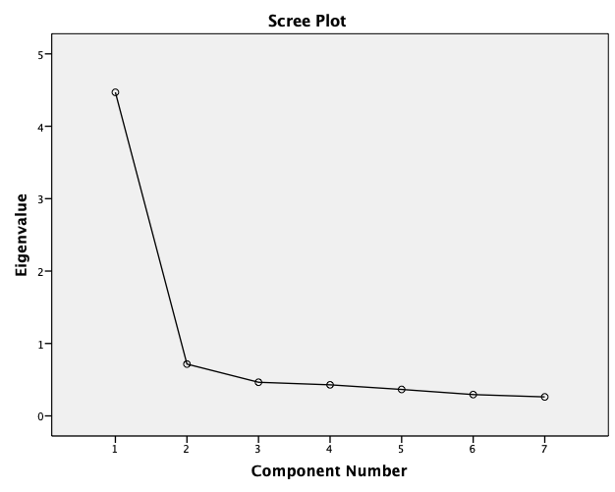
Figure 1. Scree Plot Graph

Concurrent and discriminative validity were examined by looking at the correlation of scale scores with the scores of other tools used in the research. Accordingly, it was concluded that there was a significant relationship between cognitive fusion (CFQ) with psychological flexibility (KEF-II) (r=0.74, p<0.01), valuing (VQ) (r=0.46, p<0.01) and life satisfaction (SLS) (r=. -0.30, p<0.01). On the other hand, the findings of this study revealed that there was no statistically significant correlation between CFQ and Cognitive and Affective Awareness Scale (CAAS) (r=-0.06, p>0.05).

Within the scope of this research, item discrimination was also calculated as a result of the correlation analysis of the questionnaire items with the total score of the scale. It is recommended to exclude items with item discrimination coefficients below .20 (Kline, 2015). In this context, as shown in Table 2, all of the item discrimination coefficients of CFQ were higher than .20.

Table 2. Item-total correlation coefficients

- Matter | r
1 | .73
2 | .76
3 | .68
4 | .78
5 | .70
6 | .78
7 | .75

Confirmatory Factor Analysis Results of CFQ

Missing values, outliers ​​and normality assumptions were tested before proceeding with confirmatory factor analysis. In this study, it was observed that the missing values ​​were below 5%. Therefore, the mean values were attained for the missing data. The fact that the outliers in the present study were few and did not affect the result allowed continuing without removing any data. Finally, the normality assumption was examined, and it was seen that the kurtosis and skewness values ​​were between +3 and -3 (Tabachnick & Fidell, 2007). After testing the assumptions, first level confirmatory factor analysis (CFA) was conducted to reach the findings regarding the construct validity of the questionnaire by using the IBM AMOS 21 program. The single-factor structure of the scale was confirmed by this study (Chi- Square/Degrees of Freedom (χ2/df) = 1.319; Root Mean Square Error of Approximation (RMSEA) = 0.051; Goodness of Fit Index (GFI) = 0.960; Comparative Fit Index (CFI) = 0.985; Normed Fit Index (NFI) = 0.943; Tucker Lewis Index (TLI) = 0.976). The values ​​obtained after making a suggested modification (between e6 and e7) showed that the model fits perfectly. According to the analysis results, the single-factor structure of the scale and the standardized parameter values ​​for the items are presented in Figure 2.
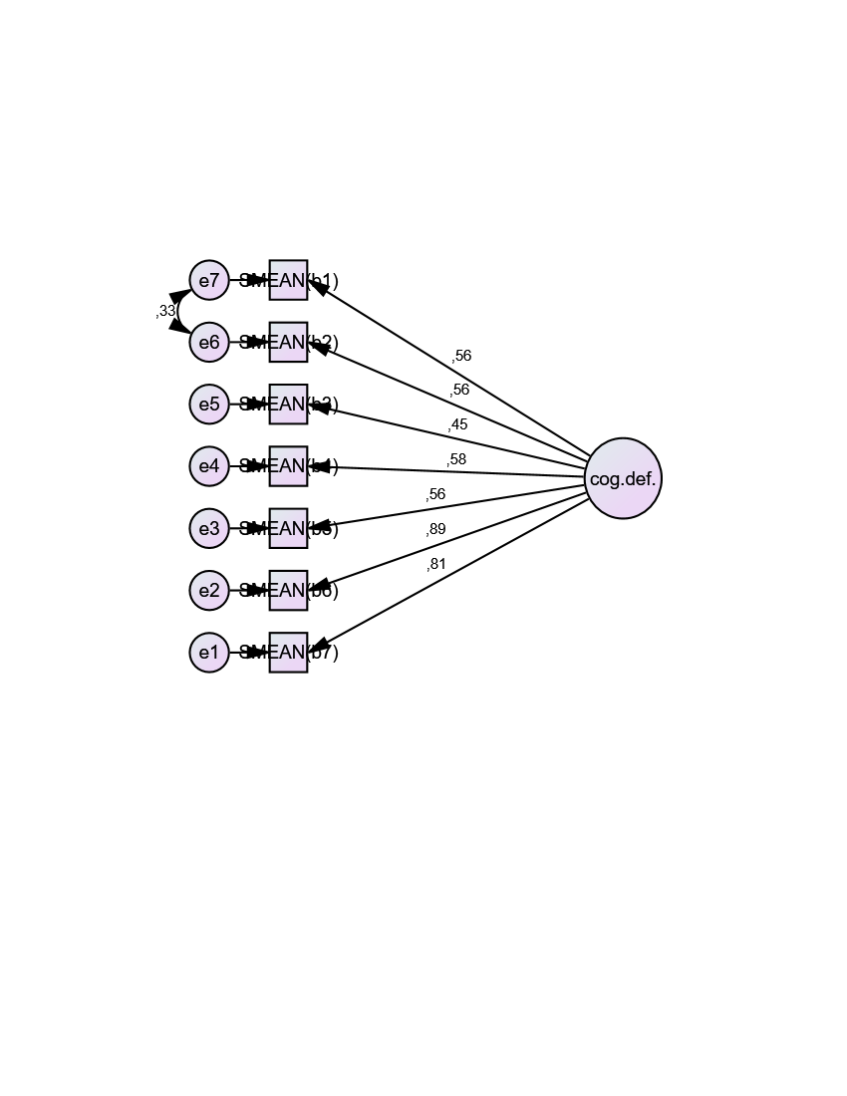

Figure 2. Confirmatory Factor Analysis Model

DISCUSSION

The present study aims to adapt the Cognitive Fusion Questionnaire (CFQ) developed by Gillanders et al. (2014) into Turkish and examine the psychometric properties of the scale. For this purpose, the translations of the CFQ were carried out and the Turkish validity and reliability studies of the scale were tested in two stages with the data obtained afterwards. As a result, it has been revealed that the Turkish version of the CFQ has a seven-item and one-factor structure just like its original form.

While cognitive fusion, which is one of the processes of psychological flexibility, expresses a strict relationship of commitment with the internal experiences of individuals, such as thoughts, feelings and images (Hayes et al., 2006), on the contrary, cognitive defusion, which can also be defined as the ability of the individual to distance himself from his internal experiences. As a result of this study, within the scope of similar criterion validity, it was concluded that there was a significant correlation between Cognitive Fusion Questionnaire (CFQ) and psychological flexibility scale (KEF-II) (r=0.74, p<0.01), Valuing Questionnaire (VQ) (r=0.46, p<0.01) and life satisfaction scale (SLS) (r=-0.30, p<0.01), but not with cognitive and affective awareness (CAAS) (r=-0.06, p>0.05). In parallel with these results, it has been revealed that cognitive fusion is associated with different psychopathologies, such as unhealthy body image and overeating (Ferreira & Trindade, 2015), rumination, shame and depression (O'Loughlin et al., 2020). In different studies, cognitive fusion was studied more specifically with university students, who also constituted the sample of this study, and it was revealed as a predictive variable for university students' emotional and social functionality (Bodenlos et al., 2020).

Acceptance and Action Form-II (AAQ-II), like the Cognitive Fusion Questionnaire, is a tool that measures psychological inflexibility and the high correlation between AAQ-II and CFQ was an expected result. Since cognitive flexibility is the basis of the Acceptance and Commitment model, the high correlation between this structure and cognitive fusion is theoretically compatible. Similar high correlations were found in the study by Gillanders and other validity and reliability studies. ( Kim & Cho, 2015; Ruiz et al.,2017)

The valuing questionnaire shows the extent to which individuals live a life in line with their values. Acceptance and commitment therapy emphasizes the importance of determining the values ​​of individuals and living accordingly. According to Acceptance and Commitment Therapy, when people live according to their values, their psychological flexibility increases (Aydın et al., 2017). In our study, a moderately significant relationship was found between the Valuing Questionnaire and the Cognitive Fusion Questionnaire, in line with this literature.

In our study, a moderately significant relationship was also found between the cognitive fusion questionnaire and the life satisfaction scale. Consistent with the findings obtained in this study, a negative correlation was found between CFQ and Satisfaction with Life Scale (SLS) in the validity and reliability study of CFQ in Colombia. (Ruiz et al., 2017)

The fact that cognitive fusion was not associated with cognitive and affective awareness in our study can be seen as one of the important findings. This finding provides us with information about the discriminant validity of cognitive fusion. Although cognitive fusion and awareness have been related in some studies (Gillanders et al.,2014; Kim et al., 2015), previous studies differ concerning sample and measurement tools used. Different correlations were found in different populations due to measurement tools and samples. In addition, in a study, it has been observed that the correlation changes in different subscales of the scale used (Pinto-Gouveia et al., 2017). Although measurement tools seem to measure a known psychological construct, each scale may measure different dimensions of this structure. While the CAAS (cognitive and affective awareness scale) that we used in our study is a scale that evaluates mindful attitudes towards internal experiences (“I can explain how I am feeling in a very detailed way at the moment”), the MAAS (Mindful Attention Awareness Scale) which is a frequently used scale in the cognitive fusion literature, is a scale that measures attention and awareness of current events and experiences (“I find it challenging to focus on what is happening right now”). In studies where cognitive fusion is associated with awareness, the most striking scale is “MAAS.” In the Turkish validity and reliability study of the CAAS (Çatak, 2012), no high correlation was found between these two scales (CAAS-MAAS) (r=0.4). This level of correlation may explain the lack of correlation between cognitive fusion and awareness in our study. This gives us information about the fact that similar scales may actually measure different structures. In the study of David et al., it is seen that both the selected measurement tool and the sample can cause different results in showing the relationship between two concepts (i.e., cognitive fusion and mindfulness) (Gillanders et al., 2014). The result we found in our study may reveal that these two concepts are different psychological constructs. There are many criteria that measure awareness. The lack of correlation in our study may be because the awareness scale we used was a one-dimensional awareness scale. The relationship between cognitive fusion and this scale, which allows for a wider range of applications and is designed for people with no prior experience of mindfulness practice, can be studied in clinical case sample groups.

The scale has been translated into many different languages ​​and psychometric properties have been examined for some of these languages, and these data are presented through the official page of the scale (https://contextualscience.org/CFQ). The majority of these studies were conducted in young adults and healthy volunteers. Conceptually similar tools were used for concurrent and discriminative validity in the studies. The tools used assessed either the parallel change in other ACT-related concepts (e.g., values, acceptance/volunteering) or the parallel change in depression, anxiety, or general quality of life, which could be considered indicators of mental deterioration.

High internal consistency and a single-factor structure were observed in almost all adaptation studies of the scale (Kim & Cho, 2015; Quintero et al., 2020; Ruiz et al., 2017; Romero-Moreno et al., 2014; Zacharia et al., 2021). In this study, which aimed to introduce the Cognitive Fusion Questionnaire into our language, it was determined that the Turkish version of the questionnaire is a valid and reliable tool concerning psychometric properties. The Cognitive Fusion Questionnaire can be used as a valid and reliable scale for both university students and mental health care providers in our language and our culture.

Declaration of competing interest

All authors state that they have no conflict of interest.

REFERENCES

Akın, A., & Çetin, B. (2007). Depresyon anksiyete stres ölçeği (DASÖ): Geçerlik ve güvenirlik çalışması.

Aydın, Y. & Aydın, G. (2017). Değer Verme Ölçeği’ni (DVÖ) Türk kültürüne uyarlama çalışması. [Adaptation of Valuing Questionnaire (VQ) into Turkish culture]. Abant İzzet Baysal Üniversitesi Eğitim Fakültesi Dergisi, 17(1), 64-77.

Bodenlos, J. S., Hawes, E. S., Burstein, S. M., & Arroyo, K. M. (2020). Association of cognitive fusion with domains of health. Journal of Contextual Behavioral Science, 18, 9-15.

Bond, F. W., Hayes, S. C., Baer, R. A., Carpenter, K. M., Guenole, N., Orcutt, H. K., Waltz, T., & Zettle, R. D. (2011). Preliminary psychometric properties of the Acceptance and Action Questionniare - II: A revised measure of psychological flexibility and experiential avoidance.Behavior Therapy, 42, 676-688.

Catak, P. D. (2012). The Turkish Version of the Cognitive and Affective Mindfulness Scale-Revised. Europe’s Journal of Psychology, 8(4), 58. http://doi.org/10.5964/ejop.v8i4.436

Cenkseven, F., & Akbaş, T. (2007). Üniversite öğrencilerinde öznel ve psikolojik iyi olmanın yordayıcılarının incelenmesi. Türk Psikolojik Danışma ve Rehberlik Dergisi, 3(27), 43-65.

China, C., Hansen, L. B., Gillanders, D. T., & Benninghoven, D. (2018). Concept and validation of the German version of the Cognitive Fusion Questionnaire (CFQ-D). Journal of contextual behavioral science, 9, 30-35.

Dell’Orco, F., Prevedini, A., Oppo, A., Presti, G. B., & Moderato, P. (2012, July). Validation study of the Italian version of the Cognitive Fusion Questionnaire (CFQ). In Poster session presented at ACBS Annual World Conference X, Washington DC, USA.

Diener, E., Emmons, R., Larsen, R., & Griffin, S. (2013). The Satisfaction with Life Scale.

Dionne, F., Gagnon, J., Balbinotti, M., Peixoto, E. M., Martel, M. E., Gillanders, D., & Monestès, J. L. (2016). " Buying into thoughts”: Validation of a French translation of the Cognitive Fusion Questionnaire. Canadian Journal of Behavioural Science/Revue canadienne des sciences du comportement, 48(4), 278.

Ferreira, C., & Trindade, I. A. (2015). Body image-related cognitive fusion as a main mediational process between body-related experiences and women’s quality of life. Eating and Weight Disorders-Studies on Anorexia, Bulimia and Obesity, 20(1), 91-97.

Flynn, M. K., Hernandez, J. O., Hebert, E. R., James, K. K., & Kusick, M. K. (2018). Cognitive fusion among hispanic college students: Further validation of the Cognitive Fusion Questionnaire. Journal of contextual behavioral science, 7, 29-34.

Gillanders, D. T., Bolderston, H., Bond, F. W., Dempster, M., Flaxman, P. E., Campbell, L., et al. (2014). The development and initial validation of the cognitive fusion questionnaire. Behavior Therapy, 45(1), 83–101. http://doi.org/10.1016/j.beth.2013.09.001

Greg, F., Adele, H., Sameet, K., & Jeff, G. (2007). Laurenceau, Jean Philippe,‘Mindfulness and emotion regulation: The development and initial validation of the Cognitive and Affective Mindfulness Scale-Revised (CAMS-R)’. Journal of Psychopathology and Behavioral Assessment, 29, 177-190.)

Harris, R. (2019). ACT made simple: An easy-to-read primer on acceptance and commitment therapy. New Harbinger Publications.)

Hayes, S. C., Luoma, J. B., Bond, F. W., Masuda, A., & Lillis, J. (2006). Acceptance and commitment therapy: model, processes and outcomes. Behaviour Research and Therapy, 44(1), 1–25. http://doi.org/10.1016/j.brat.2005.06.006

Hayes, S. C., Strosahl, K. D., & Wilson, K. G. (2011). Acceptance and commitment therapy: The process and practice of mindful change. Guilford Press.)

Kline, R. B. (2015). Principles and practice of structural equation modeling. Guilford publications.

Kim, B. O., & Cho, S. (2015). Psychometric properties of a Korean version of the Cognitive Fusion Questionnaire. Social Behavior and Personality: an international journal, 43(10), 1715-1723

Köker, S. (1991). Normal ve Sorunlu Ergenlerin Yaşam Doyumu Düzeylerinin Karşılaştırılması (Yayınlanmamış Yüksek Lisans Tezi). Ankara Üniversitesi Sosyal Bilimler Enstitüsü.

Lovibond, P. F., & Lovibond, S. H. (1995). The structure of negative emotional states: comparison of the Depression Anxiety Stress Scales (DASS) with the Beck Depression and Anxiety Inventories. Behaviour Research and Therapy, 33(3), 335–343.

Luoma, J. B., Hayes, S. C., & Walser, R. D. (2007). Learning ACT: An acceptance & commitment therapy skills-training manual for therapists. New Harbinger Publications.)

Meunier, B., Atmaca, S., Ayranci, E., Gökdemır, B. P., Uyar, T., & Baştuğ, G. (2014). Psychometrıc propertıes of the turkısh versıon of the acceptance and actıon questıonnaıre-ıı (aaq-ıı). Journal of evidence-based psychotherapies, 14(2).

O'Loughlin, C. M., Bennett, D. S., & O'Hayer, C. V. (2020). The nomological network of cognitive fusion among people living with HIV: Associations with rumination, shame, and depressive symptoms. Journal of Contextual Behavioral Science, 15, 245-252.

Pinto-Gouveia, J., Dinis, A., Gregório, S., Pinto, A. M., & Duarte, C. (2017, June). Assessment of Cognitive Fusion Among Portuguese Samples: Psychometric Properties and Factor Structure of the Cognitive Fusion Questionnaire. Poster session presentation at the meeting of the ACBS Annual World Conference 15, Spain.

Romero-Moreno, R., Márquez-González, M., Losada, A., Gillanders, D., & Fernández-Fernández, V. (2014). Cognitive fusion in dementia caregiving: Psychometric properties of the Spanish version of the" Cognitive Fusion Questionnaire". Behavioral Psychology/Psicología Conductual, 22(1).

Ruiz, F. J., Suárez-Falcón, J. C., Riano-Hernández, D., & Gillanders, D. (2017). Psychometric properties of the cognitive fusion questionnaire in colombia. Revista Latinoamericana de Psicología, 49(1), 80-87.)

Ryff, C. D. (1989). Happiness is everything, or is it? Explorations on the meaning of psychological well-being. Journal of personality and social psychology, 57(6), 1069.

Quintero, P. S. J., Biglieri, R. R., Etchezahar, E., & Gillanders, D. T. (2020). The Argentinian version of the cognitive fusion questionnaire: Psychometric properties and the role of cognitive fusion as a predictor of pathological worry. Current Psychology, 1-12.

Smout, M., Davies, M., Burns, N., & Christie, A. (2014). Development of the Valuing Questionnaire (VQ). Journal of Contextual Behavioral Science, 3(3), 164–172. http://doi.org/10.1016/j.jcbs.2014.06.001

Solé, E., Racine, M., Castarlenas, E., Vega, R. de la, Tomé-Pires, C., Jensen, M., & Miró, J. (2015). The psychometric properties of the Cognitive Fusion Questionnaire in adolescents. European Journal of Psychological Assessment. Katalan versiyon

Tabachnick, B. G., Fidell, L. S., & Ullman, J. B. (2007). Using multivariate statistics (Vol. 5, pp. 481-498). Boston, MA: Pearson.

Yavuz, F., Ulusoy, S., Iskin, M., Esen, F. B., Burhan, H. S., Karadere, M. E., & Yavuz, N. (2017). Turkish Version of Acceptance and Action Questionnaire-II (AAQ-II): A reliability and Validity Analysis in Clinical and Non-Clinical Samples. Klinik Psikofarmakoloji Bülteni-Bulletin of Clinical Psychopharmacology, 26(4), 397–408. http://doi.org/10.5455/bcp.20160223124107

Zacharia, M., Ioannou, M., Theofanous, A., Vasiliou, V. S., & Karekla, M. (2021). Does Cognitive Fusion show up similarly across two behavioral health samples? Psychometric properties and invariance of the Greek–Cognitive Fusion Questionnaire (G-CFQ). Journal of Contextual Behavioral Science.

