“Immediate effect of Bhasthrika & Bhramari pranayamas on autonomic and respiratory variables in healthy individuals”- A Randomized controlled trial.

Abstract: Introduction: Pranayamas, one of the limbs of Ashtanga yoga . It involves manipulation of the breath and works as a dynamic bridge between the body and mind. Regular practices of Pranayamas have shown an increase in parasympathetic tone and a decrease in sympathetic activity. Pranayamas especially when done in a faster pace for a longer duration produce parasympathetic dominance in contrast to the short duration training which evokes a sympathetic activity. Material and Methods: Subjects of age 18-25 years who haven’t had any form of exposure towards yogic practices for the past 3 months were randomly recruited. A total number of 210 subjects were screened. Ninety subjects met inclusion criteria and were allocated randomly by using a computer generated randomization tool into 3 groups of 30 each. Group 1, Group 2 & Group 3 were assigned for the practice of Bhasthrika, Bhramari & Breath Awareness respectively. The data was collected for autonomic and respiratory variables by using polygraph (MP 36 Biopac Student Lab) at baseline, during & immediately after 5 mins of the practice for
each group. Observations and Results: The findings of the present study indicate that a significant increase in HR, RMSSD, LF, LF/HF ratio in all the three groups during the practice. However, interestingly an increase in HF was observed during breath awareness practice. Immediately following the practices, a significant reduction in HR, RMSSD, and HF were observed in all the three groups. However, NN50 increased significantly immediately following the practice as compared to the baseline levels following Bhramari and breath awareness groups. These findings suggest that all practices increase the sympathetic tone. Interestingly, Bhrastrika and Bhramari Pranayama practices increases the cardiac tone as indicated through NN50.
Conclusion: The study investigated the immediate effects of Bhasthrika , Bhramari and breath awareness practices on autonomic and respiratory variables and concluded that there was an increase in HF during these practices which indicated an increase in cardiac tone. Short durations of Bhastrika and Bhramari Pranayama practices are therefore effective in physiological arousal among healthy individuals.
Keywords Pranayam; Bhasthrika; Bhramari;Breath Awareness; Heart rate variability.
Received: / Revised- :/ Accepted: / Published:/

- Introduction
The word “Yoga” comes from a Sanskrit root “yuj” which means union or yoke, to join and to direct and concentrate one's attention. [1,2] According to Patanjali yoga sutras, Yoga is a “union” of the mind, body and spirit. It is also understood as the science of the mind.[3] The holistic definition of Yoga is most relevant to the modern society where the matter-based paradigm has become the truth of the times. The aim of Yoga is to enhance the freedom to choose one’s way towards absolute freedom, which is freedom from tensions , stresses, diseases and miseries moving towards a positive and perfect health.[4] Since Yoga has been recognized as a form of mind body medicine having a holistic way of approach towards stress management, it can also be used as a technique to bring fitness and vigor to the physical body and also harness our emotions and expand our power of insight, vision, and analysis.[5] Physiologically, regular practice of Yoga help practitioners to become more resilient to stressful conditions and reduce several risk factors of various cardio-respiratory diseases. Muscle strength, flexibility, blood circulation and oxygen uptake as well as hormone functions have been shown to be improved by practicing Pranayamas (yogic breathing techniques) and Asanas (yogic postures) which form an integral part of the practice of yoga. In addition, meditation has also shown to help stabilize the autonomic nervous system by shifting towards a parasympathetic dominance.[6] Yoga plays a key role not only in improving mental health and quality of life in the treatment of a number of disorders.[7] but also lets its practitioners gain physical strength and a calming effect on the mind.[8] Yogic philosophies can be divided into four main branches viz; Bhakti yoga, Karma yoga, Jnana yoga, and Ashtanga yoga.[9] Of these, Ashtanga yoga is an eightfold path to awareness and enlightenment, consisting of eight limbs.[1,10] These limbs comprise of ethical principles for living a meaningful and purposeful life; serving as a prescription for moral and ethical conduct and self-discipline, they direct attention towards one's health while acknowledging the spiritual aspects of one's nature. [11] Pranayamas, one of the limbs of Ashtanga yoga [12,13] given by Maharishi Patanjali is considered to be much more important than asanas to attain sound health.[14,15] It involves manipulation of the breath and works as a dynamic bridge between the body and mind.[16] Pranayama consists of three phases “Puraka” (inhalation) considered as the first phase; “Kumbhaka” (retention) as the second phase and “Rechaka” (exhalation) as the third phase which can be either fast or slow.[17] The nasal cycle is an ultradian rhythm consisting of phases of breathing cycles and is characterized by the alternating potency of the left and right nares, with a periodicity of 2 to 8 hours.[18] The versions of breathing in a nasal cycle vary from single nostril breathing to bellow breathing .[17] The Autonomic Nervous system also known as the visceral or involuntary nervous system functions without a conscious and voluntary control and influences the activities of most of the organ systems in the body. It innervates cardiac muscles, smooth muscles and various other endocrine as well as exocrine glands. The ANS therefore makes a significant contribution to homeostasis by regulating blood pressure, gastro intestinal responses to food, contraction of the urinary bladder, focusing of the eyes, and by maintenance of body temperature.[19] Regular practices of Pranayamas have shown an increase in parasympathetic tone and a decrease in sympathetic activity which in turn decreases the effect of stress and strain on the body thereby improving cardio-vascular and respiratory functions.[20,21,22] Previous studies have demonstrated that different types of Pranayamas (including Bhasthrika and Bhramari) produce divergent effects and different physiological benefits[23,24,25] in specific ways .[26] Pranayamas especially when done in a faster pace for a longer duration produce parasympathetic dominance in contrast to the short duration training which evokes a sympathetic activity. [27] Heart rate variability (HRV) is a parameter used to assess the autonomic nervous system activity which is computed from the continuous ECG recordings and by analyzing the variability in the intervals between sinus rhythm heart beats (R-R intervals). [28] HRV is also used to assess the tonicity of autonomic balance in the body ,[29] and risks of sudden death are associated with a decreased HRV. It has been reported that HRV shows a favorable influence by yogic practices.[30] The conscious cortical regulation of brainstem respiratory centers influences the cardiovascular centers and brings about changes in HRV.[31] There have been many scientific studies on yoga and its longitudinal effects on physical function along with a phenomenal and ever increasing popularity of Pranayama in the past few years. There has however been a lack of studies done on the immediate effects of Bhastrika and Bhramari Pranayamas.
Hence, the present study has been therefore undertaken to evaluate the immediate effects of Bhastrika and Bhramari Pranayamas on autonomic and respiratory variables amongst healthy individuals.
2. Experimental Section / Material and Methods
Subjects of age 18-25 years who haven’t had any form of exposure towards yogic practices for the past 3 months were randomly recruited from the SDM College of Naturopathy & Yogic Sciences, Ujire, Belthangady (Taluk) D.K (District), Karnataka (State). A total number of 210 subjects were screened. Ninety subjects met inclusion criteria and were allocated randomly by using a computer generated randomization tool into 3 groups of 30 each. Group 1, Group 2 & Group 3 were assigned for the practice of Bhasthrika, Bhramari & Breath Awareness respectively. The data was collected at baseline, during & immediately after 5 mins of the practice for each group.

3. Results and Discussion
The data obtained following Pranayamas were analyzed for normal distribution and variance using Shapiro-wilk test with SPSS (Version 21.0). The pre, during and post data of the three groups were analyzed using Repeated measures analyses of Variance (RMANOVA), Bonferroni adjustment with post-hoc analysis.
Data of all three autonomic and respiratory variables were found to be normally distributed. The results of the pre, during and post comparisons for the 3 groups are detailed below:
3.1 Heart rate and Heart Rate variability (HRV) :
Bhasthrika pranayama:
Time domain and frequency domain analysis of HRV indicate a significant reduction in NN50 (p≤0.01) , pNN50 (p≤0.05), during the practice of Bhastrika Pranayama and there is also a reduction in RMSSD (p≤0.05), NN50(p≤0.01),VLF(p≤0.001), immediately following Bhastrika Pranayama. An increase in, VLF (p≤0.001) & LF/HF (p≤0.05)during the practice was observed. However, pNN50 (p≤0.05) increased significantly immediately after Bhasthrika Pranayama. These findings suggest that Bhastrika Pranayama caused sympathetic tone to be elevated during and immediately after the practice.
Bhramari pranayama:
Time domain and frequency domain analysis of HRV indicate a significant reduction in Respiration rate (p≤0.001), Mean RR (p≤0.001), VLF(p≤0.05) , and HF(p≤0.01) during the practice and an increase in HR(p≤0.001),RMSSD(p≤0.001), LF(p≤0.01) & LF/HF(p≤0.05) during Bhramari Pranayama. However, a significant increase was seen in Mean RR (p≤0.001) immediately after practicing Bhramari Pranayama. These finding suggest an elevated sympathetic tone with Bhramari Pranayama.
Breath Awareness :
Time domain and frequency domain analysis of HRV indicate a significant reduction in Respiration (p≤0.01) during and an increase in Mean RR(p≤0.05) & LF/HF(p≤0.01) immediately after practicing breath awareness. These finding suggest an elevated Para sympathetic tone with areath awareness.
Post-tests in between groups
A significant reduction in Respiratory rate (F_{(2,87)=}42.707;p=0.000) was observed in Bhramari Pranayama as compared to Bhastrika and breath awareness, pNN50 (F_{(2,87)}=6.839;p=0.002) was observed in Bhasthrika Pranayama as compared to Bhramari and breath awareness, VLF (F_{(2,87)}=25.191;p=0.000) seen in Bhramari Pranayama as compared to Bhasthrika and breath awareness, and LF _{(F(2,87)}=7.444;p=0.001) in breath awareness as compared to Bhasthrika and Bhramari.
A significant increase in NN50 was observed (F_{(2,87)}=7.046;p=0.001) was observed in breath awareness as compared to Bhasthrika and Bhramari Pranayamas ; HF (F_{(2,87)}=7.444;p=0.001) compared to Bhasthrika and Bhramari Pranyamas; and LF/HF (F_{(2,87)}=4.816;p=0.10) in Bhramari Pranayama as compared to Bhasthrika and breath awareness.The groups mean values ±SD for Low frequency (LF), High frequency (HF), LF/HF ratio, NN50, pNN50, Hear Rate, Respiratory Rate, Mean RR and RMSSD values for normal healthy volunteers following the intervention of all three pranayamas are given in the table-1, table-2 ^{nd} table-3 individually.
DISCUSSION

In Bhasthrika pranayama :Time domain and frequency domain analysis of HRV indicate a significant reduction in NN50(p≤0.01), pNN50 (p≤0.05), during the practice of Bhastrika pranayama and there is also a reduction in RMSSD(p≤0.05),NN50(p≤0.01),VLF(p≤0.001), immediately following Bhastrika pranayama. An increase in, VLF (p≤0.001) & LF/HF (p≤0.05) during the practice was observed. However, pNN50(p≤0.05) increased significantly immediately after Bhasthrika pranayama. These findings suggest that Bhastrika pranayama caused sympathetic tone to be elevated during and immediately after the practice.
In Bhramari pranayama: Time domain and frequency domain analysis of HRV indicate a significant reduction in Respiration rate (p≤0.001), Mean RR (p≤0.001), VLF(p≤0.05) , and HF(p≤0.01) during the practice and an increase in HR(p≤0.001),RMSSD(p≤0.001), LF(p≤0.01) & LF/HF(p≤0.05) during Bhramari pranayama. However, a significant increase was seen in Mean RR (p≤0.001) immediately after practising Bhramari pranayama. These finding suggest an elevated sympathetic tone with Bhramari pranayama.
In Breath Awareness :Time domain and frequency domain analysis of HRV indicate a significant reduction in Respiration(p≤0.01) during and an increase in Mean RR(p≤0.05) & LF/HF(p≤0.01) immediately after practicing breath awareness. These finding suggest an elevated para sympathetic tone with breath awareness.
When compared with the Post-tests in between groups :
A significant reduction in Respiratory rate (F(2,87)=42.707;p=0.000) was observed in Bhramari pranayama as compared to Bhastrika and breath awareness , pNN50 (F(2,87)=6.839;p=0.002) was observed in Bhasthrika pranayama as compared to Bhramari and breath awareness, VLF (F(2,87)=25.191;p=0.000) seen in Bhramari pranayama as compared to Bhasthrika and breath awareness, and LF (F(2,87)=7.444;p=0.001) in Breath awareness as compared to Bhasthrika and Bhramari.
A significant increase in NN50 was observed (F(2,87)=7.046;p=0.001) was observed in breath awareness as compared to Bhasthrika and Bhramari pranayamas ; HF (F(2,87)=7.444;p=0.001) compared to Bhasthrika and Bhramari pranyamas; and LF/HF (F(2,87)=4.816;p=0.10) in Bhramari pranayama as compared to Bhasthrika and breath awareness.
Bhastrika Pranayama involves forceful contraction of respiratory muscles and abdominal muscles. Earlier studies have also demonstrated an elevated heart rate immediately following Bhastrika pranayama suggesting an increase in sympathetic[32] activity. Bhastrika pranayama is found effective in decreasing BP and increasing HR immediately. Mullur Lata et.al study shown Increase MEP and PEFR immediately after Bhastrika pranayama.[33] In our study also it shows increased sympathetic activity and HRV indicate a significant reduction during the practice and there is also a reduction seen immediately after Bhastrika pranayama.
The phenomenon of Bhastrika simultaneously increasing the heart rate and decreasing blood pressure can be attributed to the duration of inhibitory neural impulses by activating pulmonary stretch receptors, which brings about withdrawal of sympathetic tone in blood vessels of skeletal muscle leading to widespread vasodilatation, thus causes decrease in peripheral resistance and thus DBP. [32]
Raghuraj et al have reported that Nadishuddi reduces sympathetic activity while Kapalabhati produces sympathetic stimulation. As like Nadishuddi, In our study there was significant HRV indicate a significant reduction in Respiration during and an increase in immediately after practicing breath awareness. These finding suggest an elevated para sympathetic tone with breath awareness.[34]
In Bhramari Pranayama there is humming sound produced during exhalation by keeping fingers on ears and eyes.[35]The vibrations and sound produced during this exercise causes increased conduction of impulses in vestibulcohclear nerve. This eventually by virtue of its connection to the cerebellum and other extrapyramidal tract improves the performance output. During Omkar recitation, the first pronunciation A creates the vibrations, which affect on the spinal cord to increase it's efficiency.[36,37] affecting intermediolateral grey column.[38]
The second pronunciation U creates the vibrations in the throat and affects the Thyroid Glands, while the last pronunciation M, brings the vibrations to the brain, thereby activating the brain centres as a result of which, the efficiency of a brain increases.[36] As our study is concerned with performance output we decided to have longer M part as it is going to affect the brain activity.[36,37]In our study we observed HRV indicate a significant reduction in Respiration during. However, a significant increase seen immediately after practicing Bhramari pranayama. These findings suggest an slightly elevated sympathetic tone with Bhramari pranayama.
Results from a study by Madanmohan et al[34] shows that regular practice of breathing exercises (pranayama) increases parasympathetic tone, decreases sympathetic activity, improves cardio-vascular and respiratory functions, decreases the effect of stress and strain on the body and improves physical and mental health.[39] In yoga tradition, it is taught that different Pranayamas have different effects. Raghuraj et al have studied the acute effect of fast and slow Pranayamas on heart rate variability [40] while, Telles and Desiraju have demonstrated the heart rate changes during the performance of different Pranayamas.
Table 1:
Showing HRV & respiratory rate measures in Bhasthrika Pranayama. Values are group mean ±S.D.
VARIABLES | PRE | DURING | POST
HR | 84.23±8.05 | 87.62±11.44 | 82.74±7.29
RESP | 15.60±1.27 | 17.77±1.11 c | 15.71±1.14
MEAN RR | 725.34±4.14 | 719.49±111.39 | 736.89±65.42
RMSSD | 51.27±52.95 | 78.41±66.90 | 39.14±32.19 ^{y}
NN50 | 77.73±68.76 | 36.53±45.38 ª | 47.97±43.35 ^{x}
PNN50 | 16.50±15.38 | 7.20±8.58 ^{b} | 10.24±9.69 ^{y}
VLF | 28.11±14.33 | 59.45±_21.69 ^{c} | 54.08±24.26 ^{z}
LF | 55.44±19.04 | 65.63±_20.87 | 61.47±15.26
HF | 44.56±19.04 | 34.37±20.87 | 38.54±15.26
LF/HF | 1.99±2.09 | 3.98±4.59 ^{b} | 2.07±1.38
Note : a= <0.01, b= <0.05, c= <0.001 ; x=<0.01 , y=<0.05 , z= < 0.001
Table 2 :
Showing HRV & respiratory rate measures in Bhramari Pranayama. Values are group mean ±S.D.
VARIABLES | PRE | DURING | POST
HR | 82.88±9.86 | 89.62±6.53 ^{c} | 82.19±9.69
RESP | 15.34±1.85 | 11.69±_25.26 ^{c} | 14.72±1.85
MEAN RR | 734.25±91.01 | 685.16±48.72 ^{c} | 746.35±94.41 z
RMSSD | 47.34±34.57 | 103.26±59.62 ^{c} | 46.08±32.12
NN50 | 86.40±63.05 | 84.03±45.19 | 87.70±70.73
PNN50 | 18.32±14.32 | 16.30±9.09 | 19.04±16.17
VLF | 28.85±17.47 | 17.00±13.67 ^{b} | 31.28±20.87
LF | 56.58±20.12 | 70.37±16.97 ª | 60.03±20.48
HF | 43.42±20.14 | 29.63±16.97 ª | 39.97±20.48
LF/HF | 2.33±3.25 | 5.02±6.51 ^{b} | 2.93±3.96
*p < 0.05, **p < 0.01 and ***p < 0.001
Table:3 Showing HRV & respiratory rate measures in Breath Awareness. Values are group mean ±S.D.
VARIABLES | PRE | DURING | POST
HR | 82.84±10.11 | 83.4±4.21 | 80.15±9.21
RESP | 15.9±1.31 | 14.87±1.93 a | 15.89±1.12
MEAN RR | 740.34±89.83 | 735.93±75.76 | 767.92±90.28 b
RMSSD | 56.89±36.37 | 100.98±125.53 | 52.35±26.61
NN50 | 97.87±85.43 | 108.77±72.98 | 99.90±2.31
PNN50 | 21.48±20.01 | 24.62±16.79 | 22.49±17.58
VLF | 29.82±14.08 | 23.69±16.04 | 36.36±19.42
LF | 48.037±17.19 | 46.99±22.23 | 53.94±19.34
HF | 51.96±17.19 | 53.00±22.24 | 46.04±19.33
LF/HF | 1.19±0.89 | 1.51±1.76 | 1.70±1.45 a
Note : a= <0.01, b= <0.05, c= <0.001 ; x=<0.01 , y=<0.05 , z= < 0.001
Table 4: Showing Post Tests of between 3 Groups
Variables | Bhasthrika | Bhramari | Breath Awareness | pŋ²
HR | 82.74±7.29 | 82.19±9.69 | 80.15±9.21 | .034
RESP | 15.71±1.14 | 14.72±1.85*** | 15.89±1.12 | .495
MEAN RR | 736.89±65.42 | 746.35±94.41 | 767.92±90.28 | .029
RMSSD | 39.14±32.19 | 46.08±32.12 | 52.35±26.61 | .025
NN50 | 97.97±43.35 | 87.70±70.73 | 99.90±2.31 | .139
PNN50 | 10.24±9.69** | 19.04±16.17 | 22.49±17.58 | .136
VLF | 54.08±24.26 | 31.28±20.87*** | 36.36±19.42 | .367
LF | 61.47±15.26 | 60.03±20.48 | 53.94±19.34*** | .146
HF | 38.54±15.26 | 39.97±20.48 | 46.04±19.33*** | .146
LF/HF | 2.07±1.38 | 2.93±3.96* | 1.70±1.45 | .100
*p<0.01, **p<0.05 and ***p<0.001
Figure 1: Trial profile
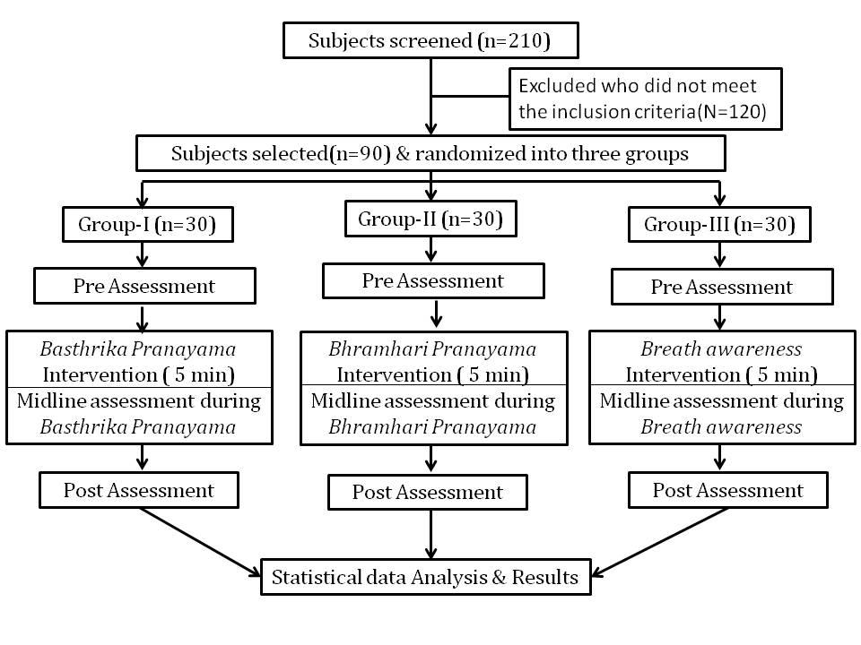

Figure 2: HRV spectrum obtained by FFT analysis

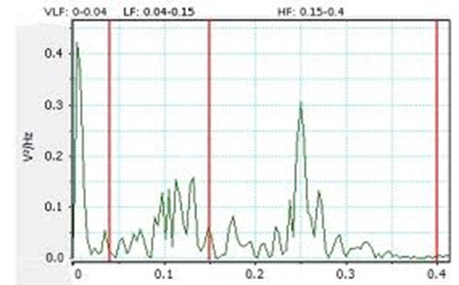

Figure 3: Schematic representation of ECG (Electrocardiogram)

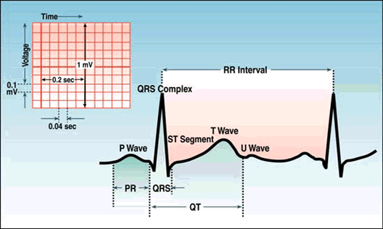

Figure 4: Measuring Heart rate variability
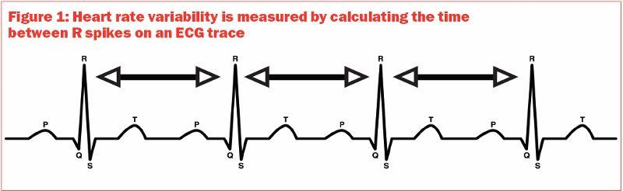

Figure 5: calculating Heart rate variability

: 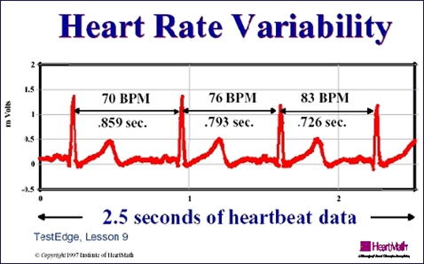

Graphical representation of the results between all the 3 groups
Graph 1: Showing the changes in heart rate

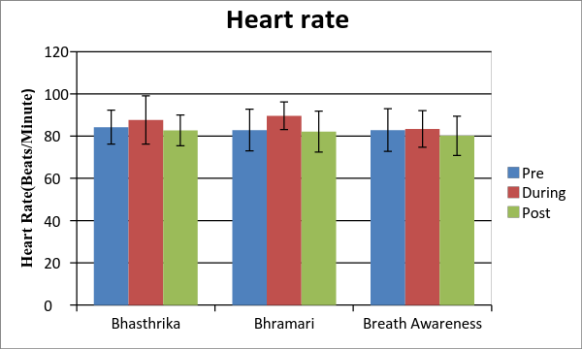

Graph 2: Showing the changes in Respiratory rate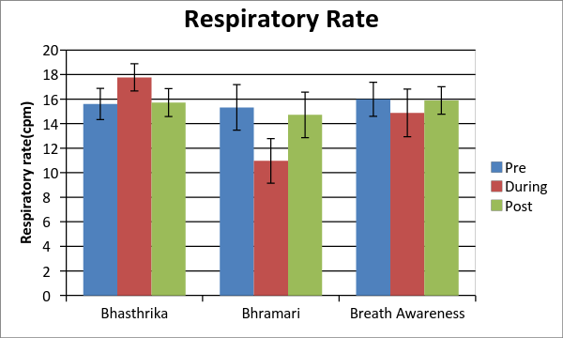

Graph 3: Showing the changes in Mean RR
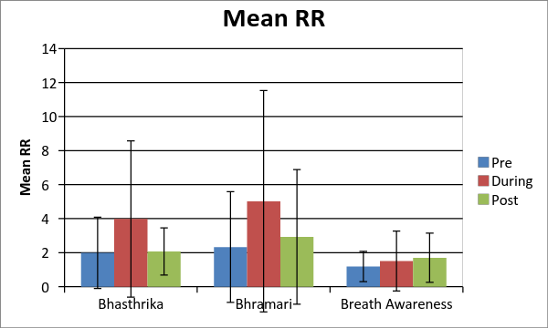

Graph 4: Showing the changes in RMSSD
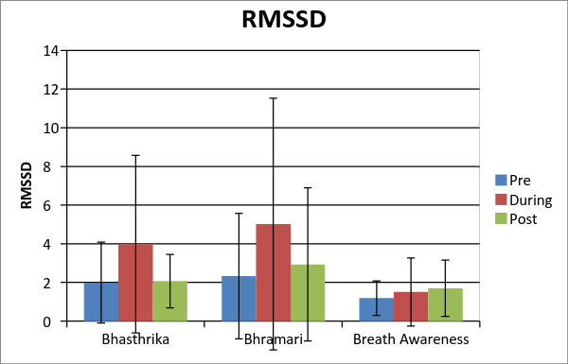

Graph 5: Showing the changes in NN50
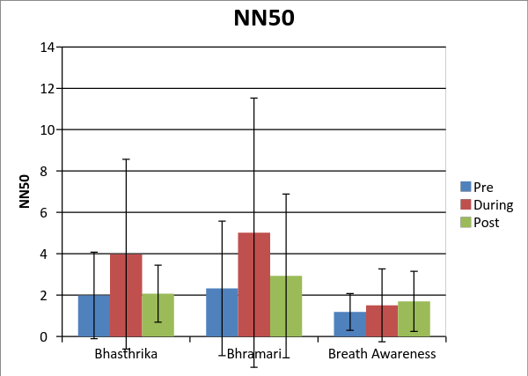
Graph 6: Showing the changes in PNN50

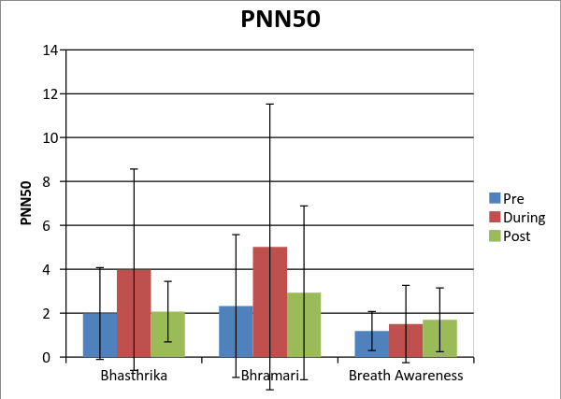

Graph 7: Showing the changes in VLF
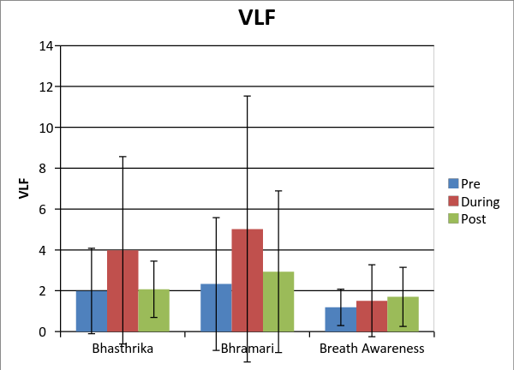
Graph 8: Showing the changes in LF
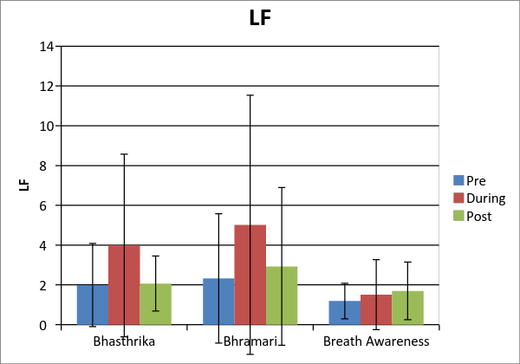

Graph 9: Showing the changes in HF
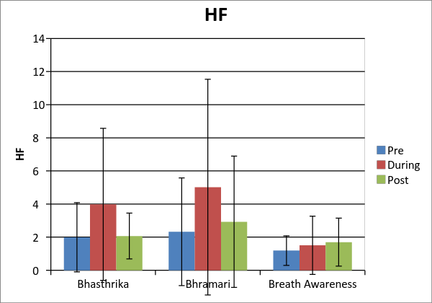
Graph 10: Showing the changes in LF/HF

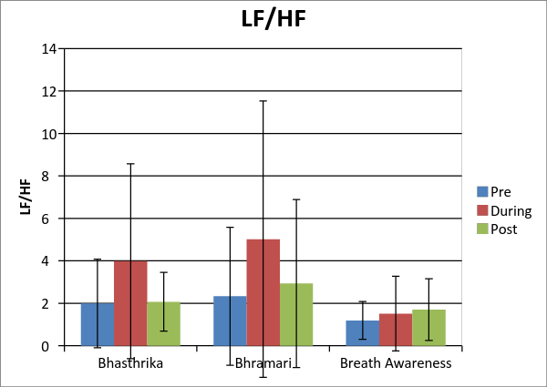

4. Conclusions
The study investigated the immediate effects of Bhasthrika, Bhramari and breath awareness practices on autonomic and respiratory variables and concluded that there was an increase in HF during these practices which indicated an increase in cardiac tone. Short durations of Bhastrika and Bhramari Pranayama practices are therefore effective in physiological arousal among healthy individuals.

References
1)Lasater J. The heart of pantajali. Yoga J. 1997;137:134–44.
2)Raub JA. Psychophysiologic effects of hatha yoga on musculoskeletal and cardiopulmonary function: A literature review. J Altern Complement Med. 2002;8:797–812.
3)Satchidananda S. Yogaville, The Yoga Sutras of Patanjali. VA: Integral Yoga Publications; 2005.

4)Nagendra H. Defining Yoga. Int J Yoga. 2008; 1:43–44.

5)Nagarathna R, Nagendra HR. New Perspectives in Stress Management. 1st ed. Bangalore, Karnataka, India: Swami Vivekananda Yoga Prakashana; 1986.

6)Parshad ODepartment of Basic Medical Sciences, The University of the West Indies, Kingston 7, Jamaica, West Indies. oparshad@uwimona.edu.jmThe West Indian Medical Journal [2004, 53(3):191-194.
7)Sharma R, Gupta N, Bijlani RL. Effect of yoga based lifestyle intervention on subjective well-being. Indian J Physiol Pharmacol. 2008;52:123–31.
8)Chandra R. Whole Health: A prescription for the new millennium. Nutrition Research. 2001;21:1–8.
9)Satchidanda S. Integral yoga hatha. 2nd ed. Buckingham: Integral Yoga Publications;1995. P14.

10)Maehle G. Ashtanga Yoga: Practice and Philosophy Analoo City, Western Australia: Kaivalya Publications; 2006.
11)Collins C. Yoga: Intuition, preventive medicine, and treatment. J Obstet Gynecol Neonatal Nurs. 1998;27:563–8.
12)Madanmohan, Rai VC Balavittal V, Thombre DP,Swami Gitananda. Cardio-respiratory changes during savitri pranayama and shavasan. The Yoga Review 1983; 3: 25-34.
13)Rai VC, Madanmohan, Subramanian N, Swami Gitananda. Oxygen consumption and ventilator changes during savitri pranayama and shavasan. J Res Edu Indian Med 1982; 1: 23-26.
14)Veerabhadrappa SG, Baljoshi VS, Khanapure S, Herur A, Patil S, Ankad RB, et al. Effect of yogic bellows on cardiovascular autonomic reactivity. J Cardiovasc Dis Res. 2011;2:223–7.
15)S Dutta Ray. Yogic Exercises - Physiologic and Psychic Process. New Delhi: Jaypee Brothers Medical Publishers; 1998.
16)Bijlani RL. 3rd ed. New Delhi: Jaypee Brothers; 2004. Understanding medical physiology; pp. 871–910.
17)Chodinzki JY. The effect of rhythmic breathing on blood pressure in hypertensive adults. J Undergrad Res. 2000:1–6.
18)Keuning J. 1968. On the Nasal cycle. Rhinology International Journal, 6: 99-136.
19)Iversen S, Iversen L, Saper C. The autonomic nervous system and the hypothalamus. In: Kandel ER, Schwartz JH, Jessell TM, eds. Principles of Neuroscience, 4th ed. New York, NY: McGraw Hill, 2000; chapter 49.
20)Bhargava R, Gogate MG, Mascarenhas JF. Autonomic response to breath holding and its variations following Pranayama. Indian J Physiol Pharmacol 1994;38:133-7
21)Udupa KN, Singh RH. The scientific basis of yoga. JAMA 1972; 220:1365.
22)Bal BS. Effect of anulom vilom and bhastrika pranayama on the vital capacity and maximal ventilatory volume. J Physical Educ Sport Manage 2010;1:11-15.
23)Madanmohan, Lakshmi jatiya, Udupa K, Bhavanani AB. Effect of yoga training on handgrip, respiratory pressures and pulmonary function. Indian J PhysiolPharmacol. 2003; 47 (4) : 387–92.
24)Pal GK, Velkumary S, Madanmohan. Effect of short- term practice of breathing exercises on autonomic functions in normal human volunteers. Indian J Med Res.2004; 120:115–21.
25)Pramanik T, Pudasaini B, Prajapati R Immediate effect of a slow pace breathing exercise Bhramari pranayama on blood pressure and heart rate. Nepal Med Coll J. 2010 Sep;12(3):154-7.
26)T. M. Srinivasan Pranayama And Brain Correlates Ancient Science of Life, Director of Institutional Laboratory, Received: 3 April 1991 Accepted: 12 June 1991 Vol No. XI No.1 & 2, July & October 1991, Pages 1 – 6.

27)Dinesh Thangavel, Girwar Singh Gaur, Vivek Kumar Sharma,Ananda Balayogi Bhavanani, Rajajeyakumar M., Syam Sunder A Effect of Slow and Fast Pranayama Training on Handgrip Strength and Endurance in Healthy Volunteers Journal of Clinical and Diagnostic Research. 2014 May, Vol-8(5): BC01-BC03.

28)Task Force of the European Society of Cardiology and the North American Society of Pacing and Electrophysiology, 1996.
29)Khattab K, Khattab A, Ortak J , Richardt G, Bonnemeier H. Iyengar Yoga Increases Cardiac Parasympathetic Nervous Modulation Among Healthy Yoga Practitioners. eCAM 2007; 4(4): 511–517.

30)Satyapriya M, Nagendra H, Nagarathna R, Padmalatha V. Effect of integrated yoga on stress and heart rate variability in pregnant women. Int J Gynaecol Obstet 2009; 104: 218-22.
31)Telles S, Nilkamal Singh, Acharya Balakrishna A. Heart rate variability changes during high frequency yoga breathing and breath awareness. Biopsychosoc Med 2011, 5:4.
32)Raghuraj P, Ramakrishnan AG, Nagendra HR, Telies S. Efffect of two selected yogic breathing techniques on heart rate variability. Indian J Physiol Pharmacol 1998; 42:467-472.
33)Mullur Lata M. , Khodnapur Jyothi P , Aithala Manjunatha. , Patil Satish G Bhastrika pranayama: a longitudinal study of its effect on blood pressure, heart rate,mep & pefr of healthy young students National Journal of Basic Medical Sciences Volume - III, Issue-1.
34)Madanmohan et al. Effect of slow and fast pranayams on reaction time and cardiorespiratory variables. Indian J Physiol Pharmacol 2005; 49 (3): 313-318.
35)Basavareddy IV. Yogic management of cardiovascular diseases, Published by National Institute of Science Communication and Information Resources; First edition 2008: 19.
36)Mandlik VV, Varkhede R. Effect of omkar chanting on concentration,memory and level of fatigue- downloaded from www.yogapoint.com ( accessed on 12/08/2009)
37)Jain AK, Textbook of Physiology, Fourth edition, Avichal Publication 2009: 498 -511.
38)Geetha N, Textbook of Medical Physiology, 2nd edition, Paras Medical Publishers 2008.601-602.
39)Bhargava R, Gogate MG, Mascarenhas JF. Autonomic response to breath holding and its variations following Pranayama. Indian J Physiol Pharmacol 1994;38:133–7.
40)Telles S, Desiraju T. Heart rate alterations in different types of pranayamas. Indian J Physiol Phrmacol 1992; 36: 287-288.

04
Number of Tables in the paper/article: ----04-------------------------
Number of Figures /Graphs in the paper/article ---05 Figures / 10 Graphs-----------
Number of Photograph in the paper/article : ___Nil___________

